**DASTAAN- THE FILM AND PHOTOGRAPHY SOCIETY**

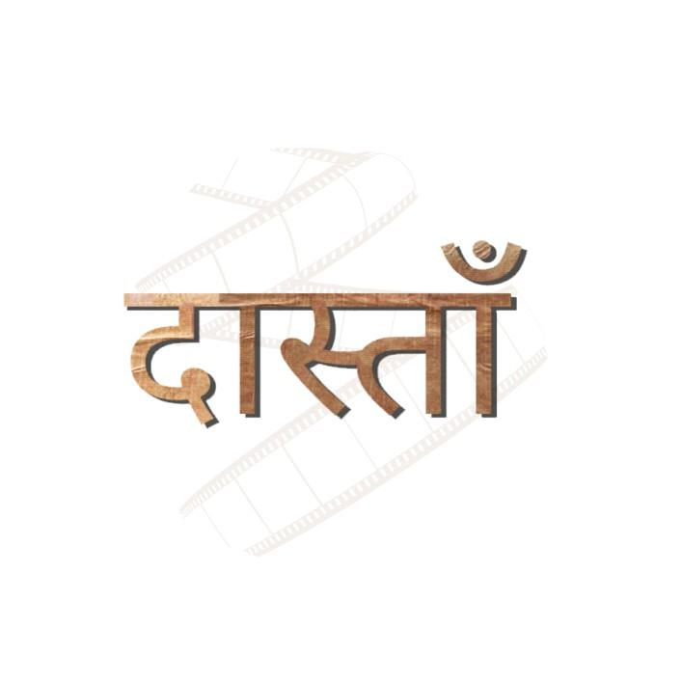

Dastaan is the Film and Photography Society of Bharati College, University of Delhi. Dastaan, which literally translates to “story” in Persian, is a community which was established in 2022 under the aegis of the Department of English of Bharati College, with the aim of telling stories through films and photographs.

Dastaan includes 40+ passionate members from various disciplines of the college.

**Council 2022-23**

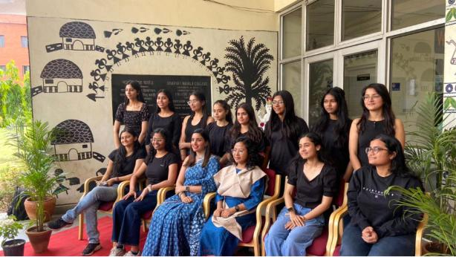

1st row (sitting, left to right): Ananya Tripathi, Archana Aggarwal, Ms Khushee Chaudhary, Ms Kangkana Roy, Ishita Sharma, Prachi Sharma

2nd row (standing, left to right): Devyani Yadav, Mitali Arora, Simarpreet Kaur, Ishani, Palak Sharma, Pragati Goyal, Rakhi, Aakriti

TIC: Dr Naila Anjum

Faculty Coordinator: Ms Khushee Chaudhary

Co-Faculty Coordinator: Ms Kangkana Roy

Founder & President: Archana Aggarwal

Vice President: Ishita Sharma

Treasurer: Prachi Sharma

General Secretary: Ananya Tripathi

PR Head: Rakhi Kumari Mahato

Graphics Head: Aakriti Bhandari

Cinematography Head: Pragati Goyal

Video Editing Head: Palak Sharma

Content Heads: Devyani Yadav and Mitali Arora

Event Management Head: Simarpreet Kaur

Film Discussion Head: Ishani Bhattacharjee

**ABOUT FOUNDER**

Dastaan was founded by Archana Aggarwal, a 2nd-year student of Bharati College pursuing a major in English. She is a go-getter, and is known to be fearless and unapologetic about her ambitions. Despite various setbacks and controversies, she puts her faith in the power of joined hands. She is deeply proud and protective of her Dastaan team, and feels extremely grateful for the love and support they constantly shower on her. To her, Dastaan is her first-born baby and the entire team, her family.

**AIM**

Dastaan was established with the aim of telling stories through films and photographs. Dastaan fosters creativity and self-expression. Budding photographers, filmmakers, designers, animators, cinephiles and scriptwriters are all welcomed and provided a platform to create and share their work here.

**VISION**

Our most significant purpose to form this society is to be able to tell stories-stories that are happening all around us, stories which bear witness to the past, and also to retell and propagate the stories which have already been told through cinema- and hence the name Dastaan, which was coined by the Founder.

**MISSION**

We, at Dastaan, do not just witness events; we witness the becoming of stories, we witness life as a series of events, having its past and its consequential future. And we make sure that we present what we witness.

We are not a crime reporting branch. We are simply the lens of our cameras.

We love to talk about films and click pictures. By films we mean quality, diverse world cinema; and by pictures, we mean photographs that are screaming to tell a tale. And we wholeheartedly welcome creative heads.

**IMPORTANT EVENTS**

**(1) Film screening and discussion**

Dastaan organized its first event on 14 November 2022, wherein we screened director Neeraj Ghaywan’s renowned work, ***Masaan,*** arguably one of the best movies Bollywood has ever given to its audience.

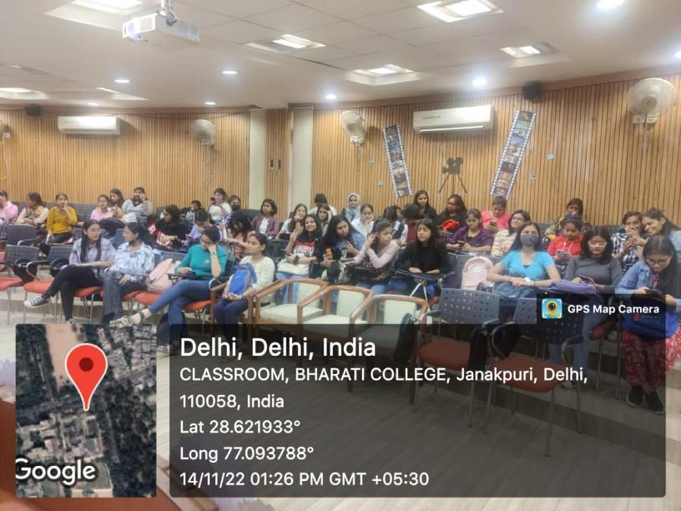

The screening event began with a consequential introduction about the film and our society by the President. Then, the film was screened, which was followed by an interactive discussion where students as well as faculty members across departments enthusiastically took part. In the discussion, we came across many opinions about the film. Masaan is truly what meaningful cinema has to offer to its spectators.

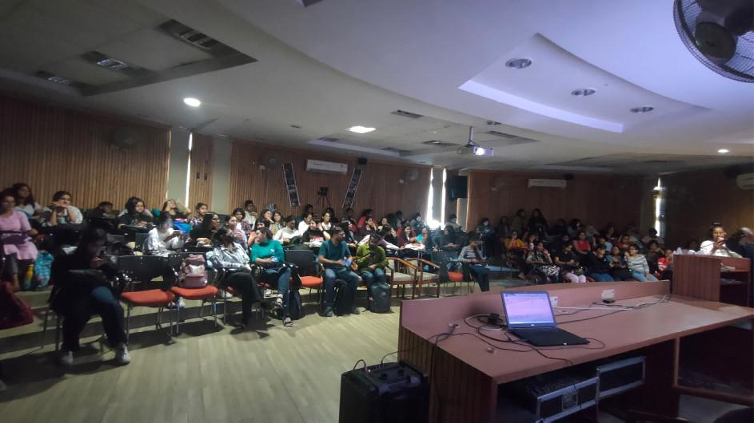

The event received an overwhelming response from the audience including the professors, and was covered by the team of DU Today, a leading news and media platform covering major highlights of University of Delhi. A detailed

[report](https://dutoday.in/film-screening-masaan%C3%AF%C2%BF%C2%BC/) of the event also featured on their website.

**Attendance**

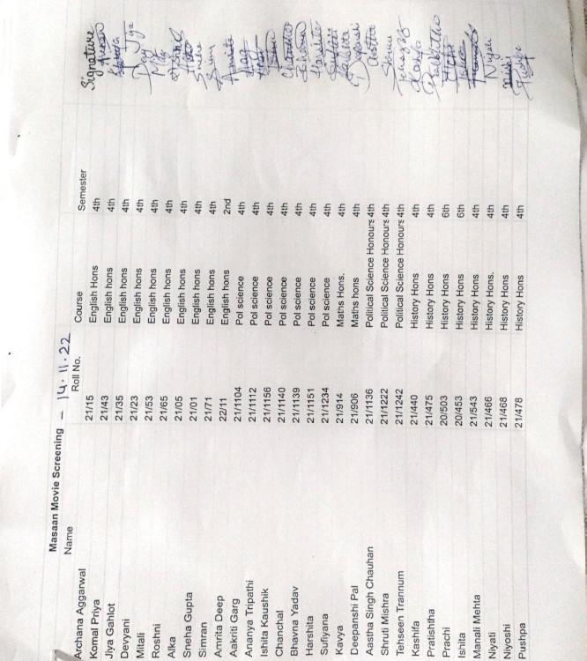

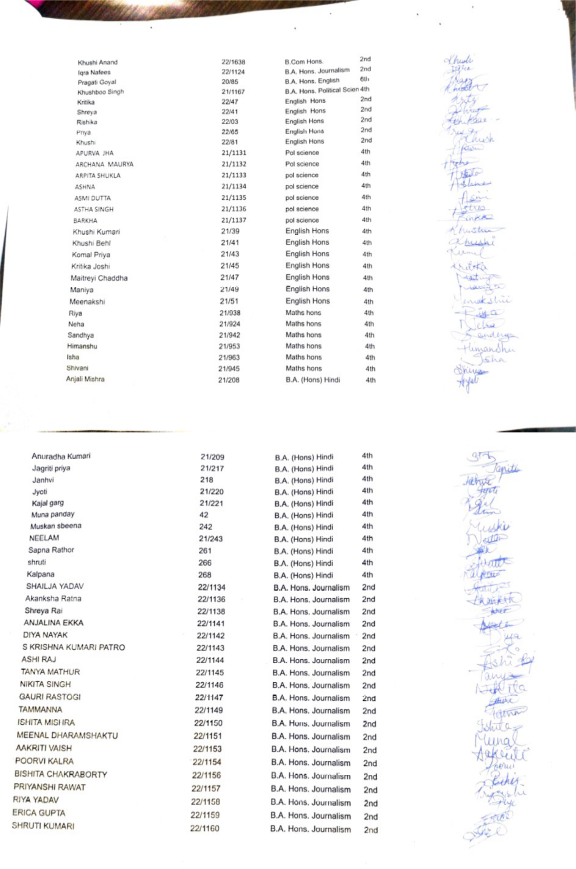

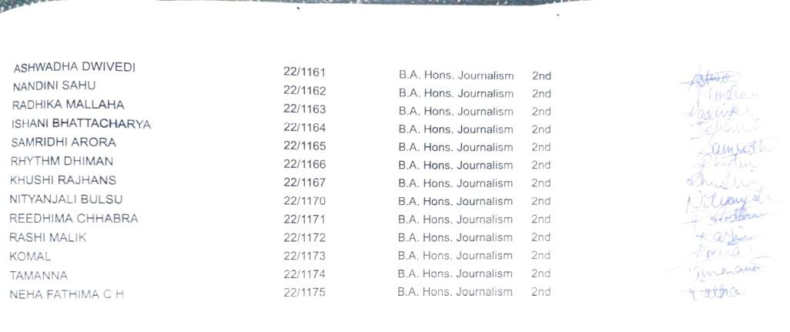

**(2) Orientation Programme**

On 24 November 2022, Dastaan held its Orientation Programme wherein the President spoke in detail about Dastaan, its aim, vision, and mission.

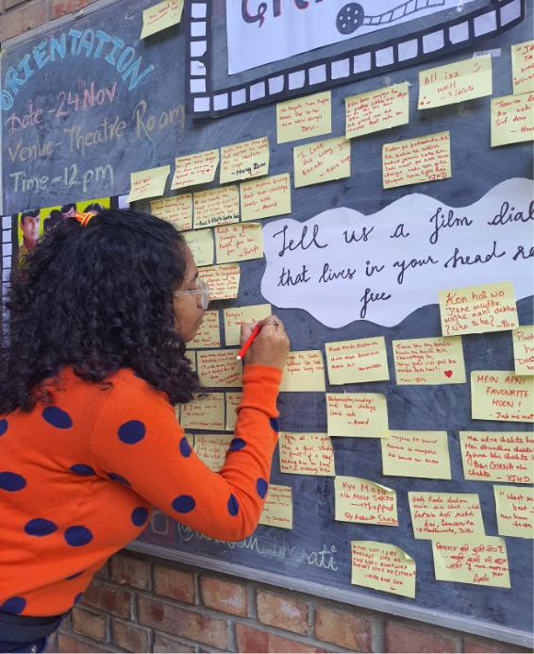

In the morning, the members of the society also decorated the blackboard near the gate where we asked the students to write their favorite film dialogues on the sticky notes pasted there. All the students wrote their favorite dialogues and it was fun reading all of it.

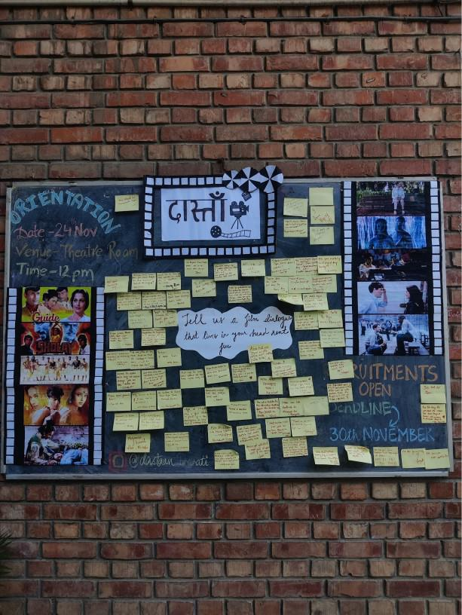

Many students stopped to have a look over the eye-catching board.

In the afternoon, the orientation took place where the President addressed the queries of the audience regarding the recruitment process of the society.

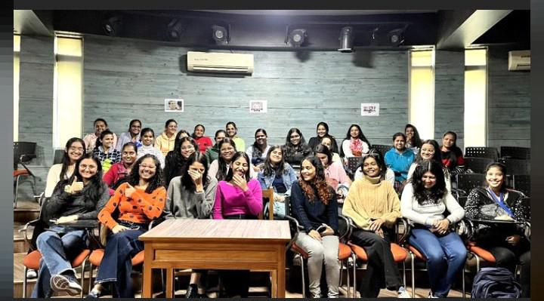

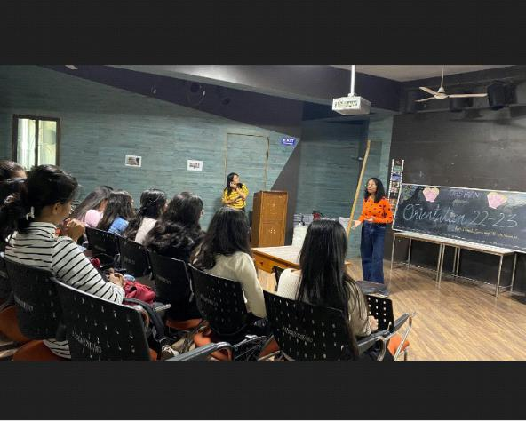

**(3) Photowalk**

The team of Dastaan went on its first ever photo walk to Chandini Chowk on 9 January 2023, despite the dense and almost blinding fog at 9 in the morning. Our team explored and captured the raw beauty of one of the oldest and busiest markets in Old Delhi.

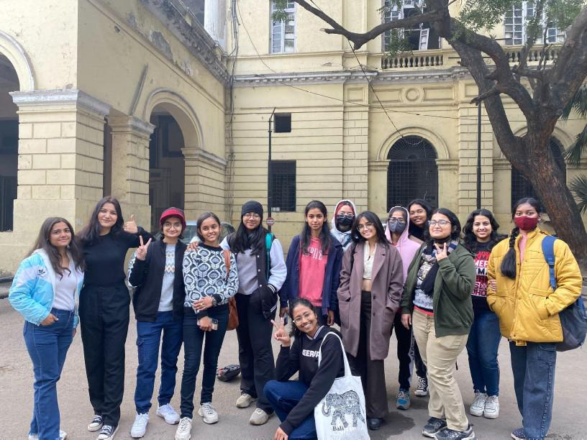

The [photographs](https://www.instagram.com/p/CpKtY6ES6AF/?igshid=MzRlODBiNWFlZA==) clicked during the photowalk went up on the social media handles of the society.

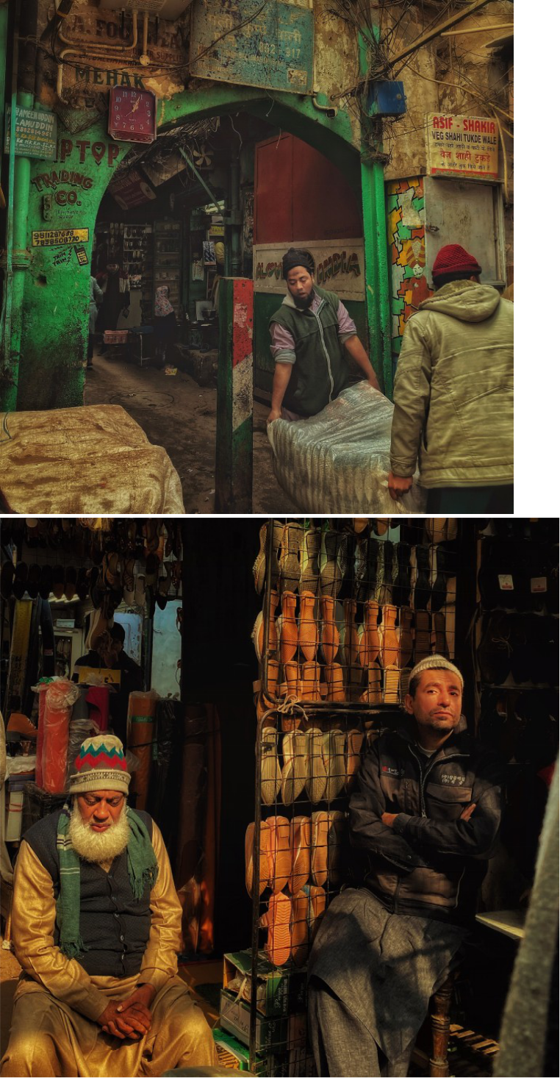

**(4) Short film screening and discussion**

Dastaan held its first movie screening and discussion of the year 2023 on 24th January, where we screened four exemplary works of short film cinema namely, *Two* ( Dir. Satyajit Ray), *Human Form* (Dir. Doyeon Noh), *Juice* ( Dir. Neeraj Ghaywan) and *Purgatory* ( Dir. Jack Stockley).

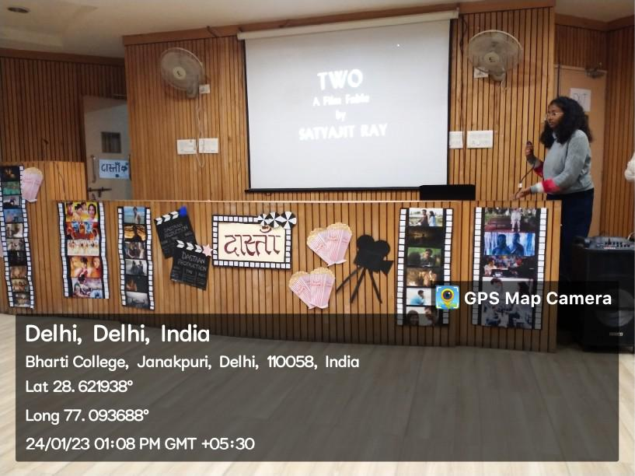

The event witnessed a turnout of more than 150 students as well as faculty members across departments. The discussion following the screenings was the major highlight of the event, wherein numerous students shared their personal stories and experiences over the themes explored in the films: disparity between the rich and the poor, body image issues, gender roles, domestic abuse and the trauma it entails.

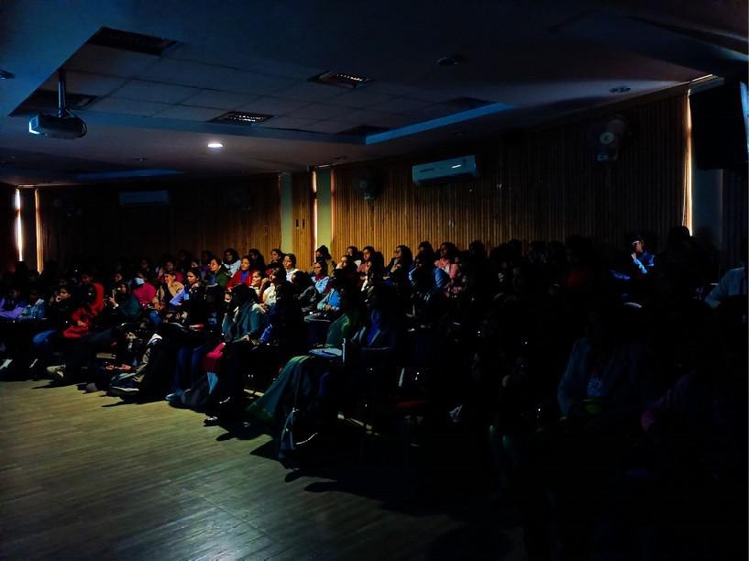

The latter two films were also a tribute on the occasion of National Girl Child Day, which is observed on the 24th of January each year.

**(5) Dastaan-e-Ishq**

On the occasion of valentine's day Dastaan organized an open mic competition where students from different colleges of Delhi-NCR participated and shared their *pyar bhari dastaan* with all the 'lovely' emotions, which included love at first sight, heartbreak, unrequited love, filial love, and self-love.

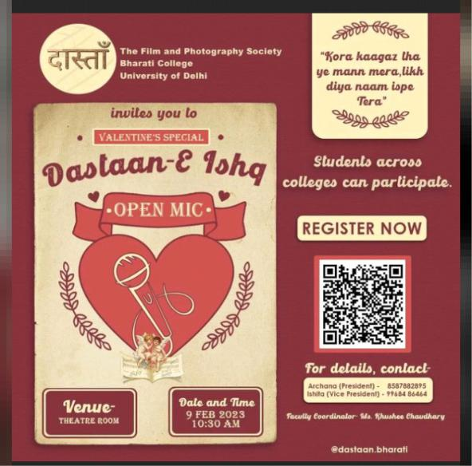

Posters were circulated among students regarding the upcoming open mic and a help desk was also set up in college during working hours for any confusion regarding the event.

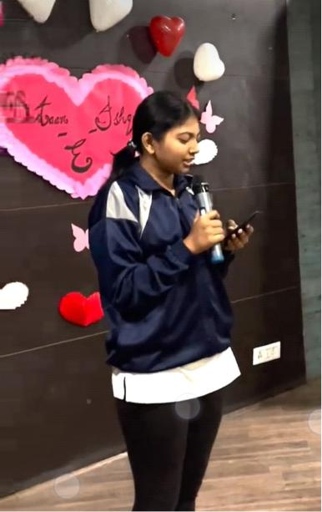

Blackboard was also decorated where we had to write our heartfelt thoughts on the heart -shaped sticky notes pasted there. On the day of the event, participants showed their full enthusiasm and made it an amazing event.

**(6) Photoshoot on the occasion of International Women’s Day**

International Women’s Day is celebrated on 8th March each year worldwide. To mark the day and express our gratitude, anger, sadness on issues concerning women, the team of Dastaan observed the whole month of March as Women’s Month. We designed a concept-based photoshoot centered around issues concerning women.

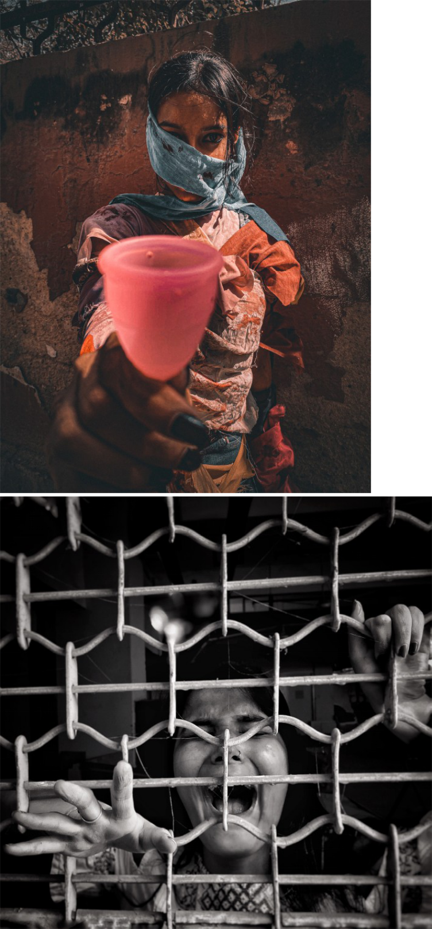

The shoot covered the following four major themes concerning women such as period poverty, gendered trauma, right to choice vis-à-vis the Hijab issue, et al. The shoot took place during a span of one week in the beginning of March at different locations within the college campus. Everything from the dresses of the models, the models themselves, makeup, production to set

design, direction and cinematography was done by the team itself, making the best use of the resources available.

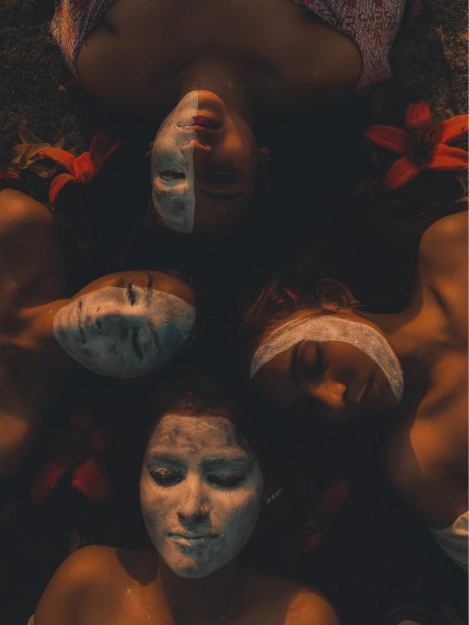

The final photographs from the shoot are now up at our socials and have garnered much attention and appreciation.

**(7) Filmmaker Talk with Utkarsh Chaturvedi**

Dastaan- The Film and Photography Society of Bharati College, conducted a movie screening of the film, ‘A Photographer Who Clicks Blur Photographs’ on 24 March 2023, which was followed by a Filmmaker Talk with the director of the film, Utkarsh Chaturvedi, who is an internationally acclaimed filmmaker. He has been nominated for “Best Standalone Director Award in Lockdown Films” in the Prestigious Standalone Film Festival and Awards, Los Angeles for his documentary “Walking under the Sun”.

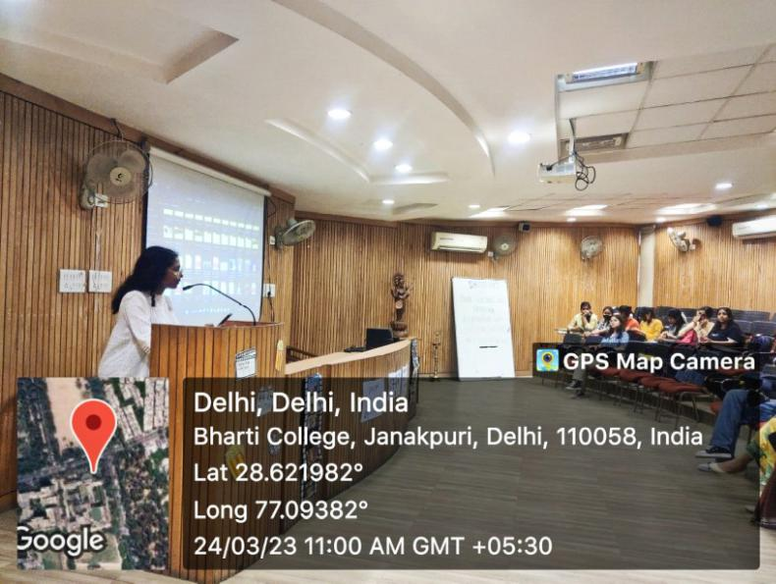

The young director shared various tips and tricks for aspiring filmmakers. He also answered various queries of the audience regarding his film, the various stages of editing, the cinematography and questions regarding a career in filmmaking- how and when to start.

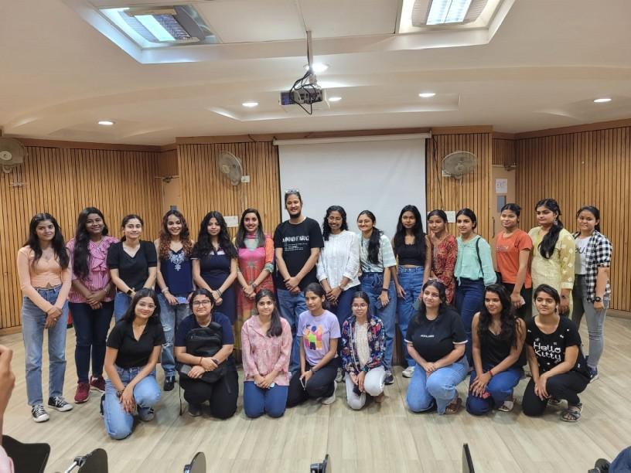

The session turned out to be very fruitful for the budding filmmakers of Dastaan and Bharati College.

**(8)Khwabon ki Dilli**

Dastaan conducted an inter-college photography competition on 11 April 2023 under the annual cultural fest of Bharati College, Abhivyakti'23.

The competition was held in two rounds- online and offline. The former was based on the theme “Khwabon ki Dilli” wherein the photographs were submitted via a google form. After much discussion among the jurists, a total of eight participants were shortlisted for the second round.

The final round was held in the offline mode within the college premises wherein the participants were given an on-the- spot theme, “Nazar aur Nazariya”. A duration of 2-3 hrs was allocated for clicking as well as editing the pictures for the second round based on the given theme, after which the entries were submitted on Dastaan's official email handle.

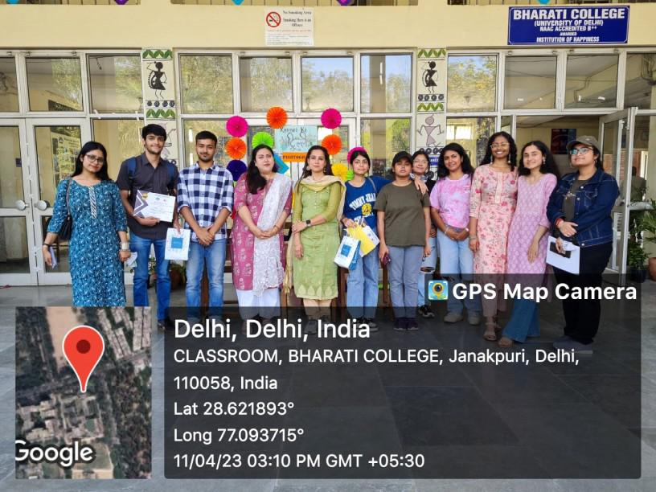

The judges, Dr Nazish Rana from the Department of Journalism and Ms Swati Bawa Sahani from the Department of HDFE, declared the results on the same day, and the winners were awarded cash prizes along with goodies worth 1k.

**INITIATIVES**

* **Filmy Friday:** We share one hand-picked movie each Friday, with its detailed analysis, on our Instagram handle. The idea is to share movie recommendations from the rich and diverse world as well as regional

cinema, turning the boring Fridays into Fri-yays.

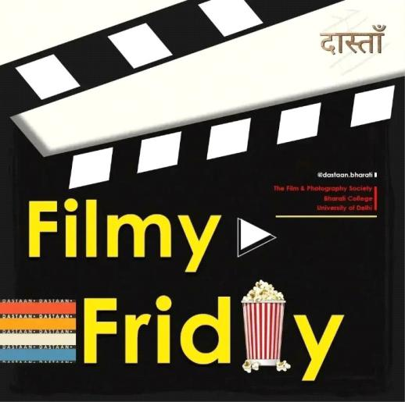

* **Celebrating Anniversaries of Important Films, Directors, Actors and others from the world of cinema:** We share short clips, stories and posts on our socials media platforms, celebrating the release anniversaries of acclaimed films, birthdays of significant directors, actors and other such significant anniversaries related to the world of cinema.

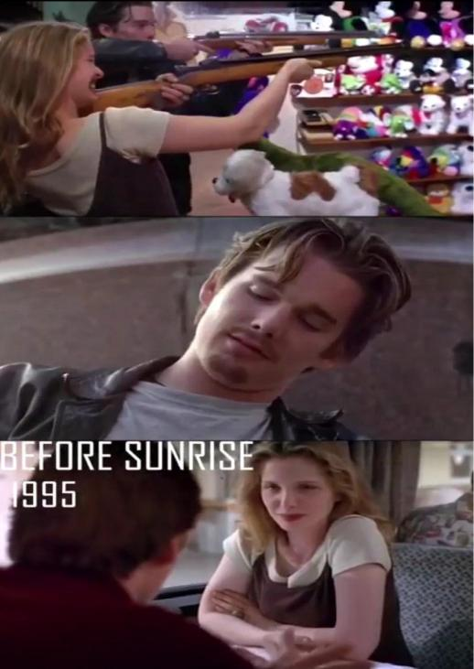

This helps us in spreading awareness and nurturing a love for cinema and its stalwarts.

Reach Out to Us:

Email- [dastaan.bharati@gmail.com](mailto:dastaan.bharati@gmail.com)

Instagram- [dastaan.bharati](https://www.instagram.com/dastaan.bharati/)

Facebook- [dastaan.bharati](https://m.facebook.com/public/Dastaan-Bharti)

LinkedIn- [dastaan.bharati](https://in.linkedin.com/company/dastaan-bharati)