**Reports Of North-East Bharati College.**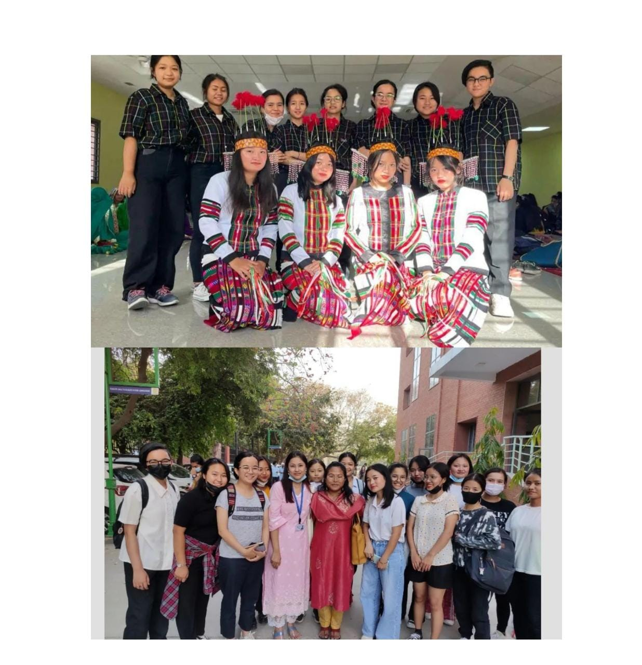

●***INTRODUCTION , AIM AND YEAR OF ESTABLISHMENT***

The ' North -East India' embracing the 8 states ( Arunachal Pradesh , Manipur , Mizoram , Assam, Nagaland , Tripura, Meghalaya and Sikkim ) well known for its diverse culture , blessed with abundant flora and fauna are referred to by many as NATURE'S ABODE and TRAVELLER'S PRIDE .

▪︎The aim of the north-east society is to uncover the diversity of our unique land and to assimilate every north eastern studying in Delhi University together as brothers and sisters under one umbrella.

Keeping in mind this initiative , the northeast society of BHARATI COLLEGE was established in Dec.2018 .It comprises of 80 plus students and 3 convenors . True to its culture , every year the society organizes various events where the students would get opportunity to showcase the talent of their living spirit and also the radiant cultures since its initiation .

▪︎ In 2018 , the executive members were elected by the convenor . The society collaborated with the history department for the fest on 11th March 2019 . Moreover , the 1st ever north- east ANNUAL FEST was held on 8th April 2019 in which Professor Yaruingam Awungshi , Dept. Of African Studies , Delhi University graced the occasion in the presence of Principal Mukti Sanyal and other well- wishers .

▪︎ The new session kicked off in August 2019 followed by an orientation programme where new candidates were appointed as executive members . The society is also gald to inform that one of the members was elected as the ' finance minister ' of NESSDU ( North East Students Society Delhi University ). It is the umbrella founding body which aims to spread the vivid culture , to look into the grievances , to foster the students in their academics as well as in co - curricular actives of every north - east student studying in Delhi University

* **PERMOMANCE TILL NOW**

**Fresher Meet orientation. (5th feb 2022)** This meet us for the fresher’s 24. On this meeting all the freshers were invited and the students from 2nd and 3rd year should also join the meet to welcome the freshers.

***28th Feb 2022-:***

Meeting for Bamboo Dance Practice for Phagun

Student Present

1. Sanjana

2. Sanjeevani

3. Jane L Sailo

4. Juliana

5. Jashmi

6. Femina

7. Lalpiani

8. Nunneni Gagnet

9. Mamonti

10. Alisha

11. Likha Deech

***2nd March 2022*:-** Program with Ex-student.

It was an interaction session with the passed out seniors. And Hengam Rita and Karishma were invited as guest.

student present

Kliulammi

Sinoulembi

Jane

Farihen

Maria

Naorem Pretty Devi

Mamonti

Shrutimol

Juliana

Sanjana

Sanjeevni

Devyanka

Ananya

Sukanya

Alisha

Gargi

Silpanjdi

Niutoli

Summima

Yashirun

Losia N

***11th March -: “Phagun’s Fest”***

The North-East society performed Bamboo dance and a Nepali Traditional Dance in a collaboration with Phagun’s society.

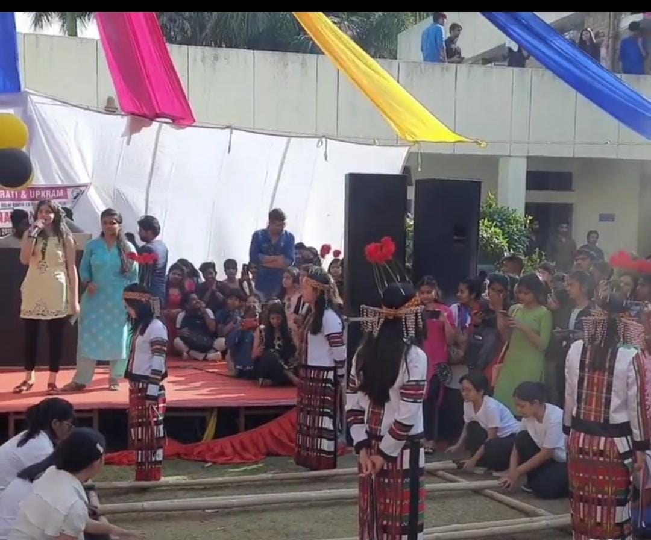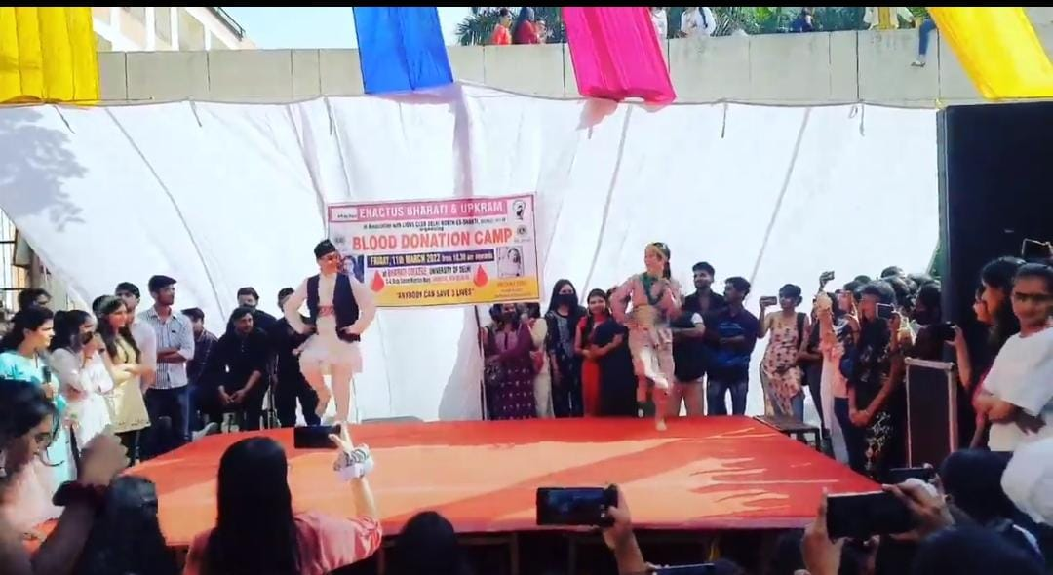

***23rd March 2022***

Group Discussion about upcoming NACC visit.

Student Present

1. Farihen

2. Maria

3. Topi

4. Mamonti

5. Veidaone

6. Naoren Preeti Devi

7. Pooja Sarah

8. Vungtanniang

9. Likha

10. Nunnem

11. Jane

12. Lalpiani

13. Sashini

***29th NACC Event.***

Performers were.

Jane

Sanjana

Sanjeevni

Ruhi

Topi

Srijana

Alisa

Jashmi

Priscilla

Muana

Femina

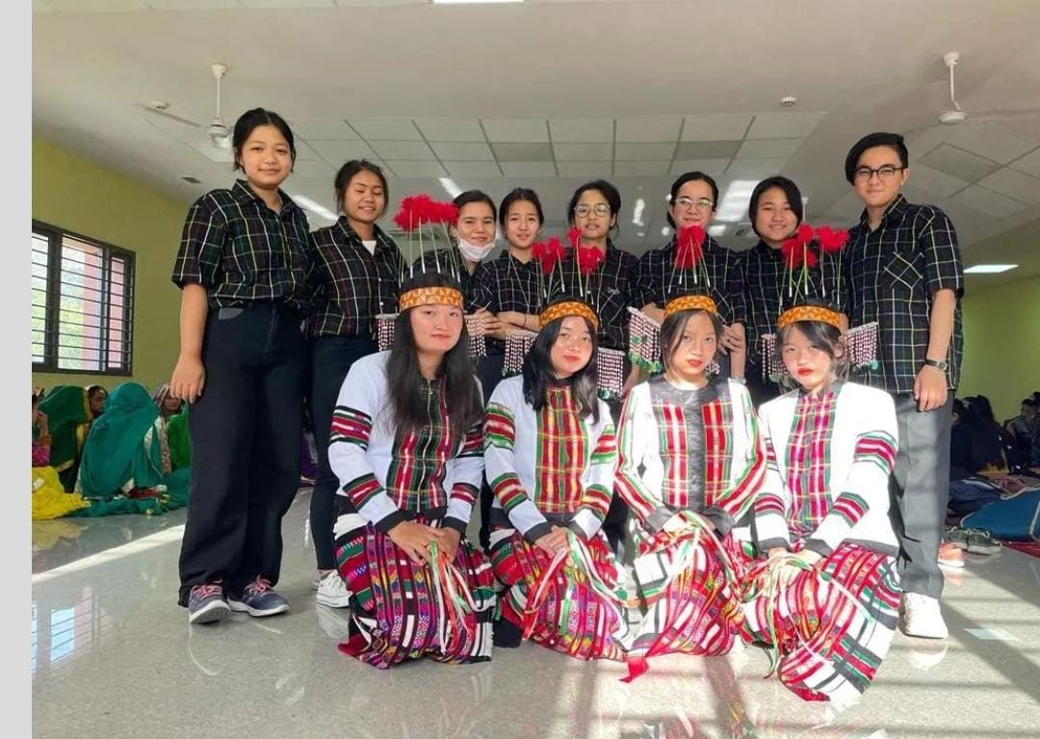

***8th April*** -:

Sanjeevni performed Solo Dance at Maharaja Agrasen College and secured 2nd position.

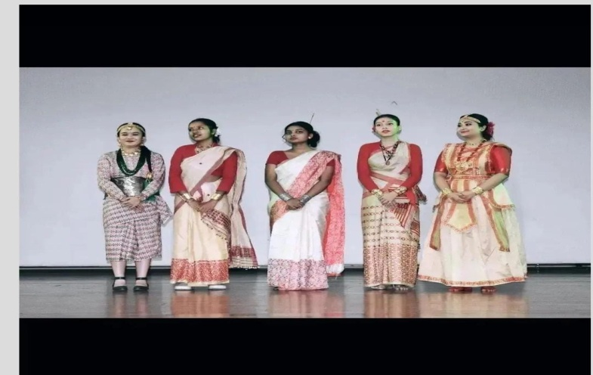

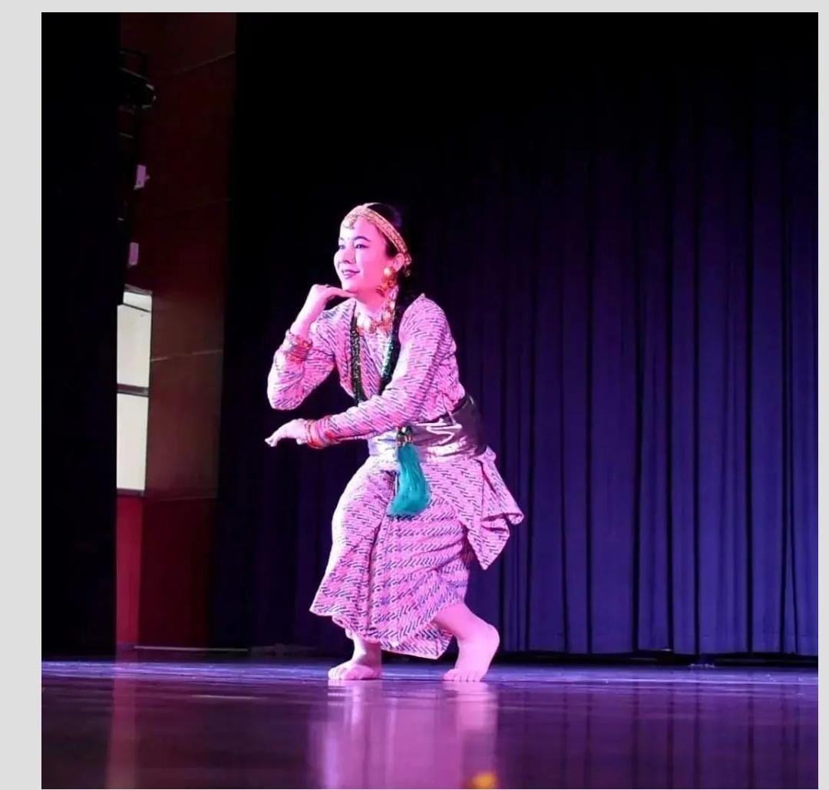

* ***ACHEIVEMENTS:***

-Sanjeevni had performed a solo dance in Maharaja Agresen College and stood 2Nd position.

* + ***Office Bearers-***

Judith (President)

Christilyn (Vice-President)

Topi (Cultural Secretary)

Maria (Treasurer)

● VISION ~▪︎ The society aims to manifest the rich tradition of NORTH -EAST INDIA in order to grow closer to the mainland INDIA.

▪︎We want the society to gain much more recognition from the college authorities so that there is enough opportunity to share the ethnicity of our culture. Also , in order to bring to light the situation of North East India as many mainland Indians are not cognizant yet after residing in the same nation.

▪︎ Moreover , we want to fight and stand against the racism where each north eastern individual encounters in their day to day college lives.

● LAST NOTE FOR FIRST YEARS WHO MAY LIKE TO BE PART OF SOCIETY ~ The Northeast society is mandatory for all north east students to join as it is for your welfare . Over and above that , the society deals with the discriminations faced by the students within the college. Plus giving you more probabilities to outshine and exhibit your living talents.

● CONTACT DETAILS ~ bharaticollegenortheast@gmail. com

● SOCIAL MEDIA LINK ~ https://instagram.com/bharati_ne_society?igshid=1x6gb0hjx2mc2

NOTE - The members of North - East Society, Bharati College also participated in NESSDU SPORTS MEET on 7th and 12th March 2020.

THE SOCIETY would like to thank the Principal , Bharati college and college authorities for giving us this opportunity to facilitate this lively society .