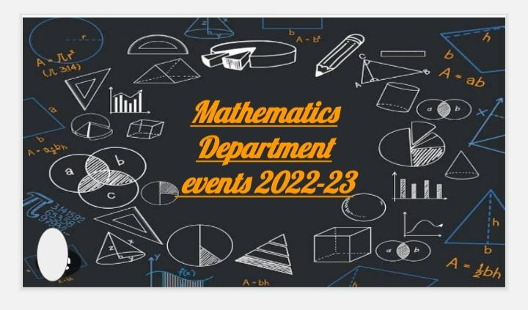

Event -1

Movie screening

Mathematics Department organised a movie screening for all the students from various courses to give them a chance to come out of their busy schedules as well as to motivate them from the life lessons of Nambi Narayan on whom the movie was based.

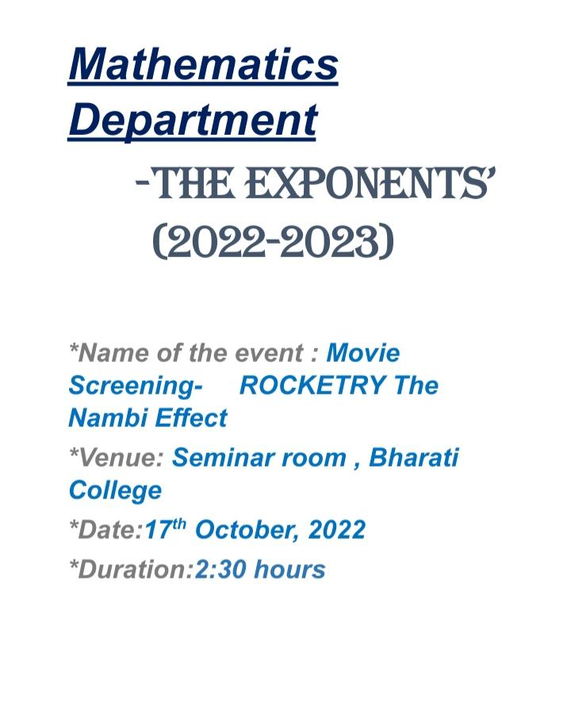Attendance:https://docs.google.com/spreadsheets/d/1SXpNaTcD3wYiihvx1gehwGmeykif8HQbykFIQ9BbsuA/edit?usp=drivesdk

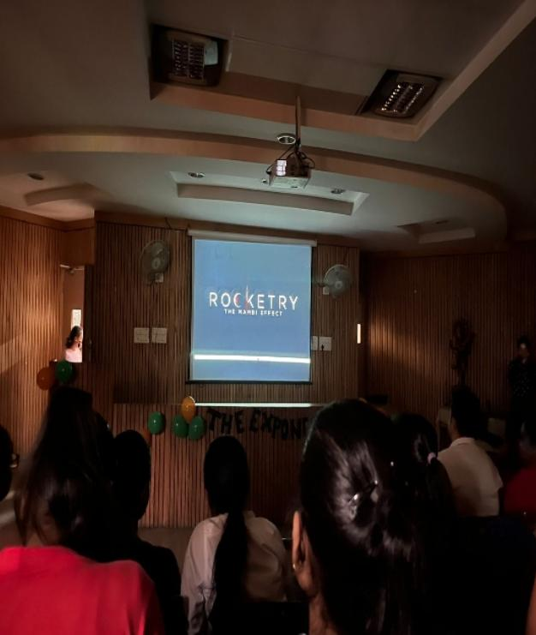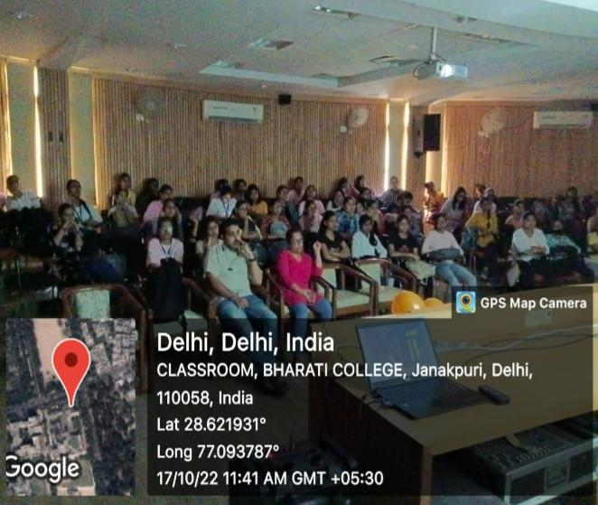

Event -2

Union elections

Every year elections are held to elect the new union members. This year too the elections were held on 19 th September 2023.

The candidates started campaigning one week prior to the elections.

Students actively voted for their favourite candidate.

Results were announced on the same day.

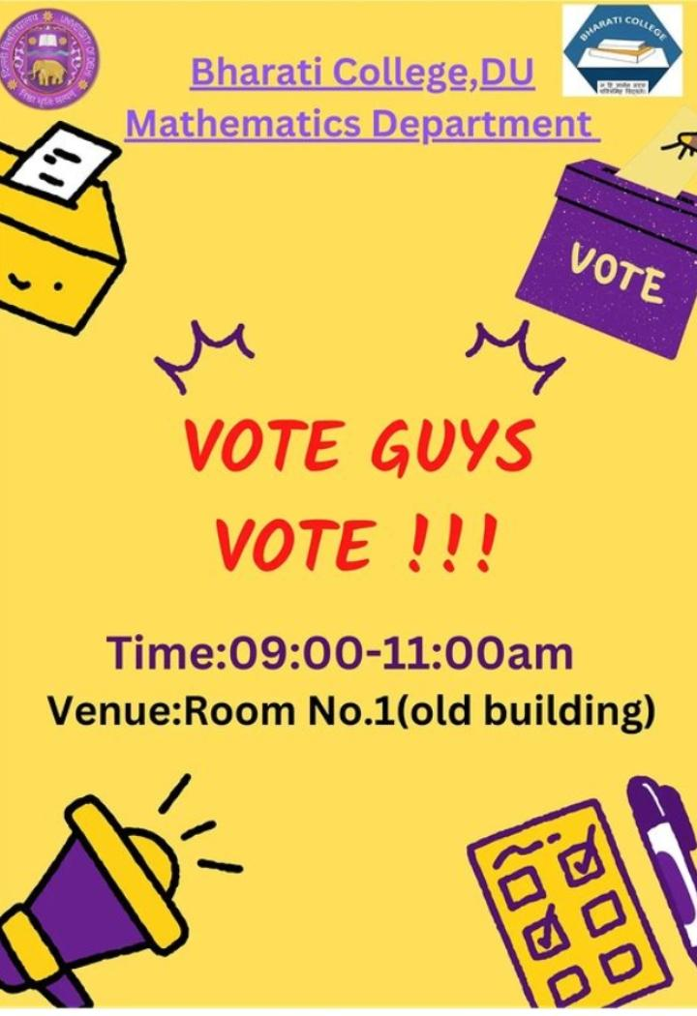

The Newly electeDunion members

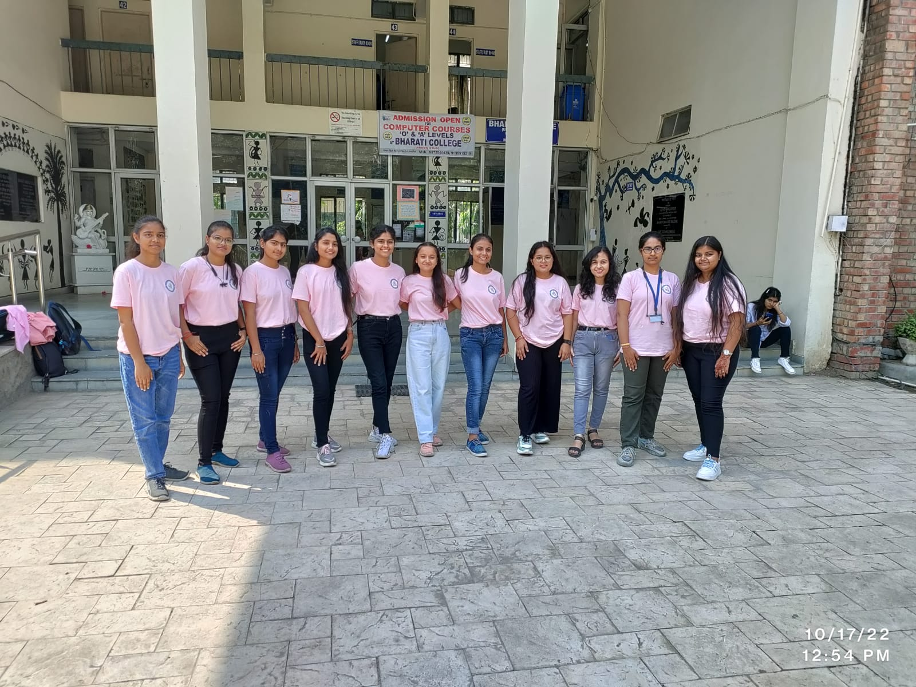

Event -3

Orientation Program

An Orientation Program was held on 3rd November, 2022 for the first semester students. They were introduced to the department, faculty members, seniors, societies, college.

The students were also informed about “ The Exponents’’ their events and future plans

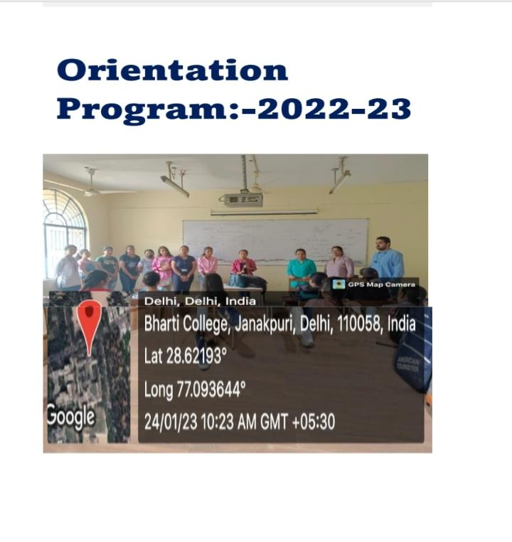Attendance: https://docs.google.com/spreadsheets/d/1AlwBgKg1qWF21s6E5OPhwXJlGRMAzIUi8EubIOUGM/edit?usp=drivesdk

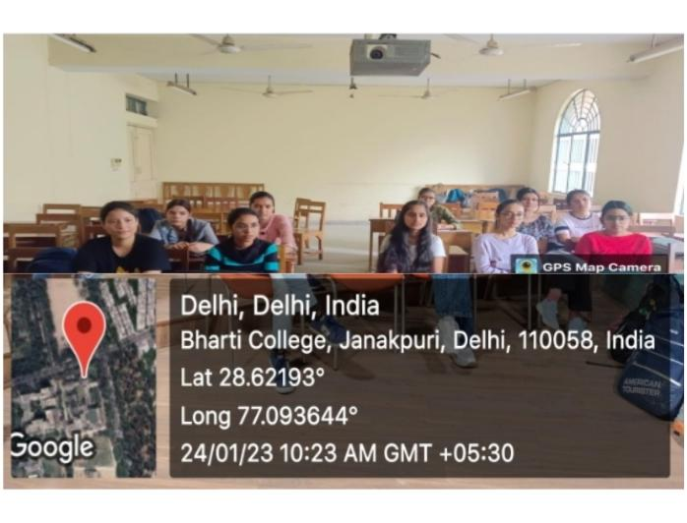

Event -4

First year CR election

The students required a Class Representative to coordinate with the teachers and students. For this purpose First year CR election were held on 9 January 2023

Students voted for different candidates.The one with the highest votes won the election

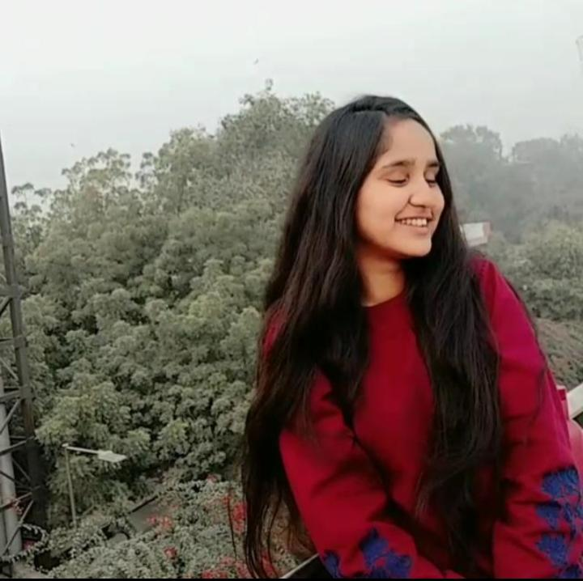StutiPachuri became the first year CR after winning the elections

Event -5

YUVA diwas(Competition)

Mathematics Department in collaboration with YUVA, Sanskrit department and NSS organised YUVA Diwas which had various competitions

Speech, Poster Making, Quiz and Poem recitation

Students from various departments participated and won in the competition of their interest.

Prizes were given to the winners.

Attendance: https://1drv.ms/x/s!AsfuHKVknD31gTu8wZlrEnEFw3Wz

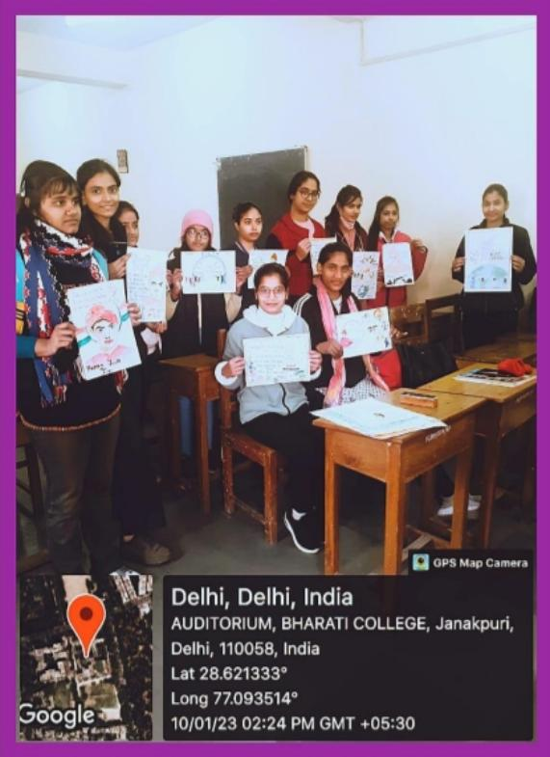

Event -6

YuvaDiwas (Vivekananda Jayanti)

Mathematics Department in collaboration with YUVA, NSS and Sanskrit Department organised a seminar on the occasion of Vivekananda Jayanti.Various eminent personalities were also invited to motivate the youth of Bharati College.

Chief Guests: Mr. Rajnish Jindal, YUVA Coordinator (attended by Mr. Aakash, YUVA Co-coordinator)

Guest of Honour:Prof. Dayal Singh Panwar, LalBahadurShastri, Central University

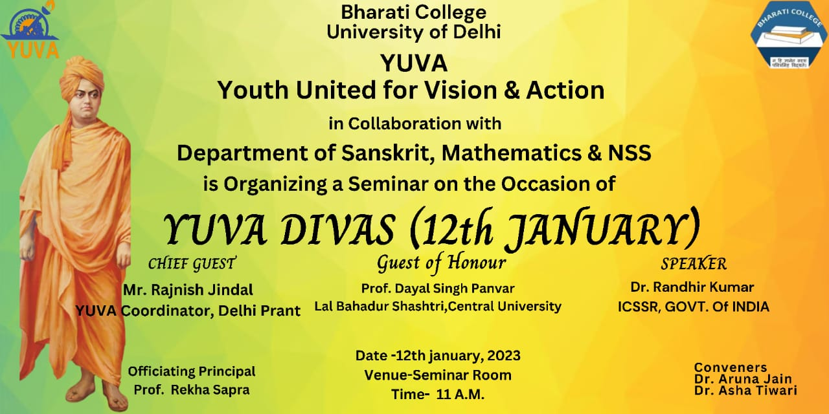

Attendance:https://docs.google.com/spreadsheets/d/1SXpNaTcD3wYiihvx1gehwGmeykif8HQbykFIQ9BbsuA/edit?usp=drivesdk

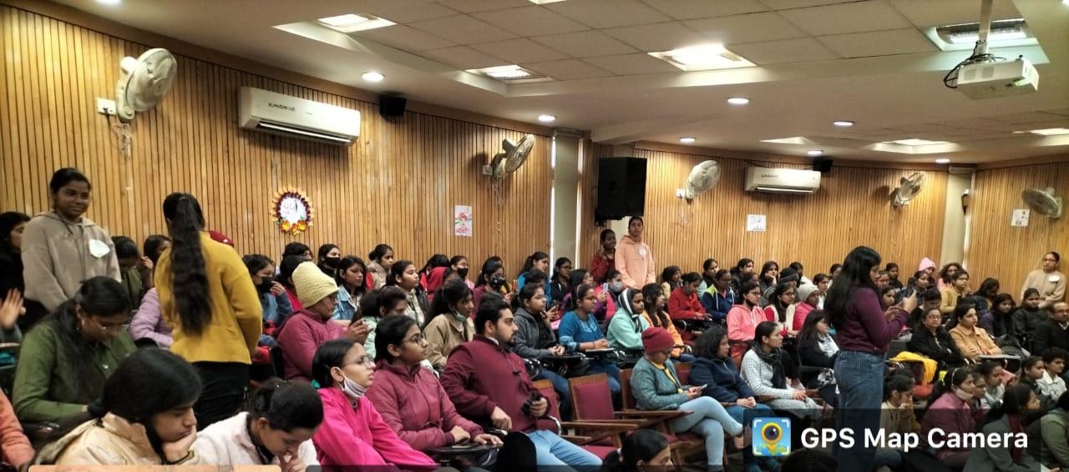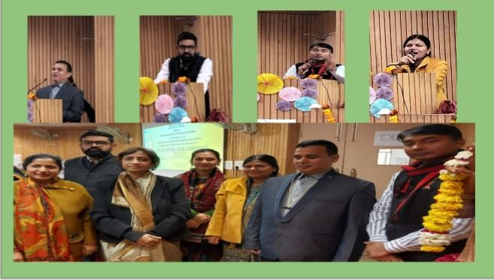

Event -7

Investiture ceremony

The newly elected union had to be officially announced about.

So the Investiture ceremony was kept. Teacher in charge of the Department, Dr. Aruna Jain congratulated all the union members and motivated them to take the department to new heights.

The union members pledged to fulfill their duties faithfully.

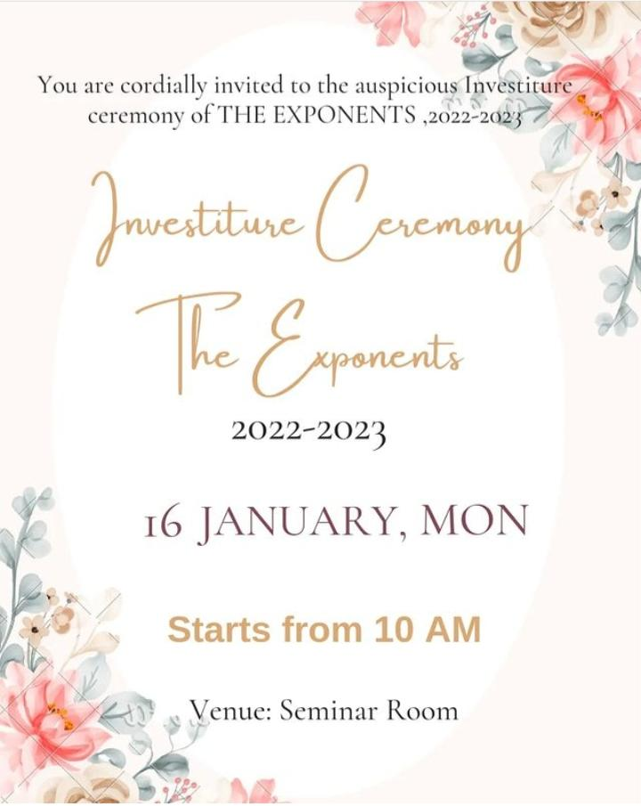

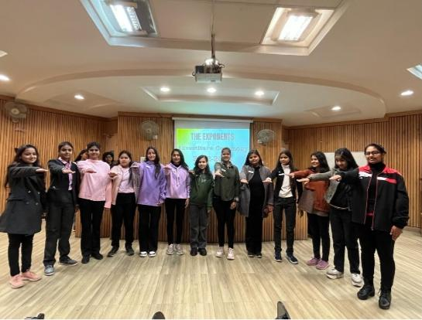

Event -8

Quiz and dance competition

On the occasion of republic day, the Exponents’along with YUVA organised a Quiz and Dance Competition.

Quiz was based on the theme of freedom fighters and

Dance was based on the theme of diversity of our country India.

Students from various departments participated in the quiz competition and from Mathematics Department participated in the Dance Competition which shows the extra curricular talent of the students of Maths department.

Attendance:https://1drv.ms/x/s!AsfuHKVknD31gUbOtvHuJV7d598a

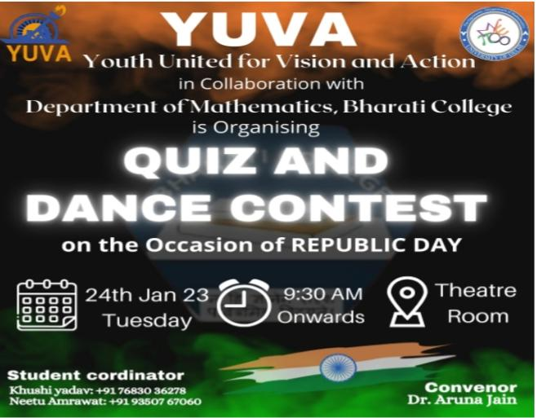

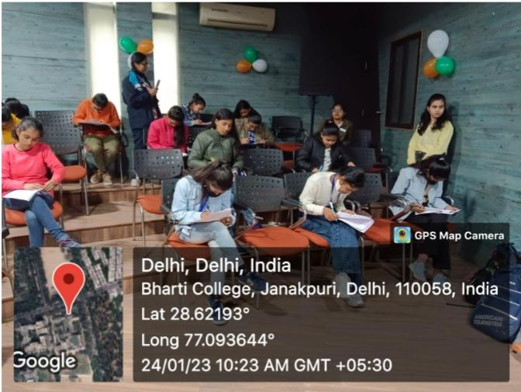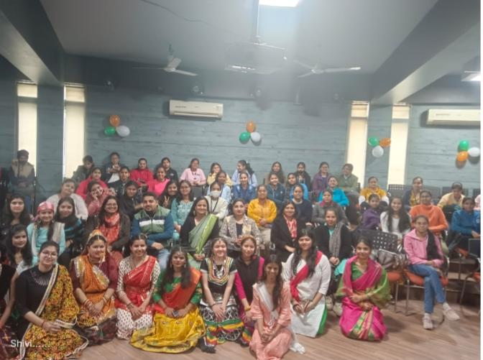

Event -9

Poster making competition

Mathematics Department in collaboration with YUVA organised a poster making competition on 24th April 2023 on the theme “anti-terrorism”.

Students from various departments participated in the competition and showcased their talents.

Attendance: https://docs.google.com/spreadsheets/d/1f4ofV1i176Ind-6EwnNSFjLsf3lALuQDiWm1hyJ_j2s/edit?usp=drivesdk

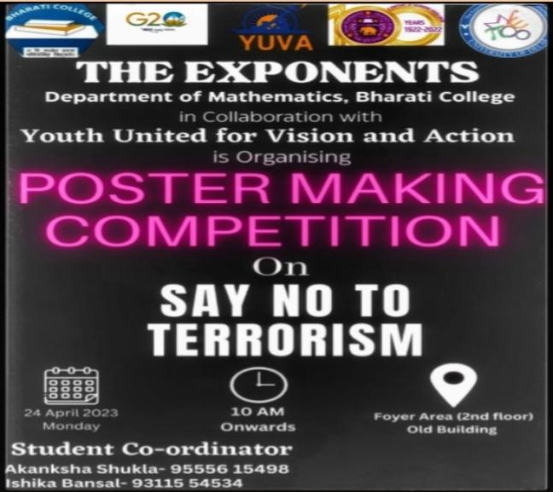

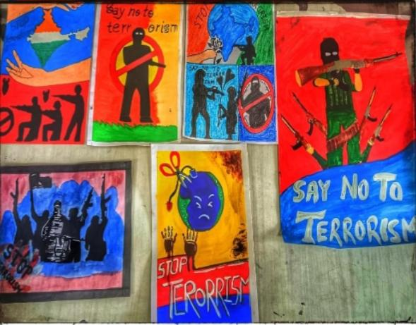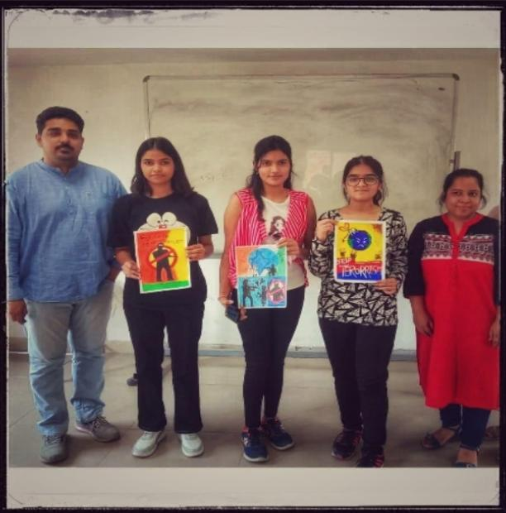

***Mathematics Department is looking forward for more such events.***