FREAKONOMICS SOCIETY
Annual Report Academic Year 2022-23
Convenor: Dr. Princy Jain
Vision
Freakonomics society of the Department of Economics of Bharati College envisions a vibrant community of students driven by a passion for economics and its practical applications. We aim to create an engaging space where members can explore economic concepts, foster critical thinking, and develop skills to navigate the complexities of the modern world.
Mission
Our mission at Freakonomics is to provide an enriching experience for students interested in economics through a variety of activities and events. We seek to promote intellectual curiosity, analytical thinking, and professional development among our members.
Objectives
Education: Offer a diverse range of educational opportunities, including seminars, workshops, and interactive sessions, to deepen members' understanding of economic theory and its real-world implications.
Engagement: Organize fun and interactive activities such as quizzes, case-studies, games, and competitions to foster camaraderie among members and reinforce learning in a relaxed setting.
Career Development: Offer career-focused activities, including networking sessions, resume workshops, and guest speaker events, to support members in their professional aspirations and enhance their employability.
Activities
Seminars and Workshops: Regular sessions featuring guest speakers and experts covering a wide range of economic topics and practical skills.
Fun Activities: Interactive quizzes, case-studies, movie screening, field visits, games, and other engaging activities to make learning economics enjoyable and accessible to all.
Policy Analysis Sessions: Conduct in-depth analysis and discussions on economic policies, providing members with insights into current affairs and encouraging critical evaluation of policy decisions.
Competitions: Host debates, declamation competitions, and contests such as poster or logo making to hone members' communication skills, creativity, and ability to articulate economic ideas effectively.
Career Development Events: Networking opportunities, career panels, competitive exam preparation and industry talks to help members explore career paths in economics and related fields.
Outcomes
Enhanced understanding of economic principles and their practical applications through engaging and interactive activities.
Development of critical thinking, communication, and problem-solving skills through participation in debates, competitions, and policy analysis.
Networking opportunities and career development support to empower members to pursue their professional goals in the field of economics.

Events (Academic Year 2022-23)

April 2023
֍ The society conducted a seminar for supporting career progression of students on CAT Exam preparation by an expert team from Career Launcher on the 19th of April 2023.
Funds sanctioned: NIL
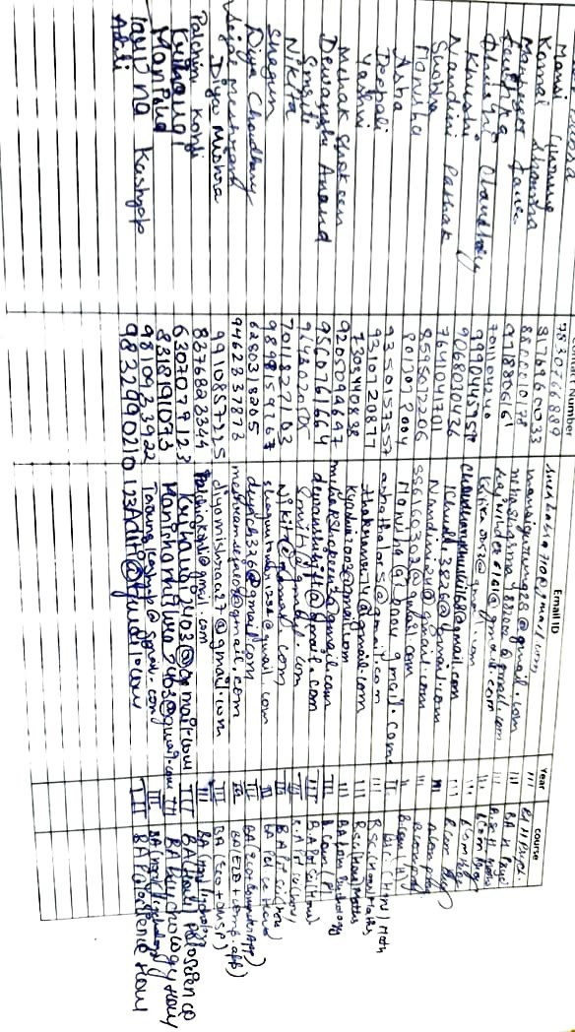
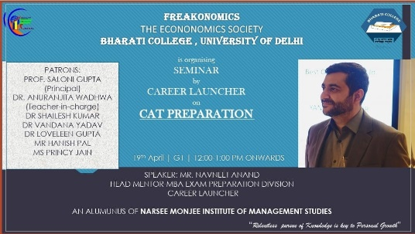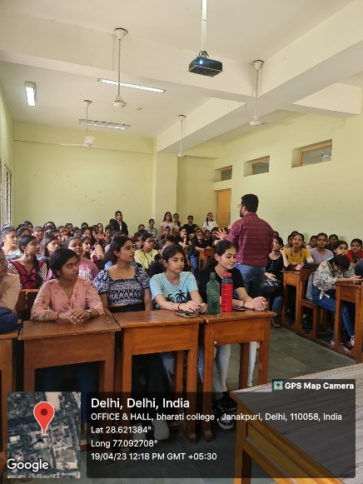

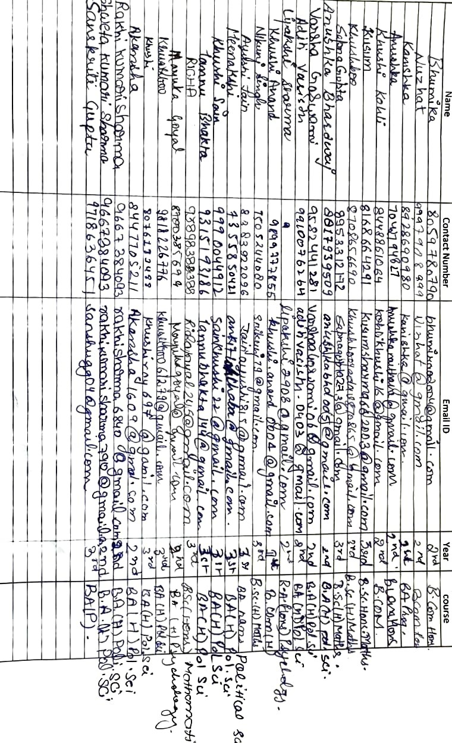

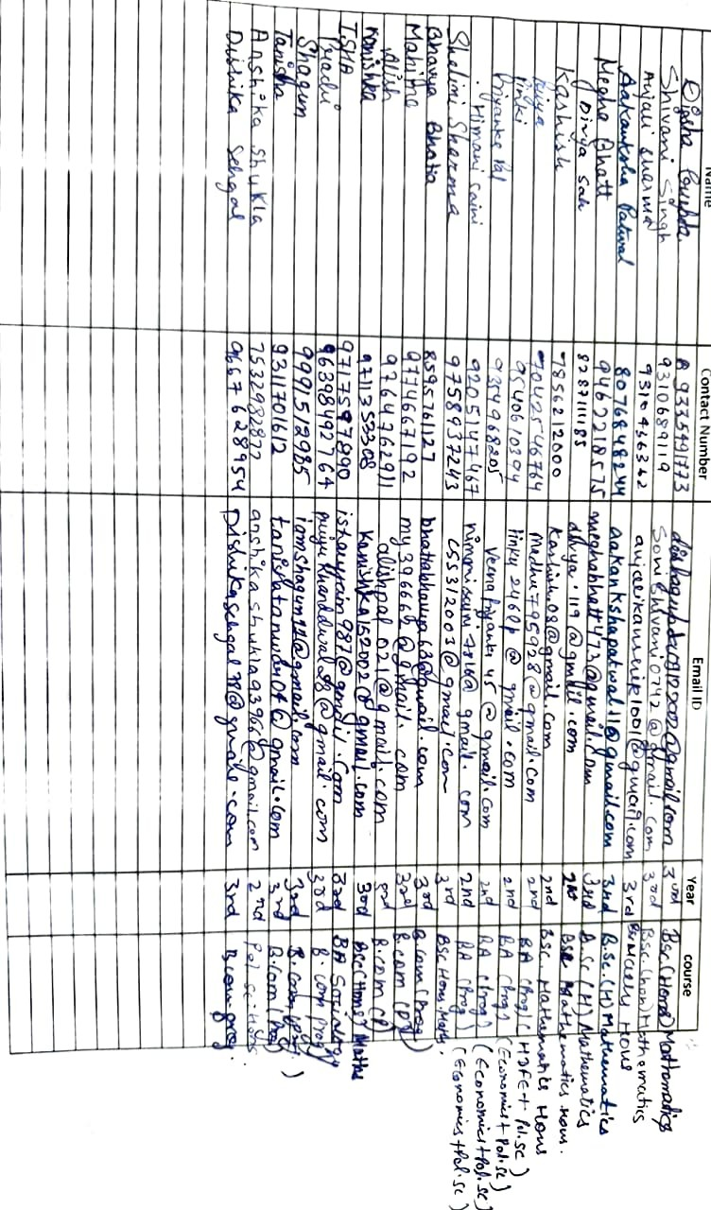

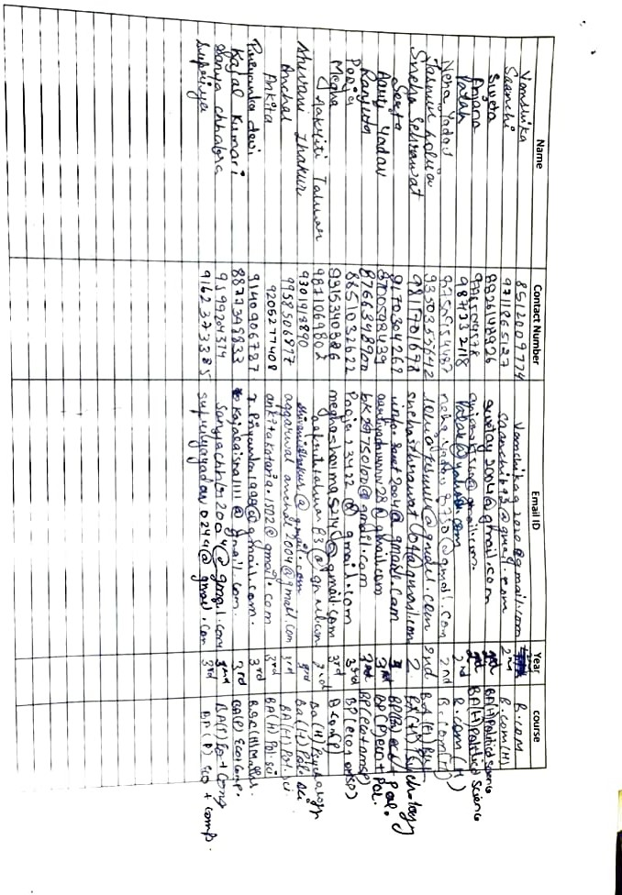

֍ The highlight of the year was the annual event ECOSPARK’23, from 5-6th April’23, which included various inter-college competitions.
♦ The ECO-PRO-QUO competition was an Economics quiz cum Treasure Hunt, on the theme “G20” organized on the 5th of April 2023.
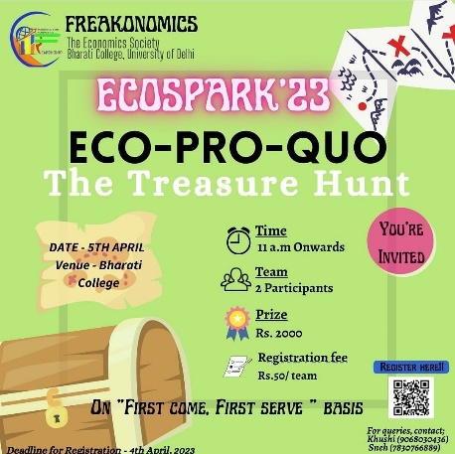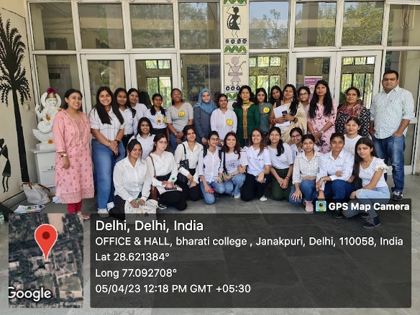

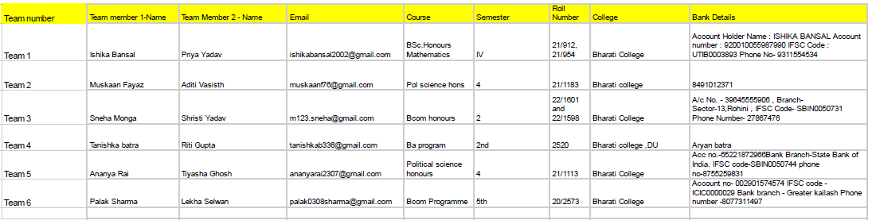

♦ Economic Policy Analysis competition, conducted on the 6th of April 2023, was an essay writing competition concerning “Policies addressing Sri Lanka Economic Crisis”.
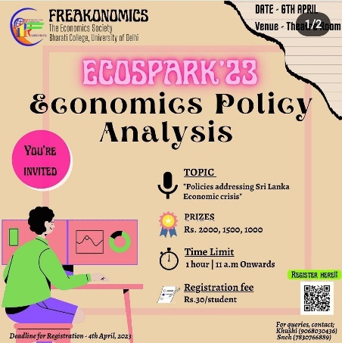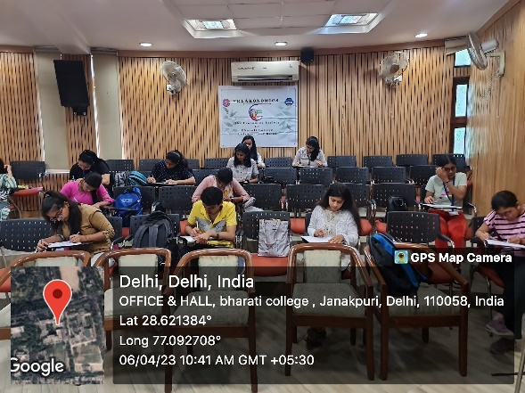
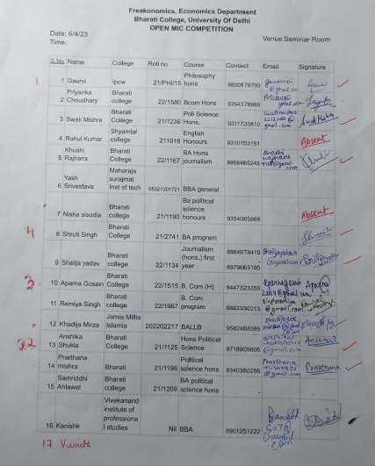
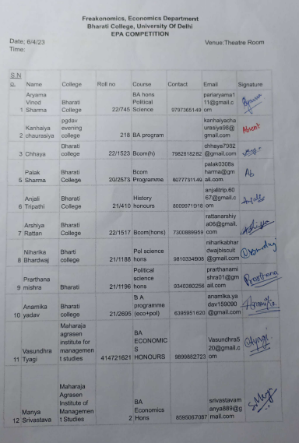
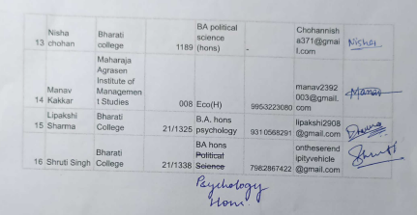

♦ Snap-onomics was the photography competition on the topic “Co-existence of different forms of markets” wherein the students were required to submit their entries online.
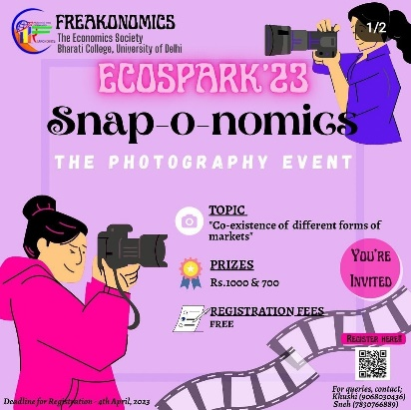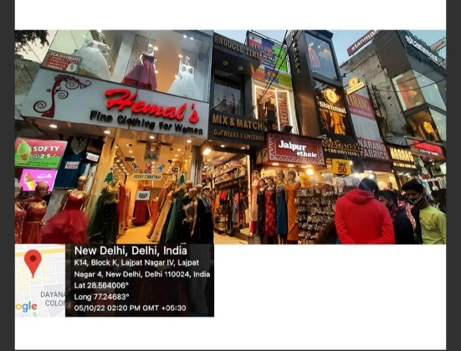

Time stamp | Name | Course | College
01-04-2023  12:31:13 | Ashish | BSc Physical Science | Zakir Husain Delhi College
01-04-2023  19:12:33 | Parth Mishra | BCom Programme | Shyam Lal College (Morning)
02-04-2023  17:33:38 | Akansha Chauhan | BA programme | Gargi college , Delhi University
04-04-2023  14:30:44 | Harsh Awana | BA prog ( commerce + economics) | Shaheed bhagat singh college
04-04-2023  19:42:15 | Akhilesh Kumar | Ba Honar's Economics | Shivaji College
04-04-2023  20:56:53 | Muskaan Fayaz | B.A hons pol science | Bharati college
04-04-2023  21:14:51 | Khushi | Bcom programme | Bharati college
04-04-2023  23:11:04 | Shubham Naskar | B.A. English Hons. | Zakir Husain Delhi College (evening)
04-04-2023  23:25:22 | Noyorika Prasad | BA. HONS SOCIOLOGY | Kamala Nehru College, Delhi University
04-04-2023  23:56:12 | Anjali | Ba English hons | Bharati college
05-04-2023  18:04:12 | Mehak Shokeen | B.com | Bharati College
05-04-2023  19:12:58 | Urvashi yadav | MBBS | Dr.SCGMC
05-04-2023  21:27:10 | Khushi choudhary | Bcom prog. | Bharati college
06-04-2023  03:27:22 | Kritika yadav | B com (prog) | Bharati college

♦ The highlight of the event was the Open Mic competition, conducted on the 6th of April 2023, where the participants reflected their ideas on the topic “Our relationship with money” in form of poetry, stand-up comedy, speech, skit etc.
All the events involved participation from various colleges of University of Delhi and GGSIP University. Students from diverse academic backgrounds participated in all the events and exciting cash prizes were distributed.
Funds sanctioned: INR 9200
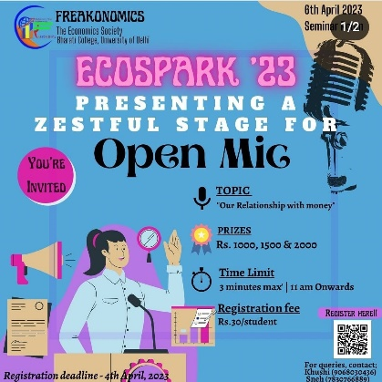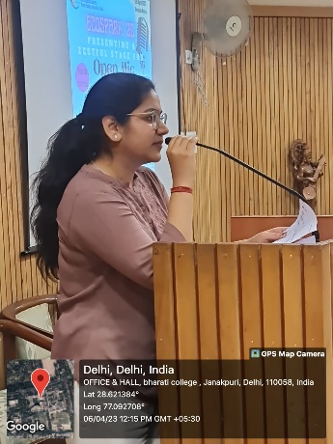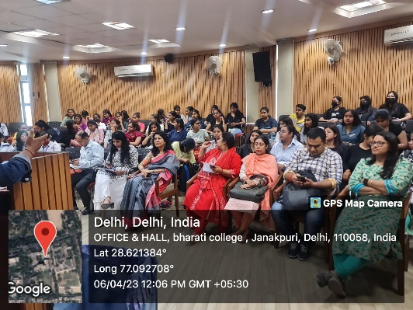
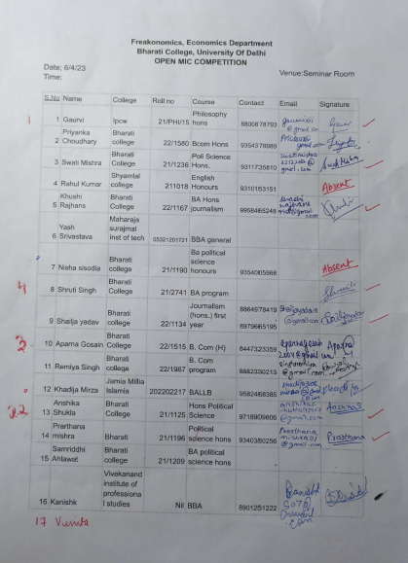
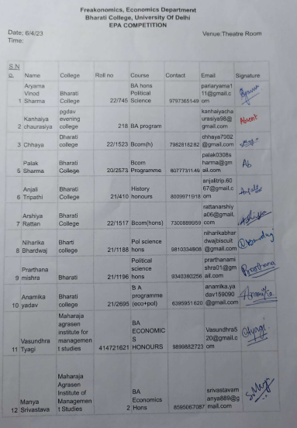
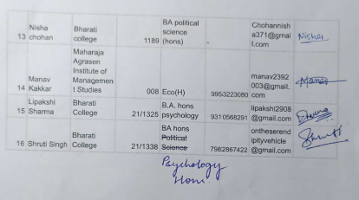

March 2023

֍ A seminar about the “Intellectual Property Rights” was conducted on the 2nd of March 2023 in collaboration with the Political Science department and Sociology department of the Bharati College. The renowned speaker Dr. Raju Tiwari, senior examiner of patents and designs, Ministry of Commerce and Industry, Government of India, explained the different types of IPRs and their relevance to the students.
Funds Sanctioned: INR 1500
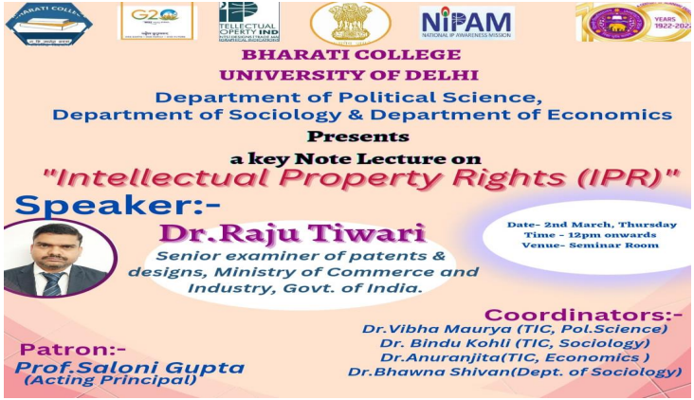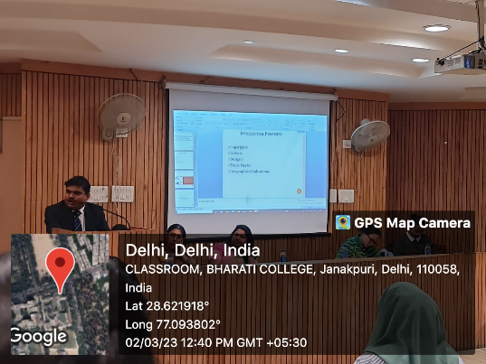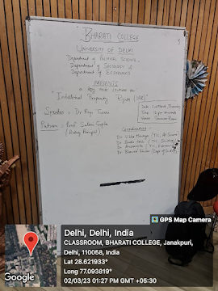

February 2023

֍ The society in collaboration with the Women Development Cell of the college organised a One-day Workshop on “Eating Disorders: Impact on women” on the 3rd of February 2023 conducted by FREED- a non-profit organisation. The students learned about the various life patterns that lead to eating orders and its harmful impact on them, and the students received certificates for participation in the workshop from FREED organisation.
Funds Sanctioned: NIL
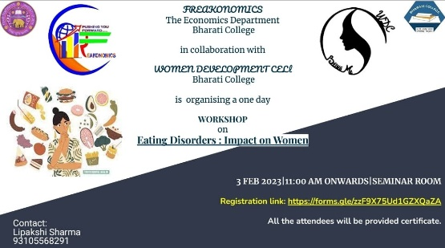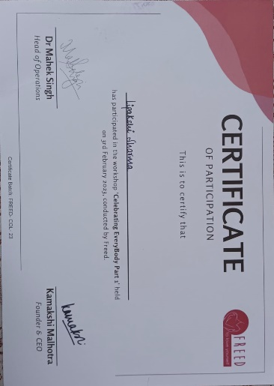
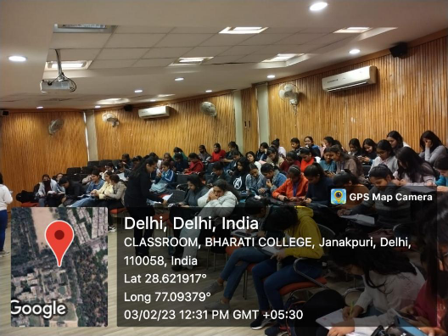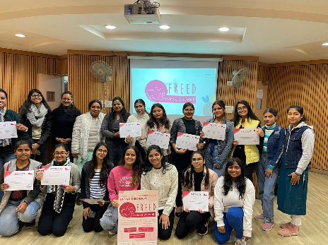

January 2023

֍ A set of students from the society, accompanied by our economics faculty Dr. Vandana Yadav, visited the Book Launch of “Igniting 37 crore growth engines” by Pradeep S. Chauhan on the 30th of January 2023. The event involved the introduction of the book and address by several dignitaries discussing the triggers required for growth of Indian economy.
Funds Sanctioned: NIL
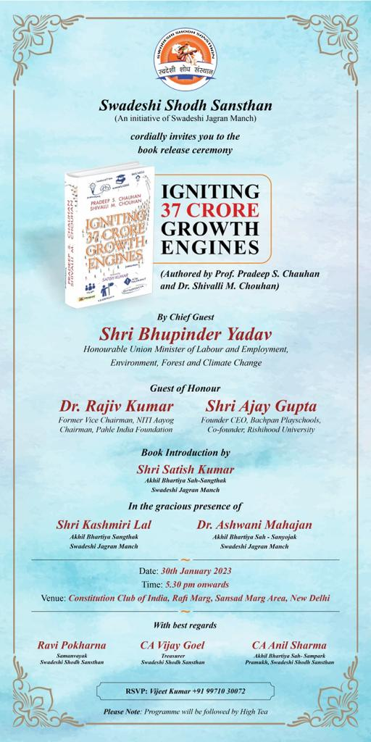
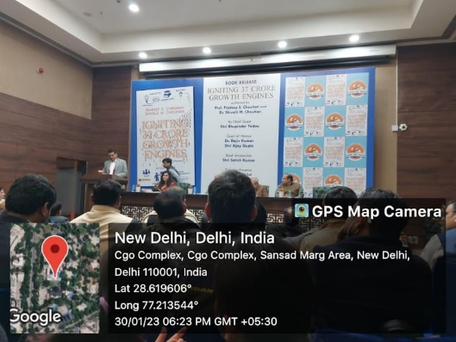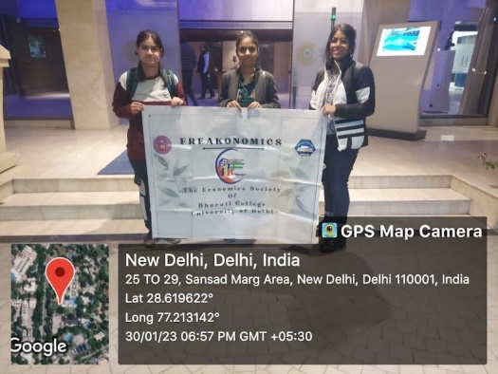

֍ A seminar was organised on the 18th of January 2023, involving a mentoring session on the Financial Markets by Mr. Rajan Luthra, the co-founder and COO of Metvy, India’s first peer-to-peer mentorship and learning platform.
Funds Sanctioned: NIL
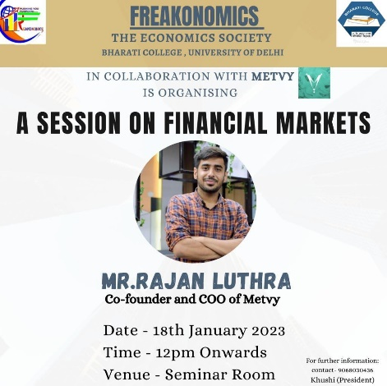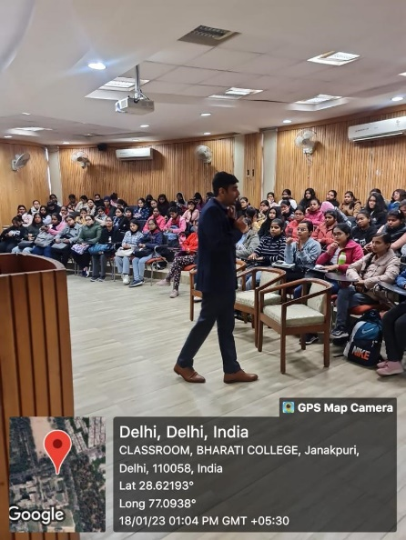

November 2022
֍ A student visit was organised to the India International Trade Fair on the 23rd of November 2022. There the students learned about the macro level monetary management in the RBI pavilion and also participated in the quiz competition organized by the SEBI. In addition to this, students witnessed the different kinds of business and products offered by different countries and states of India, and learned about various opportunities of trade across borders.
Funds Sanctioned: NIL
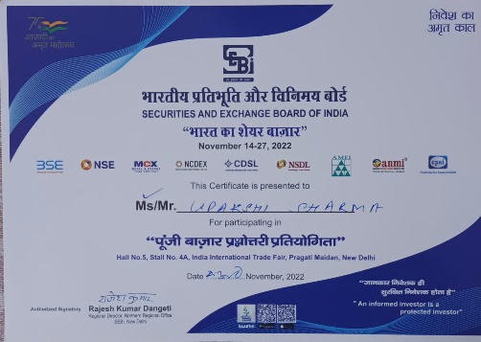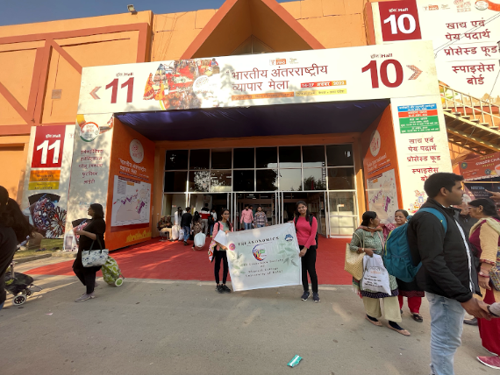
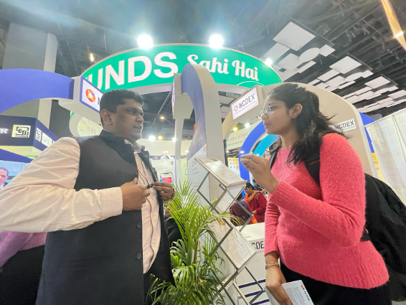

September 2022

֍ An inter-college Declamation Competition was organized on the 28th of September 2022, wherein the participants presented their views on the “Challenges and future prospects of the aviation industry”. The students presented in their ideas both in Hindi and English medium. Students from diverse academic backgrounds, including life sciences, mathematics, political science, commerce etc. and different colleges of Delhi University participated in the competition and received exciting cash prizes.
Funds Sanctioned: NIL
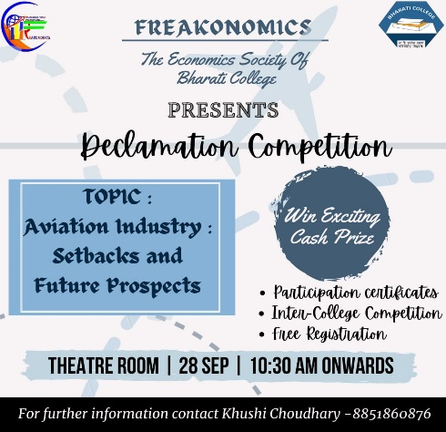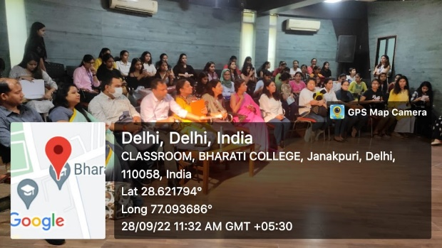

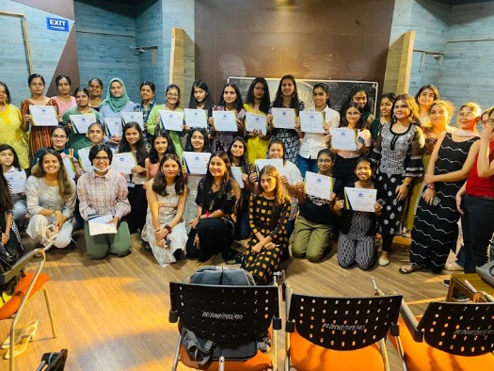
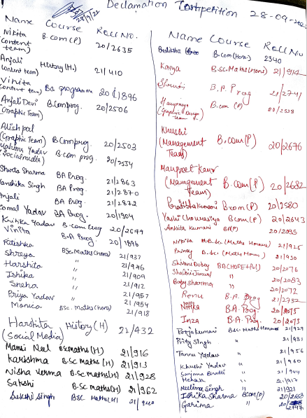
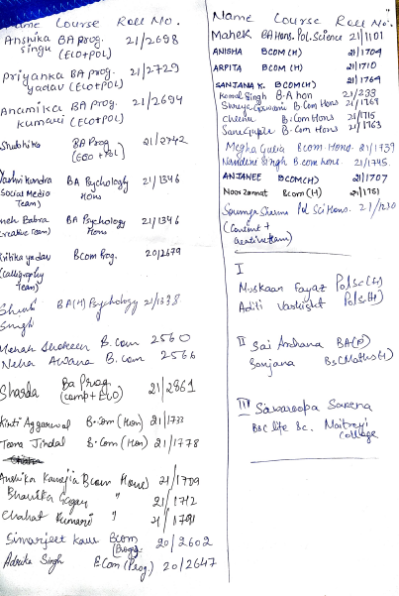
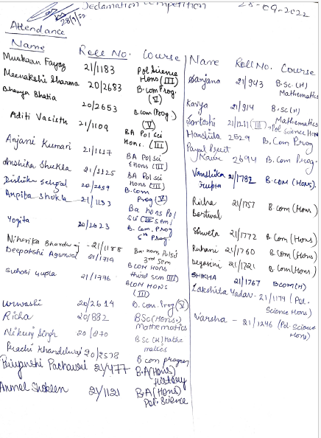

July 2022

֍ A Logo making competition on the theme “Economic Growth and Development” was organized on the 1st of July 2022. Several students participated in the event with enthusiasm and won exciting cash prizes.
Funds Sanctioned: NIL

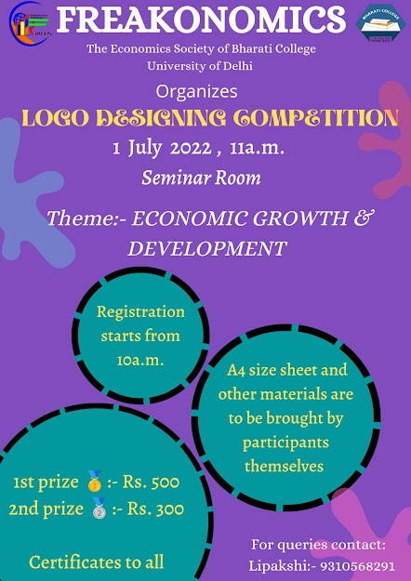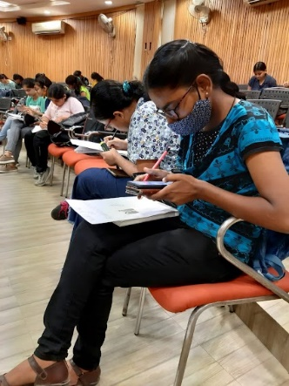
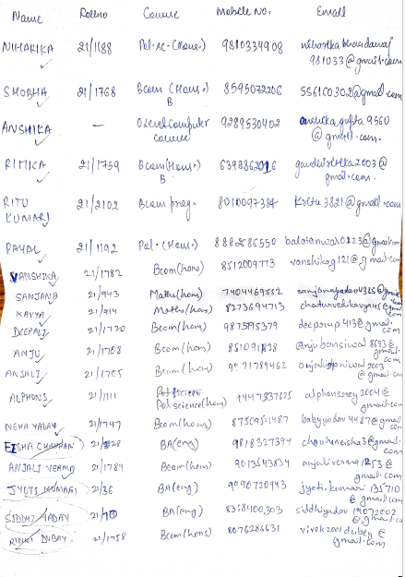
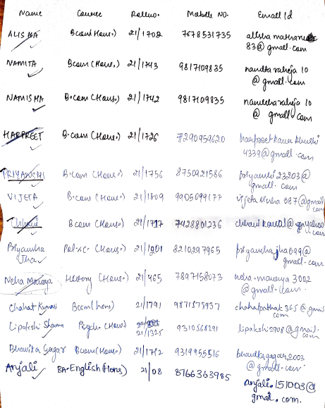
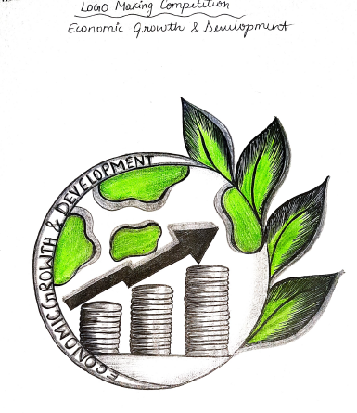

June 2022
֍ Screening of an Oscar nominee movie “Lunana-a Yak in the classroom” was organised on the 27th of June 2022. The movie demonstrated the concept of human development and gross national happiness index. Movie screening was followed by a group discussion on the different factors contributing to the human development.
Funds Sanctioned: NIL
