**MANTHAN- THE NUKKAD NATAK SOCIETY, BHARATI COLLEGE**

**ANNUAL REPORT 2021-22**

“It only takes one voice, at the right pitch, to start an avalanche.”

-Dianna Hardy

MANTHAN, The Nukkad Natak Society of Bharati College believes in raising your voice for the betterment of society, fearlessly and confidently.

The last one year has been a strange and difficult journey, due to the worldwide pandemic. MANTHAN’s working was greatly affected when the streets we performed on became a fearsome place where very few dared to tread. We were forced to conduct some of our work in the online mode.

As we look down the road of an exciting new year, we enthusiastically await the opportunity to conduct more and more events in the offline mode and get back to performing. This report is a testament to the strong will and hardwork of our team.

## HISTORY AND TECHNIQUES WEBINAR

In March 2022, shortly after the COVID-19 period, MANTHAN orchestrated a workshop centered on the 'History and Techniques of Street Plays,' featuring Dr. Anita, an esteemed associate professor from Rajdhani College. The session garnered an enthusiastic response, with attendees actively participating in dynamic and substantive discussions.

Despite the challenges endured during the pandemic, the workshop served as a revitalizing platform for students to delve into the intricate history and nuanced methodologies of street plays. Dr. Anita's expertise proved instrumental in imparting invaluable insights, fostering a heightened understanding and appreciation for this traditional form of artistic expression.

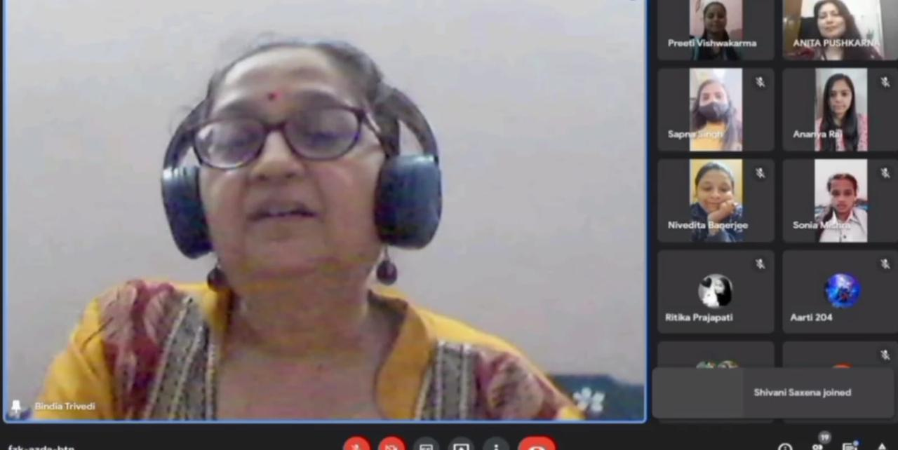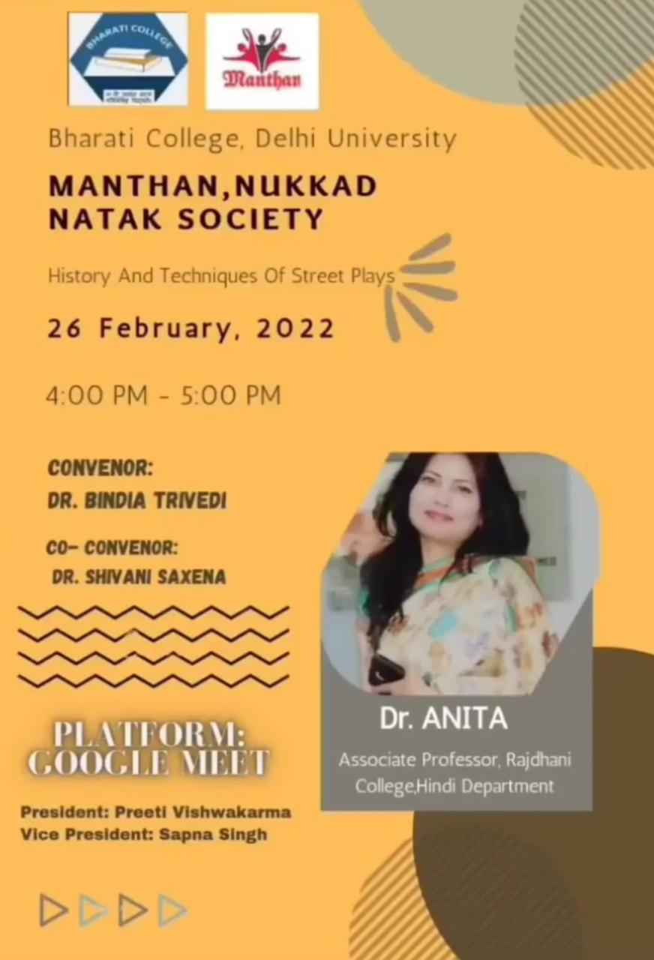

MANTHAN's initiative not only rekindled interest in street plays but also epitomized the resilience and collaborative spirit ingrained within the college community. This event marked a positive stride toward post-pandemic recovery efforts, exemplifying the collective commitment to intellectual enrichment and cultural engagement within the academic sphere.

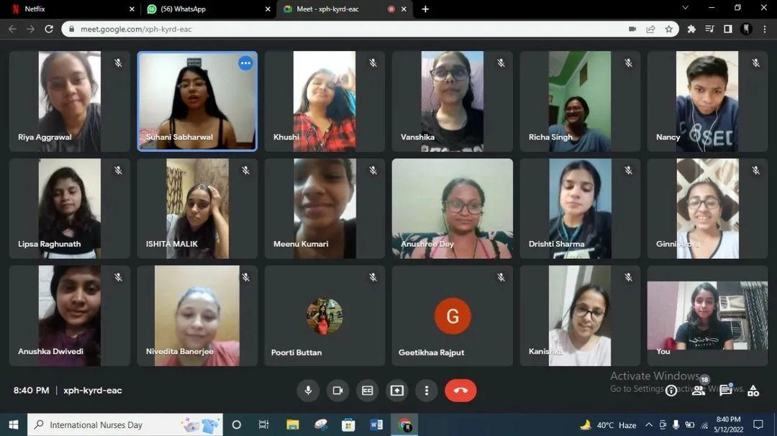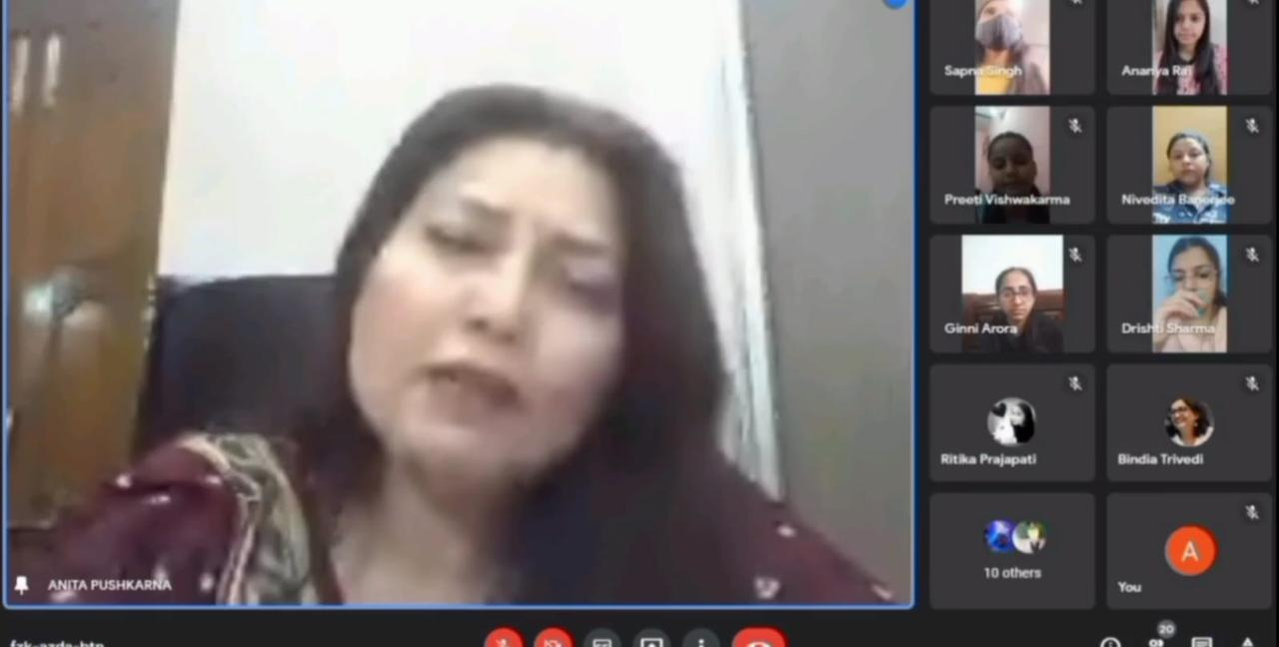

## SAVE SOIL CAMPAIGN

In April 2022, following the resumption of academic activities post the COVID-19 hiatus, MANTHAN demonstrated notable enthusiasm in their involvement with the #SaveSoil campaign. Their poignant performance underscored the critical significance of soil preservation, employing hashtags such as #SaveSoil. This proactive engagement reflects a collective commitment to environmental stewardship, exemplifying Bharati College's dedication to raising awareness and advocating for the safeguarding of natural resources.

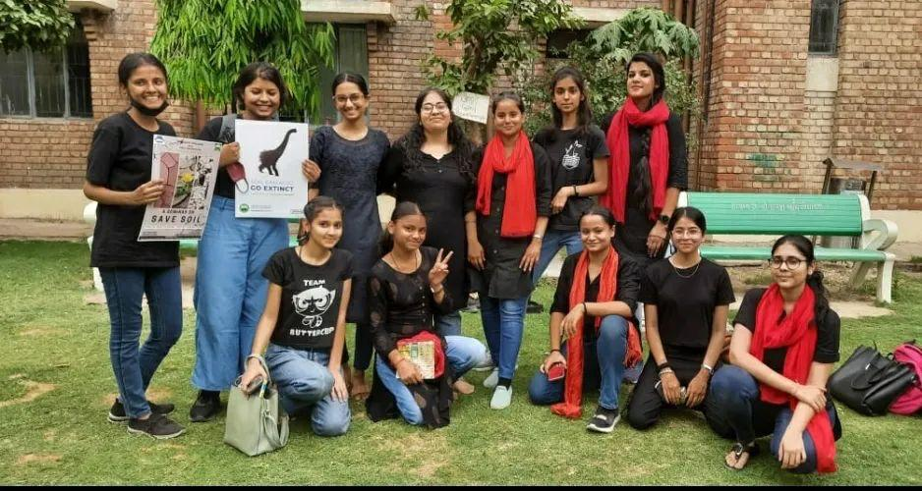 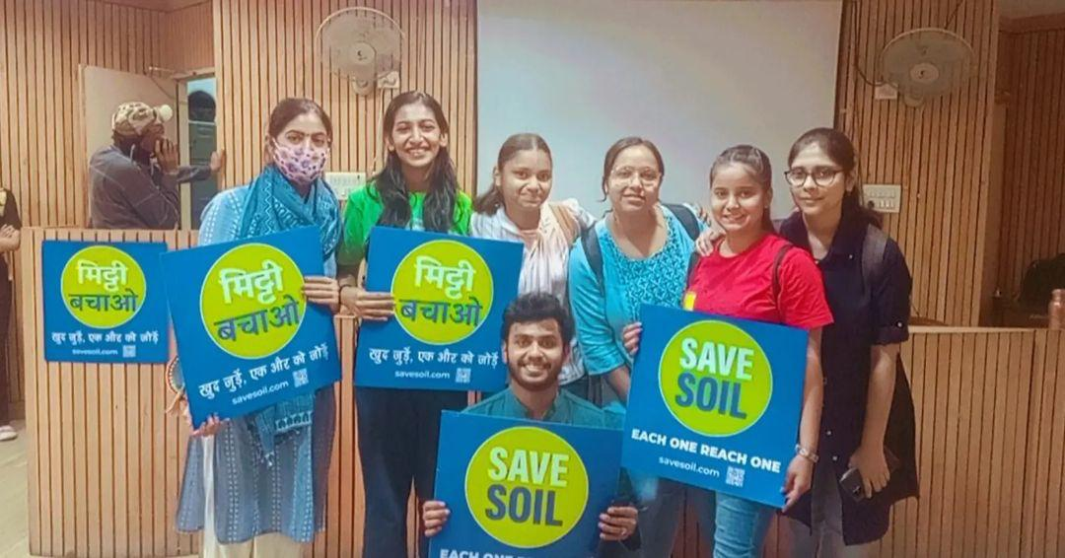

Through their participation, the society not only highlighted the urgency of soil conservation but also spurred discussions and inspired action within the college community. Such initiatives serve as commendable endeavors toward fostering a culture of sustainability and responsible environmental practices among students and faculty alike.

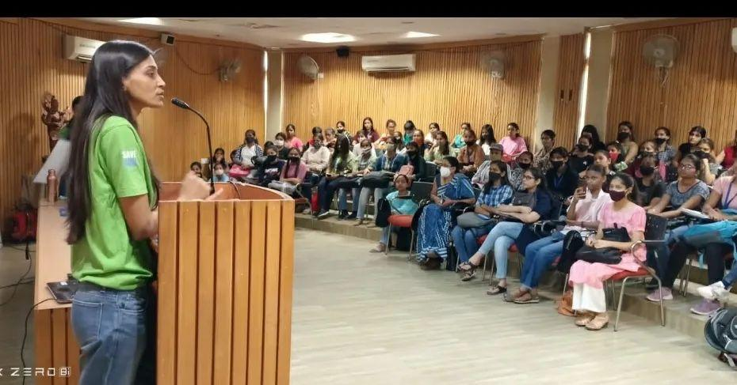 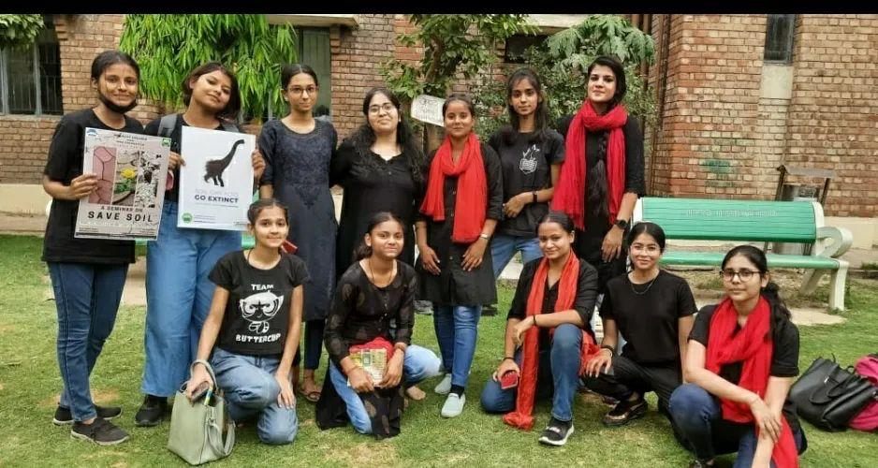

## AUDITIONS

In May 2022, immediately after colleges reopened post-COVID-19, MANTHAN held auditions near the Auditorium Building on May 10th, 2022. The auditions aimed to provide opportunities for aspiring scriptwriters and actors to demonstrate their talents. Actors were tasked with preparing a 2-minute performance, selecting from various themes such as monologues, social causes, characters, or Bollywood. Individual auditions ensured fairness in the selection process, allowing each participant to showcase their skills effectively.



Scriptwriters were encouraged to present their past works or engage in an extempore session to exhibit their creativity. These auditions not only served as a platform for talent exploration but also underscored MANTHAN's commitment to fostering artistic expression and cultural engagement within Bharati College.

## ORIENTATION

In May 2022, amidst the post-COVID-19 reopening, MANTHAN extended a warm welcome to its newest members. The team facilitated an online meeting, aiming to acquaint the newcomers with the society's rules, regulations, and overarching objectives. This session served as an opportunity for the existing members to introduce themselves and foster a sense of camaraderie among the cohort.



The meeting emphasized the importance of unity and collaboration within the society, setting the stage for a productive and fulfilling journey ahead. As the first batch of members post the pandemic, there was a palpable sense of optimism and excitement about the potential for creativity and innovation within the group.

With the collective enthusiasm of both existing and new members, MANTHAN looked forward to embarking on a journey filled with artistic exploration, cultural enrichment, and meaningful contributions to the vibrant community of Bharati College.

## COVID WARRIORS ACT

In July 2022, the members of MANTHAN conveyed their profound gratitude to the Covid Warriors through a heartfelt street play performed in Tilak Nagar, Ramesh Nagar Metro Station and within the college premises. The play aimed to express the indescribable joy felt by the society members as they honored these frontline heroes. This performance, that was initially done in collaboration with Enactus, went on to receive recognition at a national level.

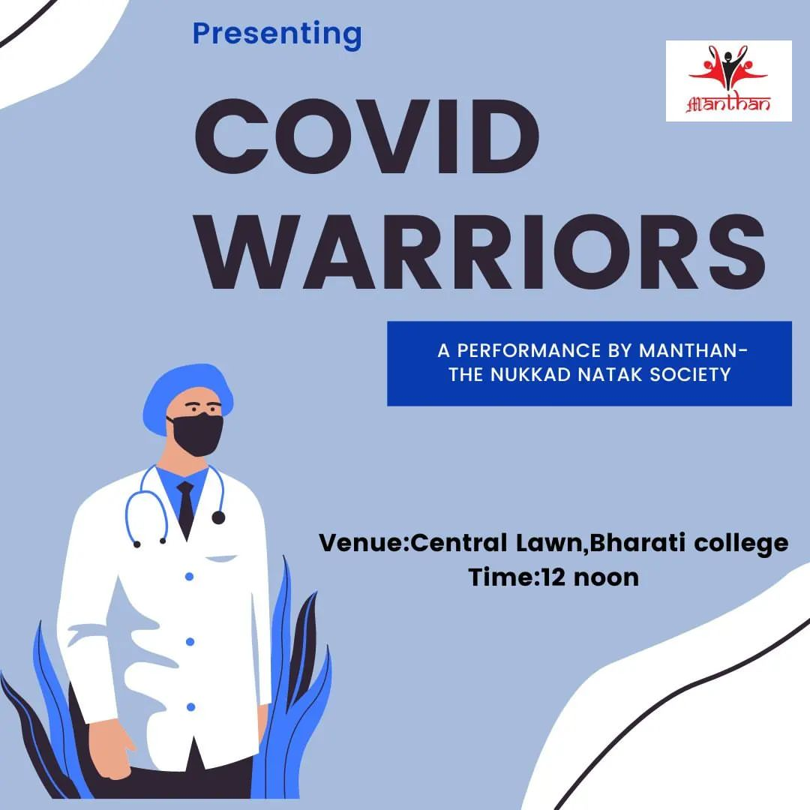

The performance served as a tribute to the sleep-deprived heroes, comprising doctors, nurses, paramedics, ambulance drivers, sweepers, security guards, cops, and various other frontline workers. Their selfless sacrifices for the safety and welfare of humanity are invaluable and merit lifelong appreciation from our end.

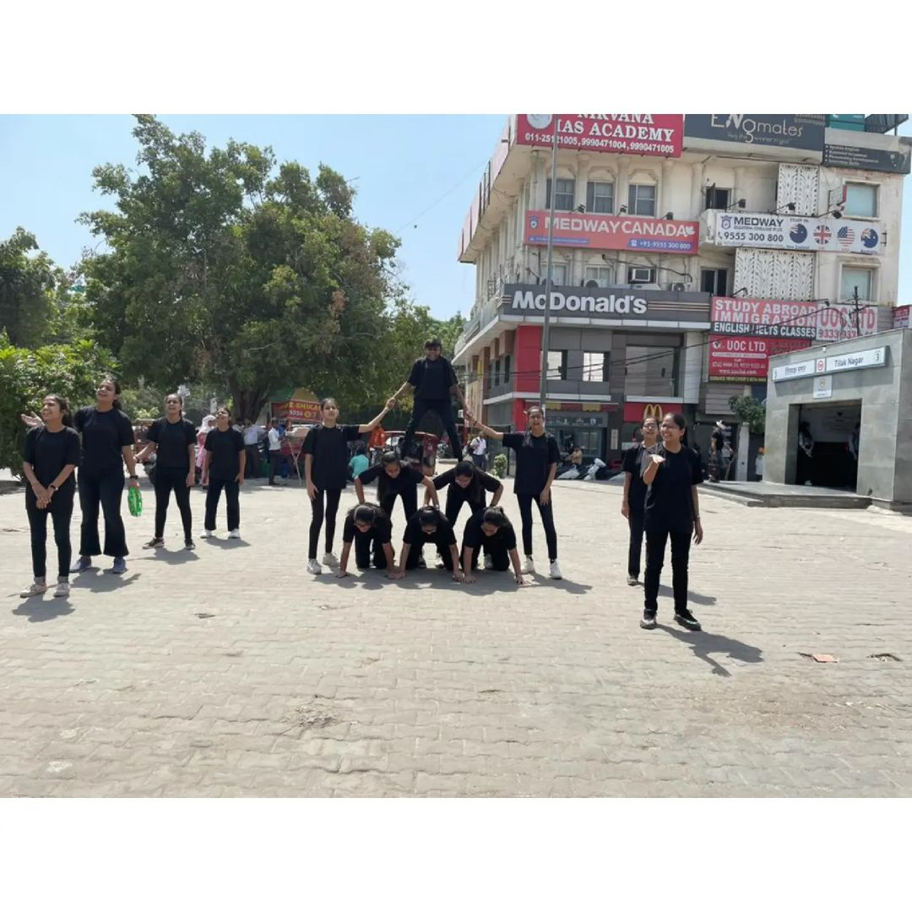

Through this initiative, MANTHAN sought to acknowledge and honor the dedication and resilience exhibited by the Covid Warriors, emphasizing the profound impact of gratitude in fostering unity and resilience within the community.

## FLASHMOB FOR LGBTQ+ COMMUNITY

In July 2022, MANTHAN presented a poignant play within the college premises to commemorate Pride Month. Collaborating with IRIS - The Queer Collective, Bharati College, the performance aimed to highlight the significance of embracing diversity and fostering inclusivity within the LGBTQ+ community.

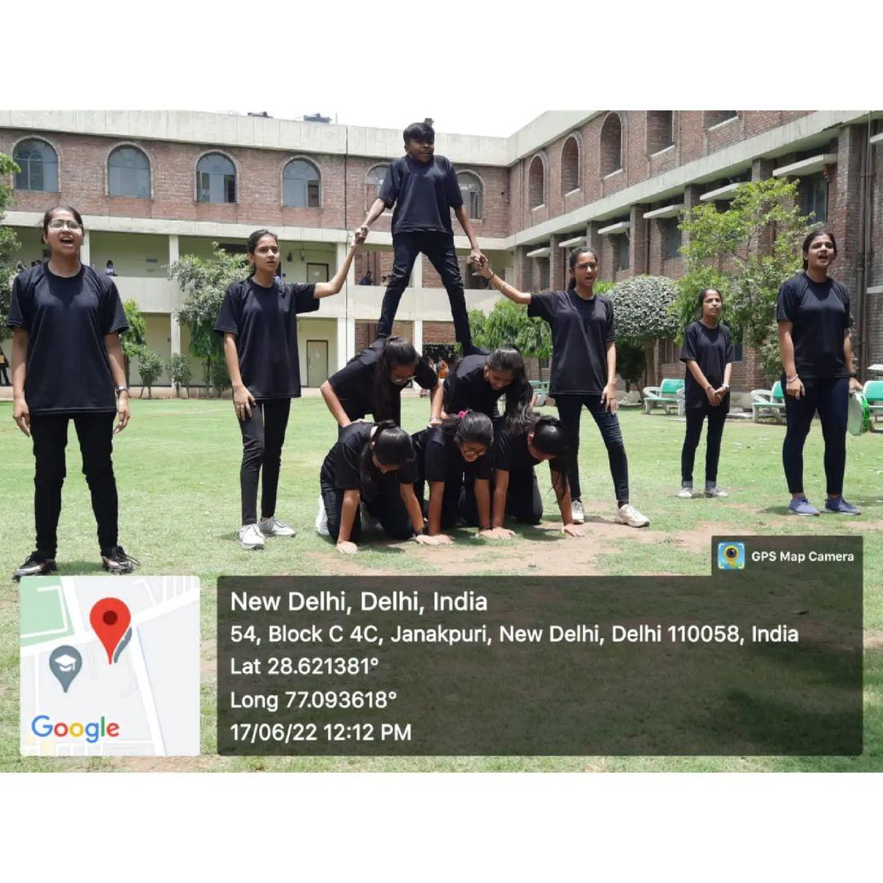

The play served as a platform to emphasize the intersectional efforts required to create a space where individuals of all identities feel valued and celebrated. Through compelling storytelling and powerful performances, MANTHAN and IRIS conveyed a message of acceptance, love, and unity.

The collaboration between MANTHAN and IRIS exemplifies the college's commitment to promoting awareness and understanding of LGBTQ+ issues, fostering a culture of acceptance and respect for diverse identities within the campus community. Through creative expression and advocacy, they strive to create a more inclusive and welcoming environment for all.

***SOCIAL MEDIA LINKS***

* <https://www.instagram.com/p/CcqXbmBB-UU/?igsh=cGF4bzF1b3Fxa3lw>
* <https://www.instagram.com/p/CcqT9i0BHqy/?igsh=MTZqbWY5N3d3MHl6dg==>
* <https://www.instagram.com/reel/CakDT4zBGIz/?igsh=am11NTd0dHljbTZq>
* <https://www.instagram.com/p/CdTc7VHhTy1/?igsh=bDM1N3ZrNjVsd3h3>
* <https://www.instagram.com/p/CeyTx6WBtoy/?igsh=MWRrbXhvdTVrMXZmOA==>
* <https://www.instagram.com/p/CdftW7rD9If/?igsh=dzYzcTh1b3p2OTJx>
* <https://www.instagram.com/p/CfraEEGB3f4/?igsh=MXVkaTBtdmRteTQybQ==>

**MANTHAN CORE TEAM 2021-22**

***Office Bearers-***

* Preeti Vishwakarma (President)
* Sapna (Vice President)
* Riya Singhla (Treasurer)
* Ria Manocha (Director)
* Jeevasha (Secretary)
* Sonia (Scriptwriter)
* Aliza Arif (Scriptwriter)
* Suhani Sabharwal (Social Media Head)
* Ananya Rai (Social Media Head)

***Conveners-***

* Dr. Bindia Trivedi (Convener)
* Dr. Shivani Saxena (Co convener)