CHINTAN-THE DEBATING SOCIETY
2022-2023 REPORT

“It is better to debate a question without settling it than to settle a question without debating it.” - Joseph Joubert

CHINTAN- The Debating Society of Bharati College builds upon this philosophy and trains its members to put their heart and soul into their arguments. All the members of Chintan are people who carefully work together to polish their Debating skills and Reasoning. There is a wonderful symphony of teamwork and coordination that binds this society together. The last one year has been exceptionally wonderful for CHINTAN and all its members.

Events in this academic year 2022-23

Webinar on “Women Empowerment And Women Related Laws”
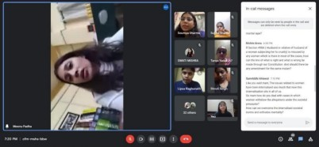

Chintan successfully organized a webinar on "Women Empowerment And Women Related Laws" on 16th of September, 2022.
The keynote speaker was Adv. Meenu Padha who is practicing law in the J&K and Ladakh High courts. She is also the President of National Child and Women Development Council(J&K)
The event began with an opening speech. Then, Dr. Anavisha Banerjee, the convener of Chintan, welcomed the speaker. Adv. Meenu Padha began the conversation by mentioning the various laws available for the Protection of Women. She mainly focused on the following acts:

- Protection of women from domestic violence act 2005
- Sexual Harassment at workplace (POSH) Act, 2013
- Pre-Conception and Pre-Natal Diagnostic Techniques (PCPNDT) Act, 1994.
- Prevention of Children from Sexual Oﬀences act (POCSO) Act, 2012.

The session was highly interactive and the students came up with various doubts. The speaker gave the students admirable advice.

Open Mic Competition- 1
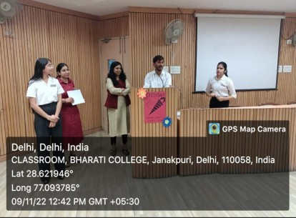
CHINTAN successfully organized its first oﬄine open mic, intra-college competition on 9th of November. Students actively took part in it. Judges for the event were Dr. Harinath Kumar, Assistant Professor at the Department of Journalism , Bharati College and Dr. Shailza Singh, Assistant Professor at the Department of Political Science, Bharati college.

The event began with an opening speech. Dr. Anavisha Banerjee, the convener of CHINTAN, welcomed the judges with a bouquet and then the competition
began with an utmost zeal. Participants presented their views on various topics. Issues like Women Empowerment, Corruption, Youth Mobile Addiction and Climate Change were heavily discussed.

The event came to an end with Judges announcing the names of winners :- Rank 1 – Nancy
Rank 2 - Kashifa Ayaz Rank 3 – Anu

And thereby giving the top 3 rankers accolades and cash prizes respectively. All the other participants were given Certificates of Participation.

CHINTAN Auditions

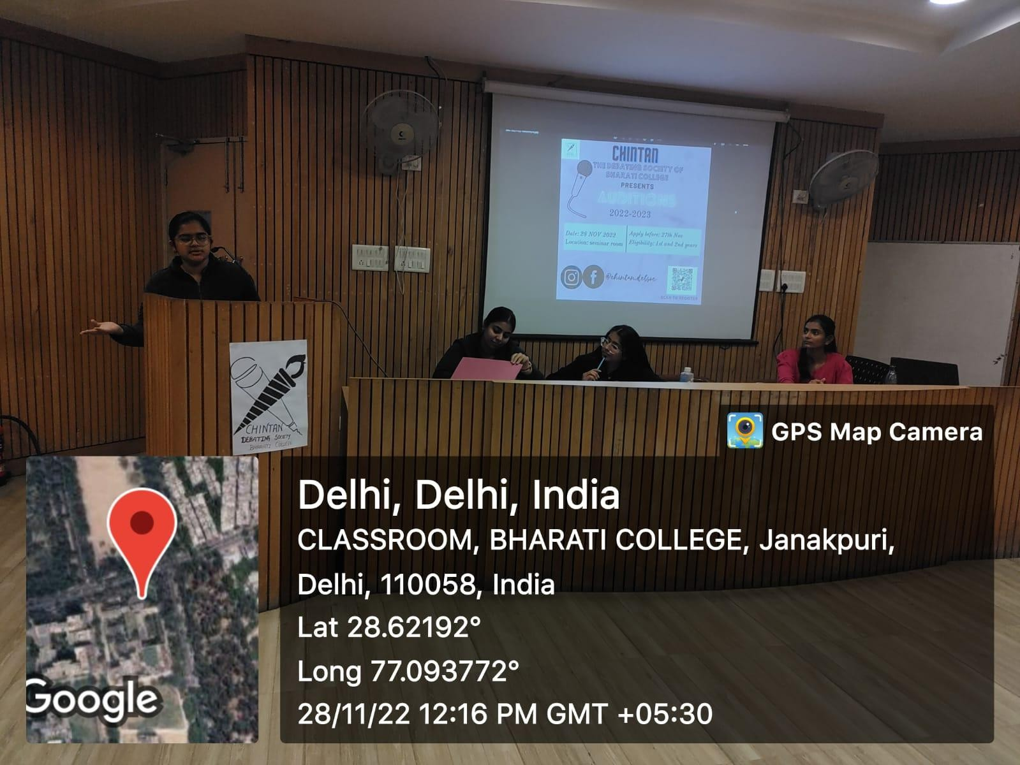

CHINTAN successfully organized the auditions for the academic year 2022-23 on 27th November. Topic for the audition was ‘Should Mental Health Days Be Counted as excused absences for students?’ More than 100 students took part in the auditions, out of which 15 got selected. The event began with an opening
speech. Then, the Vice-President, Suhani Sabharwal informed the students about the rules and regulations of a Conventional Debate. Many of the students were in favor of the motion and saw mental health as a priority and some presented strong opinions against the motion, which was followed by interjections from the core team.

Conventional Debate

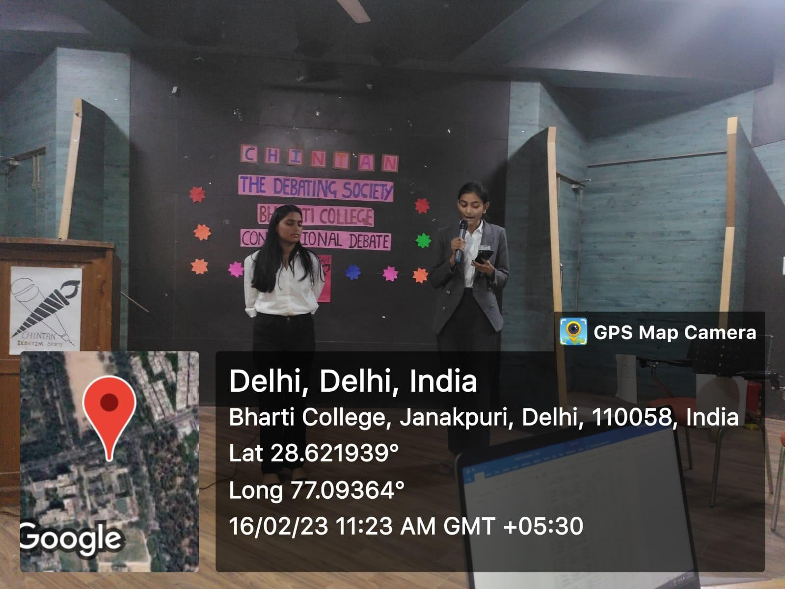

Chintan successfully organized the conventional debate session for the members of Chintan. Topic for the debate was- “Same Sex marriage are compatible with Indian culture.” All the members of the society actively participated in it.

The event began with a short introduction about the rules and regulations of the Debate by Vice-President Suhani Sabharwal, who was also the judge for the event. Teams were divided in three members in each team one For the motion , one Against the motion and one Interjector.
Everyone presented their thoughts with enthusiasm and Suhani gave them the feedback afterwards.
Event came to an end by announcing the names of winners.

Open Mic- 2

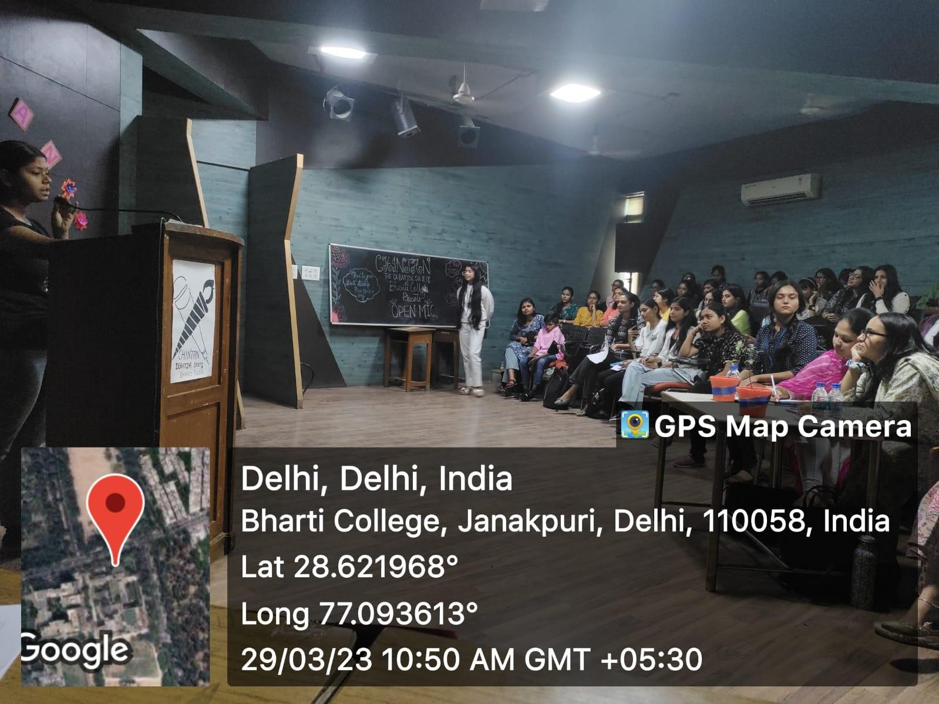

Chintan organised an open mic competition on Wednesday, 29th of March. The event was a booming success and went on from 10:30 AM to 1:30 PM. The event consisted of over 50 participants whose performances ranged from songs to poetry to speeches to even personal stories! Dr. Shimpy Pandey and Dr. Bhawna Shivan judged the competition and were truly a warm presence in the event. The event began with a felicitation of the judges by Chintan’s convener, Dr.
Anavisha Banerjee.

The whole aﬀair proved to be a wild rollercoaster of emotions where some performances brought tears to your eyes and some made you laugh until your stomach hurt! Every participant presented a unique perspective of the world and there wasn’t one performance that didn’t make you stop in your tracks and think intently about the topic being presented. The topic- “Love” proved to be extremely popular among the participants and even prompted the judges to comment on the maturity of the students.

Another theme that was talked about a lot was “Social issues”. The event came to an end with an announcement of the winners and some kind words by the judges.

AWAAZ
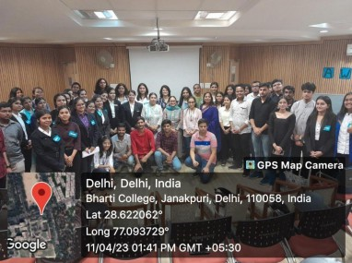

Under the annual fest of Bharati College, Abhivyakti’23, CHINTAN organised a debate competition- AWAAZ that welcomed students from many diﬀerent colleges. The competition was judged by Suhani Sabharwal, Sujata Sharda and B. Lipsa Raghunath, the Vice-President, SM Head and Senior Executive member of CHINTAN respectively.
They also took on the role of the interjectors. The event entailed a lively Debate on the topic “Will nationalism benefit or endanger countries in the context of globalization?” with students presenting logical arguments from both sides. All the winners were later felicitated with cash prizes and all the participants received certificates.

CHINTAN’S SOCIAL MEDIA

  - https://www.instagram.com/reel/CrLwYDBuHPP/?igshid=YmMyMTA2M2Y=
  - https://www.instagram.com/reel/CqbAaYHrq3r/?igshid=YmMyMTA2M2Y=
  - https://www.instagram.com/reel/Co1jklpL9-u/?igshid=YmMyMTA2M2Y=
  - https://www.instagram.com/reel/ClgZFMNudCJ/?igshid=YmMyMTA2M2Y=
  - https://www.instagram.com/reel/CkvxnWQMO09/?igshid=YmMyMTA2M2Y=
For further details, contact:
chintandebsoc@gmail.com

CHINTAN ACHIVEMENTS 2022-23

- Our Vice- President Suhani Sabharwal did Live shows with Akashvani, All India Radio [FM Rainbow] on 'Impact Of westernization on Indian Society' and Got Featured on 102.6 FM Rainbow on a Programme of "Youth icon and role model in culture" on the occasion of Azaadi Ka Amrit Mahotsav. She also won Second position in a conventional Debate organised by Deshbhandu college, University Of Delhi.

- Our treasurer, Shruti Singh, won the First prize in an open mic Competition Organised by Apeejay School of Management on the Topic ‘Human Rights’.

- Our Secretary, Nandini Dang, won the Second prize in an Open Mic Competition organised by Apeejay School of Management on the topic of Substance Abuse. She also won the Third prize in an open mic on the topic ‘Equity in the Workplace’.

- Prarthana Mishra won First prize in Speech Competition by Political Science Department in Bharati College and Second Prize in Youth Parliament by Bharati College.

- Arushi Saxena won Consolation Prize in speech competition organised by Political Science Department on the occasion of constitution day (Bharati college) and Third prize in Open Mic Competition organised by Chintan (Bharati College).

- Ananya Sacheti won Third Position in the Open Mic Competition at Hansraj College, University of Delhi and First Position in open mic competition by Department of Psychology, Bharati College.

- Lara Gautam won First Position in open mic competition by Lady Irwin College, University of Delhi.

CHINTAN ATTENDANCE 2022-23

Attendance

The drive link provides a comprehensive overview of the attendance records of our esteemed senior executive members throughout the academic year 2022-23. By sharing this information, we aim to promote greater transparency within our society and depict the contribution and dedication of our members towards chintan.

FUNDS 2022-23
Expenses

- Open mic competition-1 (9.11.2022) 1st prize: Rs. 1000
2nd prize: Rs. 500 3rd prize: Rs. 300 Total: Rs. 1800

- Open mic competition-2 (29.3.2023) 1st prize: Rs. 3500
2nd prize: Rs. 2500 3rd prize: Rs. 1500
Mementos/pots for judges: Rs. 140 Refreshment for judges: Rs. 126 Total: Rs. 7766

Final total expenses: Rs. 1800+ Rs. 7766 = Rs. 9566

Total fund allotment by college authority for the academic year 2022-23: Rs. 10000
Total utilized fund by CHINTAN for the academic year 2022-23: Rs. 9566

For reference: link

TEAM

Core Team
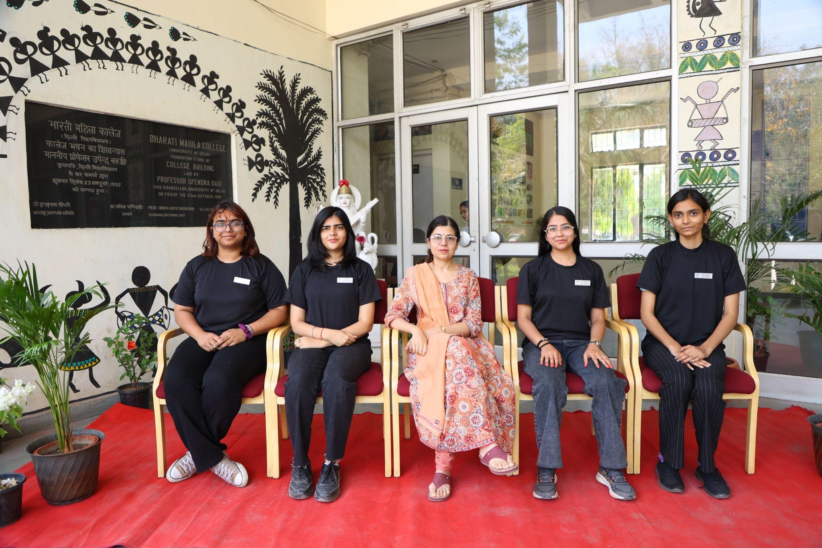
(From L to R: Nandini Dang, Sujata Sharda, Dr. Anavisha Banerjee-convener, Suhani Sabharwal, Shruti Singh)

Vice-President: Suhani Sabharwal SM Head: Sujata Sharda Treasurer: Shruti Singh Secretary: Nandini Dang

Senior Members
- B. Lipsa Raghunath
- Lara Gautam
- Ananya Sacheti
- Rashi Arora
- Anamika
- Muskan
- Priyanka
- Prarthana Mishra
- Kashifa
- Sakshi

Junior Members

- Prajakta
- Bhumika Ajegar
- Gungun Singh
- Tannu Bhakta
- Kanishka Sharma
- Sheya Oberoi
- Prachi
- Arushi Saxena
- Vidhi Arora

Convener: Dr. Anavisha Banerjee
Co Conveners: Dr. Savita Jemini
Dr. Rekha Sharma

Chintan is extremely excited to organise even more events and to welcome new opportunities in the next academic year.

Regards
CHINTAN- The Debating Society, Bharati College University of Delhi

