~~-~~



UNIVERSITY OF DELHI

CHINTAN



THE DEBATING SOCIETY OF BHARATI COLLEGE

ANNUAL REPORT 2021-22

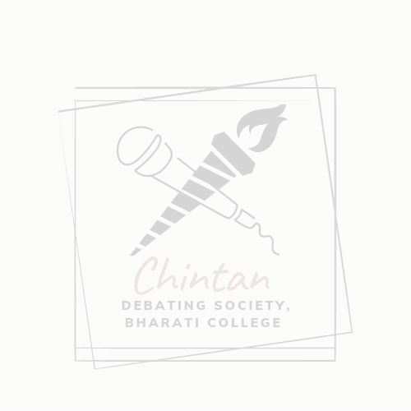

Chintan, the Debating Society of Bharati College is a dynamic society that encourages discourse and intellectual exchange amongst students. Navigating through this year was challenging, yet Chintan adapted swiftly to the digital landscape, embracing online platforms to foster its vibrant community of debaters, thinkers, and change-makers.

Despite the hurdles posed by the COVID-19 pandemic, our dedicated o£ice bearers displayed resilience and innovation, steering the members through the virtual realm with unwavering commitment and creativity. From virtual meetings to o£line events, every aspect of Chintan's operations resonated with adaptability and perseverance, embodying the essence of intellectual growth amidst adversity.

EVENTS FOR THE ACADEMIC YEAR 2021-22

1. Orientation programme(2021-22)

On November 24, 2021, Chintan - The Debating Society of Bharati College orchestrated an enriching online orientation program, spearheaded by esteemed leaders Vaishnavi Sudha, President of Chintan; Soumya Varma, Vice President of Chintan; Gauri Shukla, the super senior executive of Chintan; and Ritika Chauhan, Secretary of Chintan. This session served as a beacon of enlightenment, o£ering invaluable insights to the eager participants, primarily comprising freshers.

The seniors graciously imparted their wisdom, guiding juniors through the nuances of debating and declamations. By nurturing an environment of critical thinking and e£ective communication, this orientation program laid a solid foundation for the incoming members, fostering a culture of intellectual growth within the society. Their collective expertise and mentorship not only inspired

confidence but also set the stage for collaborative learning and development, ensuring a promising journey ahead for Chintan and its members.

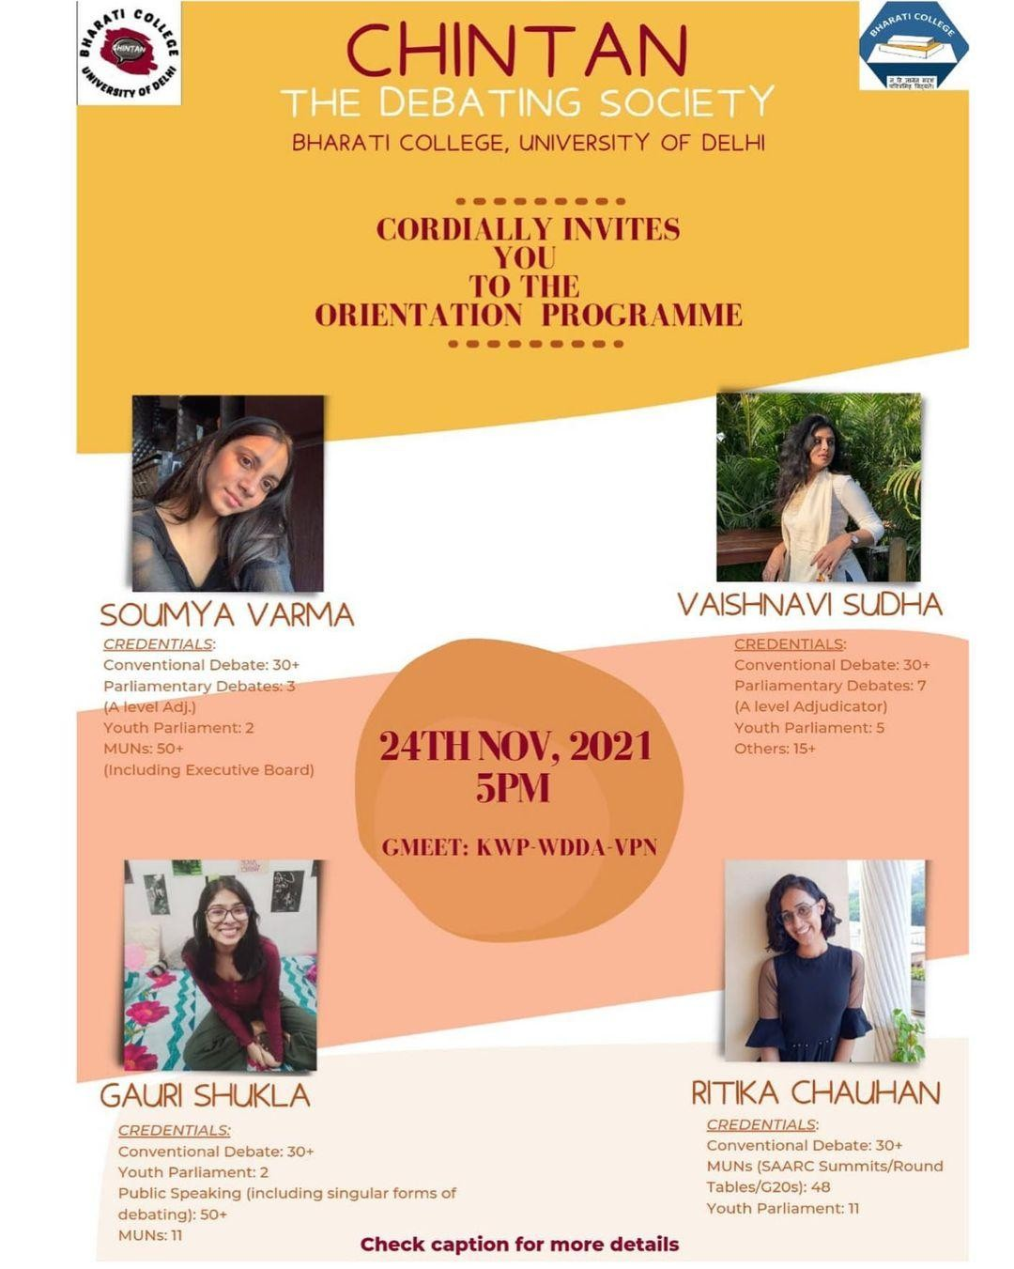

2. Auditions(2021-22)

On December 11, 2021, Chintan - The Debating Society of Bharati College organized a meticulously crafted online audition round to welcome new members into its esteemed fold. The auditions set a high bar, challenging participants with rigorous assessments and intense competition. Despite the formidable selection process, only a select cohort of students, distinguished by their exceptional skills and promise, earned the privilege of joining Chintan.

The auditions, featuring a traditional Conventional Debate format, centred on the pertinent topic of Ecological Imbalances, inviting students to demonstrate their comprehension and articulation of the subject matter. Furthermore, an interjection round injected dynamism, fostering lively discourse and critical engagement among participants. The auditions not only showcased the depth of

talent within the college community but also underscored Chintan's commitment to nurturing excellence and fostering intellectual growth among its members.

3. Cervical Cancer and Vaccination Awareness Camp

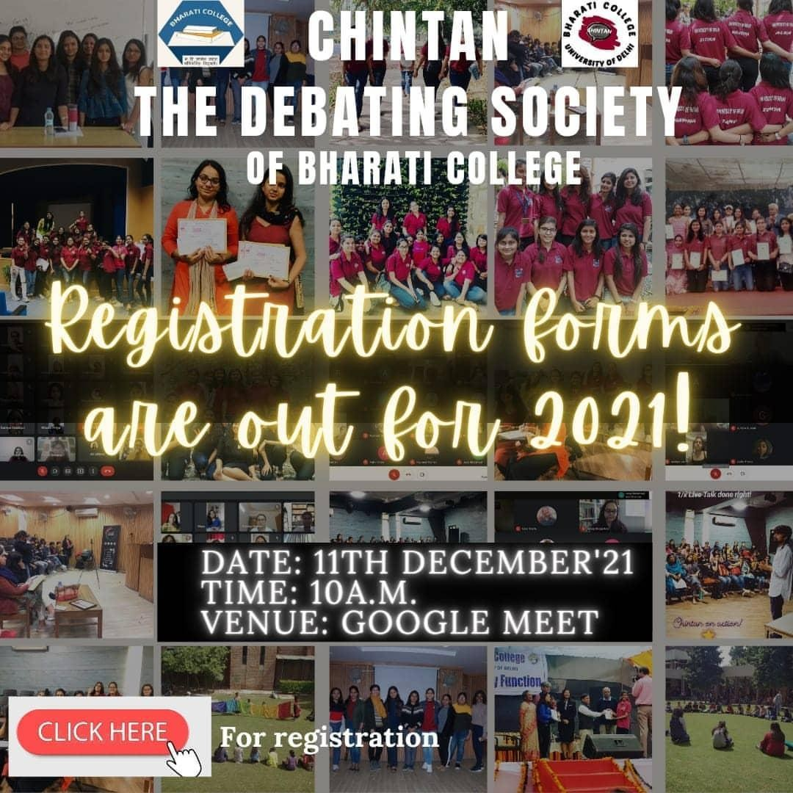

A remarkable event organized by Chintan - The Debating Society of Bharati College on March 8, 2022, under the esteemed guidance of the IQAC and WUS committee, Chintan organized its first o£line event - a cervical cancer awareness camp.

Dr. Sarbani Gon, Additional Chief Medical O£icer at BRPL (BSES), led the session with profound expertise, making it an insightful and valuable experience for all attendees.

What truly made this event captivating was the active participation of both students and professors. Witnessing students eagerly asking questions and

professors engaging wholeheartedly in the discussion highlighted the significance of this initiative. It created a supportive environment where knowledge was shared, questions were answered, and awareness was heightened. Events like these play a pivotal role in empowering women by increasing awareness about diseases that a£ect them. By shedding light on cervical cancer and its prevention, the camp undoubtedly empowered women with knowledge that could potentially save lives. Moreover, the inclusive nature of the event, with participation from both students and professors, fostered a sense of community and collective responsibility towards women's health.

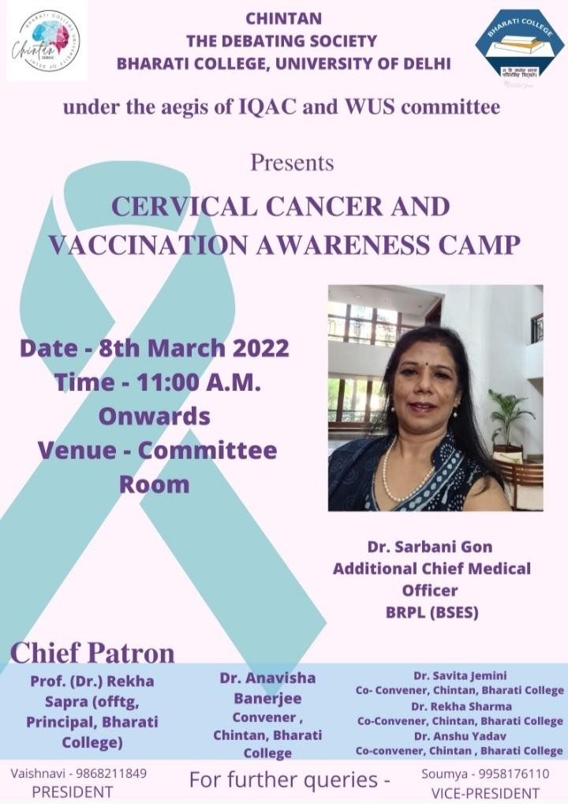

<https://www.instagram.com/p/CWlqX0wBHyK/?igsh=bHgxbGZkczNtNGty>



CHINTAN’S SOCIAL MEDIA

1.

2.



<https://www.instagram.com/p/CWxz5KohvqB/?igsh=bWhtMXQ3OGgxZngy>

3.



<https://www.instagram.com/p/CZx3kf_DZ75/?igsh=dDA5ajZhbXUwcDFy>



For further details, contact: [chintandebsoc@gmail.com](mailto:chintandebsoc@gmail.com)

CORE TEAM 2021-2022

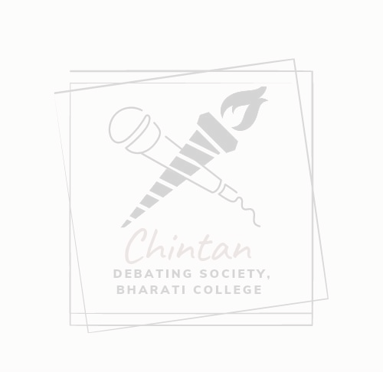

*Oﬀice bearers*

President: D. Vaishnavi Sudha Vice President: Soumya Varma Secretary: Ritika Chauhan Joint Secretary: Mohini Arora

Media Head(Social Media): Diya Sharma

Media Head(Graphic Designing): Kaumudi Kumari 2nd-year representative: Kuki Kumari

1st-year representative: Ojasvi Gupta

Convenor: Dr. Anavisha Banerjee Co-Convenors: Dr. Anshu Yadav

Dr. Savita Jemini Dr. Rekha Sharma

Through the collective e£orts of our o£ice bearers and members, we navigated uncharted territories, overcoming obstacles with creativity and determination. We express our deepest gratitude to all those who have contributed to our journey this year, and we eagerly anticipate the opportunities and growth that lie ahead.

Regards

Chintan - The Debating Society Bharati College, University of Delhi