DASTAAN

The Film and Photography Society

*YEAR REPORT*

*2024*

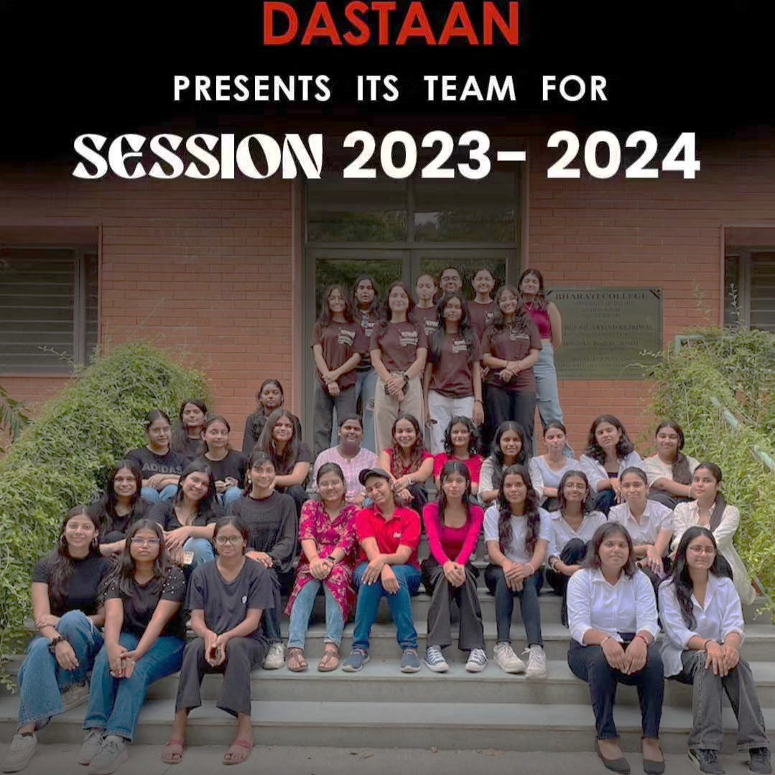

Contents

1. Durga Puja Photowalk

2. Filmy Friday

3. Short Film Production

4. Melange Coverage by Dastaan

5. Certification Ceremony

6. Fresher’s

7. Kudiyan Di Phulkari

8. Photography Workshop

9. Documentary Nomination

10. Bollywood Era Photoshoot

11. Lodhi Photowalk

12. Alumni Meet Photoshoot

13. Holi Celebration of Faculty

14. Movie Screening: Fire 1996

15. Calendar Photographs

17. Movie Screening: Jai Bhim

16. International Conference

17. Khwabon ki Dilli 2.0

**DURGA PUJA PHOTOWALK**

Date: 6th October

On 6th October Dastaan - The Film and photography society of Bharati college went on a photograph trip to know about the most famous pandals that we see during Durga Pooja.

When we entered the place there were temples, grounds which were reserved for the making of murti , and an area for pandals where the murti will be set. There was a residential area as well and hostels for the tourists.Overall there was perfect management and people were working accordingly. When we entered the temple there was a temple within the temple. There were long stairs. The building was fully elaborate, especially the pillars of the temple.The dominant colour of the temple was read which symobolise the holiness of fire. The was stone carvings on the pillar it basically was about the RAAS-LEELA OF LORD KRISHNA which made it quite fascinating and attractive on the entrance wall we can see the huge stone carvings of the devotees of lord Krishna the priest of the temple told he was the one who started the chant of HARE KRISHNA HARE KRISHNA. There were different murti in the temple. It was quite surprising as apart from deite Durga we find other deities also like SHIVA, KRISHNA, GANESHA, KARTIKEY and the major part of the temple was covered with KRISHNA idols. The priest and the people serving in the temple usually speak Bengali and were very kind. They were answering our questions and telling us about the significance of the temple and deities. The Prasad was the interesting thing because like other temples here one won't find sweets instead they were serving BHAAT AND SABJI which was way too delicious. On the ground of the temple there were names carved of the people who had donated to the temple with there father’s and mother’s name and their death and birth date was also included.

When we moved towards the place where the murti were made we were surprised and fascinated both because of the positivity the place held. There were many artists involved in the making - some were painting the murti, some were involved in making the paint and some were involved in the design of the murti. We got a chance to talk to the supervisor of that place.

He was kind and funny. He told us that people involved in the making of the Murti had been doing it since ages. It was passed from generation to generation and the person who was head there had gone to France to make murti and had won several accolades for doing the same. What we liked most about them was they were very down to earth, when I say this I mean from there dresses you won't be able to identify who was head and who is worker because they all were very much involved in there work helping each other. Their working environment was very welcoming and helping. The paint that was used was also hand made like it was in the early time through mud and other raw materials. The supervisor also told us about Choku Dhaan - after the pitra paksh the eye of the devi was made and after pitru paksha, there is DEVI PUKHA which means that the face is also covered and after BODHAN that is the sixth day of navratri, the devi is placed and the face is revealed.

Dastaan successfully covered the place through photography and content. Through a visual representation we not only covered the area of the place but also the energy and positivity that the place held. Overall it was a successful event the team members enjoyed a lot during this journey.

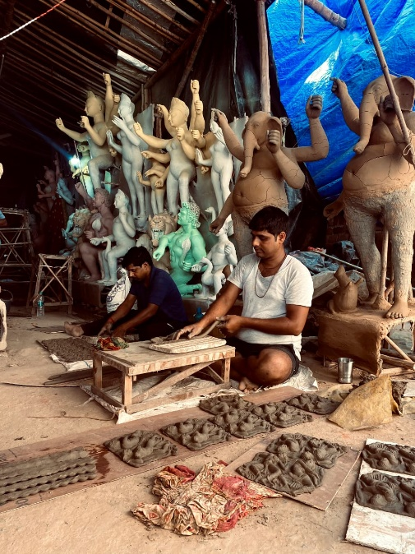 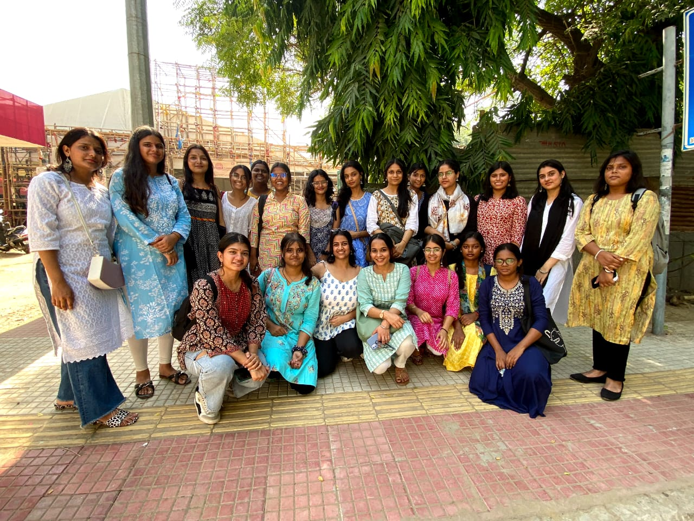

**FILMY FRIDAYS**

Dastaan - The film and photography society of Bharati College, posts film recommendations every Friday.

First the tradition started with the discussion about the films - about its context, cinematics, theme, background and how it connects different generations, their opinions of movies. Through this many underrated movies came into light which deserved more appreciation.

To connect to the larger audience, the film discussion team came up with the idea of posting film suggestions every day on Friday and it was named FILMY FRIDAY.

It began on 13 January 2023 with the film review but later shifted to movies recommendations. Through this different film industry with wide range of genres were explored.

Suggestion from the movies involves crime

Enola homes

Bell bottom

Agent Sai

The nice guys

Raat akeli hai

Gang leader

Sathiya Sothanai

To the movies about how to fall in love with

Queen

Wake up sid

Five feet apart

Hasse toh phasee

Midnight sun

What was the most striking feature was most of the pages which dealt with movie suggestions and about films they have forgotten or paid less attention to Tollywood although many of them do.

Through the efforts of Dastaan we see movies brought to light which are masterpieces but unfortunately they have not got enough audience.

While planning about FILMY FRIDAY this was the main idea of Dastaan - to look into its audience and give them a wider space to explore.

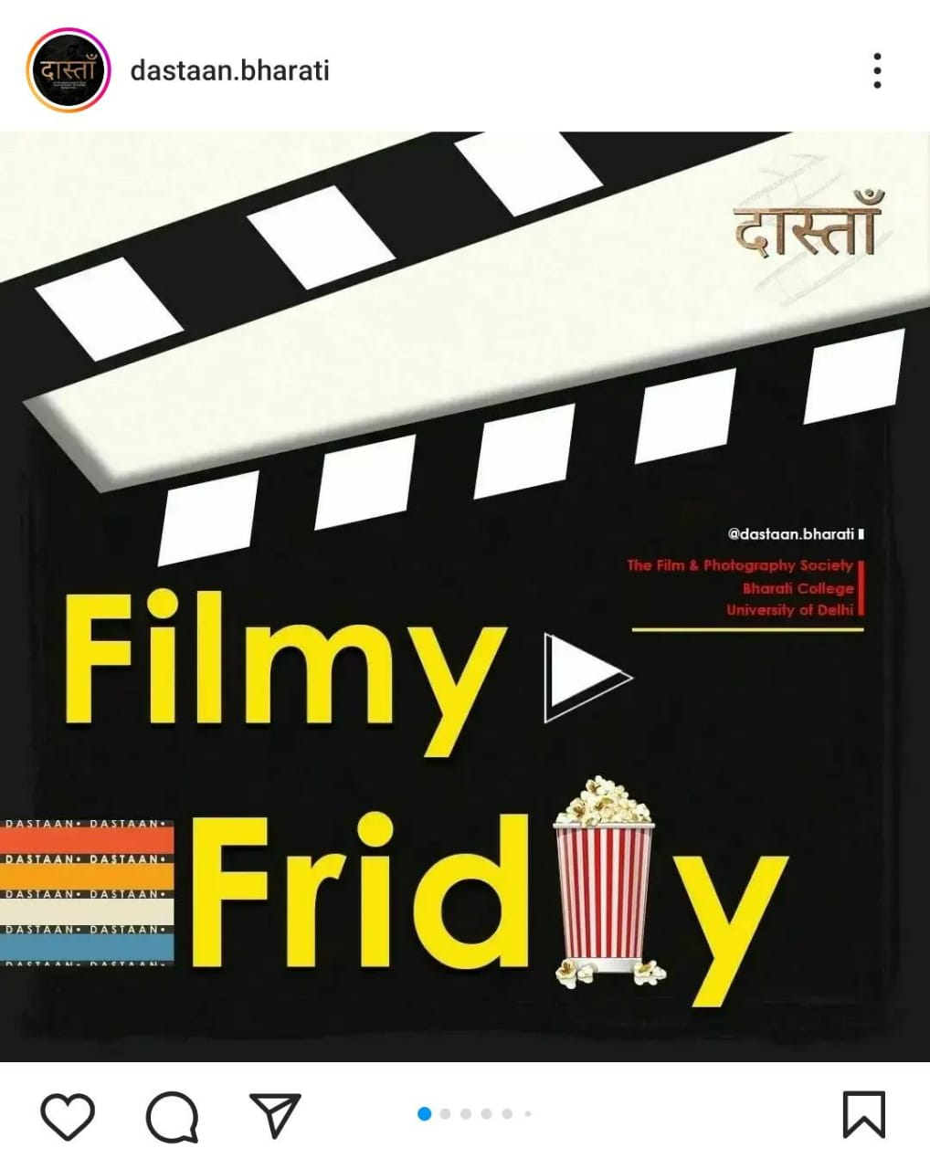 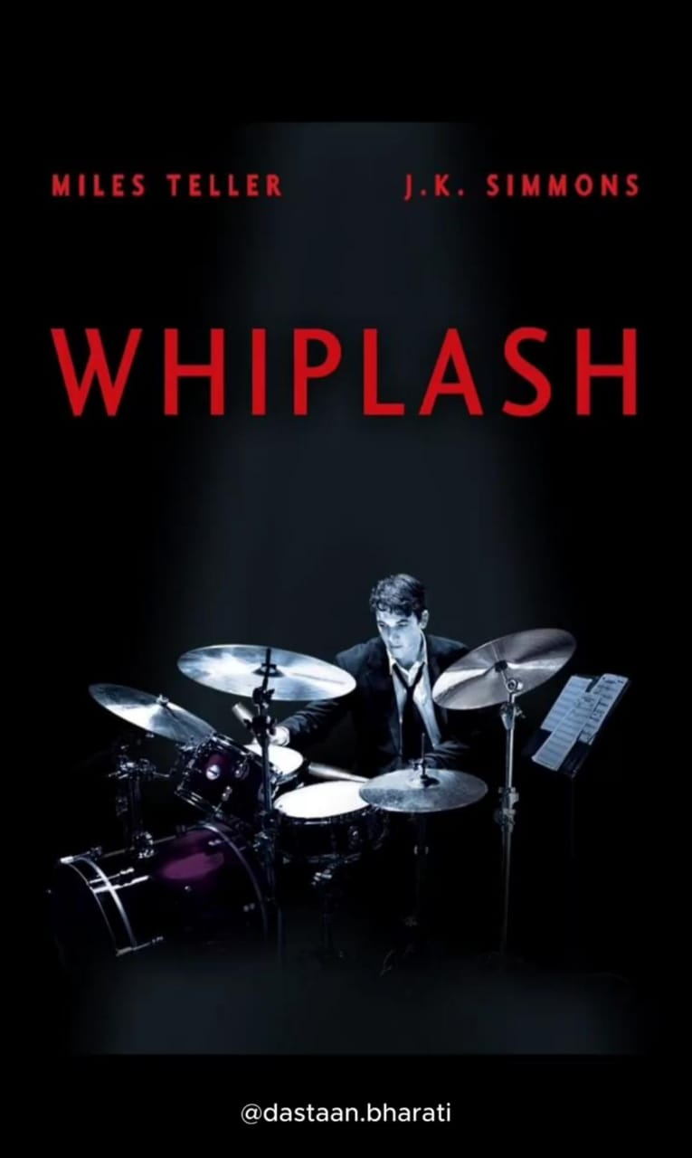

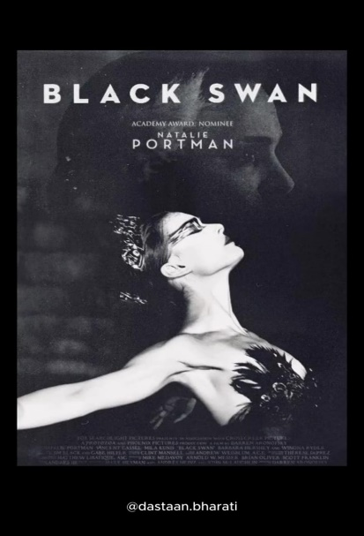 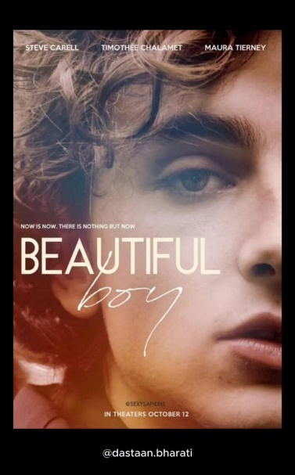 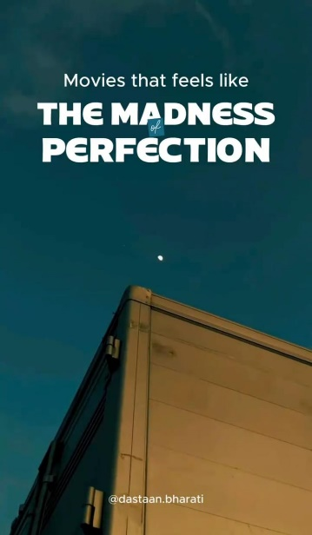

**SHORT FILM PRODUCTION**

Team Daastan's Remarkable Journey in Crafting "A Can's Journey" for the IIT Bombay Short Film Competition:

Creating a compelling short film script for a prestigious competition demands not only creativity but also collaboration, dedication, and adaptability. Team Daastan, hailing from Bharati College, affiliated to the University of Delhi, exhibited an extraordinary commitment to excellence in their entry titled "A Can's Journey" for the IIT Bombay Short Film Competition.

From the script's inception to its finalization, Team Daastan worked seamlessly to bring forth a narrative that not only entertained but also delivered a potent environmental message. The collaborative efforts were evident in the script's multifaceted journey, touching upon themes of environmental responsibility and the transformative power of individual actions. The dynamic nature of the creative process often necessitates quick thinking and on-the-spot adjustments. Team Daastan demonstrated their adaptability and creativity by incorporating on-the-spot edits and improvisations into the script. These spontaneous changes, whether in dialogue or scene composition, added depth and nuance to the narrative, showcasing the team's ability to think on their feet and enhance the overall quality of the script.

The visual appeal of a short film is often its most striking feature, and Team Daastan's cinematography team brought their vision to life with finesse. From the bustling city streets to the serene farmlands, the cinematography skillfully captured the essence of each scene, enhancing the emotional impact of the narrative. The team's keen eye for detail and creative use of angles contributed to the overall aesthetic quality of "A Can's Journey."

The success of any film script lies in the strength of its content, and Team Daastan's content team played a pivotal role in shaping the narrative of "A Can's Journey." The team's meticulous research and thoughtful consideration of environmental issues elevated the script beyond a mere story. It became a compelling vehicle for conveying a meaningful message about responsible choices and their impact on the world.

Team Daastan's success in crafting a memorable short film script can be attributed to the harmonious dynamics of the team. Each member, whether from the content, cinematography, or other departments, played a crucial role in the film's development. The overall synergy of the team allowed for a seamless integration of diverse skills and perspectives, resulting in a cohesive and impactful final product.

"Journey of a Can," the screenplay is a powerful narrative of the impact of human actions on the environment, focusing primarily on a seemingly insignificant soda can The story plays out circles the consequences of careful disposal, emphasizing the positive consequences of responsible choices, especially recycling The text thoroughly addresses issues of environmental responsibility, the consequences of negligence and the transformative power of individual behavior. It carries a strong message about the importance of recycling and healthy choices to improve the environment. The article effectively emphasizes the relationship between human behavior and its impact on the ecosystem. The screen’s visual appeal lies in its dynamic landscapes, from busy city streets to peaceful farmlands. The use of situations adds depth to the story, effectively emphasizing the bottle’s journey and encounter in society. A flashback scene at the convenience store and subsequent scene at the recycling factory helps tell the story by providing context and demonstrating the positive outcomes of responsible garbage disposal. "A Can's Journey" is a compelling piece of writing that skillfully combines storytelling with a strong environmental message. It encourages reflection on individual choices and their broader impact on the planet. The screenplay’s compelling narrative, coupled with its visuals, makes it a brilliant entry for the IIT Bombay Short Film Competition. It has the power to sensitize the audience and motivate them to make conscious decisions.

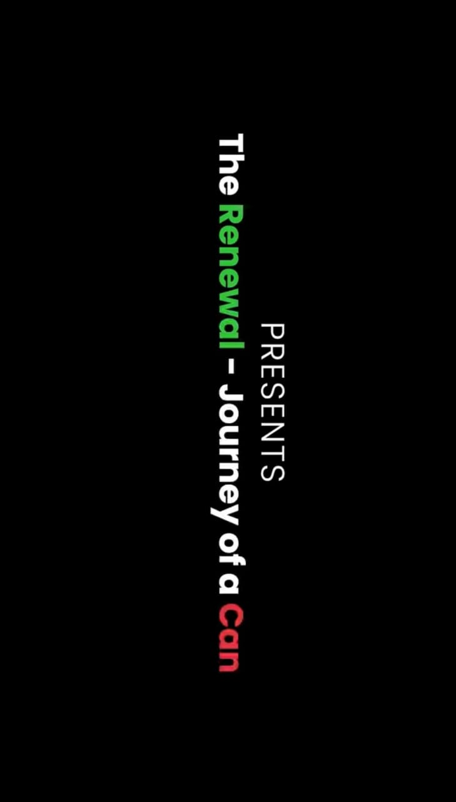

**Attendance Sheet**

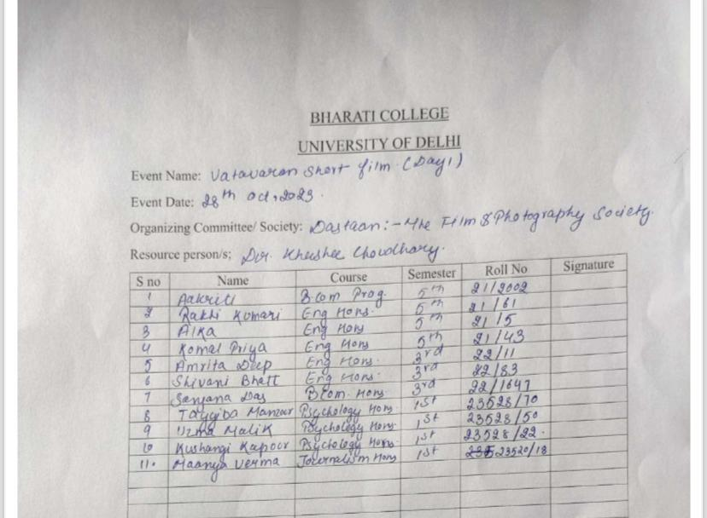

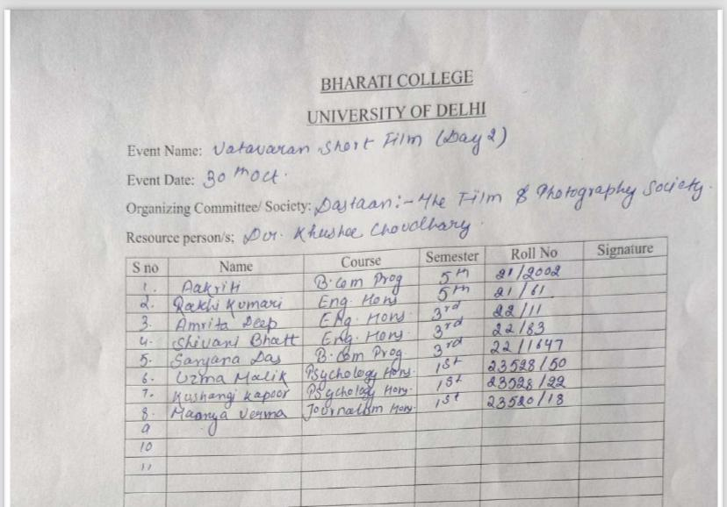

**MÉLANGE COVERAGE BY DASTAAN**

Date: 17th - 19th October, 2023

Redstockings literary Society of Bharati college organized their annual literary fest, “Mélange”, from 17th to 19th October, 2023. This three-day Literary Society Fest witnessed a close collaboration between Dastaan and the Redstockings literary society, the photography society, capturing the essence of each event through a skillful blend of pictures and videos. This report delves into the methodology employed by the photography team, highlighting their efforts to encapsulate the diverse range of activities that unfolded

during this engaging literary fest.

Methodology:

The Photography Society meticulously planned and executed their coverage strategy, ensuring that no event of the literary fest went unnoticed. Armed with cameras and equipment, the team strategically positioned themselves to capture key moments, ranging from quizzes and debate competitions to poetry slams and dramatic performances. The team adopted a multi-pronged approach, employing various styles of photography to suit the diverse nature of the events. Moreover, the use of both wide-angle and close-up shots added depth and variety to the visual narrative.

Video Recording:

In addition to photography, the Photography Society excelled in recording high-quality videos of the events. Equipped with video cameras, the team ensured that the audience could relive the festival's highlights through dynamic video content.

Coordination with Literary Society:

Close collaboration between the Photography Society and the Literary Society played a pivotal role in the success of the coverage. This collaboration fostered a seamless integration of visual storytelling with the overarching theme of the literary events.

Conclusion:

Dastaan's coverage of the three-day Literary Society Fest stands as a testament to their dedication and proficiency in capturing the vibrancy of intellectual gathering. Through a thoughtful combination of photography and videography, the team successfully crafted a visual narrative that not only documented the events but also conveyed the spirit and energy of the literary fest. Their commitment to excellence has undoubtedly enriched the festival experience for both participants and those who missed the event, leaving a lasting impression on the collective memory of the Literary Society.

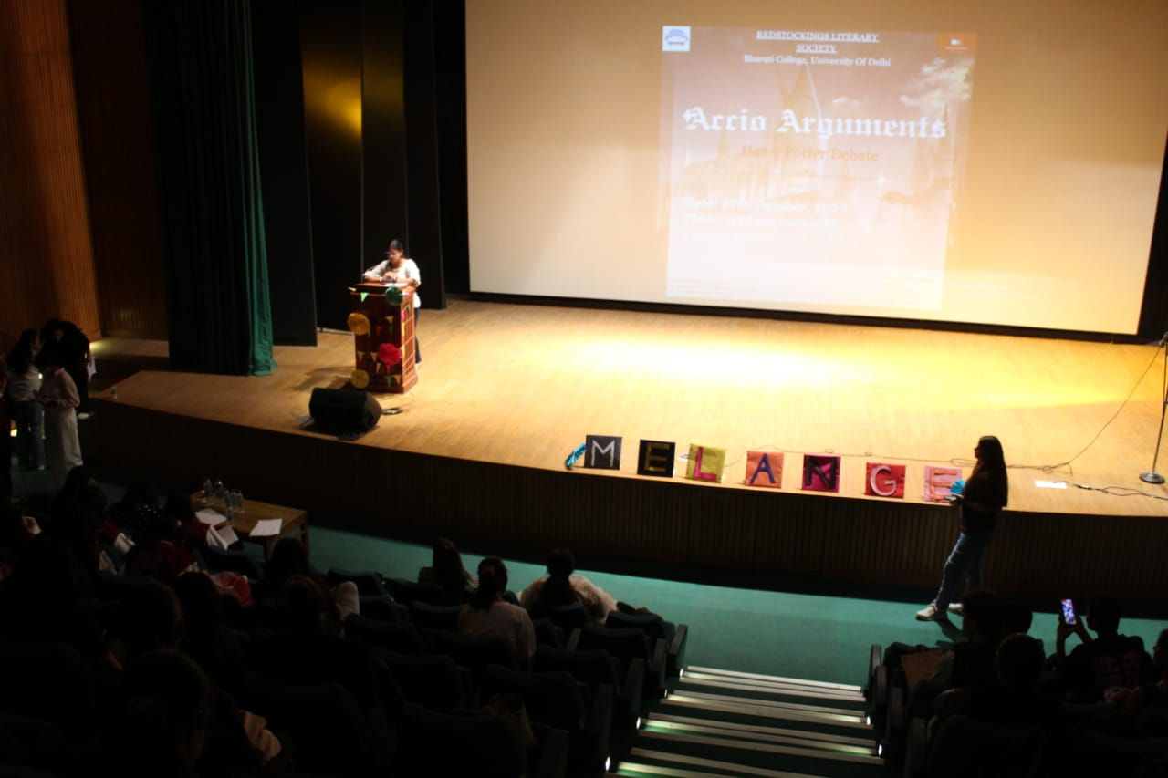

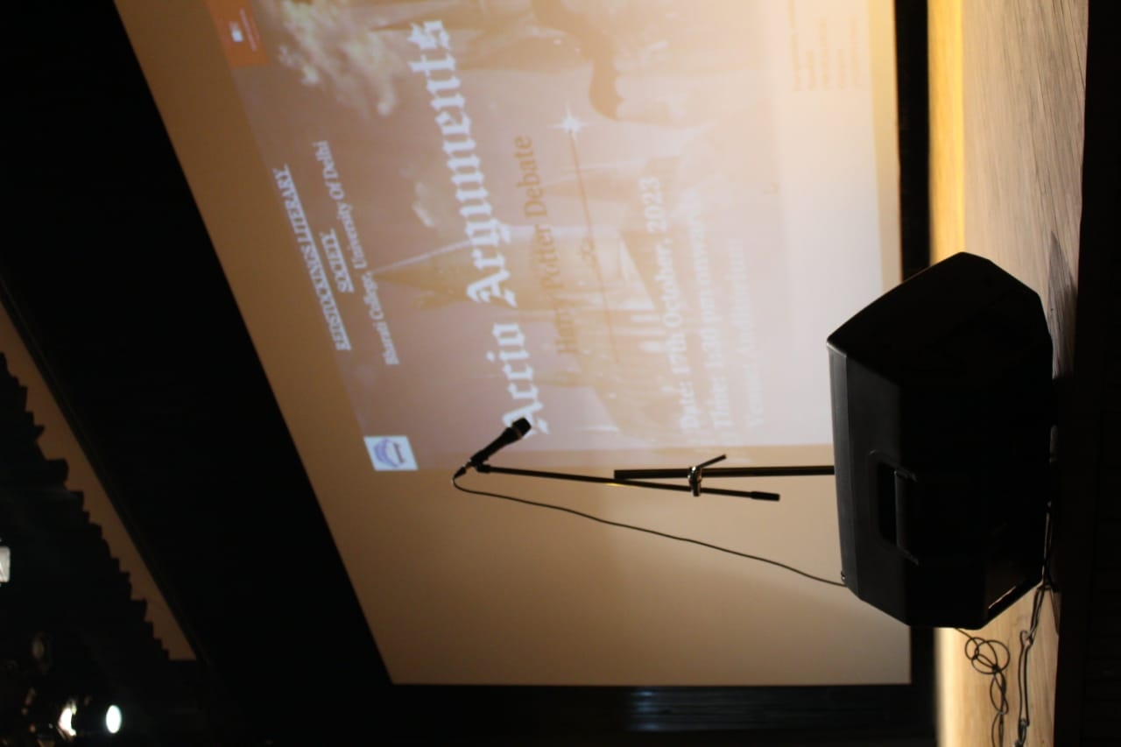

**Attendance Sheet**

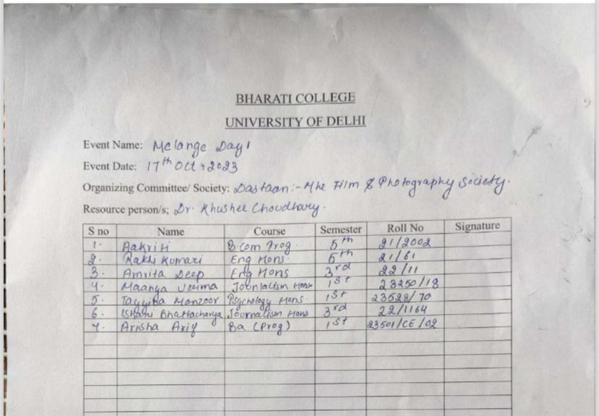

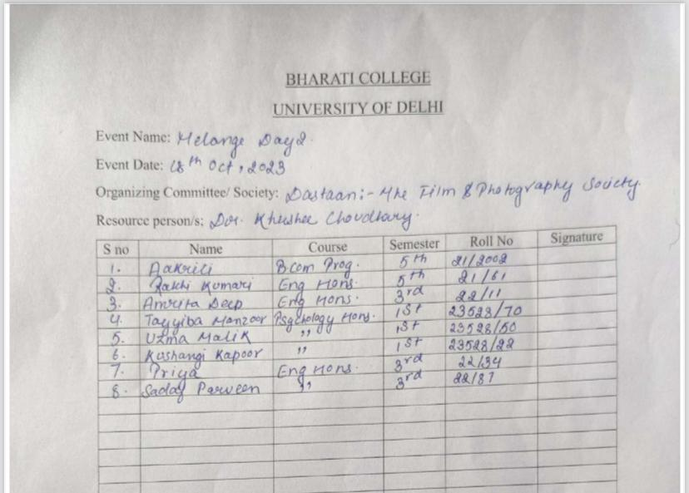

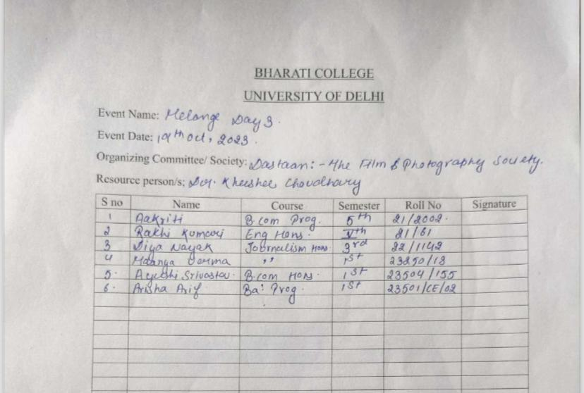

**CERTIFICATION CEREMONY**

Date: 12th October 2023

Dastaan, the film and photography society of Bharati College, organized a memorable Certification Ceremony on 12th October, 2023 to acknowledge the contributions and efforts of its members throughout the year.

The ceremony commenced with a heartwarming video compilation showcasing cherished memories and achievements of the society throughout the year 2023. The video included Dastaan's first photo walk to Chandni Chowk, the first IWD photoshoot and all the screenings Dastaan hosted in the college premises. Dr Khushee Chaudhary, the esteemed convener of Dastaan, graciously presented certificates of appreciation to all the dedicated members in recognition of their hard work and commitment. Each member was applauded for their unique contributions to the society's success.

Following the certificate distribution, the ceremony transitioned into a lively and festive atmosphere with entertaining games such as dumb charades and musical chairs. The celebration continued with a joyous cake cutting ceremony, symbolizing the sweet moments shared and the successes achieved by the society. Members enthusiastically participated in dancing, further adding to the celebratory mood of the event.

Hence, Dastaan's certificate ceremony was a joyful celebration of creativity. It honored the contributions of its members and highlighted the unity and spirit of the society. Here's to more memorable moments ahead in our shared journey of storytelling through film and photography.

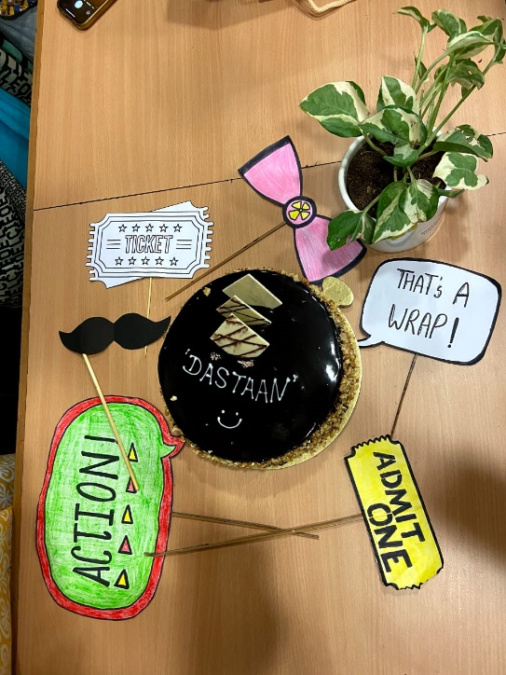 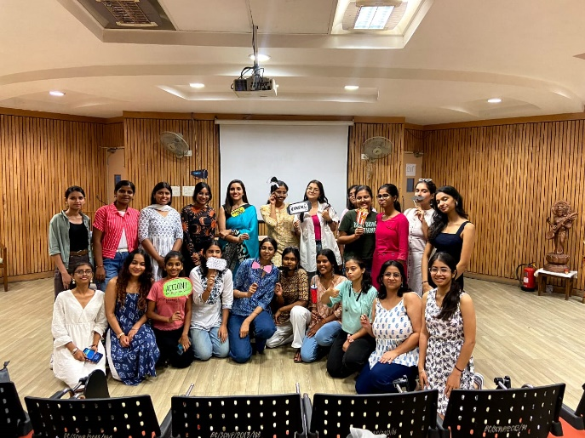

**FRESHER’S**

Date: 1st November 2023

The much anticipated yearly college festival for first-year students, "Parambhotsav" took place on November 1, 2023, and represented the topic of "Cultural Unity in Diversity - Bridging Gaps, Breaking Barriers" with a brilliant display of cultural expression. The Photography club of Bharati College, Dastaan, the storytellers behind the lens, captured the occasion, emphasising the students' mesmerising demonstration of togetherness and variety via their culture and diversity.

With competitors adorning the stage in a rainbow of traditional attire, the Pageant

Competition emerged as a symphony of customs. The participants' pride in their

ancestry and the overall beauty that resulted from the tasteful blending of many styles were captured by Dastaan's lenses as they focused on the subtle cultural differences. The resulting pictures served as a visual representation of the concept of the event, highlighting the harmony found in each traditional ensemble's uniqueness. The traditional clothing worn by freshmen represented their ethnic heritage. The exuberant movements of the performance of the Fashion Club of Bharati College, Elantre, were expertly frozen by Dastaan's lenses, preserving the elaborate details, vibrant colours, and rich textures of the various traditional attire. The topic was portrayed in a seamless manner by the visual narrative, which celebrated the distinct ethnic heritage that each participant brought to the runway and symbolised unification. Cultural performances added even more zest to the festival as students celebrated the diversity of cultures within the student body by taking the stage in a stunning assortment of traditional costumes.

Through the skillful documentation of these performances, Dastaan created a visual story that emphasised the beauty of unity found in the appreciation of various cultures by everyone involved. The cultural resonance of the festival was further enhanced by the Tabla Performance and a musical performance, which was complemented by the rhythmic beats, and cultural diversity. In addition to capturing the musical prowess, Dastaan's cameras also filmed the striking spectacle of students proudly dressed in their traditional attire, which added to the overall story of harmony through variety. The carefully curated photo collection reflected the first year class's diversity, talent, and joy through a visual journey. By using their cameras, Dastaan not only captured the festival but also developed into skilled storytellers, assembling a tale that will surely be treasured for years to come.

In short, Parambhotsav was an experience that Dastaan immortalised; it was more

than just an occasion. The team's commitment to perfection and skillful photography turned infrequent moments into priceless recollections, making the freshmen's introduction to college life more than just an occasion but also a sight to see and cherish.

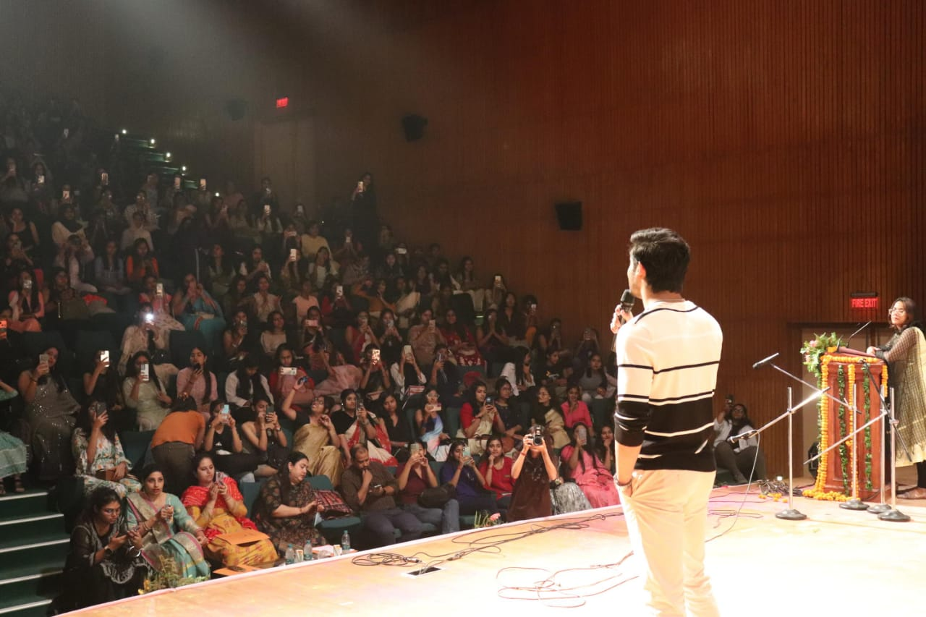

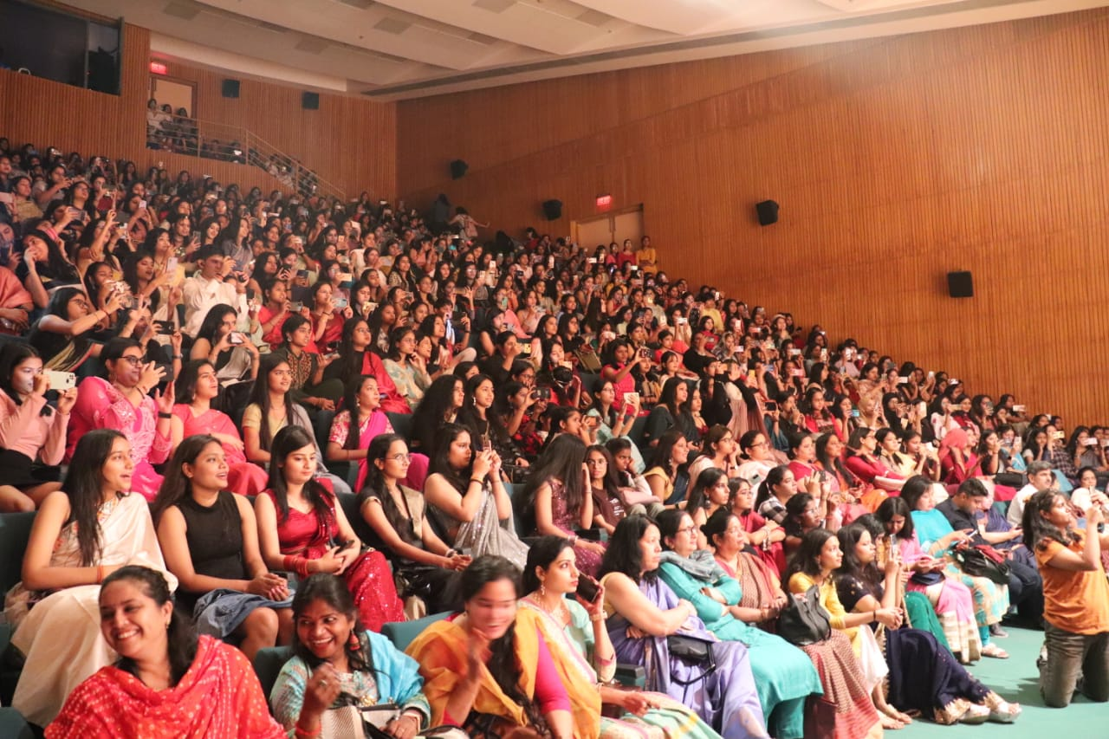

**Attendance Sheet**

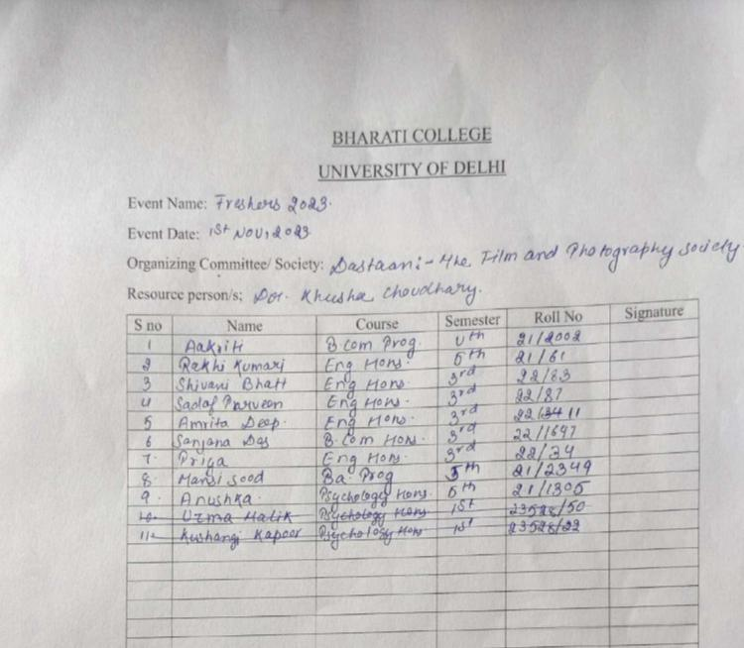

**KUDIYAN DI PHULKARI**

Date: December 29, 2023

Program: Event Coverage

On December 29, 2023, Bharati College's Punjabi department organised a lively celebration to honor Guru Nanak Dev Ji's Gurupurab. The event was full of cultural and spiritual importance, with various activities paying homage to Guru Nanak Dev Ji's teachings.

Professor Beant Kaur from Sri Guru Nanak Dev College gave an insightful lecture on "Guru Nanak Bani vich Narivaadi Chetna," delving into Guru Nanak Dev Ji's profound teachings. Her discourse shed light on the spiritual and humanitarian values advocated by Guru Nanak Dev Ji. A group of talented girls presented soulful Shabad Kirtan, showcasing their devotion and musical talents. Their beautiful singing resonated with the essence of Sikh spiritual traditions.

The celebration ended with a Langar, a communal meal symbolizing community and equality, principles dear to Guru Nanak Dev Ji. Dastaan, our photography team, captured the essence of each part of the celebration, preserving its cultural heritage and memorable moments. From capturing the emotions during the lecture to the joyful atmosphere of the Shabad Kirtan performance, and the heartwarming scenes at the Langar, our photographers ensured complete coverage.

The celebration served as a powerful reminder of Guru Nanak Dev Ji's timeless teachings and principles. Through meaningful discussions, soulful music, and shared meals, the event brought spiritual enrichment and cultural unity to all participants.

Dastaan's careful documentation captures the essence of this special occasion, preserving its significance for future generations

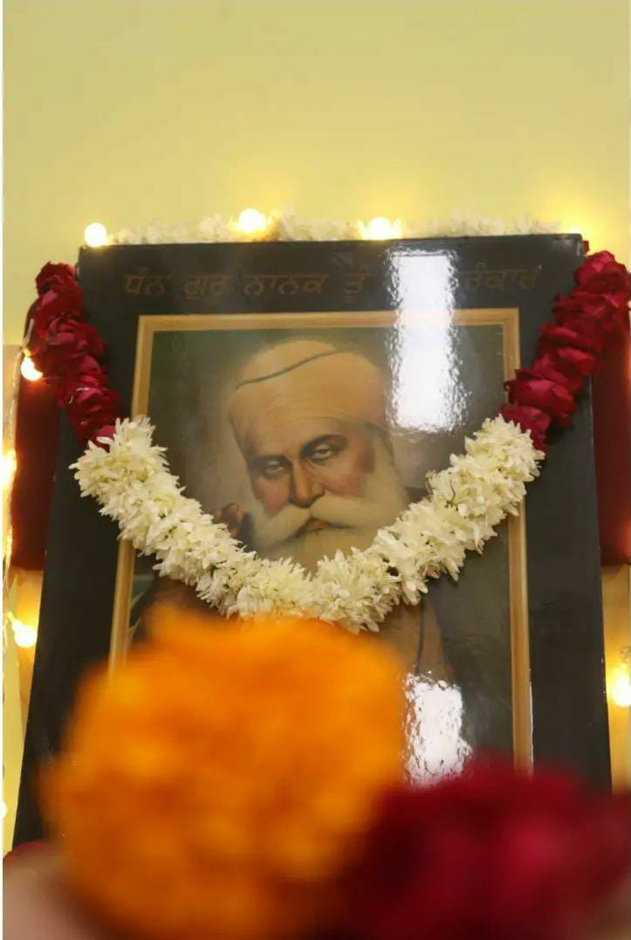

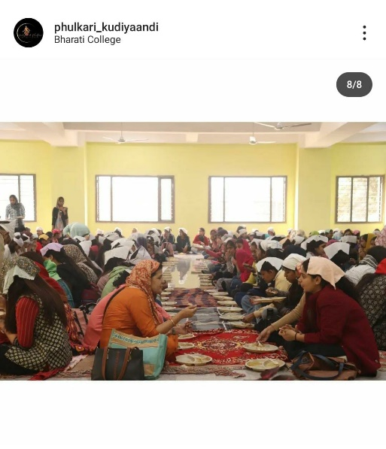

**PHOTOGRAPHY WORKSHOP**

Date: January 30, 2024

The Cultural Council of University of Delhi organised a four day Photography Workshop on Portraiture and Photography, which commenced from January 30, 2024. Sh. Nitin Rai Ji, an internationally acclaimed multi - gene photographer and the recipient of the Nikon International Award in 1993, aimed to enhance the skill set and creativity of the students under his guidance. A total of 29 students across Delhi University were a part of the workshop.

On the last day of the workshop, students were paired up to shoot portraiture as part of a special activity. Notably, the Cinematography Head of Dastaan, Uzma, participated in the activity and clinched the third prize. Their exceptional talent and creativity were evident in the captivating portraits they captured, showcasing their proficiency in both photography and cinematography.

The Photography Workshop organized was a resounding success, thanks to the active participation of students and the expert guidance provided by Sh. Nitin Rai Ji. The workshop not only empowered students with photography skills but also encouraged creativity and collaboration across disciplines.

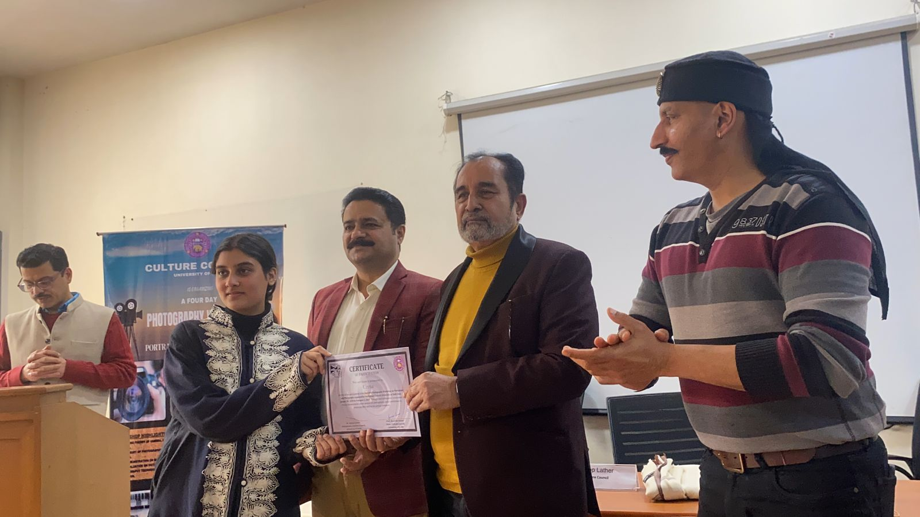

**DOCUMENTARY NOMINATION AND SHORT FILM**

"The Renewal Journey of a Can" is a short film directed by Dastaan, the film and photography society of Bharati College. The film has been nominated in the 'School and College Students' category at the prestigious 'Green Frames: Vatavaran Short Film Competition and Festival.' This competition focuses on environmental issues and sustainability, making it a significant platform for filmmakers advocating for ecological consciousness.

The film delves into the life cycle of a can, from its creation to its disposal. It highlights the impact of human actions on the environment, using the journey of the can as a metaphor for the larger ecological footprint of consumerism and waste. Through a poignant narrative, the film urges viewers to reflect on their consumption patterns and the importance of recycling and sustainability.

Being nominated in the 'School and College Students' category is a remarkable achievement for Dastaan and Bharati College, showcasing their talent and commitment to environmental advocacy. The film is currently under review by the award jury, who will select the winners. The awards ceremony is scheduled for March 5, 2024, in Bhopal, where the winners will be honored.

The nomination itself is a testament to the film's impact and relevance in addressing environmental concerns. It not only raises awareness but also inspires action towards a more sustainable future. The recognition at 'Green Frames: Vatavaran Short Film Competition and Festival' will further amplify the reach of the film and its message, potentially sparking conversations and initiatives for environmental conservation.

"The Renewal Journey of a Can" stands as a powerful narrative advocating for environmental stewardship. Its nomination at 'Green Frames: Vatavaran Short Film Competition and Festival' highlights the importance of using art and storytelling to address pressing issues like sustainability. Dastaan and Bharati College's work exemplifies the potential of young filmmakers in driving positive change through their craft.

**Capturing Bollywood's Essence through Eras**

Date: February 20, 2024

Program: Bollywood Era Photoshoot

On February 20, 2024, Bharati College's Photography Club, Dastaan, orchestrated an engaging affair titled "Bollywood Era Photoshoot." The occasion served as a platform for members to showcase their imaginative flair and enthusiasm by embodying various periods of Bollywood cinema.

Garbed in thoughtfully curated ensembles, the participants adeptly recreated the fashion of diverse Bollywood epochs. Paying meticulous attention to hair and makeup, they authentically captured the essence of each era.

Throughout the photoshoot, a palpable spirit of collaboration permeated among the club members. They offered assistance with costume adjustments and exchanged creative suggestions for poses, enriching the collective experience.

Helmed by accomplished photographers within Dastaan, the event showcased the club's dedication to artistic prowess. Through adept framing and lighting techniques, they immortalised the timeless allure of Bollywood on film.

Dastaan's Bollywood Era Photoshoot celebrated the cinematic heritage of India while spotlighting the talent and camaraderie within the club. The event left behind a captivating collection of images that stand as a testament to Bollywood's enduring legacy.

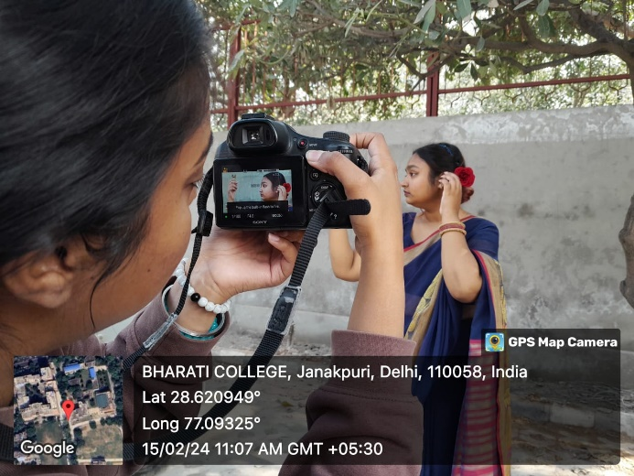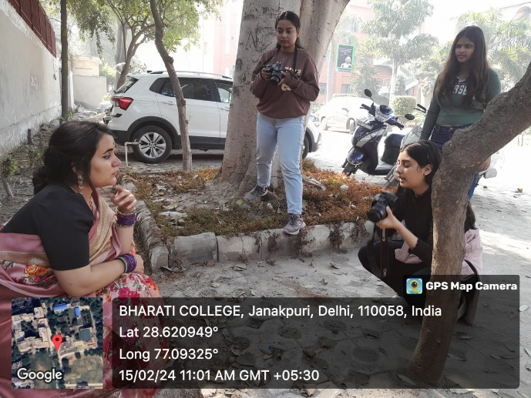

**Attendance Sheet**

|  |  |  |
| --- | --- | --- |
| Name | Roll Number | Course |
| Sanjana Das | 22/1647 | Bcom Hons |
| Malvika | 21/2345 | BA prog History political science |
| Uzma | 23528/50 | Psychology Hons |
| Aakriti | 21/2002 | Bcom Prog |
| Shivani Bhat | 22/83 | English Hons |
| Rakhi Kumari Mahato | 21/61 | English Hons |
| Arisha | 23501/ce/02 | Ba prog |
| Kushangi Kapoor | 23528/22 | Psychology Hons |
| Harshita rana | 22/1115 | Journalism dept |
| Prajakta | 22/1120 | Journalism dept |
| Drishi Chopra | 21/26 | English honors |
| Sana Siddique | 21/489 | History Hons |
|  |  |  |

**EXPLORING DELHI’S CULTURAL TREASURES: A PHOTOGRAPHIC JOURNEY**

Date: February 17, 2024

Program: Photowalk at Lodhi Garden and Lodhi Art District

Our expedition began in the historic neighbourhood of Jor Bagh Metro Station, where the team embarked on a picturesque journey through Delhi's cultural gems. Led by photography expert Varun Varma, our cinematographers were primed to capture the essence of the city's vibrant landscape.

As we strolled towards Lodhi Garden, the perfect setting for our creative endeavour, the weather bestowed upon us ideal conditions for capturing stunning visuals. Varun Varma the photographer who accompanied us shared invaluable insights with our team, offering guidance on advanced photography techniques to elevate our craft.

Lodhi Garden welcomed us with open arms, adorned with the mesmerizing hues of blooming tulips - a spectacle of nature's beauty in full bloom. Amidst the lush greenery, families, children, and tourists alike revelled in the tranquillity of the surroundings, while the majestic Sikander Lodi's tomb provided a timeless backdrop for our photographic pursuits.

A serendipitous encounter with a delightful couple led to a heartwarming exchange, as they graciously offered to immortalize our team's camaraderie with a candid snapshot.

Varun Varma's expertise continued to enrich our experience as we ventured towards the fort, where he imparted invaluable lessons on harnessing the nuances of natural light and mastering the fundamentals of photography. From understanding ISO and aperture to mastering shutter speed and exposure, our journey served as a beginner's guide to unlocking the full potential of our cameras.

The fort's vibrant ambiance proved to be a magnet for creativity, with Kathak dancers from IILM capturing the essence of their art amidst the ancient architecture. Meanwhile, the fort provided a captivating backdrop for pre-wedding photoshoots, underscoring its timeless appeal as a haven for romance and celebration.

Our expedition culminated in the vibrant Lodi Art District, where the streets came alive with a kaleidoscope of colours and creativity. The walls adorned with vibrant murals served as a canvas for artistic expression, encapsulating Delhi's rich cultural tapestry in every brushstroke.

As the sun set on our photographic odyssey, we bid farewell to Delhi's cultural treasures, enriched by the experiences and memories captured through the lens of our cameras. In this journey of discovery, each frame serves as a testament to the enduring beauty and spirit of India's capital city.

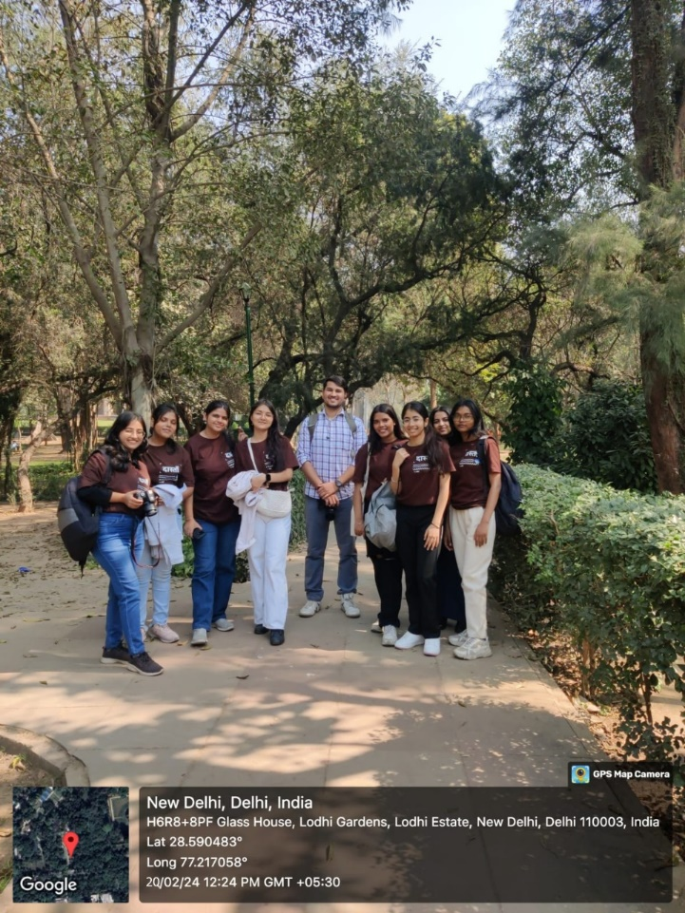

**Attendance Sheet**

|  |  |  |
| --- | --- | --- |
| Name | Roll Number | Course |
| Rakhi Kumari Mhato | 61 | English Hons |
| Malvika | 21/2345 | BA Prog (History + Pol science) |
| Maanya | 23520/18 | Journalism Hons |
| Komal Priya | 43 | English Hons |
| Prerna Jha | 1041 | Sanskrit Hons |
| Jiya | 35 | English Hons |
| Swati Bansal | 23503/148 | BCom |
| Kushangi Kapoor | 23528/22 | Psychology Hons |
| Diya Nayak | 22/1142 | Journalism Hons |
| Aakriti | 21/2002 | Bcom Prog |

**ALUMNI MEET**

Alumni Reel Shoot by Dastaan on Female Friendships

Date: 24th February 2024

Dastaan, the film and photography society of Bharati College, organized an alumni reel shoot on the theme of female friendships. The event aimed to explore and celebrate the complexities, joys, and challenges of women’s friendships through the lens of alumni who have experienced and reflected upon these relationships.

The alumni reel shoot featured a diverse group of former students who shared their personal stories, anecdotes, and reflections on female friendships. The participants discussed various aspects of their friendships, including how the bonds were formed, the challenges they faced, and the support they provided to each other.

Alumni shared touching and emotional stories about their friendships, highlighting the deep connections and support system that female friendships provide. It aimed to capture the essence of female friendships that blossom during college years and often transcend time and distance. By featuring Bharati College alumni, Dastaan intended to showcase the lasting connections forged within the college walls and inspire current students.

The reel had a profound impact on both the participants and the audience. It served as a reminder of the importance of female friendships in our lives and the power of these relationships to shape and enrich our experiences. It captured the essence of female friendships that blossom during college years and often transcend time and distance. By featuring Bharati College alumni, Dastaan intended to showcase the

lasting connections forged within the college walls and inspire current students.

**Attendance Sheet**

|  |  |  |
| --- | --- | --- |
| Name | Roll Number | Course |
| Sanjana Das | 22/1647 | Bcom Hon |
| Uzma Malik | 22528/50 | Psychology hons |
| Ariha arif | 23501/ce/02 | Ba prog computer application + eco |
| Kushangi kapoor | Psychology hons | 23528/22 |
| Shivani bhatt | 22/83 | English hons |
| Tayyiba manzoor | 23527/70 | Psychology hons |
| Maanya verma | 23520/18 | Journalism hons |

**KHWABON KI DILLI 2.0**

Date: March 14, 2024

Dastaan, the Film and Photography Society of Bharati College, orchestrated an engaging On-the-Spot Photography Competition, dubbed "Khwabon Ki Dilli 2.0", during the Annual College Fest, Abhivyakti '24, in Bharati College. Themed "Vogue Visions: Elegant Encounters in Every Frame," the contest spurred participants to capture magazine-worthy images worthy of fashion magazines.

Participants were encouraged to channel their inner fashion photographers and compose shots that emulate the style and elegance of a fashion editorial. The theme prompted contestants to let their creativity shine, framing each image to perfection and showcasing models in their most glamorous and captivating poses.

Participants were able to hone their photographic abilities and try out different fashion photography approaches thanks to the tournament. Each picture showcased the various viewpoints and skills of the subjects, from glittering stances to creative compositions. The competition promoted a culture of artistic expression and displayed the talent of students from various colleges.

Photographers were able to refine their photographic techniques, try out different looks, and create visually arresting images thanks to the competition. The challenge was enthusiastically accepted by the participants, who produced a multitude of creative photos. All in all, the occasion showcased the skill and imagination of everyone involved, adding to the lively atmosphere of Abhivyakti '24.

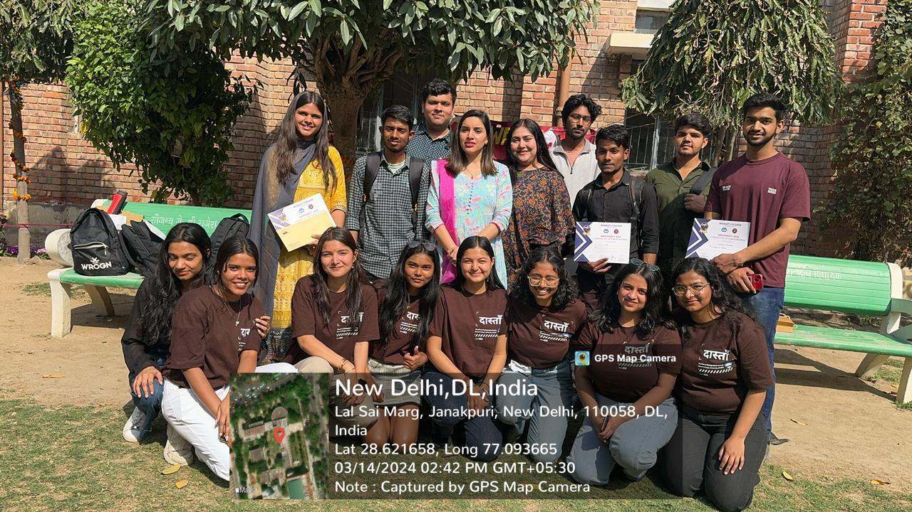

**HOLI CELEBRATION OF FACULTY**

Date: 23rd March

On 23rd March, Bharati College's seminar room was transformed into a colorful spectacle as the Dastaan Film and Photography Society captured the vibrant spirit of Holi. The event, organized for the staff, was a delightful affair marked by joyous revelry and enthusiastic participation.

The highlight of the event was the presence of the college principal, who not only graced the occasion but also delighted everyone by singing some traditional Holi songs. Her participation added a personal touch to the celebration, creating a warm and festive atmosphere.

Adding to the charm of the event, several teachers brought their children along, infusing the gathering with youthful energy and innocence. The kids enthusiastically participated in the festivities, spreading joy and laughter all around.

The Dastaan Film and Photography Society did a commendable job of capturing the essence of the event. Their lenses captured the riot of colors, the playful exchanges, and the genuine camaraderie that characterized the celebration. The photographs and videos captured by them are sure to become cherished memories for the staff members.

Overall, the Holi celebration event covered by Dastaan was a resounding success. It not only brought the staff together in a spirit of camaraderie but also provided a platform for them to unwind and enjoy themselves. The event was a testament to the inclusive and festive spirit of Bharati College, and a fitting tribute to the festival of colors.

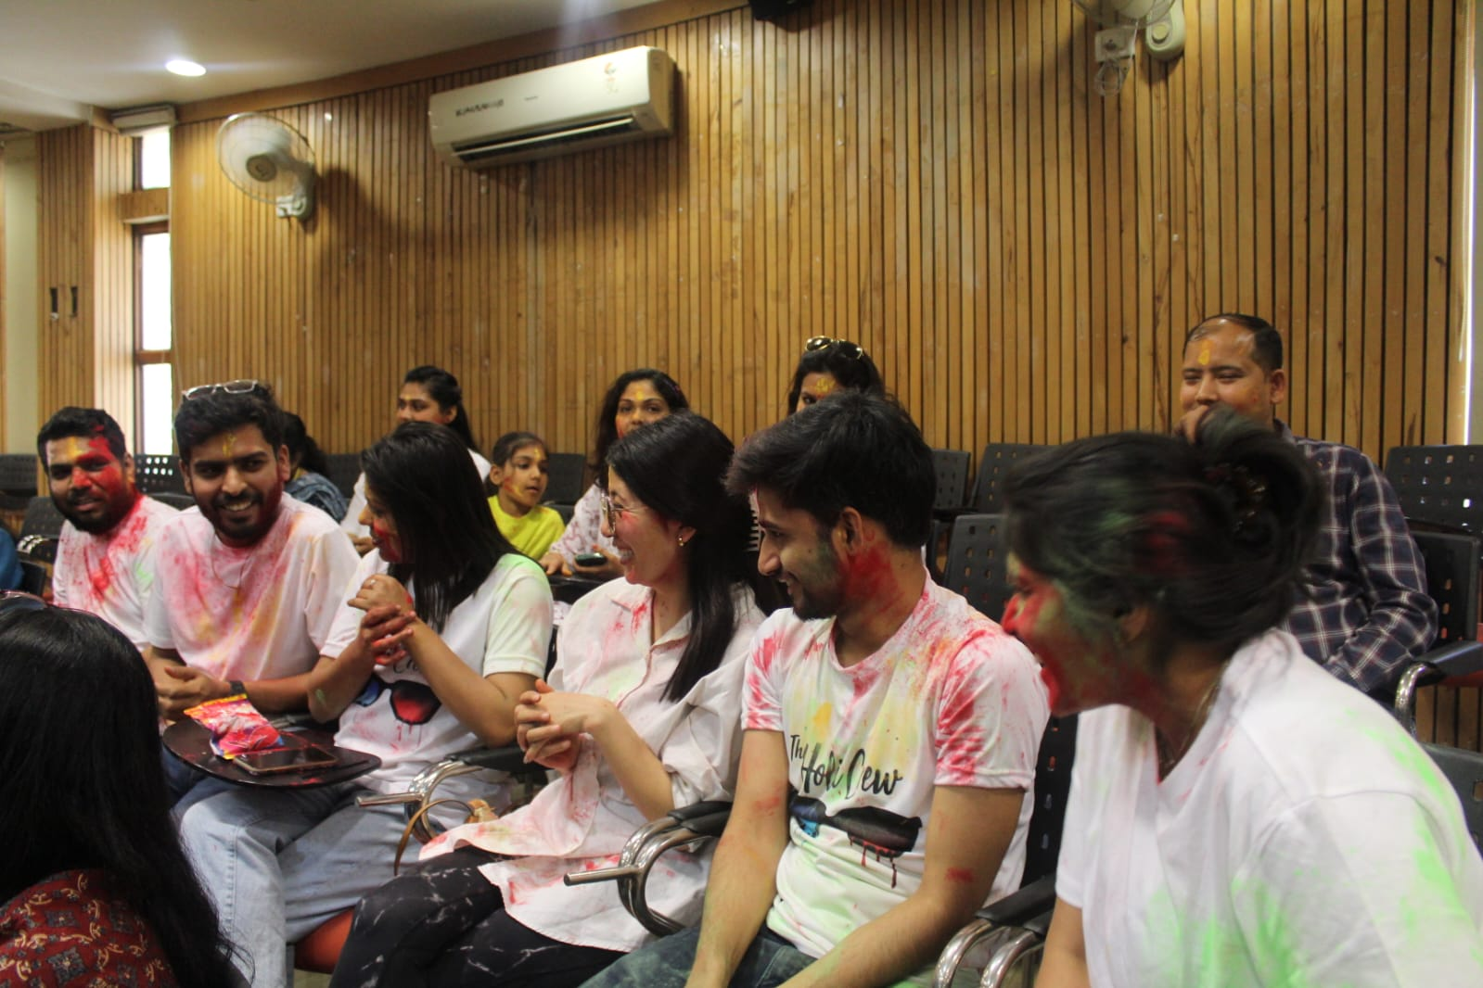

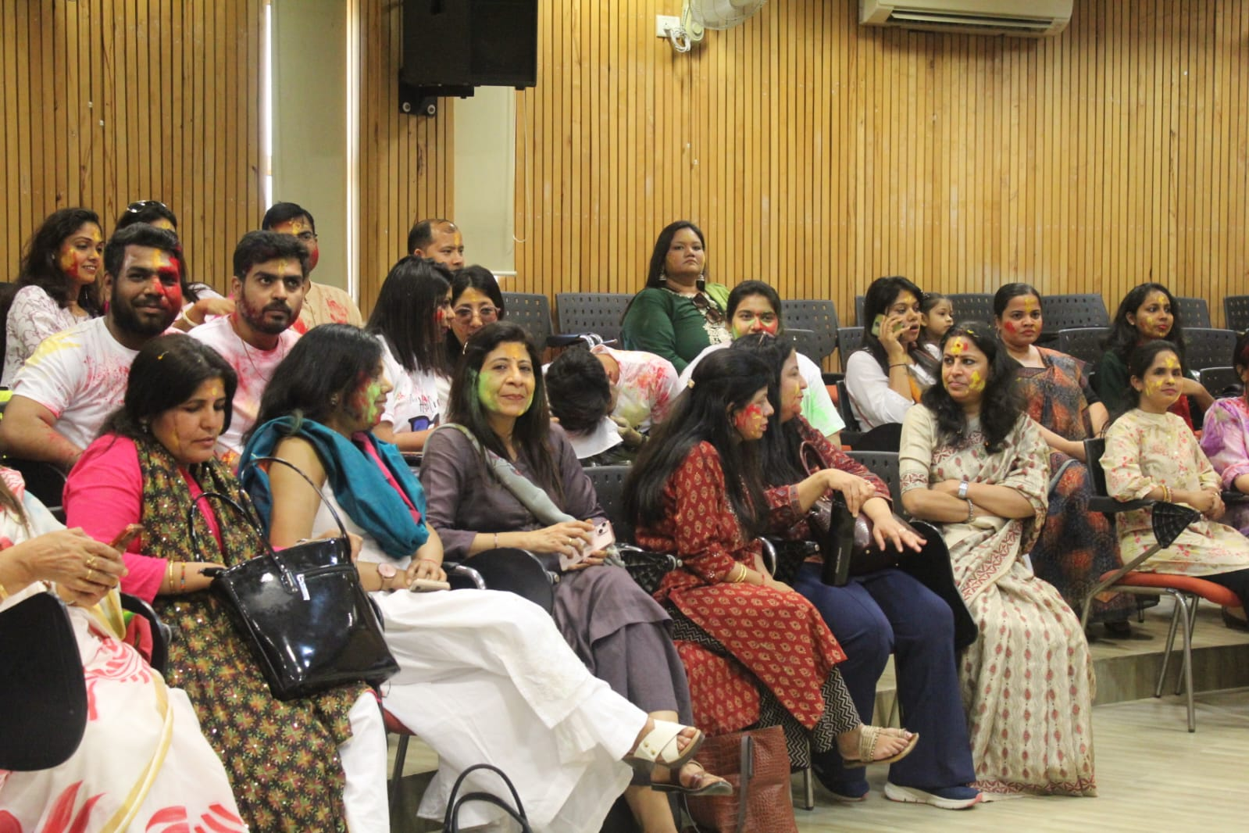

**Report on Movie Screening of 'Fire 1996' by Dastaan and IRIS**

Date**:** 9th October

Dastaan, the film and photography society of Bharati College, in collaboration with IRIS, the queer collective, organized a movie screening of 'Fire 1996' on 9th October at 2 pm in the seminar room. The event aimed to explore themes of love, identity, and acceptance, as portrayed in the film.

'Fire 1996,' directed by Deepa Mehta, is a groundbreaking film that challenges societal norms and explores the complexities of human relationships. The movie tells the story of two women, Radha and Sita, who find solace and companionship in each other's company, eventually developing a deep and meaningful relationship that defies traditional norms.

The screening was well-attended, with a diverse audience comprising students, faculty, and members of the queer community. Before the screening, members of IRIS provided a brief introduction to the film, highlighting its significance in the context of queer cinema and its impact on LGBTQIA+ representation in Indian cinema.

The film screening was followed by a discussion session, where attendees had the

opportunity to share their thoughts and reflections on the movie. The discussion touched upon various aspects of the film, including its portrayal of love and desire, its exploration of societal taboos, and its relevance in today's context.

Overall, the movie screening of 'Fire 1996' organized by Dastaan and IRIS was a thought-provoking and engaging event. It provided a platform for meaningful discussions and raised important questions about love, identity, and acceptance. The event was a testament to the inclusive and progressive ethos of Bharati College, and a celebration of diversity and representation in cinema.

**CALENDER PHOTOGRAPHS**

The photography task assigned to Dastaan reflects a commendable initiative aimed at capturing the essence of each month through a single photograph. This practice, which commenced in the middle of March, has been executed with dedication and creativity by the team.

Since its beginning, the practice has been carried out effectively, with each month witnessing the planning and execution of a photograph that encapsulates the unique aspects of that particular month. Our photographers have displayed remarkable creativity and dedication in exploring various angles, lighting conditions, and compositions to ensure that the final photograph not only reflects the month but also resonates with the college community.

Feedback from our viewers has been overwhelmingly positive, with the photographs being widely shared across social media platforms and communication channels. The initiative has garnered appreciation for its ability to capture the spirit of each month and showcase the vibrant atmosphere of Bharati College. The photographs serve not only as visual representations of time but also as artifacts of the college experience, evoking memories and emotions among students.

Looking ahead, there is potential to further enhance the impact by encouraging greater student involvement in selecting themes and ideas for each month's photograph. Additionally, promoting student participation in capturing the photographs could foster a sense of ownership and pride in the initiative, further strengthening its success.

The monthly photography task undertaken by Dastaan has proven to be a successful endeavor in representing each month through a single photograph. The dedication, creativity, and enthusiasm demonstrated by the team have contributed to the initiative's effectiveness and positive reception. As such, it stands as a testament to the power of art and creativity in enriching the college experience and fostering a sense of community and belonging.

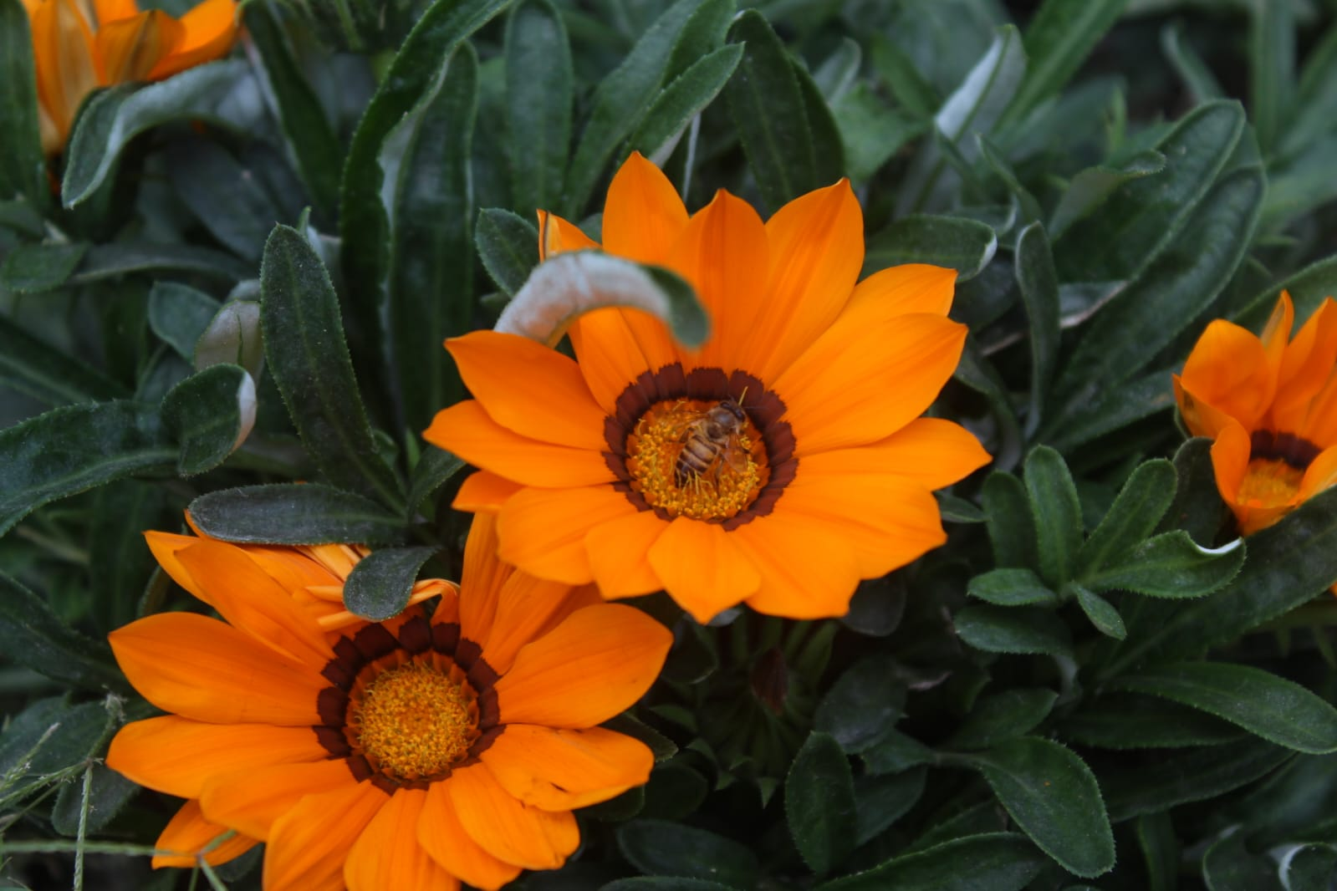

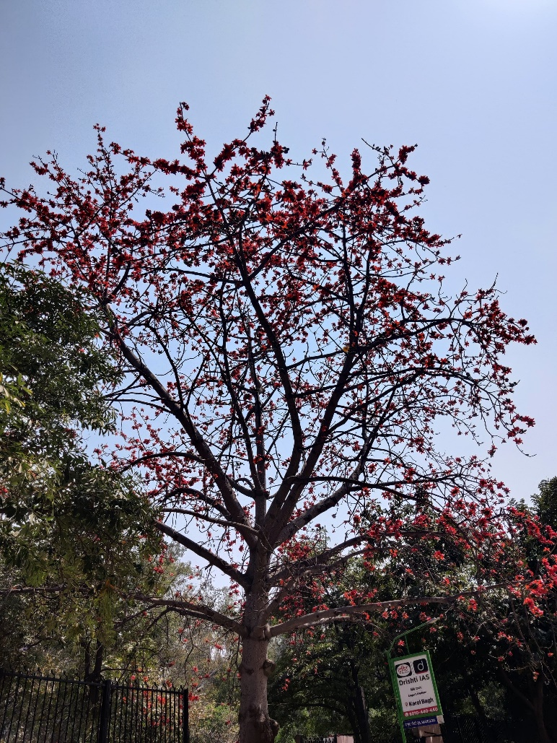

**JAI BHIM: MOVIE SCREENING**

Date: 24 August 2023

Jai Bhim was featured on 24 August 2023 in the seminar room, 12 pm onwards with a film review. It is a masterpiece from T.J. Gananeval who is known for his passion and patience in creating a biopic so commendable. The audience enjoyed it invariably. Tribal life and their rights are cleverly delivered and are shown with great craft and intensity which was the striking feature of the movie.

Every scene of the movie is crafted with excellence. The movie showcases the true history of our nation which includes the struggle of Dr B.R. Ambedkar for the betterment of “oppressed” classes.

It was a good initiative taken up by Daataan to move to different genres and it was a unique approach because very few people know about the tribal communities. By screening this biopic, many non fiction readers connect with the thought and idea of Bhim.

The movie was mesmerizing and amazing, the acting of Suriya made it even more compelling. It depicts all aspects of Dr. Ambedkar's life and his achievements.

It has been studied that the real case upon which the movie is based was dragged on for more than ten years. Although, it has been shown for about a year in the movie.

And it has been stated that after the film's release actor Suriya received many death threats from various communities in India. Various communities criticized that actor/producer Surya had deliberately manipulated the real events in his film, in view of making a clash between "Vanniyars" and "Irulars" communities. After receiving death threats, Surya was provided special police protection at his residence.

The screening was a success, multiple students and teachers attended it and were moved after witnessing the scenarios shown in the movie.

**INTERNATIONAL CONFERENCE**

Coverage: Auditorium

Date: March 12 & 13, 2024

The International Conference on "The Increasing Role of Russian Language in the BRICS and SCO Countries: Education, Language, and Culture" was a collaborative effort organized by the Department of Slavonic & Finno-Ugrian Studies, North Campus, Department of English, and Department of Sociology of Bharati College. The event was held in collaboration with the Embassy of the Russian Federation in New Delhi.

The conference aimed to explore the growing significance of the Russian language in the BRICS and SCO countries. It focused on various aspects such as education, language, and cultural exchange, highlighting the role of language as a bridge between nations.

It was a dynamic gathering that celebrated cultural diversity and academic exchange. Colourful performances by students of Bharati College and Russian performers added vibrancy to the event, showcasing the rich cultural heritage of both nations. Eminent diplomats and scholars delivered enlightening speeches, emphasising their role in fostering global cooperation.

Throughout the conference, Dastaan, the Photography Society of Bharati College, served as the lens capturing the essence of the event. Through their keen eye and creative vision, Dastaan members meticulously documented every moment, from the captivating performances to the insightful discussions. Their photographs not only preserved the memories of the conference but also conveyed its spirit to a wider audience.

By providing a visual narrative of the event, Dastaan became an integral part of the conference, immortalising its highlights and contributing to its legacy. Their efforts ensured that the impact of the conference transcended its physical boundaries, reaching and inspiring individuals far beyond the event's duration.

