CHILMAN- The Dramatics Society

**[About society]**

The Dramatics Society of the College became active in the year 1999 under the RedStockings Society of the Department of English. In the year 2001, it became an independent body under the name Chilman, no longer limited to one department but open to all students of

the College. The word Chilman means screen or drapes. Since its inception, Chilman has done significant work and has given a new impetus to the theater in the College.

**[Team Intro]**

Convenor- Sonali Jain

Co- Convenor- Mala Rani

President- Drishti Rao

Vice President- Manisha Sharma

**[Aim]**

The objective of the society is to foster talent for theater and to promote in the College a

vibrant theater culture. For this purpose, it stages productions, mimes, and mono-acting

performances, participates in competitions, and the like. Its activities can be categorized

under three heads: theatre workshops, major productions, and minor and experimental

productions.

**[Vision]**

Theater groups in our society play an important role in promoting social discourse and potential social change. Theater and performance are cultural phenomena for self-expression and the process of mirroring in society. Through them, we can represent social issues and

concerns, and come together as a community attempting to move toward social change. University spaces, they provide an opportunity to students, boost their morale, enhance communication skills, and raise appreciation for various art forms existing in the world.

**[Mission]**

Through society, we wish to represent social issues and concerns and come together as a community attempting to move toward social change. In the university space, we wish to provide an opportunity to students, boost their morale, enhance communication skills, and raise appreciation for various art forms existing in the world.

**[Achievements and Initiatives]**

From 2023-24 Chilman has done numerous productions as mentioned below:

* In January 2023, Chilman participated in the preliminary round of IIT kanpur and IIM Lucknow, where we submitted a short online production namely "**Devi**," which was a short play centered upon sexual harassment.
* In February 2023, Chilman got shortlisted for the stage play competition Antarnaad,organized by IIM-Lucknow, where the team performed the play on “**HIV AIDS**.”
* In April 2023, Chilman participated in an online film making competition on the theme "***Light and Darkness*,**" organized by Delhi College of Arts and Commerce, DU.
* In October 2023, Chilman participated in **Inter College mime Competition** organized by Cultural Council, University of Delhi and Rajdhani College, in which the team secured **1st Position.** Furthermore, Chilman also performed a play namely “***Swarnim Bharat Ek Yatra”***directed by NSD director, Yogesh Bhatt, in the G20 event organized by Cultural Council, University of Delhi and Bharati College.
* In February 2024, Chilman got the opportunity to participate in the **37th Inter-University North West Zone Competition in the Mime Category**, organized by Maharshi Dayanand University, Rohtak.
* In March 2024, Chilman shot a production on Sadat Hasan Manto's short story “***Khol Do***”, which was performed in the Annual Fest, Manch Utsav and got the recognition of the Best Production. Chilman also organized a stage play Competition namely "**Manch Utsav**," in the Annual Fest Abhivyakti, where the dramatics societies of colleges across delhi participated.
* In April 2024, Chilman participated in the **Ad Mad Competition**, organized by Dyal Singh College (Evening), Delhi University. Additionally, Chilman also participated in various **ono Acting Competitions** organized by Bennett University, Maharaja Agrasen College and Institute of Home Economics.

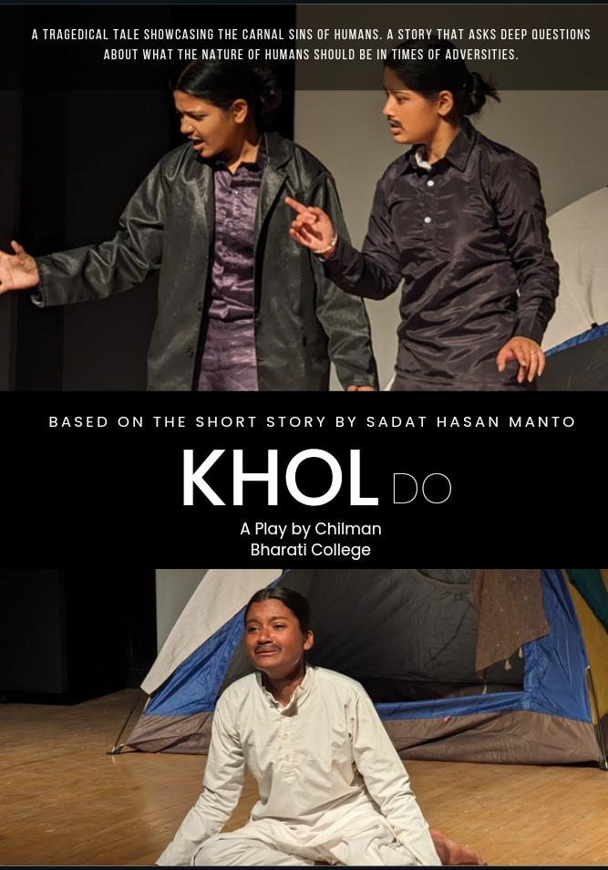

ANNUAL PRODUCTION POSTER

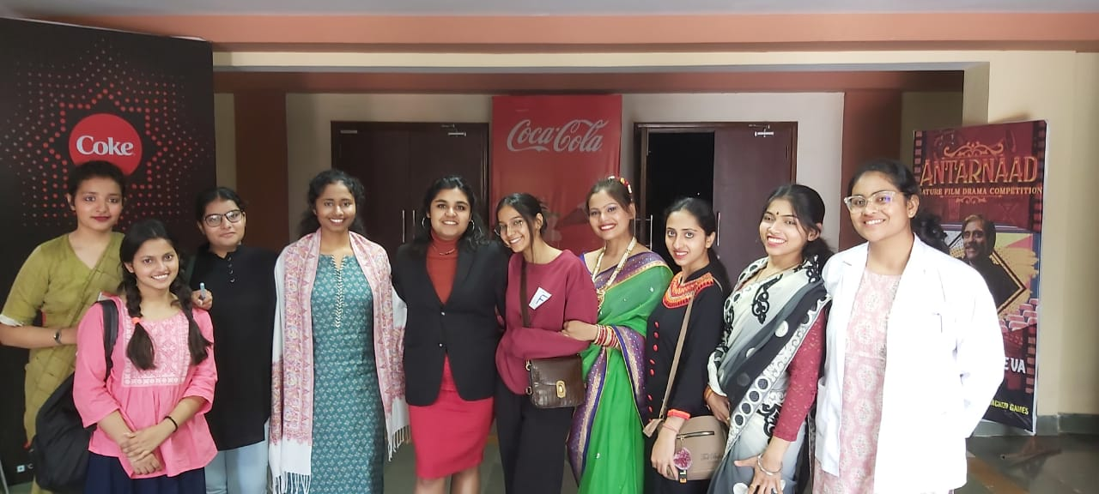

HIV AIDS

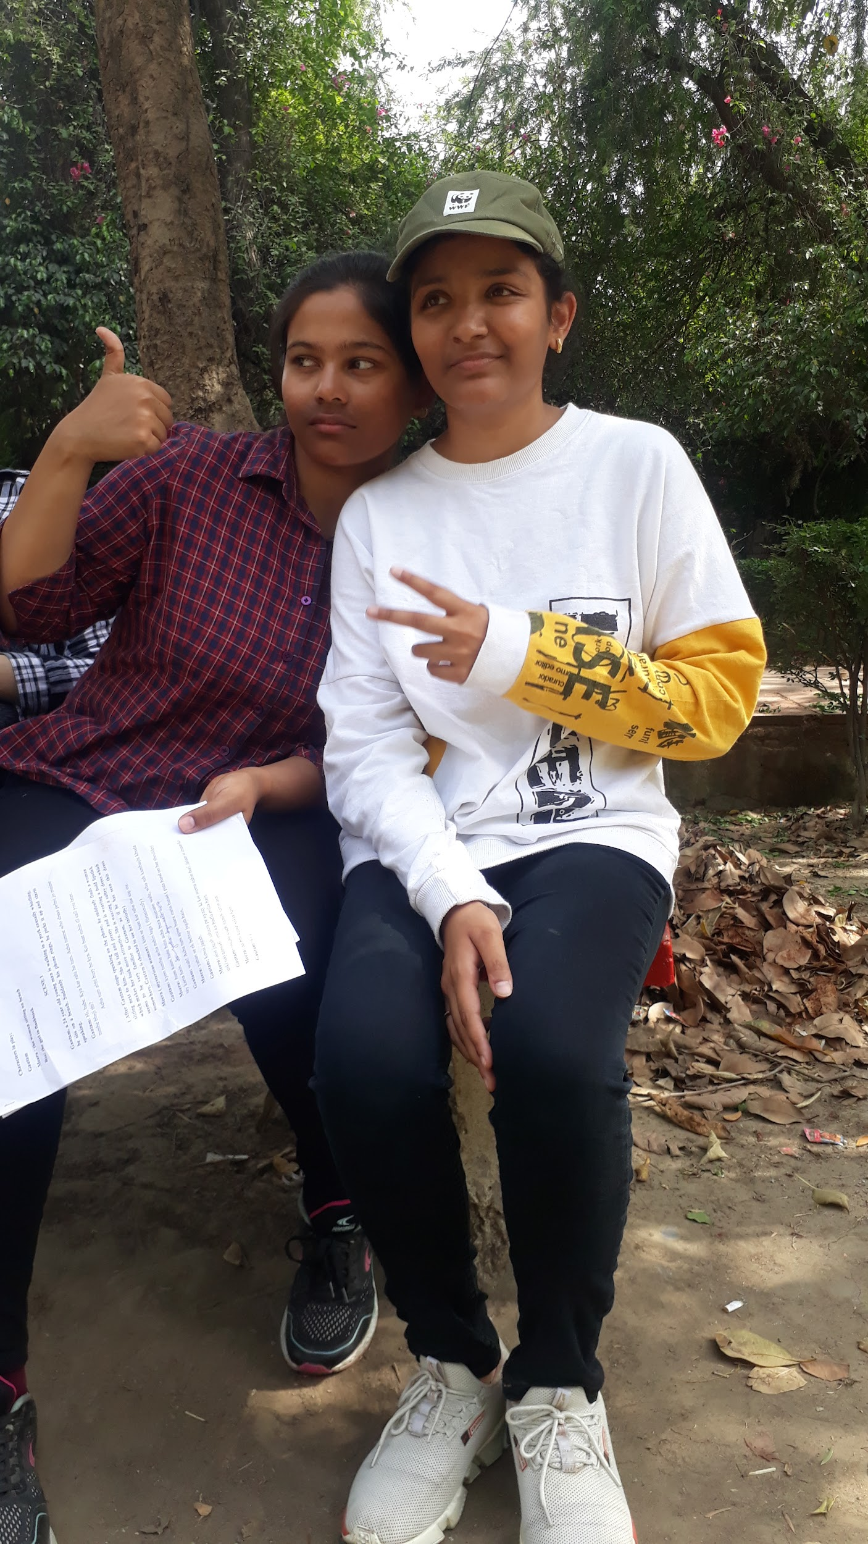

LIGHT AND DARKNESS

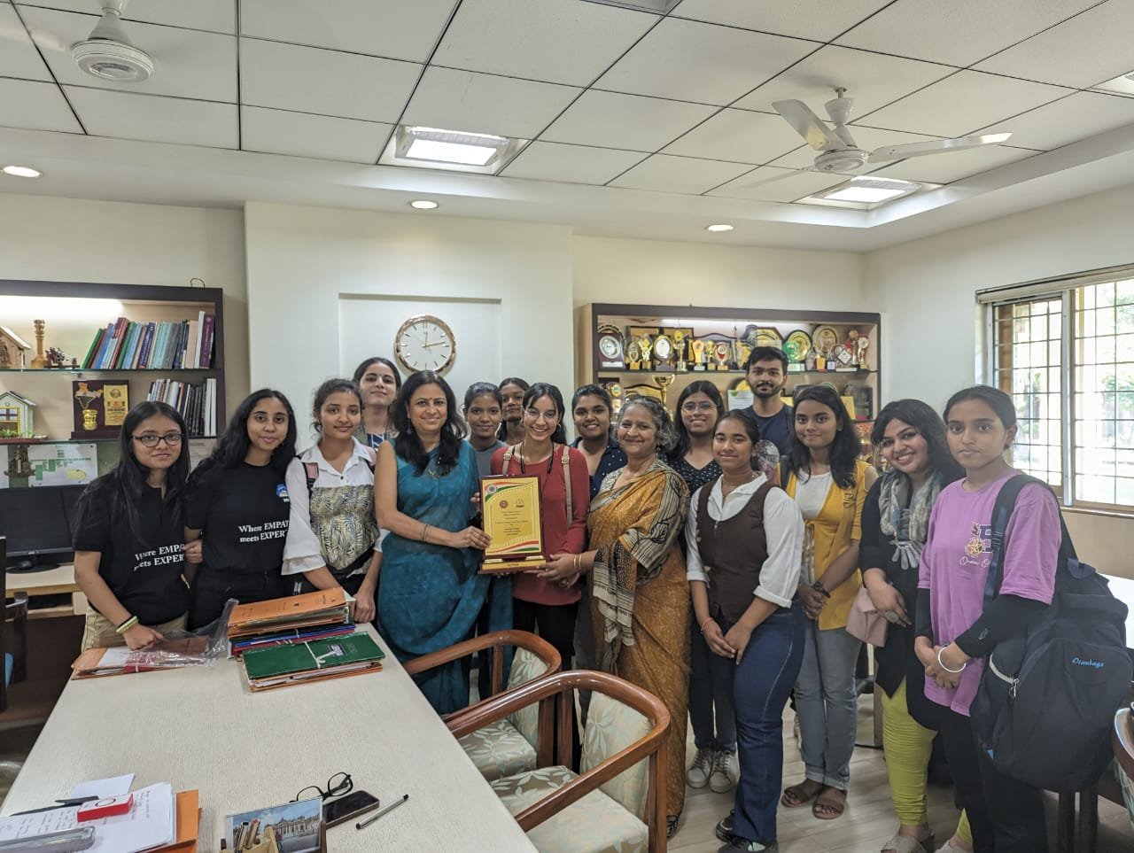

MIME COMPETITION

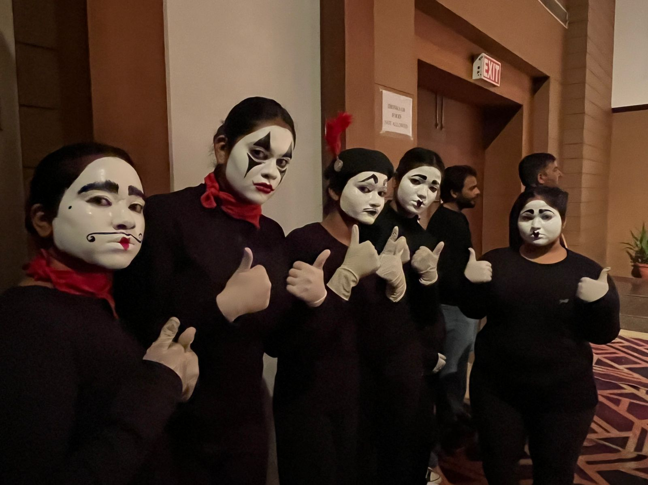

INTER UNIVERSITY NORTH WEST ZONE COMPETITION

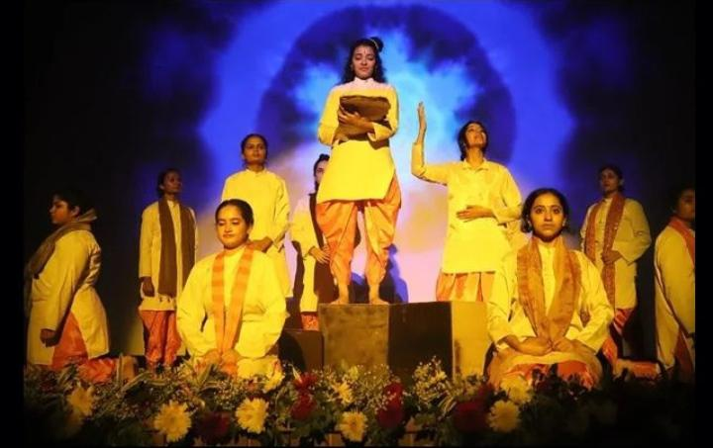

G20 PRODUCTION