ANNUAL REPORT (2023-2024)  
  
**Name of the Society:** Student’s HelpDesk **Name of the Convenor:** Dr. Asha Tiwari **President:** Aliza Arif  
**Vice-President:** Aditi Jain

Inauguration Ceremony  
Bharati College Student’s Helpdesk conducted its inauguration ceremony on 4th January 2023. It was founded by Aliza Arif and Co–Founded by Aditi Jain, embodying our vision of creating an inclusive and supportive space catering to the diverse needs of all college students, irrespective of their backgrounds or abilities. The Student’s Help Desk through this initiative, is actively working to build a brighter future for both Bharati College and the students who are the heart of our mission, together forging a “Sunehra Kal” for all.  
  
 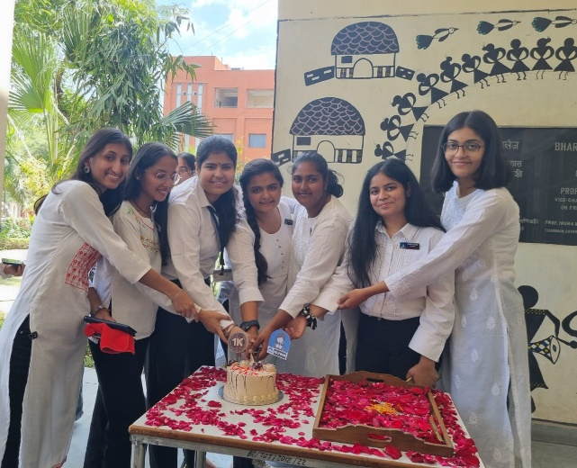

Opening of Stationery Shop in College Premises

On the date of 20th March 2023, the Student's Help Desk took the initiative to conduct a survey regarding the issues faced by students on the college premises. We received 500+ responses on the form and the majority of students stated the issue of lack of stationery shop in College Premises. To address this issue and provide a solution, the Student's Help Desk proposed the opening of a stationary shop on the college premises. By providing access to stationery items within the college premises, the Student's Help Desk aims to create a more conducive and efficient learning environment for all students.

Book Fair Event

The book fair was organized by the Student’s Help Desk at Bharati College on April 17, 2023, and was a resounding success! The participation of Delhi University official publishers and various vendors, offering a vast variety of books including course-related books, fiction, non-fiction, historical books, computer and science books, entrance exam preparation books, and novels, must have attracted a wide range of visitors. Many student entrepreneurs from our college were also given an opportunity to exhibit their products. An inter-college Poetry Competition was also organised. Winners were felicitated with trophies and certificates.  
  
 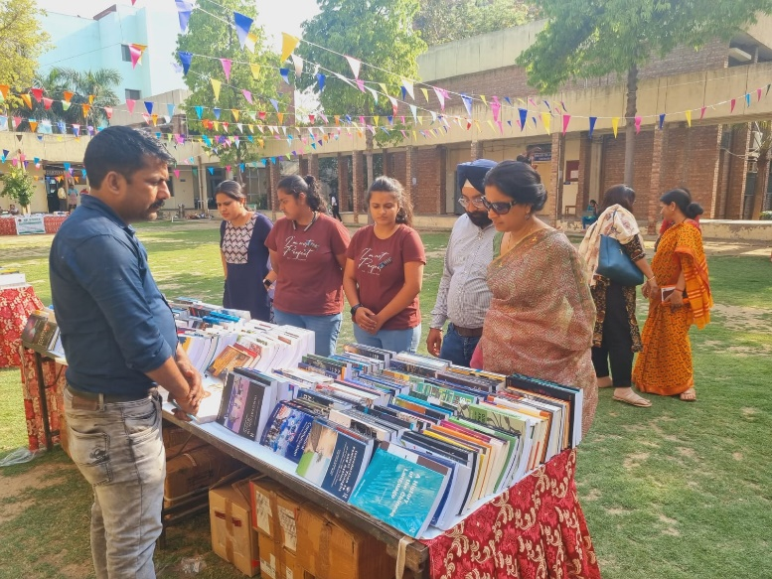  
  
  
ECA Admission

The Student's Help Desk at Bharati College, University of Delhi, played a pivotal role in providing support during the ECA Trials for Music Quota Admission held from August 8, 2023, to August 15, 2023. Under the guidance of Sadhna Maam, the Help Desk team worked diligently from 8:00 AM to 4:00 PM daily to provide assistance to participants and ensure the smooth execution of the event. The help desk team, consisting of dedicated members, notably Aditi and Aliza, coordinated efficiently to ensure smooth functioning of the event. By offering assistance to students the help desk team facilitated a conducive environment for the selection process.  
  
Orientation Program  
On 21st August, Bharati College Student’s Help Desk organised an orientation programme for the first-year students regarding their subjects for General electives, skill enhancement courses and value-added courses being provided to them as per their courses and departments. The event was a great success harnessing an audience of 300+ students who after gaining the required knowledge were able to make the right choice for their subjects.

Query Quorum Seminar

On 6th, September 2023, the Student’s Help Desk organized a seminar called “Query Quorum” with the primary objective of resolving queries related to examination forms. Tanveer from the administrative team was the speaker at the seminar. By offering a platform where students could both learn about and complete their examination forms, the seminar served as a valuable resource. It provided guidance, clarification, and practical support, ultimately enabling students to navigate the form-filling process more efficiently and with increased confidence.  
  
College Magazine Initiative  
Bharati College Student’s Helpdesk initiated the plan to re-continue College Magazine. It played a pivotal role in the photo shoot of all the college societies, clubs and cells. It acted as a major member of the College Magazine Editorial Team Board.  
  
 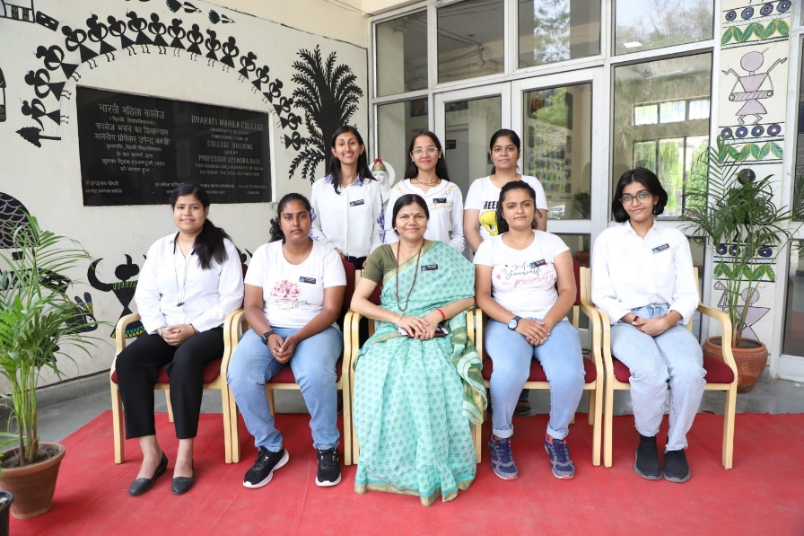  
  
  
Other Notable Achievements  
  
Besides, organising these timely events, the Helpdesk was active throughout the year by continuously trying to comply with its objective:

* Addressing an average of 100 queries a day which we received on the WhatsApp group joined by 3000+ students.
* HelpDesk from its initiation is maintaining 3 groups to cater to all the college students addressing their diverse queries. The queries addressed include scholarship-related enquiry, fee refunds, exam results errors for 100 students assisting the nodal officer, Ms Sadhna Gupta etc.
* We also assisted the administration department with office work.
* During the start of the College semester, HelpDesk assisted students with teacher form checking and document filling.
* During examinations, HelpDesk closely maintain balance by resolving the students’ queries regarding examination form filling and admin office for results.

At Last, the session 2023-2024 was a huge success for the Helpdesk and created a major impact on the lives of the students of Bharati College. This was not possible without the tireless efforts and guidance of our dear convenor, Ms. Asha Tiwari Maam. She was a great source of inspiration and motivation for the team of HelpDesk.