MANTHAN-THE NUKKAD NATAK SOCIETY
BHARATI COLLEGE
UNIVERSITY OF DELHI
ANNUAL REPORT: 2023-2024
“Words mean more than what is set down on paper. It takes the human voice to infuse them with deeper meaning.”
~Maya Angelou
Manthan, The Nukkad Natak Society of Bharati College, is a bright example of social consciousness and activism. They have effectively raised important social concerns to the attention of young people via their steadfast dedication, making a lasting impact on both individuals and communities. Beyond the sphere of performances, MANTHAN is an essential forum for strengthening ties within the community and reviving ties to the larger social fabric. It's a sombre opportunity to consider the team's amazing accomplishments as the new academic year draws near. Their inventive spirit and perseverance have been crucial in bringing about constructive change.
Manthan aims to empower the voiceless, spark important dialogues, and inspire meaningful deeds in addition to merely increasing awareness. It encourages the greater community to actively participate in tackling societal issues while also enabling its members to become change agents. Beyond the walls of Bharati College, Manthan's influence is felt in addressing issues of social justice and inclusivity and gender equality. Let’s take a moment to honour Manthan's important accomplishments and its continued legacy of activism and social responsibility as we start a new year full of opportunities.

EVENTS OF THE ACADEMIC YEAR 2023-24

- WORKSHOP ON HEALTH AND WELLNESS [11TH August 2023]

In commemoration of Azadi Ka Amrit Mahotsav, Manthan- The Nukkad Natak Society extended a warm invitation to Mrs. Meenakshi Emmanuel to deliver a keynote address during an insightful webinar themed "Health and Wellness." Renowned as both an educator and child counsellor, Mrs. Meenakshi Emmanuel imparted invaluable advice to students, shedding light on ways to foster their physical and emotional well-being. The event featured an engaging Q&A session, allowing members to delve deeper into the subject matter, enriching their understanding and learning. The session helped members in learning more about their mental health and getting acquainted with tips and tricks to endure through long practice sessions. These methods will help each member in making practice session relaxing and comfortable.

.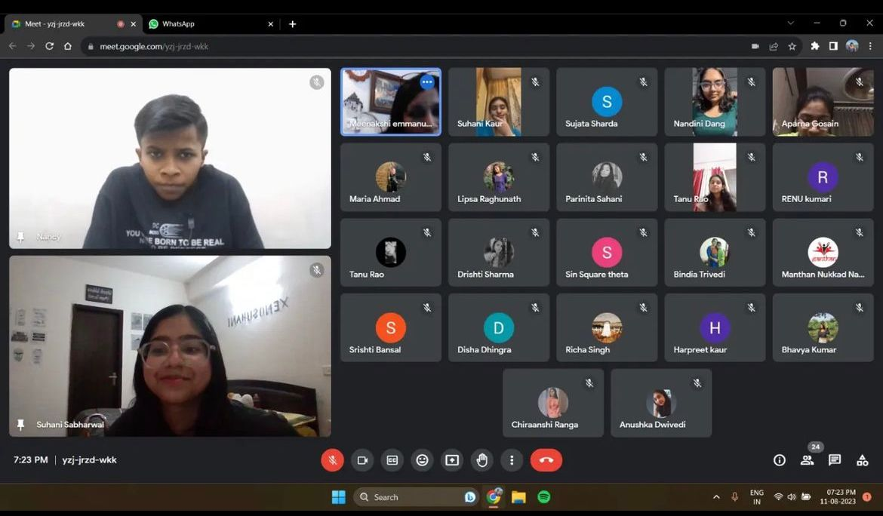 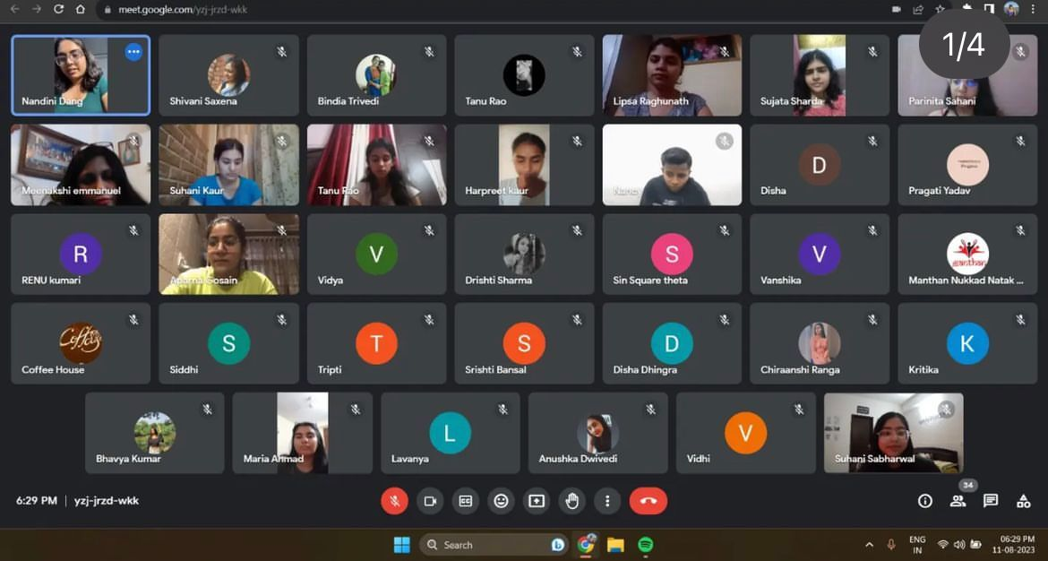

2) FAREWELL- CUM- INVESTITURE CEREMONY [4th September 2023]

The Society's "Farewell cum Investiture Ceremony" was a significant occasion that combined continuity and change. It highlighted the commitment of present members while honouring the efforts of past ones. The investiture of badge signified a new phase that smoothly connected the past and the future. An emotional farewell that blended optimism and nostalgia was given to the members who left. President Suhani Sabharwal led alongside the distinguished convenor, Dr. Bindia Trivedi.
Dr. Bindi Trivedi ma’am gave motivational remarks to kick off the celebration, and there was a happy cake-cutting ceremony. Present office bearers offered their perspectives, while president awarded certificates along with highlighting the contribution of past participants. Motivational talks that fostered togetherness and purpose concluded the ceremony. The long-lasting impact of former members demonstrated their inspiration and guaranteed a continuity of principles.

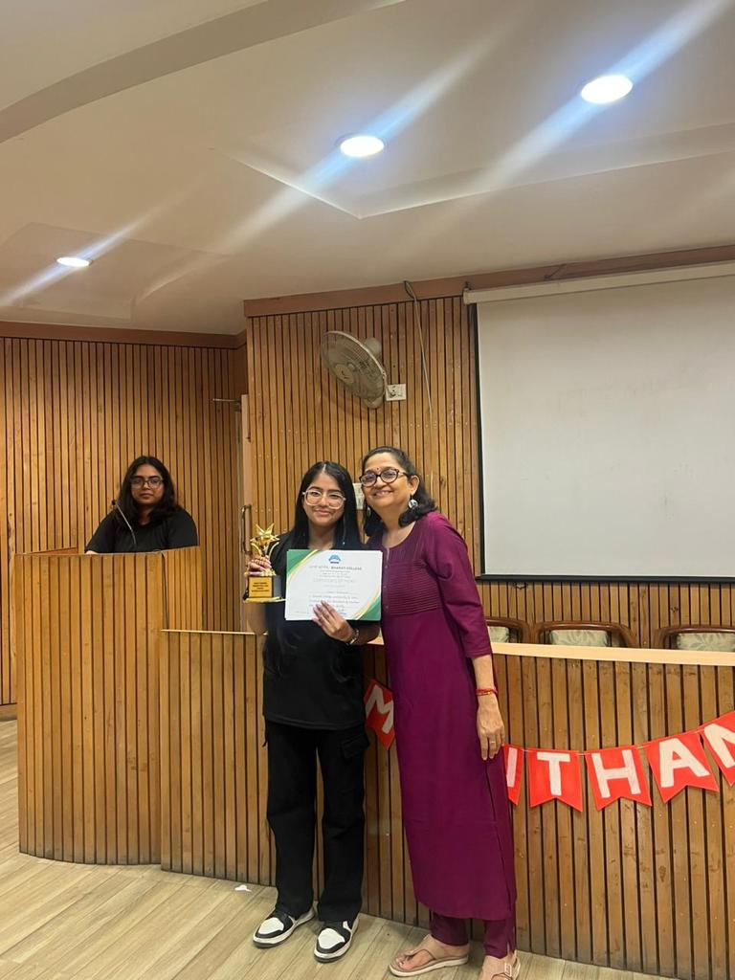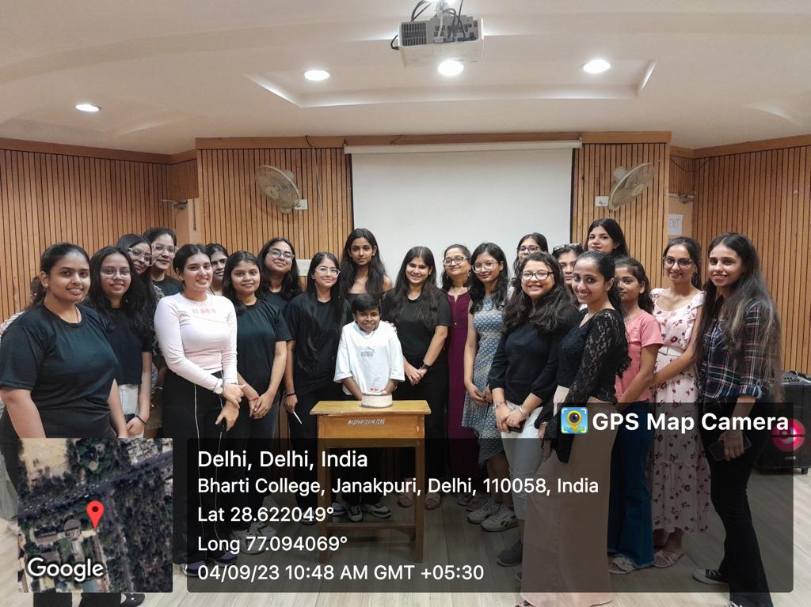

3) PROMOTIONAL ACT [12th September 2023]

Manthan - The Nukkad Natak Society embarked on a strategic promotional campaign to disseminate awareness among all college students about its vibrant presence and offerings. Through a meticulously planned promotional act, including posters, flyers, and social media outreach, Manthan ensured comprehensive coverage across campus. Leveraging the power of word-of-mouth, members engaged actively with fellow students, articulating the society's mission, events, and opportunities for involvement. Additionally, eye-catching act in central lawn served as focal points, captivating the attention of passersby and sparking curiosity. By employing a multi-faceted approach, Manthan effectively penetrated the student body, fostering a sense of belonging and enthusiasm for participation in its dynamic activities.
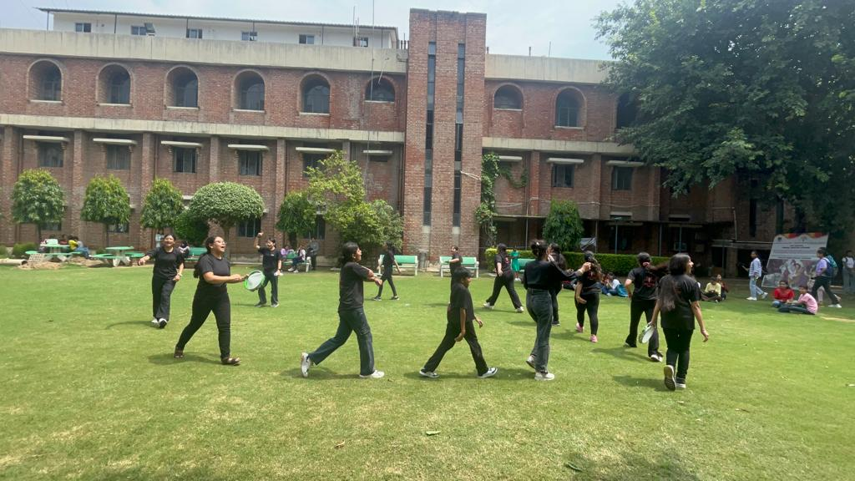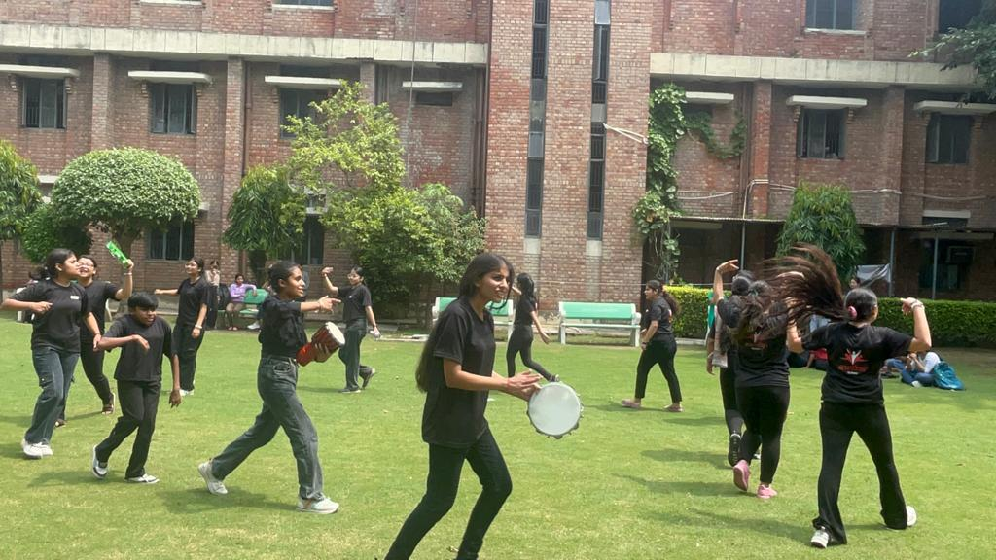

4) AUDITIONS’ 23 [ 14th September 2023]

The Society's Audition was a colourful event that exuded warmth and unity with
more than 150 participants who performed. President Suhani Sabharwal ascended the stage as the curtains raised, her presence commanding attention as she opened the auditions with a formal but passionate address. Her remarks set the tone for an evening of profound performances meant to elicit contemplation and thought in addition to providing entertainment. In every performance, the actors deftly explored a wide range of societal topics, boldly taking on problems that frequently lurk in the background of day-to-day existence. They illuminated the grim reality of rape, female foeticide, domestic abuse, dowries, and mental health concerns with moving portrayals and impactful dialogue.
.
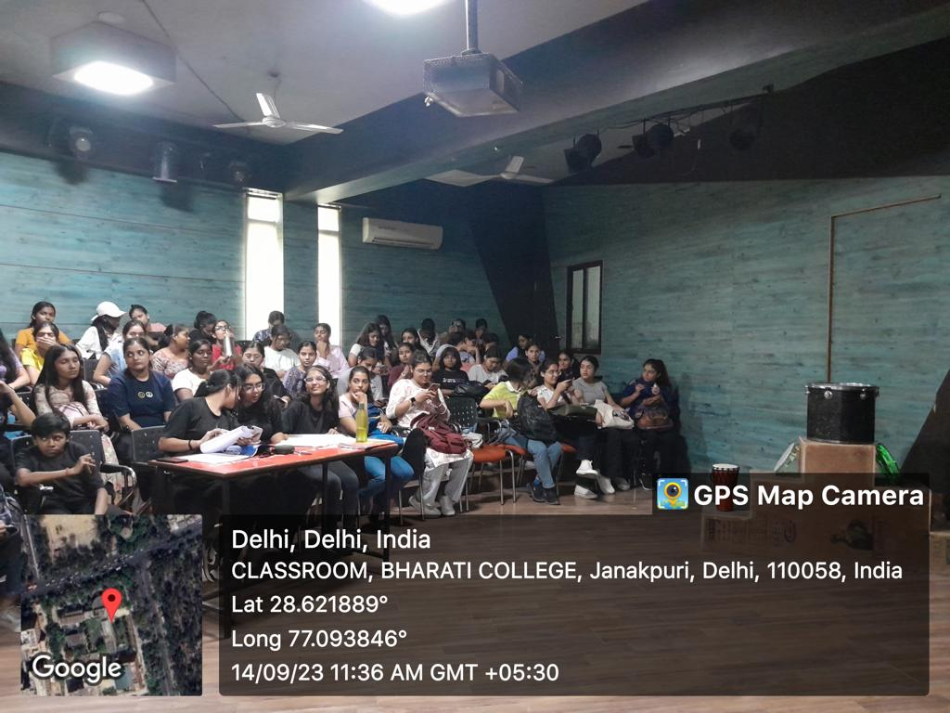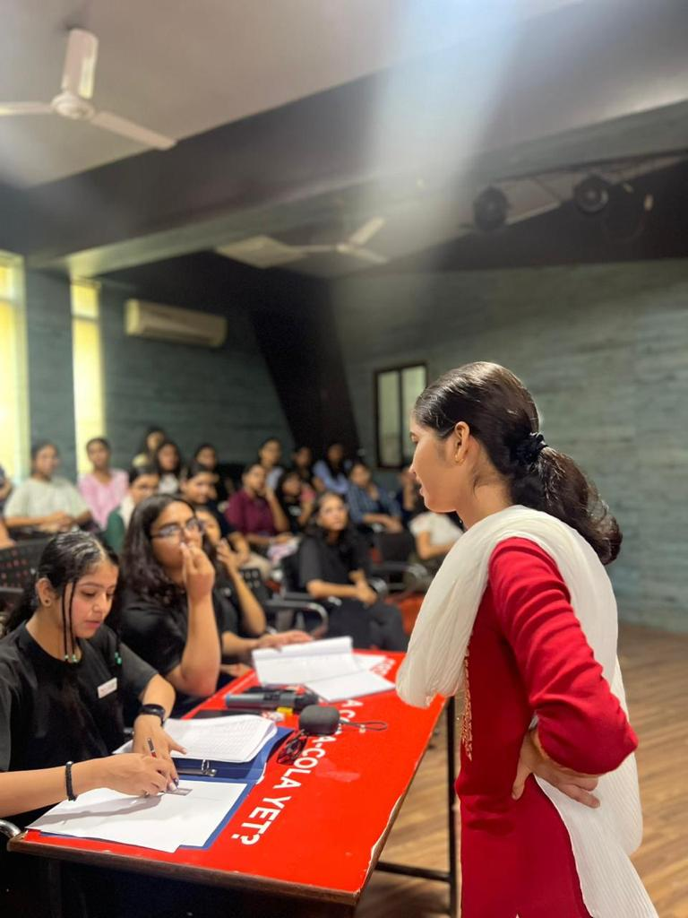

5) ORIENTATION’23 [03rd October 2023]

The orientation welcomed new members of the society with open arms. The responsibilities of each office bearer were clearly defined, emphasising the value of dedication. Every member fervently affirmed the society's pact, signifying respect for one another and committed participation. The new members were introduced to convenor, Dr. Bindia Trivedi who motivated them with her words of motivation. Following that, President Suhani Sabharwal gave a thorough summary of the upcoming events and acknowledged accomplishments, offering insight into the operating environment of the society. Members were introduced to the working and core purpose of the society, they were given a brief introduction regarding the society. The program sought to instil a sense of welcome, awareness, and motivation in new members by means of a structured introduction, formalisation of commitment, refreshment break, and educational summary, enabling them to actively participate and contribute to the society's overall goals.

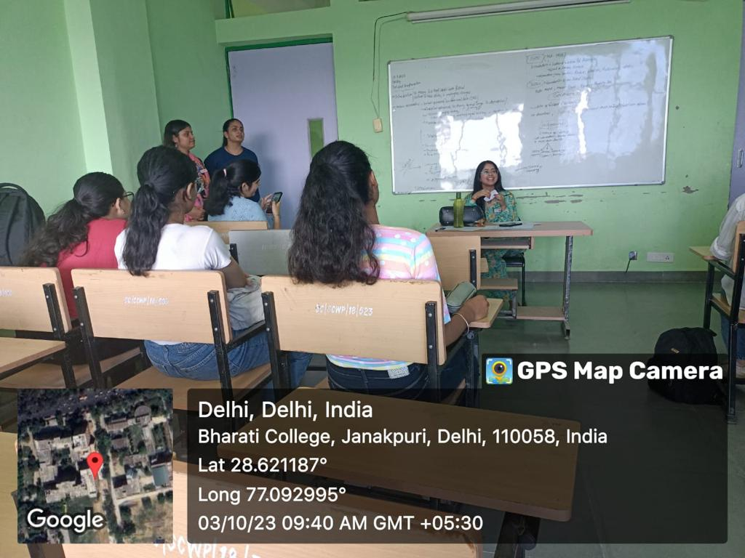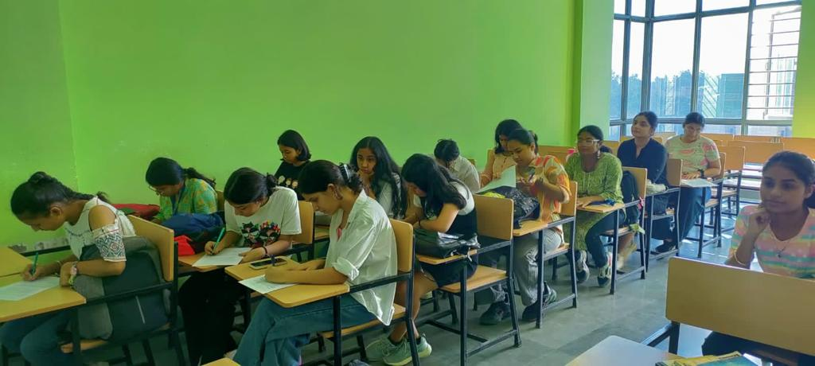

6) PERFORMANCE ON FRESHERS’ 2023 [1st November 2023]

Manthan - The Nukkad Natak Society stole the show at Freshers’ 2023 with a powerful performance focused on women's empowerment. The society took advantage of the chance to use the entertaining medium of Nukkad Natak to raise awareness of important topics. Their presentation, a moving story, depicted the complex path taken by women who aspire to be empowered. They brought attention to the difficulties women confront and their tenacity through thought-provoking conversations and powerful scenes. The crowd was enthralled with the emotionally charged performance, which skilfully combined entertainment with a thought-provoking social message. It sought to stimulate discussions about female empowerment and equality. This performance started a conversation and raised awareness among the Freshers 2023 cohort, establishing the foundation for a group of people dedicated to social change.
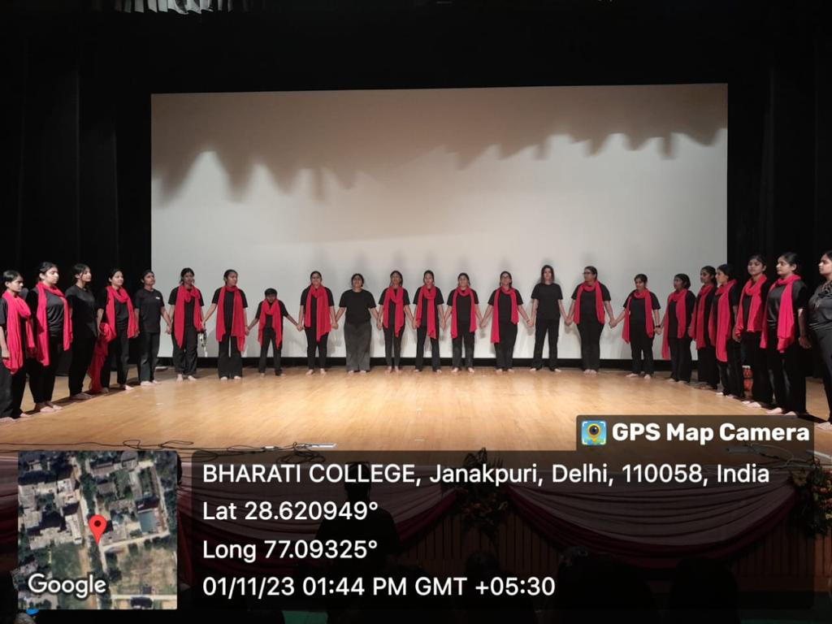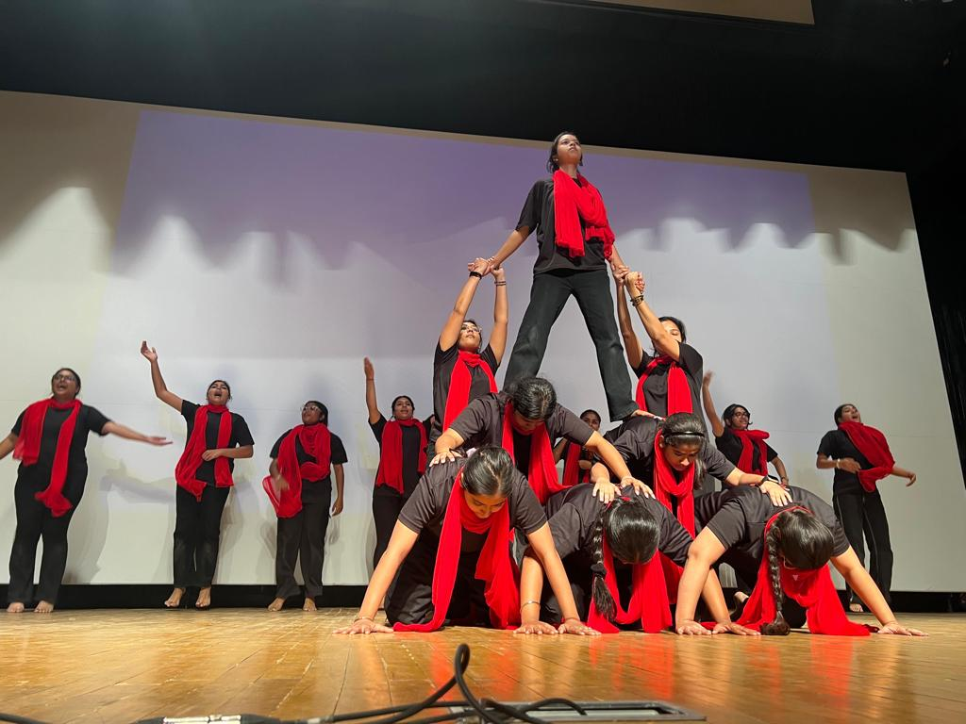

7) WEBINAR BY YASHVARDHAN GAUR [27th January 2024]

On January 27, 2024, Manthan-The Nukkad Natak Society held a webinar with the goal of educating attendees and improving their comprehension of acting with speaker, Yashvardhan Gaur, the program offered insightful information about the use of the seven senses in acting and character development. Actors such as Andrew Scott, Irrfan Khan, and Nawazuddin provided examples that demonstrated the value of critical thinking, active listening, and observation in acting. President Suhani Sabharwal conveyed her appreciation for the enlightening encounter while highlighting the importance of the occasion in enabling attendees. The learning process was further improved by an engaging Q&A session that promoted deeper investigation of the subjects covered. The goal of the webinar was to demystify acting by providing participants with useful tools to improve their abilities and self-assurance, ultimately enabling them to excel in their artistic endeavours.

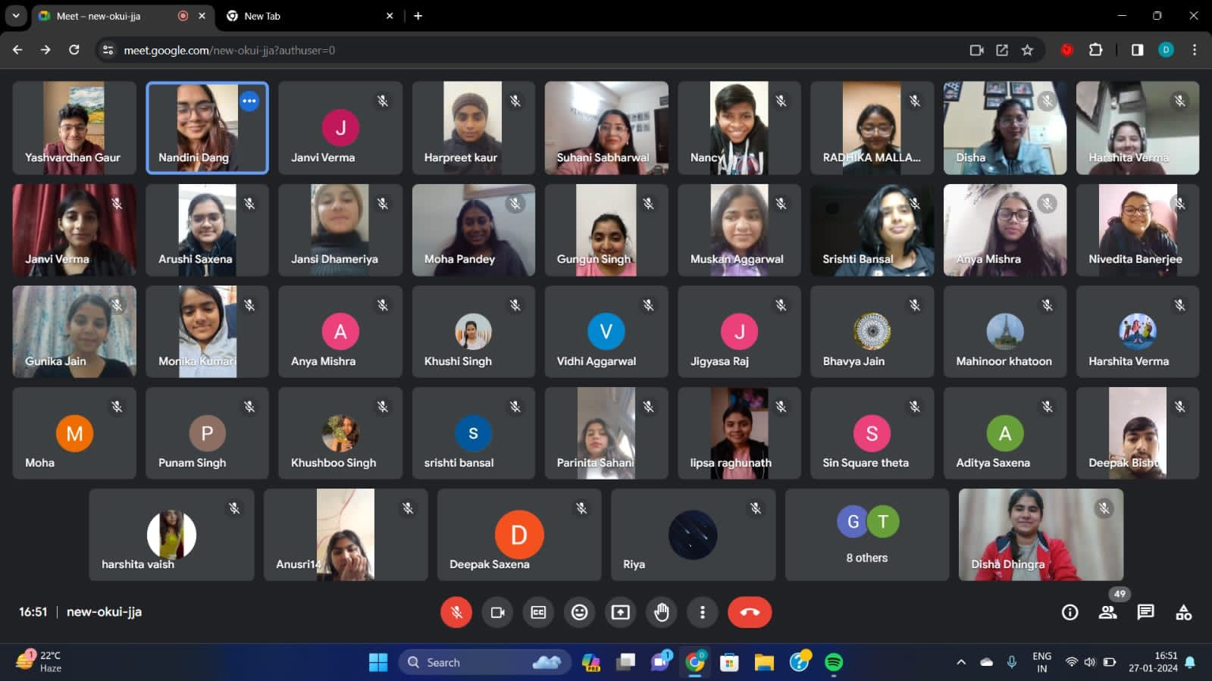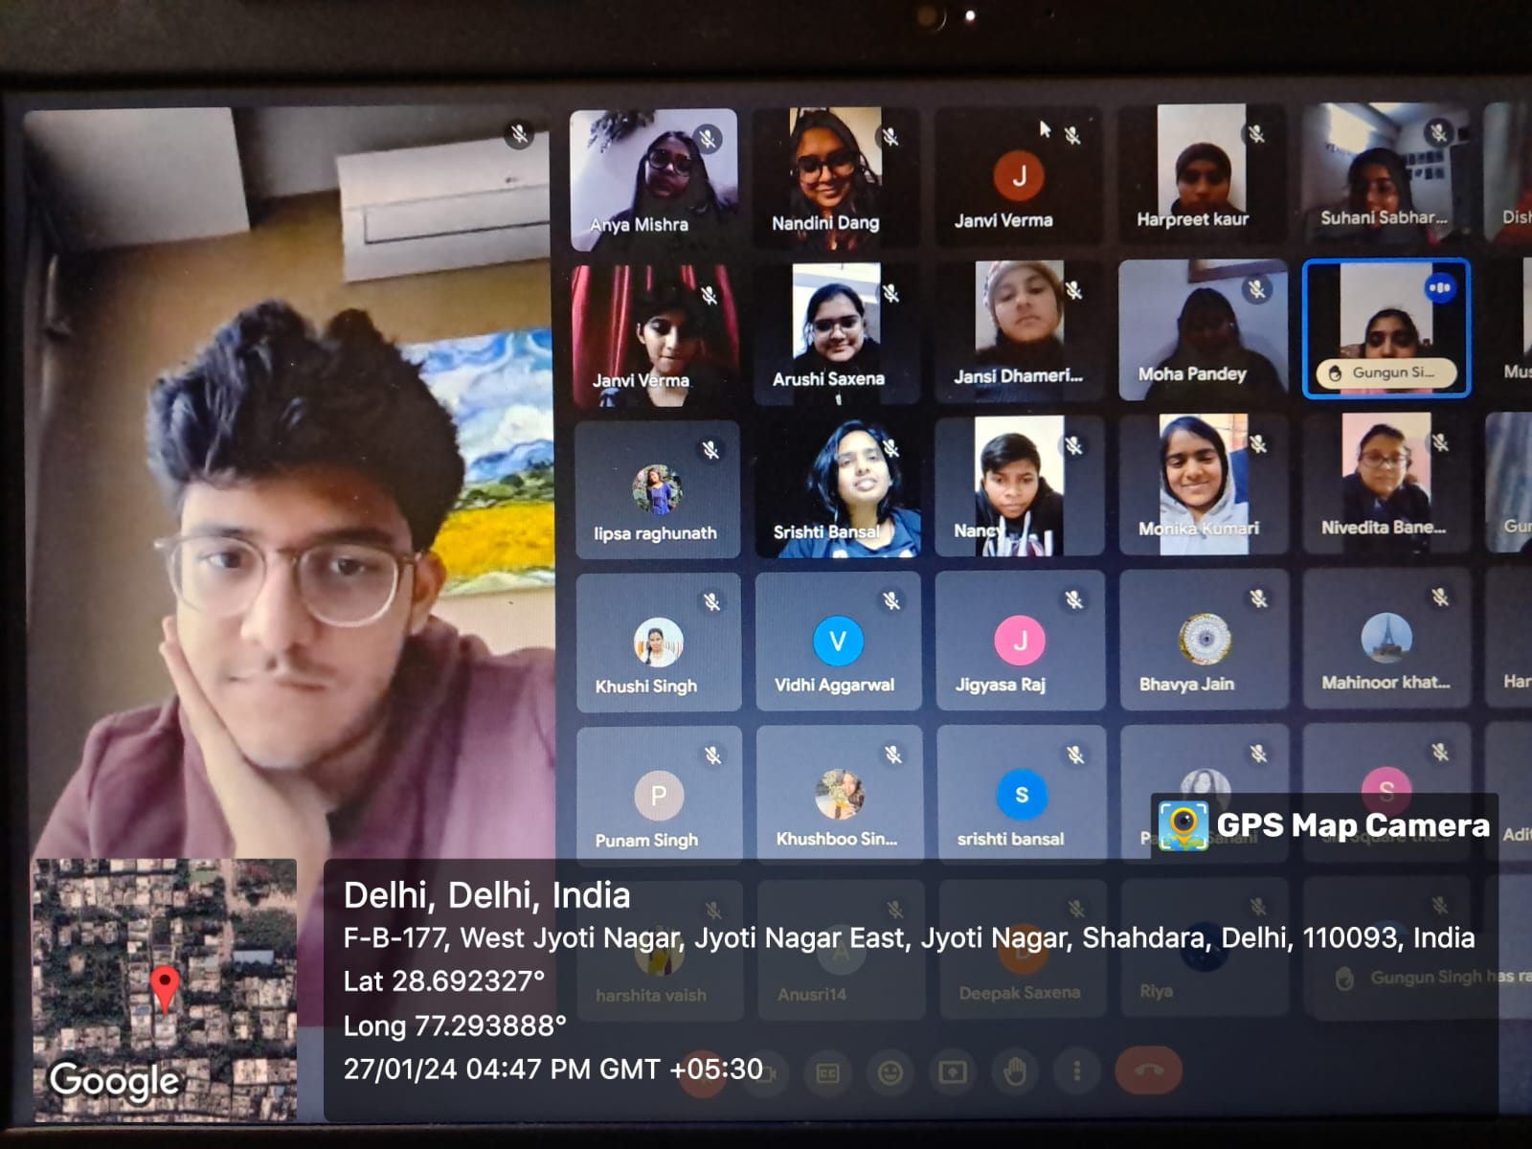
8) PERFORMANCE AT ENTREPRENEURSHIP CONCLAVE [27th February 2024]

Manthan -The Nukkad Natak Society of Bharati College, gave a remarkable performance at the Entrepreneurship Conclave. During their performance, they praised the transforming potential of entrepreneurship and encouraged students to think about it as a possible career path. They emphasised the value of female entrepreneurs and the role that entrepreneurship plays in innovation and economic growth through gripping stories and outstanding performances. The audience applauded the powerful presentation and responded enthusiastically. Manthan's accomplishments highlight how crucial it is to support programs that empower women in business and encourage the upcoming generation of entrepreneurs. Such compelling performances demonstrate Bharati College's dedication to promoting an inclusive business ecosystem. The response from the crowd demonstrates how much of an impact Manthan's act had, encouraging discussions on gender equality and entrepreneurship. Such initiatives drive positive change, shaping a future where entrepreneurship flourishes and gender equality prevails.
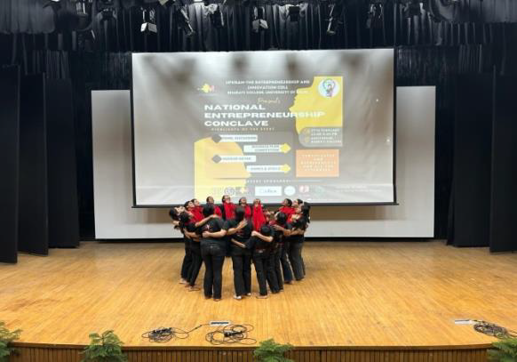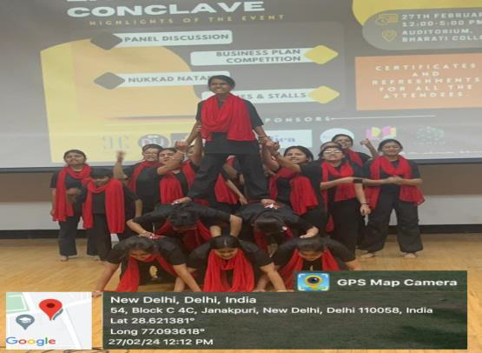

9) OPEN MIC COMPETITION [4th March 2024]

The "Viksit Bharat@2047" open mic competition, hosted by Manthan, The Nukkad Natak Society, in collaboration with Chintan, The Debating Society of Bharati College, was a resounding success, seamlessly blending vibrant energy with intellectual discourse. Participants showcased their talents, engaging in thought-provoking debates that captured the essence of shaping India's future. The deserving winners were honoured with certificates and cash rewards, symbolizing their pivotal role in shaping the nation's destiny. This event served as a beacon of hope, promising a future filled with more enriching projects aimed at fostering growth and unity. It underscored the power of collaboration in driving societal development and nurturing a profound sense of community among individuals dedicated to India's progress.

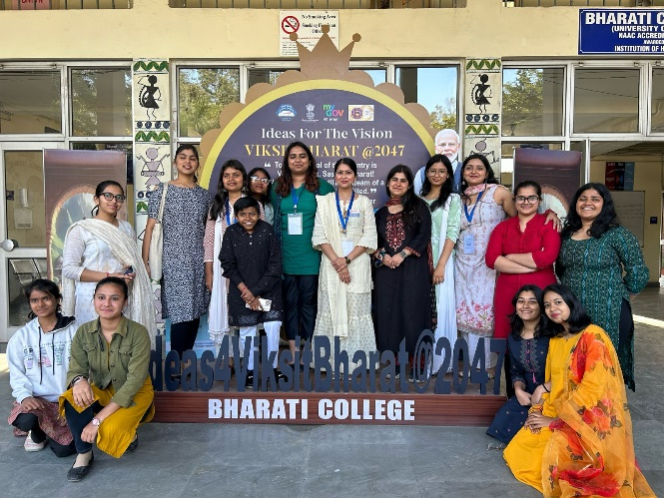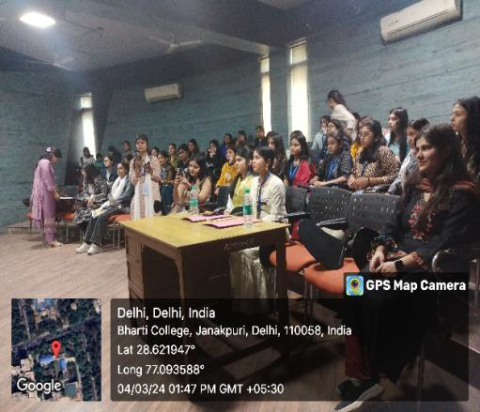

10) TAMAASHEBAAZI’24, A STREET PLAY COMPETITION [ 15th March 2024]

In highlight of Bharati College's Annual Cultural Fest - Abhivyakti'24, Tamaashebaazi'24 left an indelible mark with its showcase of extraordinary talent, garnering widespread acclaim from all quarters. Renowned theatrical artist Mr. Vipin Kumar from National School of Drama, graced the occasion as the esteemed judge, adding prestige to the event. Organized by Manthan - The Nukkad Natak Society, Tamaashebaazi'24 witnessed participants from various universities, each showcasing their unique talents in a spirited competition for recognition and lucrative financial awards. The powerful street plays lit up the ground. The audience was enthralled as each act unfolded. Through laughter, tears, and moments of awe, Tamaashebaazi'24 celebrated the boundless potential of artistic expression, leaving an indelible mark on all who attended. Tamaashebaazi'24 not only showcased the diverse talents within the college but also fostered a spirit of camaraderie and collaboration among participants, reinforcing the values of teamwork.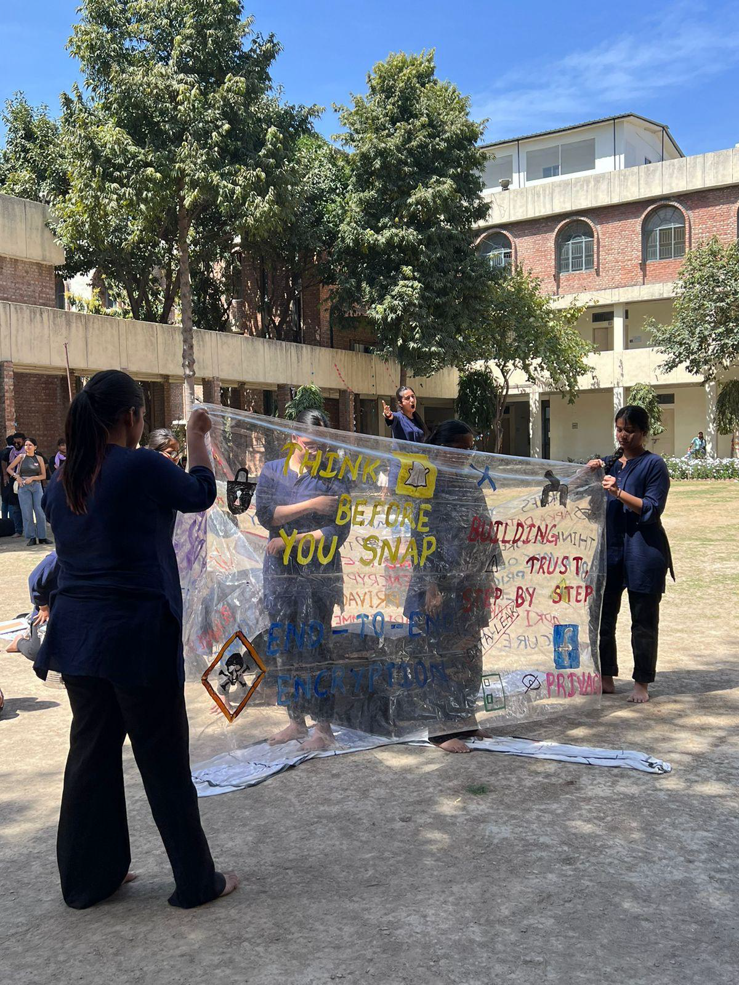 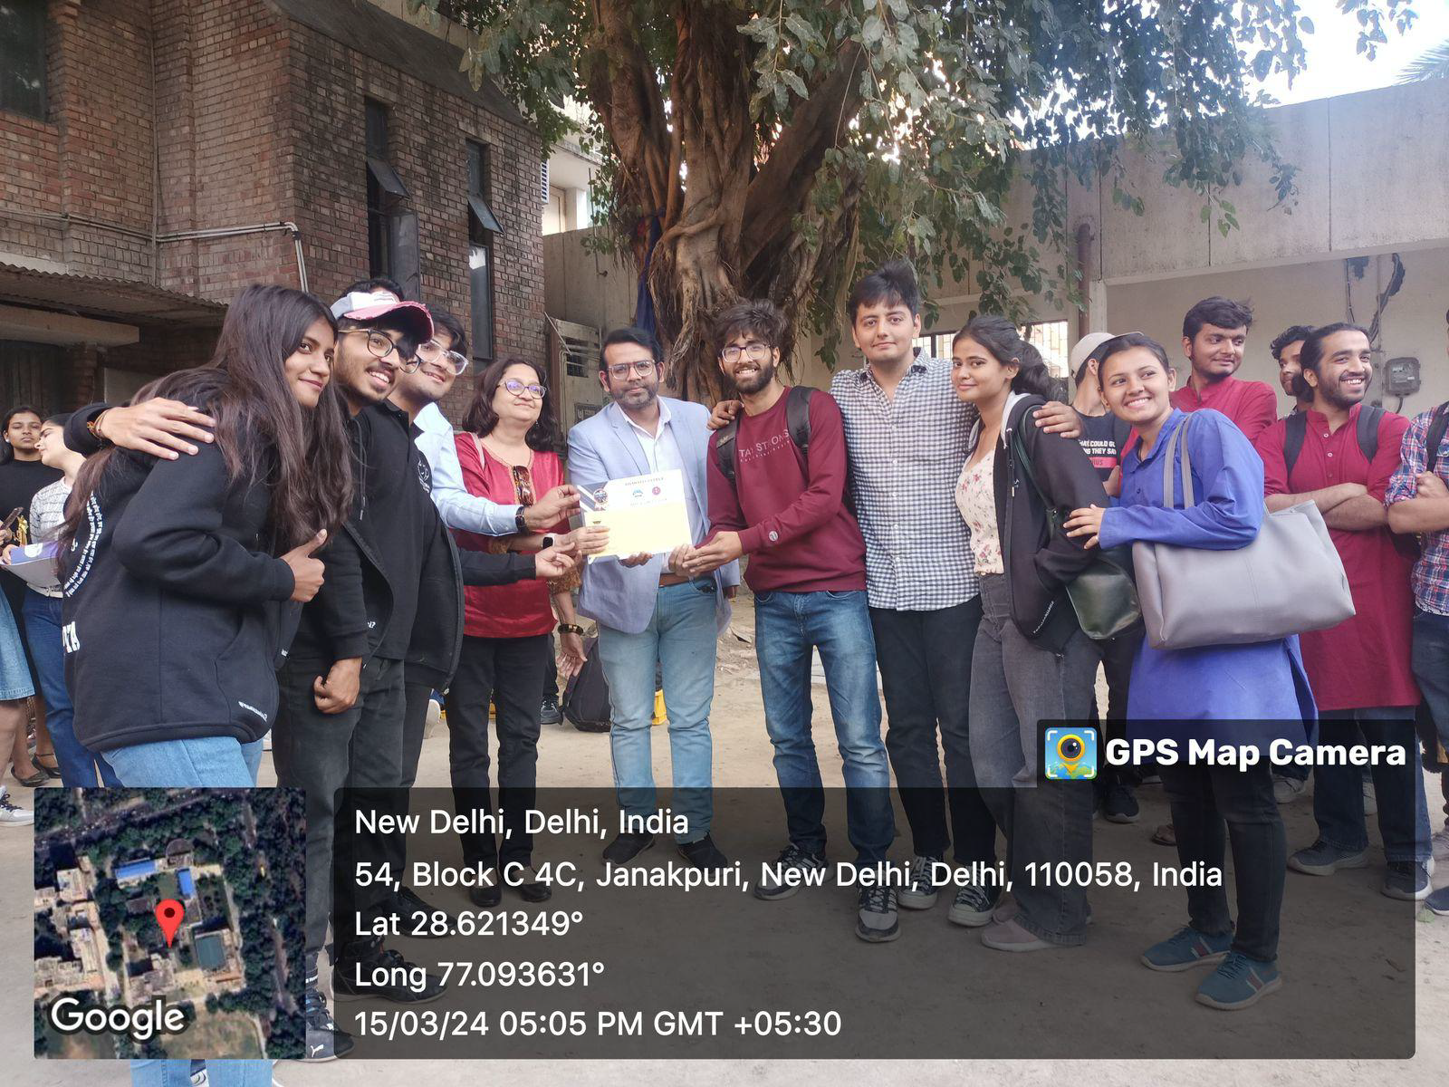

11) MONO – ACT COMPETITION [29th April 2024]

Manthan, the Nukkad Natak Society of Bharati College, hosted a memorable mono-act competition, guided by the esteemed convenor, Dr. Bindia Trivedi who inspired everyone with her motivating words and guided everyone for better performance. Participants showcased their talents, receiving invaluable feedback from seniors, fostering a deeper understanding of societal issues. The event commenced with gratitude for the seniors' guidance. Performances addressed diverse social challenges, followed by transformative feedback sessions enhancing authenticity. Reflecting on their journey, a sense of camaraderie emerged, emphasized by the President's heartfelt address. In a touching gesture, seniors were honored for their support. As the semester concludes, Manthan extends gratitude, epitomizing values of camaraderie. The event, including a final training session, highlighted the society's commitment to talent nurturing and social awareness.
. 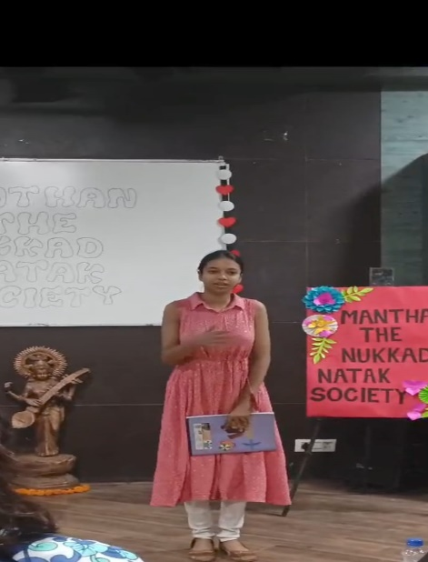 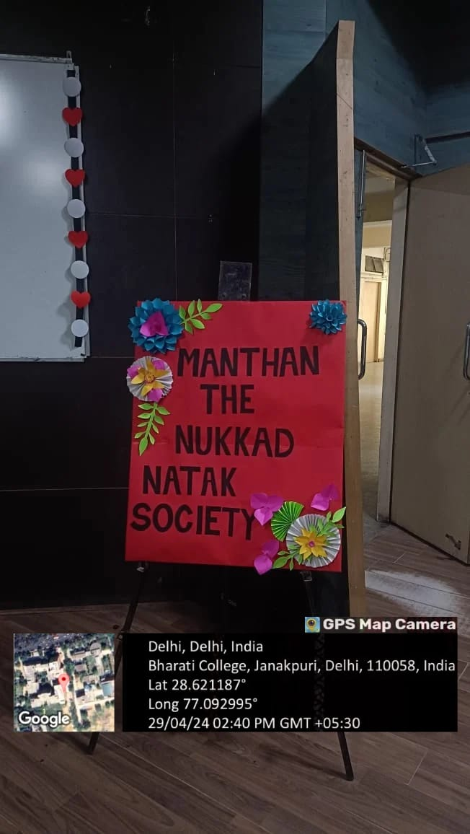

COLLABORATIONS FOR THE ACADEMIC YEAR 2023-2024

1.MANTHAN X KAVYA
Manthan - The Nukkad Natak Society of Bharati College, and Kavya – the Poetry Society of Bharati College, embarked on a collaborative initiative aimed at expanding their audiences and promoting each other's creative endeavours. By exchanging followers and engaging in mutual support, the two societies not only enhanced their reach but also fostered a culture of artistic appreciation within the college community. This partnership exemplifies the power of collaboration in nurturing creativity and strengthening bonds among students, paving the way for continued synergistic efforts in the future.

2.MANTHAN X DU FEST
Manthan – The Nukkad Natak society of Bharati college, forged a partnership with DU Fest - a distinguished Instagram platform with more than 25k dedicated followers enthusiastic for curating updates on the diverse talents and events within Delhi University's vibrant community. This collaborative effort saw us exchanging followers, with DU Fest generously promoting our Manthan page while we reciprocated the gesture. This mutual exchange drastically expanded the audience reach of our page, effectively elevating our visibility and engagement levels. Furthermore, our collaboration extended to crafting captivating reels, which served to enhance our collective online presence and facilitate mutual promotion. This synergistic alliance vividly illustrates the multitude of benefits that collaboration can offer, showcasing how teamwork can pave the way for increased success and exposure for all involved stakeholders.

3.MANTHAN X CHINTAN
This collaboration brought together Manthan-Tthe esteemed Nukkad Natak Society, and Chintan - The revered Debating Society, both pillars of Bharati College's vibrant cultural landscape. Together, they organized an enlightening open mic competition centred around the theme 'Viksit Bhara@2047t'. This event aimed not only to educate students about the envisioned developed state of India by 2047 but also to honour the invaluable contributions of our freedom fighters.
ACHIEVEMENTS

- Suhani Kour, senior executive member of Manthan, won first prize in two open mic competitions this year by performing a mono act. The Apeejay School of Management organized one, while Chintan, the Debating Society of Bharati College, organized the other.
- Suhani Sabharwal, the President of Manthan, demonstrated her skills in live broadcasts on FM Rainbow on Akashvani, All India Radio. During the Azaadi Ka Amrit Mahotsav celebrations, she was featured on 102.6 FM Rainbow for a program emphasizing "Youth Icon and Role Model in Culture" and spoke about the "Impact of Westernization on Indian Society,” while embracing the power of voice.
- Nandini Dang, The Vice President of Manthan, bagged second position in Apeejay School of Management's open mic competitions where she performed an act on women empowerment.
- Disha Dhingra, The Secretary of Manthan bagged third position in an open mic competition organized under the banner of Viksit Bharat@2047where she performed an act on Freedom Fighters.
- Gungun Singh, senior executive of Manthan bagged second position in an open mic hosted by Viksit Bharat where she performed an act promoting cultural inclusivity.
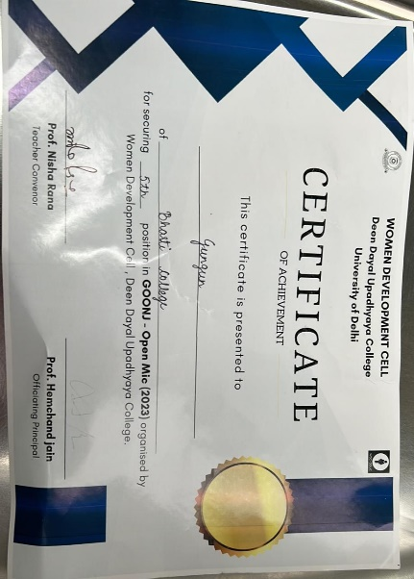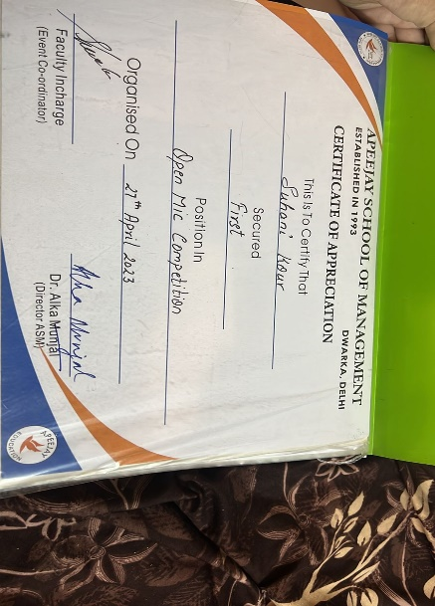

SOCIAL MEDIA HANDLES OF MANTHAN

https://www.instagram.com/p/CvzwNokRwJB/?utm_source=ig_web_copy_link

https://www.instagram.com/p/Cwu-8FLtKH9/?utm_source=ig_web_copy_link

https://www.instagram.com/reel/Cw0dIltxO6u/?utm_source=ig_web_copy_link

https://www.instagram.com/reel/CxzmnqVRAMX/?utm_source=ig_web_copy_link

https://www.instagram.com/reel/CzDiZ7YxGkK/?utm_source=ig_web_copy_link

https://www.instagram.com/reel/CzNs0gFCsX_/?utm_source=ig_web_copy_link

https://www.instagram.com/reel/C2iJLUQSBV9/?utm_source=ig_web_copy_link

https://www.instagram.com/reel/C38IXlAy75o/?utm_source=ig_web_copy_link

https://www.instagram.com/p/C35kQC0SsRe/?utm_source=ig_web_copy_link

https://www.instagram.com/p/C4BUnJ2y2JV/?utm_source=ig_web_copy_link

https://www.instagram.com/reel/C6qvXRTyk2d/?igsh=M2NsNHRsZHVkeGVh

FOR MORE DETAILS CONTACT:

manthannukkadnataksociety@gmail.com
https://www.instagram.com/manthannukkadnataksoc?igsh=cGc0cjhzeXdueXZ4

ANNUAL ATTENDANCE REPORT

MEMBERS OF SOCIETY | SEMESTER (1,3,5) | ATTENDANCE SLOT
Suhani Sabharwal | 5 | S3
Nandini Dang | 3 | S3
B Lipsa Raghunath | 5 | S3
Disha Dhingra | 3 | S3
Disha | 5 | S3
Srishti Bansal | 5 | S3
Anusri Ramavath | 3 | S1
Arushi Saxena | 3 | S1
Bhavya Jain | 1 | S2
Gungun Singh | 3 | S2
Gunika Jain | 1 | S2
Harpreet Kaur | 5 | S2
Harshita Verma | 1 | S1
Jansi | 1 | S1
Janvi Verma | 5 | S3
Monika Kumari | 1 | S1
Muskan Aggarwal | 1 | S2
Nivedita Banerjee | 5 | S1
Priya Singh | 1 | S2
Radhika Mallaha | 3 | S2
Suhani Kour | 3 | S2
Nancy | 5 | S3
Anya Mishra | 1 | S1
Parinita Sahani | 3 | S1

MEMBERS OF SOCIETY | SEMESTER (2,4,6) | ATTENDANCE SLOT
Suhani Sabharwal | 6 | S3
Nandini Dang | 4 | S3
B Lipsa Raghunath | 6 | S3
Disha Dhingra | 4 | S3
Disha | 6 | S3
Srishti Bansal | 6 | S3
Anusri Ramavath | 4 | S3
Arushi Saxena | 4 | S1
Bhavya Jain | 2 | S3
Gungun Singh | 4 | S2
Gunika Jain | 2 | S3
Harpreet Kaur | 4 | S3
Harshita Verma | 2 | S3
Jansi | 2 | S3
Janvi Verma | 6 | S2
Monika Kumari | 2 | S3
Muskan Aggarwal | 2 | S3
Nivedita Banerjee | 6 | S3
Priya Singh | 2 | S3
Radhika Mallaha | 4 | S3
Suhani Kour | 4 | S2
Nancy | 6 | S3
Anya Mishra | 2 | S2
Parinita Sahani | 4 | S1

TEAM

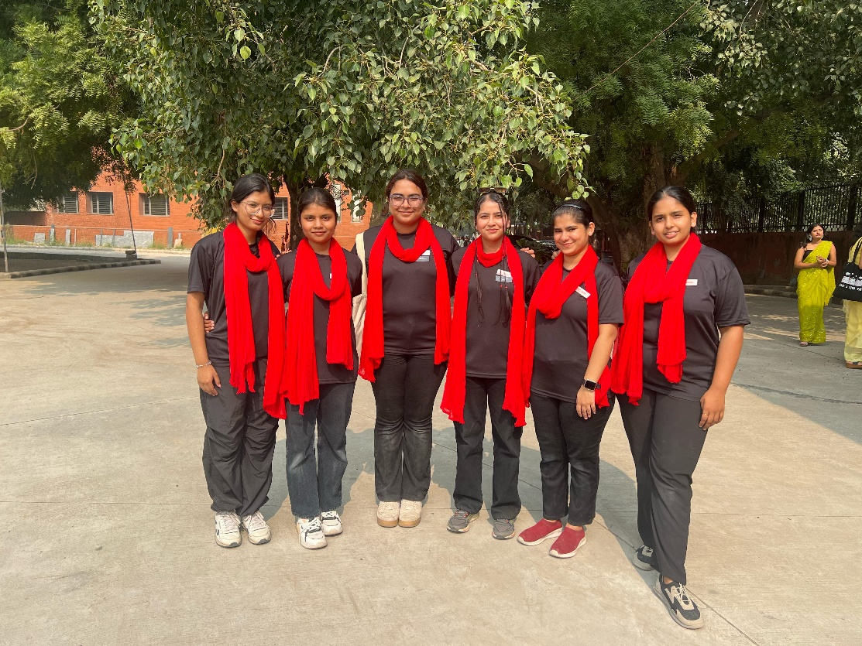
(From L to R, Disha, B Lipsa Raghunath, Nandini Dang, Suhani Sabharwal, Disha Dhingra, Srishti Bansal)

CORE MEMBERS
Suhani Sabharwal [President]
Nandini Dang [Vice President]
B Lipsa Raghunath [Treasurer]
Disha Dhingra [Secretary]

TEAM HEADS
Disha [Public Relations Head]
Srishti Bansal [Scriptwriter]

SUPER SENIOR EXECUTIVES
- Nivedita Banerjee
- Janvi Verma
- Nancy

SENIOR EXECUTIVES
- Parinita Sahani
- Arushi Saxena
- Suhani Kour
- Harpreet Kaur
- Radhika Mallaha
- Gungun Singh
- Anusri Ramavath

EXECUTIVES
- Bhavya Jain
- Muskan Aggarwal
- Gunika Jain
- Harshita Verma
- Priya Singh
- Jansi
- Monika Kumari
- Anya Mishra

In the academic year,2023-24, Manthan-The Nukkad Natak society demonstrated remarkable dedication, contributing to the performance of impactful street plays and a promotional act. Proud of our achievements, we eagerly anticipate future opportunities and challenges. With a commitment to excellence, we aim to gives more dynamic street play performances, fostering societal awareness and artistic expression. The upcoming year holds promise as we continue to pursue our goals and polish our acting skills with unrelenting resolve and dedication within our society's vibrant community.

Convenor: Dr. Bindia Trivedi
President: Suhani Sabharwal
Vice President: Nandini Dang

