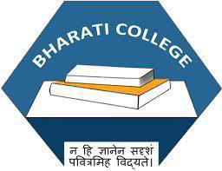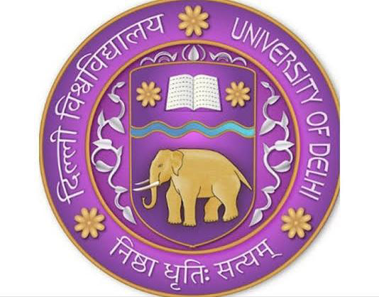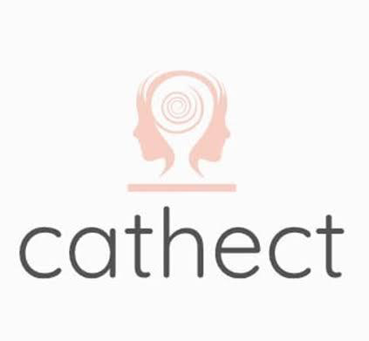

Cathect- Department of Psychology
Bharati College
University of Delhi

Collective reports of the council elections,
mental health day event, activities and workshop
that happened under the banner of
Cathect - Department of Psychology
from September 2023 onwards under
Dr. Sonia Kaushik, TIC
Department of Psychology

Cathect- Department of Psychology
Bharati College
University of Delhi
Report on Council Elections - 2023- 24

20th September 2023, Bharati College, University of Delhi: Cathect Society, the Department of Psychology of Bharati College conducted the council elections for the session 2023-24.
The nominations for the council posts were pre-invited via departmental email address. The candidates contesting for the position of the President, Vice President, Joint Secretary and Treasurer had successfully carried out their campaigning for all the years, providing distinct yet encouraging visions for their roles in the council. Every election is determined by the people who show up and students from the department give their coveted votes to their desired candidate. The elections were held with utmost transparency under the supervision of the esteemed professors. The new office bearers expressed their gratitude and vowed to work for the betterment of society.
The individual interviews for the remaining council were carried out by Dr. Nitin Kumar Verma and Ms. Tavishi Sanghi on 21st September 2023 along with the presence of the President. The heads and respective members of the creative, editorial, event management, public relations and social media team were finalised. The new council was warmly welcomed with each member looking forward to work with full potential and vigour.

Key Highlights of the Election
- Held on 20th September 2023 at Bharati College by Cathect Society, Department of Psychology.
- Transparent elections with pre-invited nominations.
- President, Vice- President, Treasurer and Joint Secretary were elected by the students of the department.
- Remaining council was selected on the basis of an interview by Dr. Nitin Verma and Ms. Tavishi Sanghi.

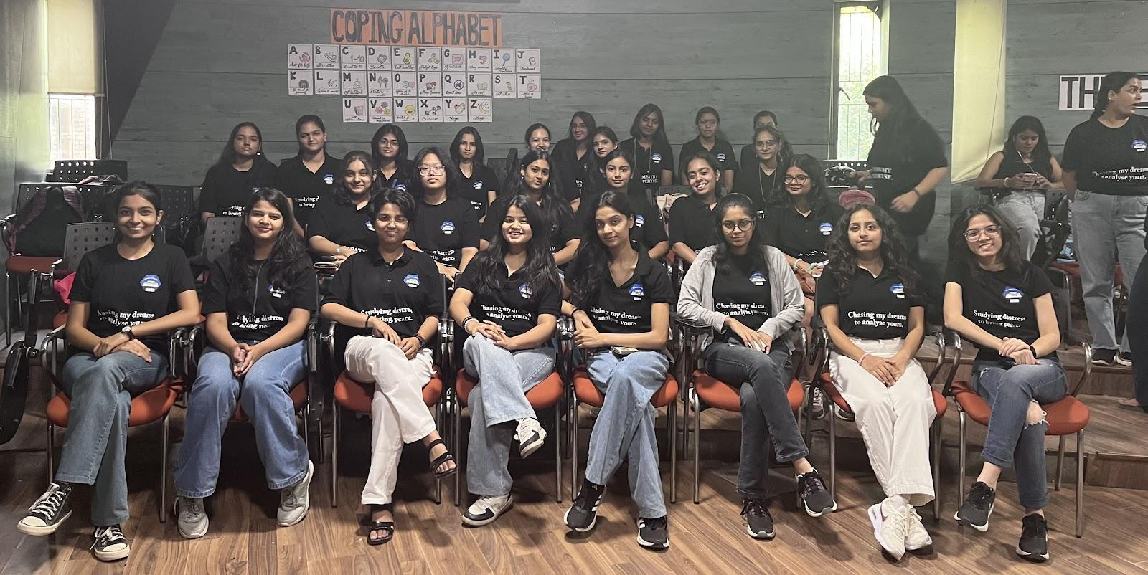

Cathect- Department of Psychology
Bharati College
University of Delhi
Report on Mental Health Day event, Wabi-Sabi: The Elusive Beauty of Imperfection

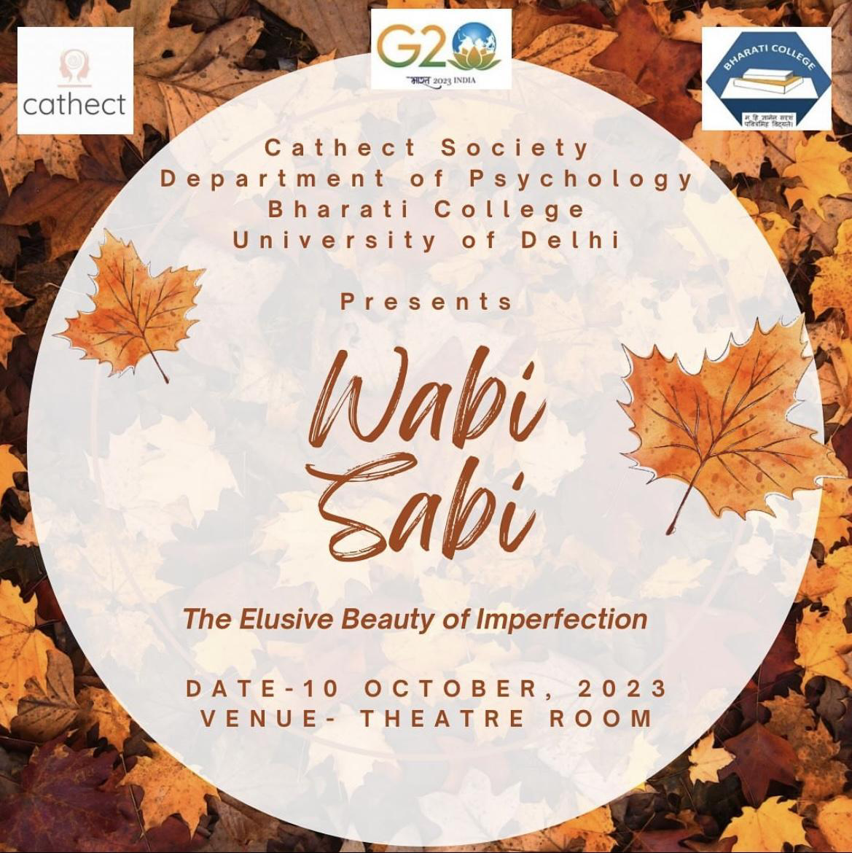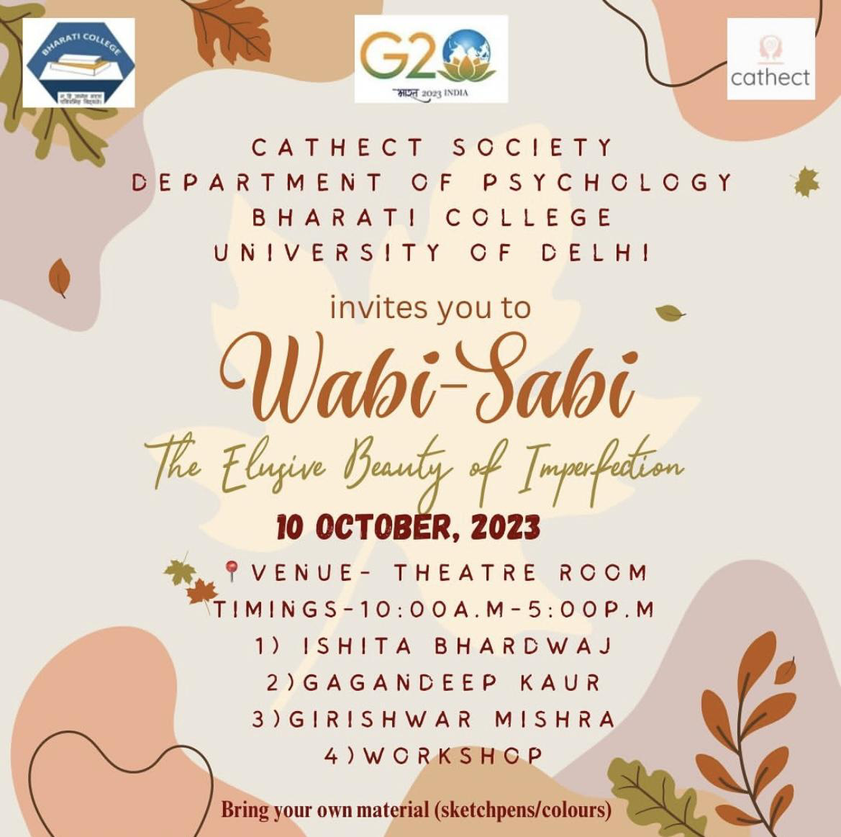

10th October 2023, Bharati College, University of Delhi: Cathect Society, the Department of Psychology of Bharati College celebrated World Mental Health Day to create awareness among the youth regarding mental health. The theme of this year’s event was “Wabi Sabi: the Elusive Beauty of Imperfection”. The event took place in the theatre room of Bharati College with a warm and gracious welcome accompanied by the ceremonial lighting of the lamp, as well as a mesmerising dance performance. The event was graced by Dr. Sonia Kaushik our TIC who delivered a welcome speech for the attendees.
The event was graced by the speaker of the day Dr. Ishita Bharadwaj who elaborated on the “I think, therefore I am” concept which was given by Descartes. She talked about the importance of pause and relaxation in everyday life and addressing the gaps in communication and concluded her session with a poem by Shankar Nath. It was enlightening for the students to hear her words of wisdom.
The second speaker for the day was Ms. Gagandeep Kaur. She took the audience on a journey into the heart of the event’s theme: Wabi Sabi and how one needs to accept their broken parts to heal and find peace within themselves. At the end of her speech Ms. Gagandeep Kaur, along with her team conducted a small activity with the students that helped identify the things that are actually under our control and the reason why we cherish them so much. The team also gave out handwritten self- love affirmations to all the seminar attendees.
Ms. Mehak, the director and founder of Youth Action of India was invited to the stage. She focused on sustainable goals and how every action, however small it is, has a definite consequence.
The most awaited speaker of the day was none other than the renowned Professor Girishwar Mishra with his years of expertise and knowledge in the field of psychology who talked about the meaning and importance of well- being and the connection between happiness and success. He emphasised on the importance of "yoga" to gain a clarity of self and talked about the importance of change and permanence quoting "the only thing that's permanent in human life is change". It was highly educational for all the students who were present in the audience.
The event took an interesting turn as the hosts welcomed Miss Shruti Garg who is a well-versed drama therapist. She encouraged the audience to join her on the stage forming a circle where she performed different types of activities like introducing ourselves through fun filled attention activities, picking your favourite sport from the magic box to name a few, in order to help everyone feel calm and release their emotions. It was really an enriching experience and enlightening for everyone present there.
The department of psychology set up stalls that represented the talent of the students of the department through beautiful handmade stickers, bookmarks, paintings, resin keychains etc. Multiple purchases were made from the stalls and it was successful at creating awareness on mental health and its growing impact on people.
The event concluded with an appreciation speech by esteemed professor of the psychology department Dr. Nitin Verma and a reminder that the concept of beauty is subjective and personal. Each individual’s journey towards self- awareness and acceptance is unique and true beauty is found when one learns to appreciate their imperfections and those of the world around them.

Key Highlights of the Event
- Celebrated on 10th October 2023 in the Theatre Room, Bharati College.
- Theme: "Wabi-Sabi: The Elusive Beauty of Imperfection."
- Event graced by TIC of Psychology Department Dr. Sonia Kaushik.
- Enlightening talks by Dr. Ishita Bharadwaj, Ms. Gagandeep Kaur and Professor Girishwar Mishra.
- Drama therapy workshop conducted by Ms. Shruti Garg.
- Vote of thanks and appreciation given by the TIC Dr. Sonia Kaushik and Prof. Nitin Verma.

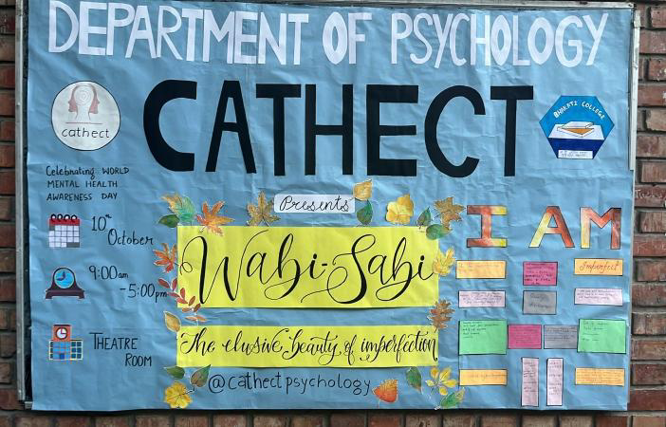

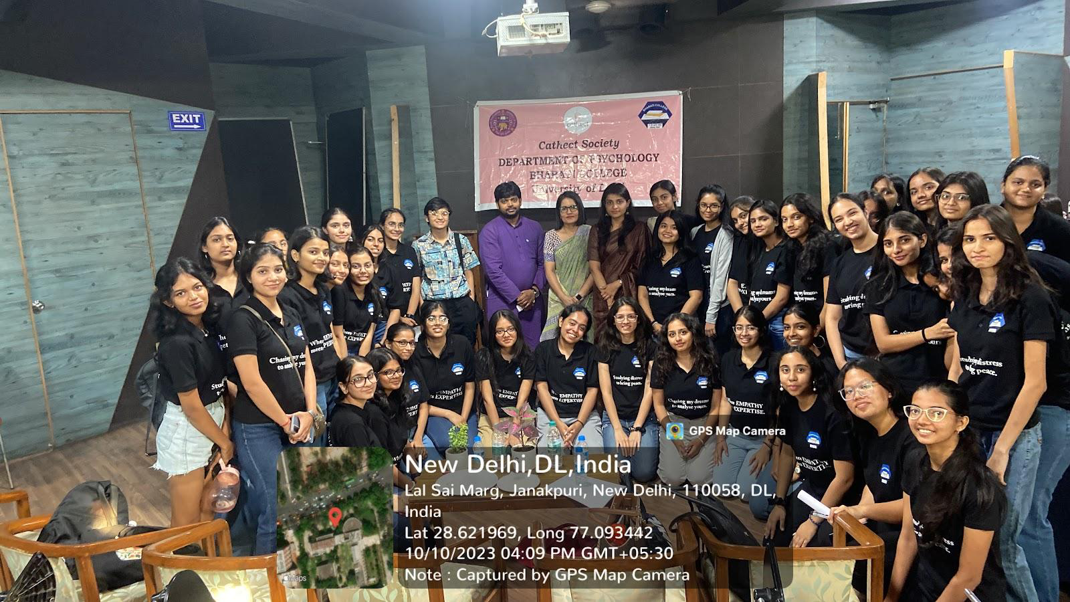

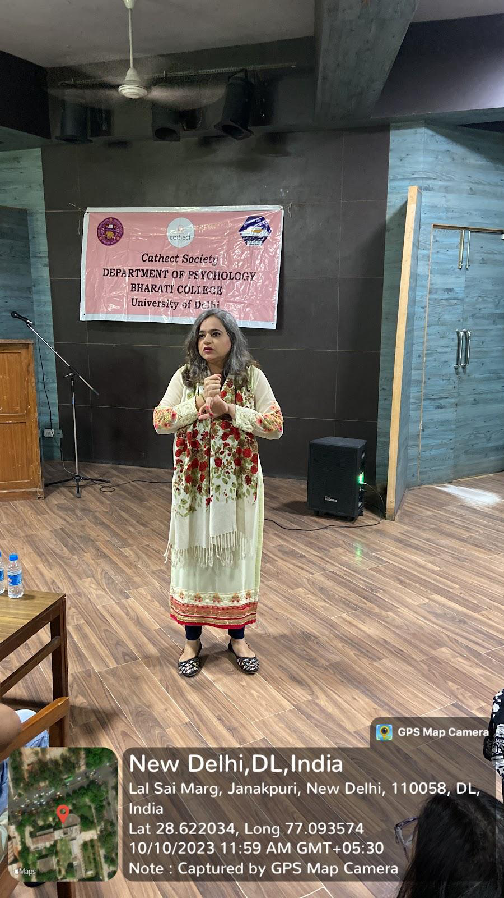
.

Cathect- Department of Psychology
Bharati College
University of Delhi
Report on Team Bonding Activity

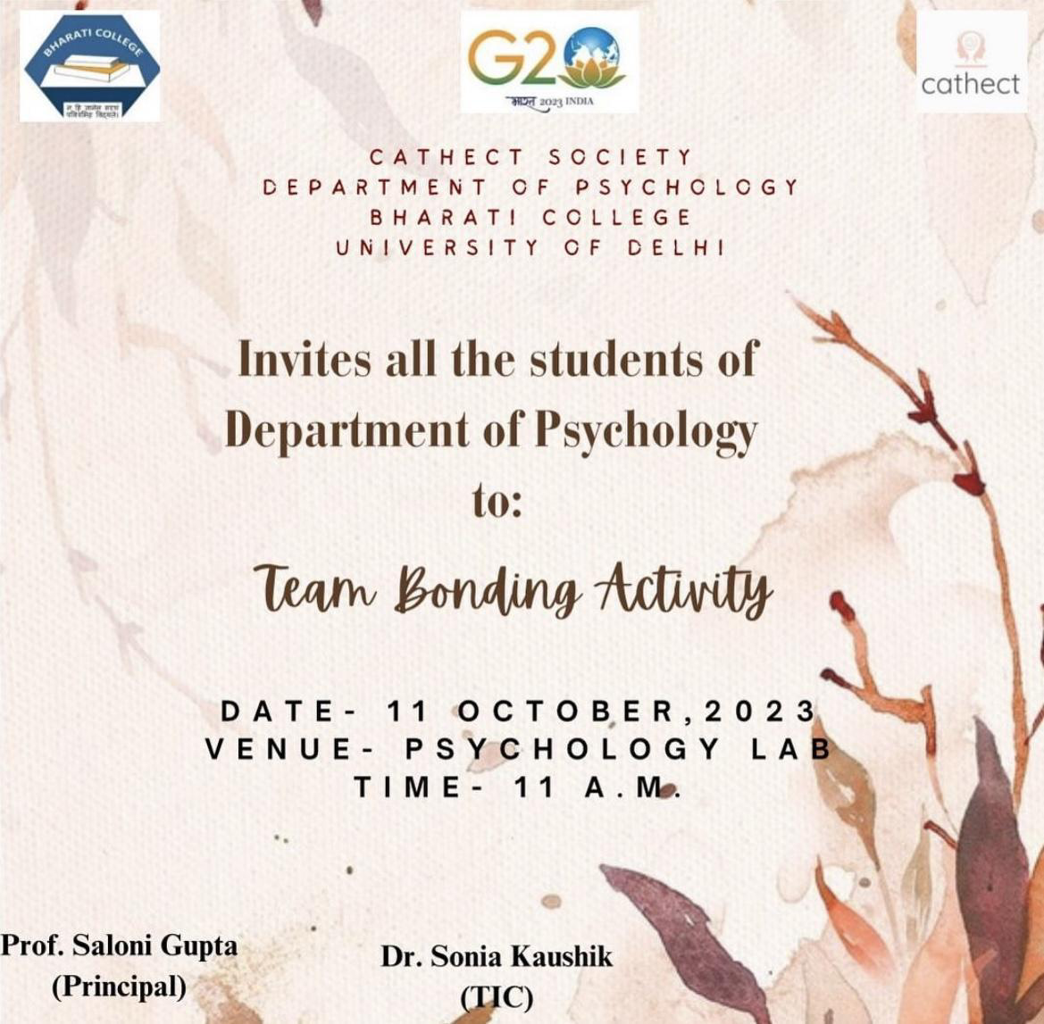

11th October 2023, Bharati College, University of Delhi: Cathect Society, the Department of Psychology of Bharati College organised a team bonding activity for the students of the department in the psychology lab.
The bonding activity was organised by the volunteers from 3rd year who organised various fun activities to increase cohesiveness and interaction among the students for all three years. Students from each year were randomly selected and grouped into various teams each. As an ice breaker activity every group had to come up with a unique name and a characteristic that they felt defined them. The teams had competed in various games such as enacting a movie scene, musical chairs etc. with each member representing their group and making effective strategies to win the game. As a closing activity students gathered in a circle and told the name and a quality of the person that they admire standing right next to them. The closing activity helped students to know about each other better and the words of affirmations from each one present filled the lab with positivity and hope
The team bonding activity was successful in establishing a healthy freshmen-senior bond with credits owed to the organisers from 3rd year, society, our respected professors and all the participants who attended the activity.

Key Highlights of The Activity
- Organised on 11th October 2023 in the Psychology Lab, Bharati College.
- Fun activities fostering interaction and cohesion among students were conducted.
- Pleasant freshmen-senior bond was successfully established

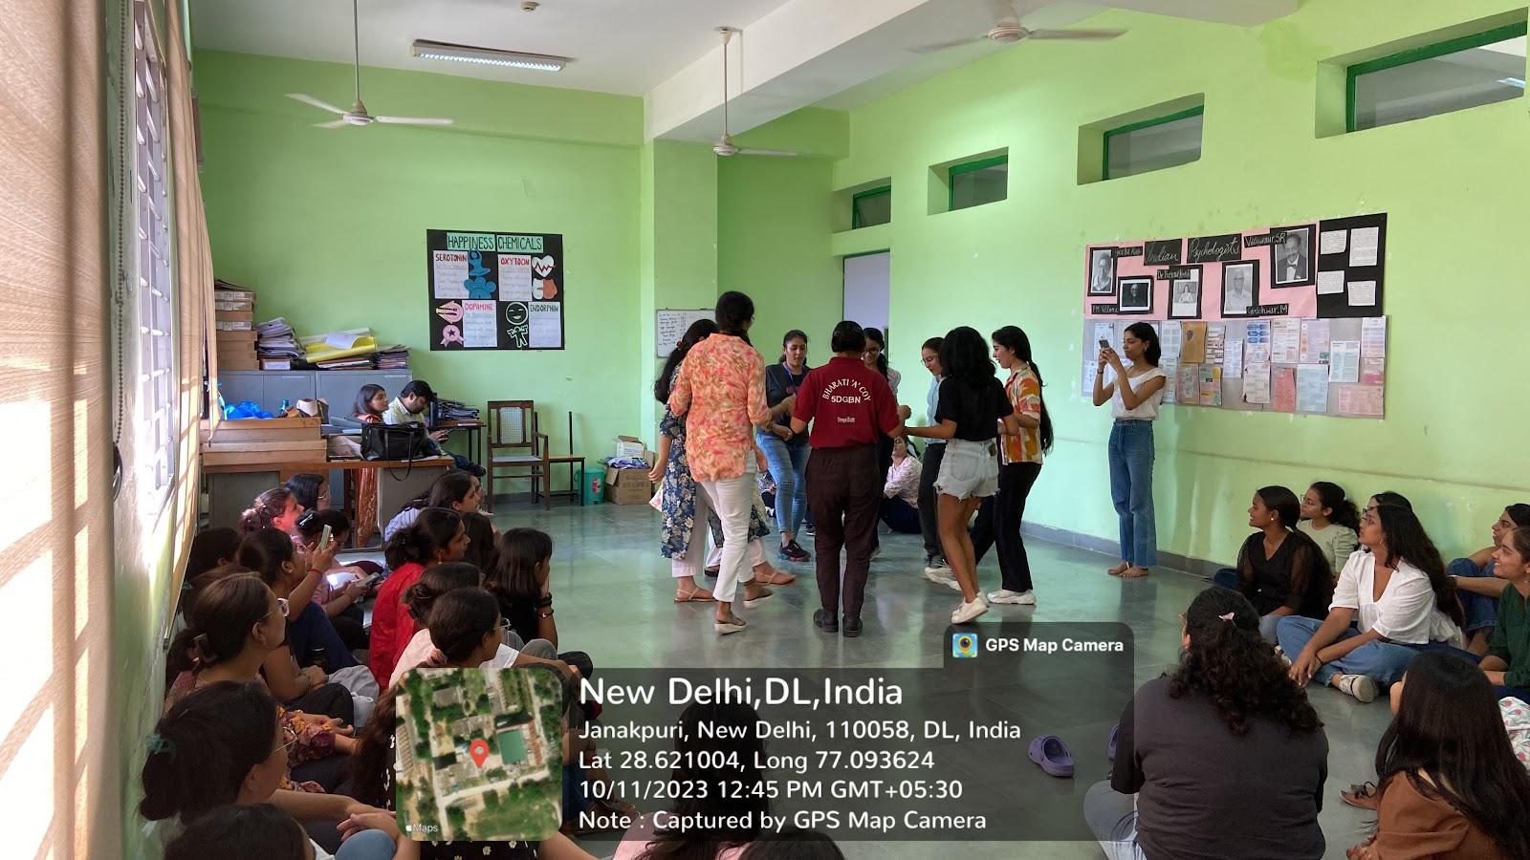
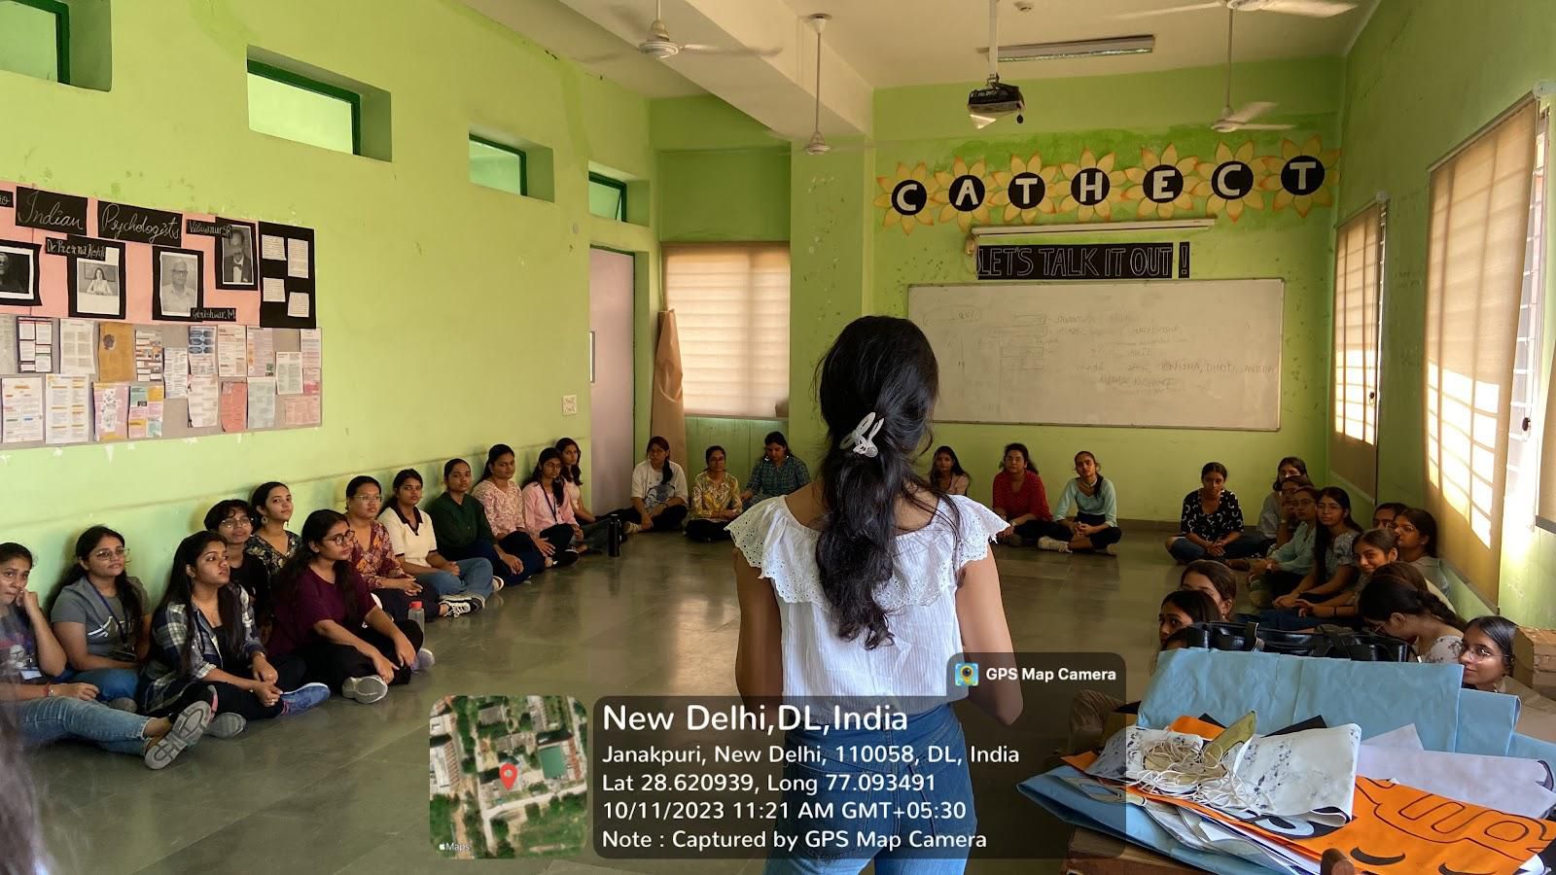

Cathect- Department of Psychology
Bharati College
University of Delhi
Report on Mental Status Examination Workshop

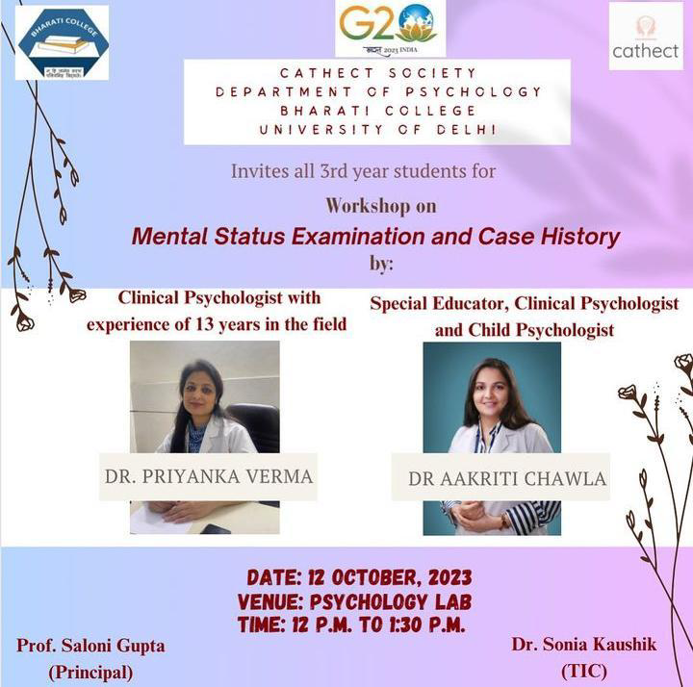

12th October 2023, Bharati College, University of Delhi: Cathect Society, the Department of Psychology of Bharati College organised a workshop on case history and mental status examination for all the students of third year in the psychology lab.
The facilitators of the workshop were Dr Priyanka Verma a clinical psychologist with over 13 years of work experience and Dr Aakriti Chawla a special educator, clinical psychologist and child psychologist affiliated to the renowned World Brain Hospital, New Delhi.
The workshop which lasted for about an hour included a detailed description and procedural demonstration of case history taking as well as administration of mental status examination on patients in clinical and counselling settings. The facilitators provided knowledge through presentation of cases and examples and was marked with an interactive and doubt clearing session.

Key Highlights of the Workshop
- Conducted on 12th October 2023 at Bharati College, University of Delhi.
- The workshop facilitators were Dr. Priyanka Verma, Clinical psychologist and Dr. Aakriti Chawla, Special Educator and Clinical Psychologist.
- The workshop on case history and mental status examination facilitated included detailed description and procedural demonstration of Mental Status Examination on patients in clinical and counselling settings.

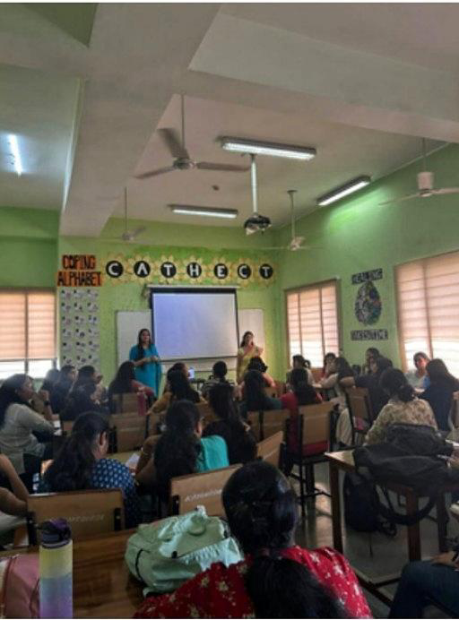

Cathect- Department of Psychology
Bharati College
University of Delhi
Report on Alumni Meet 2023-2024

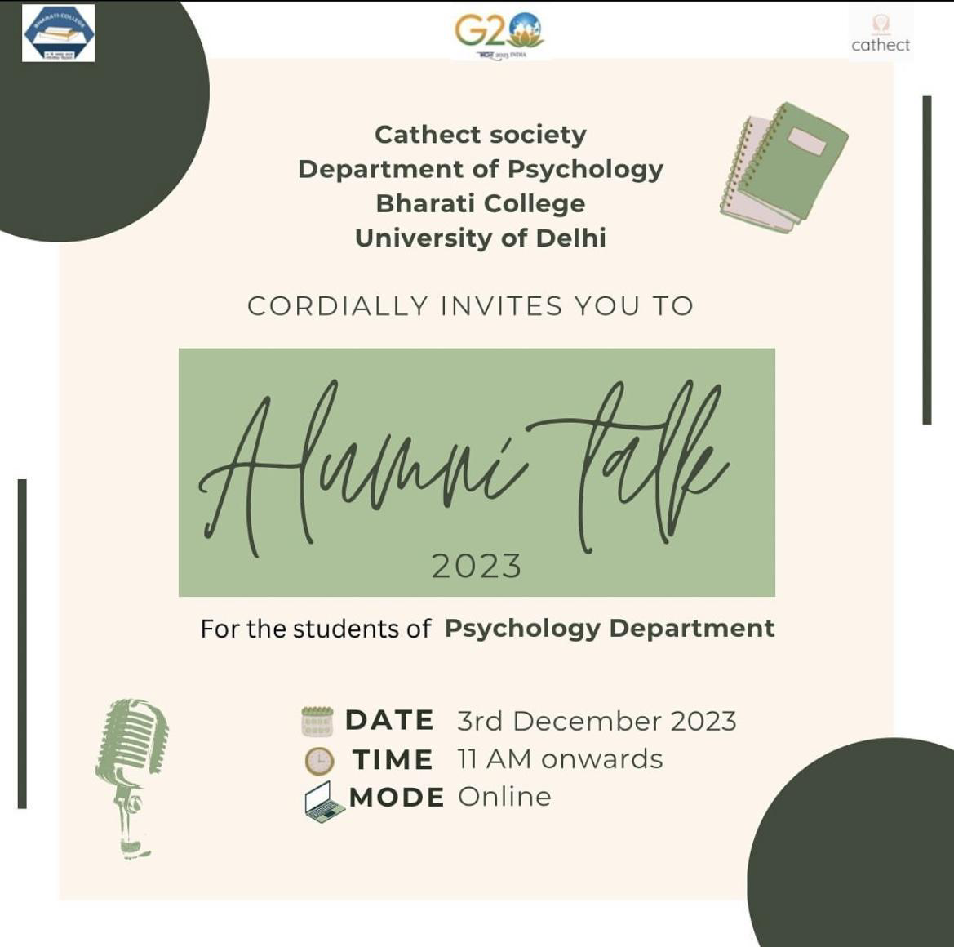

3rd December 2023, Bharati College, University of Delhi: Cathect Society, the Department of Psychology of Bharati College conducted the Alumni Meet to guide the students regarding the process of securing admission in Masters programmes in India and abroad. The session kicked off promptly at 11:00 A.M. sharp in an online mode via google meet. The speakers for the event came from diverse prestigious institutes from all around the world.
The session commenced with Trisha Ladha, currently pursuing a M.Sc. in Counselling Psychology from Christ University, Bangalore sharing her thoughts on opting counselling psychology. Following Trisha, Muskaan Misrapursuing M.A. in Psychology from University of Delhi and Bhoomi Rajpal from Amity University pursuing M.A. in Clinical Psychology gave their respective insights and tips to prepare for entrance exams. Keeping the session engaging, Muskan Makhija from the Adler University pursuing M.A. in Industrial and Organisational Psychology talked about her experiences.
After a refreshing break, Disha Bhatt enlightened the audience with her experience as a student specialising in M.A. Applied Psychology (Clinical and Counselling) from the renowned Tata Institute of Social Sciences (TISS) in Mumbai. Next, Riya Shokeen from National Forensic Science University explained her field of interest in M.A. Criminology with specialisation in Forensic Psychology. Continuing the informative session Simran Dua from University of Bath pursuing M.Sc. in Applied Clinical Psychology and Kriti Malhotra from Jamila Milia Islamia pursuing M.A. Applied Psychology interacted with the audience and exchanged their ideas.
All the speakers not only gave their insightful opinions but also guided the students about the admission process and entrance exam preparation for their respective universities. They cheered for the audience and highlighted the importance of balance between studies and self- care. Concluding the event, Ms. Tavishi Sanghi thanked all the speakers for successfully connecting different experiences and insights, providing a comprehensive guide for the students.

Key Highlights of the Alumni Meet
- Held on 3rd December 2023 at Bharati College, University of Delhi.
- The speakers for the talk were - Trisha Ladha from Christ University Bangalore, Muskaan Misra from University of Delhi, Bhoomi Rajpal from Amity University, Muskan Makhija from Adler University, Diksha Bhatt from Tata Institute of Social Sciences (TISS) in Mumbai, Riya Shokeen from National Forensic Science University, Simran Dua from University of Bath and Kriti Malhotra from Jamia Milia Islamia.
- Alumni shared insights and tips for admission into Masters programs, both in India and abroad. They talked about their unique experiences as well.
- Ms. Tavishi Sanghi thanked the speakers for providing a comprehensive guide for the students.

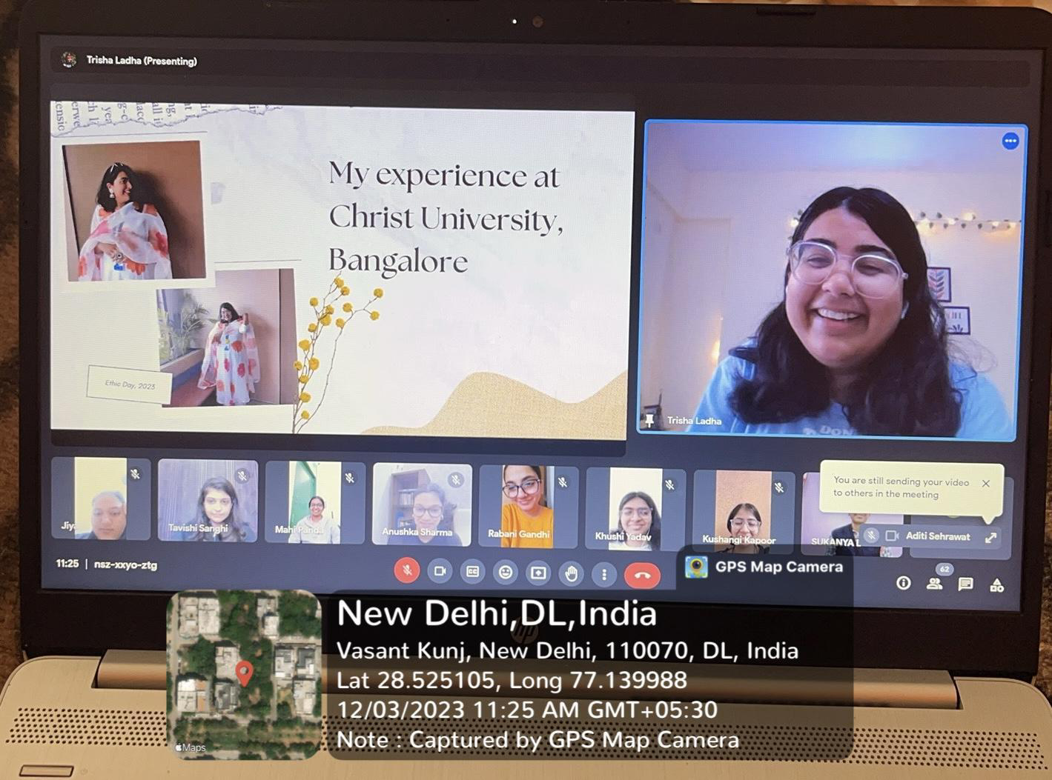

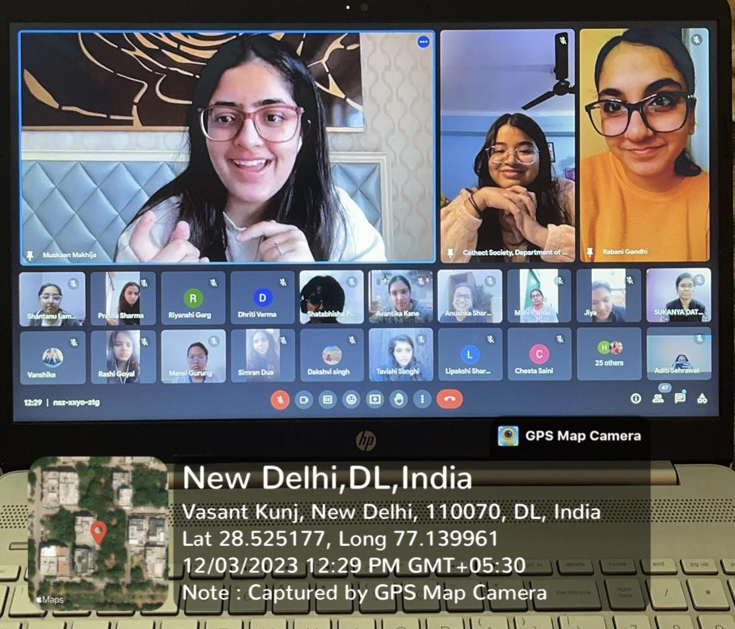

Cathect- Department of Psychology
Bharati College
University of Delhi
Report on Wallpaper Installation

6th December 2023, Bharati College, University of Delhi: Cathect Society, the Department of Psychology of Bharati College Collectively took the initiative to
renovate the psychology lab by installation of wallpaper.
The planning and execution for the renovation of the psychology lab was preceded by the approval of all the respective authorities for the usage of wallpapers along with the presentation of a well-structured budget funded by the department students. The creative team of the department worked with dedication and precision to make use of each and every material to make the designated area look flawless.

Key Highlights of the Work
- Completed on 6th December 2023 at Bharati College, University of Delhi.
- Renovation initiative by Cathect Society, enhancing the aesthetics of the psychology lab was initiated.
- Approval of all the respective authorities for the usage of wallpapers along with the presentation of a well-structured budget, funded by the department students.
- The creative team worked with precision to make use of each and every material to make the designated area look flawless.
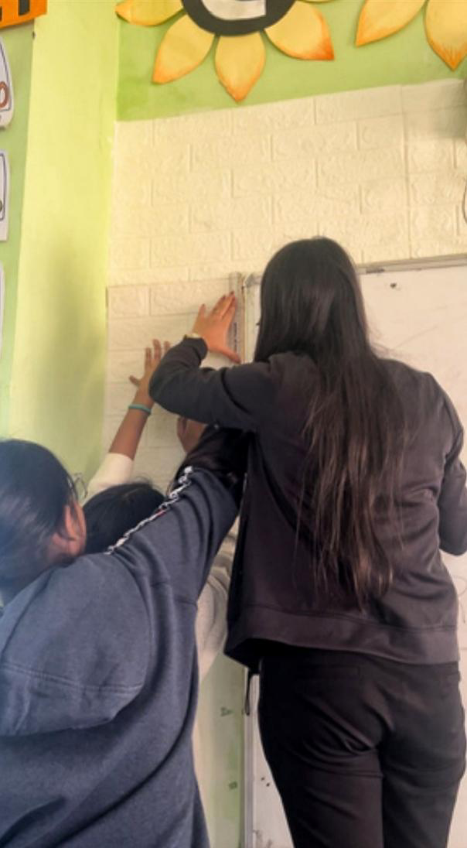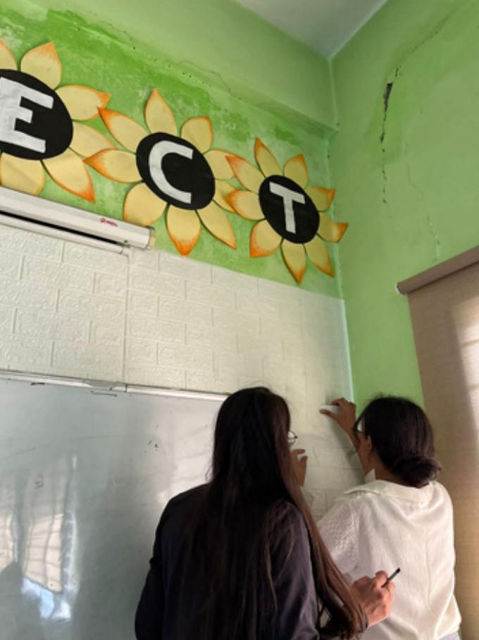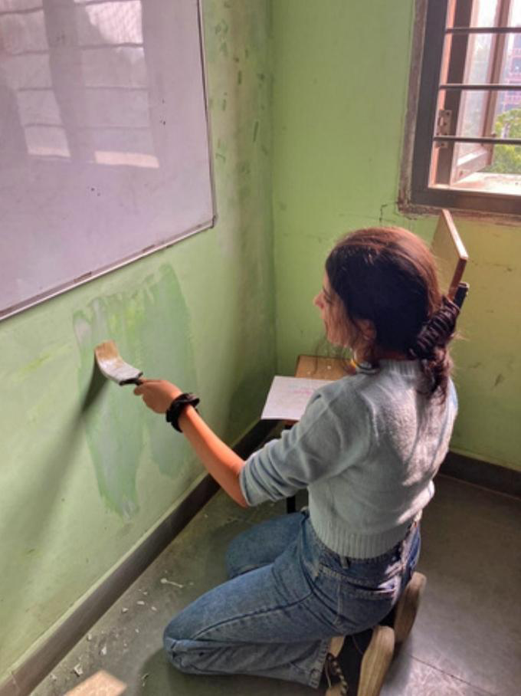

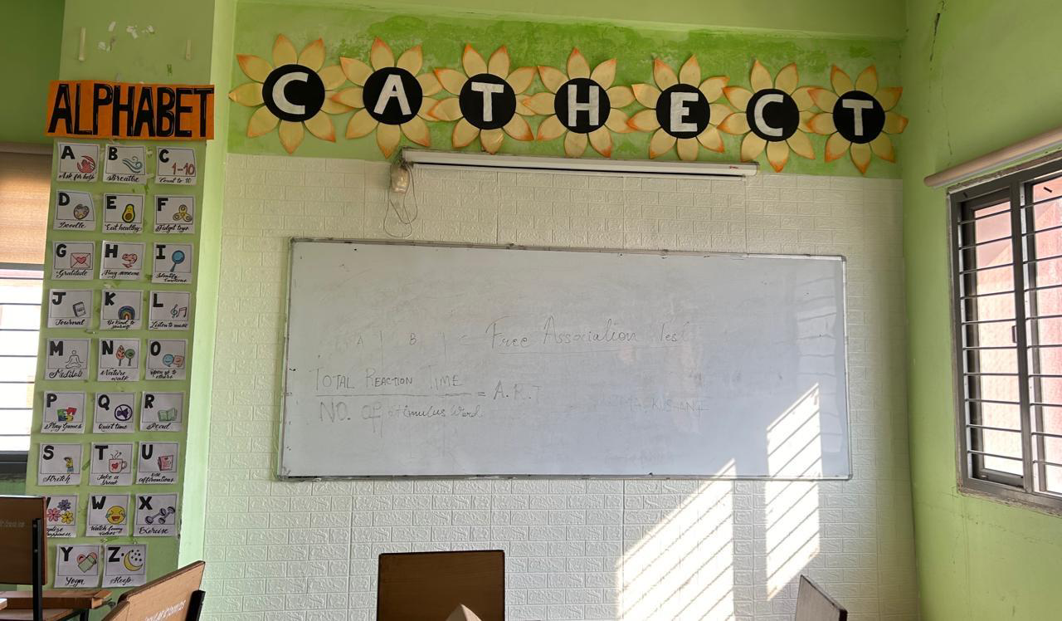

Cathect- Department of Psychology
Bharati College
University of Delhi
Report on Movie Screening
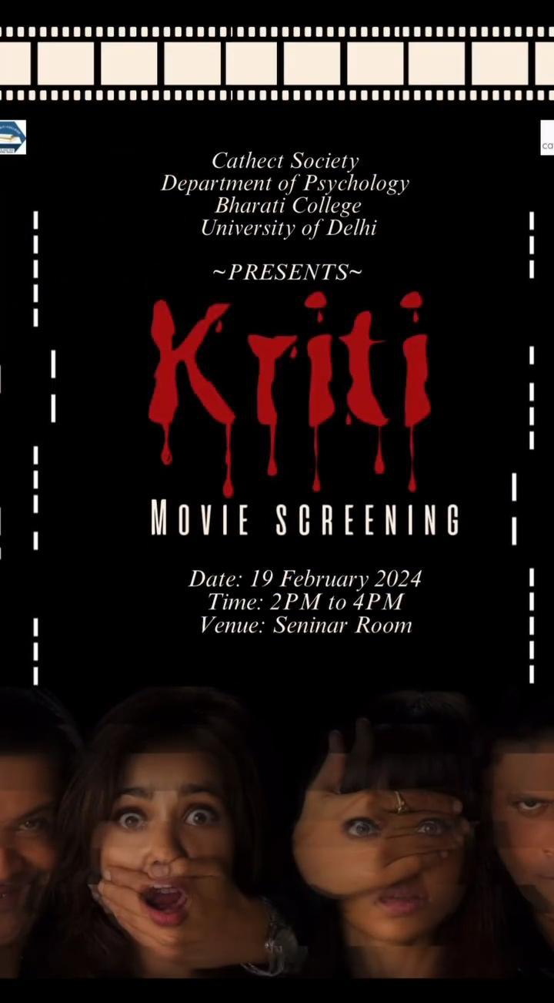
19th February 2024, Bharati College, University of Delhi: Cathect Society, the Department of Psychology of Bharati College organised a Movie Screening in the seminar room. The short film ‘Kriti’ was essentially a psychological thriller which revolved around the life of a schizophrenic character and a brief scene depicting agoraphobia. It touched important aspects of the life of people going through such mental disorders.
Following the screening, Ms. Tavishi Sanghi of the psychology department elaborated on the ethics of clinical therapy, delving deeper into the fact that how an ideal therapist should deal with a client having a mental illness. An engaging discussion took place, with the students focusing on the psychological aspects depicted in the movie. The students discussed the difference between depiction of mental illness in the movie and in real life. Following the insightful discussion, a quiz was organised to test the knowledge of the students. The questions were related to the mental illnesses and symptoms depicted in the movie. The event ended with a feedback session wherein students appreciated the initiative and encouraged more such events.
Key Highlights of The Activity
- Screening of the short film ‘Kirti’ in the seminar room.
- Ms. Tavishi Sanghi facilitated the discussion on the movie.
- A small quiz based on the symptoms and disorders depicted in the movie.
- Feedback of the movie screening.
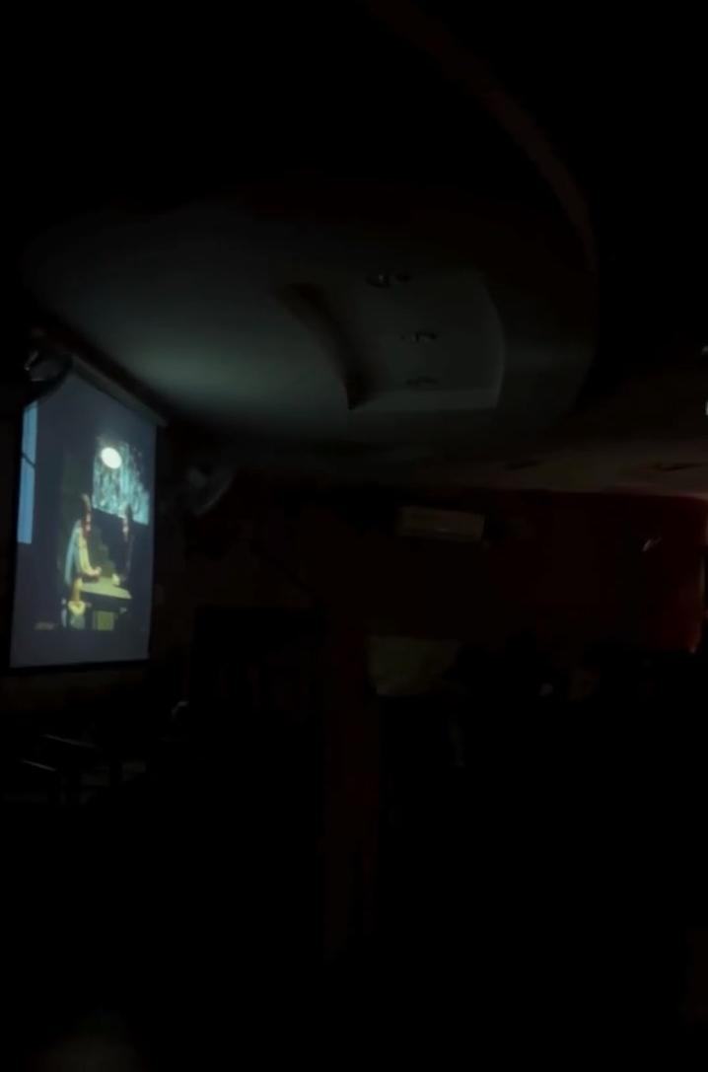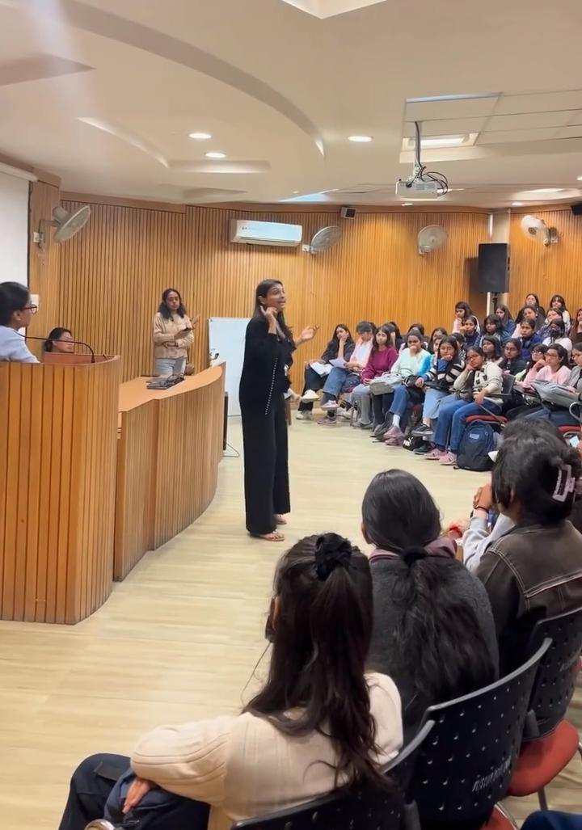

Cathect- Department of Psychology
Bharati College
University of Delhi
Report on Field Visit

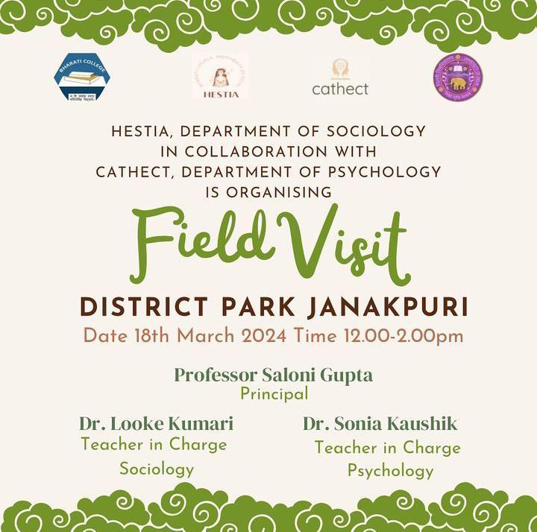
18th March, 2024, Bharati College, University of Delhi:
Program: Field visit to District park, Janakpuri in collaboration with Hestia, Department of Sociology
Objective of the Event: To foster an environment for the students of second year where they can observe and interact with nature and people, and understand why certain things appeal to us.
Summary of the event:
Cathect: Department of Psychology organized a collaborative field visit to District park, Janakpuri with Hestia: Department of Sociology, Bharati College. The aim of the field visit was to help students observe and interact with people and understand social realities from the point of view of a budding psychologist or sociologist. The event was led by Ms. Reebika on behalf of the psychology department.

Upon reaching the park, the teachers briefed the students about the guidelines to be followed during visit. These involved instructions such as refraining from littering in the park and avoiding plucking flowers. After making sure that the guidelines were understood by the students, the teachers proceeded to elaborate on the tasks that were to be taken up. The students were divided into groups or individuals based on their preferences and were asked to interact and observe the people in the park while simultaneously making notes of their observations.

After a period of observation, everyone was asked to gather and form different groups to discuss their observations from the interactions they had. Students shared that spending time in nature had a calming effect and made them feel at peace. The event was concluded by diving into some wholesome perspectives gained through the visit. The students were asked to submit their written reflections of the visit to their respective teachers.

Highlights of the event:

- The field visit was executed in collaboration with Hestia: The Sociology Department.
- 2nd year students visited District Park, Janakpuri on Feb. 18th, 2024.
- Students got the opportunity to interact with nature and interact with their peers.
- An exchange of perspectives was observed through the collaborative approach.

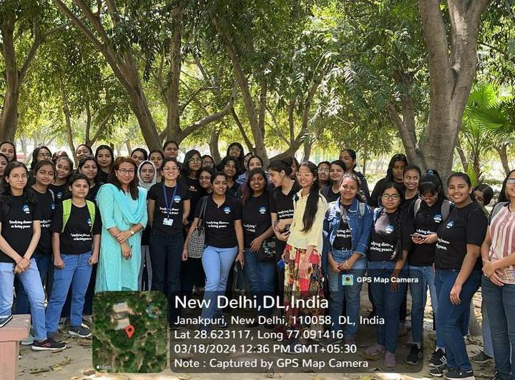

Cathect- Department of Psychology
Bharati College
University of Delhi
Report on Mental Status Examination Workshop

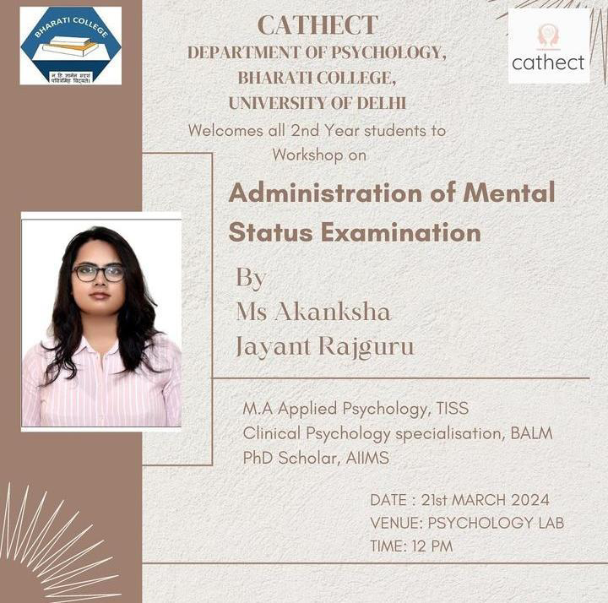

21st March, 2024, Bharati College, University of Delhi:
Program: Mental Status Examination, Case History and APA Formatting Workshop
Objective of the Event:
To guide the second year psychology students on conduction ofMental Status Examination, Case History and the format of research at APA.

Summary of the Event:
Cathect: The Department of Psychology, Bharati College, University of Delhi organized a workshop in the psychology lab for second year students on Mental Status Examination and Case History. The workshop was conducted by Ms. Akanksha Jayant Rajguru, who holds a Master's degree in Applied Psychology along with a specialization in Clinical Psychology. Ms. Tavishi Sanghi commenced the session by giving a brief introduction about the workshop facilitator to the students. After the introduction, Ms. Rajguru was welcomed on the stage with a resounding round of applause.

As Ms. Akanksha started the workshop, she lightened the whole atmosphere with her cheerful aura. She talked about the importance and procedure of doing a case history examination. She made sure that the students were clear about minute details that need to be taken care of while taking a case history and highlighted the importance of demographic details, psychiatric, genetic, medical and substance history. She made sure that students can comprehend well whatever she explains and used a bilingual approach.

Before delving into the topic of mental status examination, Ms. Rajguru addressed the queries raised by the students. She then proceeded forward with a brief introduction of MSE, talking about its significance in clinical psychology. Following that she elaborated on the dimensions that are required to be assessed while conducting MSE. Furthermore, she provided students with some techniques and tips that will help them evaluate these dimensions effectively. She used a practical approach while enlightening the students and took help of role play activities and mnemonics while helping students understand and memorize the information shared during the workshop.

Towards the end of the workshop, she explained to students about the APA format and things that need to be taken care of while writing the practical. Overall the workshop was truly insightful and fostered an interactive learning session for the students. The cheerful demeanor of Ms. Akanksha Jayant Rajguru created a comfortable atmosphere for the students, encouraging them to freely ask questions and participate actively.

Highlights of the event:
- Conducted on Mar. 21st,2024 in Bharati College premises.
- The workshop was facilitated by Ms. Akanksha Jayant Rajguru.
- Ms. Akanksha Jayant Rajguru ensured that students gained a comprehensive understanding of the minute details essential in taking a case history and Mental Status Examination (MSE).
- Ms. Akanksha Jayant Rajguru's positive and friendly attitude during the workshop fostered a comfortable environment for students to raise their queries.

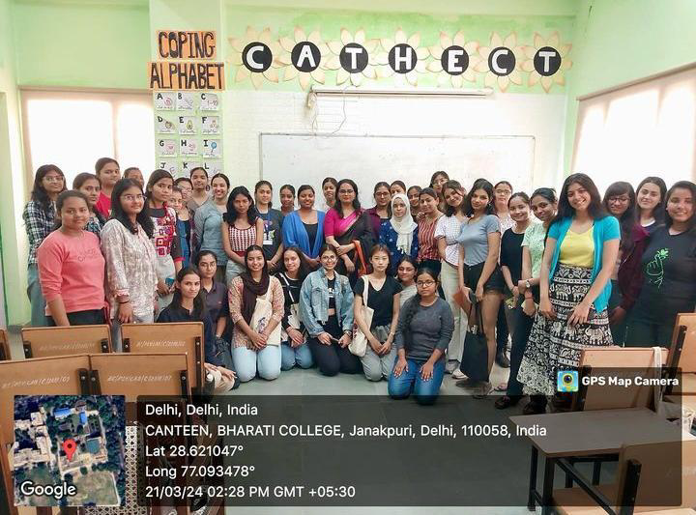

Cathect- Department of Psychology
Bharati College
University of Delhi
Report on Annual Event ‘Mudita’

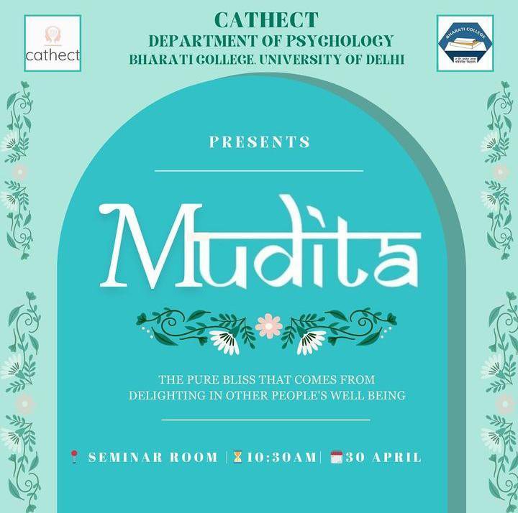

30th April, 2024, Bharati College, University of Delhi:
Program: Annual Departmental Fest- ‘Mudita 2024’
Objective of the Event: To enlighten the students of the department of psychology about the importance of finding joy in the happiness of others.

Summary of the Event:
Cathect: The Department of Psychology of Bharati College organised the annual departmental fest “Mudita”, which is a Sanskrit word literally meaning ‘taking delight in the happiness of others’ vicarious joy’. The distinguished speakers for the event were - Dr. Navin Kumar, Dr. Priya Kanwar, Prof. Pooja V. Anand and Ms. Ridhima Sethi.
The event began with lighting the auspicious lamp of hope after warmly welcoming all of the esteemed speakers. The guest speakers were gifted with a sapling as a small token of appreciation. This auspicious start was followed by a radiant ode to the divine presence of Lord Ganesha by Ishika and Neha with their graceful dance movements, after which the speakers took the floor for their respective speeches.
Dr. Navin Kumar linked happiness to societal transformation and education, advocating gratitude and societal sharing within the National Education Policy for sustainability and collective well-being. He urged meaningful progress by addressing the gap between theory and practice, prompting listeners to prioritise holistic well-being in personal and societal development.
Dr. Priya Kansar emphasised meaningful connections over prosperity, highlighting qualities like friendship and deriving joy from others' well-being. She stressed setting boundaries, self-reflection, and empathy for personal growth, along with gratitude and finding meaning in adversity. Her speech inspired listeners to navigate life's challenges with a deeper understanding of happiness and fulfilment.
Moreover, Professor Pooja V.'s discussion navigated challenges like competition, personal struggles, and COVID-19, urging individuals to prioritise well-being and resilience. She emphasised the importance of self-improvement and focusing on strengths, particularly in the face of adversity. Additionally, professor Pooja V. addressed therapy stigmas and mental health, creating a safe space for discussion and destigmatization.
After the speakers shared their insights, there was a short break followed by a lively musical performance by Yuvraj Kakkar. His melodies filled the room and entertained the audience, who joined in on the singing spree, making the event even more lively.
Shortly after the break, Ms. Ridhima Sethi conducted a workshop on coping strategies and resilience-building techniques, emphasising the importance of prioritising mental health. She encouraged participants to view therapy as a preventive measure, echoing the age-old saying "Precaution is better than cure." One activity involved writing down sources of joy on paper, sealing them in balloons, and exchanging them, fostering laughter, understanding, and reflection among participants as they discovered shared experiences.
Concluding the event on a good note, Ms. Tavishi Sanghi gave the vote of thanks.
Feekings Ka Adda- Activities
At the event, the 'Feelings Ka Adda' booth, organised by the Department of Psychology students, offered engaging activities for emotional well-being. Feelings ka Adda initiative aims to provide a confidential and supportive listening environment for students, the activities at the booth further made the experience at the booth more interactive and promoted emotional expression and self-care. Participants who came to the booth could express feelings through Emotions and Mandala activities, while an anonymous Vent Out Box allowed for anonymous expression. Thumbprint activity and Reflection Buckets encouraged introspection. Symbolic henna tattoos added to the fun. The Feelings Ka Adda booth at Mudita 2024 proved to be a wholesome experience for the visitors and wrapped up at 1.30 PM.
Highlights of the event:
- Conducted on 30th April, 2024 in the seminar room of Bharati College.
- The fest commenced with the lighting of the lamp of hope, followed by a graceful dance tribute to Lord Ganesha.
- Dr. Navin Kumar advocated for societal transformation through gratitude and sharing in education.
- Dr. Priya Kansar emphasised meaningful connections and deriving joy from others' well-being.
- Professor Pooja V. addressed challenges like competition and COVID-19, promoting well-being and resilience.
- Yuvraj Kakkar's musical performance engaged the audience, making the event lively.
- Ms. Ridhima Sethi conducted a workshop on coping strategies and resilience-building, promoting mental health.
- 'Feelings Ka Adda' booth provided interactive activities for emotional well-being, including Emotions and Mandala activities, Vent Out Box, Thumbprint activity, and Reflection Buckets.
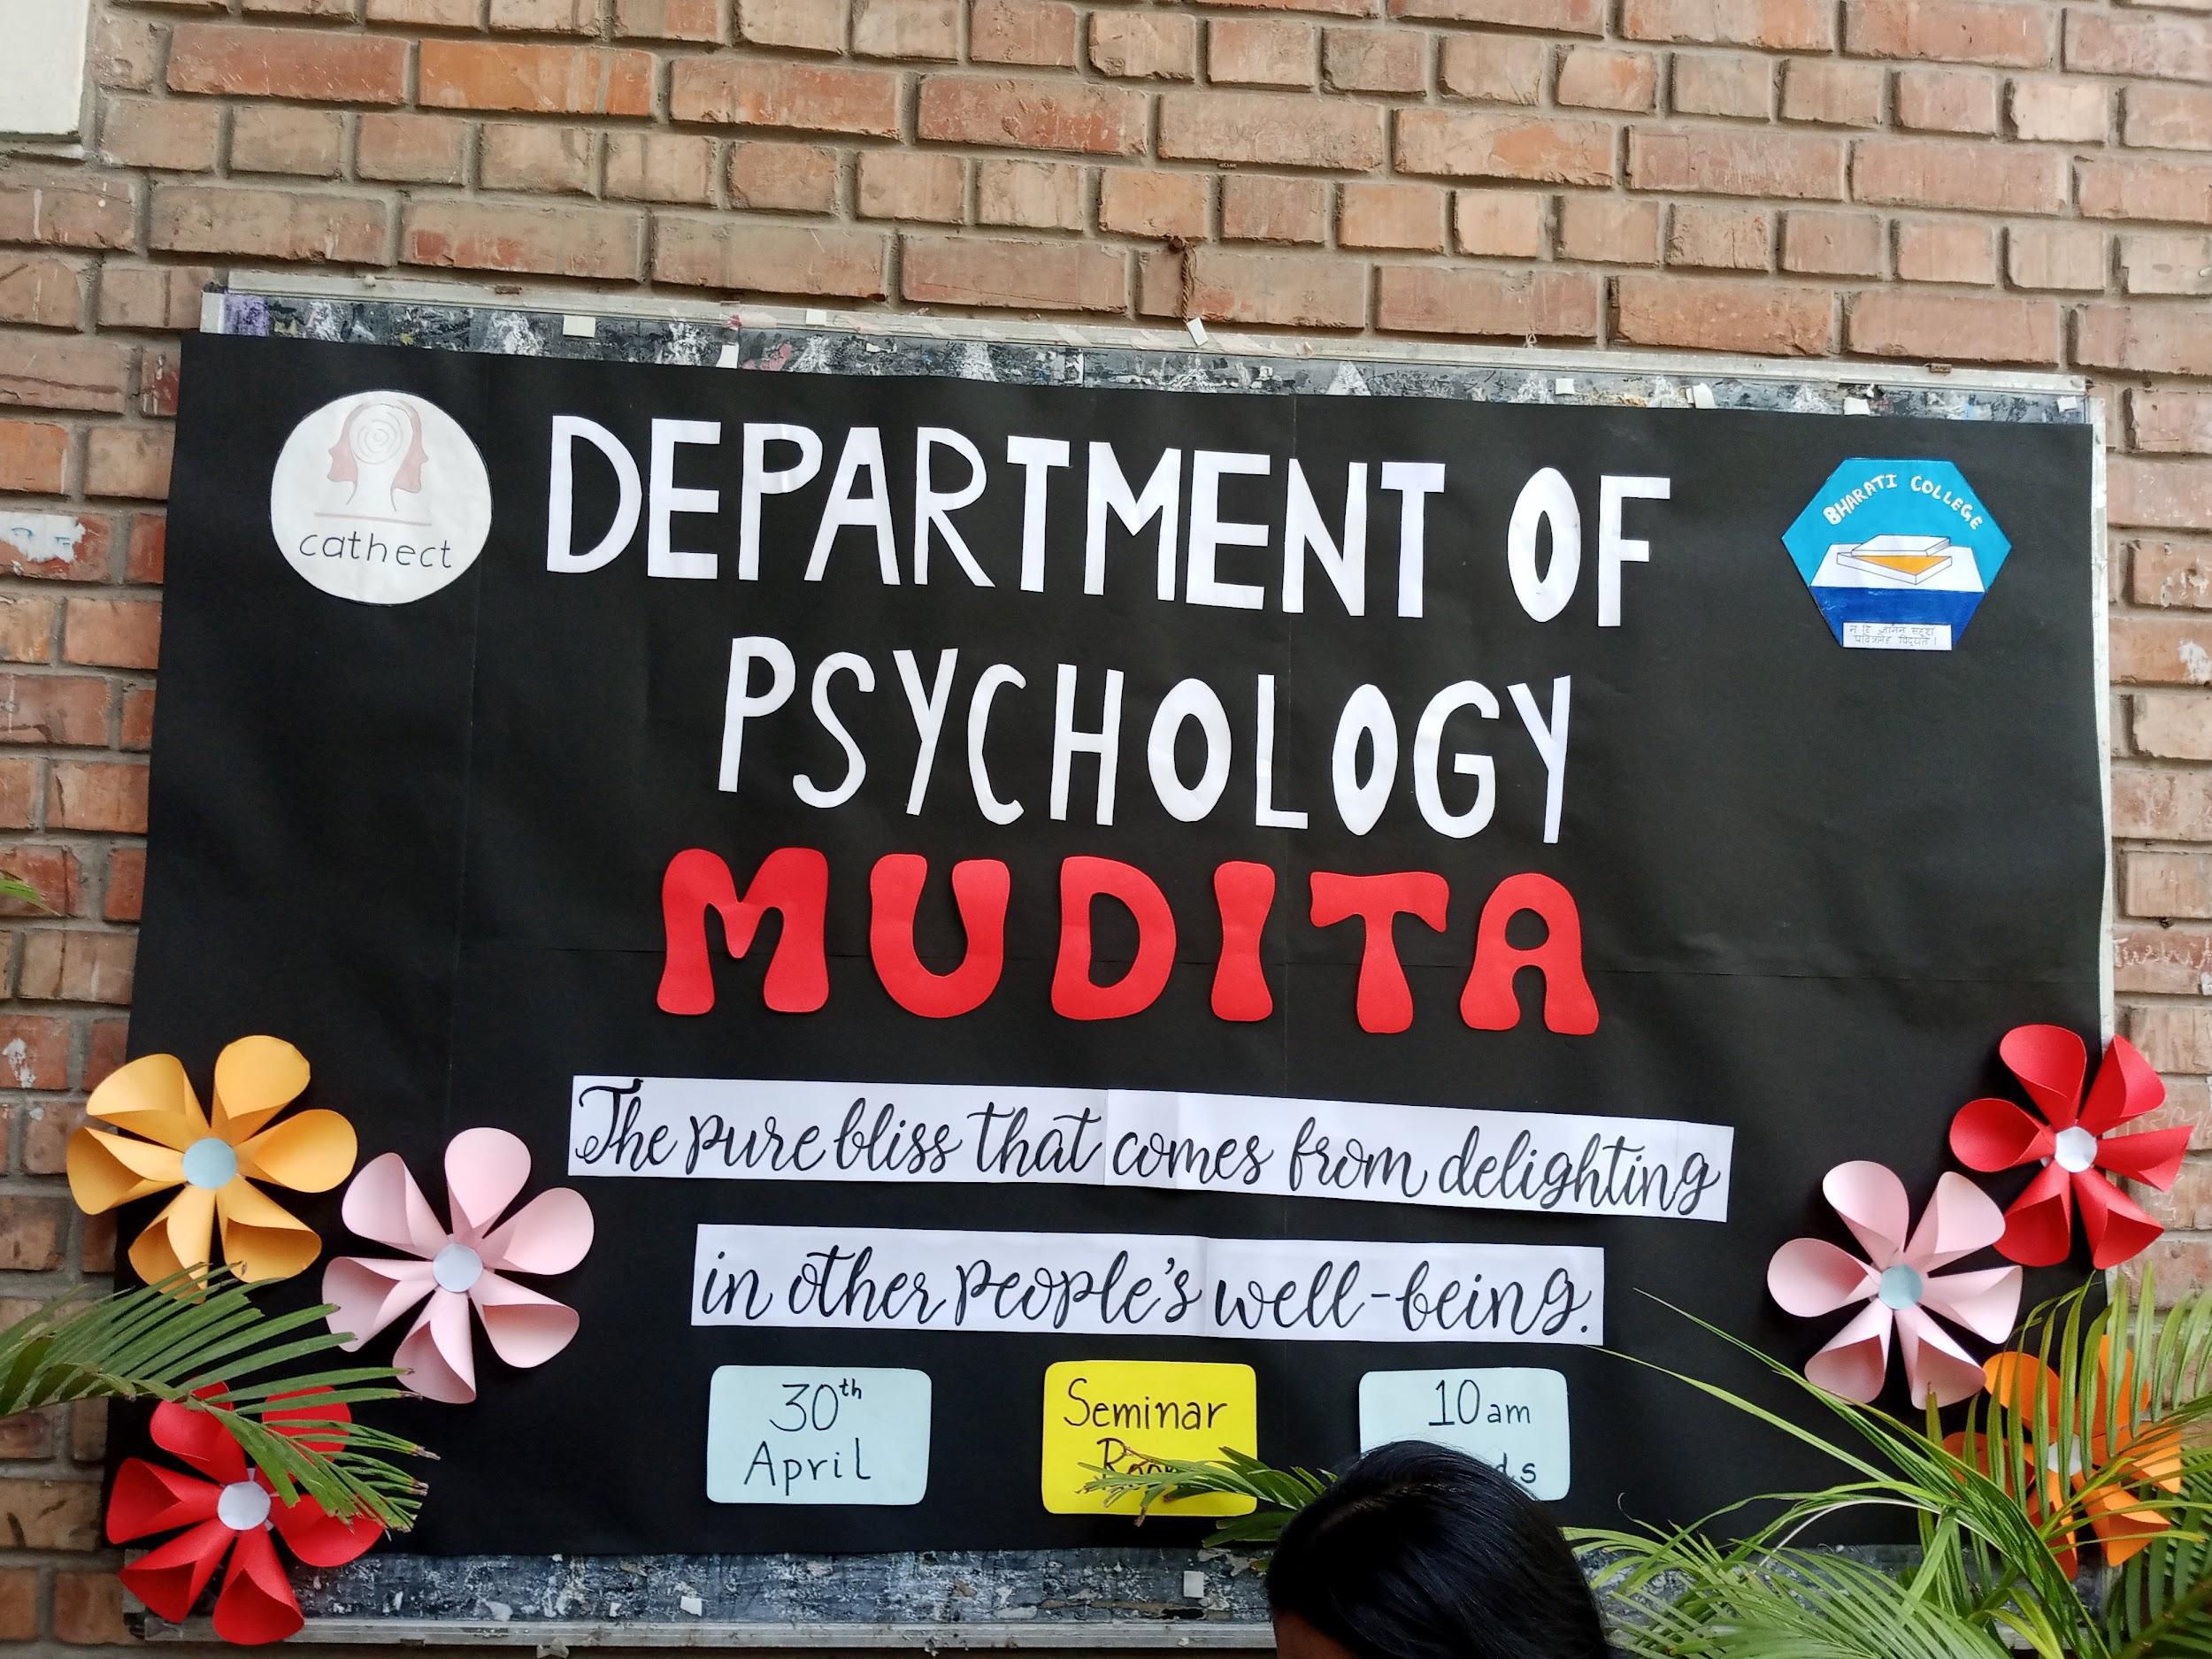

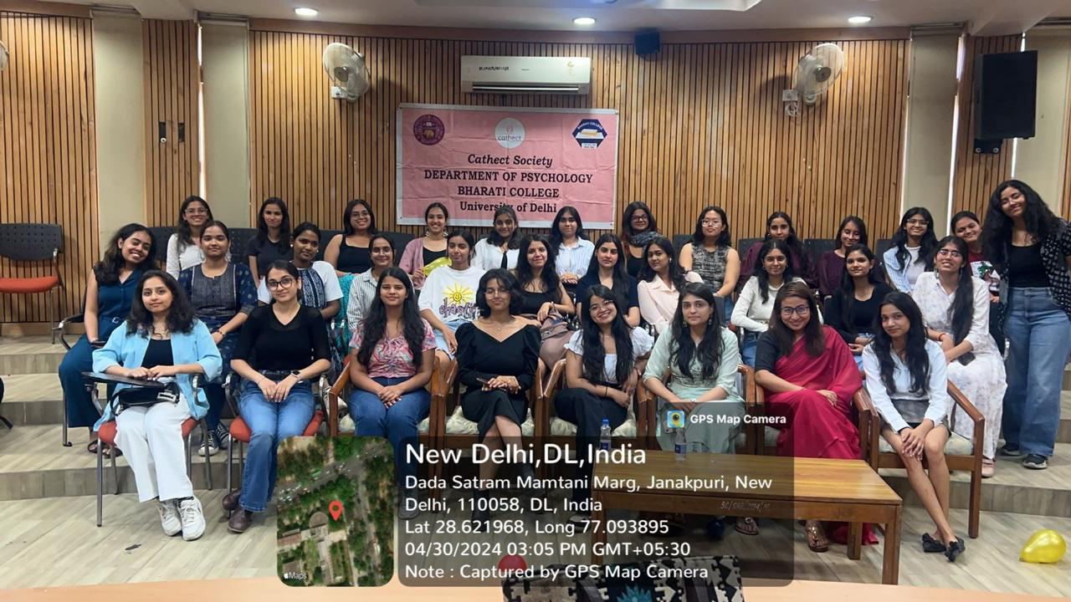

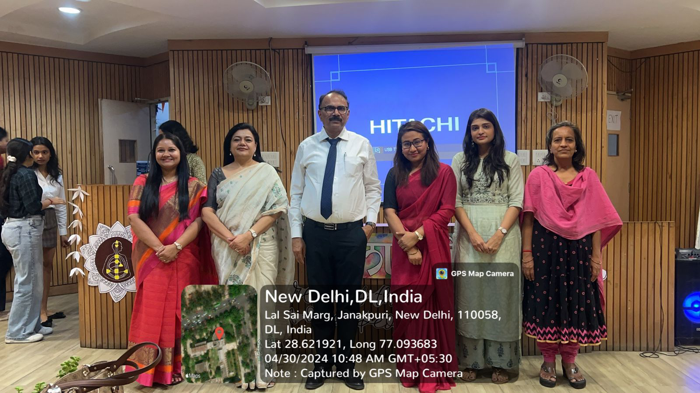

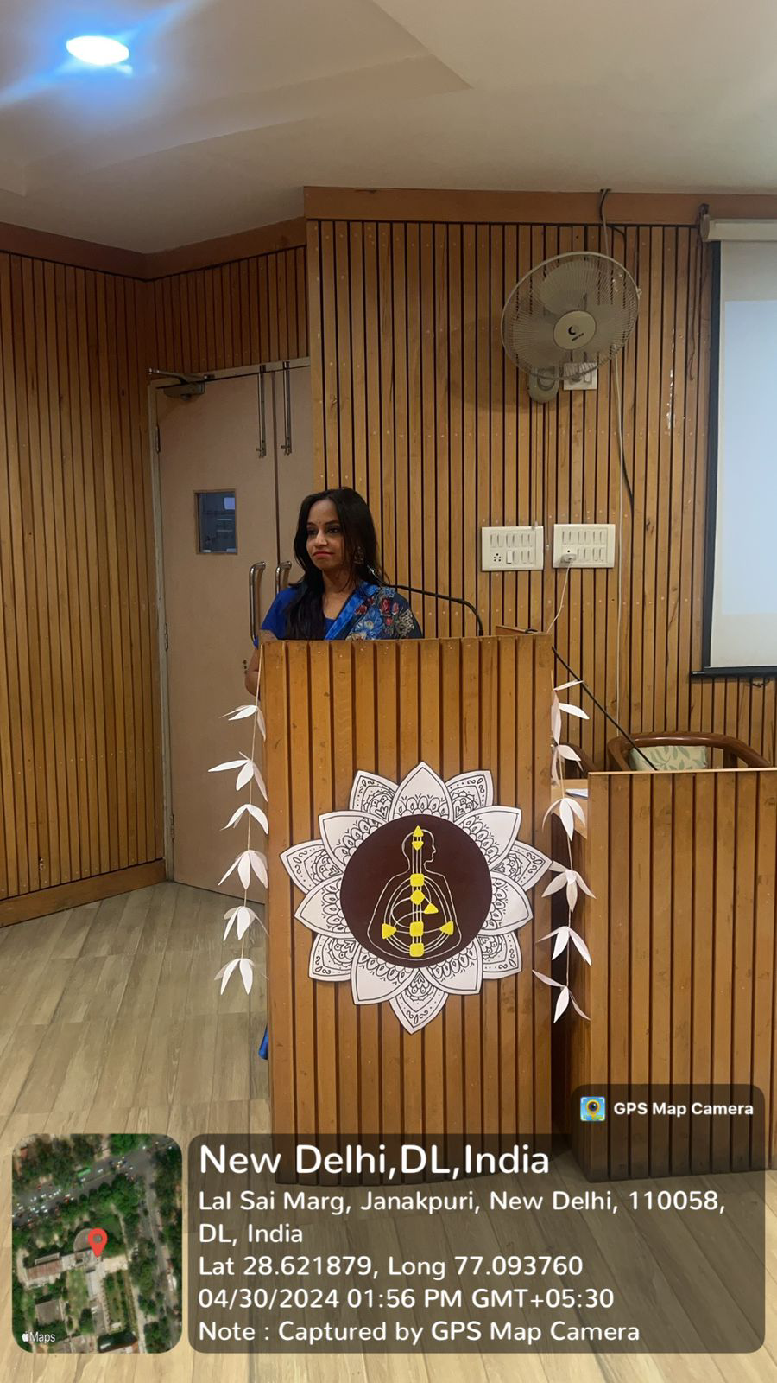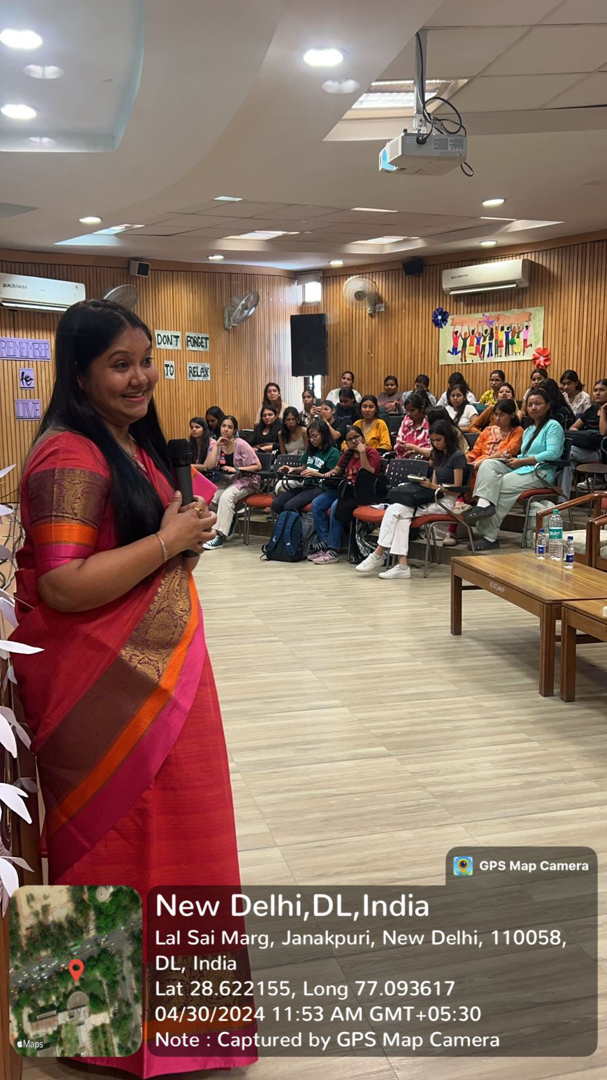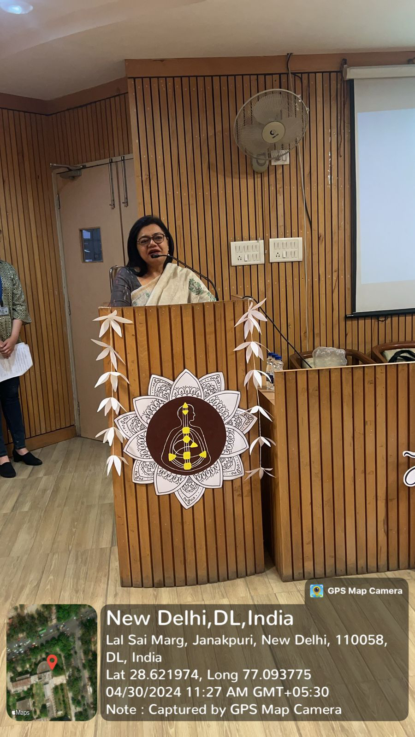

Cathect- Department of Psychology
Bharati College
University of Delhi
Report on Farewell'24

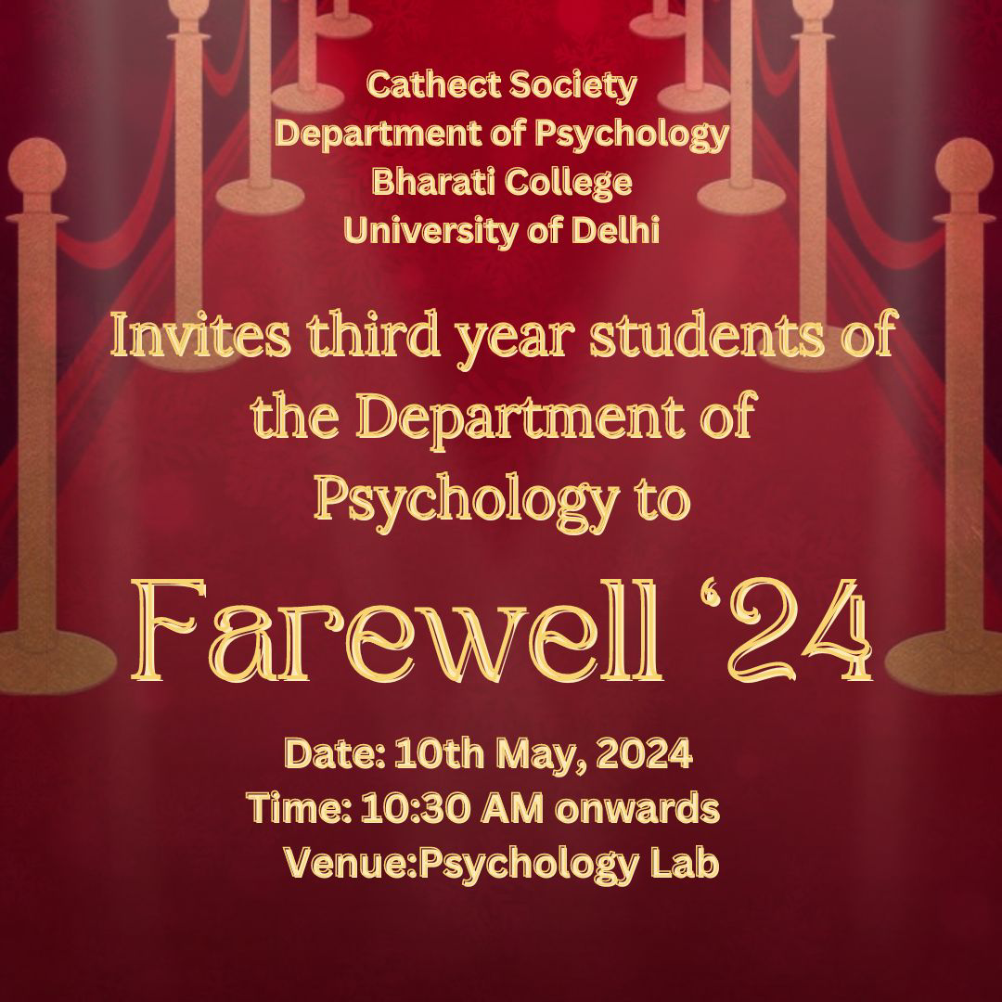

10th May, 2024, Bharati College, University of Delhi:
Program: Farewell'24
Objective of the Event: Hosting a Farewell Ceremony for the Batch of 2024.
Summary of the Event
Cathect Society, the Department of Psychology of Bharati College, hosted a heartfelt Farewell Ceremony for the class of 2024. The event, held in the psychology lab, featured a variety of performances and activities celebrating the achievements and memories of the departing students. It began with a group song by the juniors, followed by a fun trivia quiz, the first round of student titles, a vibrant dance performance, and crowd interactions that highlighted the department's strong community spirit. A short video was also prepared by the juniors with memories and highlights of the three year journey of the third year students, the video also included a message from Ms. Tavishi Sanghi. The second round of titles and creative activities showcased the students' understanding of their own peers. The highlight of the evening was the "Miss Cathect'' competition which had various rounds like cried work, Talent Hunt, and question and answers round. The title of ‘Miss Cathect’ was awarded to Devyanshi Bharti for her outstanding performance and clever answers.
The event also included a trophy distribution to honor the office bearing members of the council 2023-2024. The student body president delivered a moving speech reflecting on shared experiences, while faculty members offered wisdom and encouragement, emphasizing the close-knit relationship within the department. The ceremony concluded with a vote of thanks, acknowledging everyone's efforts in making the event a success. As the evening ended, graduates and attendees shared hugs, took photos, and promised to keep in touch, marking both an end and a new beginning. The farewell was a beautifully orchestrated event that left everyone with cherished memories and a strong sense of belonging, celebrating the bright futures ahead for the Class of 2024.
Key Highlights of the Ceremony
- Included titles and fun games for the class of 2024, along with group performances by the junior batches.
- Highlight was the "Miss Cathect" competition, awarded to Devyanshi Bharti
- Trophies distributed to honor students of the council 2023-2024.
- Student body President - Ms. Jayantika Rawat gave a moving speech.
- Faculty offered wisdom and encouragement along with a vote of thanks.
- The event celebrated cherished memories and bright futures for the Class of 2024.

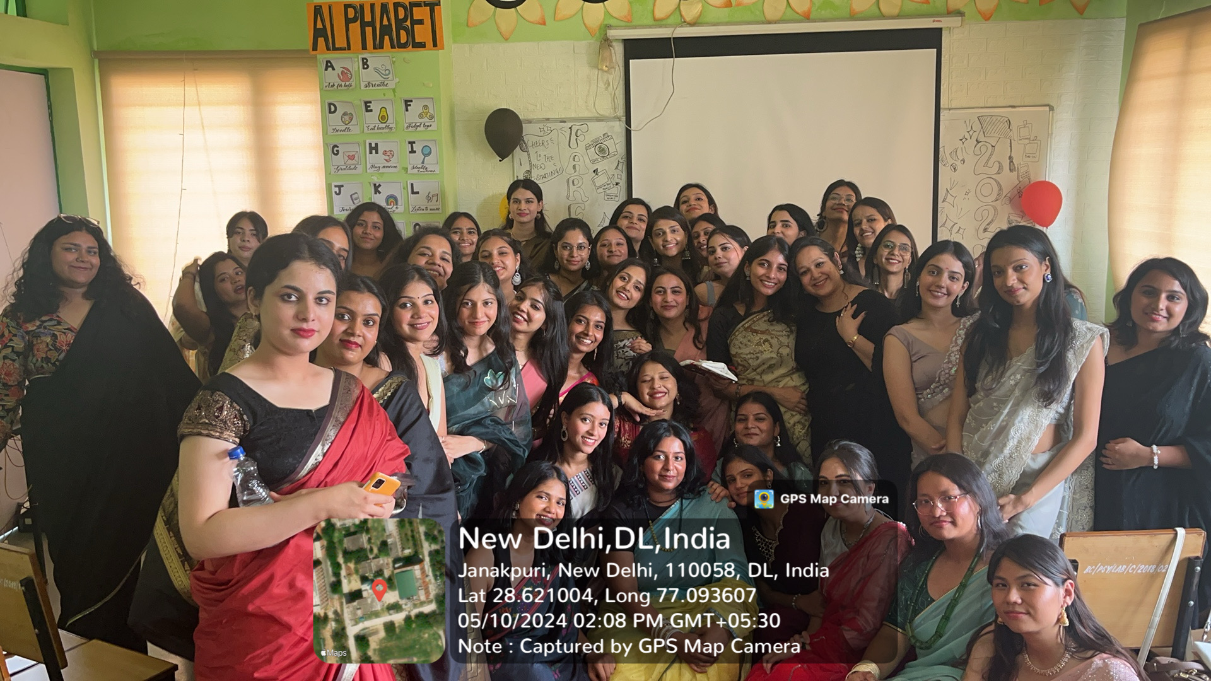
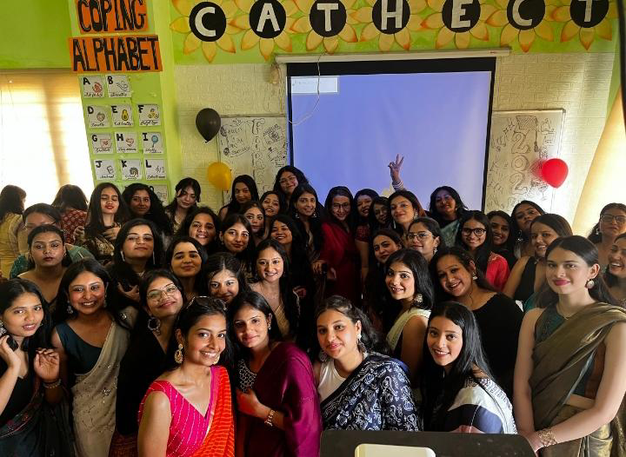

Attendance Sheet 2023
