**GIRL UP AGNI**

**BHARATI COLLEGE, UNIVERSITY OF DELHI**

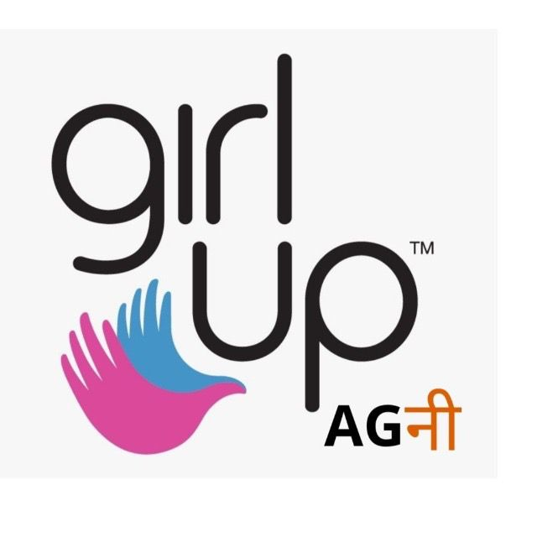

**ABOUT US**

Girl Up Agni is a non-governmental organisation/club affiliated with the United Nations Foundation. GirlUp Agni was established at Bharati College, University of Delhi, through a student initiative to establish gender equality. It works on two prominent pillars; i.e., intersectionality and fulfilment of Sustainable Development Goal 5 (gender equality) and Goal 10 (reducing inequalities).

**ABOUT THE FOUNDER**

“*However, one must not think that simple juxtaposition of the right to vote and a job amounts to total liberation; work today is not freedom*.” - Second Sex by Simone De Beauvoir.

From school, I have always felt the difference of treatment between a male and female student. The boys were asked to shift chairs and benches, whereas girls were asked to decorate classes on certain occasions. The difference somewhat bridged itself when I enrolled myself into a Girls’ college. A space filled where everyone was like me, the scope of discrimination became lesser. The college allowed me to pursue my idea to work for gender equality outside the college space and work on the contradiction of society. I wanted to extend the same space for all. The idea was to construct this into a student body where we women build the capacity to be critical towards society biases. We successfully donated 5000+ pads, educated young girl children about menstruation, conducted seminars for intellectual building, conducted workshops against gender based violence, organised parades, recited manifestos for empowerment with a hope that the journey shall never stop.

— **Soumya Varma**

**Founder**

**Girl Up Agni, Bharati College**

**AIM**

Girl Up Agni envisions to establish a subaltern and intersectional approach in order to fulfil the context-specific goals of giving all genders the rightful space they deserve. The aim is to create a space for feminist leadership to grow by carrying out all possible initiatives for capacity building. Girl Up Agni strives to use its potential to mainstream or at least echo the issues which blur out due to the outcries of privilege at various levels.

**EVENTS**

**Online Summer Reading Circle Club**

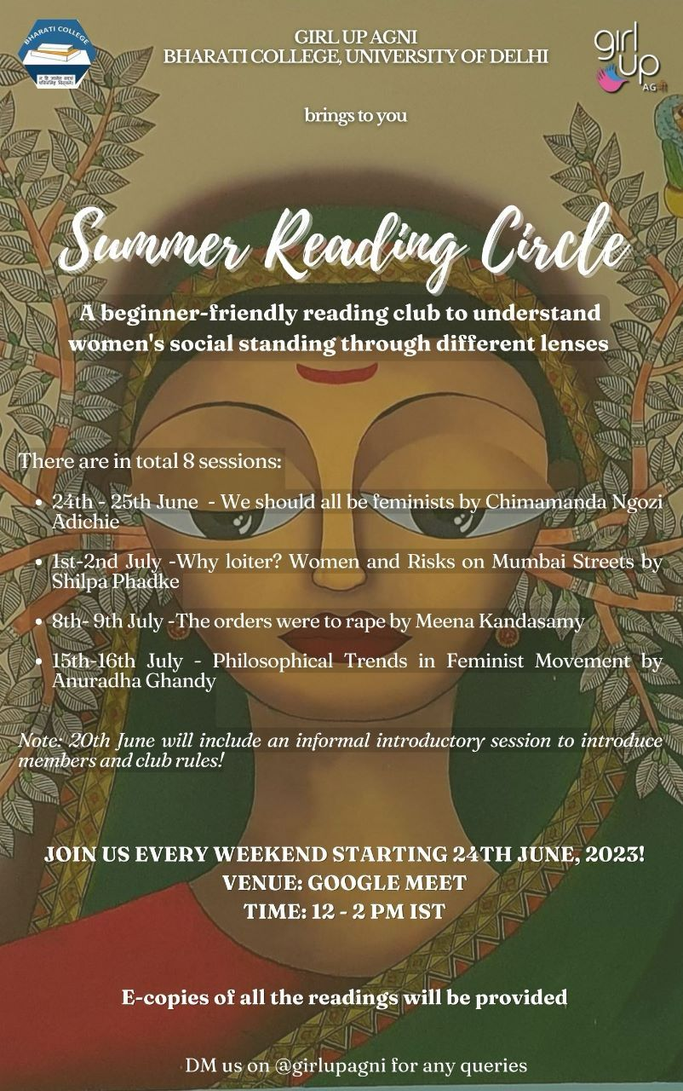  
  
Girl Up Agni hosted an engaging online Summer Reading Circle, spanning from 20th June to 16th July 2023 with a total of 8 sessions. The club, under the guidance and expertise of Dr. Madhuri Sharma, provided a platform for exploring feminist literature with the intent to promote critical thinking and a true understanding of gender issues. Throughout the sessions, our participants engaged in thought-provoking discussions, reflecting on the importance of creating spaces for dialogue and learning about feminist issues. The use of e-readings facilitated accessibility and enhanced the overall learning experience for all. Therefore, the club contributes to the collective empowerment and growth of all participants.

**Poster Making Competition**

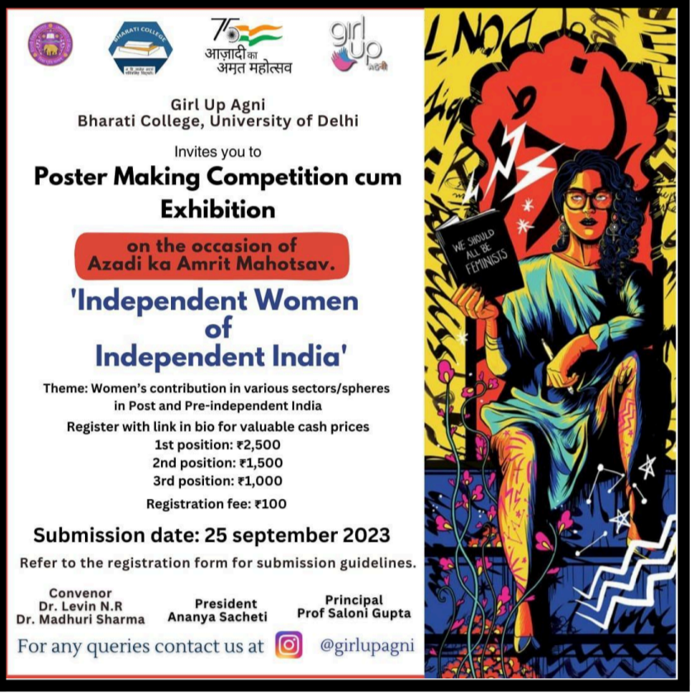

On the occasion of “Azadi Ka Amrit Mahotsav” Girl Up Agni organised a poster-making competition with an indispensable theme “Independent Women of Independent India.” The competition, primarily aimed to showcase Women's contribution in various spheres in pre and post-independent India. It sought to empower women by enlightening them about their self-esteem and capabilities that are equally or even more dominant than those of men. In addition to this, the event successfully achieved its motive to further inspire various forms of independent women of independent India that exist in this world despite several challenges.

**Movie Screening “MATILDA”**

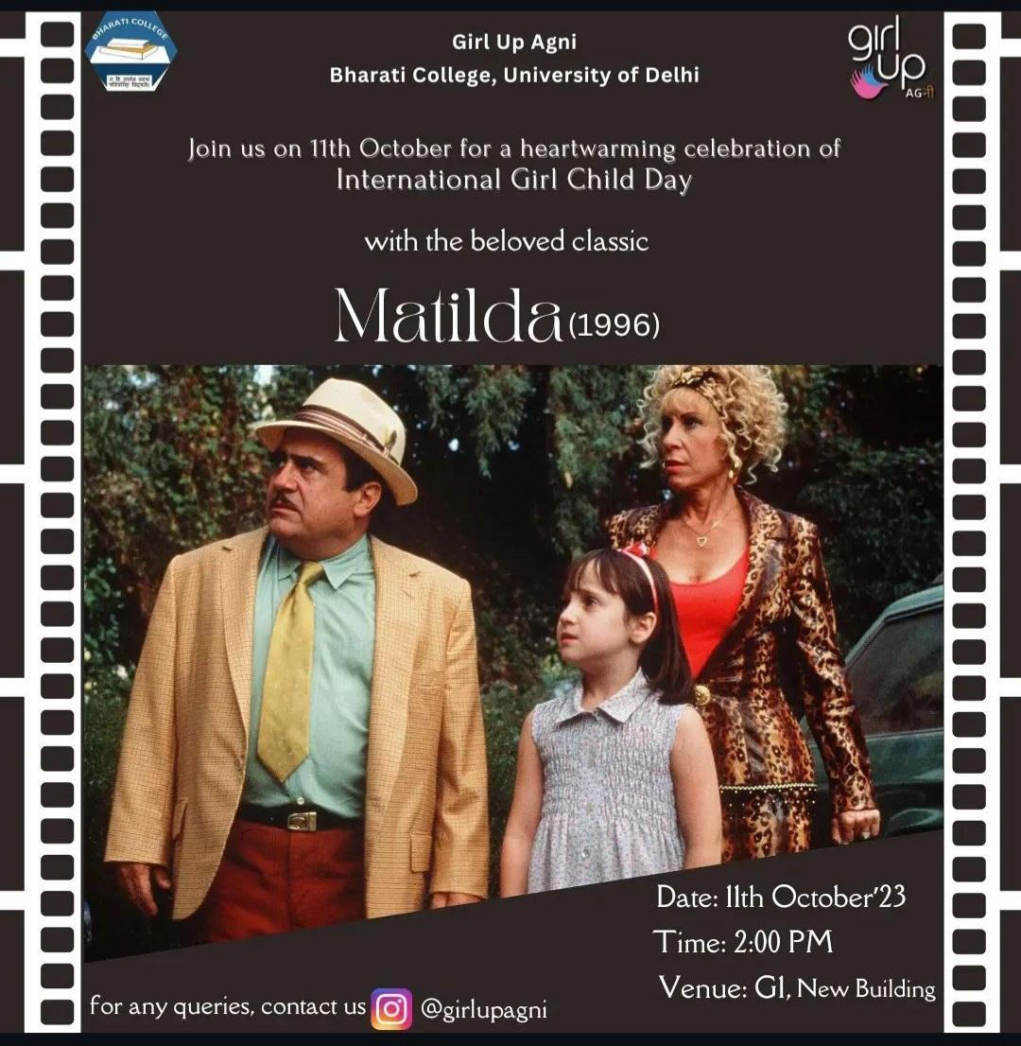

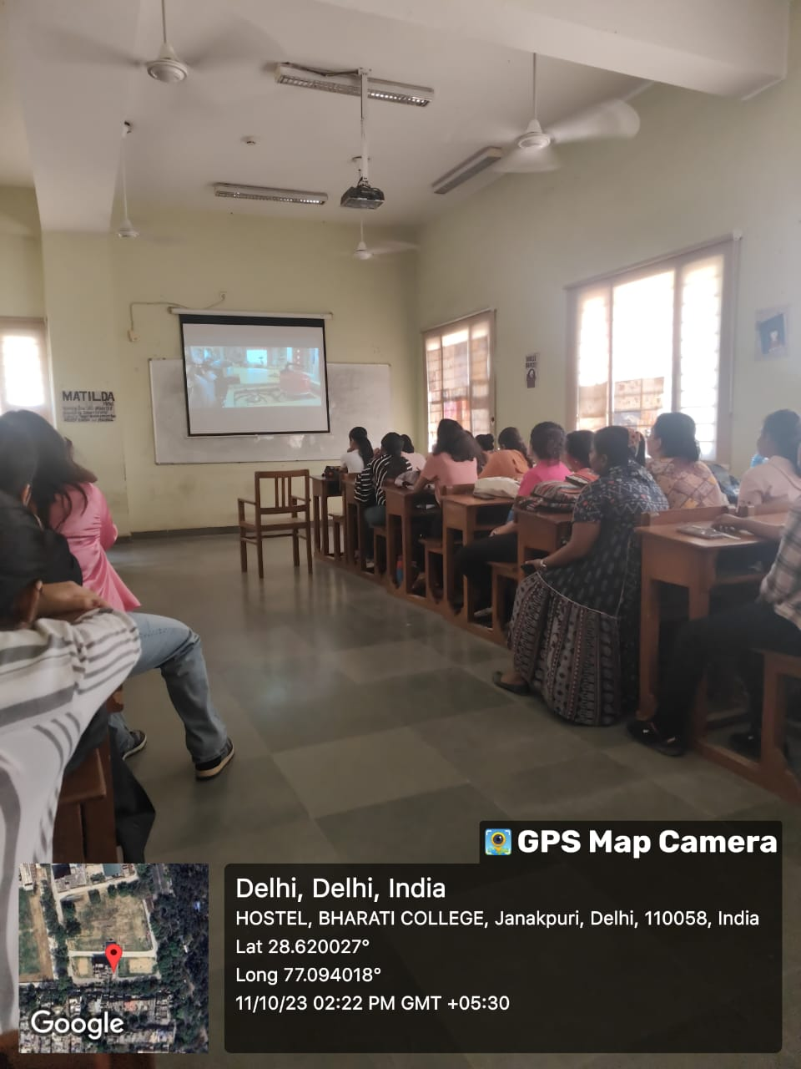

A heartwarming celebration of International Girl Child Day was done by Girl Up Agni which organised the movie screening of the beloved classic, “MATILDA”(1996). This movie screening stands as a testament to the power of collective action, creativity, and the unwavering dedication of its members and organisers. The screening of the timeless classic unfolds seamlessly and captivates the audience with its timeless charm. The event was a great celebration filled with inspiration, entertainment, and a reaffirmed commitment to the cause of empowerment and equality.

**Seminar on Constitutional Rights and Welfare of Women in India**

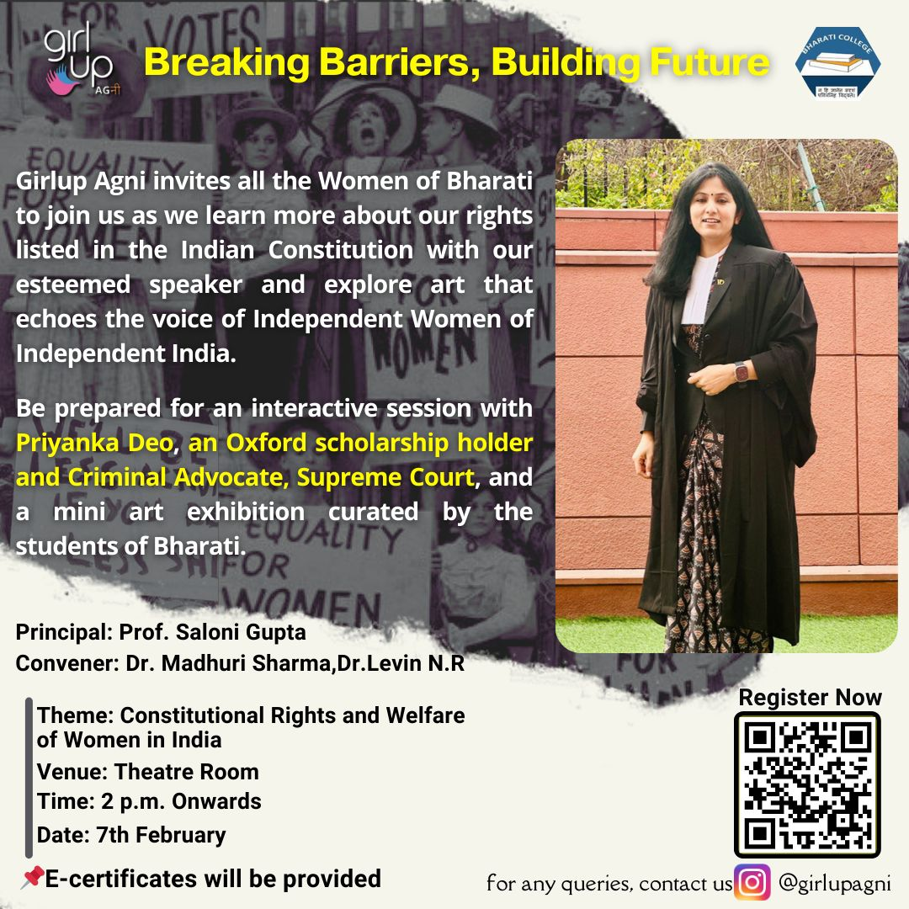

Girl Up Agni organised a seminar titled, “***Breaking Barriers, Building Future***” on 7 February 2024 featuring **Priyanka Deo** Ma’am, a distinguished figure from the field of the legal profession, a Criminal Defense Advocate on Record of the Supreme Court of India and a University of Oxford graduate. This seminar aimed to empower young women by enlightening them on ways to actively advocate for their equality and justice, utilising the rights bestowed upon them and the laws established in their favour within the Indian Constitution. Priyanka Ma’am's extensive experience and engaging communication style enhanced the seminar’s impact which proved to be a great success.

**Open Mic Event**

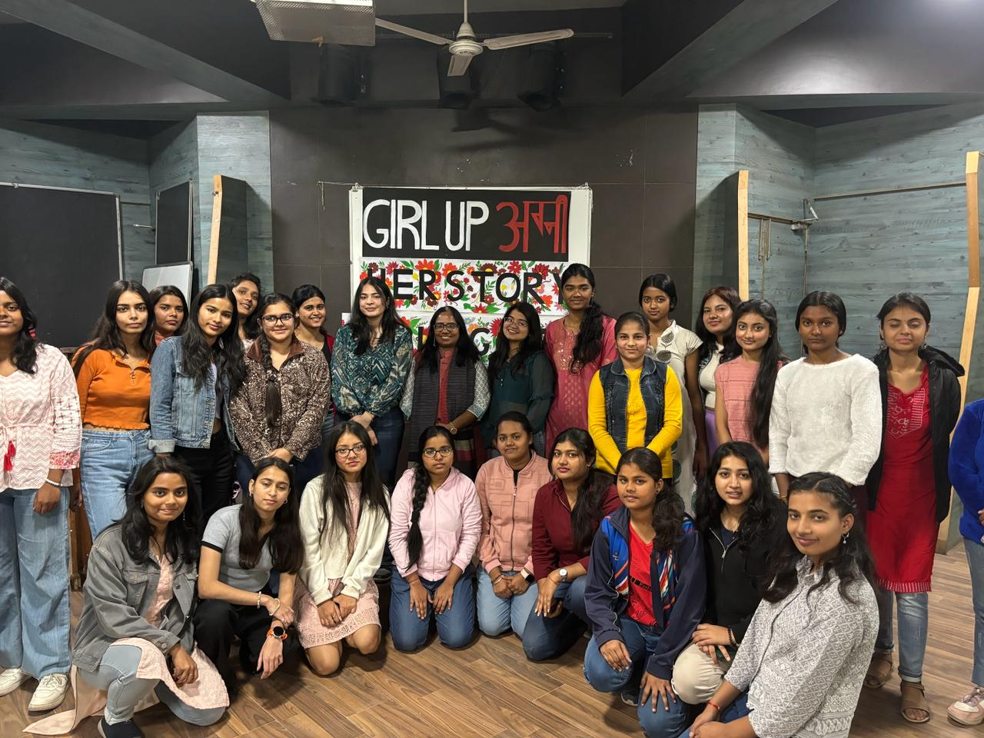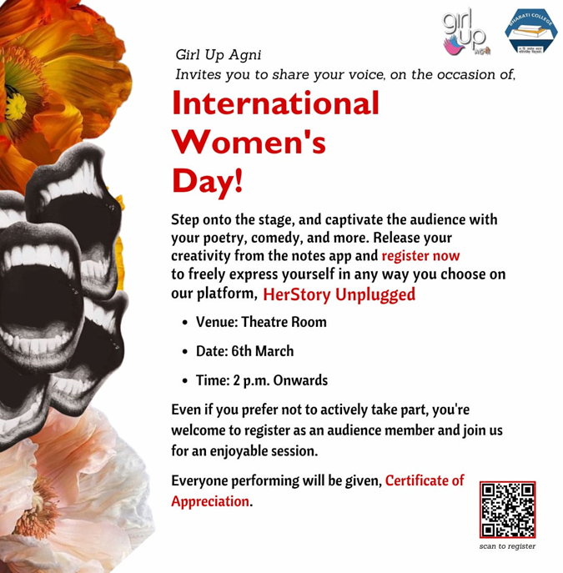

Girl Up Agni celebrated International Women's Day by organising an open mic event on 6 March 2024 titled "***HerStory Unplugged*** ” which provided a safe and open platform for young women to share their thoughts and expressions in diverse forms ranging from speech, storytelling, singing, poetry, dance and even monoacting. The power of expression through this Open Mic event united us as the essence of International Women's Day was honoured through the magic of words and melodies. The intention was to inspire a proactive engagement in dismantling systemic disparities and promoting a more equitable and just society for women. Therefore the event’s success in creating a safe and supportive space underscores its importance in amplifying women's voices and advancing gender equality was truly remarkable.

**CONCLUSION**

At Bharati College, University of Delhi, GirlUp Agni, stands as a testament to the power of collective action, creativity, and the unwavering dedication of its members and organisers. GirlUp Agni has always served as a catalyst for positive change, inspiring action and fostering a more inclusive and equitable society for women through a diverse range of events by using literature, art, movie screenings, seminars, open mics, etc.