CHINTAN - THE DEBATING SOCIETY BHARATI COLLEGE

UNIVERSITY OF DELHI

ANNUAL REPORT 2023-24

“The true measure of success in debate lies not in the volume of one's voice, but in the power of one's reasoning.”

-Anonymous

Chintan, the Debating Society of Bharati College, stands as a beacon of intellectual enlightenment, fostering critical thinking and effective communication among its members. Through tireless dedication, we organise captivating events that transcend mere engagement, sparking profound introspection and impassioned discourse. Our commitment is evident in our partnerships with prestigious entities, which have propelled us to unprecedented heights within our college community.

Over the past year, Chintan has made significant strides in enriching the debating culture within our college. We have hosted thought-provoking debates on pressing societal issues, conducted workshops, and provided training sessions to hone the skills of our members. Additionally, our participation in intercollegiate and national-level competitions has not only showcased our talent but has also brought recognition to our college, enhancing its reputation on a broader scale.

As we reflect on our achievements, we are filled with pride and gratitude for the dedication of our members. Looking ahead, Chintan remains committed to its mission of promoting intellectual curiosity, fostering critical thinking, and inspiring meaningful dialogue within our college community and beyond.

EVENTS FOR THE ACADEMIC YEAR 2023-24

1. Webinar

Chintan, the Debating Society of Bharati College, University of Delhi, organized a thought-provoking webinar on July 2, 2023, via Google Meet, to commemorate Azadi ka Amrit Mahotsav. Renowned debater Krishaang Kohli served as the distinguished speaker, exploring the topic "Can Azadi to love become Azadi to hate?" Kohli's presentation navigated the intricate terrain of freedom in the context of love, exploring the nuanced interplay between liberation and its potential transformation into resentment and animosity. Through a captivating discourse, Kohli urged participants to critically examine the boundaries and complexities inherent in the freedom to love, contemplating its potential metamorphosis into the freedom to hate.

Attended by Chintan's executive and core members, the event facilitated intellectual discourse and diverse opinions. Kohli's articulate arguments sparked lively discussions, embodying Chintan's intellectual ethos. The webinar, marking Azadi ka Amrit Mahotsav, heightened participants’ awareness of the intricate dynamics surrounding freedom, love, and the potential transition into hatred.

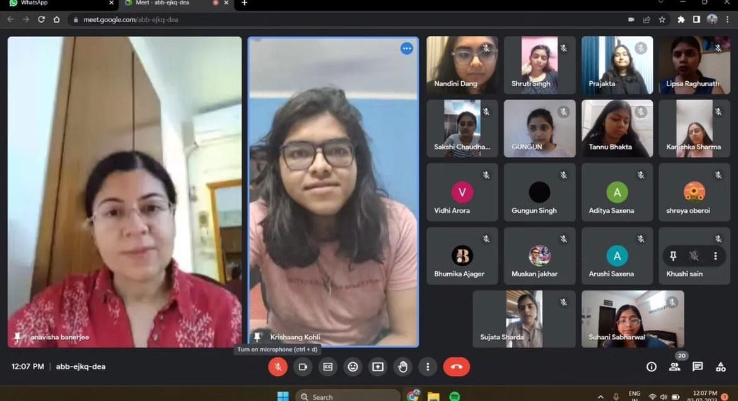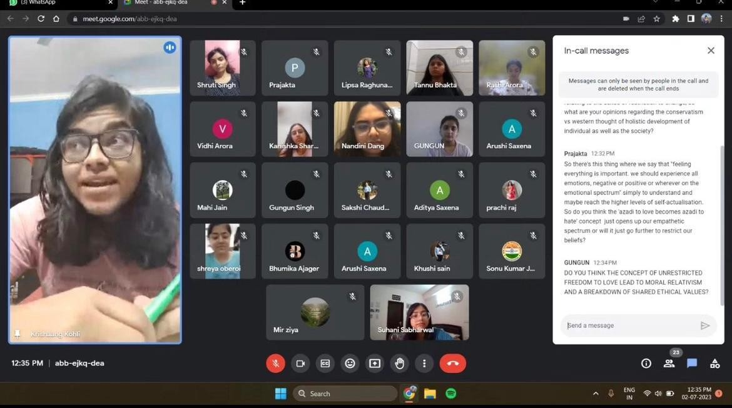

1. Farewell-Cum-Investiture Ceremony

Chintan, the Debating Society of Bharati College, organised a heartfelt Farewell-cum-Investiture ceremony, serving as a special occasion to bid adieu to the departing members while welcoming and honouring the new core team. The event celebrated the contributions and achievements of both past and present members, fostering a sense of gratitude, recognition, and unity within the Chintan community.

All of the past members of Chintan were presented with certificates of appreciation, while the old core team got certificates as well.. The batch ceremony of the new core team by the Convener, Dr. Anavisha Banerjee, followed this. All of the new core members took the stage after receiving their batches to share their visions for Chintan with the rest of the team. The president gave a moving and personal speech that left a lasting impact on everyone in the room. The event brought the entire team closer together and nurtured a sense of love and appreciation for Chintan in the hearts of all the members.

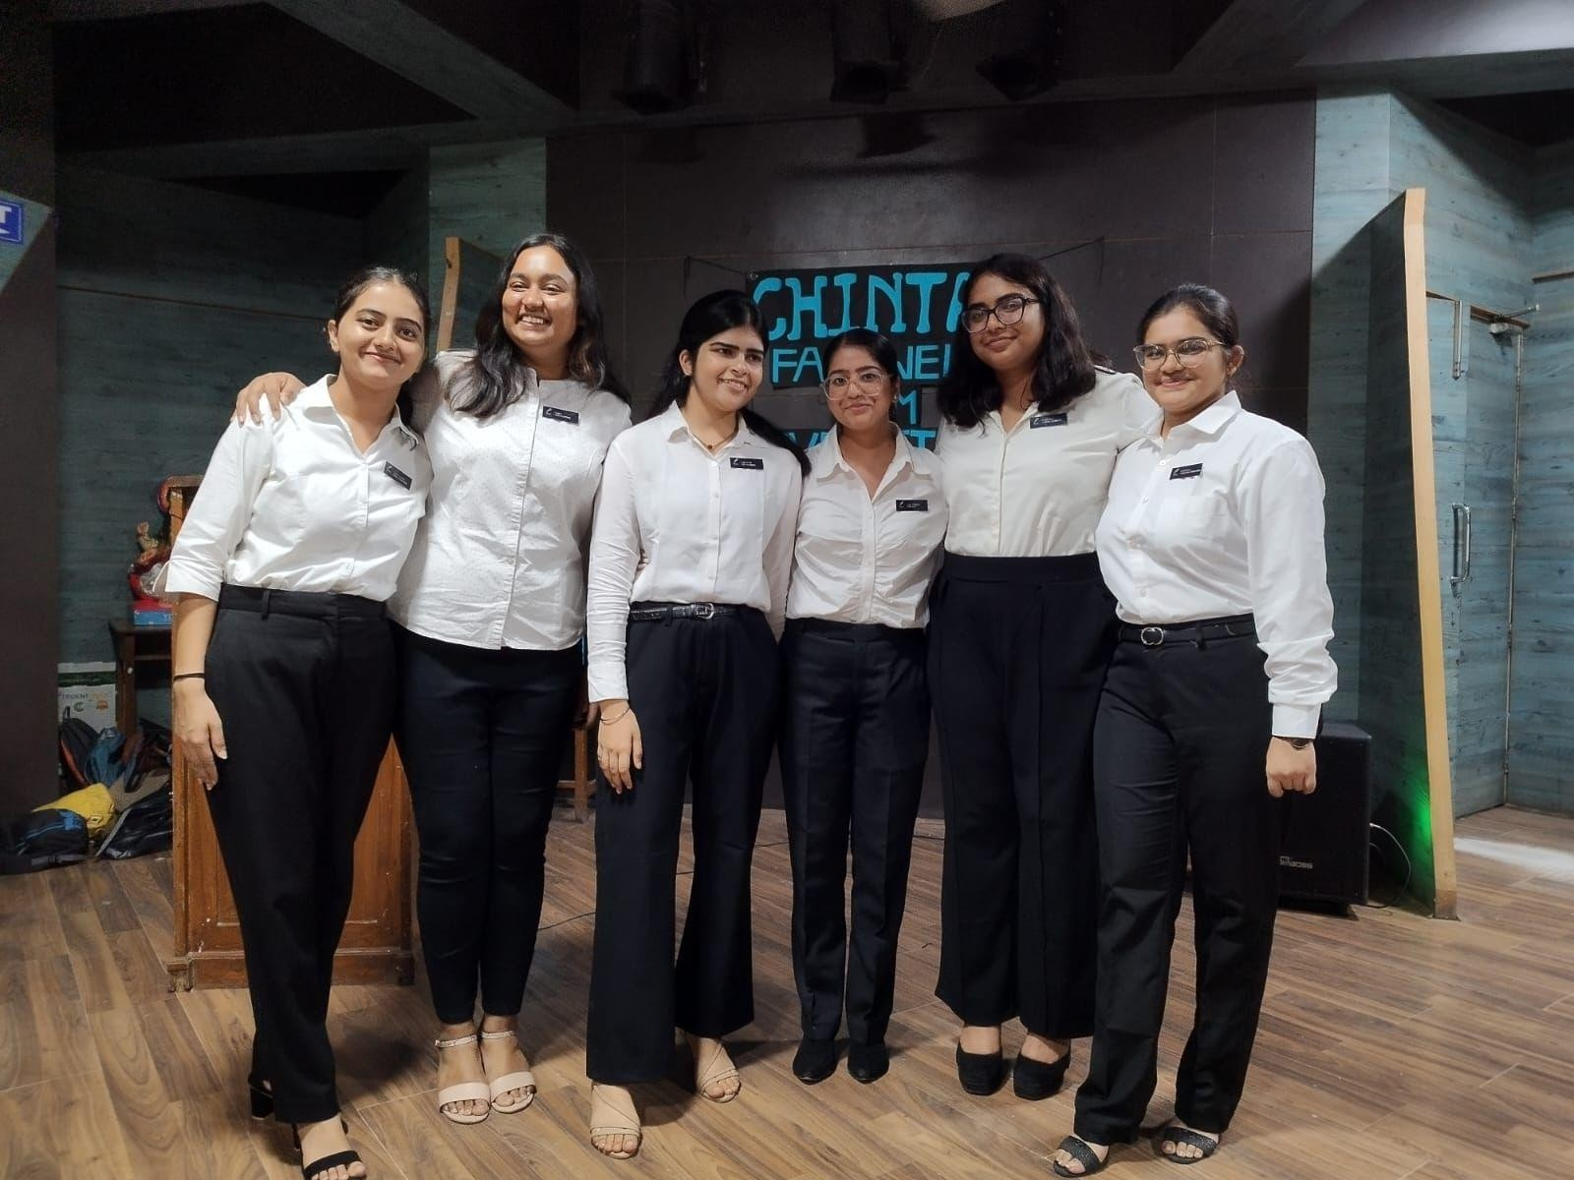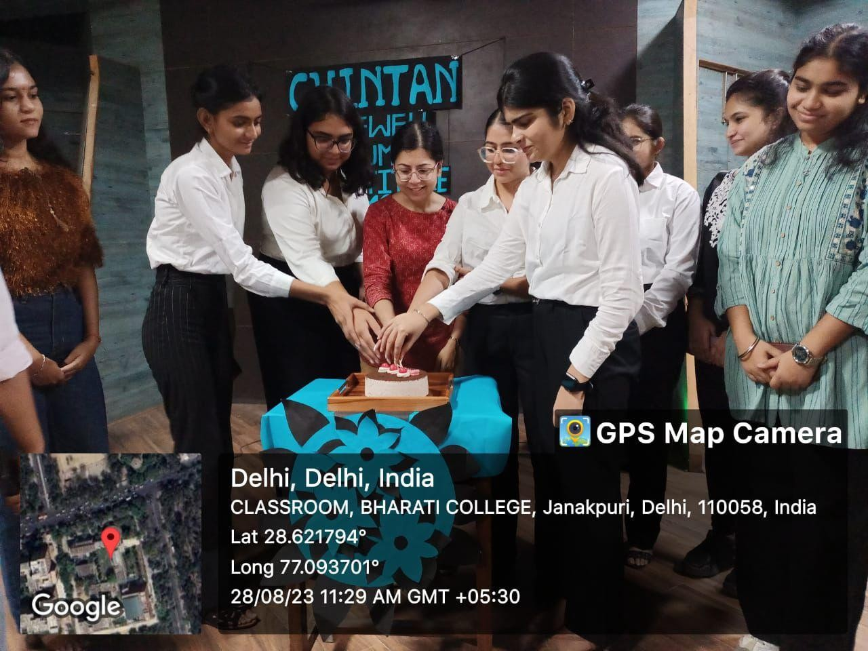

1. Auditions(2023-24)

Chintan, the Debating Society of Bharati College, University of Delhi, conducted the highly anticipated auditions for the academic year 2023-24. Against the backdrop of the compelling topic, "Is it more important to protect online privacy or national security?" participants embarked on a journey of critical analysis and persuasive argumentation, showcasing their skills in the art of debate.

The distinguished panel, featuring President Suhani Sabharwal, Vice President Sujata Sharda, General Secretary Nandini Dang, and Super Senior Executive B Lipsa Raghunath, evaluated individual speaking styles, noting eloquence and analytical prowess. Amidst the competitive atmosphere, participants demonstrated their deep-seated commitment to fostering constructive dialogue and meaningful engagement. Their ability to navigate nuanced issues with poise and clarity underscored the intellectual rigour and depth of thought that define Chintan's ethos.

Following rigorous deliberation, the panel unveiled the selected auditionees, whose exceptional performance and dedication to the craft of debate stood out amidst stiff competition.

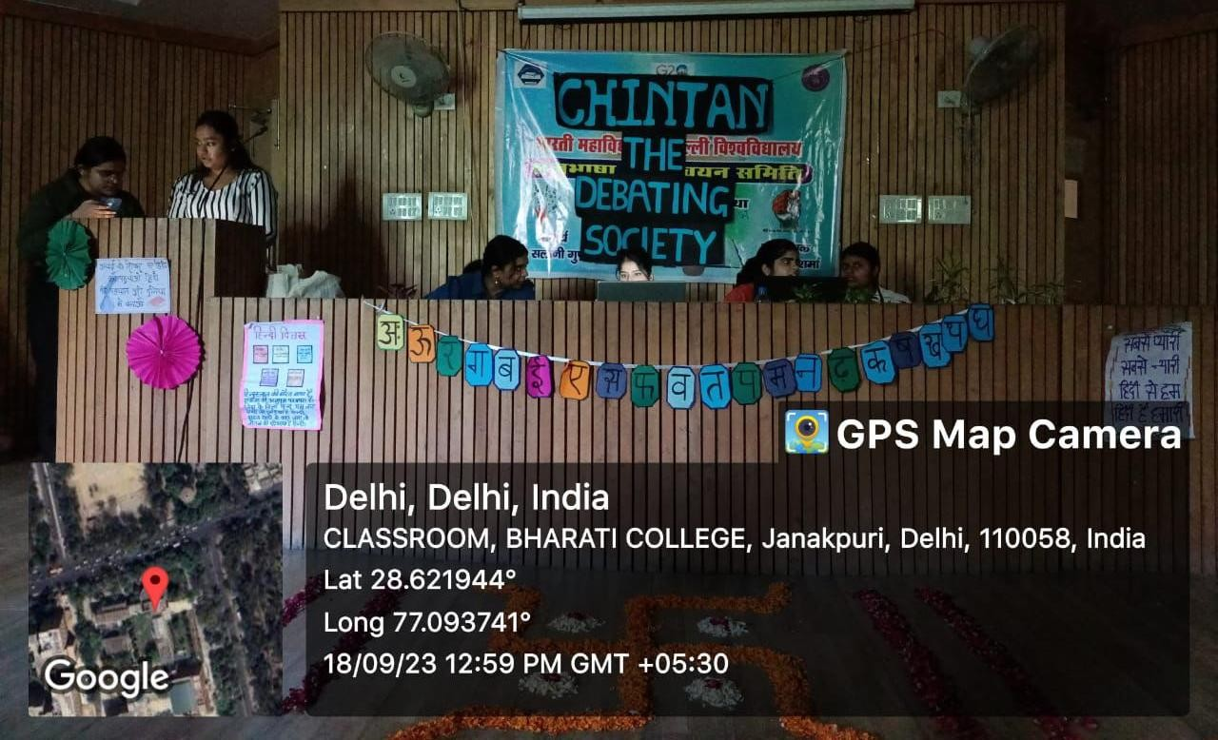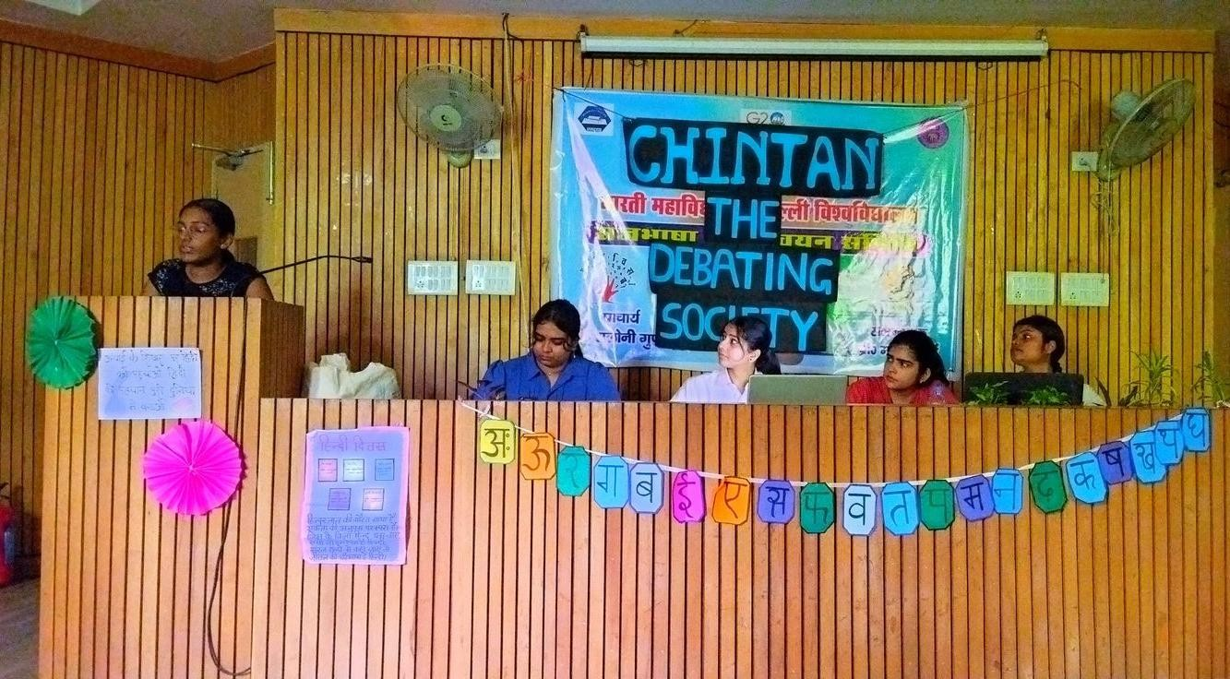

1. Orientation(2023-24)

Chintan, the Debating Society of Bharati College, University of Delhi, arranged an orientation to welcome all the newly appointed executive members. The core team warmly welcomed all the new members. Reflecting

on the society's humble beginnings and remarkable evolution over the past twelve years, the team underscored the pivotal role that Chintan continues to play in fostering intellectual curiosity, critical thinking, and vibrant discourse within the college community.

The rest of the Core Members introduced themselves briefly, explaining their roles and responsibilities associated with their respective positions. The Super Senior Executives and the Senior Executives also introduced themselves, narrating their experiences with Chintan. Through heartfelt anecdotes and reflections, they imparted wisdom and guidance to the incoming members, embodying the spirit of mentorship and camaraderie that defines Chintan's community. The new executive members also gave their introduction, talking about themselves and their reasons for auditioning for the debating society. Listening to the experiences of all the existing and new members, encouraged a sense of warmth and enthusiasm in the society. The orientation was indeed a cheerful session.

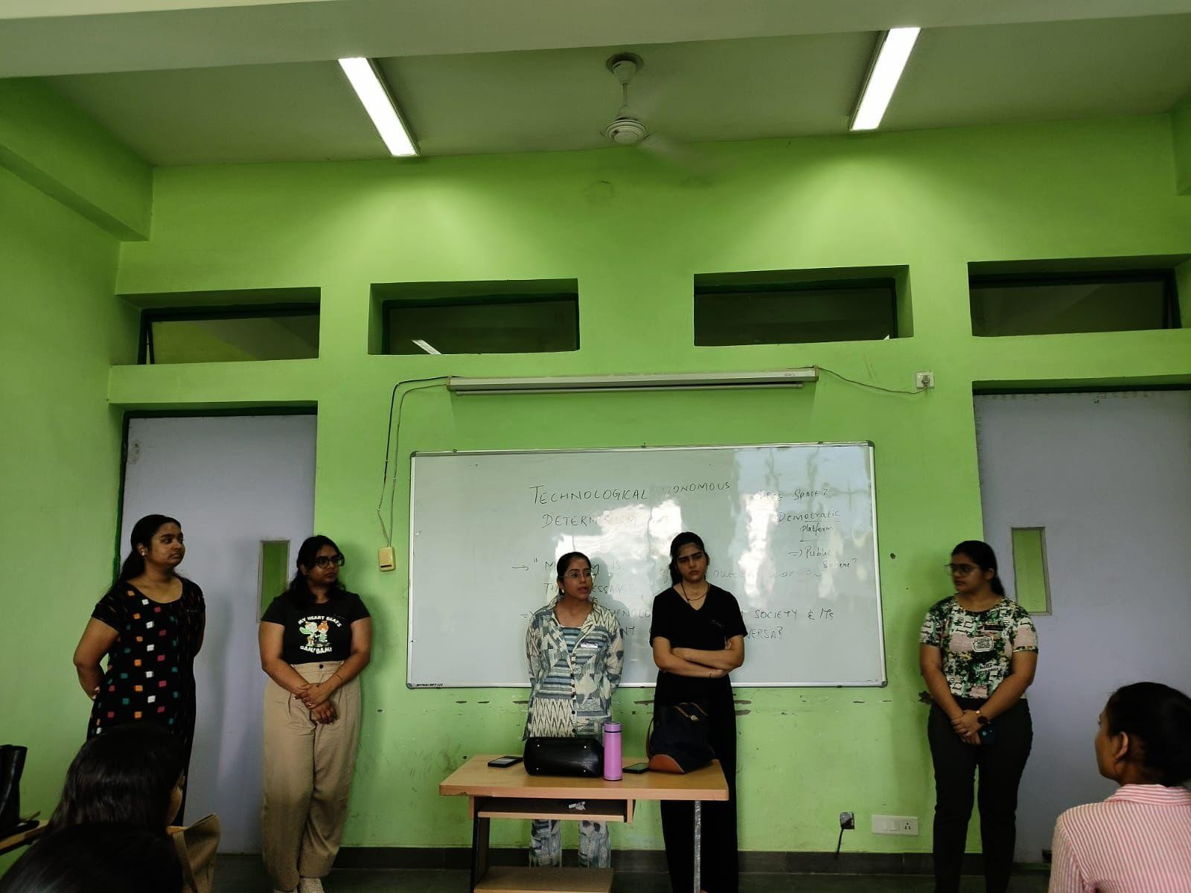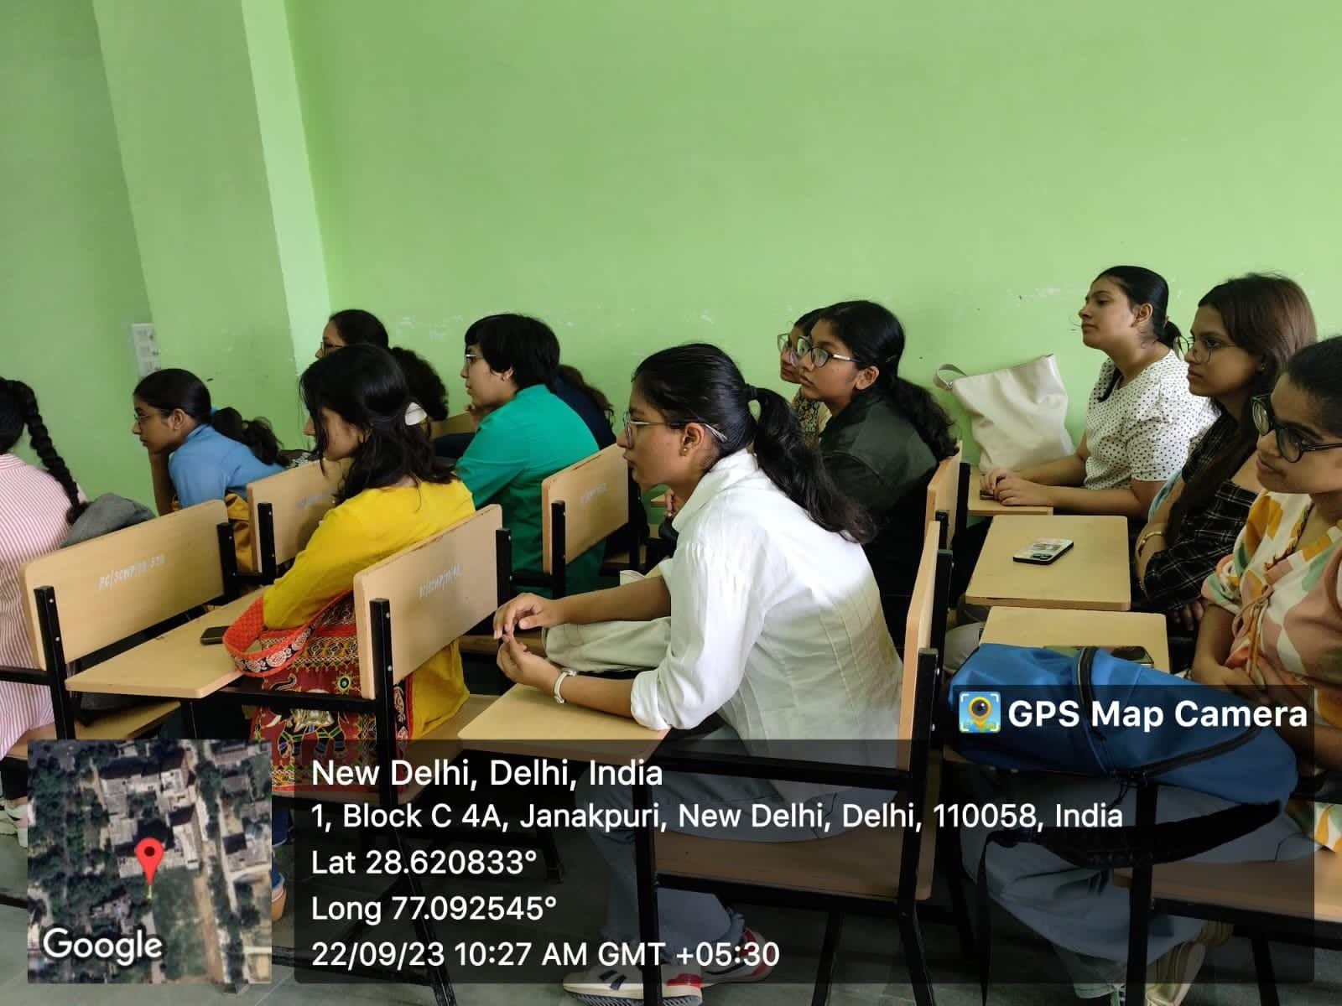

1. MUN Training Session

Chintan, the Debating Society of Bharati College organised an MUN training session for its members. The session was taken by Vice-president, Sujata Sharda and General Secretary, Nandini Dang. Beginning with an overview of the MUN procedure, they delved into the intricacies of parliamentary proceedings, emphasising the importance of diplomacy, negotiation, and consensus-building. They elucidated the rules governing

MUN sessions, parliamentary decorum, speaking order, and resolution drafting protocols. Furthermore, the session addressed the significance of adhering to a formal dress code and code of conduct, underscoring the necessity for professionalism and decorum throughout MUN simulations. They provided practical insights and tips on appropriate attire and demeanour, ensuring the members were well-prepared to navigate the formalities of MUN conferences seamlessly.

The interactive nature of the session was evident as all members actively participated, engaging in meaningful discussions and posing insightful questions. This active involvement enriched the learning experience and fostered a sense of collaboration among the participants. As the session drew to a close, it was apparent that each member departed with a newfound sense of self-assurance, equipped with the requisite knowledge and skills to excel in MUNs moving forward.

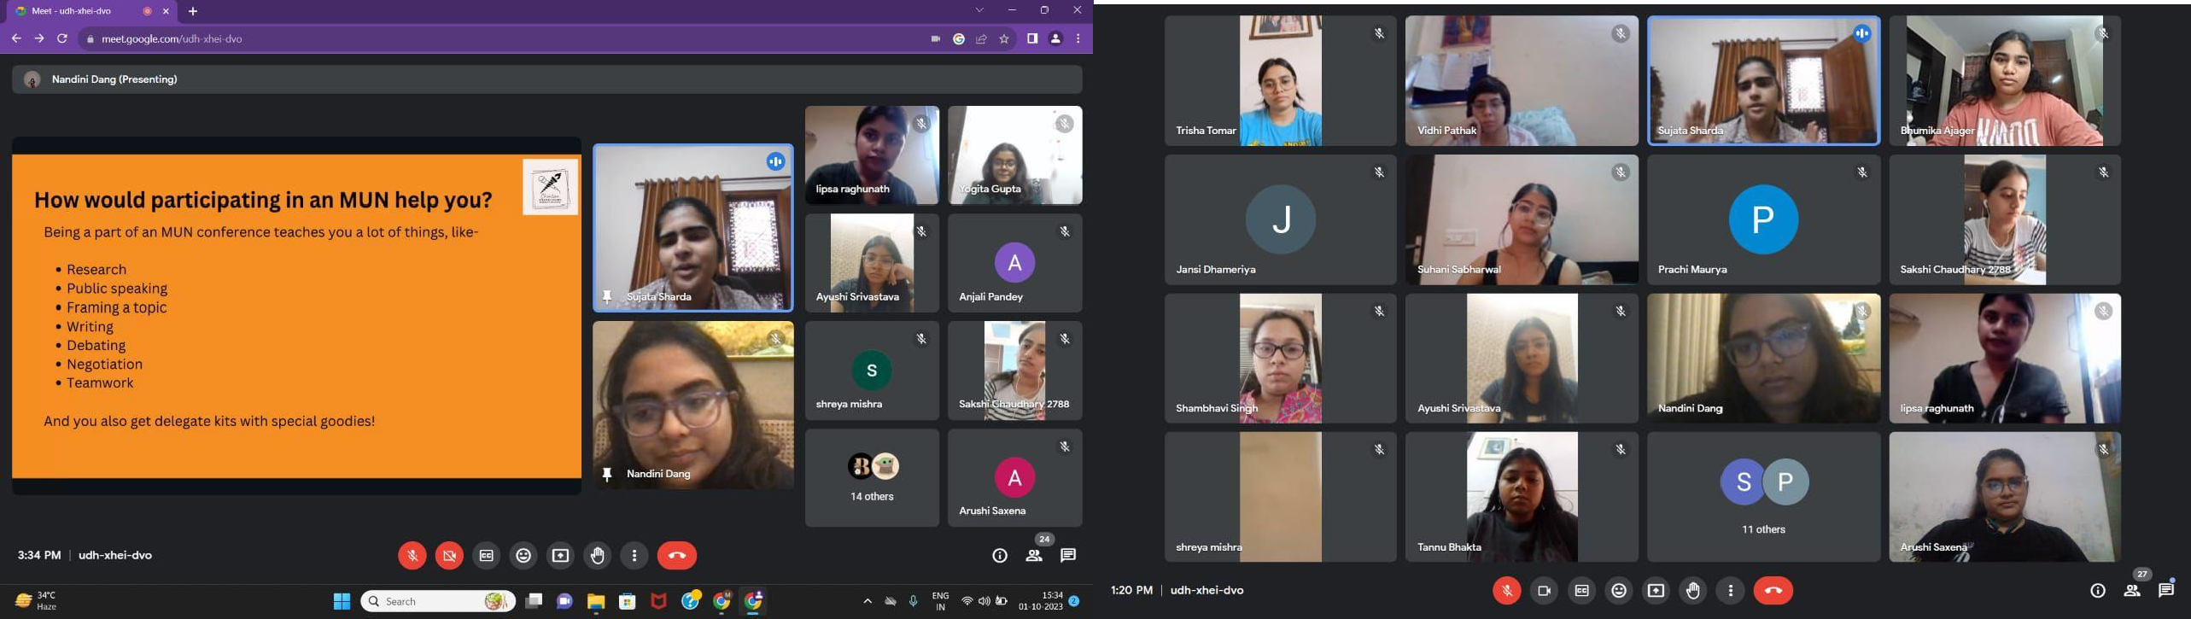

1. Mock MUN Session

Chintan, the Debating Society of Bharati College, University of Delhi, organised a Mock Model United Nations (MUN) Session to familiarise members with MUN proceedings. The session simulated the United Nations Security Council (UNSC), focusing on "Strengthening International Legal Frameworks to Combat Terrorism." With 28 delegations, including Hindi and English debaters, discussions commenced with a General Speakers List, followed by a lively session lasting over two hours. The session transitioned seamlessly into a Moderated Caucus, a pivotal segment of MUNs, which delved into potential solutions for countering terrorism. This segment proved

to be the highlight of the conference, as delegates engaged in debates, exchanged innovative ideas, and worked collaboratively towards formulating effective strategies. Time constraints prevented a Draft Resolution but prompted an Unmoderated Caucus. At the end of the event, accolades were bestowed upon standout participants for their exemplary contributions. Anjali Pandey (South Korea) secured 'Best Delegate,' Nandini Dang (USA) 'Best Speaker,' with 'Honorable Mentions' for Vidhi Pathak (Japan) and Anamika Chatterjee (France). Engaging discussions empowered newcomers, infusing renewed enthusiasm among the participants.

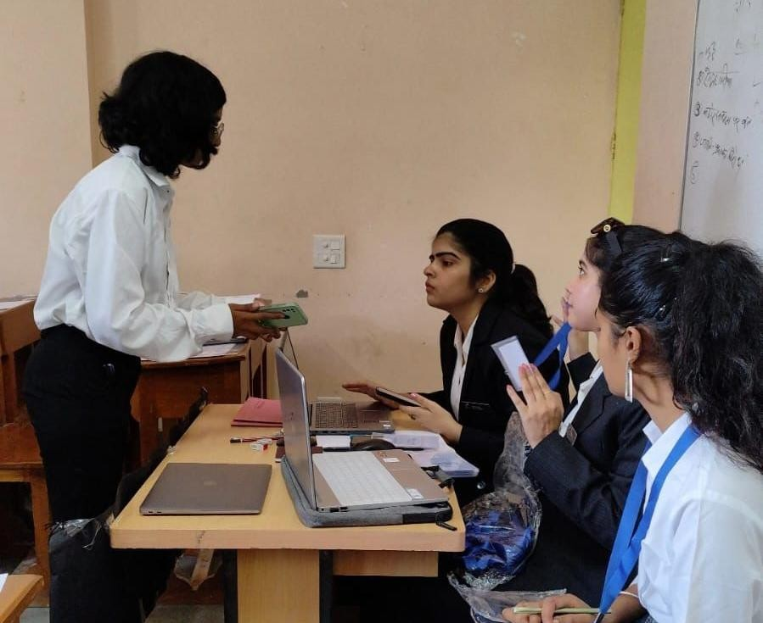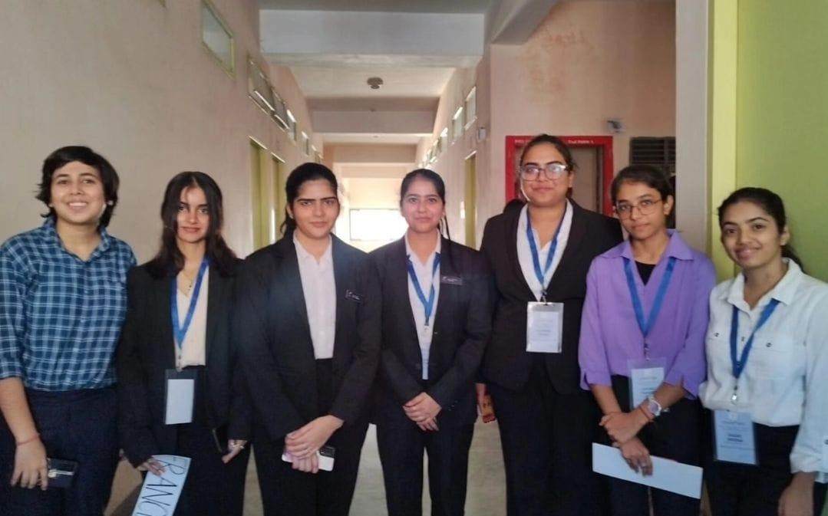

1. An Induction at the Freshers’

The Bharati College Students’ Union (BCSU) hosted 'Prarambotsav' (Freshers’ 23) on November 1, 2023. Dazzling performances by cultural societies captivated the audience, followed by a 15-minute break amidst the Miss Freshers’ contest for society introductions. Chintan, the Debating Society, seized the opportunity with Joint Secretary Prajakta to articulate its mission and leadership. She underscored the society's steadfast commitment to cultivating critical thinking, communication skills, and civic engagement among its members, equipping them with the tools and confidence to thrive in an increasingly complex and interconnected world. Highlighting achievements and events emphasised Chintan's commitment to intellectual pursuits. The introduction aimed to inform and inspire, promising a fulfilling journey for the society and its members.

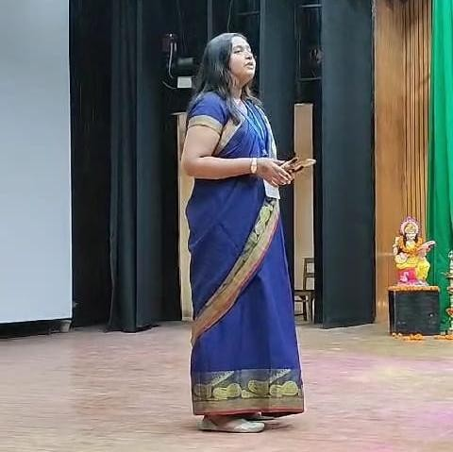 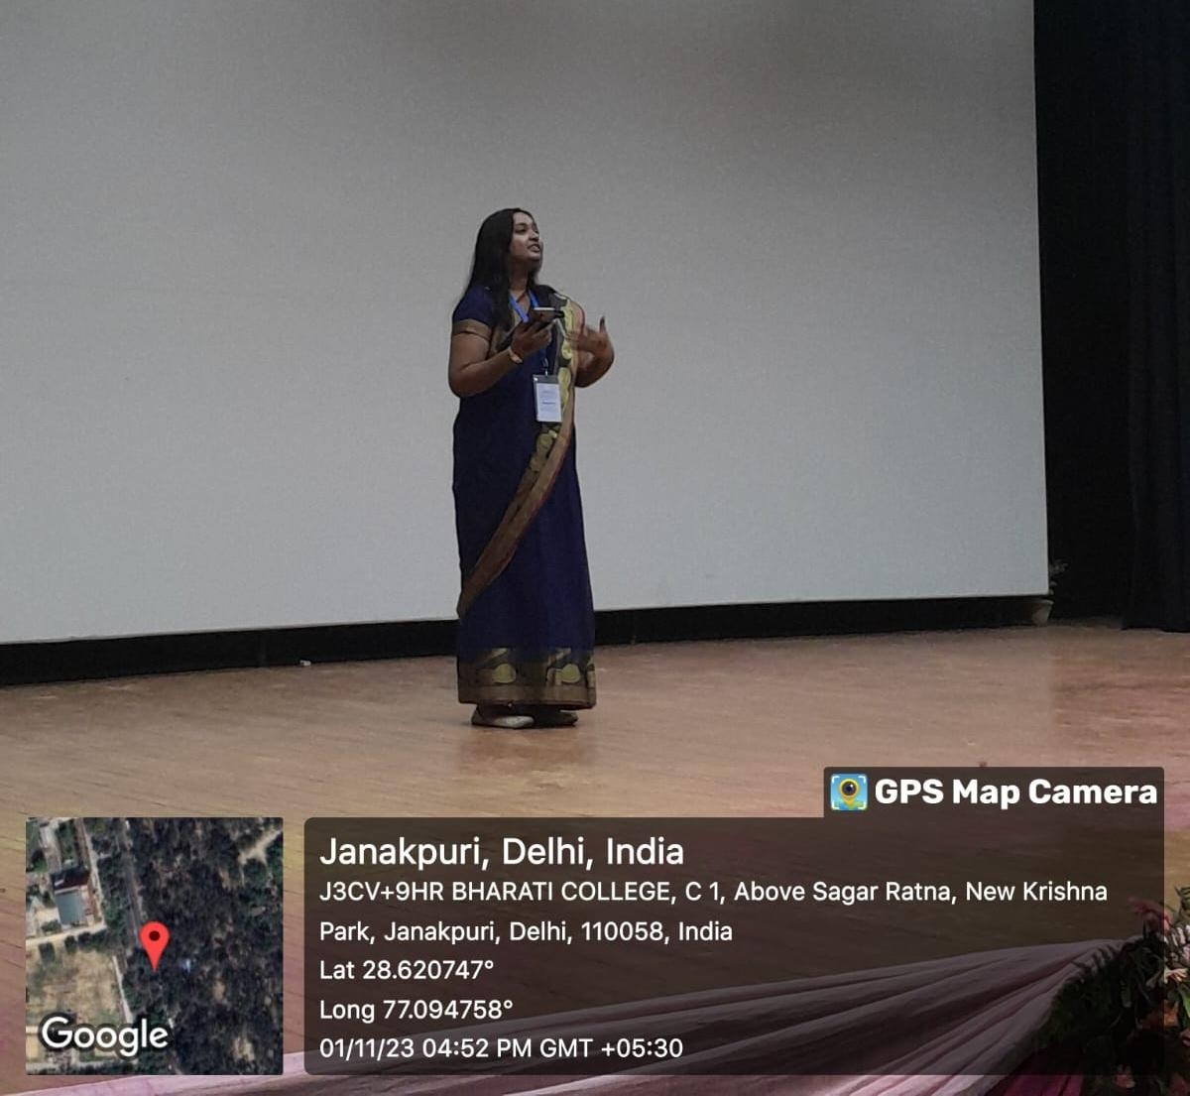

1. Group Discussion Session

Chintan, the Debating Society of Bharati College, University of Delhi, organised a Group Discussion (GD) Session with precision. Suhani Sabharwal, the President of Chintan, conducted the session, recognising its valuable contribution to students' preparation for interviews and placements. Students apart from the Chintan members also participated in this instructive session. The session began with an intense discussion on how content like ‘Kabir Singh’/ ‘Animal’ and ‘Four More Shots’ depict and challenge traditional gender roles, where all the participants were compelled to contribute to the discourse, bringing in their fiery insights. After the warmup session, the President carried on with the session, briefing the participants on the importance, and various types of models under a GD. Students were then divided into seven groups, and given different models and topics to engage in spirited discussions. The diversity of perspectives shared and the depth of analysis added to the zeal. From exploring ethical dilemmas to debating contemporary socio-political issues, participants embraced the opportunity to engage in meaningful dialogue, cultivating essential skills of critical

thinking, persuasion, and teamwork. Chintan eagerly anticipates nurturing the skills of group discussion and debate among students.

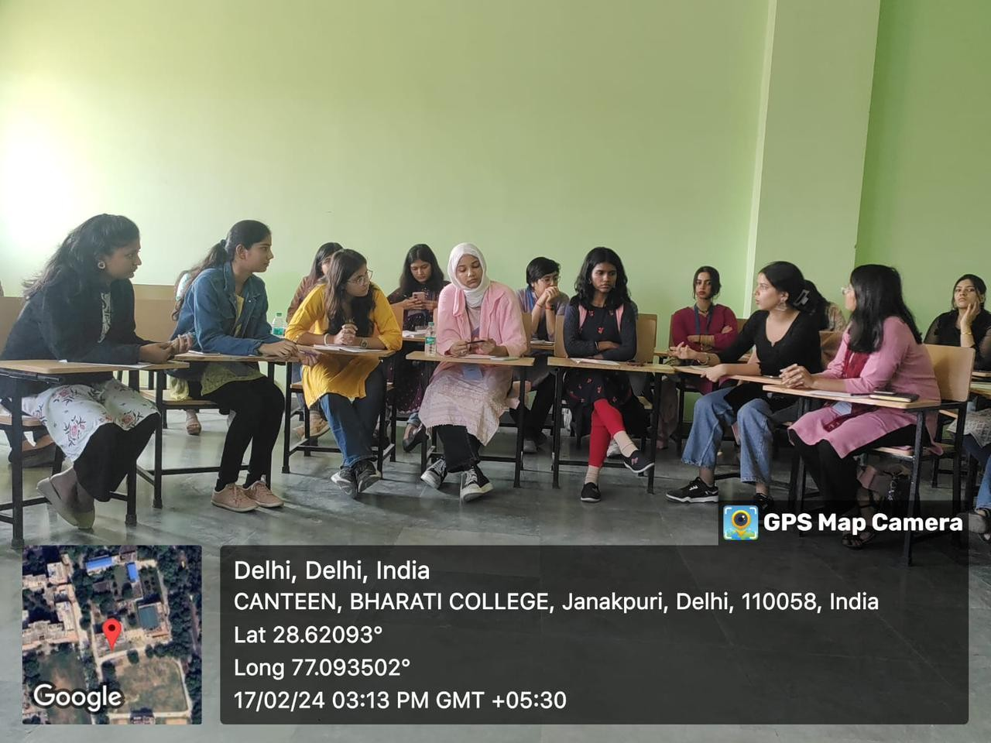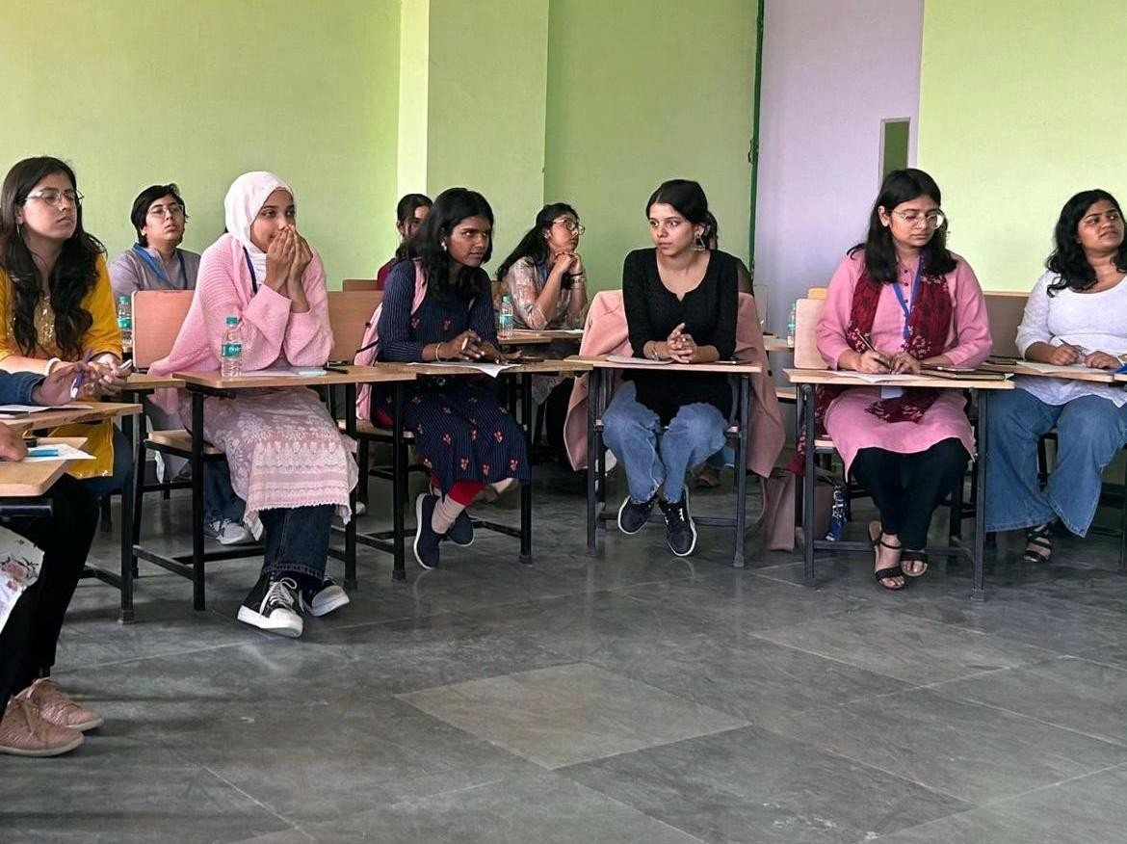

1. Open Mic Competition

Chintan, the Debating Society, collaborated with Manthan, the Nukkad Natak Society of Bharati College, organising an Open Mic Competition themed “VIKSIT BHARAT @ 2047”. Leveraging Chintan's event organisation prowess and Manthan's social issue engagement, the partnership provided a platform for talent and societal reflection. Prizes totalling ₹3000 were awarded.

The Open Mic Competition captivated audiences with its vibrant energy and thought-provoking performances. From spoken word poetry to musical compositions, participants showcased a kaleidoscope of artistic expressions, each offering a unique perspective on the theme of empowerment in India.

As the competition unfolded, it became evident that the participants had poured their hearts and souls into their presentations, channelling their passion for social change into powerful performances that resonated with the audience. The judging panel included Dr. Anavisha Banerjee and Dr. Bindia Trivedi.

Anjali Pandey emerged as the winner, with Gungun Singh and Disha Dhingra following closely as runners-up, while Anya Mishra earned a

Special Mention. Certificates of Appreciation acknowledged participants' contributions, affirming the event's success in fostering dialogue on India's empowered future.

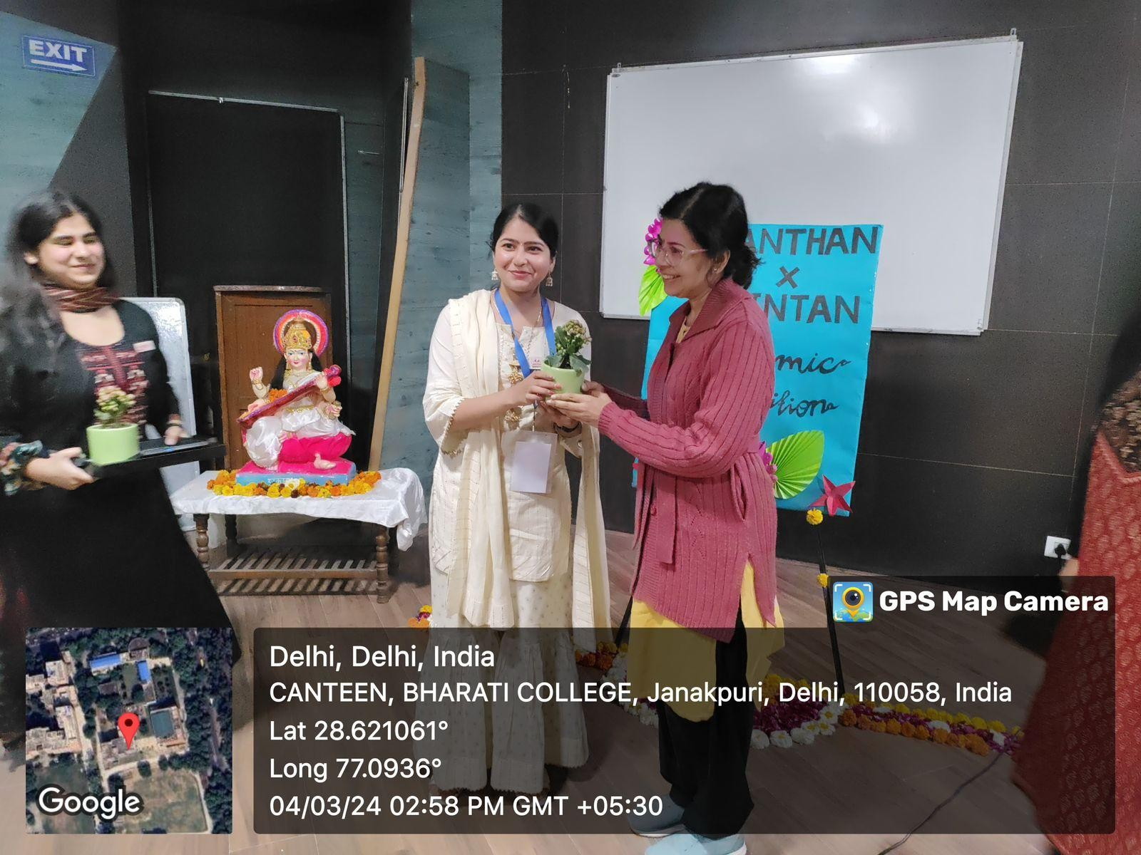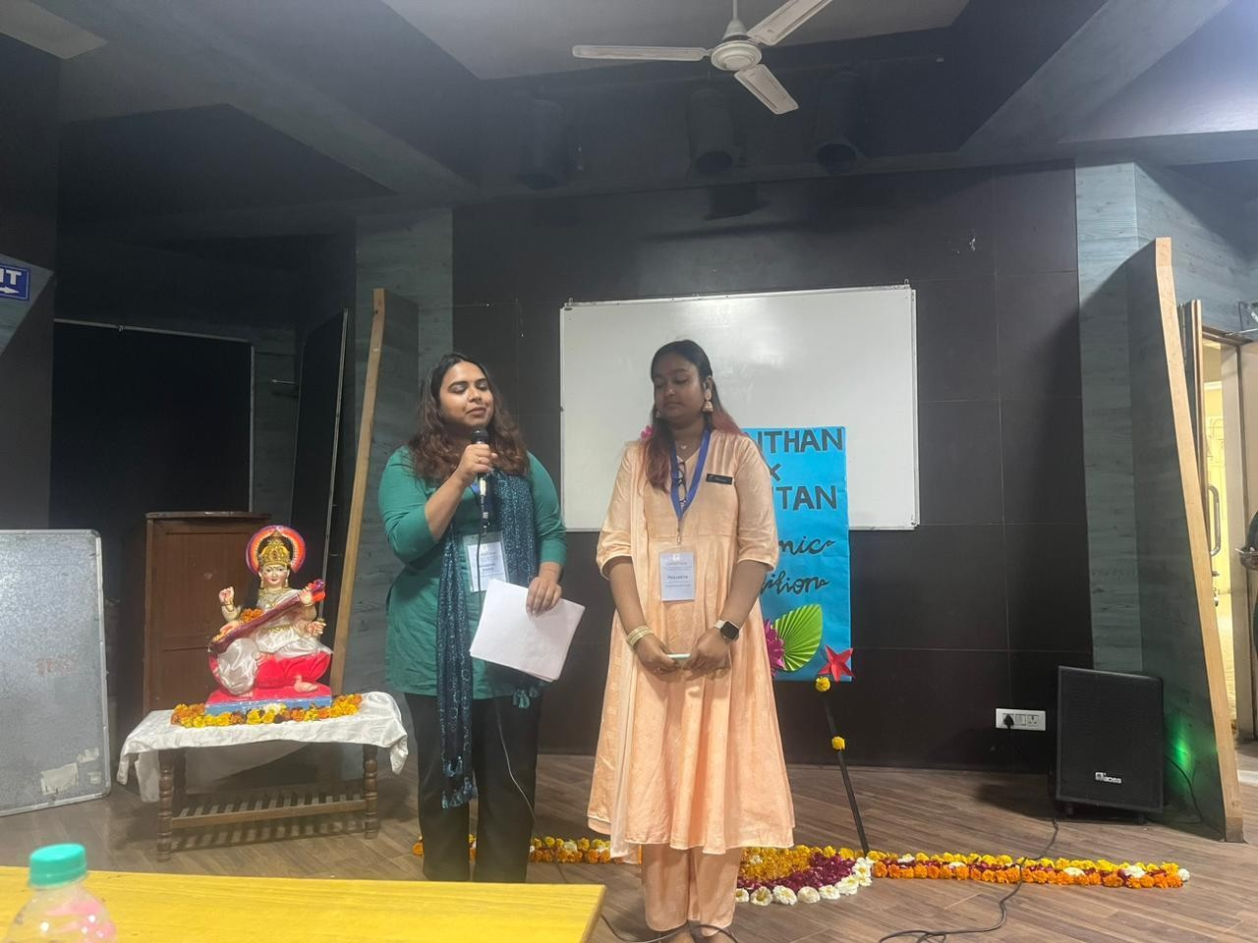

1. Awaaz ’24

Over the years, Chintan has thrived with steadfast support from Abhivyakti, the Annual Cultural Fest of Bharati College, serving as a vital platform for students' talent showcase and enduring experiences. Within Abhivyakti's framework, Chintan annually hosts Awaaz, a revered conventional debate competition epitomising intellectual engagement. Esteemed Chintan leaders, including Suhani Sabharwal, Sujata Sharda, Nandini Dang, and B Lipsa Raghunath, enriched the event as expert panellists. The competition witnessed spirited participation from students representing various institutions, showcasing their analytical acumen and rhetorical prowess on the designated theme. Rohit Kumar Yadav from Starex University clinched the top spot, with Avinash Gautam from Hindu College securing the runner- up position. Special mentions were awarded to Manish from IMS Law College and Vidhatri Nautiyal from Bhaghwan Parshuram Institute of Technology. Awaaz ’24 underscored Chintan and Abhivyakti's enduring commitment to fostering intellectual discourse and academic excellence, leaving participants enriched and inspired.

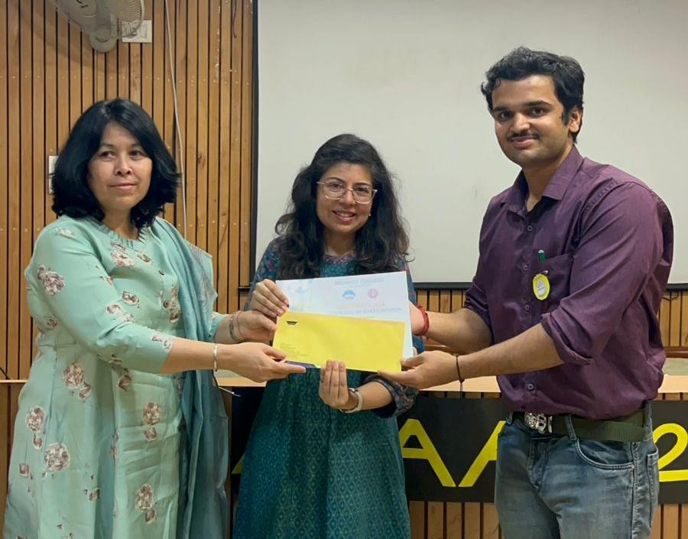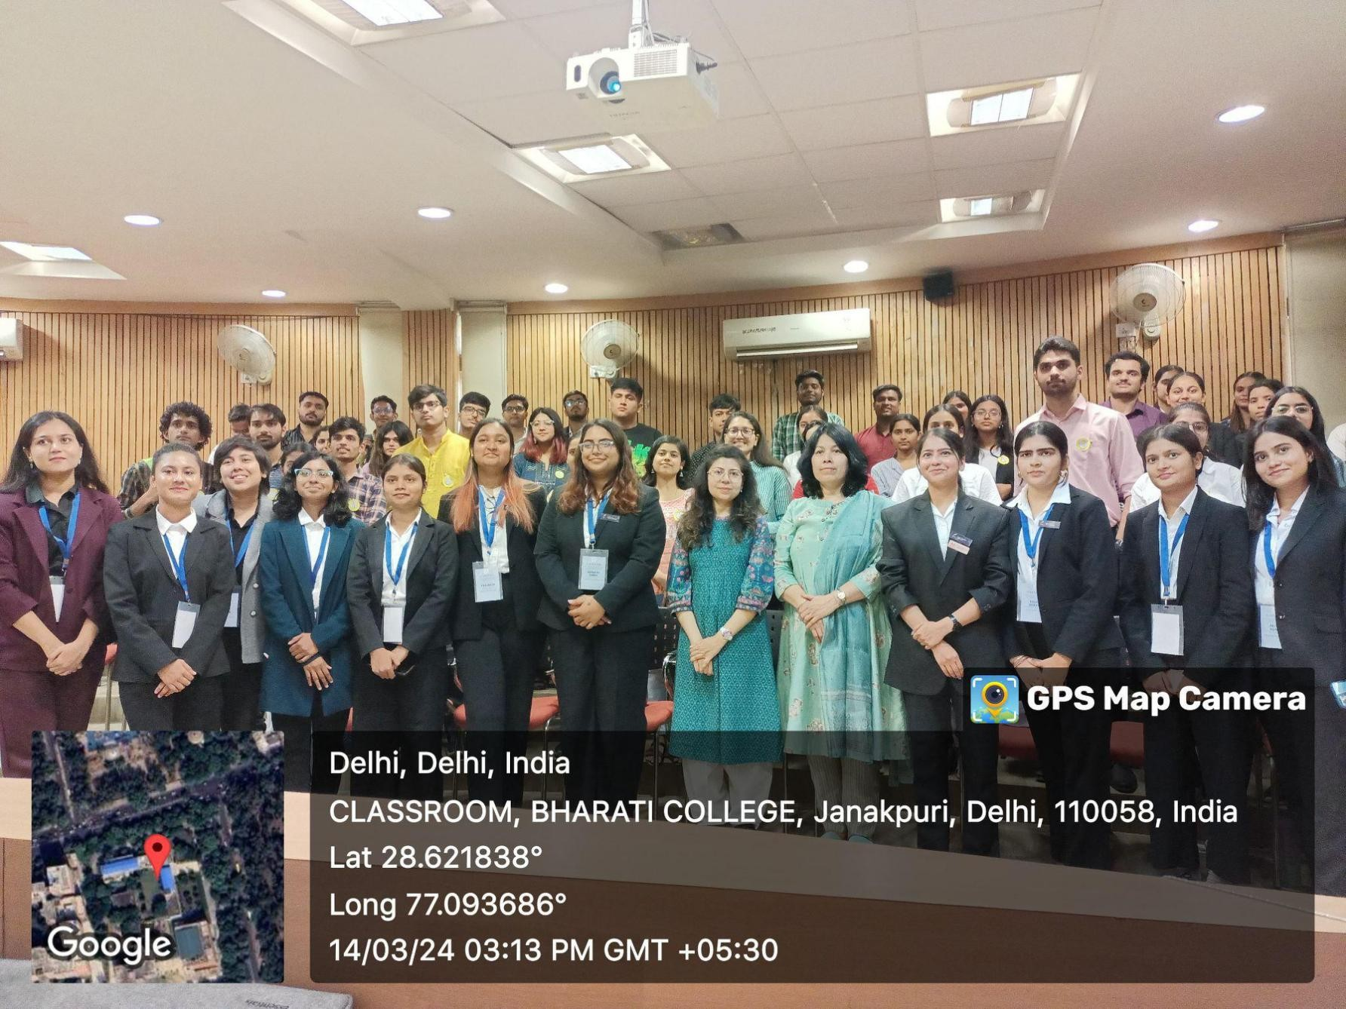

1. Group Discussion

Chintan- The Debating Society, organised a compelling group discussion session delving into the topic, ‘Does technology impact modern relationships?’.

In a world where the dynamics of love and human connection are constantly evolving, this topic struck a chord with the diverse perspectives prevalent among the younger generation. The discussion unfolded with a palpable energy, fueled by the active participation of Chintan members who brought forth a myriad of compelling viewpoints. Facilitated by the General Secretary of Chintan, the discourse navigated through the complexities of how technology intersects with the intricacies of modern relationships. Dr. Anavisha Banerjee, the Convener, imparted her profound wisdom, enriching the discourse. The President and Vice President lent their invaluable insights and guidance, bolstering the event's significance. The session emerged as a resounding success, igniting intellectual fervour and leaving a lasting impression on all participants. It served as a fitting conclusion to a successful academic year, igniting intellectual fervour and leaving a lasting impression on all participants. Following the session, as we wrapped up the semester, we took a moment to express our gratitude to our seniors for their guidance and mentorship throughout the year, recognising their invaluable contributions to Chintan. With heartfelt thanks and fond memories, we conclude the academic year, looking forward to the adventures that await us in the future.

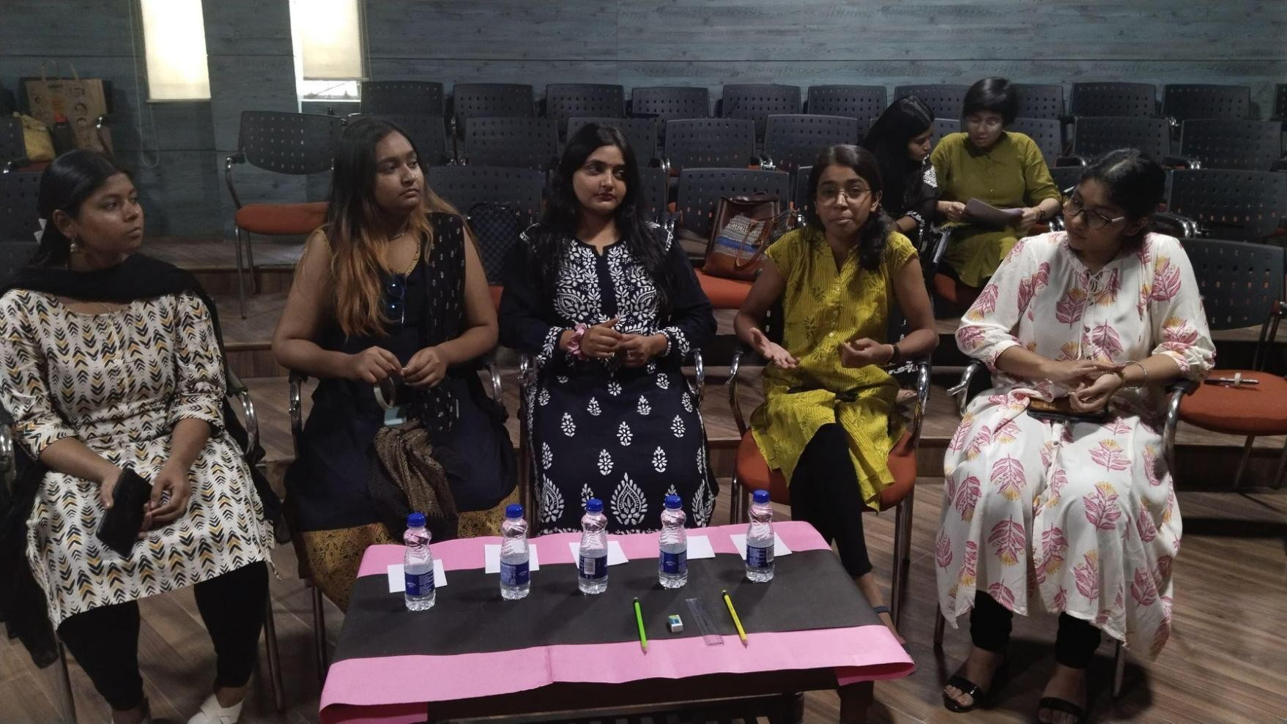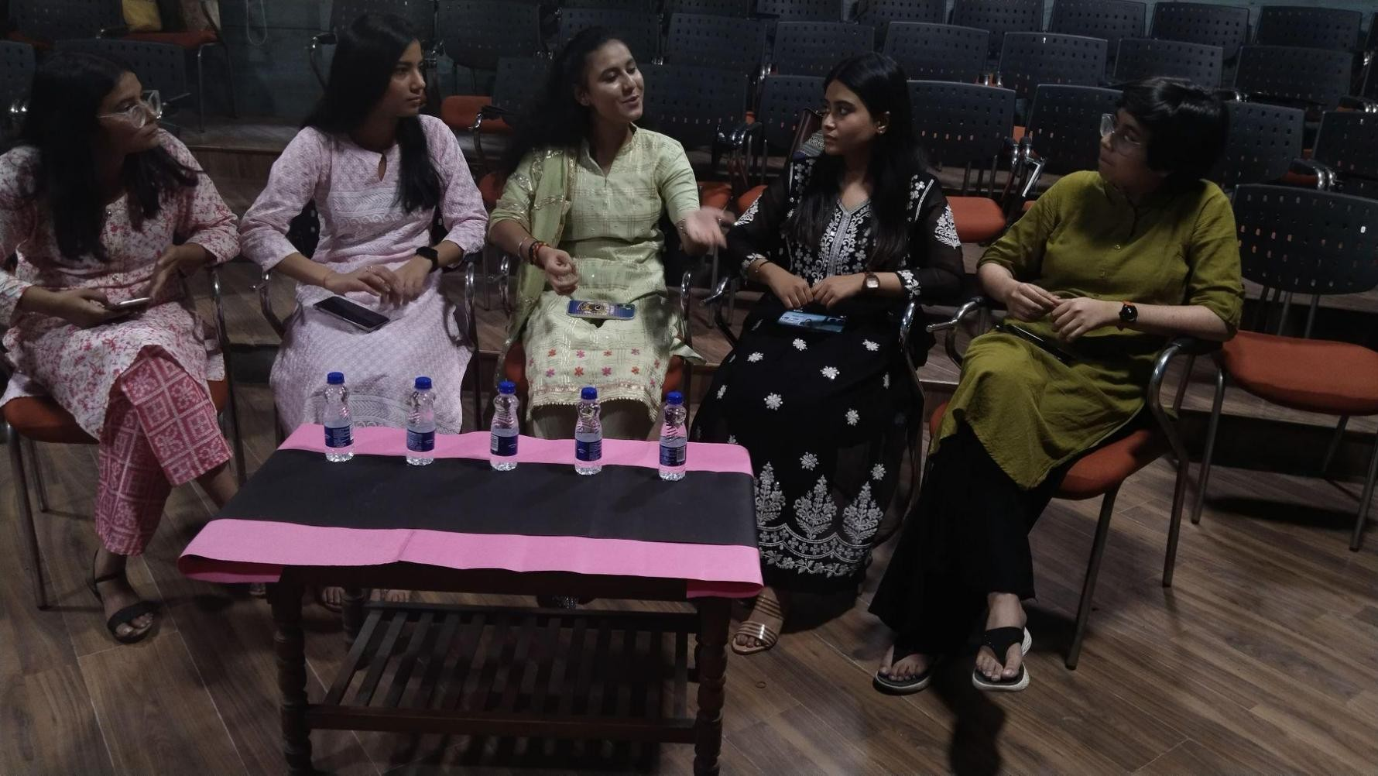

COLLABORATIONS FOR THE ACADEMIC YEAR 2023-24

* 1. CHINTAN X SAKSHAM

Chintan, the Debating Society of Bharati College, joined forces with Saksham, the Career Counselling, Placement, and E-Cell of Satyawati College(M), in a collaborative effort aimed at amplifying their online presence. This collaboration was solidified through a formal Memorandum of Understanding (MoU), where both parties agreed to reciprocally exchange followers on social media platforms such as LinkedIn.

Furthermore, they committed to promoting each other's events through their respective networks, striving to maximize reach. This strategic alliance was rooted in the mutual desire to leverage their combined networks and digital platforms to enhance their respective impacts within their target demographics. By pooling their resources and expertise, Chintan and Saksham aimed to establish a robust online presence and engage with a wider audience, thereby furthering their shared mission of fostering intellectual growth and professional development among college students.

* 1. CHINTAN X KAVYA

Chintan, the Debating Society of Bharati College entered into a collaborative partnership with Kavya- The Poetry Society of Bharati College, formalized through the signing of a Memorandum of Understanding (MoU). This agreement aimed to foster mutual support and promotion between the two esteemed societies. Under this collaboration, both parties committed to

promoting each other on social media platforms through activities such as reposting, resharing, and exchanging followers. Additionally, they pledged to extend support to one another in all capacities within the college environment. As a debating society, Chintan actively champions the promotion of other public speaking and performing societies, facilitating the dissemination of ideas and thoughts in front of diverse audiences. In this regard, the collaboration with Kavya, an esteemed and highly active society within Bharati College, proved to be mutually beneficial, enriching the academic and cultural landscape of the institution. This professional collaboration underscores a shared commitment to fostering an environment of collaboration, creativity, and intellectual exchange within the college community, thereby contributing to the holistic development and enrichment of its members.

* 1. CHINTAN X MANTHAN

Chintan, the Debating Society of Bharati College, solidified a collaborative alliance with Manthan, the Nukkad Natak Society of the same institution, through the formal signing of an MoU. This strategic partnership was established with the shared objective of promoting and supporting each other within the college community. Both societies committed to enhancing visibility on social media platforms and providing steadfast support within the college ecosystem. By actively collaborating with societies like Manthan, Chintan aimed to facilitate the exchange of ideas and foster an inclusive environment for intellectual discourse within Bharati College. The societies even came together to organise an event under the banner of ‘Viksit Bharat’. The Chintan-Manthan collaboration epitomized a professional dedication to mutual advancement and cultural enrichment within the vibrant college community. Through joint initiatives and collaborative efforts, Chintan and Manthan sought to inspire and empower students, while also strengthening the fabric of the college community.

CHINTAN’S SOCIAL MEDIA

* [https://www.instagram.com/p/CuHXHSmRqAW/?igsh=ejF6dTZ4dWlqMW](https://www.instagram.com/p/CuHXHSmRqAW/?igsh=ejF6dTZ4dWlqMWs1) [s1](https://www.instagram.com/p/CuHXHSmRqAW/?igsh=ejF6dTZ4dWlqMWs1)
* [https://www.instagram.com/p/CuPlZU3S6Jq/?igsh=MWowempyOWI5dWY](https://www.instagram.com/p/CuPlZU3S6Jq/?igsh=MWowempyOWI5dWY1Yg%3D%3D) [1Yg==](https://www.instagram.com/p/CuPlZU3S6Jq/?igsh=MWowempyOWI5dWY1Yg%3D%3D)
* <https://www.instagram.com/p/CwVWgfJtj-N/?igsh=ZzNuZ2tuY2YyNzBn>
* [https://www.instagram.com/p/CwqJF4lSTXa/?igsh=MWxmcGhnOGc3enQ](https://www.instagram.com/p/CwqJF4lSTXa/?igsh=MWxmcGhnOGc3enQ3Zg%3D%3D) [3Zg==](https://www.instagram.com/p/CwqJF4lSTXa/?igsh=MWxmcGhnOGc3enQ3Zg%3D%3D)
* [https://www.instagram.com/reel/Cwxgrsxxanl/?igsh=MXNleXZ2OHVrY2R](https://www.instagram.com/reel/Cwxgrsxxanl/?igsh=MXNleXZ2OHVrY2R3Mg%3D%3D) [3Mg==](https://www.instagram.com/reel/Cwxgrsxxanl/?igsh=MXNleXZ2OHVrY2R3Mg%3D%3D)
* <https://www.instagram.com/p/CxGdf1Gtp7i/?igsh=aWMzMWI3OG1peDUz>
* [https://www.instagram.com/p/Cxk9RtTRBG5/?igsh=MTFtaXdvZGppM2lm](https://www.instagram.com/p/Cxk9RtTRBG5/?igsh=MTFtaXdvZGppM2lmYg%3D%3D) [Yg==](https://www.instagram.com/p/Cxk9RtTRBG5/?igsh=MTFtaXdvZGppM2lmYg%3D%3D)
* [https://www.instagram.com/reel/CxdZ-](https://www.instagram.com/reel/CxdZ-9xSnuM/?igsh=MWh2MGplY2RhMnR6MQ%3D%3D) [9xSnuM/?igsh=MWh2MGplY2RhMnR6MQ==](https://www.instagram.com/reel/CxdZ-9xSnuM/?igsh=MWh2MGplY2RhMnR6MQ%3D%3D)
* [https://www.instagram.com/p/CxsurWiNX0M/?igsh=ZzRncG1zZjM5YWI=](https://www.instagram.com/p/CxsurWiNX0M/?igsh=ZzRncG1zZjM5YWI%3D)
* [https://www.instagram.com/p/CyBdwsvRbIv/?igsh=MXIwbG55YTZwbmU](https://www.instagram.com/p/CyBdwsvRbIv/?igsh=MXIwbG55YTZwbmU%3D)

[=](https://www.instagram.com/p/CyBdwsvRbIv/?igsh=MXIwbG55YTZwbmU%3D)

* <https://www.instagram.com/p/CyVMFIdBwdU/?igsh=bzFqNnBydDI0cXEy>
* <https://www.instagram.com/p/CycsDKlRSVb/?igsh=ODQ4MjE2YjR3ODNt>
* <https://www.instagram.com/p/C3X0iT5R96S/?igsh=em44ZzBrcDRtN2hj>
* <https://www.instagram.com/p/C3p-5pHxLeU/?igsh=ZjhteHp4OHh0dnMy>
* [https://www.instagram.com/reel/C3nOsl7RVmT/?igsh=MWFhemt1aWdlY3](https://www.instagram.com/reel/C3nOsl7RVmT/?igsh=MWFhemt1aWdlY3BzcA%3D%3D) [BzcA==](https://www.instagram.com/reel/C3nOsl7RVmT/?igsh=MWFhemt1aWdlY3BzcA%3D%3D)
* <https://www.instagram.com/p/C35kQC0SsRe/?igsh=OXM4dnY5bDJ3b3dh>
* [https://www.instagram.com/reel/C5V9woERHfO/?igsh=MWxmdGh4eWNh](https://www.instagram.com/reel/C5V9woERHfO/?igsh=MWxmdGh4eWNhYnU0) [YnU0](https://www.instagram.com/reel/C5V9woERHfO/?igsh=MWxmdGh4eWNhYnU0)
* [https://www.instagram.com/p/C4BU46nymIK/?igsh=M2xqMnVuaHR2am](https://www.instagram.com/p/C4BU46nymIK/?igsh=M2xqMnVuaHR2amM%3D) [M=](https://www.instagram.com/p/C4BU46nymIK/?igsh=M2xqMnVuaHR2amM%3D)
* <https://www.instagram.com/p/C48bRlFy2q_/?igsh=cmR3b2U5ZWJvYWFz>
* [https://www.instagram.com/reel/C45vMt2RUt5/?igsh=MXYzM3dkY25vcm](https://www.instagram.com/reel/C45vMt2RUt5/?igsh=MXYzM3dkY25vcmdsYQ%3D%3D) [dsYQ==](https://www.instagram.com/reel/C45vMt2RUt5/?igsh=MXYzM3dkY25vcmdsYQ%3D%3D)

For further details, contact: [chintandebsoc@gmail.com](mailto:chintandebsoc@gmail.com)

CHINTAN ACHIEVEMENTS 2023-24

* On 14th April 2023, Nandini Dang, the General Secretary of Chintan, featured in Open Mics organised by Kommune Delhi and Unfiltered Gupshup. She also got featured on their respective social media handles.
* On 30th September 2023, Vidhi Pathak, a Senior Executive member of Chintan, secured the first position in ‘V for Verbal Vendetta: INKlination's debate competition’ by Dr Babasaheb Ambedkar Medical College.
* On 2nd October 2023, Shreya Mishra, a Senior Executive member of Chintan, participated in the Samanta Sangam - A Speech Competition organised by the Delhi University Ahimsa Unit. She secured the 3rd position and was awarded a certificate and a cash prize of ₹500.
* On 13th October 2023, Prajakta, the Joint Secretary of Chintan, won second place in an Open Mic Competition organised by Bharati Vidyapeeth's Institute of Computer Applications and Management (BVICAM). She was awarded a certificate and a cash prize of ₹1000.
* On 19th October 2023, Ayushi Srivastava, an Executive member of Chintan, won first place in ‘Chai Pe Charcha’, a Group Discussion competition organised by Dhairya, The Civil Services Society, Bharati College. She was awarded a Certificate of Merit.
* On 30th October 2023, Trisha Tomar, a Senior Executive member of Chintan, bagged the first position in an Open Mic Competition organised by NSS, Bharati College.
* On 30th October 2023, Ayushi Srivastava, an Executive member of Chintan, bagged the second position in an Open Mic Competition organised by NSS, Bharati College.
* On 6th November 2023, Gungun Singh, the PR Head of Chintan, secured fifth position in an Open Mic Competition by Deen Dayal Upadhyaya College. She was awarded a certificate and a cash prize of ₹500.
* On 4th December 2023, Sakshi Raj Wardhan, an Executive member of Chintan, participated in Prabodhan 1.0 - Youth Parliament, AIPPM, organised by Aaroh, the Hindi Debating Society of Ram Lal Anand College. She was acknowledged with a Verbal Mention and awarded a Certificate of Commendation.
* On 9th January 2024, Prachi Maurya, a Senior Executive member of Chintan, achieved victory at the District Level Declamation Contest and moved forward to represent the South-West district of Delhi at the State Level Contest organised by Nehru Yuva Kendra Sangathan, Delhi. Her eloquent oratory skills garnered appreciation and earned her a Certificate of Merit and a memento.
* On 12th January 2024, Jansi, an Executive member of Chintan, secured the second position in a Declaration/Speech Competition organised within Bharati College by the Department of Sanskrit in collaboration with ‘Youth United for Vision and Action Bharati unit’ and NSS Bharati. She was awarded a cash prize of

₹300.

* On 8th February 2024, Prachi Maurya, a Senior Executive member of Chintan, secured the 3rd position in Tark Vitark, a Debate Competition organised by Tarseel, the Department of Journalism at Bharati College. She was awarded a Certificate of Merit and goodies.
* On 16th February 2024, Anamika Chatterjee, a Senior Executive member of Chintan, received a special mention in the UNSC committee of Eloquence MUN organised in Bharati College.
* On 26th February 2024, Trisha Tomar, a Senior Executive member, and Azra Sharfia, an Executive member of Chintan, participated in ‘Tark Utsav - A Conventional Debate Competition’ organised by Cypher X - The Mathematics Society of Satyawati College and secured 2nd position as a team.
* On 2nd March 2024, Sakshi Raj Wardhan, an Executive member of Chintan, participated in a National Declamation Contest organised by INDIA - The Debating Forum on the topic 'UPSC: An Exam or Life'. She was awarded a Certificate of Achievement along with a cash prize of ₹200.
* On 26th April 2024, Vidhi Arora, a Senior Executive member of Chintan, participated in the Annual Bilingual Inter-College Debate Competition, GREEN MATTERS, organised by AVANI - The Environment Club of Janki Devi Memorial College, University of Delhi under the Annual Fest EKATVAM'24. She secured the 2nd position and was awarded a certificate and cash prize.

CHINTAN ATTENDANCE 2023-24

|  |  |  |
| --- | --- | --- |
| MEMBER NAME | SEMESTER | ATTENDANCE |
| Suhani Sabharwal | 5 | S3 |
| Sujata Sharda | 5 | S3 |
| B Lipsa Raghunath | 5 | S3 |
| Rashi Arora | 5 | S1 |
| Prachi Raj | 5 | S1 |
| Nandini Dang | 3 | S3 |
| Prajakta | 3 | S3 |
| Gungun Singh | 3 | S2 |
| Bhumika Ajegar | 3 | S3 |
| Vidhi Arora | 3 | S2 |
| Tannu Bhakta | 3 | S2 |
| Trisha Tomar | 3 | S2 |
| Prachi Maurya | 3 | S1 |
| Vidhi Pathak | 3 | S2 |
| Anamika Chatterjee | 3 | S2 |
| Shreya Mishra | 3 | S1 |

|  |  |  |
| --- | --- | --- |
| Mahak Verma | 1 | S1 |
| Jansi Dhameriya | 1 | S1 |
| Varsha Kumari | 1 | S1 |
| Sakshi Raj | 1 | S1 |
| Ayushi Srivastava | 1 | S2 |
| Azra | 1 | S1 |
| Yogita Gupta | 1 | S2 |
| Anjali Pandey | 1 | S2 |



|  |  |  |
| --- | --- | --- |
| MEMBER NAME | SEMESTER | ATTENDANCE |
| Suhani Sabharwal | 6 | S3 |
| Sujata Sharda | 6 | S3 |
| B Lipsa Raghunath | 6 | S3 |
| Rashi Arora | 6 | S2 |
| Prachi Raj | 6 | S2 |
| Nandini Dang | 4 | S3 |
| Prajakta | 4 | S3 |
| Gungun Singh | 4 | S3 |
| Bhumika Ajegar | 4 | S3 |
| Vidhi Arora | 4 | S1 |
| Tannu Bhakta | 4 | S3 |
| Trisha Tomar | 4 | S2 |

|  |  |  |
| --- | --- | --- |
| MEMBER NAME | SEMESTER | ATTENDANCE |
| Prachi Maurya | 4 | S2 |
| Vidhi Pathak | 4 | S3 |
| Anamika Chatterjee | 4 | S3 |
| Shreya Mishra | 4 | S1 |
| Mahak Verma | 2 | S2 |
| Jansi Dhameriya | 2 | S2 |
| Varsha Kumari | 2 | S2 |
| Sakshi Raj | 2 | S2 |
| Ayushi Srivastava | 2 | S3 |
| Azra | 2 | S2 |
| Yogita Gupta | 2 | S2 |
| Anjali Pandey | 2 | S3 |

Team

* + Core Team

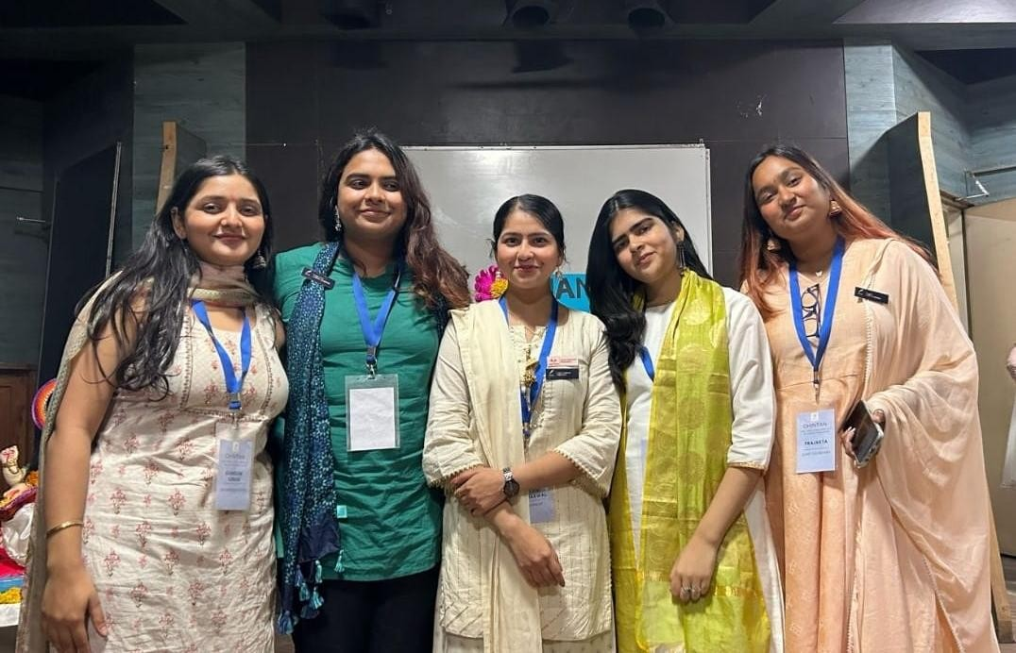

(From L to R: Gungun Singh, Nandini Dang, Suhani Sabharwal, Sujata Sharda, Prajakta)

**President:** Suhani Sabharwal **Vice-President:** Sujata Sharda **General Secretary:** Nandini Dang **Joint Secretary:** Prajakta

**PR Head:** Gungun Singh

# Super Senior Executive members

Prachi Raj Rashi Arora

B Lipsa Raghunath

# Senior Executive members

Shreya Mishra Anamika Chatterjee Vidhi Pathak Prachi Maurya Trisha Tomar Tannu Bhakta Vidhi Arora Bhumika Ajager

# Executive members

Mahak Verma Jansi

Varsha Kumari Sakshi Raj Ayushi Srivastava Azra Sharfia Yogita Gupta Anjali Pandey

**Convenor:** Dr. Anavisha Banerjee

**Co-Convenors:** Dr. Savita Jemini

Dr. Rekha Sharma

With unwavering dedication, we conquered challenges, guided by creativity and determination. Chintan actively strives to grow and help all of its members become better versions of themselves. We desire to keep up such work in the future.

Regards,

Chintan - The Debating Society Bharati College, University of Delhi