NAME OF THE CELL:

North-East Cell (August 2023- June 2024)

CONVENER:

Ms. Kangkana Roy

FACULTY MEMBERS:
Ms. Kangkana Roy
Ms. Elangbam Reebika Devi
Ms. Stanzin Chuskit
Ms. Chingmuankim.

ABOUT THE CELL:

The North-East Cell of Bharati College is a part of the initiative of Delhi University which looks into the welfare of the students coming from the Northeastern states of India. The Cell organizes cultural, social and academic events and addresses issues related to the North-East India. It provides various opportunities for the North-East students to express themselves, mutually co-exist, learn and cope in varied settings and cultural milieus. It also serves as a platform for these students to form solidarity with fellow students and to orient as well as assimilate themselves with the mainstream culture.

Highlights of the academic year Aug 2023- October 2024:

- On the 25th of September, 2023, the North-East Cell presented a Manipuri dance form called “Leima Jagoi”, as part of the Bharati College Annual Fest.
- On the 27th of October, 2023 the Cell showcased the Cheraw dance (also known as the Bamboo dance) and a Fusion dance showcasing the rich culture of all the Northeastern States of India, as part of the G20 event held at the Bharati College Auditorium.
- On 8th November, 2023 A theater talk by Prof Riken Ngomle from NSD was organized by the Cell. The students interested in theatre took part in the event and were highly inspired by the interaction with Prof. Riken. He gave a talk on the basic nuances of theatre as an art form and also talked about the history of theatre cultures from the North-East India and their gradual inspiration from and also assimilation with the mainstream theatre culture.
- On February 16th, 2024, the North-East Cell contributed a vibrant cultural dimension to the closing ceremony of the Model United Nations, organized by the Loksamvad, Political Science Department. The MUN provided a platform for students to hone their debating skills.
- On 22nd February,2024, the Cell presented a dance form from Arunachal Pradesh titled "Tami Ngok Gisa Si Galo," at the cultural festival "ONENESS," organized by the North-East Society of Shri Venkateshwara College, University of Delhi.
- On 14th March, 2024, A vibrant cultural ramp walk showcasing traditional North Eastern attire was presented by the Cell at the Bharati College Annual Fest, ABHIVYAKTI’24. The Cell collaborated with other male participants from North-East Cells from across various other colleges in the University of Delhi. On 15th March, the second day of the fest the Cell organised an Inter-College Folk Dance Competition. A total of 12 colleges participated, with Hansraj College and Dayal Singh College clinching the first and second positions, respectively.
- During the annual NSS festival "Jaagrat'24" held on March 20th, 2024, The North-East Cell of Bharati College set up a booth showcasing the cultural diversity of the North East states. The booth featured traditional attires from the region and a separate stall offering delicious North Eastern cuisine.
- The North-East Cell actively participated as hosts at the “Poorvattar Theatre celebrations” organized by NSD in collaboration with the NCWEB Bharati college held on the 28th-29th March,2024. The plays performed were titled "UNCHAYI" by the renowned Assamese playwright by actor and director Baharul Islam and his troupe “The Seagull Theatre” and the play called "SARAL BARTA” by playwright and director Partha Pratim Acharya and his “Natyabhumi Theatre Group” from Tripura. Both the Conveners and students from the Cell were actively present as hosts, audience and as volunteers and contributed immensely in the interpersonal communications with the NSD. The NSD Staff and actors were immensely happy with our reception and expressed their desire to have further collaborations with the college in future.
- From the 7th to 24th of August 2024, the Cell collaborated with NSS to organize a donation drive for the victims of Sikkim and Manipur. The drive collected a significant amount of clothing, food, medicine and other essential relief for the affected.

STUDENTS ACHIEVEMENTS (AUG, 2023- OCTOBER,2024):

- The North-East Cell of Bharati College, secured a Third place in the Girl’s Football match for the SHIRUI TROPHY, organized by the North-east Society of Satyawati College Evening on March 16-17, 2024.
- On April 15th, 2024, the Cell secured the 1st position in their Bihu dance presentation in the Inter-College Folk Dance Competition organized by Shivaji College during their annual Cultural Utsav. The Society presented a captivating Bihu dance, showcasing their cultural knowledge and versatility.
- The students from the Cell secured 2nd place in the Relay Race and 3rd position in the 100 meter dash at NESSDU annual sports event, an inter-collegiate competition held at the Kingsway Camp, Police Ground, held from April 22nd to 24th, 2024. The students competed in various sporting events, including football, basketball, arm wrestling, volleyball, relay race, 100m dash, and tug-of-war.
- On May 2nd, 2024 the North-East Cell of Bharati College presented a Tripuri Dance and secured the Second position in the Folk Dance Competition held in the cultural festival ‘Keteki’ at Kalindi College.

STUDENTS ACHIEVEMENTS (AUG, 2023- OCTOBER,2024):

- North-East Cell of Bharati College in collaboration with Redstockings Literary Society of Bharati College organised a “Speaker Session” on 11th of September, 2024 in the seminar hall on the topic - “Northeast in Indian Literature : How the region is represented in the broader Indian Literary Canon”. The event on the Northeast role in Indian Literature was a resounding success, drawing a significant audience of students and faculty members. The program commenced with insightful speeches from Ms. Kangkana Roy, the North-East Cell Convener, and Dr. Anavisha Banerjee, the Convener of RLS. Both speakers expressed their gratitude to the distinguished guest speaker, Dr. Achingliu Kamei, for her valuable insights and contributions. Dr. Kamei, an accomplished short story writer, poet, long-distance runner, and author of folktales, delivered a captivating presentation on the significance of the North-East region in Indian literature. Her discourse was both informative and engaging, fostering an interactive atmosphere that encouraged audience participation. As a token of appreciation, Dr. Kamei was presented with a pot and Gamusa by the conveners of North-East Cell and RLS. Following the presentation, Dr. Kamei took center stage, sharing her expertise on the topic and answering a variety of questions posed by the audience. The event concluded with a vote of thanks extended by the hosts of both societies. Notably, Dr. Kamei brought along a collection of her literary works, including poems, short stories, and novels. The North-East Cell and other societies wholeheartedly joined this interactive event.
- On 20th September 2024, our college was honored to host its annual day celebration, in the presence of the distinguished Chief Guest, Former Governor of Assam, Jagdish Mukhi Sir. The North-East Cell performed a Bihu dance, the traditional folk dance of Assam. The Chief Guest, Dr. Mukhi was highly impressed by the Bihu performance and spoke words of encouragement and praise to the students, in his brief interaction with the North-East Cell members.
- The North-East Cell of Bharati College organized a two-day cultural dance workshop. The aim of the event was to promote the rich and diverse culture of the North East region and to provide interested students with the opportunity to learn the various dance forms of the North-East states. The workshop was inaugurated with a formal ceremony, during which the new members of the North-East Cell's core team were presented with badges, and certificates of appreciation were conferred upon the former core members in acknowledgement of their valuable contributions. The workshop was graced by the presence of the college's esteemed convenors. Their encouraging words and valuable insights served as a source of inspiration for the participants motivating them to delve deeper into the cultural heritage of the region. The day's activities were dedicated to the exploration of various North East dance forms. With the guidance of accomplished instructors, the enthusiastic participants learned the intricate movements and unique styles of Assam, Sikkim, Tripura, Arunachal Pradesh, Manipur and Mizoram. The participants delved further into the cultural depths of the region, discovering the nuances and cultural significances of each dance form. The instructors, with their expert guidance, led the students through the steps and gestures, instilling in them a deep appreciation for the cultural richness of the North East.
- The North-East cell of Bharati College participated enthusiastically in the NESSDU elections held on 26th October, 2024. The elections were held at Nagaland House where the members of North-East Cell of Bharati College assembled at 10:00 am sharp along with necessary identification and coordination. Kishania Debbarma, a member of the cell, won the elections as Joint Secretary (West) and officially became a part of the NESS DU. The elections proved the true importance of voting and the significance of each individual’s opinion and contribution for the nomination of suitable candidates for leading and representing the students of North East.

Pictures of the events :

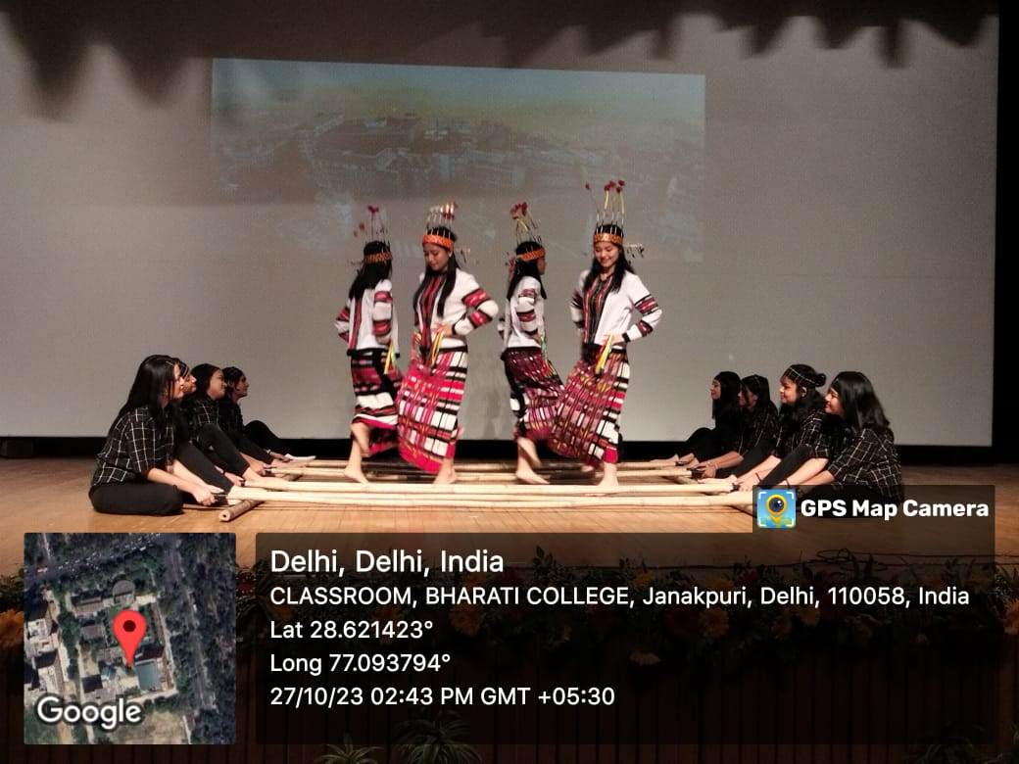

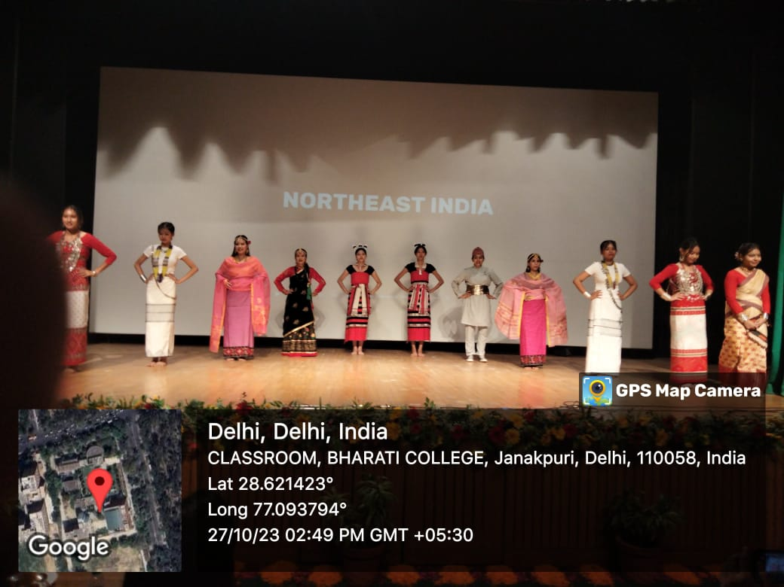

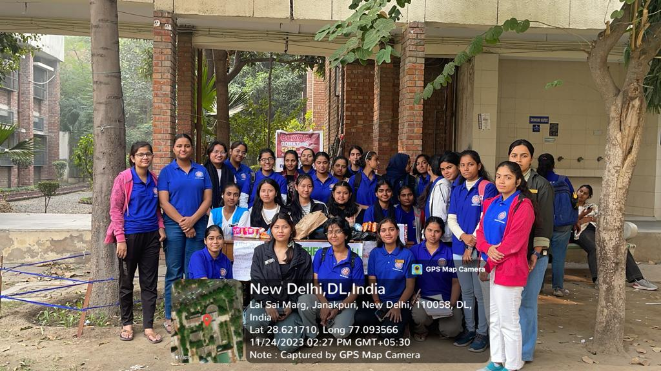

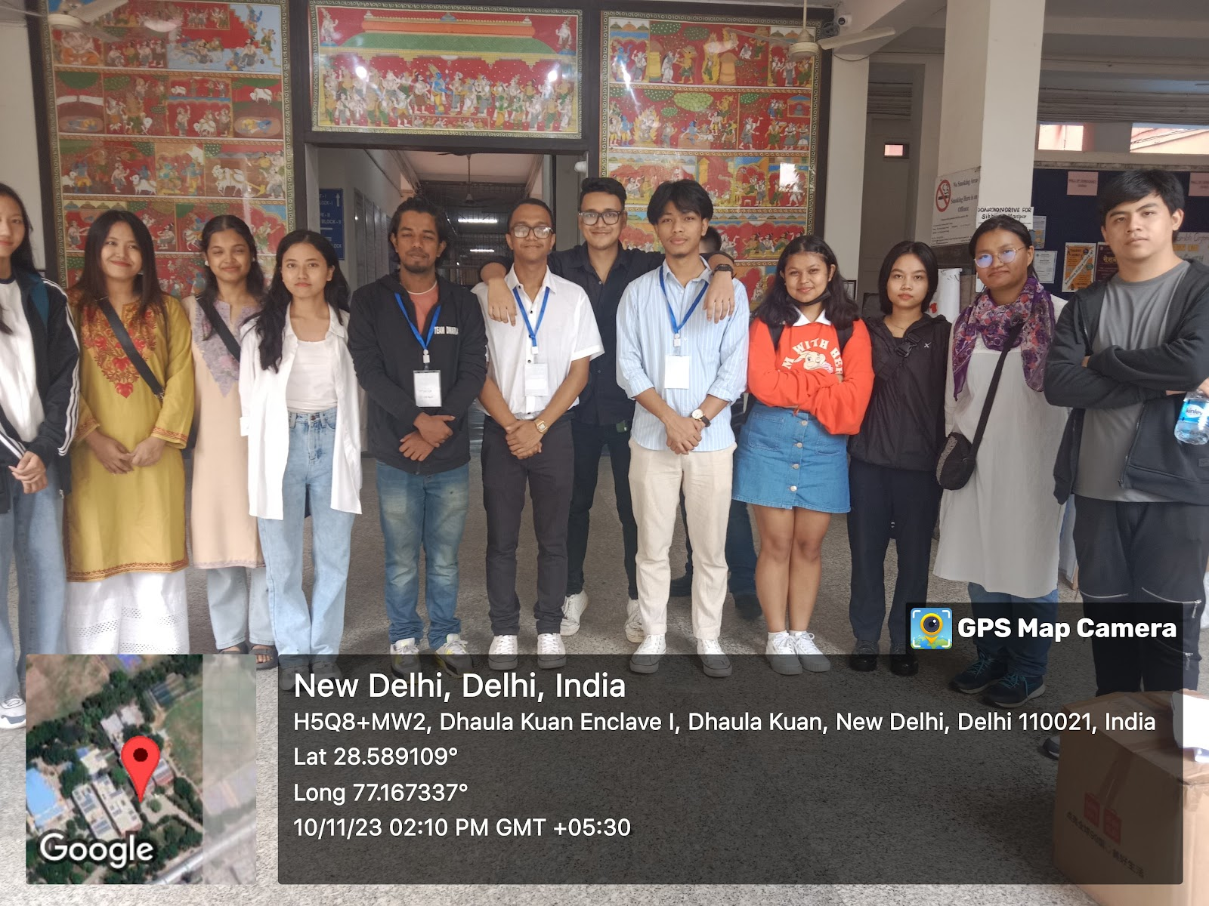

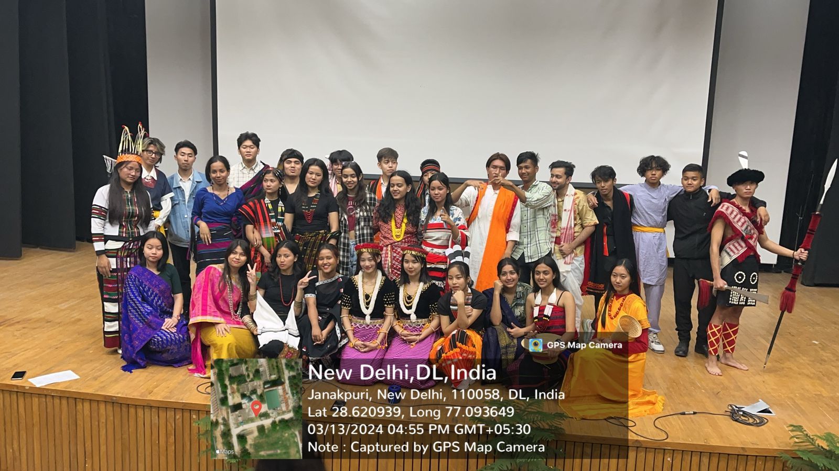
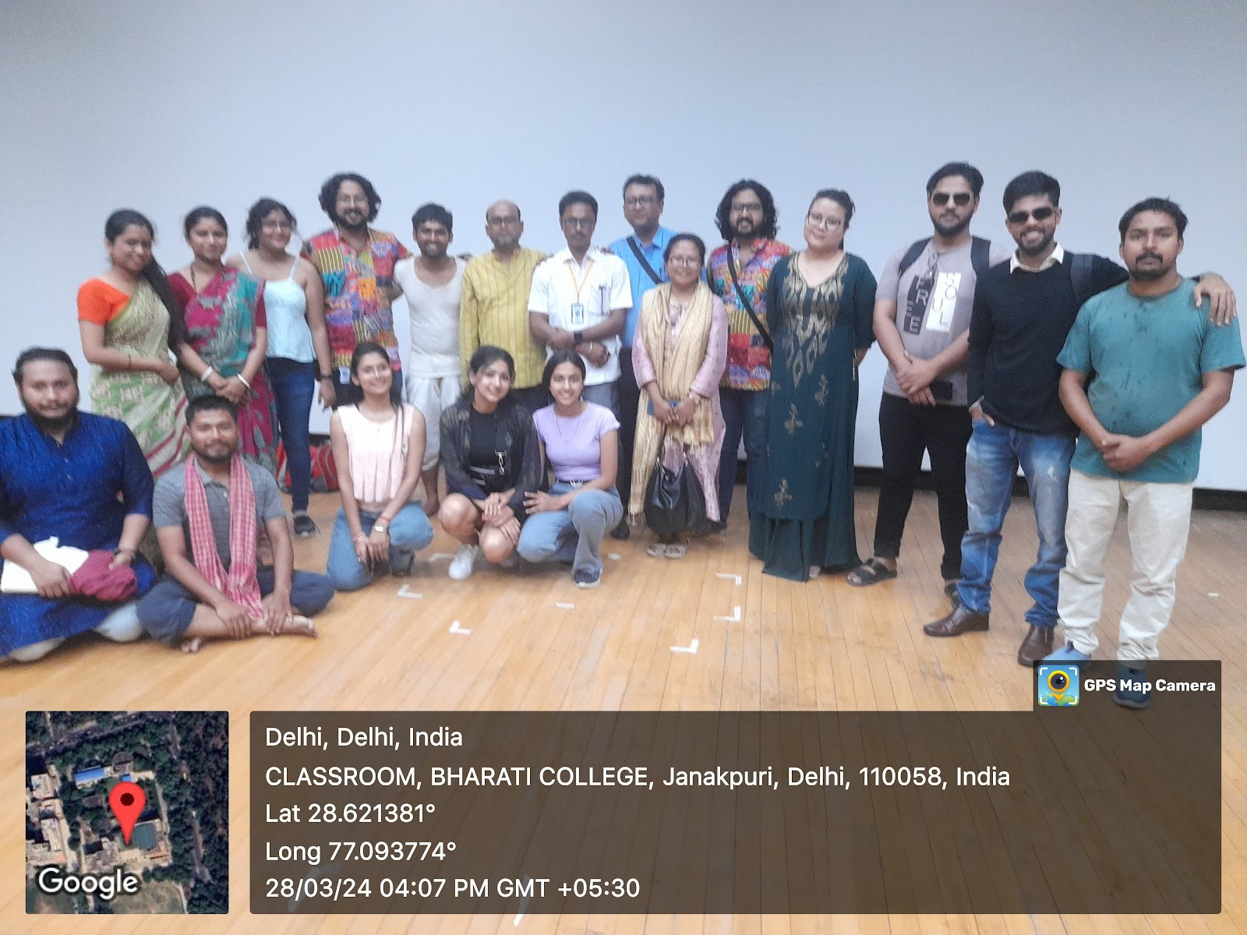
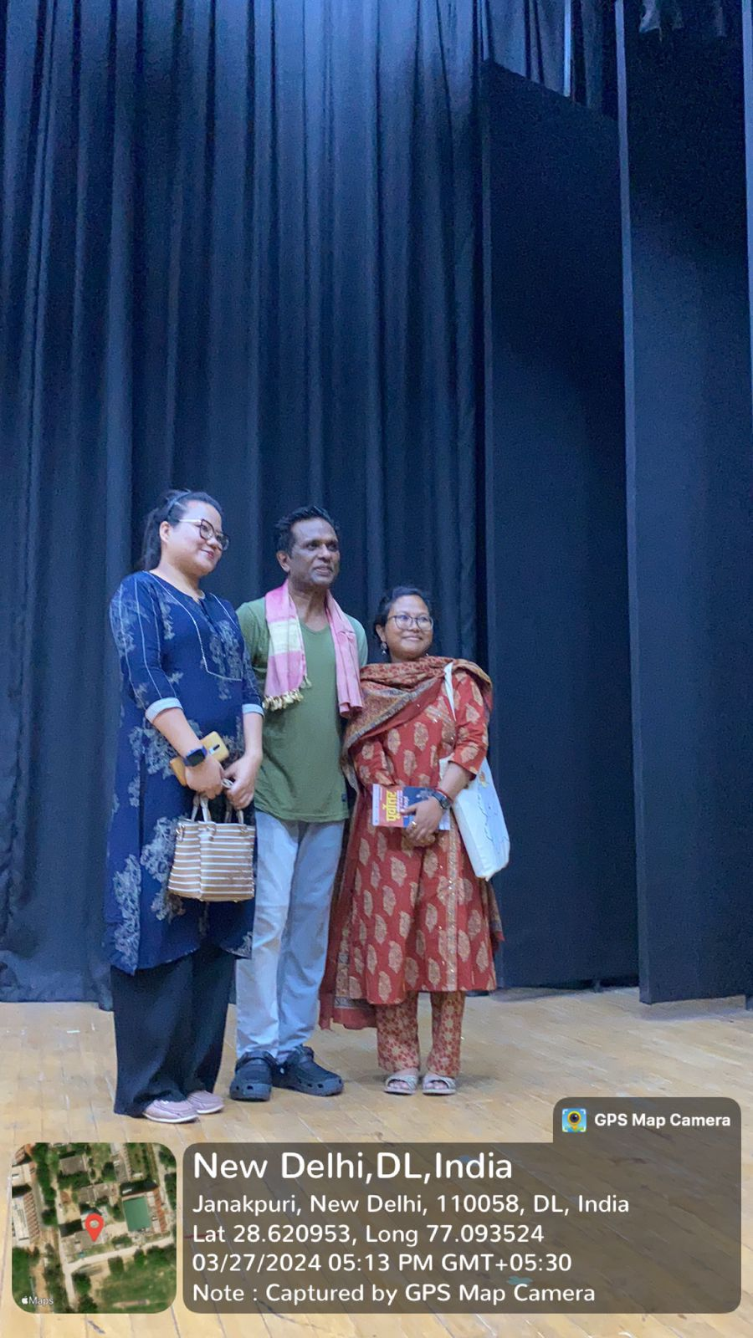
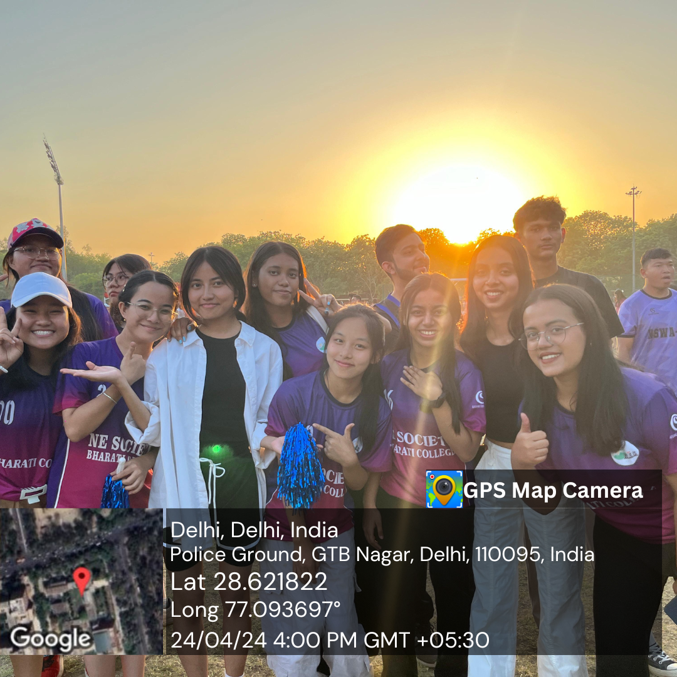

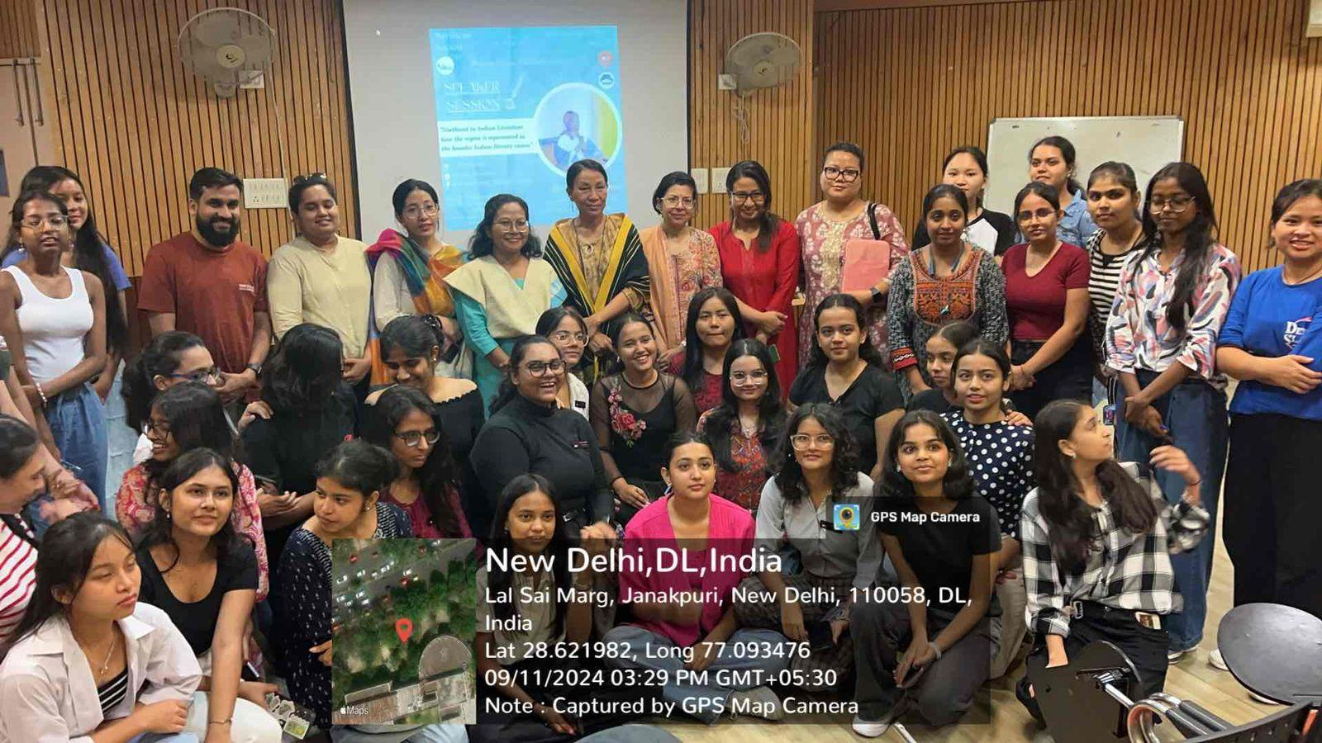
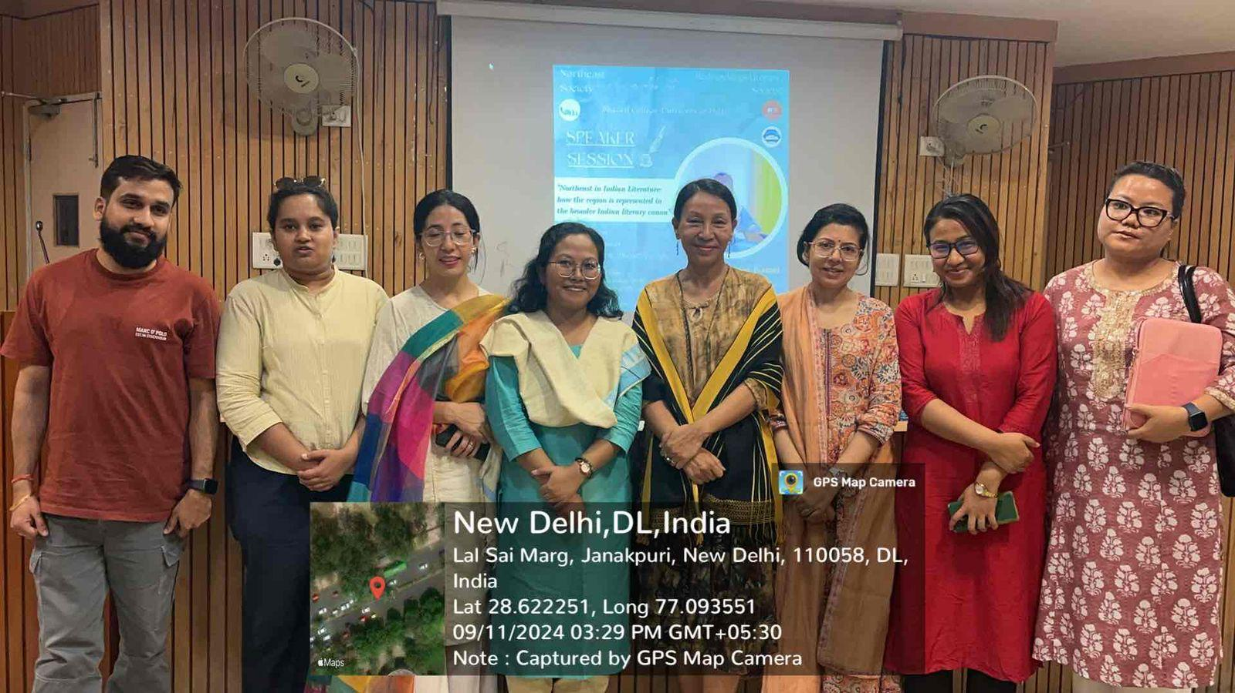
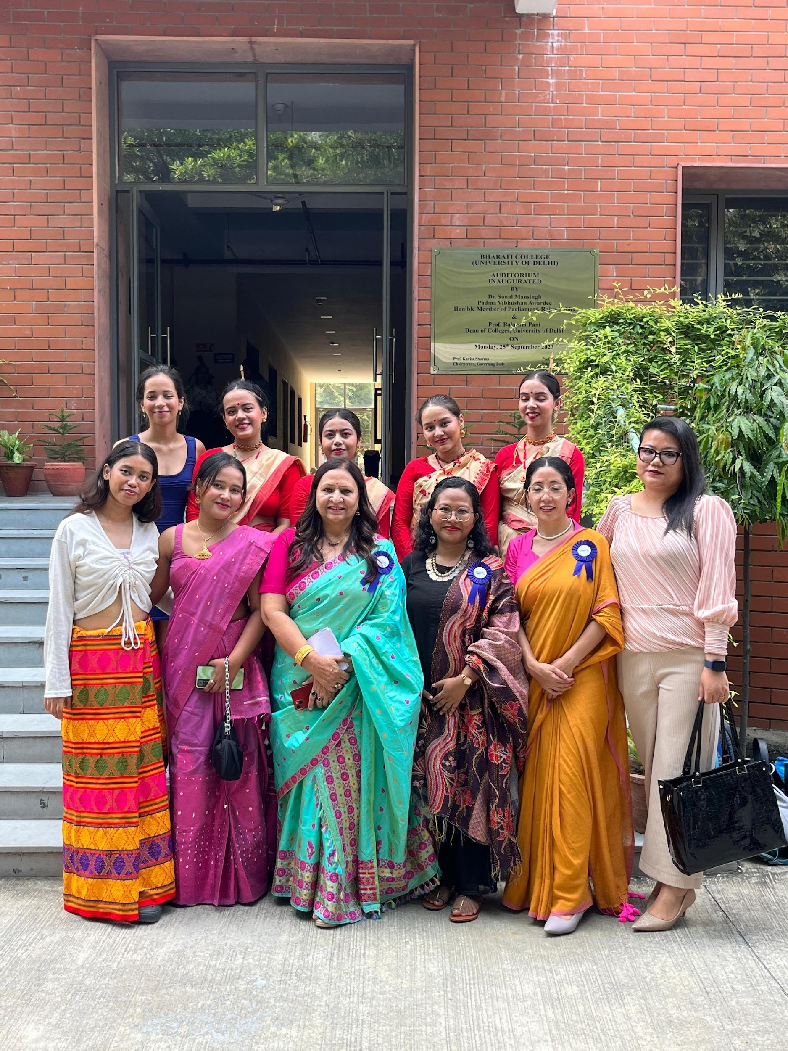
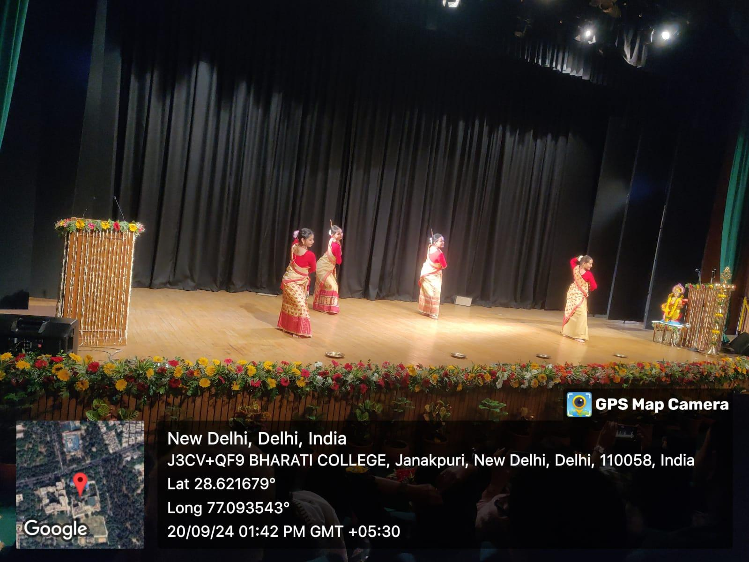
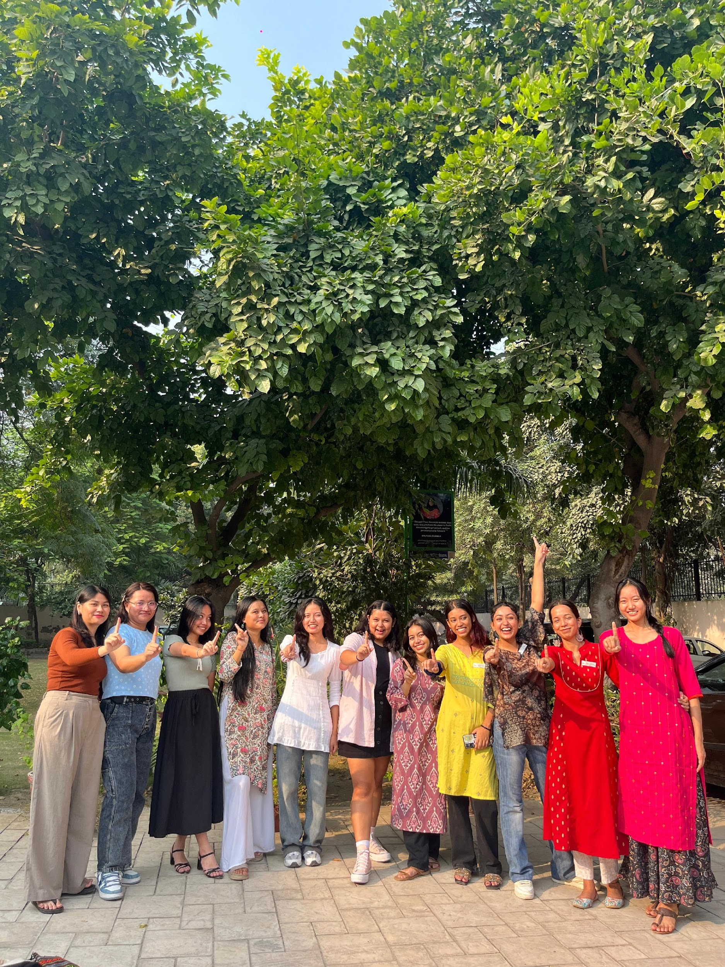
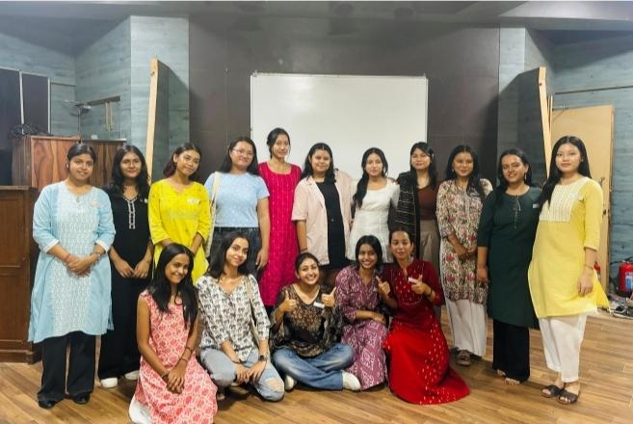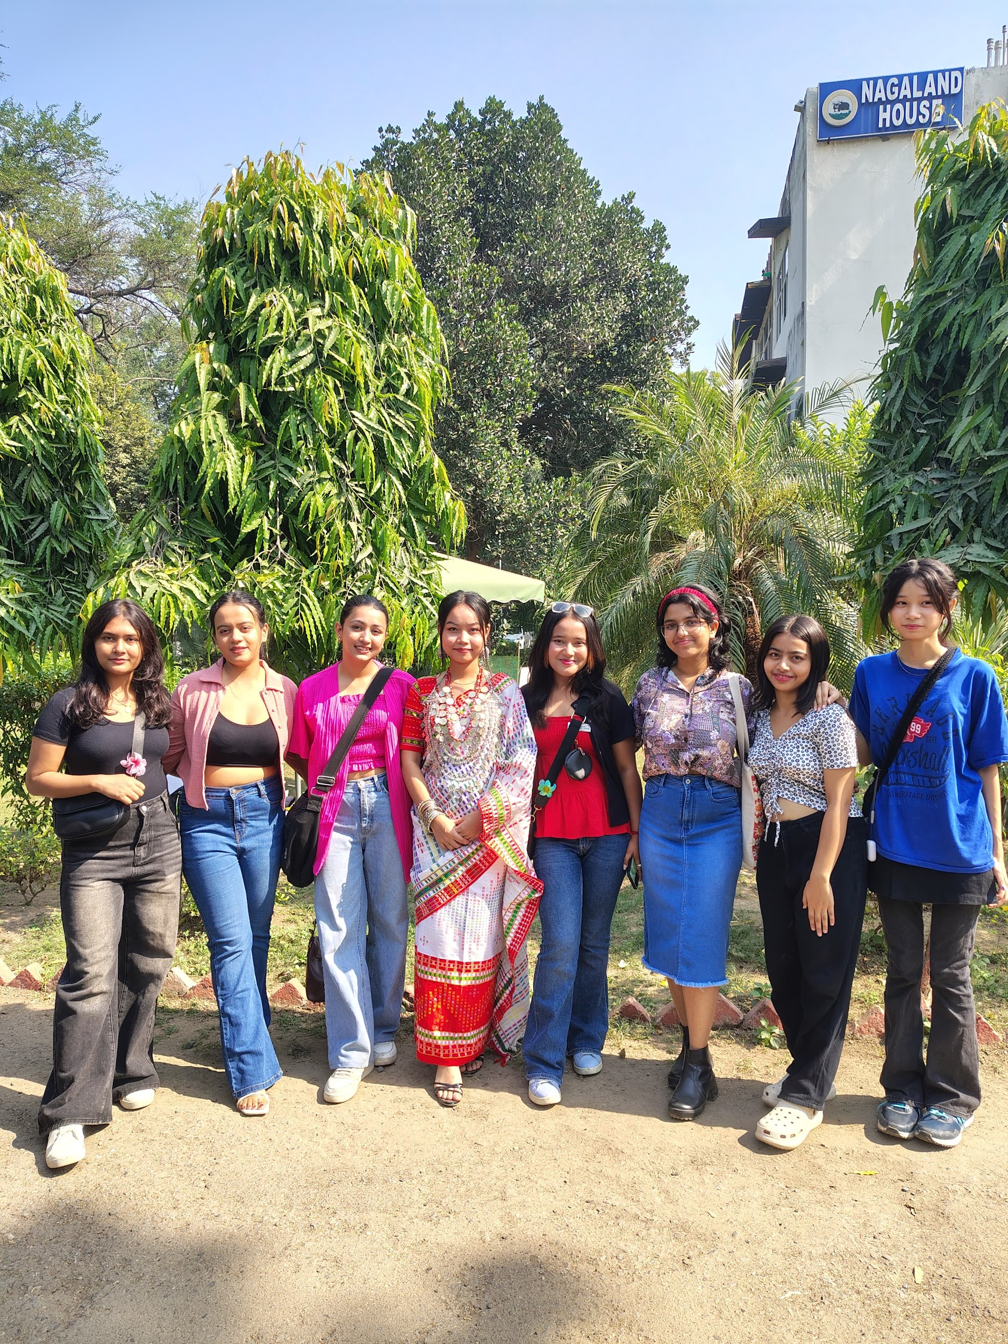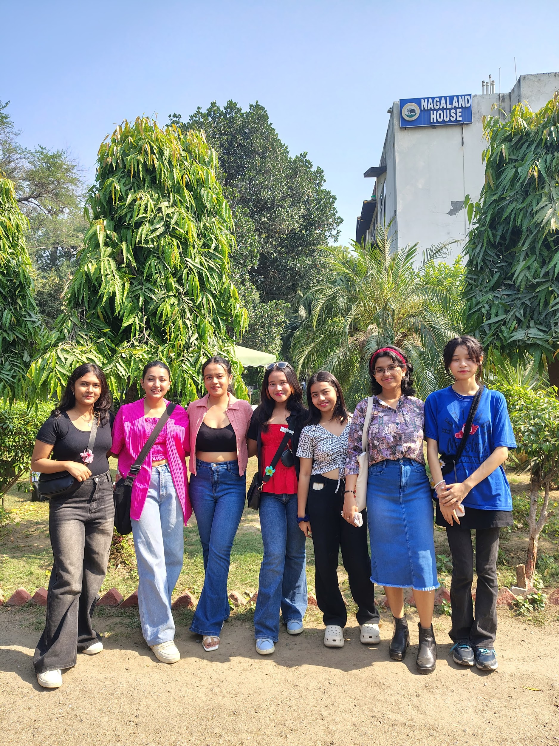

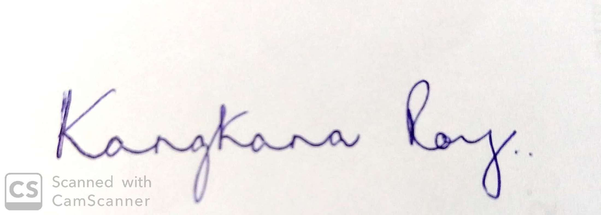

Kangkana Roy
(CONVENOR)
North-East Cell

