**Report: Mindful Meanderings– Inner Child Therapy (26th April 2024)**

On the 26th of April 2024, participants gathered for Mindful Meanderings– Inner Child Therapy, a vibrant and emotionally charged event that formed part of our ongoing meditation series. The session centered around reconnecting with the inner child, and fostering a nurturing environment for self-reflection, healing, and joy.

Each attendee brought a plain white t-shirt, which became a canvas for positive quotes, affirmations, and kind words. As everyone took turns writing on each other's shirts, filled with colors, laughter, and an outpouring of warmth. The act of sharing these words became a beautiful reminder of the strength and hope we often forget exists within us. More than 50 students attended session, embracing the journey of self-reflection and healing with open hearts and minds.

The group discussions invited participants to revisit cherished childhood memories, sparking conversations about personal growth, healing old wounds, and reigniting passions. The therapeutic nature of the event allowed everyone to feel connected, not just to their inner selves but also to one another, creating a sense of community and shared healing.

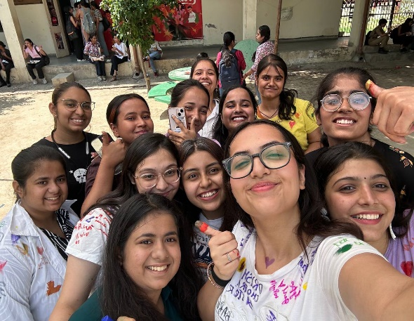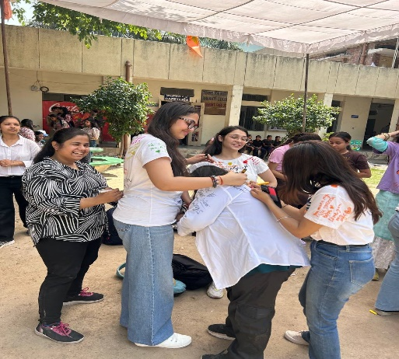Overall, the event was a touching success, leaving participants with not just the t-shirts adorned with affirmations, but with lasting memories and a renewed sense of emotional well-being.

**Report: Body Positivity Workshop by UNWIND Connect and Cure (1st May 2024)**

On 1st May 2024, UNWIND Connect and Cure hosted an empowering Body Positivity Workshop, led by psychologist Dr. Netra. The workshop focused on self-love, body image, and the mental perception we carry of ourselves. It was a highly interactive session where participants openly discussed how society and personal experiences shape their relationship with their bodies.

Dr. Netra encouraged a deep dive into self-reflection, helping attendees redefine their body image with kindness and acceptance. The session was packed with engaging tasks designed to reinforce positive self-perception, making the experience dynamic and enjoyable. Around 50 students attended the Workshop, creating a safe and empowering space to embrace self-love and confidence.

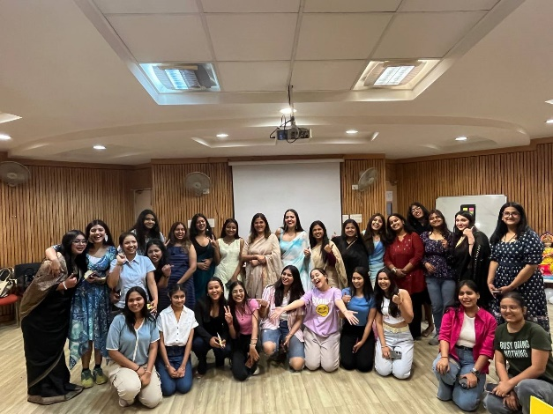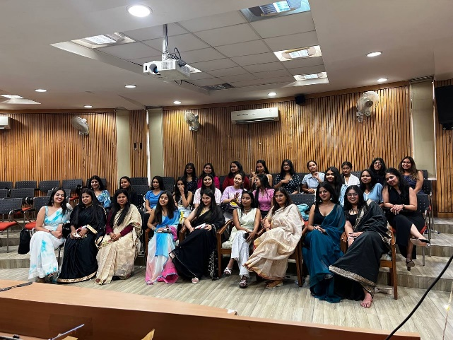 The Q&A segment added a personal touch, allowing participants to ask their most pressing questions and receive tailored advice from Dr. Netra. This engaging, task-filled session left participants with actionable insights on how to embrace self-love and cultivate a healthier relationship with their bodies.

**Report: Laughter Therapy Session (7th May 2024)**

On 7th May 2024, we hosted a Laughter Therapy session, an activity dedicated to spreading smiles and fostering genuine connections through shared laughter. It was filled with infectious joy as participants embraced their playful side—acting silly, cracking jokes, and sharing their most embarrassing stories with each other. Around 50 students participated in the session, filling the room with joy, positivity, and endless smiles.

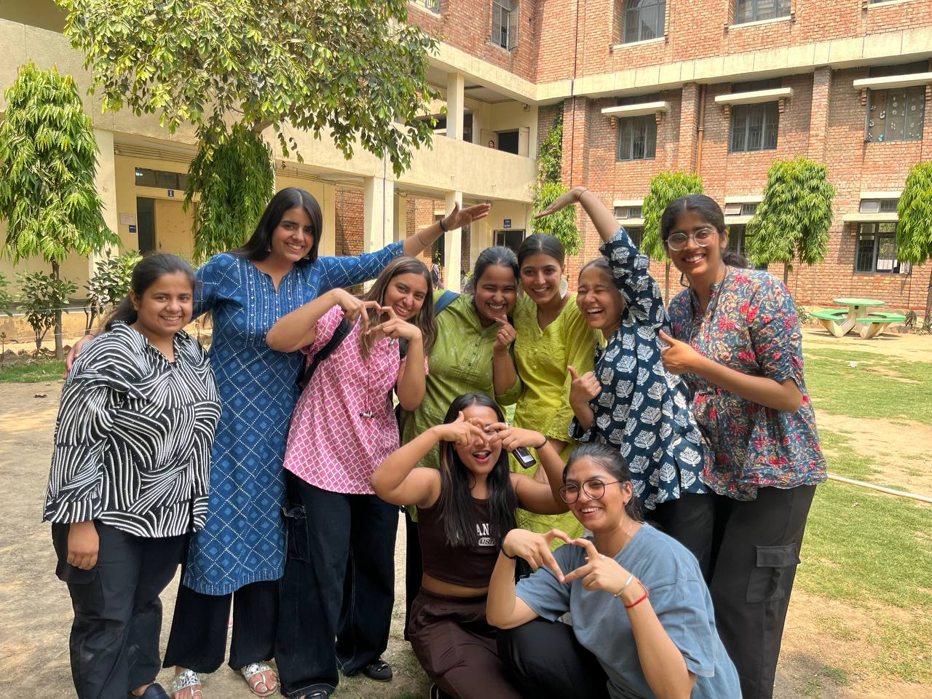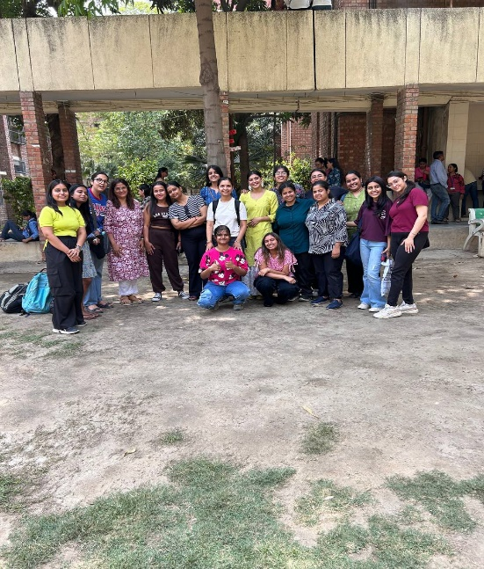This group activity wasn’t just about laughter; it was about letting go of inhibitions and finding comfort in the humor of life’s quirks. By the end of the session, the environment was lighter, hearts were fuller, and the bond between everyone felt stronger. Though no reels or posts captured the day, the memories of laughter will linger for a long time.

**Report: Flashmob– Ananda is Back! (13th September 2024)**

On 13th September 2024, the campus buzzed with energy as we hosted our first official activity for the freshers—a Flashmob that left everyone talking. With high-octane music setting the tone, the event kicked off with an explosion of dance, smiles, and infectious excitement. For a full 30 minutes, students—both new and old—joined in, letting loose to the most energetic beats, turning the entire campus into a celebration of movement. Approximately 60 plus students joined the Ananda Flashmob, lighting up the campus with their energy, enthusiasm, and incredible dance moves.

It wasn’t just a performance; it was an experience that had everyone on their feet, sharing laughter and rhythm. As the music faded, we made a massive announcement that reverberated across the campus: Ananda is back! It was the perfect way to welcome the freshers and reignite the spirit of togetherness and fun

**Report: Chill and Chat Session for Freshers (23 September 2024)**

On 23 September 2024, we hosted an engaging "Chill and Chat" icebreaker session for our freshers, designed to promote connection and ease their transition into our community. The atmosphere was lively as students joyfully interacted, sharing laughs and personal stories that sparked genuine connections. From humorous anecdotes to playful banter, the energy in the room was infectious.

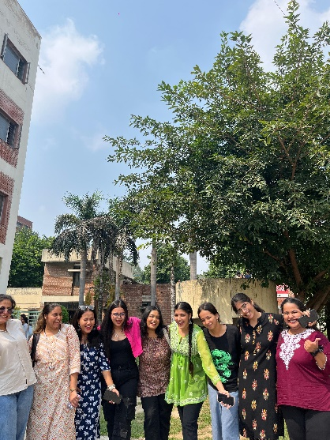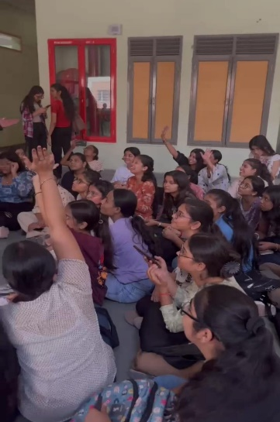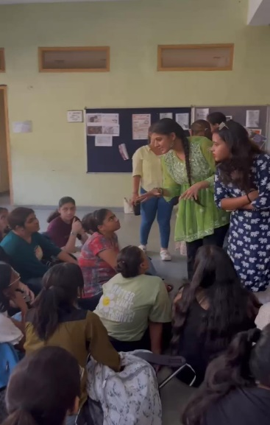The ice was thoroughly broken as participants embraced their playful sides, resulting in a wonderful exchange that turned initial nervousness into hearty laughter. Around 50 students enthusiastically took part in our icebreaker session, creating an engaging atmosphere filled with energy, laughter, and meaningful interactions. As the session came to a close, it was evident that new friendships were formed amidst the smiles and shared experiences.

**Report: Navratri Flashmob (7 October 2024)**

On 7th October 2024, our campus was filled with joy as we celebrated Navratri with an exciting flashmob. Approximately more than 75 students enthusiastically participated in the Flashmob. Everyone wore bright, colorful outfits, adding to the festive atmosphere. For thirty minutes, students danced with enthusiasm, immersing themselves in the lively music and infectious energy. The event turned into a moment of pure fun, with laughter echoing throughout.

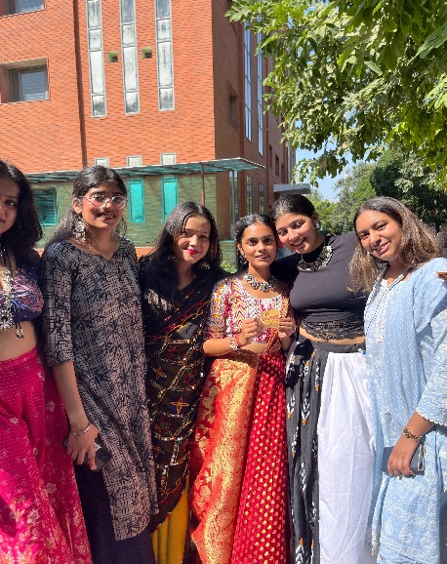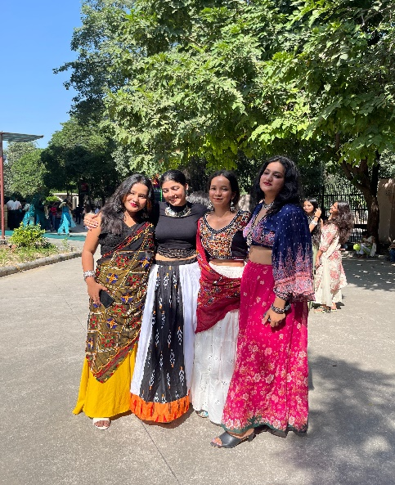As the music played on, the spirit of Navratri brought everyone together, creating unforgettable memories. This event truly captured the essence of Navratri, showcasing our community's vibrant spirit and love for celebration.

**Report: "Joy of Giving" Kindness Day Event (November 13, 2024)**

On November 13, 2024, we hosted the "Joy of Giving" event in collaboration with Areya to celebrate Kindness Day. The event involved writing positive messages on chits, which were distributed to our non-teaching staff along with small gifts. More than 50 students came together with heartfelt enthusiasm to participate in this initiative.

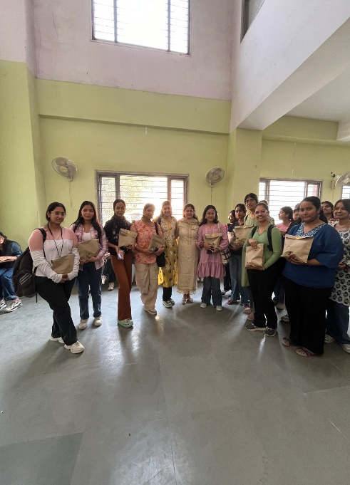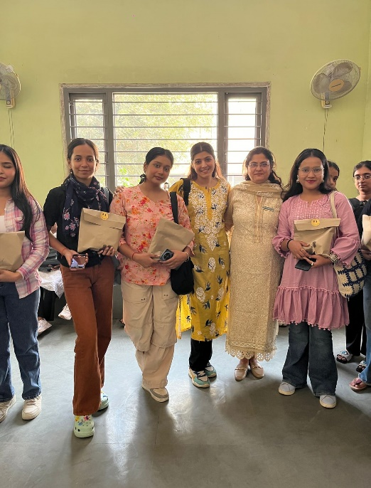The response from the staff was overwhelmingly positive, and many expressed their joy and appreciation, creating a warm and uplifting atmosphere. Participating in acts of kindness allows us to cultivate a more supportive environment, fostering mutual respect and gratitude. Such gestures remind us of the impact we can have on one another's lives, contributing to overall happiness and cohesion within our organization.

**Report: Children’s Day Event (November 14, 2024)**

On November 14, 2024, we held a lively event called "मुस्कुराहट" to celebrate Children’s Day. The event featured a colorful board for students to write touching notes for their inner child. Participants enjoyed engaging activities like "Complete the Song" and "Get a Free Hug", filling the air with laughter and joy. The atmosphere was vibrant and cheerful, creating a wonderful sense of community.

Approximately more than 50 students actively participated in the event, contributing their energy and enthusiasm to make it a resounding success

"मुस्कुराहट" was not just a celebration; it was a heartwarming reminder of the joy of childhood. This fun-filled day will remain in the students' memories for years to come, inspiring them to cherish their playful spirits.

