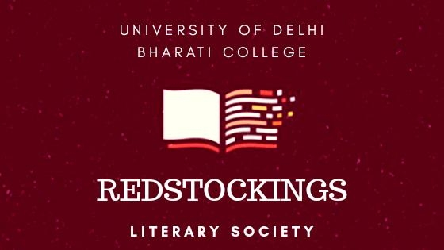

Redstockings Literary Society

Redstockings is the English Literary Society of Bharati College, University of Delhi. It was established in the year 1999 and is run by the English Department of the College. Over the years, Redstockings has organised play reading competitions, literary quizzes, film quizzes, a quiz centred on Shakespeare and poetry competitions. One year, students also recreated literary characters which was great fun. One of our brilliant students from Sri Lanka, Shefani Reffai, started a newsletter in 2013, which became very popular and which has been continued by students that have followed in her wake. Another reticent student Heer deserves special mention as the most diligent and keen reader in the College library. And so, Redstockings marches on.

Council 2023-2024

TIC: Dr. Naila Anjum

Convener: Dr. Anavisha Banerjee

President: Archana Aggarwal  
Vice-President: Devyani Yadav

Editor-in-Chief: Nandini Dang

Treasurer: Arhama Malik

Author Talk with Saksham Garg

The Author Talk was organised by Redstockings Literary Society on 29th March 2023, and began with a brief introduction by the author Saksham Garg to his book *Samsara: Enter the Valley of the Gods*. Afterwards, the process of writing was discussed upon and the author, who has also been an editor at Penguin Random House, put forward a comprehensive introduction to the field of publishing.

The author held an enlightening session underlining the author's journey and Samsara, and elaborated on the process of polishing one's manuscripts, giving an overview of the publishing industry. Highliting the different stages of editing, Garg essentially gave a comprehensive list of Dos and Don’ts of writing a killer book proposal in this talk, providing fruitful guidance for the aspiring writers and attendees.

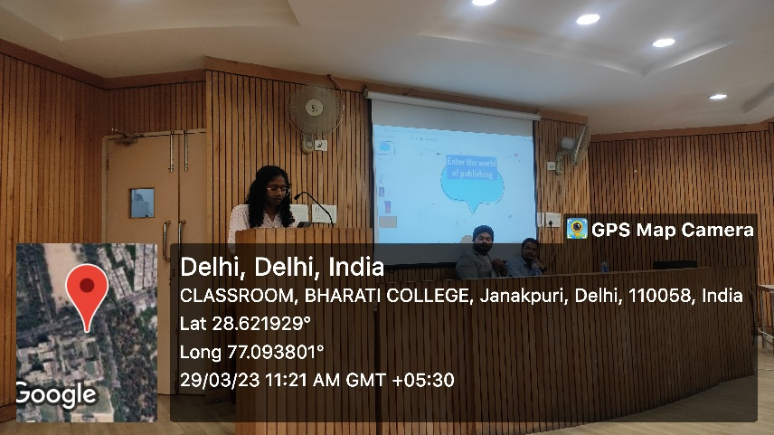

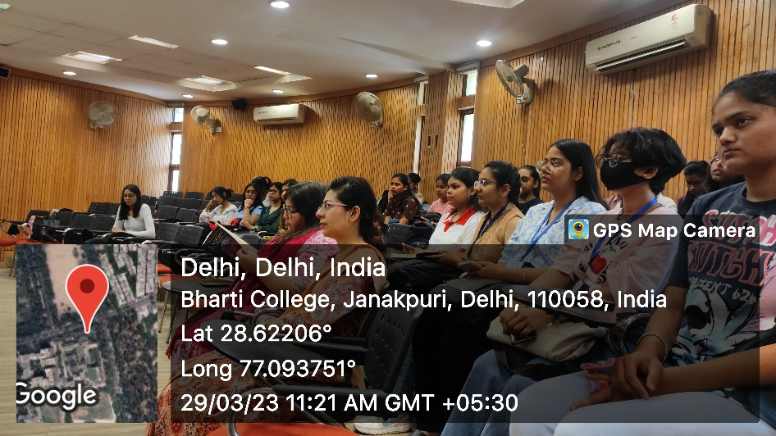

Workshop with Bijit Sinha

Shortly after the Author Talk, the founder of The Tale of You, Bijit Sinha held a very tantalizing Workshop. Although titled as Poetry Session and Workshop, it was much more than that. Sinha commenced the session with intriguing questions that kept the audience engaged with him throughout the hour. The session was not only interactive but it also helped the young and budding writers go into new depths and put forward the new limits that they can explore. Sinha introduced himself and went over the Booklist of 2022. He delved into the 3 tenets of a scintillating pitch, and talked about the editors checklist – helping to plan your marketing campaign as an author, giving an approachable conclusion by giving his team contact for the attendees’ benefit.

The insider information and highlights about the marketing in the industry was the golden highlight of his session along with the common love for reading and poetry which was discovered in very appealing discussions that followed.

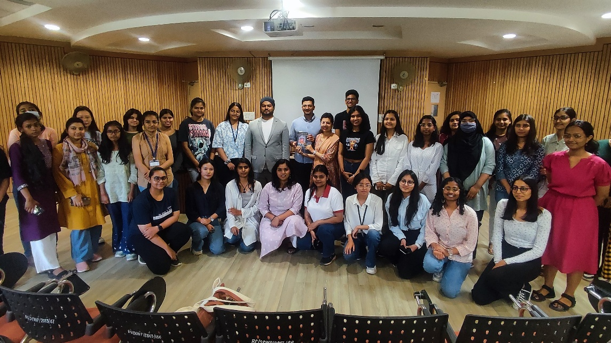

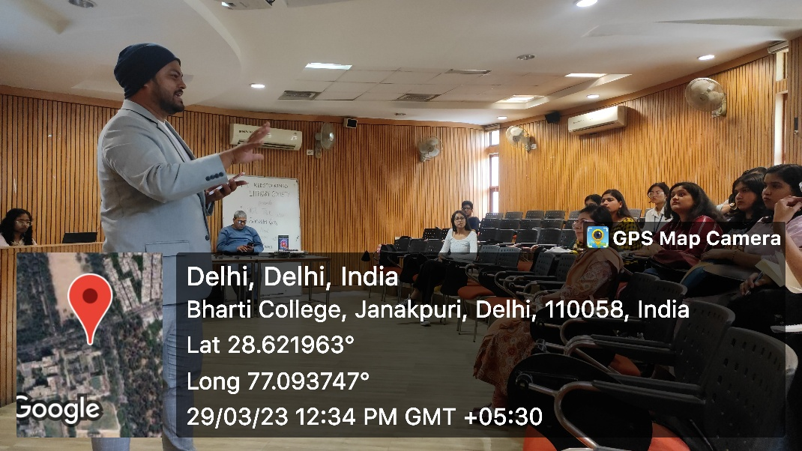

Literary Spell Bee- under Abhivyakti’23

On 11th of April, 2023, The Redstockings Literary Society organised a Literary Spell Bee under Bharati College’s Annual fest- Abhivyakti’23. The competition consisted of three rounds, each more challenging than the last. In the first round, participants from Bharati College alongwith other colleges of the University of Delhi were given ten words that they had to write down on a sheet of paper provided to them. The participants who spelled the maximum number of words correctly were sent on to the next round. In the second round, the anchor read out three words, out of which the participants had to correctly spell two words in order to qualify for the next round.

The participants who qualified for the ultimate round were given the hardest words to spell and finally the top three participants were awarded with exciting cash prizes. The competition was judged by Dr. Anavisha Banerjee and Dr. Naila Anjum, convener of Redstockings Literary Soceity, and TIC of Dept. of English, Bharati College, respectively. The nail-biting competition was a joy to witness, and brought out everyone’s competitive literary spirit, fostering an enriching closeness to literature.

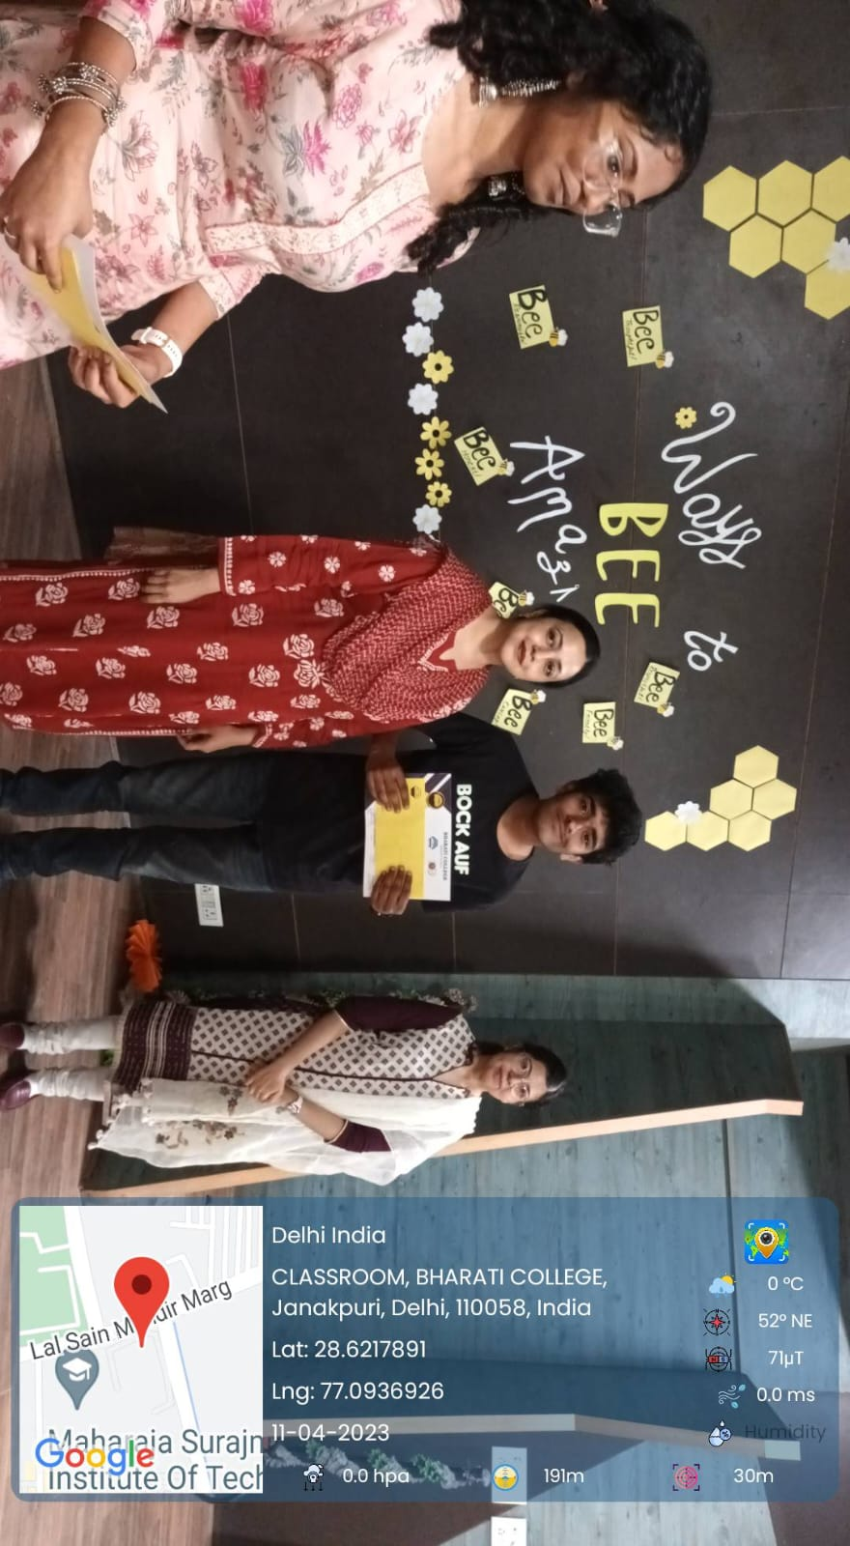

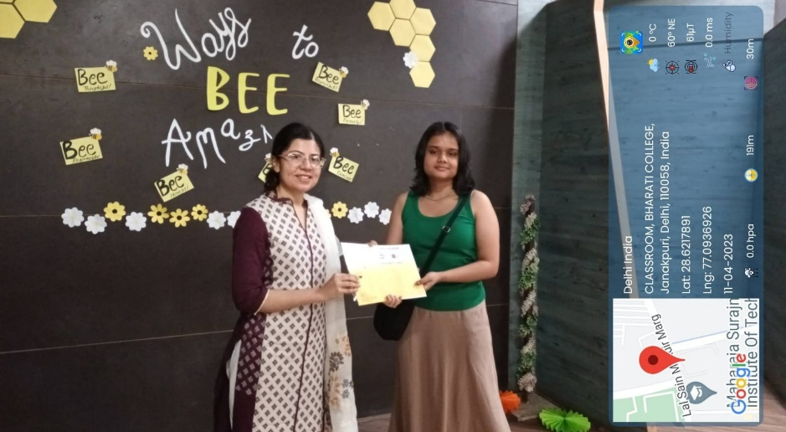

Shakespeare Day Dramatic Reading Event

On 3rd May 2023, the Redstockings Literary Society organized a memorable dramatic

Reading event to pay tribute to the renowned playwright William Shakespeare. The event served as a platform for students to showcase their talent and passion for Shakespeare’s works through captivating portrayals of his plays and sonnets. Students from various departments enthusiastically participated in the event,bringing Shakespeare's characters and verses to life with their compelling performances. The competition was judged judiciously by Redstockings' Convener, Dr. Anavisha Banerjee, and the Society President Archana Aggarwal, considering both artistic interpretation and technical skill.

As the event reached its climax, Dr.Anavisha Banerjee announced the winners.

Gungun Singh backed the first position while Divya Malhotra and Taarini Goyal stood second.Thewinners won exciting prizes for their dedicated pieces. Dr. Banerjee concluded the event with encouraging words, highlighting the importance of literary appreciation and expression. She commended the participants for their outstanding efforts, urging them to follow in the literary footsteps of legends like Shakespeare. The event celebrated literary fervour in the spirit of Shakespeare Day.

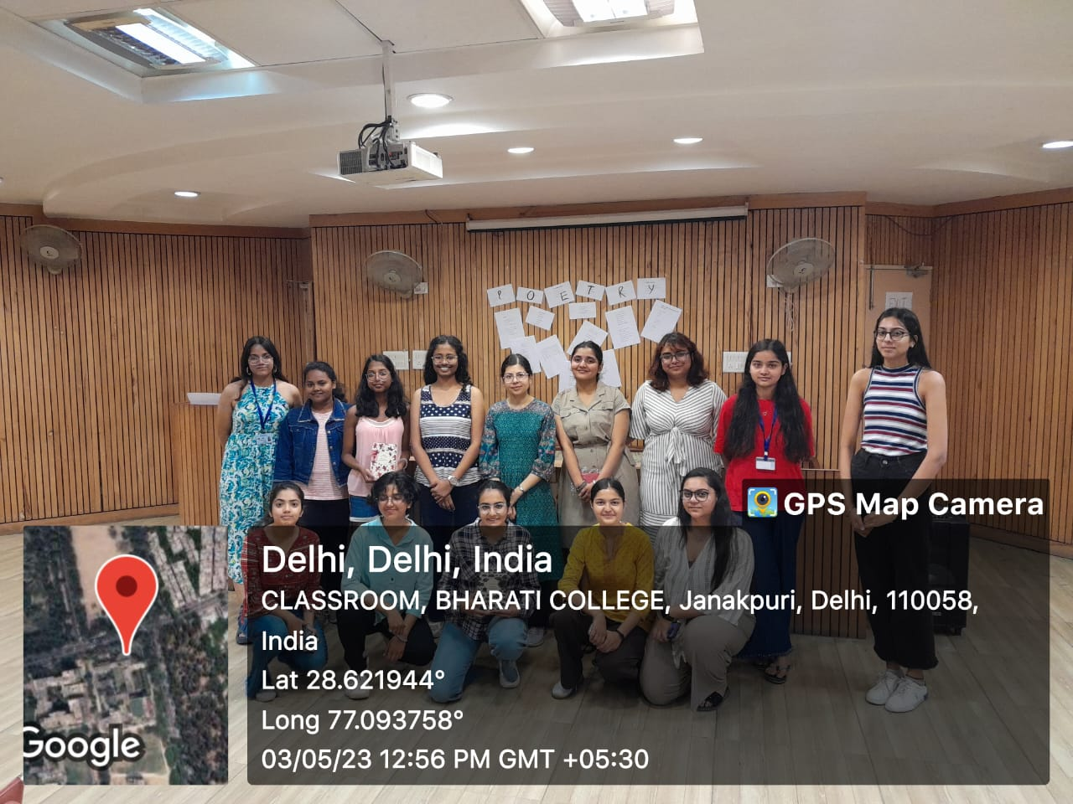

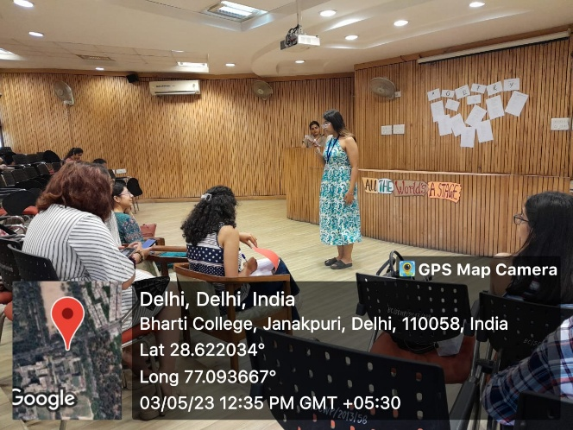

REDSTOCKINGS CHRONICLE VOL VI- WOMEN’S DAY ISSUE

The sixth volume of “The Redstockings Chronicle” was published on May, 2023, celebrating Women's Day, the Chronicle published empowering pieces, echoing the voices of strong women everywhere. The call for entries to this relevant issue of the Chronicle was posted on 5th May 2023, in honour of the United States’ National Day of Awareness for Missing and Murdered Indigenous Women and Girls. The issues showcased sincere pieces dedicated to the resilience of women, invitng the readers to delve into the myriad experiences and complexities of womanhood in a patriarchal world, expressed through evocative pieces.

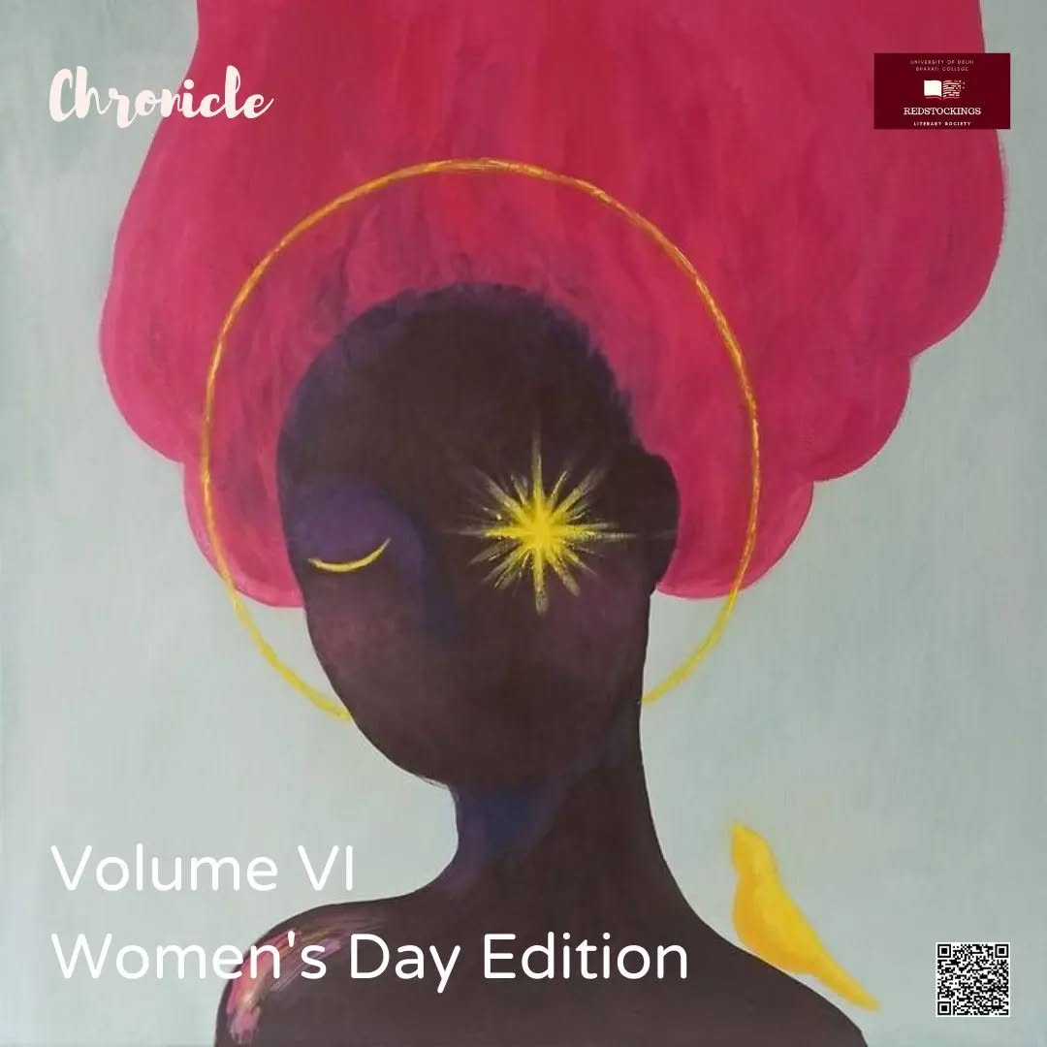

REDSTOCKINGS CHRONICLE VOL VII- PRIDE MONTH ISSUE

The seventh volume of “The Redstockings Chronicle” was the Pride Month edition in June 2023, a jouyous celebration of the queer community and experiences. The edition gave a platform to writers and featured a rich variety of pieces detailing the many shades of pride, invitng the readers to share in the pride experince, and contributing to the normalisation of LGBTQIA+ people and uplifting queer voices in literary spaces, as well as society at large, with sensitivity and instilling the spirit of pride on the occasion of the Pride Month through the power of writing.

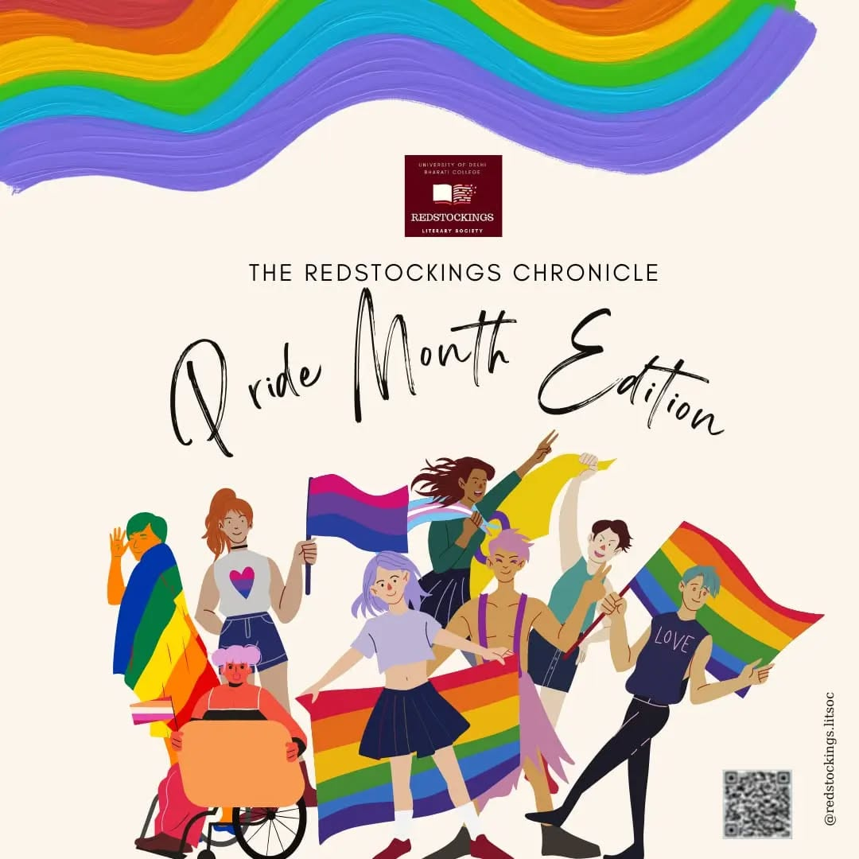

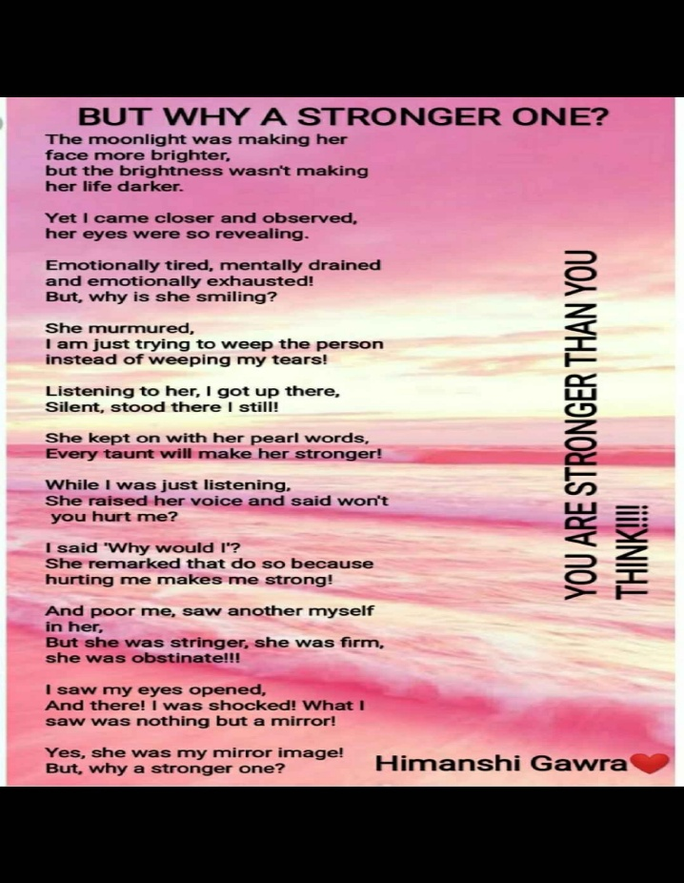

JAM: BOWL NA HALKE HALKE

On 25th August 2023, The Redstockings Literary Society organised a "Just A Minute” (JAM) competition, titled “Bowl Na Halke Halke,” thoughtfully aligned with the *Azadi ka Amrit Mahotsav* theme, encapsulating the essence of the celebratory spirit. The event provided an engaging platform where participants from different courses sequentially took the spotlight, randomly selecting topic chits, and having exactly "Just A Minute" to explore their thoughts. They shared their perspectives on the assigned topic then within 2-3 minutes, employing diverse presentation styles encompassing speeches, humor, poems, songs, and other creative expressions that could be conjured within the given timeframe.

Dr. Anavisha Banerjee, the esteemed convenor of the society, played a pivotal role as the

event judge. Her evaluation criteria included the content, clarity of delivery, and the ability to

engage the audience. As the event concluded followed by a heartfelt speech from the judge, the winners were awarded with Shreya Oberoi bagging the first, Shivani securing the

second, and Priyanka Chaudhary and Muskan Verma sharing the third position.

The event had enthusiastic participation from the newcomers especially, earning praise for Redstockings and encouraging thought-provoking conversations on dynamic topics, such as women empowerment, *Aatmanirbhar Bharat*, and the juvenile justice system, among others, sparking social awareness.

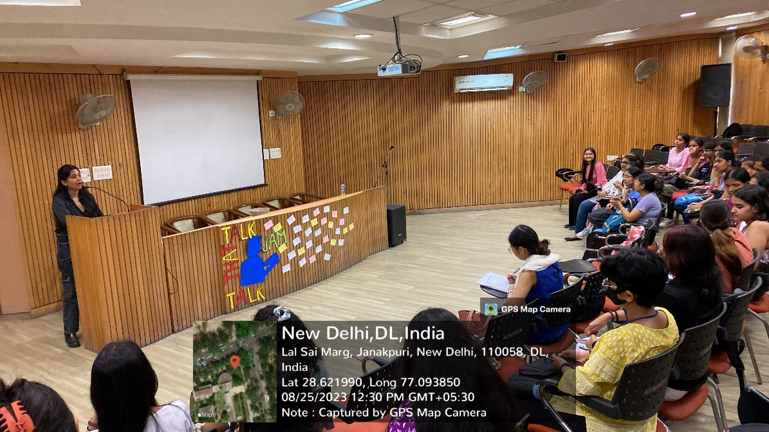

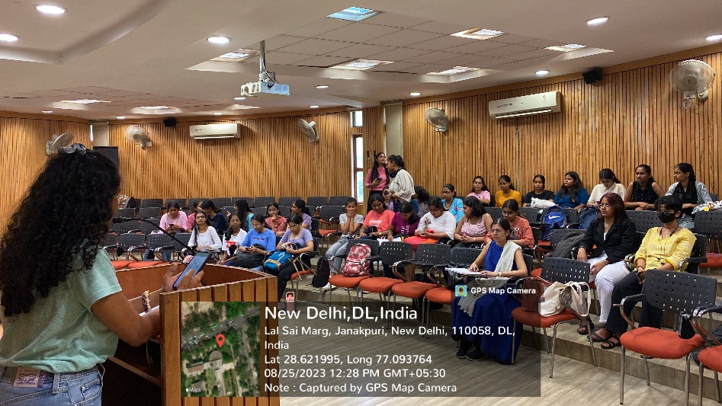

MÉLANGE 2023  
  
**17th October 2023, Day 1**

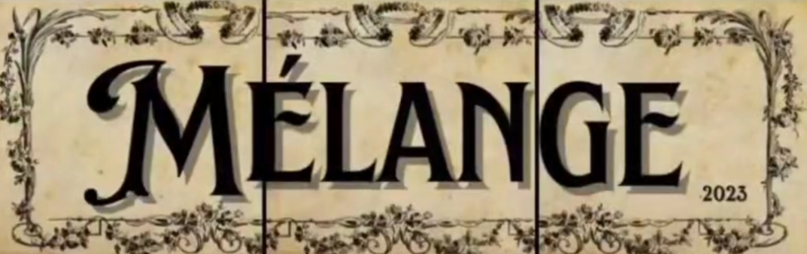   
  
Mélange – A Symphony of Words and Culture.

Bharati College kicked off its vibrant literary festival, Mélange, on October 17th with the launch of eye-catching posters and the official opening of registrations. Within just a few hours, we saw an overwhelming response for the events and a promising start to competition sign-ups, setting the stage for an exciting and engaging festival ahead.

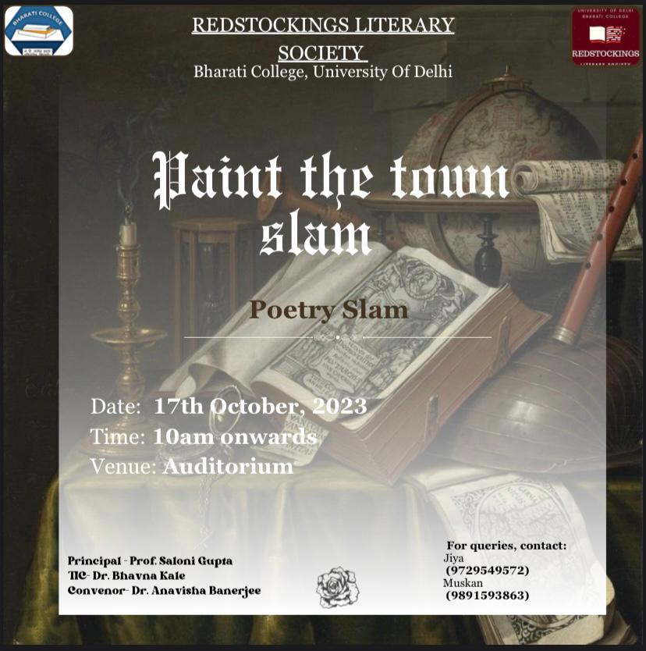

Paint the Town Slam was a slam poetry competition wherein poetry and performance intertwined to craft a scintillating lyrical blend. Encouraged to let their poetic- self shine and their artistic side unravel on the stage, participants recited original poems, showcasing diverse themes and styles. The poetry pieces by the students from different colleges, and even non-college attendees were strong, visceral, and captured a diversity in experiences, leading to an awarding experience.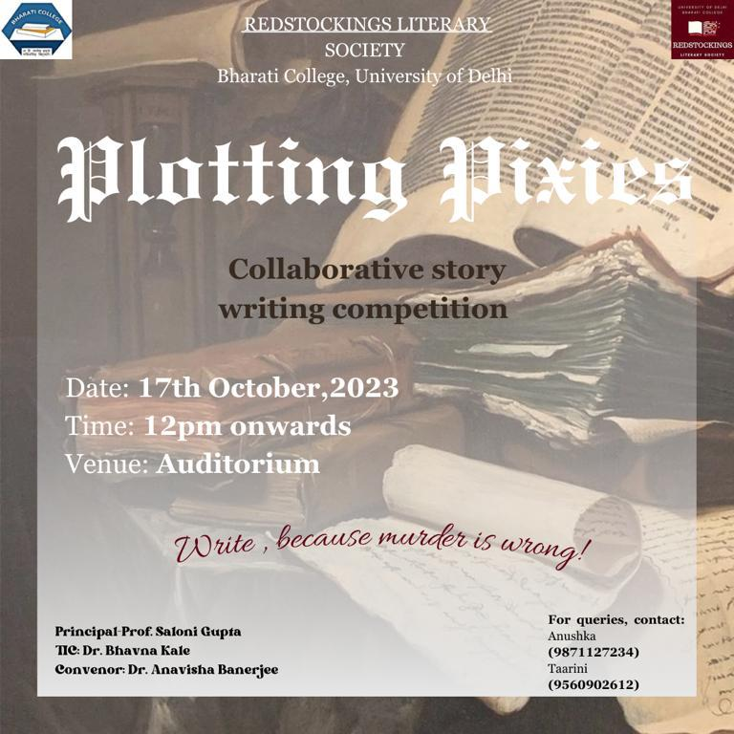

Plotting Pixies was a collaborative story writing competition which brought out the spirit of creativity and collaboration together in the participants, who had to piece together a story from a given random word without prior narrative discussion, all in a concise 25- minute timeframe. This event garnered significant interest from participants across various age groups and writing backgrounds, thereby enhancing the depth and diversity of the narratives presented.

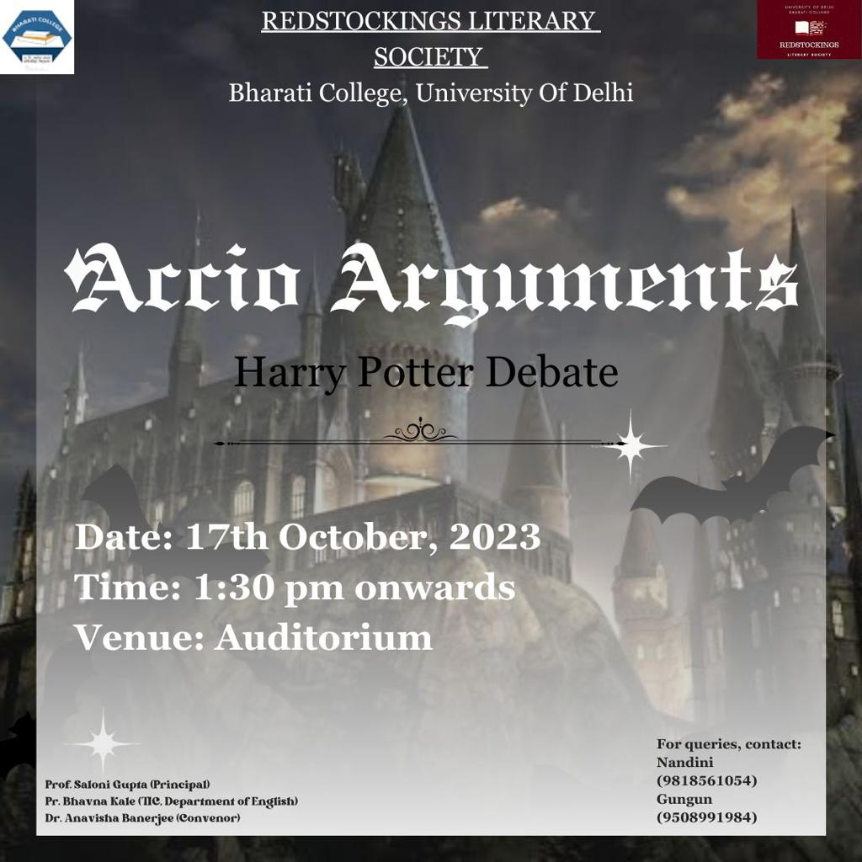

Accio Arguments was an engaging debate competition based on “Harry Potter” wherein passionate fans of the wizarding world gathered to engage in an intellectual discourse about one of the most iconic characters in the realm of literature – Lord Voldemort. The event was structured around a spirited debate that divided the participants into two groups:

those in favor of the topic and those against it. The topic of contention, "Was Lord Voldemort a Compelling Villain?" was carefully chosen to ignite a deep and meaningful discussion, as it

delves into the intricacies of character development and storytelling in the Harry Potter series. The audience, consisting of fellow students, professors, and Potterheads, actively engaged in the debate through well-thought interjections and questions. The choice of the topic, the structured format, and the dedication of the participants made it a memorable occasion for all attendees. It demonstrated how literature, particularly the enchanting world of Harry Potter, can spark insightful discussions and encourage critical thinking.

**18th October 2023, Day 2**

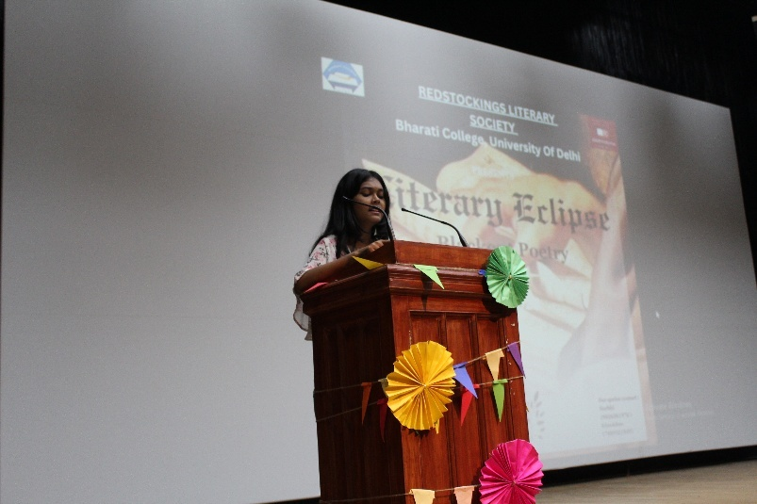

As Mélange proceeded to Day 2, the spark only brightened with the audiences' enthusiasm for the line up. The registration form for the cosplay and movie screening had already gained good responses within a few hours of going live, showing how Mélange had the pulse of the students.

The Blackout Poetry competition gave a lyrical start to Day 2 of Mélange showing how shadows of words could be delved into to create our own meaning with them. Attendees created unique poems by redacting text from existing literature, channelling artistic flair in the realms of creativity.

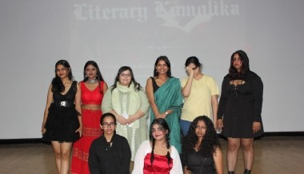

Literary Komolika: The Cosplay competition was a fun-filled engagement for all the literature lovers who are fashion enthusiasts, wherein they got a chance to dress up as their favourite “Literary Villain Characters” to win. Fans dressed up as iconic literary villains, bringing characters to life. The participants recreated their signature looks of the characters, bringing them closer to literature, and giving a fun platform to celebrate their fondness to the characters and the narratives that shape them through style.

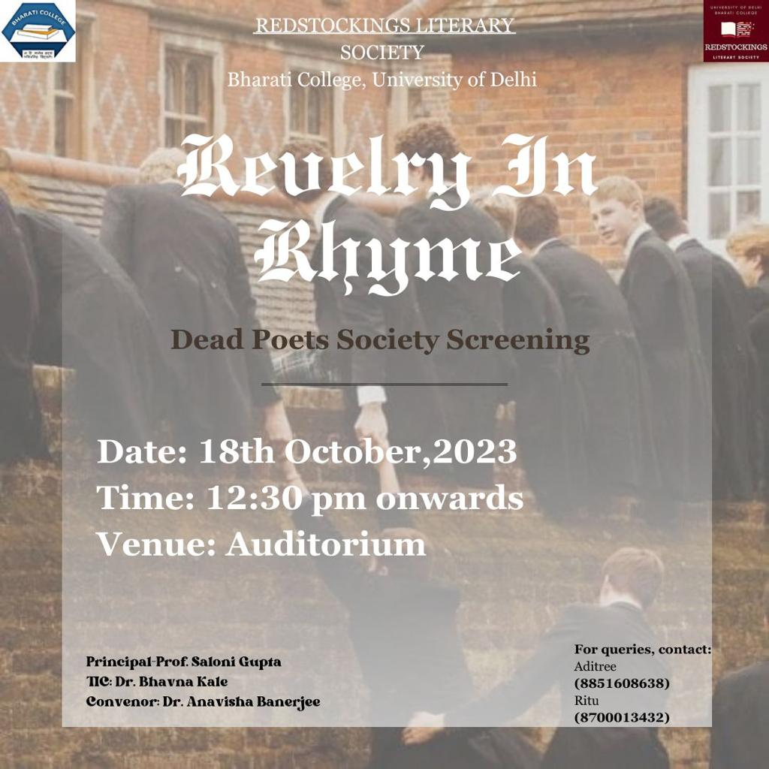

The next event which had the attendees saying “Oh Captain, My Captain!” was the movie screening showing the movie- “*Dead Poets Society/”* Audience enjoyed the classic film, moved to tears by Robin Williams’ portrayal of the effervescent literature teacher John Keating and his band of students and aspiring poets, celebrating the beauty of poetry with the timeless movie. Many audience members thanked the Society members for refreshing their fondness for the movie, while many first-time watchers announced it their new favourite, strengthening the cult status of the movie for literature enthusiasts and cinephiles.

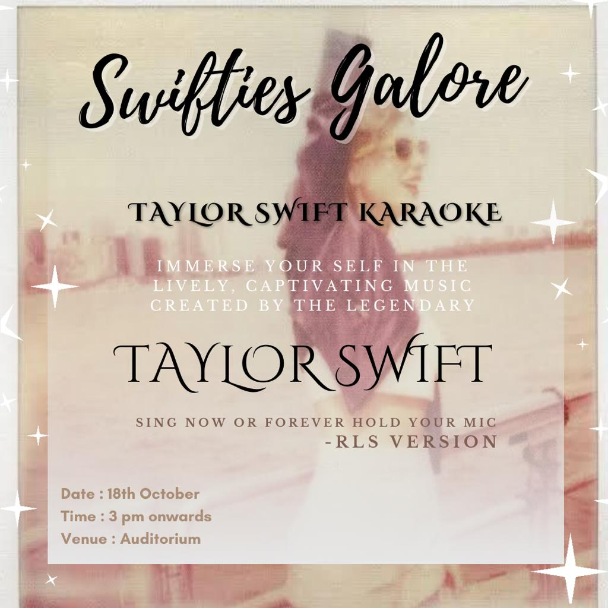

To conclude the event on a high-energy note, we hosted a Taylor Swift Karaoke, inviting everyone to sing along to their favourite tracks of the international popstar. The event witnessed a large number of registrations as excited Swifties lighted up the auditorium with their flashlights and sang along to a choice selection of tracks from Swift’s discography, setting the perfect tone for the final segment of the evening in a picture of solidarity and girlhood, the perfect musical sojourn to a literary fest.

**19th October 2023, Day 3**

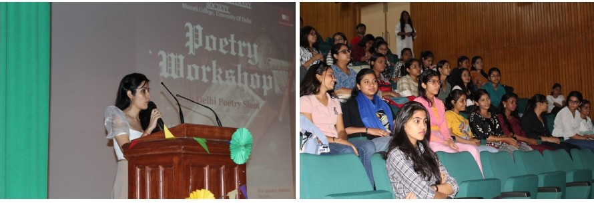 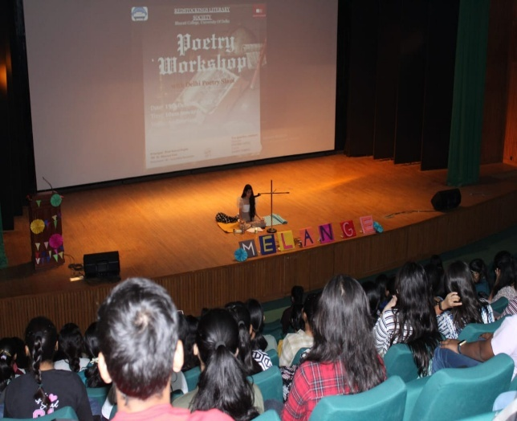

The concluding day of Mélange started on a poetic high through a Poetry Workshop by Delhi Poetry Slam. With the workshop, the audience embarked on a journey into the heart of poetic expression. Redstockings welcomed two brilliant poets Parul and Dyutima Kapoor, who represented a poetry community with a massive online presence and exceptional work that is Delhi Poetry Slam.

Aspiring poets honed their craft through interactive sessions and feedback by Dyutima and Parul, who spoke on how contrary to popular belief, poetry isn’t just about rhyme or rhythm, it’s a sacred medium of expression. Poetry resides everywhere, and belongs to everyone, emphasizing on its spirituality. The workshop gave many other useful tips and messages related to poetry, and literature at large. The workshop was concluded with a vote of thanks and thunderous applause by the riveted audience. We’re sure that the workshop edified the budding poets in the audience, and inspired new ones to become lovers of poetry.

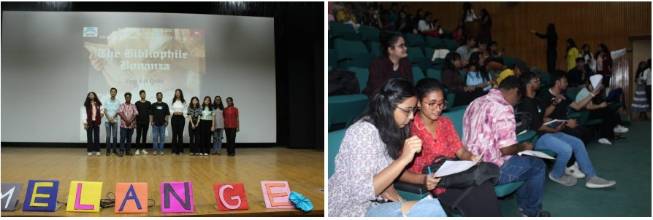

The Pop Lit Quiz drew participants from various departments, creating a diverse and

enthusiastic crowd. Pop Lit Quiz: Participants tested their knowledge of popular literature in a fun and competitive atmosphere. The event featured three rounds of challenging literary questions, spanning various genres, time periods, and cultures- the Book to Film Adaptation Round, Classic Crossword Challenge, Lost in Translation, and Comic Caping Round.

The Pop Lit. Quiz received an overwhelming response. The event succeeded in creating

an intellectually charged atmosphere and promoting literary interest among the participants.

Participants from various departments showcased their literary knowledge, and the winners

received well-deserved recognition.

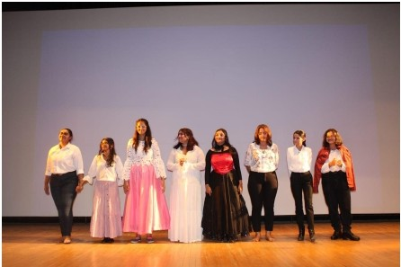

Mélange, The Literary Fest of Redstockings Literary Society dropped its curtains for this edition with a bang with the play Rosaline & Juliet: A modern interpretation of the classic tale Shakespearean tale of Romeo and Juliet. The queer twist on the play encapsulated the fresh and diverse perspectives which RLS stands for, and brought alternative narratives to the forefront. The heartfelt performances of the cast as star-crossed lovers torn apart by society tugged at the heartstrings of the audience, and the play quickly became a fan-favourite. Thus, Redstockings successfully took another fruitful step towards exploring new perspectives and themes in literature, whilst respecting literary traditions.

_____________________________________________________

As Redstockings Literary Society looks back and reflects on its past endeavours, it looks forward to higher grounds and more opportunities to host enriching events, and march forward in its goal of being a platform and a beacon of creativity, diversity, and a love for literature among its members, and the literary circuit. We are thankful for the accomplishments we achieved with our Hon’ble Principal, respected Convenors’ and professors’ support, and we march on to embrace new challenges and milestones in the pursuit of literary excellence!

________________________________________________________