**HDFE Department Annual Report (2024-25)**

**Annual Event**

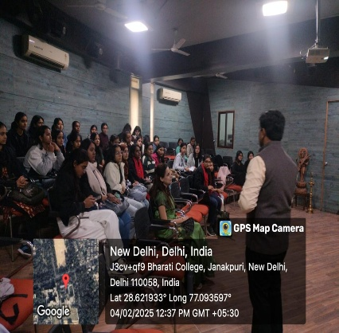The HDFE Department hosted an impactful Academic Fest focused on inclusive education and disability rights. The event aimed to raise awareness about the challenges faced by children with disabilities, promote inclusion through early intervention and adaptive teaching, and inspire student engagement in advocacy and community work. Guest speakers included Professor Asha Singh, who emphasized inclusive teaching in Early Childhood Care and Education (ECCE), and Dr. Ravi K. M. from Lady Irwin College, who discussed

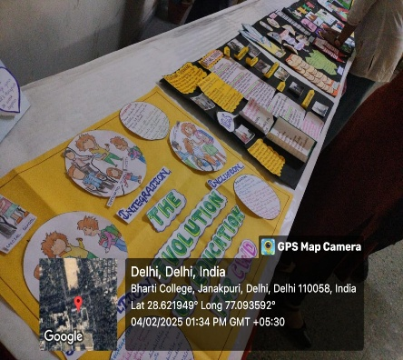intervention strategies and policy frameworks. Faculty members Prof. Rekha Sapra, Ms. Swati, and Ms. Aditi Gupta facilitated sessions and interactive components, enriching the learning experience. Students from the HDFE Department and Bharati College actively participated in seminars, poetry recitals, essay writing, and a powerful nukkad natak (street play), highlighting real-world issues. Key outcomes included increased awareness of the barriers faced by children with disabilities, practical insights into inclusive practices, and stronger community engagement. The event blended academic discussions with creative performances, creating a meaningful and engaging platform for learning. It fostered collaboration among students, faculty, and experts, and sparked interest in future research and initiatives in the field. Overall, the fest inspired students to champion inclusivity and take active roles in promoting accessibility in education and beyond.

**Donation drive**

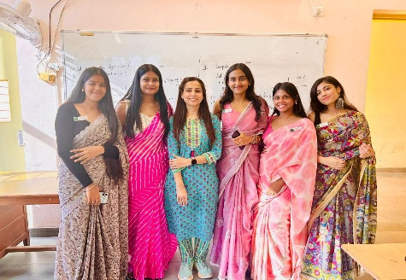On 14th October, the HDFE Department hosted a seminar featuring Goonj, an NGO known for transforming urban waste into resources for rural development. The event showcased impactful initiatives like Goonj’s “Cloth for Work,” where villagers receive clothing in exchange for labor on local projects, and “Not Just a Piece of Cloth,” which creates sanitary pads from urban fabric waste. “Green by Goonj” and “Dignity for Work”

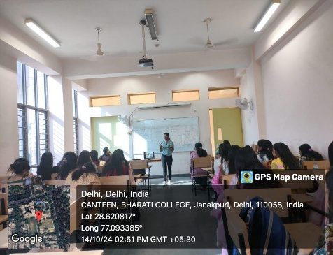further highlighted sustainability and community involvement. Stalls from Goonj and the Harmonious Children Rehabilitation Association (HCRA) demonstrated how NGOs address rural and marginalized community challenges. The seminar aimed to raise awareness about sustainable development, promote the reuse of urban waste, and encourage student involvement in social initiatives. Key participants included Goonj and HCRA representatives, HDFE faculty members such as Dr. Swati, and actively engaged students. The event provided valuable insights, particularly regarding innovative waste repurposing and the importance of community rehabilitation. HCRA’s stall shed light on the struggles of marginalized children and the need for ongoing support. The strong student response demonstrated growing interest in social responsibility. Overall, the seminar effectively inspired attendees to contribute toward sustainability and community service, promoting long-term engagement in meaningful social efforts.

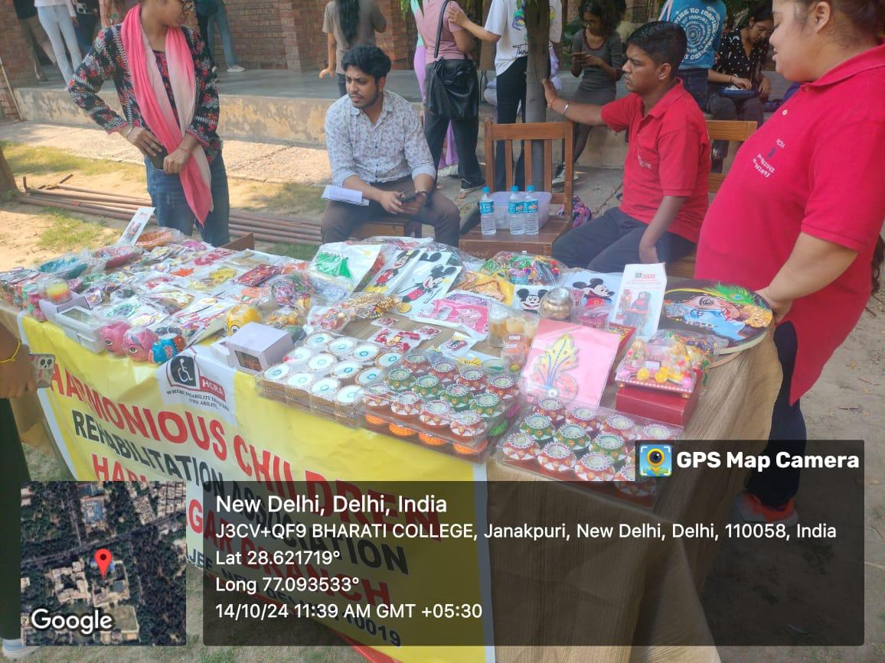

**Mobile creches visit**

Students from the HDFE Department visited Mobile Crèches, a Delhi-based NGO dedicated to providing Early Childhood Care and Education to children of migrant and construction workers on 30th September'24. The visit aimed to help students understand the challenges faced by underprivileged children and the importance of accessible childcare in marginalized communities. Mobile Crèches offers a safe, nurturing environment for children aged birth to 6 years, focusing on nutrition, health, early education, and protection. During the visit, students observed daily activities including structured play, storytelling sessions, and meal distribution. They also interacted with the caregivers and staff who shared insights into the developmental needs of the children and the strategies used to support them. The visit emphasized the critical role Mobile Crèches plays in bridging the gap for children who are otherwise left unattended at construction sites. It highlighted how early intervention can significantly impact a child’s cognitive and emotional development. The experience was eye-opening for students, reinforcing the importance of community-based child care and the need for more such initiatives in urban areas. Overall, the visit aligned with the HDFE Department’s focus on early childhood development and inspired students to engage in meaningful social work and advocacy for child rights.

**Godhuli Old Age Visit**

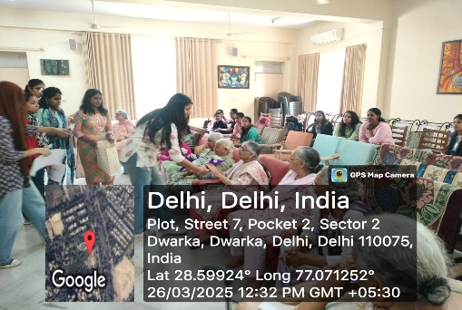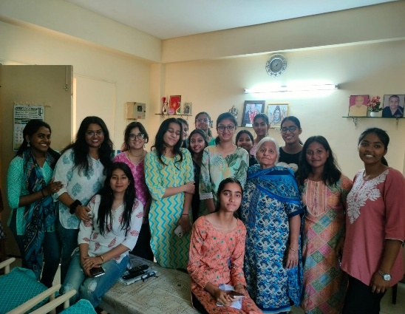Students rom the HDFE Department visited Godhuli Old Age Home, an institution dedicated to providing care, comfort, and dignity to the elderly on 29th April’24. The visit aimed to sensitize students to the emotional, physical, and social challenges faced by senior citizens, and to understand the importance of elder care in today’s rapidly changing family structures. During the visit, students interacted with the residents, listened to their life stories, and engaged in activities such as singing, storytelling, and games to bring joy and companionship. The staff at Godhuli shared insights into the daily routine, healthcare services, and psychological support provided to the residents. The students also observed how the home promotes a sense of community through shared meals, celebrations, and group activities. The visit was a deeply moving experience, highlighting the significance of empathy, respect, and intergenerational bonding. It also shed light on the growing need for institutional support systems for the elderly, especially those abandoned or without family support. Overall, the visit to Godhuli Old Age Home aligned with the HDFE Department’s emphasis on holistic human development and social responsibility, inspiring students to reflect on their roles in creating an inclusive and caring society.

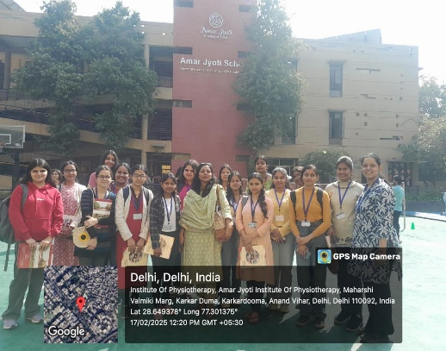**Amarjyoti Charitable Trust Visit**

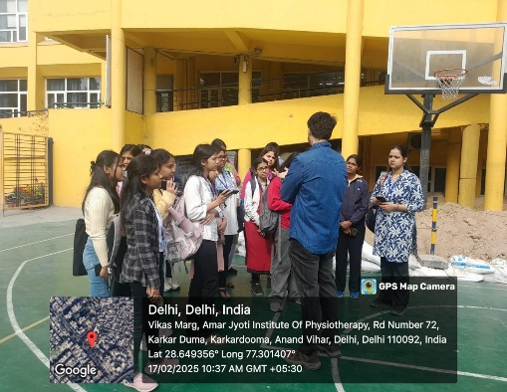Students from the HDFE Department visited Amar Jyoti Charitable Trust in Delhi, an NGO committed to the inclusion and empowerment of individuals with disabilities on 1st March’24. The visit offered an insightful look into the organization’s integrated education model, which promotes inclusive learning by educating children with and without disabilities together. Students observed classrooms, vocational training units, and rehabilitation facilities, gaining a comprehensive understanding of how Amar Jyoti fosters independence and skill development. The objective of the visit was to expose students to inclusive practices, highlight the importance of accessibility, and inspire them to contribute meaningfully to social change. Interactions with faculty members and students at the center provided valuable perspectives on the challenges faced by differently-abled individuals and the need for inclusive infrastructure and policy support. Key highlights included witnessing therapeutic services such as physiotherapy and occupational therapy, along with skill-based training in areas like tailoring, art, and computer education. The experience was deeply impactful, reinforcing the role of empathy, education, and empowerment in community development. Overall, the visit motivated students to consider careers in the area of disability and advocate for a more inclusive society, aligning with the HDFE Department’s commitment to holistic development and social responsibility.

**Chetna NGO visit**

Students from the HDFE Department visited CHETNA (Childhood Enhancement through Training and Action), a Delhi-based NGO dedicated to empowering street and working children through education, health, and child rights advocacy on 30th September’24. The purpose of the visit was to understand the realities of marginalized children and observe how grassroots interventions can lead to meaningful change. During the visit, students were introduced to CHETNA’s key programs, including Balaknama—a newspaper written by street children—and Badhte Kadam, a federation that encourages child leadership. Students observed learning sessions, interacted with children, and spoke with field workers who shared their experiences and challenges in working with vulnerable populations. The visit provided a deeper understanding of child rights, especially in the context of street and working children who are often deprived of basic needs and protection. CHETNA’s model of empowering children to speak up for themselves left a strong impact on the students. This exposure highlighted the importance of community-based efforts in ensuring every child has access to education, dignity, and protection. The visit aligned with the HDFE Department’s values of advocacy, inclusion, and empowerment, and encouraged students to consider active roles in promoting child welfare and social justice.

**GALLERY**

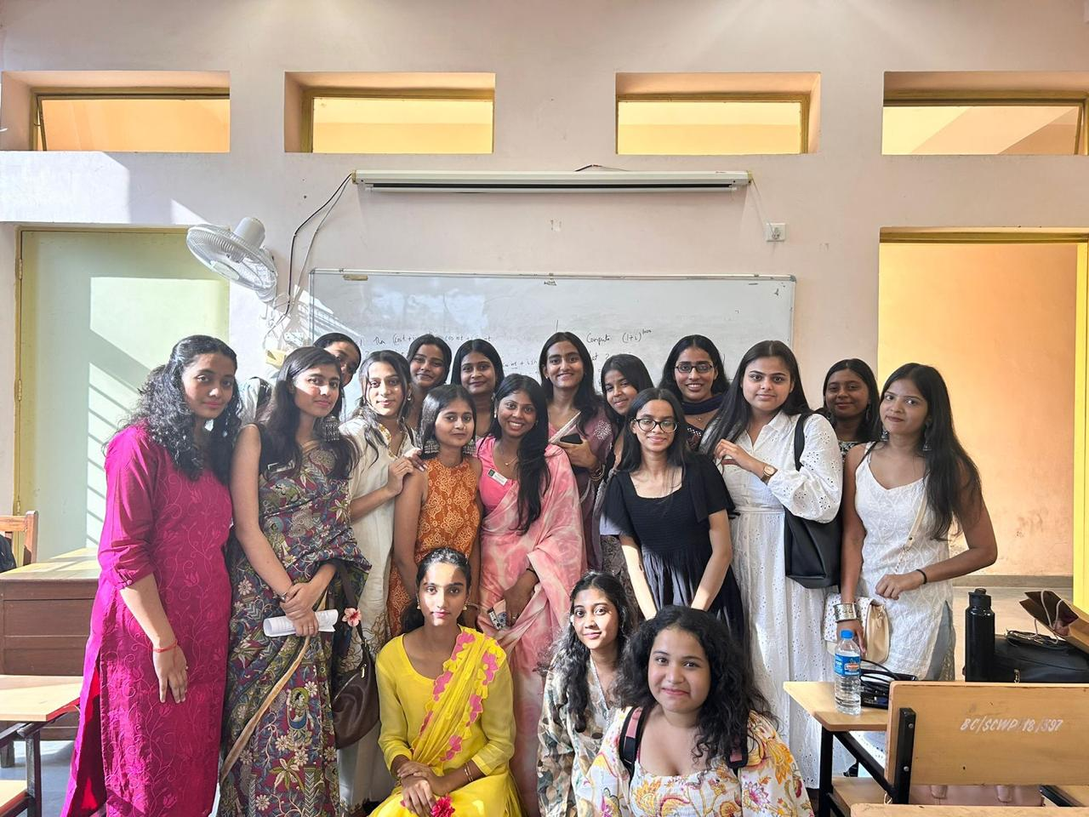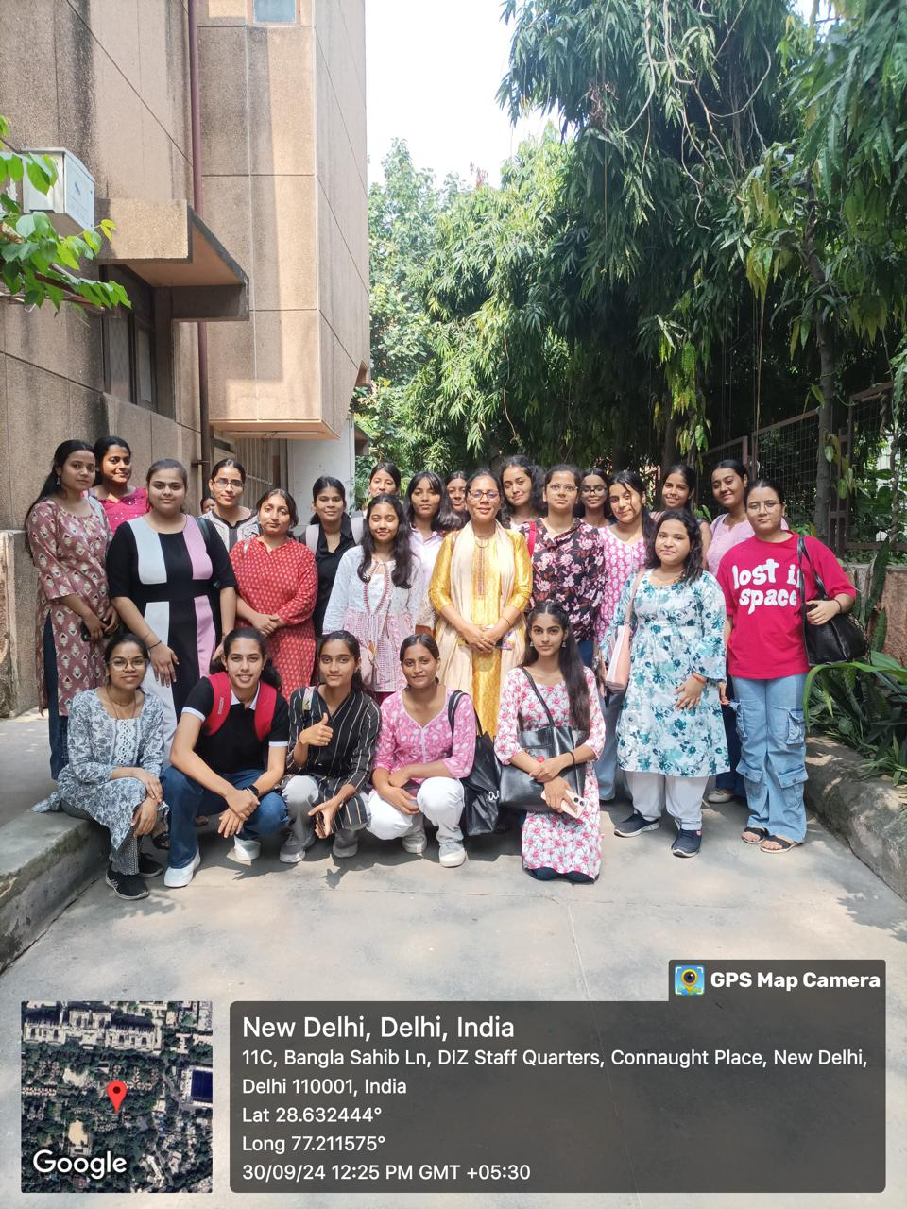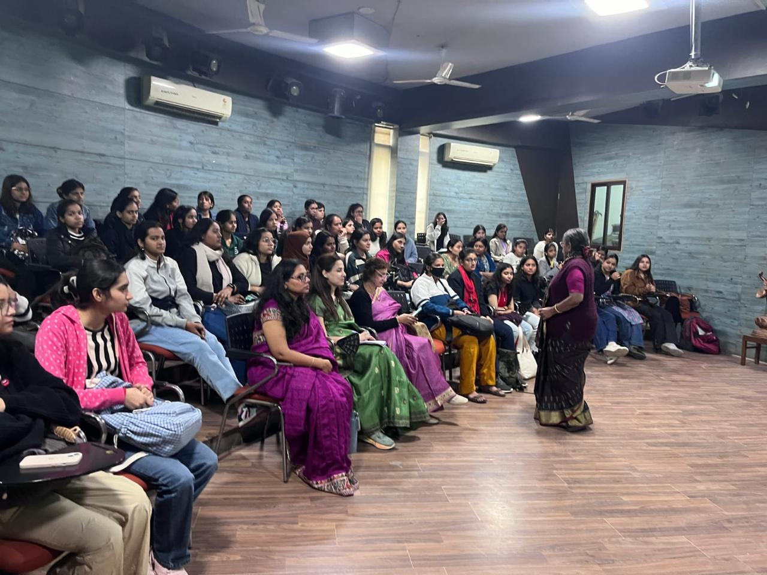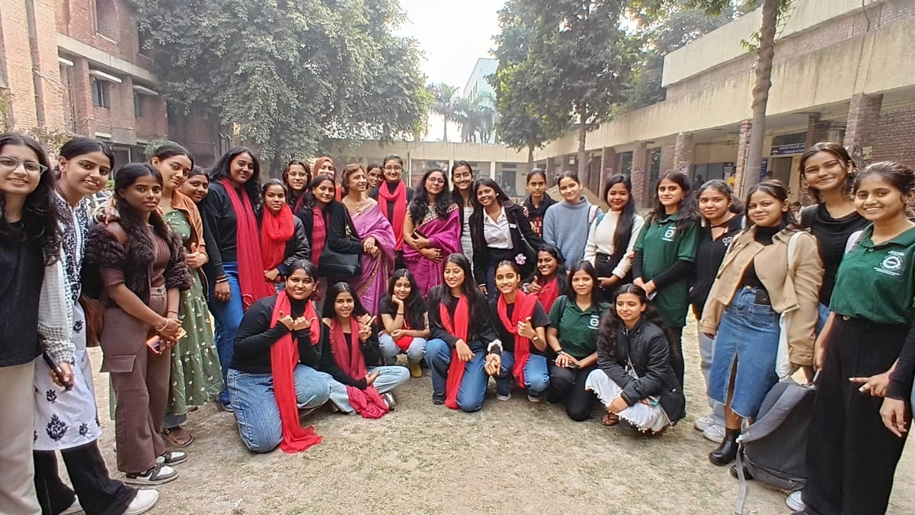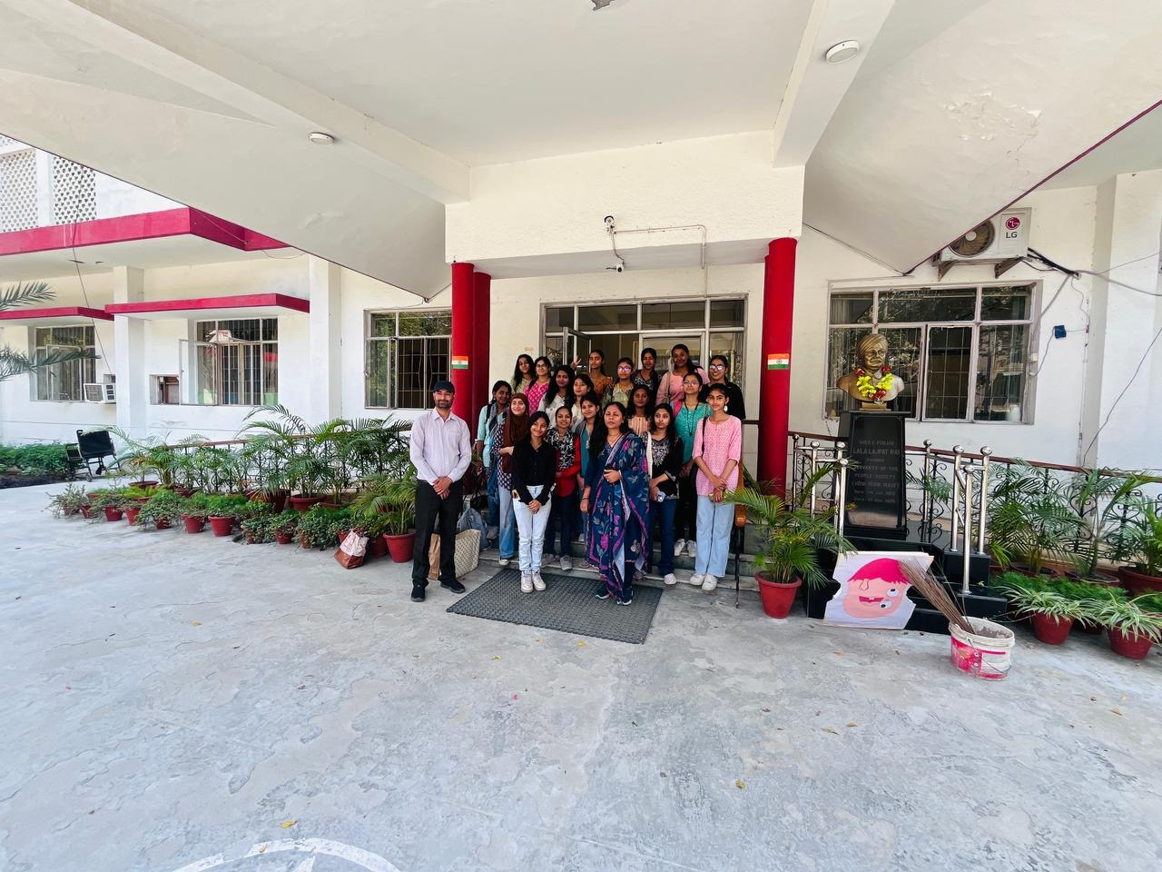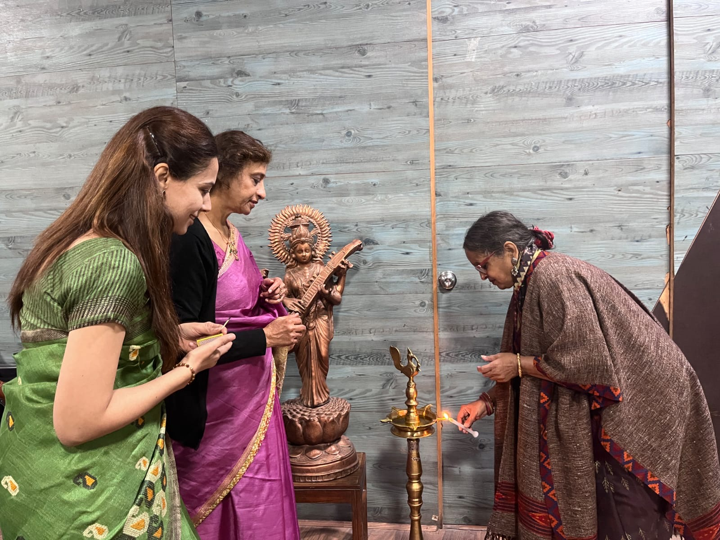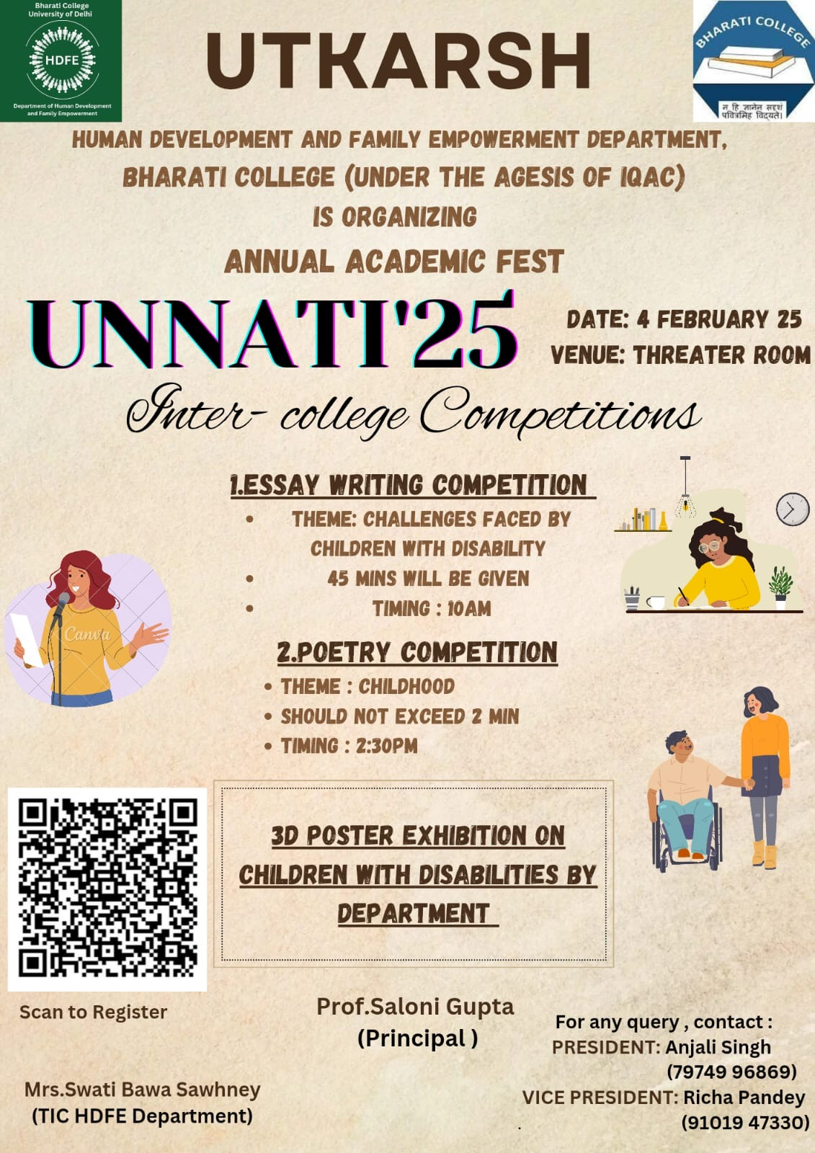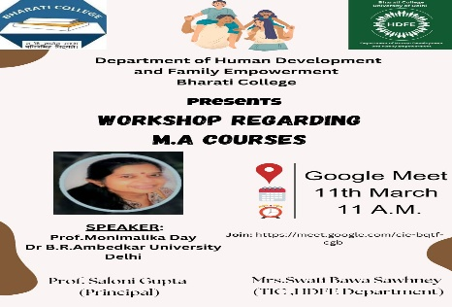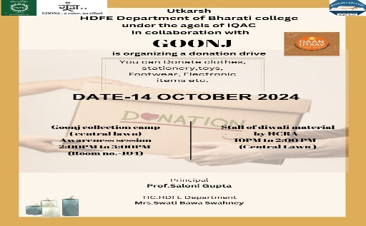

# **Contact:**

Email ID : [utkarsh@bharati.du.ac.in](mailto:utkarsh@bharati.du.ac.in)

Instagram ID : hdfeofficial