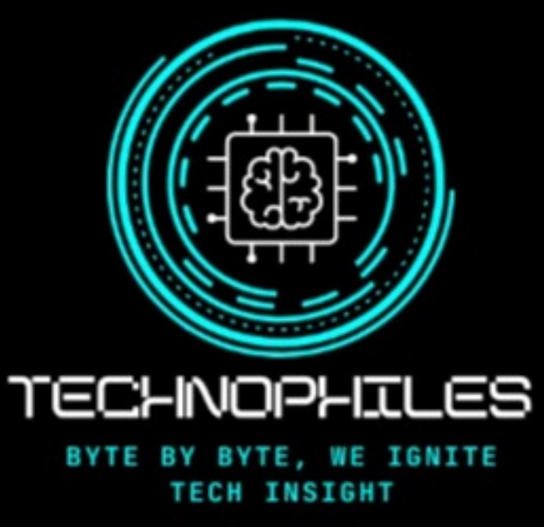

Technophiles: The Computer Science Department Bharati College, University of Delhi

*(Departmental Society Page - Content)*

# An image for header

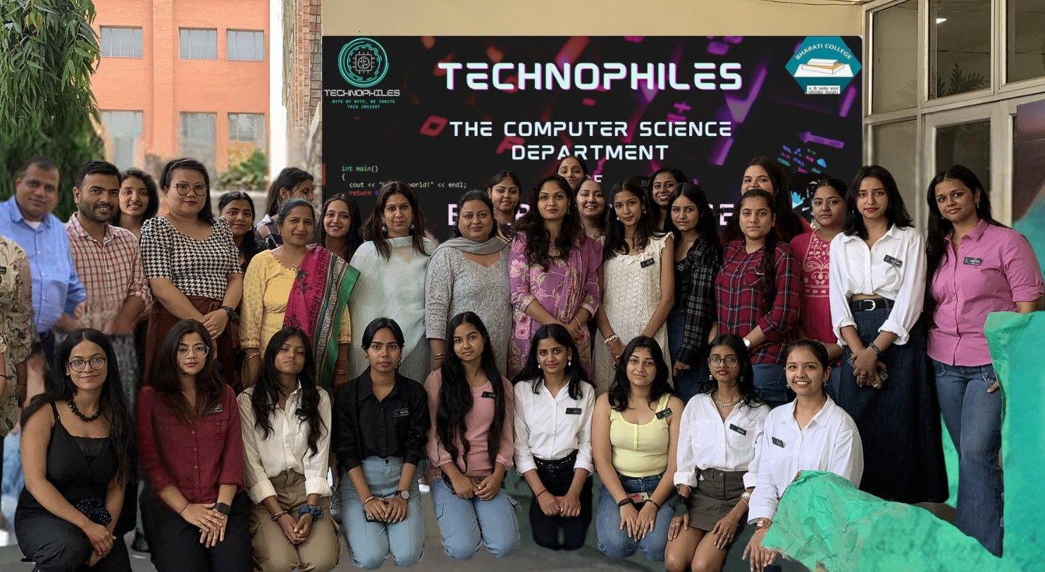

**A quote about the society or Moto ( In a line or two only) :**

Bite by Bite, We ignite Tech insight

# About the Society:

Technophiles is the vibrant student-run initiative of the Department of Computer Science at Bharati College, University of Delhi. Established in 2024, our name reflects our core mission: fostering a love for technology (technology enthusiasts are often called "technophiles"). We believe learning goes beyond textbooks. Technophiles provides a platform for students to delve

deeper into the exciting world of computer science, experiment with innovative ideas, and connect with a passionate community of fellow tech enthusiasts.

We aim to create a dynamic and collaborative environment where students can develop their technical skills through hands-on experiences. We go beyond the curriculum, offering workshops and events featuring industry experts. This fosters a deeper understanding of computer science concepts and their real-world applications. We also encourage students to explore their creative potential by providing opportunities to experiment with new technologies and participate in coding competitions. Ultimately, Technophiles aims to empower students to become future leaders and innovators in the ever-evolving tech industry.

# Mission and Vision:

Shaping the Future of Tech Education

Our vision is to make Technophiles synonymous with excellence in computer science education at Bharati College. We strive to be a leading force in fostering a culture of innovation and exploration within the department. We envision a future where Technophiles provides students with the resources and support they need to not only excel in academics but also translate their knowledge into practical solutions. We believe in nurturing a diverse and inclusive community where students from all backgrounds can feel comfortable exploring their interests and developing their technical expertise. By providing a platform for collaboration and knowledge sharing, we aim to empower the next generation of tech leaders who will shape the future of the industry.

# Faculty Advisors/Convenor & Office Bearers (Current):

* **Faculty Advisors:**
  + Convener: Ms. Sheetal Mavi
  + TIC & Coordinator: Dr. Sarita Kadian

# Office Bearers:

* + President: Riti Gupta
  + Secretary: Archita Sharma
  + Treasurer: Sanskriti Gupta
  + Chief HR Officer: Tisha Prajapati

# Flagship Events and Activities (Name of the Event with Description of about 200 words)

|  |  |  |
| --- | --- | --- |
| **Start Date** | **End Date** | **Event Name** |
| 8 March 2024 | 8 March 2024 | Guest Lecture on Data Science using Python |
| 12 March 2024 | 12 March 2024 | Seminar on Future Challenges and Threats in Cyber Security with AI and Legal |
| 17 March 2024 | 17 March 2024 | Merch Design Competition |
| 23 March 2024 | 23 March 2024 | Webinar on AR/VR |

|  |  |  |
| --- | --- | --- |
| 30 March 2024 | 30 March 2024 | Podcast on The Social Media Effect |
| 2 April 2024 | 2 April 2024 | Podcast on Unleash the Power of Dev Tools |
| 5 April 2024 | 12 April 2024 | Comment Clash Competition |
| 7 April 2024 | 7 April 2024 | The Byte: Monthly Magazine Launch - Technophiles |
| 25 April 2024 | 25 April 2024 | Seminar on Data Science and Data Analysis |
| 25 April 2024 | 26 April 2024 | Nirmaan Fest |
| 1 July 2024 | 19 July 2024 | Women and AI Workshop |
| 12 July 2024 | 12 July 2024 | Microsoft Community Meetup - External Event |
| 19 July 2024 | 19 July 2024 | Design Thinking Workshop Behind a Microsoft Product |
| 28 July 2024 | 28 July 2024 | Treasure Hunt Competition |
| 30 July 2024 | 30 July 2024 | Skill Series Workshop by IMS Proschool |
| 3 August 2024 | 3 August 2024 | SMBs Community Meetup - External Event |
| 4 August 2024 | 4 August 2024 | Google I/O Connect - Community Meetup - External Event |
| 5 August 2024 | 5 August 2024 | Podcast on Women in STEM |
| 5 August 2024 | 5 August 2024 | Podcast on Preparing for Industry: Comparing Skills and Processes |
| 12 August 2024 | 12 August 2024 | Product Management as A Career - Seminar |
| 12 August 2024 | 12 August 2024 | Technophiles Official Town Hall Event |
| 31 August 2024 | 3 September  2024 | The Webinar Bootcamp |
| 6 September  2024 | 6 September  2024 | Women & AI: AI Empowerment Summit |
| 8 September  2024 | 8 September  2024 | Podcast on Program Management & Developer Relations |
| 8 September  2024 | 8 September  2024 | Podcast on Gen AI Developer Roadmap |
| 8 September  2024 | 8 September  2024 | Podcast on The Technical Torchbearer To Ace The Placements |
| 8 September  2024 | 8 September  2024 | Podcast on A Day In The Life Of An ML Engineer |
| 8 September  2024 | 8 September  2024 | Podcast on Crafting A Seamless UX For A Billion Users |
| 8 September  2024 | 8 September  2024 | Podcast on Getting Started With MLOPS |
| 19 September  2024 | 19 September  2024 | Design Samwaad 2.0 @ IIIT DELHI, External Event |
| 25 September  2024 | 25 September  2024 | Future of Work With AI @ IIT DELHI, External Event |
| 7 October 2024 | 7 October 2024 | Freebies Contest and Photo Booth |
| 8 October 2024 | 8 October 2024 | Data & Gen AI Nexus 4.0 @ Ecosphere Coworking, External Event |

|  |  |  |
| --- | --- | --- |
| 17 October 2024 | 17 October 2024 | Recode Brand Collaboration |
| 23 October 2024 | 23 October 2024 | ThinkLocal Business Solutions Challenge |
| 28 October 2024 | 28 October 2024 | Town Hall Meeting 2.0 |
| 23 November  2024 | 23 November  2024 | TechX @ Microsoft Gurugram |
| 25 November  2024 | 25 November  2024 | Brand Collaboration - PeeSafe |
| 4 January 2025 | 4 January 2025 | Official Webpage Launch |
| 11 January 2025 | 12 January 2025 | Webinar Bootcamp 2.0 |
| 27 January 2025 | 27 January 2025 | Tech Talks: Podcast Season 4 |
| 8 February 2025 | 9 February 2025 | Skill Series Workshop by IMS Proschool - 2.0 |
| 22 March 2025 | 29 March 2025 | Skill Series Workshop by IMS Proschool - 3.0 |

**Cumulative Events Description:**

Over the past year, Technophiles BHC at Bharat College, Delhi University has championed a diverse slate of events designed to ignite curiosity and bolster tech skills. The calendar kicked off with **inspiring guest lectures and seminars**—ranging from a deep dive into **data science using Python** to exploring future challenges in **cyber security with AI** and legal insights—setting a tone of academic rigor and industry relevance. Creative competitions such as the **Merch Design and Comment Clash** captivated students’ innovative spirits, while interactive **webinars on AR/VR** and **hands-on podcasts** highlighted the evolving digital landscape.

The initiative extended beyond traditional lectures; it embraced skill enrichment and career readiness through a **series of workshops**, including multiple editions of the **Skill Series and Women & AI workshops**, which not only fostered technical capabilities but also promoted gender inclusivity in STEM. **Community meetups**, such as those in **collaboration with Microsoft for TechX and Google**, bridged educational experiences with real-world applications, offering platforms for networking and practical learning. Furthermore, brand **collaborations with PeeSafe** and initiatives like the **ThinkLocal Business Solutions Challenge** contributed to a vibrant, integrated ecosystem of innovation. The official launch of their **monthly magazine “The Byte”** and revamped webpage underscored Technophiles’ commitment to continuous growth and thought leadership in the tech community.

# Resources and Publications (Newsletters/Magazines/Research Papers, Awards (students))

* Networking opportunities with industry professionals during events and workshops.
* Exclusive invitation to a Microsoft Community Meetup, providing insights into career paths and industry trends.
* Collaboration with 50+ sponsors for various events, reflecting strong industry connections.
* Access to certificate courses and workshops, enabling students to upskill in latest tech trends.
* Launch of a monthly magazine featuring student-driven content, showcasing their talents and insights.
* Successful execution of 20+ online webinars, 10+ offline seminars, 15+ online workshops, tech podcasts with global audience on Spotify & YouTube and a mega annual fest within a span of 12 months.
* Securing internship and volunteering opportunities with renowned tech giants, providing valuable real-world experience.
* Exposure to 100+ community events across Delhi NCR, in collaboration with IIT, IIIT, Microsoft, Neo4j, Google Developer Groups.
* A month-long “Women & AI” workshop with active participation across colleges in Delhi NCR.
* Brand collaborations with top-tier tech companies.
* Offline community meetup with 200+ students and 50+ industry experts involving active networking and workshops in collaboration with Microsoft Gurugram.

# Gallery

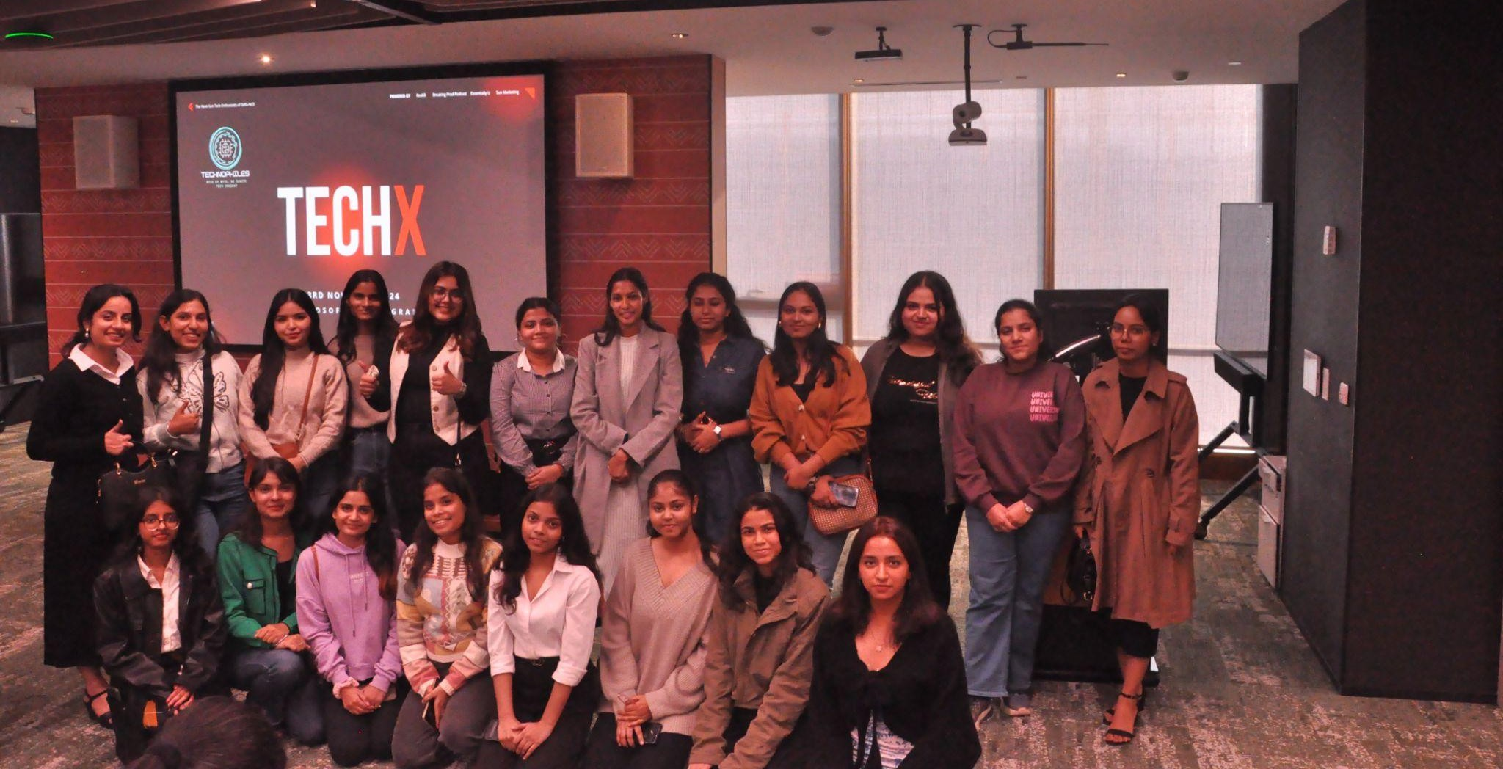

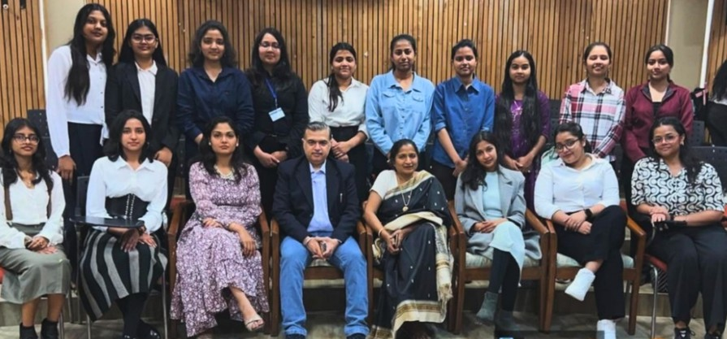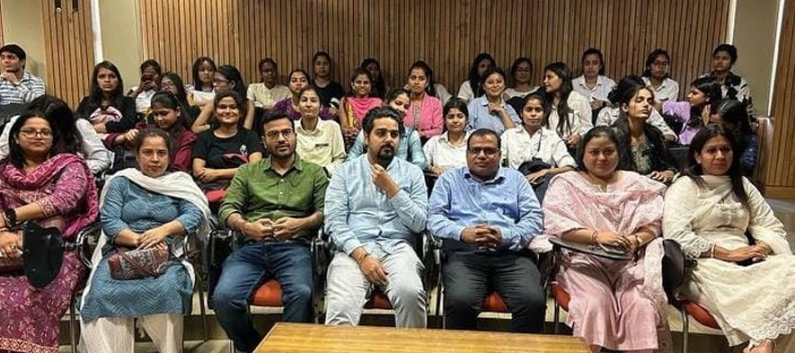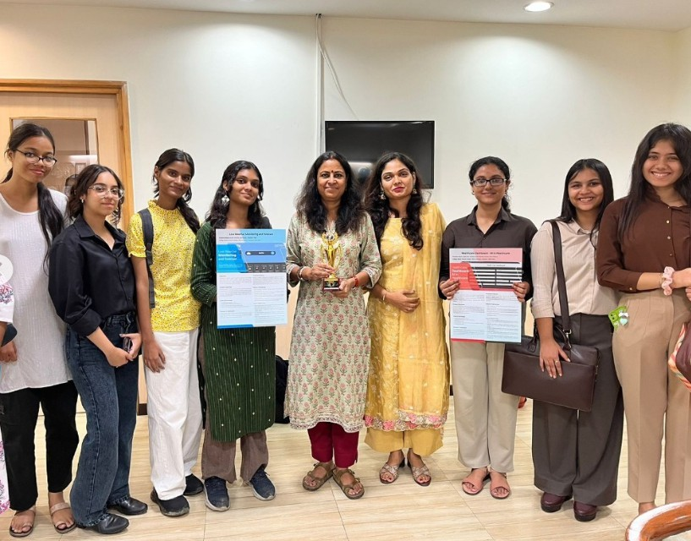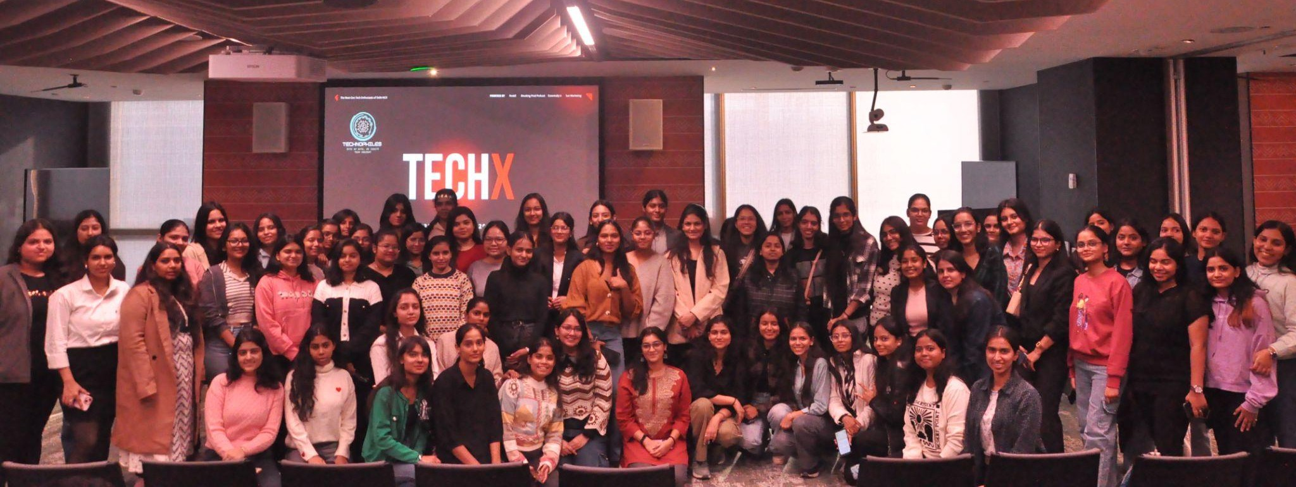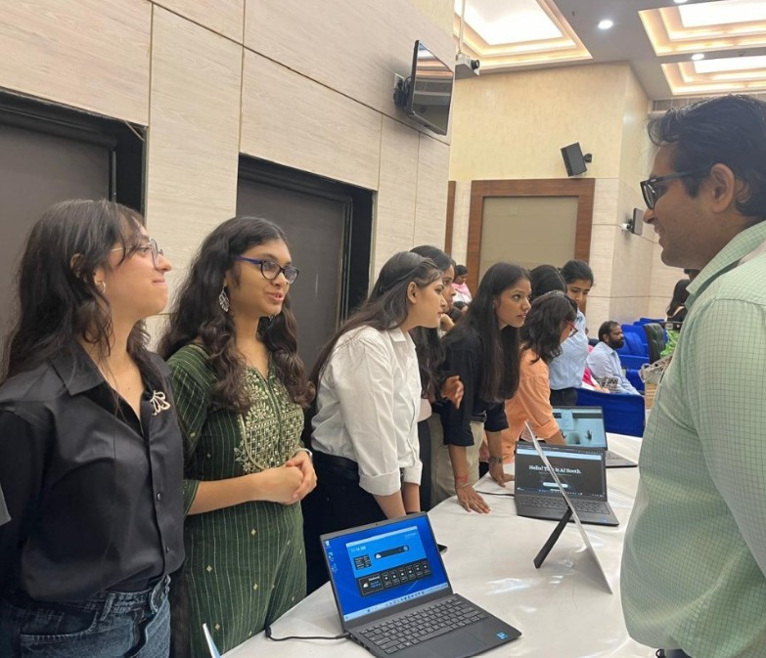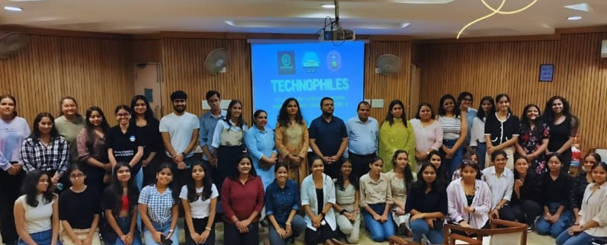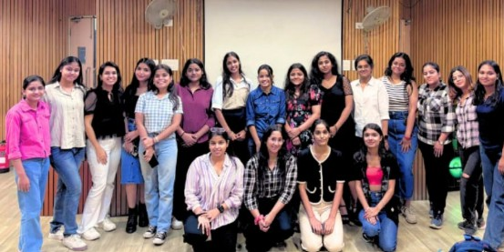

**Contact and Social Media with logo**

Riti Gupta

President, Technophiles

+91-9971434800

Instagram: <https://instagram.com/technophiles.bhc> Threads: [https://threads.net/@technophiles.bhc](https://threads.net/%40technophiles.bhc)

LinkedIn: <https://linkedin.com/in/technophiles-bharati-a668122ba> YouTube: [https://youtube.com/@TechnophilesBharati](https://youtube.com/%40TechnophilesBharati)

Email: [technophilesbharati24@gmail.com](mailto:technophilesbharati24@gmail.com) Website: <https://tech-bhc.github.io/explore/>