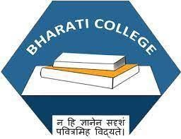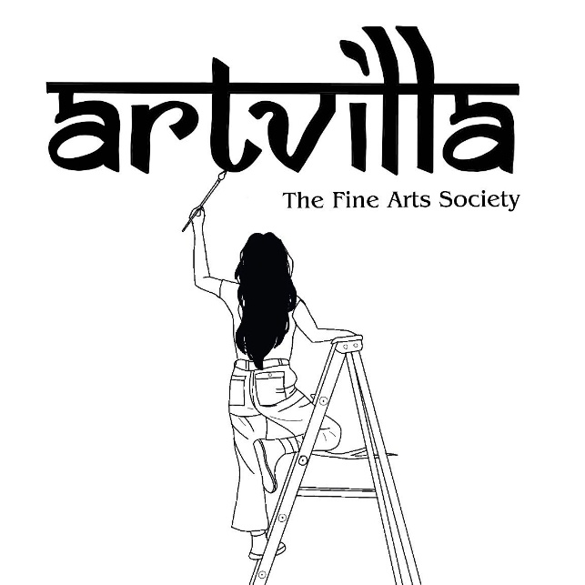

ARTVILLA:

**The Fine Arts Society**

Of Bharati College, University of Delhi

*Annual Report (2024-2025)*

*of events that took place in Artvilla from August 2024 to June 2025 under the convenorship of Prof. Sakshi Mittal.*

**Team Artvilla 2023-24**

**Convenor Prof.Sakshi Mittal Aggarwal**

**Co - Convenor Ms. Mahima**

**CORE TEAM**

|  |  |  |  |
| --- | --- | --- | --- |
| **Post** | **Full Name** | **Course** | **Year** |
| President | Ekagrata Kumar | B.Com (Prog) | 3rd Year |
| Vice-President | Kanak Gandharv | B.A. (Hons.) Psychology | 2nd Year |
| Secretary | Piyansi Sultania | B.Com (Prog) | 2nd Year |
| Event Head | Khushi Karki | B.A. Prog (History+Music) | 2nd Year |
| Media Coordinator | Tanisha Senapati | B.A. (Hons.) Journalism | 2nd Year |
| Content Head | Gungun Singh | B.A. (Hons.) English | 3rd Year |
| Treasurer | Anjum Ara | B.A. (Hons.) Psychology | 3rd Year |
| Social Media Head | Navya Roshan | B.A. (Hons.) Journalism | 2nd Year |
| Social Media Head | Devina Gilani | B.A. (Hons.) Psychology | 2nd Year |

**Members:**

|  |  |  |  |
| --- | --- | --- | --- |
| **S. No.** | **Full Name** | **Course** | **Year** |
| 1 | Bhawna Talan | B.Com (Prog) | 2nd Year |
| 2 | Vaishnavi Garg | B.A. Prog (Computer Applications + Economics) | 2nd Year |
| 3 | Komal Srivastav | B.A. (Hons.) Political Science | 1st Year |
| 4 | Anshika Singh | B.Com (Prog) | 1st Year |
|  |  |  |  |
| 6 | Kishti Kumari | B.Com (Hons.) | 1st Year |
| 7 | Kashish Kuhar | B.Com (Hons.) | 2nd Year |
| 8 | Anushka Prasad | B.Com (Hons.) | 1st Year |
| 9 | Komal Gupta | B.A. (Hons.) History | 1st Year |
| 10 | Harshita | B.Com (Hons.) | 1st Year |
| 11 | Tanisha | B.A. (Hons.) Psychology | 2nd Year |
| 12 | Ritisha Chhibber | B.Com (Prog.) | 2nd Year |
| 13 | Anjali Pandey | B.A. (Hons.) Journalism | 2nd Year |
| 14 | Ananya Singh | B.A. (Hons.) Political Science | 1st Year |
| 15 | Somya Aggarwal | B.Com (Hons.) | 3rd Year |
| 16 | Sonal Yadav | B.Com (Prog.) | 2nd Year |
| 17 | Sneha Sharma | B.A. Prog (Music + Political Science) | 1st Year |
|  |  |  |  |
| 19 | Pallavi Kumari | B.A. (Hons.) Psychology | 1st Year |
| 20 | Ravita | B.Com (Hons.) | 1st Year |
| 21 | Gunika Jain | B.A. (Hons.) Psychology | 2nd Year |
| 22 | Ishita Garg | B.Com (Hons.) | 1st Year |
|  |  |  |  |
| 24 | Sejal Baniya | B.A. Prog | 2nd Year |
| 25 | Aparna Dubey | B.A. Prog | 1st Year |
| 26 | Janvi | B.A. (Hons.) Sociology | 1st Year |
| 27 | Kashish | B.A. (Hons.) Journalism | 1st Year |
| 28 | Vidhi Mundhra | B.A. Prog | 1st Year |
| 29 | Bhumija Punjabi | B.Com (Prog) | 2nd Year |
| 30 | Amanpreet Kaur | B.Com (Prog.) | 2nd Year |
| 31 | Pransu Kumari | B.Com (Prog.) | 1st Year |
| 32 | Ananya Gautam | B.A. Prog (History + OMSP) | 1st Year |

***“Art enables us to find ourselves and lose ourselves at the same time.”***

— *Thomas Merton*

Art is not just creation; it's discovery. It gives us the space to lose ourselves in imagination and find ourselves in expression. It connects us—with nature, with our inner selves, and with each other. At Artvilla, we believe in this power of art to heal, inspire, and transform. With open arms and open minds, we welcome all who dare to dream, doodle, and design.

**Our Aim & History**

Formed in 2019, Artvilla—The Art and Aesthetic Society of Bharati College, University of Delhi—is a collective of imaginative and passionate individuals devoted to creative expression. Our mission is to offer students a nurturing platform to explore and develop their artistic identities, stepping beyond traditional boundaries. Whether it’s through painting, doodling, design, or decor, we aim to amplify creativity in all its forms while encouraging participation in inter-college competitions, workshops, and cultural events.

**Our Vision**

True to its name—*Artvilla*, a home of beauty and expression—our society envisions a space where every student feels welcome and empowered to create. We believe art should be accessible, inclusive, and transformative. Here, creativity isn’t judged—it’s celebrated. We strive to inspire students to view art not just as a passion, but also as a path, a voice, and a potential profession.

**Why Join Artvilla?**

Artvilla is more than a society—it’s a sanctuary for creativity. In our space, students are encouraged to experiment freely, without fear of perfection or the pressure of outcomes. They are free to create, make mistakes, and learn organically—because it is often in those moments of imperfection that the most meaningful discoveries are made.

Artvilla is a haven for every kind of artist—those who draw, those who dream, and even those who simply observe. Some come to paint, others to reflect. But all leave with inspiration. Whether you’re sketching silently, sharing stories, or just soaking in the atmosphere over lunch and music—here, you belong.

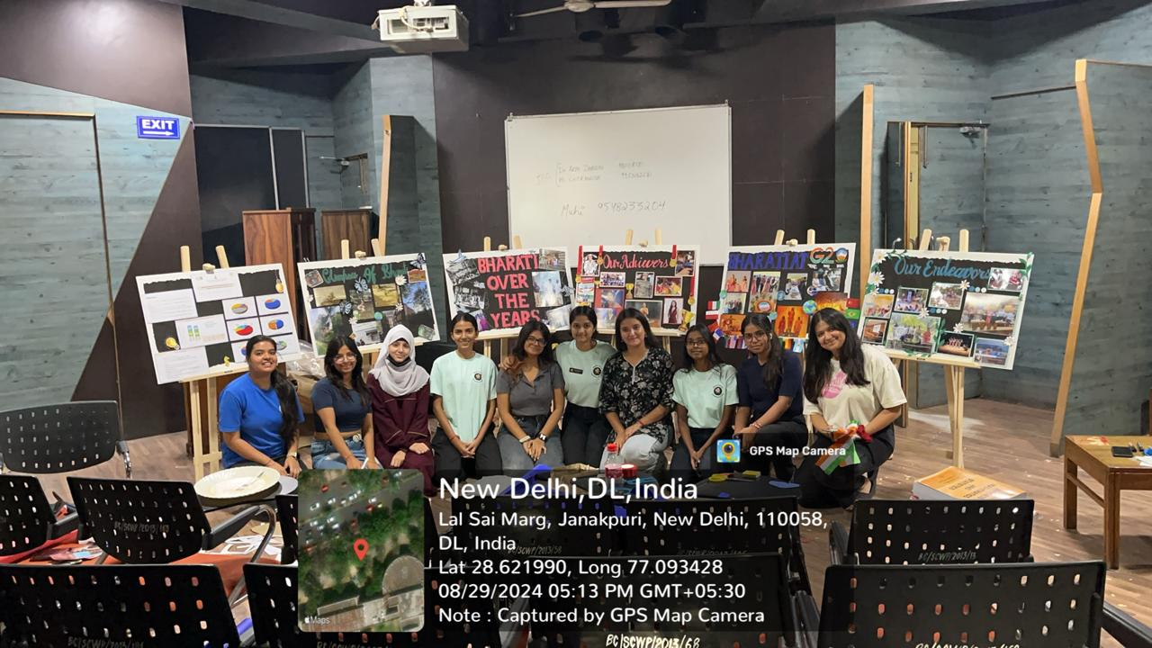

**Decoration for Vice President Visit**

**Date:** 29th August 2024  
**Venue:** Bharati College Premises

On the occasion of the Hon’ble Vice President of India’s visit to Bharati College, the Artvilla-Fine Arts Society played a vital role in visually enhancing the event by creating thoughtful and engaging decorations around three key themes: *“Bharati College Over the Years,” “College Achievers,”* and *“College's Participation in G20.”*

Under the guidance of faculty mentors and with collaborative effort from students across disciplines, the society designed and executed an array of artistic installations. A timeline mural illustrating the evolution of Bharati College since its inception was the centerpiece of the *“Bharati College Over the Years”* theme, incorporating archival photographs and hand-painted visuals.

The *“College Achievers”* section featured creative portrait displays and write-ups celebrating notable alumni and recent student accomplishments across academics, sports, and cultural fields. This was done using mixed-media art and innovative layouts that added vibrancy and inspiration to the space.

For the *“College's Participation in G20,”* students used global and national symbols to highlight the college's engagement with G20-related activities. The section included posters, collages, and an interactive corner reflecting student-led initiatives and seminars aligned with the G20 agenda.

The decorations were widely appreciated by guests and dignitaries, and they significantly contributed to the welcoming and intellectually stimulating atmosphere of the visit. The efforts of the Artvilla Society were a testament to the creativity, teamwork, and dedication of Bharati College students.

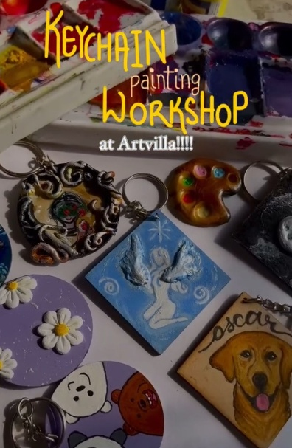

**Keychain Painting Workshop**

**Date:** 23rd August 2024  
**Venue:** Bharati College Premises

On the 23rd of August, 2024, Artvilla organized an interactive and vibrant **Keychain Painting Workshop** on the Bharati College premises. The event was designed to provide a relaxed and enjoyable space for members to tap into their creativity while experimenting with different painting techniques. Unlike many structured workshops, this allowed participants the freedom to choose their designs, enabling a diverse array of artistic expressions, from abstract patterns to miniature landscapes. With no predefined themes, the workshop encouraged each individual to craft something that was entirely unique and reflective of their personal style.

The participants were provided with all necessary materials, including a variety of paints, brushes, and keychains, allowing them to explore their artistic potential without constraints. The atmosphere was filled with enthusiasm and camaraderie, as members of Artvilla collaborated, exchanged tips, and shared laughter over their creations. At the end of the session, everyone left with a beautifully personalized keychain, not only as a memento of the event but as a tangible reminder of the joy and creativity that thrives within the Artvilla community.

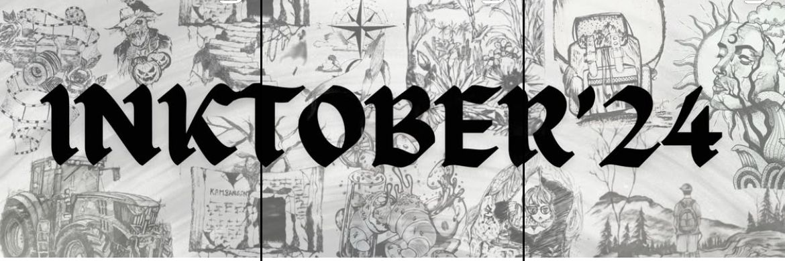

**Inktober’24**

**Date:** Throughout October 2024  
**Venue:** Online Participation (via Artvilla platforms and social media)

In October 2024, Artvilla participated in the annual **Inktober** challenge, a month-long event that celebrates the art of inking. This year, members were invited to create one ink drawing every day, exploring their creativity and honing their skills with ink. The challenge encouraged experimentation with various inking techniques, from bold lines to intricate detailing, allowing participants to push their artistic boundaries.

To add an interactive dimension, Artvilla showcased the participants' artwork across its social media platforms, creating a vibrant space for engagement. Members eagerly shared their daily creations, drawing not only inspiration from the prompts but also from each other. The community’s enthusiasm was evident as members interacted, commented, and supported one another throughout the month, fostering a strong sense of camaraderie and artistic growth.

The event concluded with an online gallery featuring the diverse array of works produced during the month, celebrating the creativity and dedication of all those who took part in the challenge.

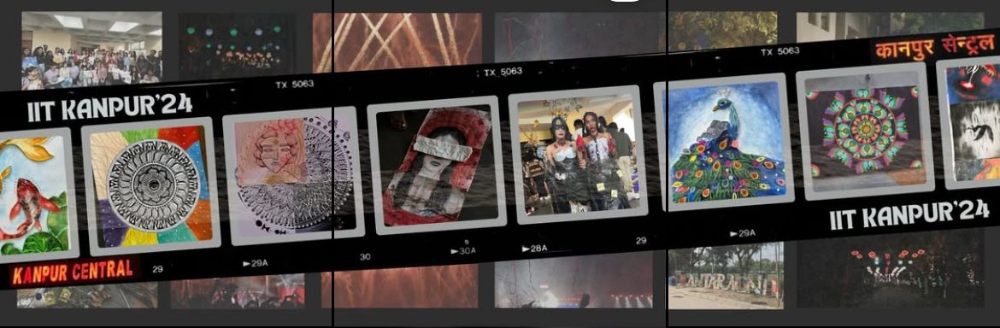

**IIT Kanpur “Antaragni”**

**Date:** 17th–20th October 2024  
**Venue:** IIT Kanpur

Artvilla's participation in **Antaragni 2024**, the iconic cultural fest at IIT Kanpur, was nothing short of remarkable. From 17th to 20th October, the event served as a dynamic platform for Artvilla members to showcase their creativity and artistic skills across a wide range of competitions, each offering its own unique challenge and opportunity for expression.

One of the standout events was **Japanese Quilling and Origami**, where Artvilla’s participants captivated audiences with their intricate and meticulous creations. The delicate art of quilling was paired with the precision of origami, resulting in stunning pieces that showcased both patience and expertise. The team’s attention to detail and innovative designs made them a strong contender in this challenging competition.

In the **Fashion Geek** competition, Artvilla’s artists displayed their ability to seamlessly blend art with fashion, creating wearable pieces that were both visually striking and conceptually profound. The event encouraged participants to push the boundaries of traditional art and explore how fashion could be a canvas for their creative expression, and Artvilla members did so with flair.

The **Battle of Art** was an exhilarating test of speed and skill, where participants were required to create art on the spot, responding to prompts in real-time. Artvilla’s team embraced the pressure and excitement, producing visually compelling works that captured the energy and spontaneity of the moment. Their performance in this fast-paced environment reflected their quick thinking and deep passion for art.

In the more meditative **Mandala** competition, Artvilla’s members demonstrated their expertise in creating intricate, symmetrical designs that conveyed a sense of peace and harmony. Their use of precision and symmetry impressed the judges and audiences alike, showcasing their mastery of a traditional and deeply symbolic art form.

Finally, in the **Surrealism** competition, Artvilla participants let their imaginations run wild, producing thought-provoking, dreamlike pieces that challenged conventional perspectives. This competition allowed them to explore the depths of creativity, presenting artworks that invited viewers into fantastical worlds and questioning the boundaries between reality and the unreal.

Throughout the events, Artvilla’s members not only displayed their technical artistry but also embodied the spirit of collaboration, resilience, and artistic exploration. Their participation in Antaragni was a testament to the talent and passion that defines the Artvilla community, making their presence felt in one of the country’s most prestigious cultural fests.

**Winners:**

* **First Position (Mandala):** Aparna Dubey
* **Second Position (Fashion Geek):** Devina Gilani, Gungun Singh, Anjum Ara, Khushi Karki, Ritisha Chhibber
* **Third Position (Battle of Art):** Ekagrata Kumar, Kanak Gandharv, Navya Roshan

**Art Date at Sunder Nursery (15th November 2024)**

**Date:** 15th November 2024  
**Venue:** Sunder Nursery, Delhi

On 15th November 2024, Artvilla organized an inspiring and peaceful **Art Date** at the scenic **Sunder Nursery**, a heritage park located in the heart of Delhi. This event provided Artvilla members with the perfect blend of nature and creativity, offering them a serene environment to draw, paint, and connect with their artistic side.

Participants brought their sketchbooks, canvases, and other art supplies to the lush greenery of Sunder Nursery, where they could immerse themselves in the natural beauty surrounding them. The venue, with its vibrant flora, historical structures, and peaceful atmosphere, offered a stunning backdrop that encouraged both quiet reflection and artistic expression.

Members were free to choose their artistic medium, whether it was watercolor, sketching, or acrylics, allowing them to capture the intricate details of the nursery’s flowers, trees, and architecture. The event was not only an opportunity to create but also a chance to bond with fellow artists, share creative ideas, and enjoy a relaxing day outdoors.

The **Art Date at Sunder Nursery** was more than just an art event; it was an enriching experience that allowed participants to reconnect with nature while creating beautiful artwork. It embodied the spirit of Artvilla, fostering a sense of community and creativity in an inspiring environment.

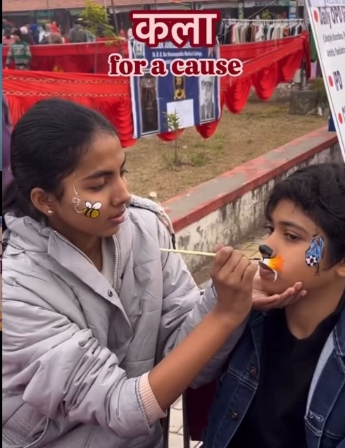

**Shanti Shiksha Samiti NGO Collaboration - Face Painting Stall**

**Date:** 14th January 2025  
**Venue:** Shanti Shiksha Samiti NGO

On 14th January 2025, Artvilla partnered with **Shanti Shiksha Samiti NGO** to host a **Face Painting Stall** at the NGO’s premises, a vibrant and heartwarming event aimed at spreading joy while supporting a meaningful cause. The collaboration beautifully blended creativity with social responsibility, bringing the artistic talents of Artvilla members together with the mission of the NGO to uplift underprivileged children.

The Face Painting Stall was set up within the NGO’s welcoming environment, where children and adults alike eagerly participated in getting their faces painted with colorful and imaginative designs. From animals to superheroes, the event allowed everyone to immerse themselves in a world of creativity and fun, turning the day into an artistic celebration. The stall became a place of joy, laughter, and connection, as Artvilla members painted with skill and enthusiasm, transforming visitors with each brushstroke.

In addition to offering a fun and artistic experience, the event served as a reminder of the vital work being carried out by the **Shanti Shiksha Samiti** in providing education and support to underprivileged children. The collaboration helped raise awareness about the NGO’s initiatives and the importance of education in transforming lives. This event not only showcased the power of art to bring people together but also highlighted the significance of community support and social responsibility.

Through this collaboration, Artvilla contributed not only to the artistic enjoyment of the participants but also to a cause that directly impacts the lives of children in need, reinforcing the idea that creativity can be a catalyst for positive change.

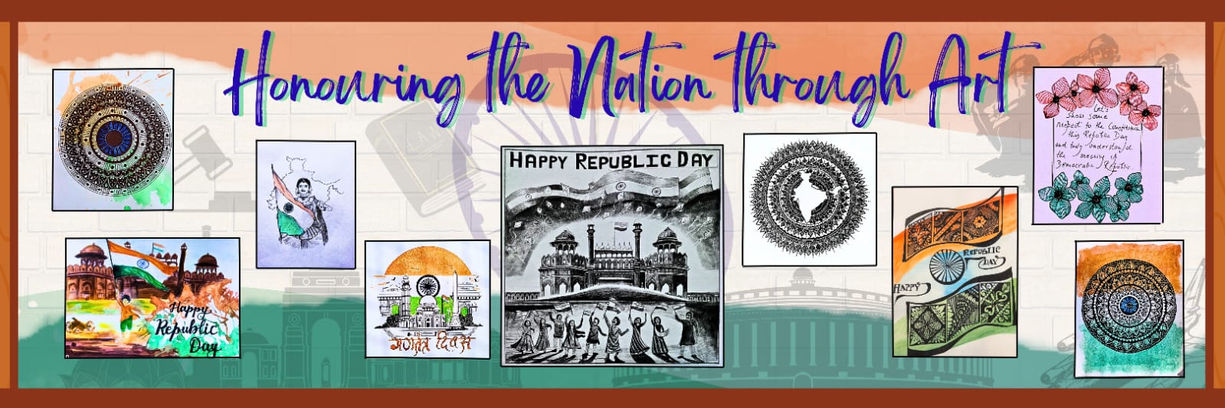

**Republic Day Artwork Activity**

**Date:** 26th January 2025  
**Venue:** Bharati College

On **26th January 2025**, Artvilla celebrated **Republic Day** with an inspiring **Artwork Activity** at **Bharati College**, offering members the opportunity to express their patriotism through art. This event, held in honor of India’s 75th Republic Day, celebrated the nation’s heritage, culture, and progress.

Participants were invited to create artwork that reflected the spirit of the day, with designs focusing on themes like **national pride**, **unity**, and **freedom**. From the vibrant **Indian flag** to illustrations of India’s **historical landmarks** and **freedom fighters**, the activity provided an opportunity for members to express their love for the country. Various mediums, including sketches, paintings, and digital art, were used, allowing each participant to put their unique artistic touch on the day’s theme.

The artwork was shared on **Artvilla's social media**, showcasing the members' creativity and patriotism. The online post received a warm reception, with the community engaging with the artwork and appreciating the talent of the participants. It was a wonderful way to celebrate Republic Day and promote artistic expression while honoring the values of democracy and unity.

The **Republic Day Artwork Activity** not only brought Artvilla together but also allowed the members to reflect on the significance of the day through the lens of art, fostering both creativity and national pride.

**Art Workshop**

**Date:** 10th February 2025  
**Venue:** Bharati College

On **10th February 2025**, Artvilla hosted an enriching **Art Workshop** at **Bharati College**, focusing on various techniques and creative processes in art. This hands-on workshop was designed to help participants explore their artistic potential and expand their skills in multiple mediums.

The workshop kicked off with a session on **creative thinking**, encouraging attendees to approach art with an open mind and experiment with new ideas. This segment was aimed at helping participants break free from conventional methods and think outside the box, nurturing a mindset of innovation and creativity.

The following sessions were tailored to provide a deeper understanding of different art forms:

* **Sketching:** Participants learned the fundamentals of sketching, including composition, shading, and perspective, which served as a foundation for creating more complex artworks.
* **Still Life:** The still life session allowed members to capture the beauty of inanimate objects, focusing on realistic rendering and the study of light and shadow. Participants had the opportunity to create their own still life compositions.
* **Watercolor:** With watercolors, participants were introduced to the techniques of blending and layering colors to create fluid, expressive paintings that evoked both softness and vibrancy.
* **Calligraphy:** A session on calligraphy helped participants understand the art of beautiful writing. From basic strokes to forming intricate letter designs, this segment encouraged attendees to appreciate the visual art of words.
* **Oil Pastels and Acrylics:** Participants explored the use of **oil pastels** and **acrylic paints**, learning to manipulate these versatile mediums to create vibrant, textured artwork.

The workshop fostered a collaborative and creative environment where attendees could experiment, learn, and develop their skills across a variety of art forms. By the end of the session, participants walked away with not only new techniques but also a deeper appreciation for the creative process.

The **Art Workshop** at Bharati College was an engaging, hands-on experience that encouraged artistic exploration, making it a memorable event for everyone involved.

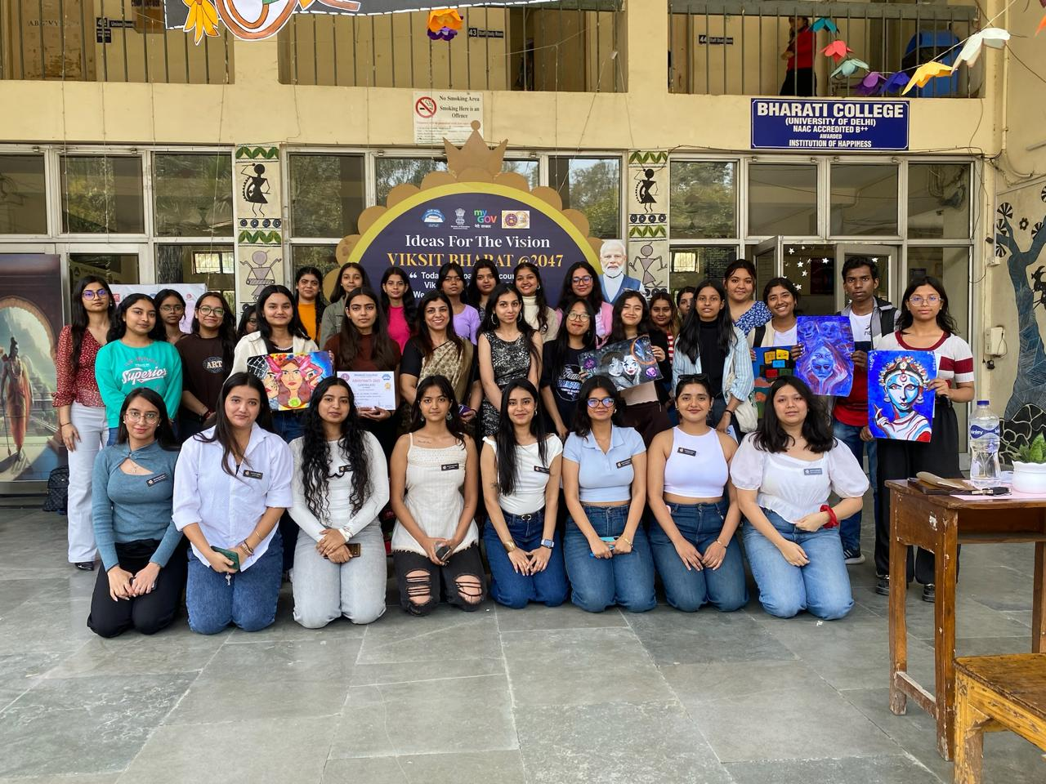

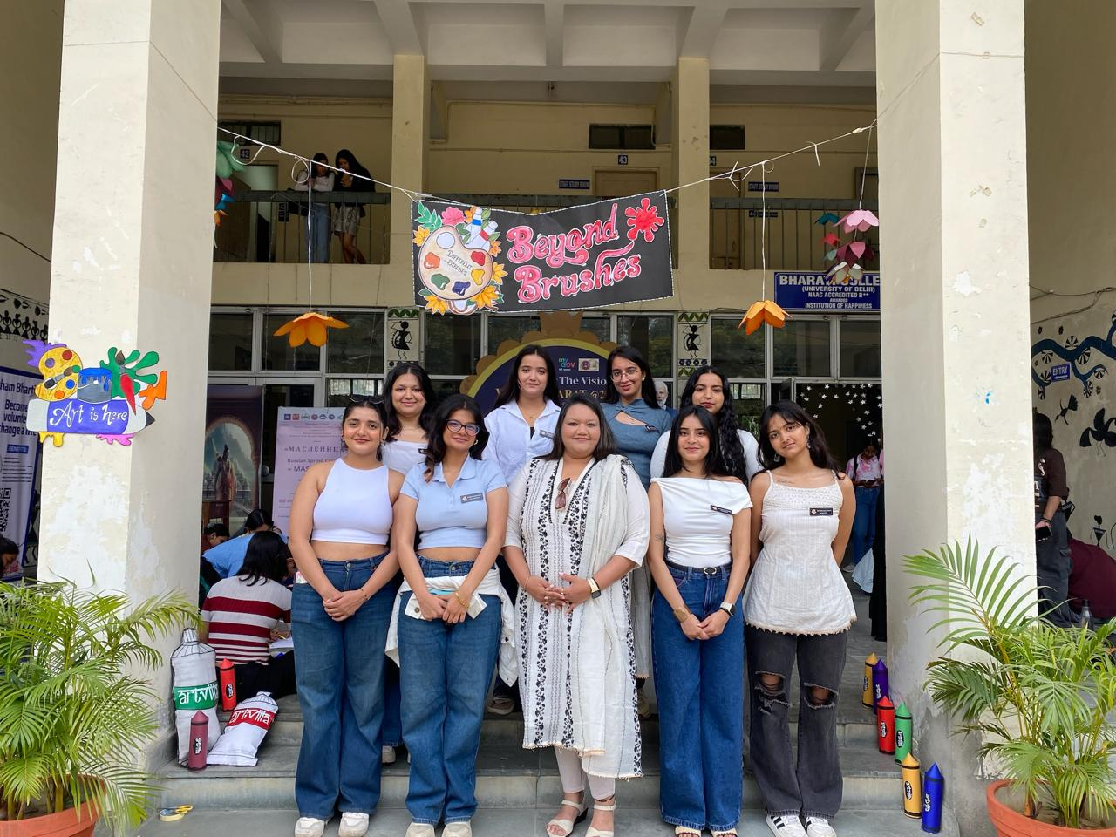

**Abhivyakti’2025**

**Date:** 28th February – 1st March 2025  
**Venue:** Bharati College

Artvilla proudly participated in **Abhivyakti 2025**, a celebration of creativity and artistic innovation, held at **Bharati College**. As part of the festival, Artvilla hosted two exciting and creative competitions: **Beyond Brushes** and **Trashtastic**. Both events were designed to push the boundaries of traditional art, challenging participants to explore new techniques and engage with thought-provoking themes.

**Beyond Brushes**

The **Beyond Brushes** competition encouraged participants to break away from traditional painting methods by creating artwork without using conventional brushes. Artists were tasked with using alternative tools, such as sponges, fabric, and even their hands, to express their creativity. This competition aimed to promote innovative thinking and allow participants to experiment with unconventional materials and techniques. It was an exciting challenge for participants to explore the vast range of possibilities in art beyond the usual tools.

**Winners:**

* **1st Position:** Jagriti and Anika from Miranda House
* **2nd Position:** Sonakshi Senapati and Shunthing Zimik from Hindu College
* **3rd Position:** Durga from Maharaja Agrasen Institute of Technology

**Trashtastic**

**Trashtastic** was an artistic challenge focused on **upcycling** and sustainability. Participants were tasked with transforming discarded materials into meaningful works of art, encouraging creativity and raising awareness about the importance of reusing and repurposing materials. Using items like plastic, metal, fabric, and paper, participants created stunning artwork that not only showcased their artistic skills but also conveyed an important environmental message. The competition highlighted how art can be used as a tool for change, promoting eco-conscious practices while celebrating artistic talent.

**Winners:**

* **1st Position:** Mehak, Prarthana, and Shashwat from Rajdhani College
* **2nd Position:** Ahsan Raqeeb, Akshat Gupta, Bhavay Jain and Shreyafrom Keshav Mahavidyalay
* **3rd Position:** Ayush Kumar Jaiswal, Hanshika Gupta, Rishabh Singh and Himanshu Khatri from Keshav Mahavidyalay
* **3rd Position:** Khushi Karki and Piyansi Sultania from Bharati College

Both competitions at **Abhivyakti’25** were a celebration of artistic innovation and creativity. The events allowed participants to express their creativity while exploring important themes like sustainability and the limitless potential of artistic expression. Artvilla’s involvement in the festival showcased its commitment to fostering creativity, pushing artistic boundaries, and engaging with contemporary issues through art.

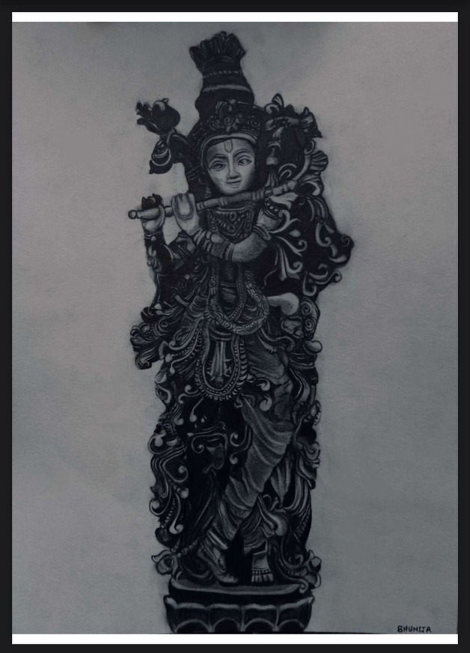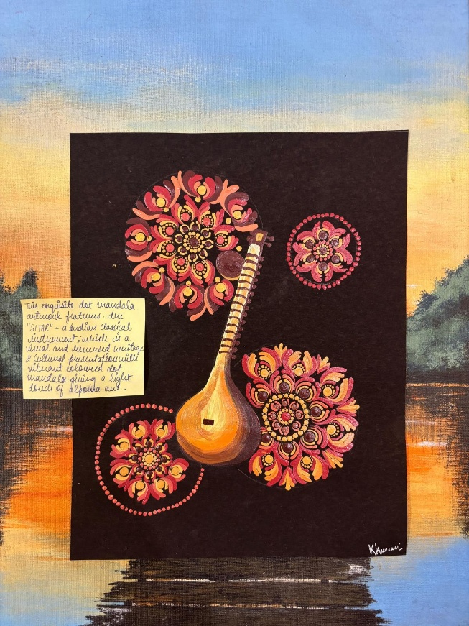

**Viksit Bharat Competition**

**Date:** 5th April 2025  
**Venue:** Online

**Artvilla** organized and participated in the **Viksit Bharat Competition** on **5th April 2025**, which provided a creative platform for artists to engage with significant themes surrounding India's culture, heritage, and future. The competition consisted of two distinct categories: **Traditional Art** and **Digital Art**, each with a unique theme that allowed participants to explore various aspects of India's past, present, and future.

**Traditional Art Competition**

The **Traditional Art** competition had the theme of **Heritage and Cultural Preservation**, inviting participants to create artwork that celebrated India's rich cultural legacy while emphasizing the importance of preserving it. This competition encouraged participants to explore and depict India's diverse heritage, such as its historical monuments, traditional art forms, cultural practices, and folklore. Artists were free to use various traditional mediums, from painting and drawing to sculpture and other handcrafted art, as long as their artwork conveyed the theme of cultural preservation. The competition aimed to inspire a deeper appreciation for India’s cultural roots and the importance of safeguarding them for future generations.

**Winners (from Bharati College):**

* **1st Position:** Kishti Kumari
* **2nd Position:** Bhumija Punjabi
* **3rd Position:** Vashita Vishwakarma

**Digital Art Competition**

The **Digital Art** competition focused on the theme of **India in the 22nd Century**. In this category, participants were asked to envision and create digital artwork that imagined India’s future in the coming century. From technological innovations to social changes, participants depicted how India might evolve in terms of its cities, culture, and global presence. This competition encouraged futuristic creativity, where participants used digital tools to showcase their imaginative ideas, exploring the possibilities of advanced technology, sustainable development, and how India’s rich traditions could harmonize with modern advancements in the future.

Through these two competitions, **Artvilla** fostered a deeper conversation about India’s cultural preservation while also encouraging forward-thinking creativity about the country’s future. Both categories provided a platform for participants to showcase their artistic talents and engage with essential topics regarding India's identity, heritage, and progress in the global landscape.

**Winners:**

• **1st Position:** Somya Aggarwal

• **2nd Position:** Ritisha Chhibber

Through these competitions, **Artvilla** was able to provide a platform for participants to explore critical issues such as cultural preservation and future progress while fostering creativity across traditional and digital art forms. The **Viksit Bharat Online Competition**, organized by **Artvilla** at **Bharati College**, successfully engaged participants in meaningful artistic conversations about India’s heritage and its evolving future.

**Student Achievements**

* **Khushi Karki**  
  *Position:* 2nd  
  *Event:* Tiny Totems (Keychain-Making Competition)  
  *Institution:* Bharati Vidyapeeth University
* **Divyanshi Kumari**  
  *Position:* 2nd  
  *Event:* Painting Competition  
  *Institution:* Institute of Home Economics
* **Anushka Prasad**  
  *Position:* 1st  
  *Event:* Amnesia'24  
  *Institution:* BAMC
* **Anshika Singh**  
  *Position:* 3rd  
  *Event:* Amnesia'24  
  *Institution:* BAMC
* **Muskan**  
  *Position:* 2nd  
  *Event:* Mini Canvas Painting Competition  
  *Institution:* BSA Medical College
* **Aparna Dubey**  
  *Position:* 1st  
  *Event:* Mandala Painting  
  *Institution:* IIT Kanpur
* **Devina Gilani, Gungun Singh, Anjum Ara, Khushi Karki, Ritisha Chhibber**  
  *Position:* 2nd  
  *Event:* Fashion Geek  
  *Institution:* IIT Kanpur
* **Ekagrata Kumar, Kanak Gandharv, Navya Roshan**  
  *Position:* 3rd  
  *Event:* Battle of Art  
  *Institution:* IIT Kanpur
* **Komal Srivastav**  
  *Position:* 3rd  
  *Event:* Sketch-o-Nova  
  *Institution:* Genesis'25, MSIT
* **Ananya**  
  *Position:* 3rd  
  *Event:* Caricature Competition  
  *Institution:* Bharati College
* **Bhawna Talan**  
  *Position:* 3rd  
  *Event:* Pocket Picasso Competition  
  *Institution:* Deshbandhu College
* **Kishti Kumari**  
  *Position:* 2nd  
  *Event:* Karigari Competition  
  *Institution:* Shyam Lal College
* **Somya Aggarwal**  
  *Position:* 1st  
  *Event:* Digital Art Competition (Theme: India in the 22nd Century)  
  *Institution:* Bharati College
* **Ritisha Chhibber**  
  *Position:* 2nd  
  *Event:* Digital Art Competition (Theme: India in the 22nd Century)  
  *Institution:* Bharati College
* **Kishti Kumari**  
  *Position:* 1st  
  *Event:* Traditional Art Competition (Theme: Heritage and Cultural Preservation)  
  *Institution:* Bharati College
* **Bhumija Punjabi**  
  *Position:* 2nd  
  *Event:* Traditional Art Competition (Theme: Heritage and Cultural Preservation)  
  *Institution:* Bharati College