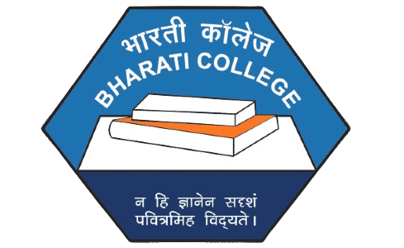DASTAAN
The Film and Photography Society
Bharati College
University of Delhi, New Delhi

Year Report
2025

Contents
- Photowalk through Khan Market
- Photowalk through Qutub Minar and Hauz Khas
- Film Screening - Laapata Ladies
- Film Screening and Discussion: The Earth 1947
- Short Film Competition - DDUC
- Short Film - the Last Patient
- Photography Competition- Emotions in Motion, at Inside Out, the Annual Fest of Cathect, Psychology Department, Bharati College.
- National Conference on Society and Sustainability for Vision Viksit Bharat @2047: Socio-Economic and Environmental Challenges in the North East Region of India
- Photostory Competition – Tasveeron Ki Kitaab
- Holi Shoot
- Movie Recommendation- Delhi 6
- Photo Submission Drive

Photowalk through Khan Market
COVERAGE REPORT – Dastaan Photowalk at Khan Market
Date: 27th April, 2024
Dastaan, the Film and Photography Society of Bharati College, embarked on an exciting photo walk through the lively streets of Khan Market, one of New Delhi’s most iconic shopping districts. Known for its blend of luxury boutiques, quaint bookshops, and cozy cafes, Khan Market proved to be the perfect setting for an immersive exploration of both culture and creativity.
The photowalk provided Dastaan members with an opportunity to capture the vibrant spirit of the market, with its unique mix of chaos and calm. The group ventured through the bustling lanes, photographing the busy shoppers, tranquil corners, and striking street art, each frame telling a different story. The experience was as much about capturing moments as it was about exploring the stories behind the faces and places.
One of the key highlights of the walk was a visit to Faqir Chand Book Depot, a beloved spot among bibliophiles, known for its vast collection of books and its charm. Despite being a small space, the bookshop holds a world of literary wonders and added a quiet yet intriguing contrast to the vibrancy of the market.
The photowalk not only allowed Dastaan members to engage with their surroundings through the lens but also celebrated the spirit of togetherness and creativity within the group. Dastaan’s photo walk through Khan Market was an enriching experience that combined creative exploration with a deeper understanding of the vibrant stories that unfold in everyday life. It was a chance for the members to witness the power of photography to capture fleeting moments and turn them into powerful visual narratives.
The photo walk through Khan Market was a journey of memories, shared experiences, and artistic exploration. The photographs taken during this walk will serve as lasting records of Dastaan’s creative spirit and the beauty of Khan Market, immortalizing the essence of Delhi’s heart in every frame.
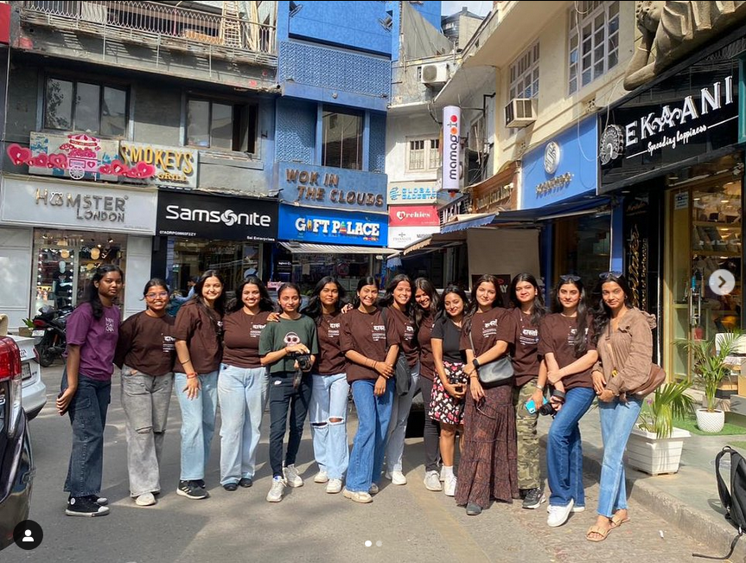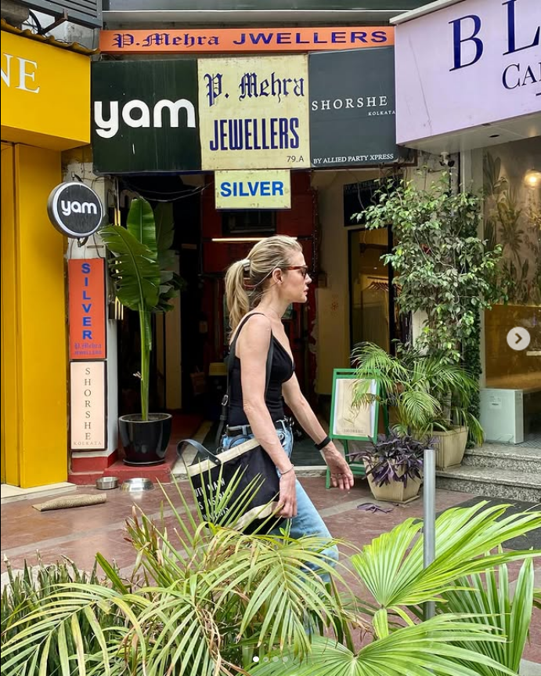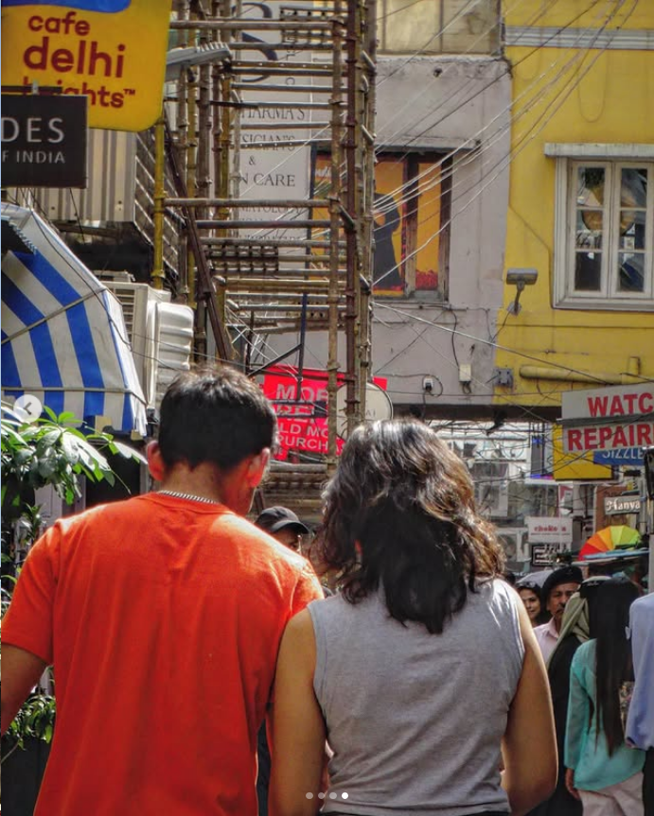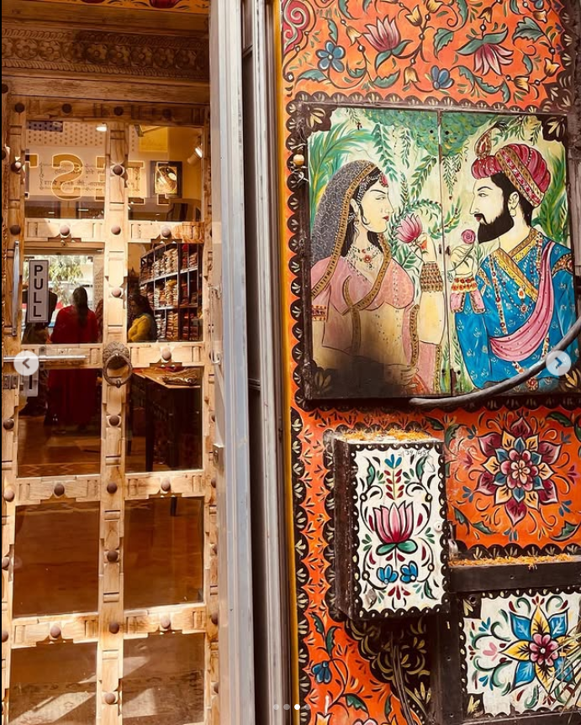

Photowalk through Qutub Minar and Hauz Khas
COVERAGE REPORT – Dastaan's Photowalk
Date: April 18, 2025

Dastaan, the Film and Photography Society of Bharati College, took part in an exhilarating photowalk that captured the essence of Delhi’s historical landmarks and serene nature spots. The day began with a visit to the iconic Qutub Minar, one of Delhi's most renowned UNESCO World Heritage Sites. The towering minaret, standing tall at 73 meters, offered an incredible opportunity for photographers to capture the intricate carvings and breathtaking symmetry of Mughal-era architecture.

After soaking in the history at Qutub Minar, the photowalk continued towards Hauz Khas, an area known for its scenic beauty and historical significance. The cool breeze near Hauz Khas Jheel offered a refreshing break as the group captured the tranquil water reflecting the greenery of the park. The lush green spaces of Deer Park provided the perfect escape from the scorching heat, with photographers capturing candid moments of nature and wildlife.

The highlight of the day was the collaboration with Polaroid, the Film and Photography Society of DDUC. The Dastaan and Polaroid teams met at Hauz Khas, where the collaborative energy and creative exchange among members turned the walk into an even more exciting experience. Photographers from both societies connected, shared tips, and exchanged stories while capturing the beauty of the park. The picturesque surroundings made for the perfect backdrop, as each member clicked shots that reflected their unique perspective on the world.

From the architectural wonders of Qutub Minar to the natural beauty of Hauz Khas, the photowalk was a perfect blend of culture, nature, and creativity. As the sun set, the members wrapped up the day with smiles, laughter, and a camera roll full of memories. This collaborative photowalk left everyone with a sense of fulfillment and a deeper appreciation for the beauty of Delhi through the lens.

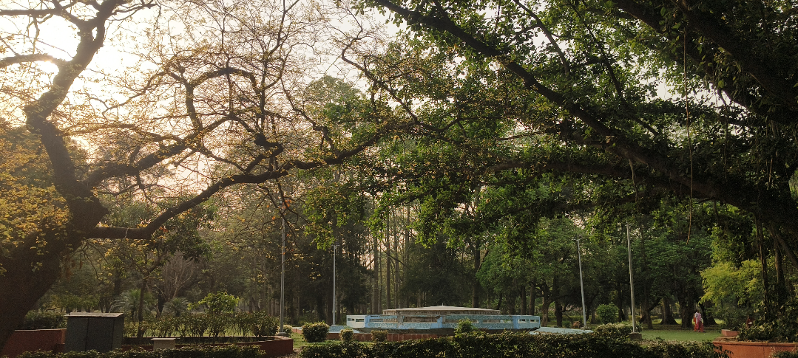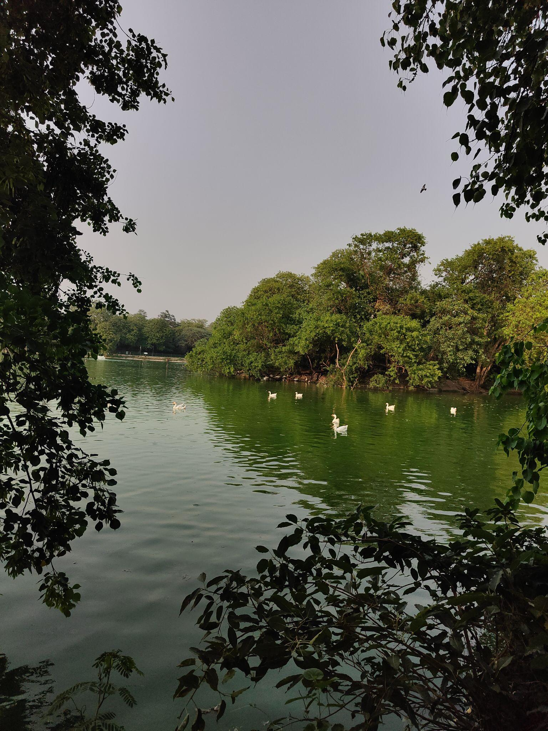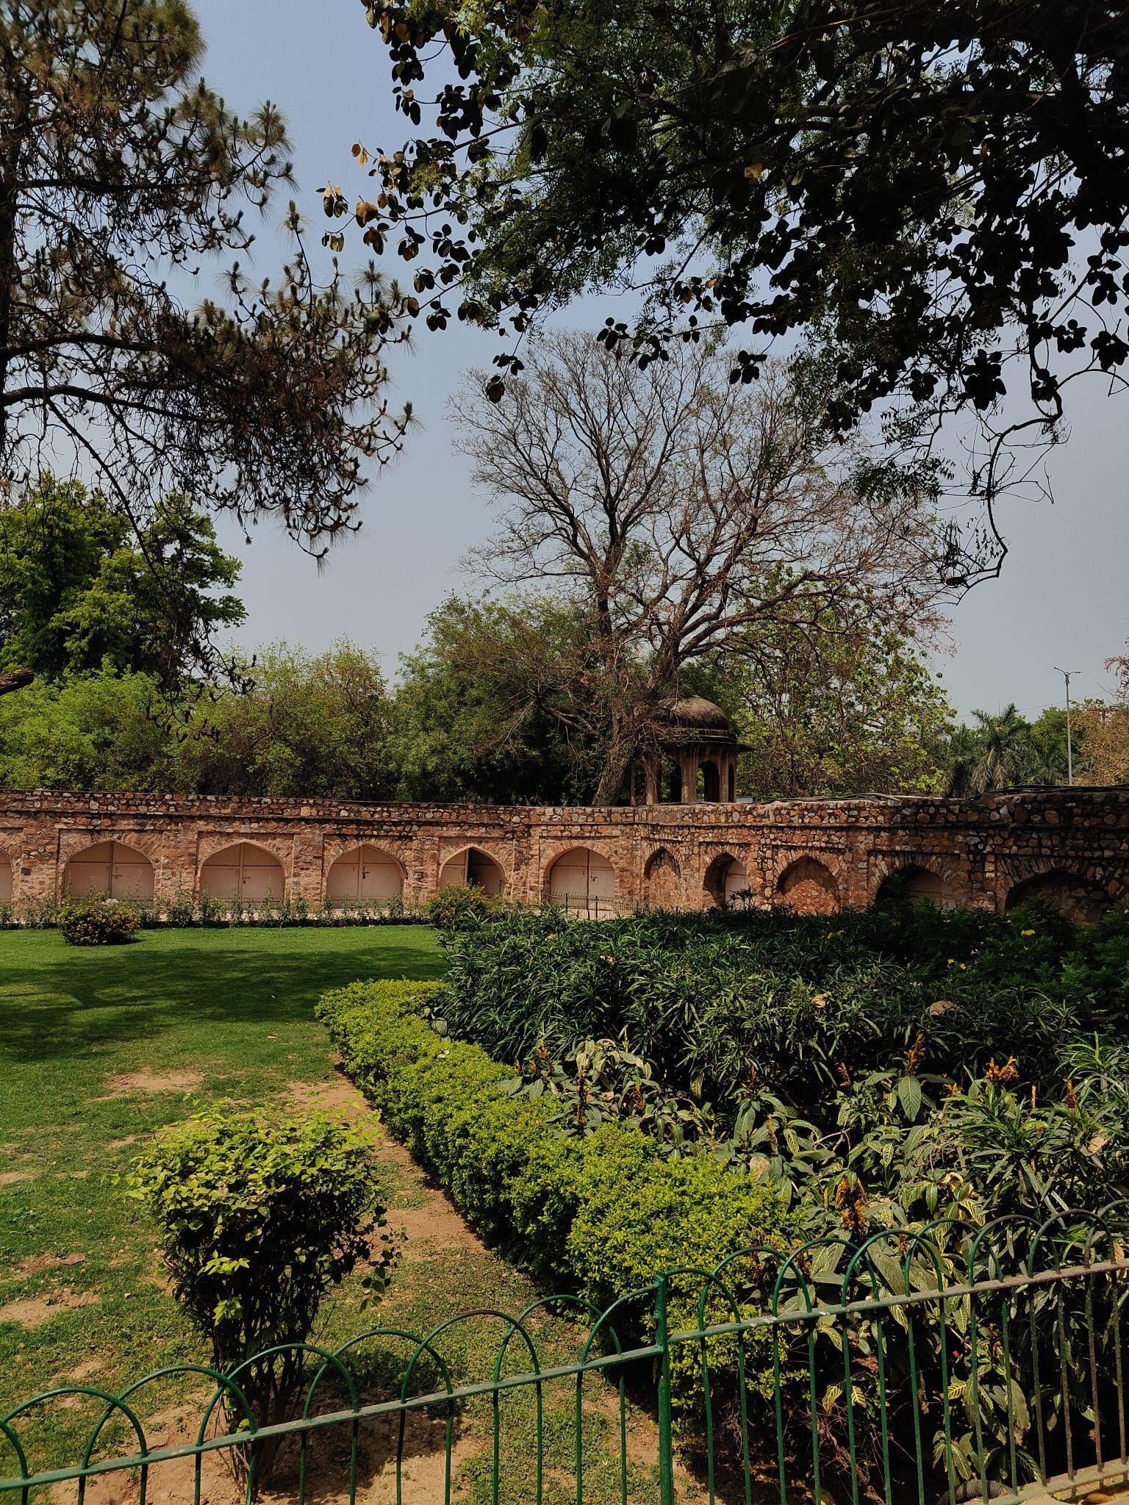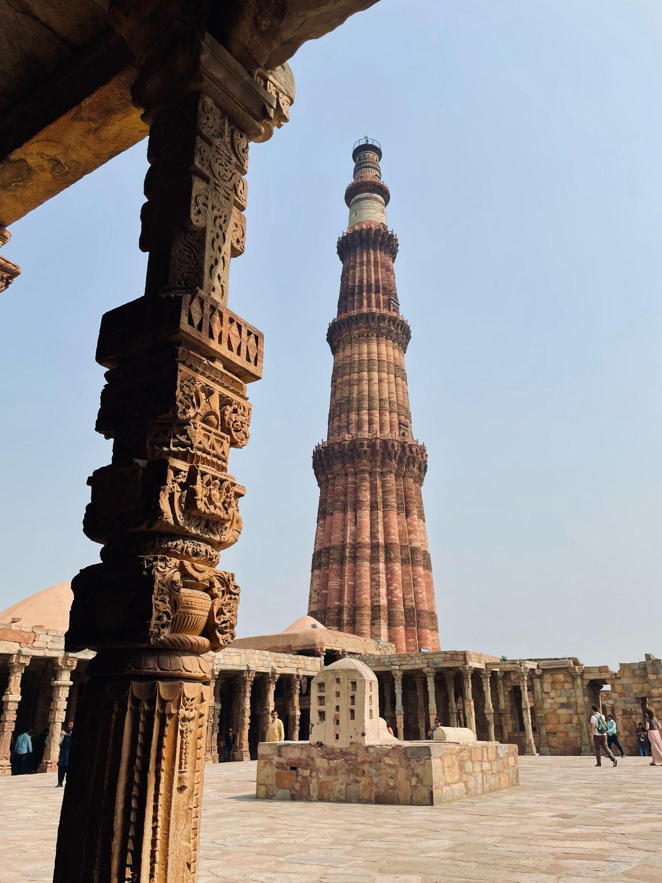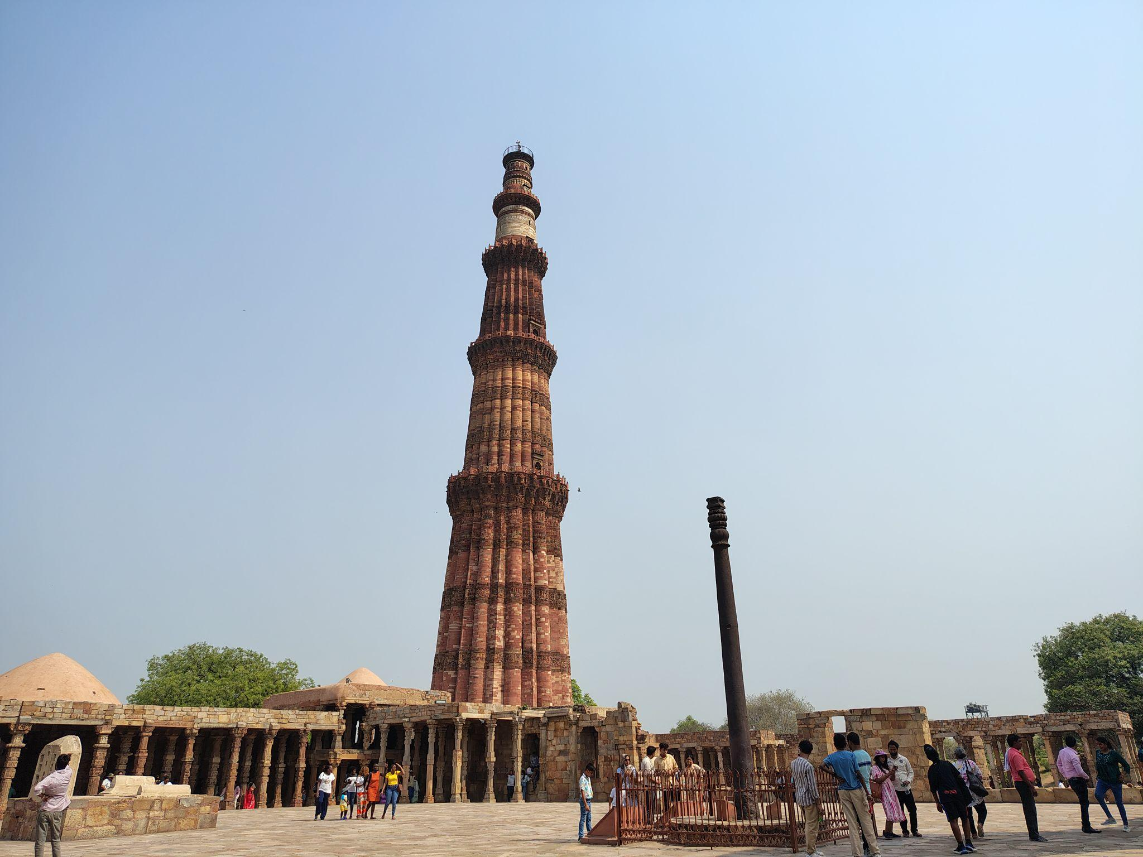

Film Screening - Laapataa Ladies
COVERAGE REPORT – Laapataa Ladies
Date: May 8, 2024
Dastaan, the Film and Photography Society of Bharati College, hosted a vibrant screening of Laapataa Ladies, a delightfully witty and heartwarming film that had the audience in splits while leaving them with much to reflect on. Directed by Kiran Rao and produced by Aamir Khan, the film cleverly blends satire and social commentary, exploring themes of identity, womanhood, and small-town resilience through the amusing chaos of two brides who accidentally swap places.
To kick off the screening, Dastaan members enthusiastically welcomed the audience and introduced the film’s plot and cinematic style. Held in the Seminar Room, the event created a space full of energy, laughter, and connection.
Laapataa Ladies stood out for its sharp wit and carefully layered narrative. The screenplay, filled with irony and clever symbolism, delivered laughter while subtly critiquing social norms and gender roles. The film’s cinematography beautifully captured the rustic charm of rural India—its fields, railway stations, and bylanes—becoming an essential part of the storytelling. Each frame, rich in color and detail, deepened the emotional impact of the characters’ journeys, making the film both visually and thematically compelling.
Following the screening, attendees participated in a lively discussion, where they shared reactions to the film’s humorous yet insightful portrayal of rural life, the subtle critique of gender norms, and the empowering journeys of the characters. The conversation highlighted how comedy can be a powerful vehicle for social messaging.
Overall, the screening of Laapataa Ladies turned out to be an unforgettable afternoon—fun-filled yet thoughtful—leaving everyone with smiles on their faces and ideas to ponder.
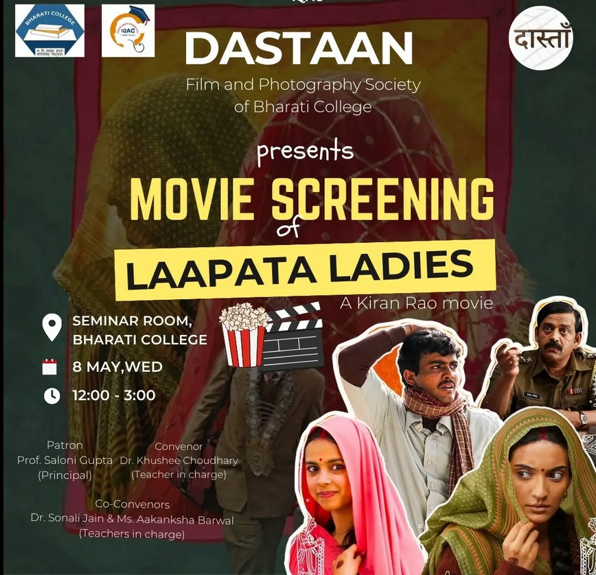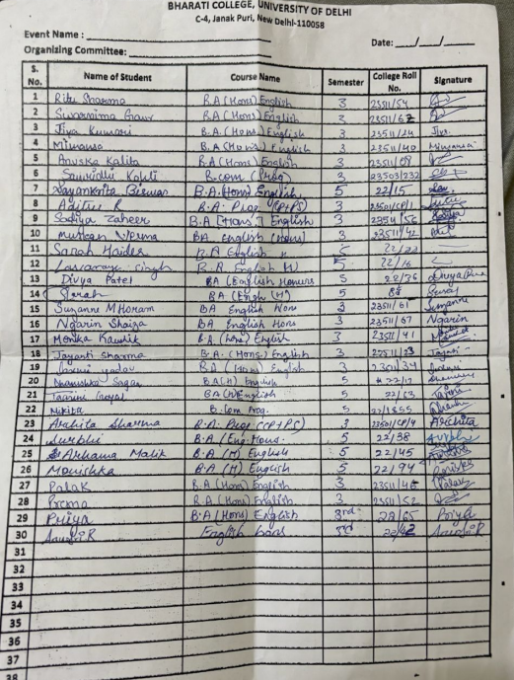

Film Screening - Earth 1947
COVERAGE REPORT- Earth 1947
Date: October 1, 2024
Dastaan, the Film and Photography Society of Bharati College, recently organized a screening of "1947, Earth", a moving film directed by Deepa Mehta that delves into the heart-wrenching events surrounding India’s Partition. Based on Bapsi Sidhwa's novel Cracking India, the story unfolds through the eyes of Lenny, an eight-year-old Parsi girl in Lahore. Central to the narrative is her nanny, Shanta, who becomes entangled in a love triangle between Dil Navaz, a Muslim, and Hassan, a Hindu. As the communal tensions among Hindus, Muslims, and Sikhs intensify during the Partition, personal relationships begin to fracture, mirroring the larger social divide. The film poignantly illustrates the devastating effects of Partition, exploring themes of betrayal, loss, and the tragic disintegration of friendships amid political chaos.
To set the context for the audience, society members introduced the movie, providing insights into its storyline and cast. Following the screening, an engaging discussion session took place where students and audience members explored their thoughts and questions about the film and the historical events it portrays.
The discussion touched upon the historical accuracy of the Partition, its emotional impact, and the motivations of characters like Shanta and Dil Navaz. Attendees reflected on how the film portrayed the personal toll of communal violence, drawing parallels to present-day tensions. Additionally, they analyzed the director’s cinematographic choices in highlighting the tragedy, making the conversation both insightful and thought-provoking.
Overall, the screening turned out to be a meaningful and reflective experience for both the Dastaan team and the audience, sparking thoughtful discussions and a deeper appreciation of the film’s powerful storytelling.

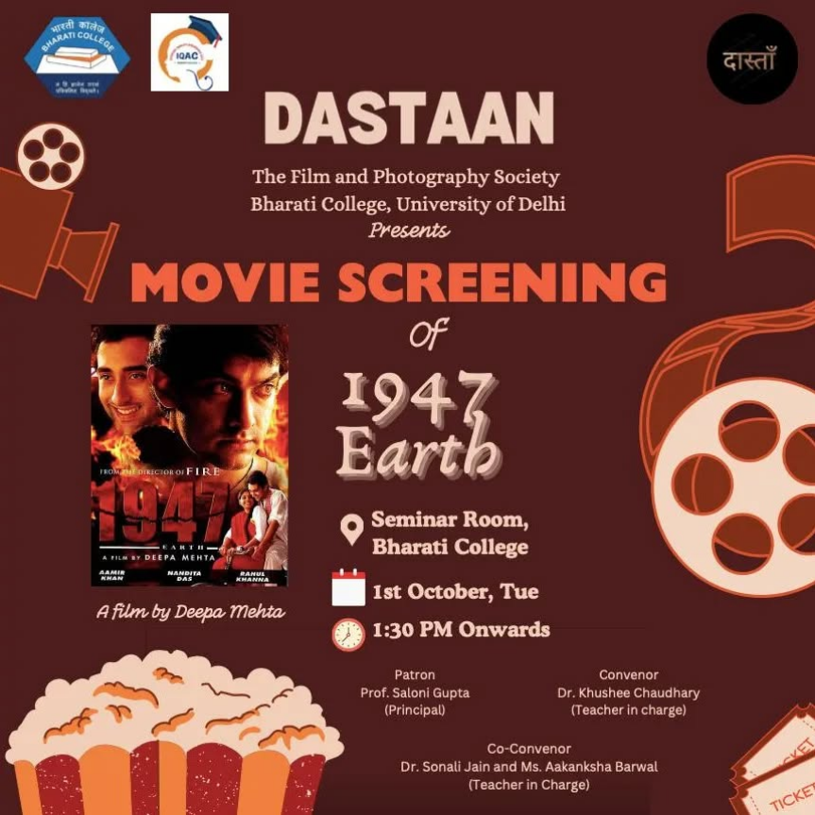
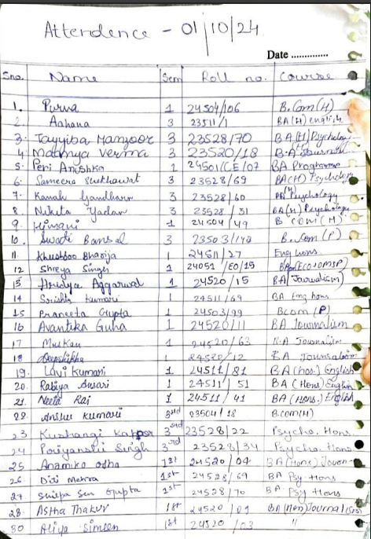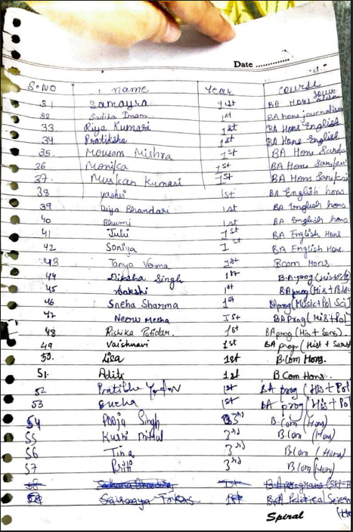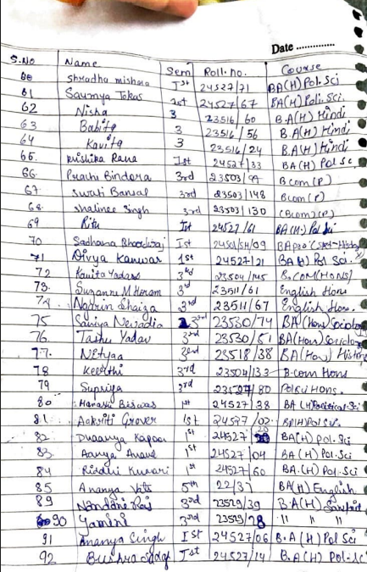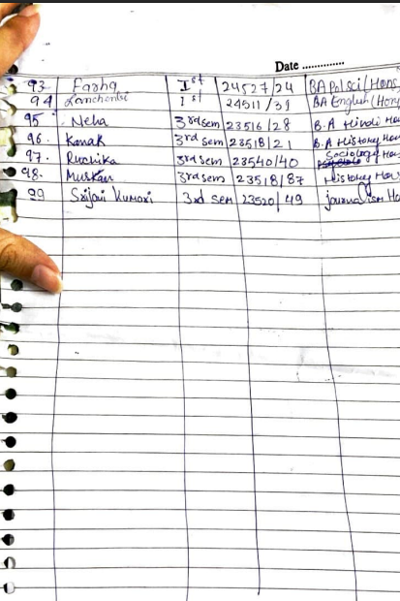

Short Film Competition- Akari at DDUC
COVERAGE REPORT – Akari: Short Filmmaking Competition
Date: March 6, 2025
Dastaan, the Film and Photography Society of Bharati College, proudly participated in Akari – The Short Filmmaking Competition organized by Polaroid, the Film and Photography Society of Deen Dayal Upadhyaya College. The event celebrated the art of visual storytelling, inviting participants across Delhi University to translate emotion, narrative, and imagination into short cinematic experiences.
As part of the competition, Dastaan presented their original short film Chidiya—a poignant and powerfully crafted narrative that subtly explores the journey of reclaiming one’s strength after being broken. Rooted in themes of resilience and emotional healing, Chidiya portrays a young woman’s quiet yet fierce fight to rise above the trauma inflicted upon her. Though the film delicately hints at difficult realities, it focuses on the courage it takes to stand again—to live, to rise, to fly.
With evocative visuals and minimal dialogue, Chidiya relied on expressive cinematography to convey emotion, supported by symbolic imagery and carefully composed frames. The backdrop and mood created a space for reflection, making the film not only a story but a feeling. It was an attempt to show that even in silence, voices can echo—and even in darkness, there is light.
Participating in Akari allowed Dastaan to share its vision with a wider audience, while also witnessing the diverse talent and creative energy from across the university. It was an inspiring and enriching experience that reaffirmed the society’s commitment to storytelling that speaks to the soul.
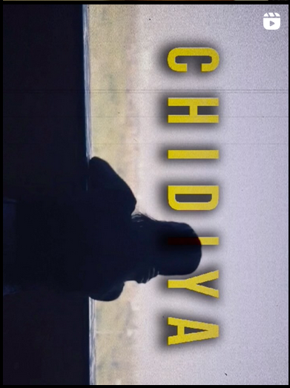

Attendance:

Name | Year | Course | Roll No.
Maanya | 2nd Year | B.A. Journalism (H) | 23520/18
Purva | 1st Year | Bcom Hons | 24504/106
Vidya | 3rd Year | English hons | 22/61
Prachi | 2nd Year | Bcom prog | 23503/97
Shalinee | 2nd Year | Bcom prog | 23503/130

Short Film Competition- Delhi School of Journalism
Coverage Report: The Last Patient
Date: November 19, 2024
Dastaan participated in the Annual Journalism Fest organised by the Delhi School of Journalism, where the short film The Last Patient was showcased before an audience that included several renowned directors and producers. Under the sub-theme Wellness Unscripted: The Journey of Health and Healing, The Last Patient delivers a haunting yet deeply human portrayal of therapy and emotional restoration. Set in 2047, the film imagines a future where mental health care has moved beyond traditional therapy into immersive virtual reality, allowing patients to confront their traumas within simulated worlds where healing is lived, not just spoken.
At the center of the narrative is a celebrated therapist known for guiding patients through the most complex mental landscapes. Yet, when a patient becomes trapped in a feedback loop within the simulation, the therapist's own subconscious memories begin to surface. As past fears and long-suppressed traumas bleed into the therapeutic space, the story unfolds into a powerful exploration of vulnerability, self-confrontation, and the silent battles often endured by caregivers themselves.
The film’s emotional climax reveals that the therapist must first heal their own wounds to save the patient, offering a poignant commentary on how personal histories shape professional lives. In an increasingly digital world, The Last Patient invites reflection on the enduring need for emotional presence, human connection, and inner courage. Visually striking and conceptually rich, the film positions mental health not as a fixed destination but as a continuous journey—one that begins with the willingness to face one’s own story.

Attendance:

Name | Year | Course | Roll No.
Maanya | 2nd Year | B.A. (H) Journalism | 23520/18
Purva | 1st Year | Bcom Hons | 24504/106
Vidya | 3rd Year | B.A (H) English | 22/61
Shreya | 1st Year | B.A Prog (ECO+ OMSP) | 24501/EO/15
Prachi | 2nd Year | Bcom prog | 23503/97
Niyati | 1st Year | B.A Prog | 24501/CE/13
Shalinee | 2nd Year | Bcom prog | 23503/130
Arhama | 3rd Year | B.A (H) English | 22/61

Photography Competition- Inside Out, Cathect
Coverage Report: Emotions in Motion
Date: 25th and 26th March, 2025
Dastaan, the Film and Photography Society of Bharati College, participated in Emotions in Motion, a thought-provoking photography competition organized as part of Inside Out, the annual fest hosted by Cathect – the Psychology Department of Bharati College, University of Delhi. The competition invited participants to explore the theme of human emotion through a visual and narrative lens, requiring a submission of three interconnected photographs accompanied by a written piece of 120–150 words, weaving a story of emotional evolution or expression.
Representing Dastaan, four talented members—Shreya Singh, Tara, Dhairya, and Praneshowari—submitted entries that highlighted the society’s signature blend of creativity, concept-driven imagery, and nuanced storytelling. Each frame captured subtle emotional transitions, focusing on the fluidity of feelings and the inner worlds that often remain unspoken. Their write-ups offered an introspective backdrop, guiding viewers through layered interpretations of the emotional journeys depicted.
Among the entries, Dhairya’s submission stood out, earning her the Second Position in the competition. His narrative conveyed an impactful arc of emotion, resonating with both the theme and the audience. The achievement not only reflects Dhairya’s individual excellence but also showcases Dastaan’s continued dedication to exploring the art of visual storytelling and pushing the boundaries of creative expression through film and photography.
With this recognition, Dastaan adds another feather to its cap, reaffirming its role as a platform for budding visual artists who aim to capture the world in its rawest, most heartfelt forms.

National Conference on Society and Sustainability for Vision Viksit Bharat @2047: Socio-Economic and Environmental Challenges in the North East Region of India
Coverage Report: One-Day National Seminar on “Society and Sustainability for Vision Viksit Bharat @2047: Addressing Socio-Economic and Environmental Challenges in the North East Region of India”
Date: 31st January 2025
Dastaan, the Film and Photography Society of Bharati College, proudly volunteered at the ICSSR-sponsored One-Day National Seminar on “Society and Sustainability for Vision Viksit Bharat @2047: Addressing Socio-Economic and Environmental Challenges in the North East Region of India” held on 31st January 2025.
Our talented photography team was tasked with capturing the key moments of this significant event. The seminar featured notable dignitaries like Dr. Jagdish Mukhi, former Governor of Assam, Nagaland, and Mizoram, as well as Dr. Prasanna Kumar Pathak, Dean of Assam Agricultural University. The team from Dastaan meticulously documented the speakers' addresses, panel discussions, and the enriching interactions that unfolded throughout the day.
In addition to the photography coverage, our volunteers worked to ensure the seamless execution of the event. Their efforts contributed greatly to the success of the seminar, and the photographs captured provide a lasting visual record of this impactful event.
Dastaan continues to value such platforms where creative expression meets academic excellence, and we look forward to more chances to engage, document, and contribute in meaningful ways.

Attendance:

Name | Year | Course | Roll No.
Vidya | 3rd Year | B.A. (H) English | 22/61
Kushangi | 2nd Year | B.A (H) Psychology | 23528/22
Anshu | 2nd Year | English hons | 23504/ 18
Prachi | 2nd Year | Bcom prog | 23503/97
Shalinee | 2nd Year | Bcom prog | 23503/130

Photo Story Competition – Tasveeron Ki Kitaab
COVERAGE REPORT – Photo Story Competition
Date: April 3, 2025
Dastaan, the Film and Photography Society of Bharati College, proudly participated in Tasveeron Ki Kitaab, a photostory competition organized by Chitrika, the Photography and Film Society of Lady Irwin College. The competition offered an evocative and creative challenge—telling a story entirely through visuals, without relying on words or dialogue. It encouraged participants to let each frame become a chapter, allowing viewers to experience a tale shaped entirely by moments, emotions, and visual depth.
For this unique opportunity, Dastaan crafted a thoughtful and emotionally resonant series that reflected the unspoken narratives carried by hands. The story began with “Bridging Time,” where the image of a young hand tightly holding an elderly one symbolized the enduring connections between generations. This opening frame set the tone for a story of memory, love, and inevitable partings. It was followed by “Tracing Memories,” capturing an elderly woman delicately touching a faded photograph—her fingers tracing faces from the past, frozen in time yet living vividly in her memory. This frame represented remembrance and the longing to preserve fragments of life that quietly slipped away.
The series continued with “Slipping Away,” an image of two clasped hands slowly releasing their grip, representing a wordless goodbye. It captured the ache of letting go, of releasing something dearly held. The final frame, “Holding It Together,” portrayed a mother gently braiding her daughter’s hair, a gesture brimming with silent care, security, and routine love. This moment grounded the story in the comfort of everyday tenderness and the continuity of care across time.
The submission reflected Dastaan’s belief in photography’s ability to go beyond aesthetic appeal and serve as a mirror to our shared human experience. It emphasized how the quiet gestures, the fleeting touches, and the physical imprints of memory can hold entire stories within them.
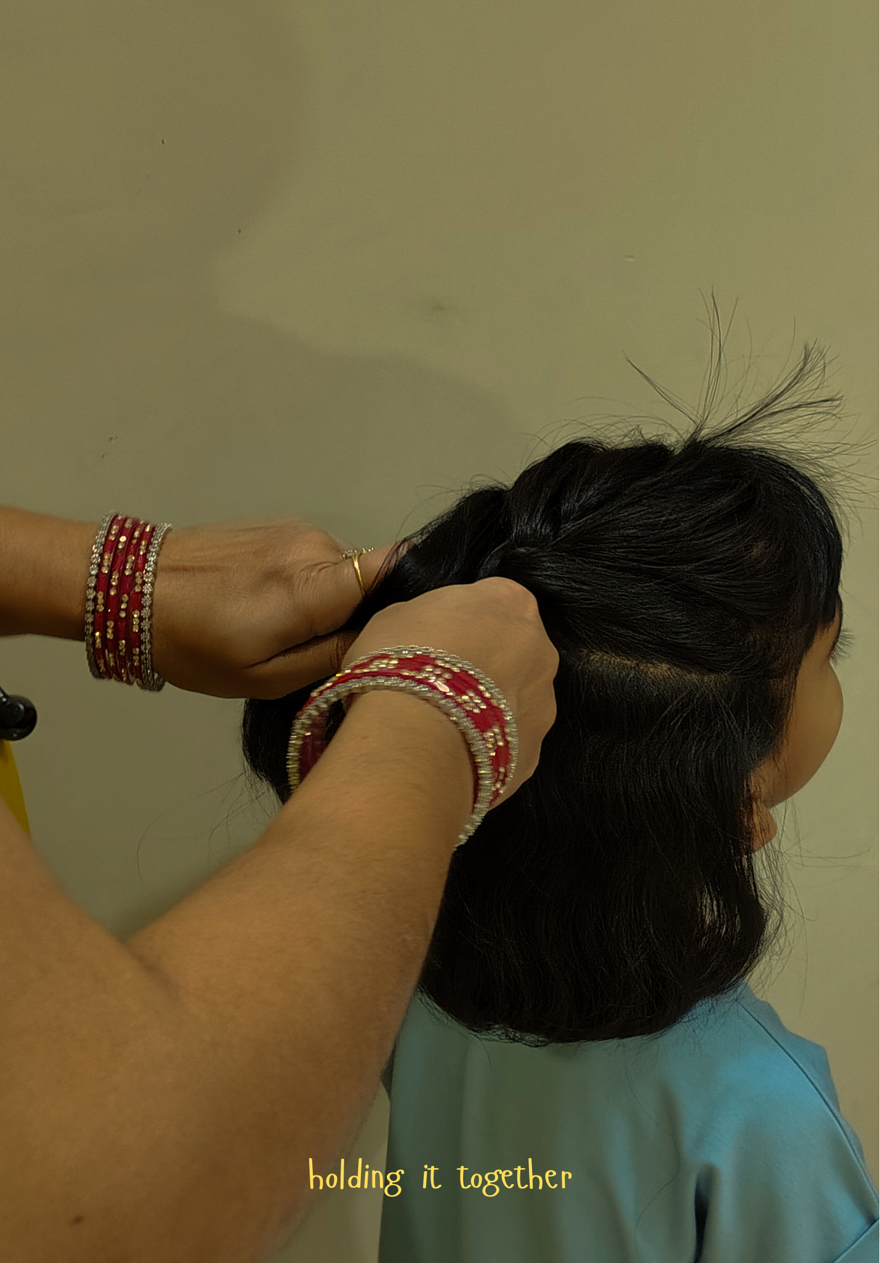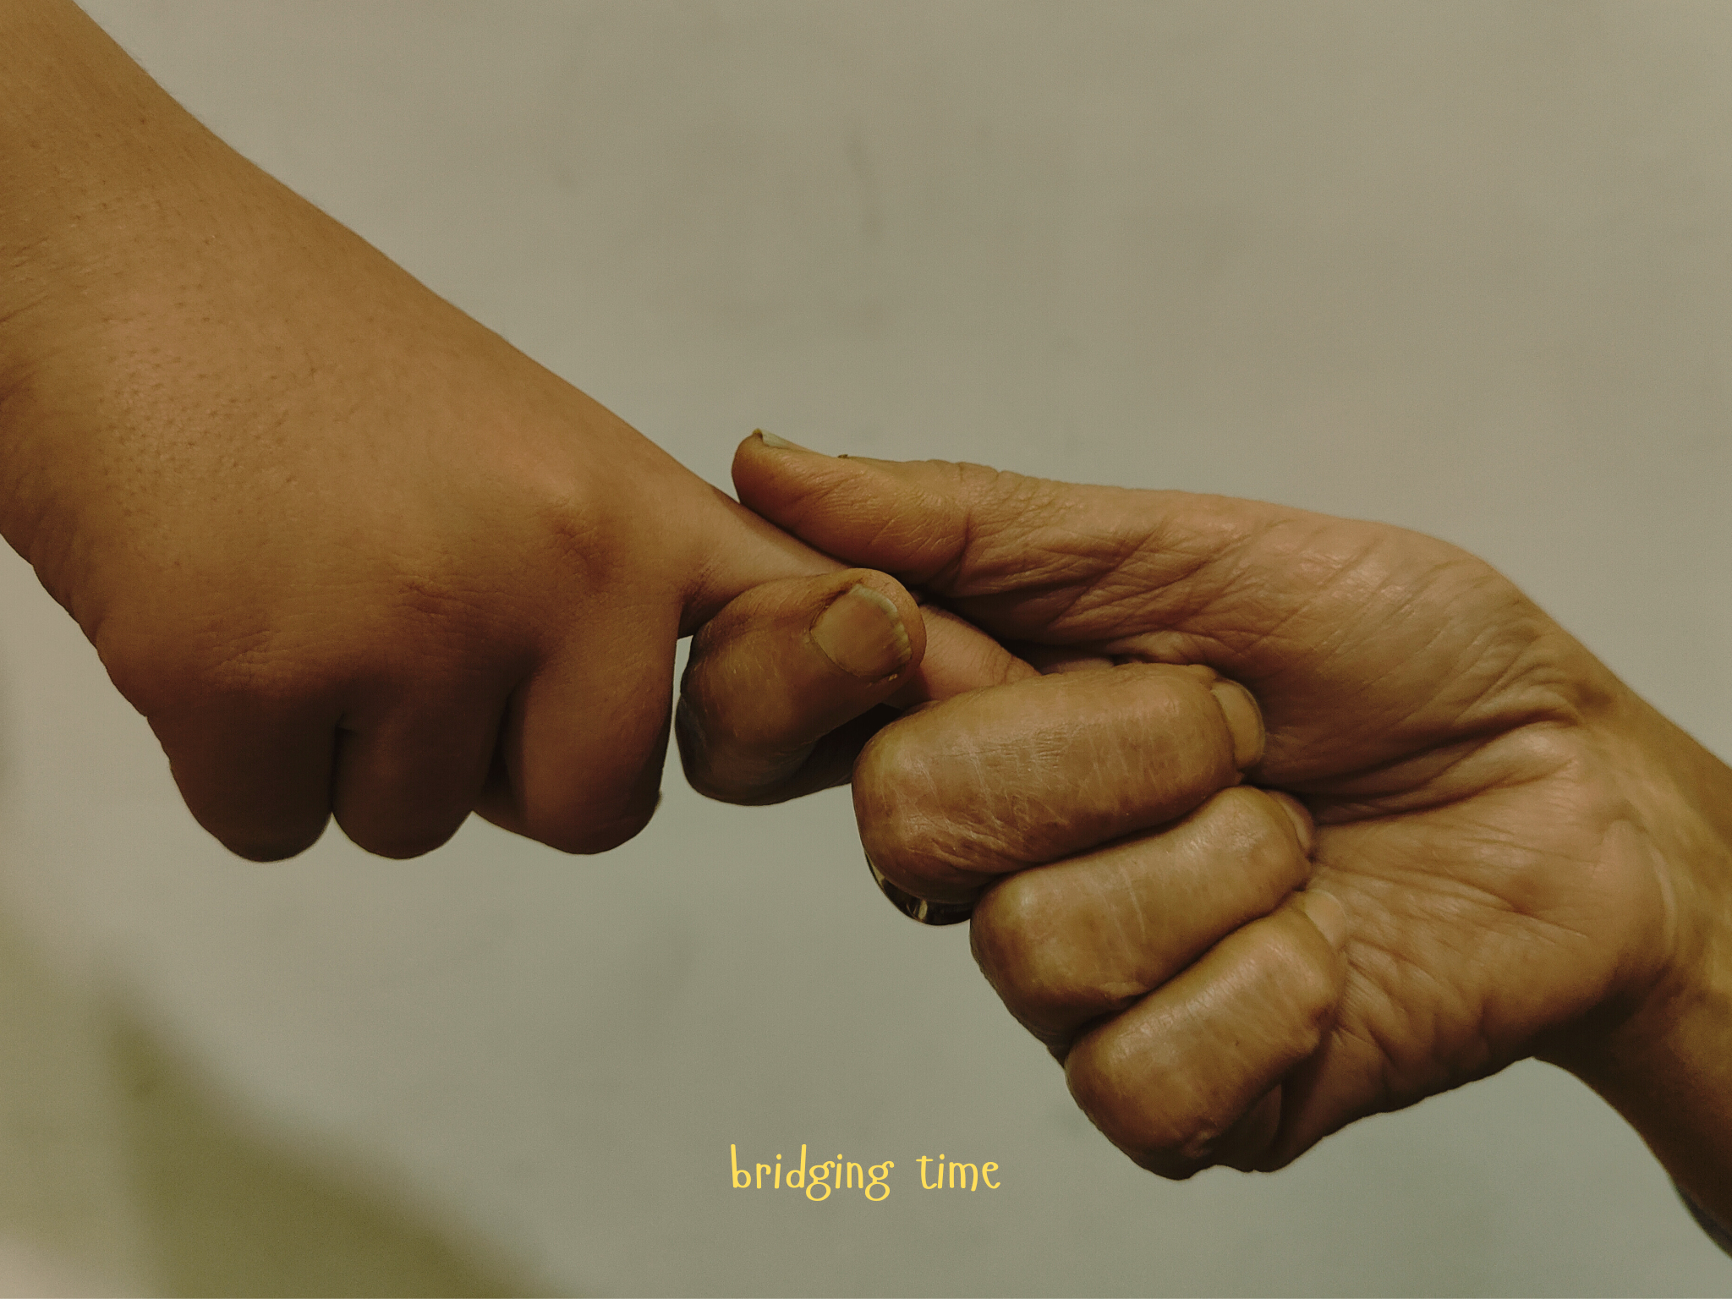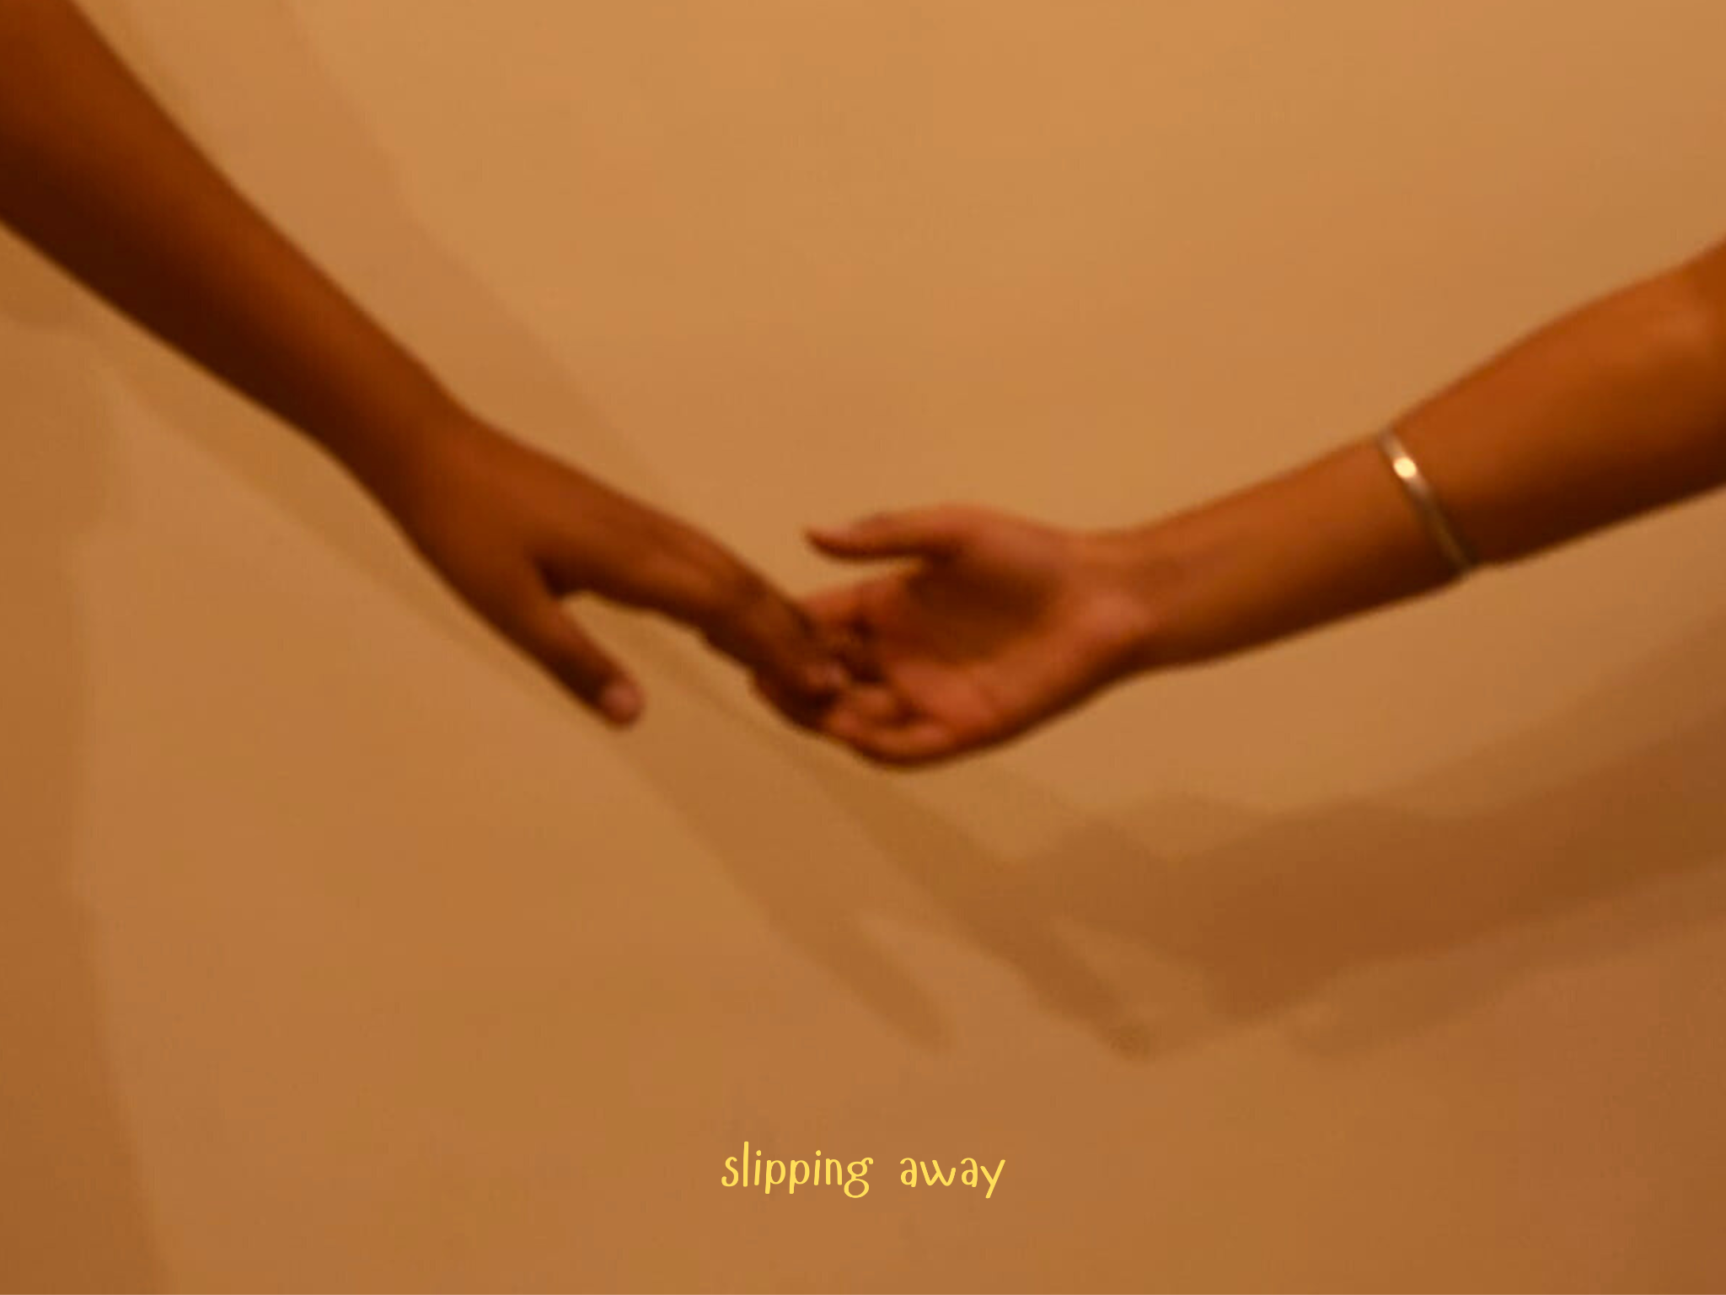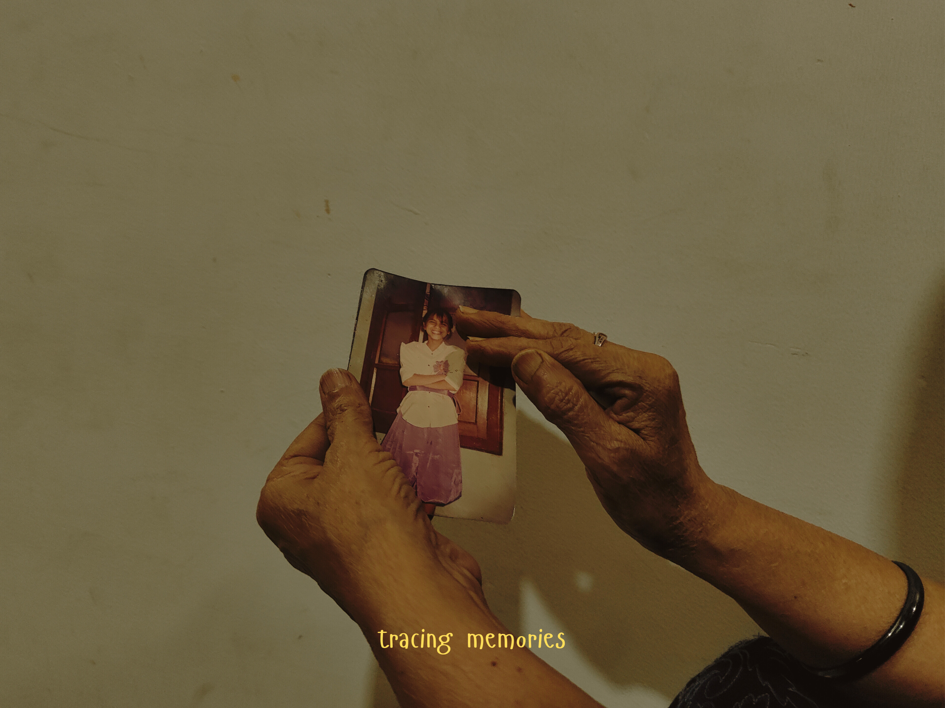

Holi Shoot
COVERAGE REPORT – Dastaan’s Holi Shoot
Date: March 24–25, 2025
Dastaan, the Film and Photography Society of Bharati College, celebrated the festival of colours with a vibrant Holi-themed shoot, inviting its members to capture the spirit of both Chhoti Holi and Badi Holi. Holi, one of India’s most cherished festivals, marks the triumph of good over evil and the arrival of spring, bringing people together through colours, laughter, and shared joy. It begins with Chhoti Holi—a symbolic Holika Dahan signifying the burning away of negativity—and culminates in Badi Holi, when streets fill with vibrant hues, music, and cheerful celebration.
Dastaan encouraged its members to document these two days through their unique visual perspectives. On Chhoti Holi, members captured the ceremonial fires, warm glows, and quiet moments of community reflection. Frames were filled with flickering flames, silhouettes gathered around the pyre, and the intimate rituals performed under the night sky.
The next day, Badi Holi brought a burst of energy. Members dove into the colorful chaos, photographing joyful faces smeared with gulaal, hands mid-throw tossing colours into the air, and the raw energy of Holi in full bloom. Water balloons, powdered colours, and candid laughter became the palette for every frame.
This Holi shoot wasn’t just a celebration—it was an artistic journey into capturing emotion, motion, and tradition. Dastaan's photographers documented the spectrum of Holi in all its vibrancy and subtlety, creating a collection that was as festive as it was visually striking. Through this activity, members further honed their storytelling skills, using their lenses to freeze the fleeting, colourful moments of togetherness and tradition.

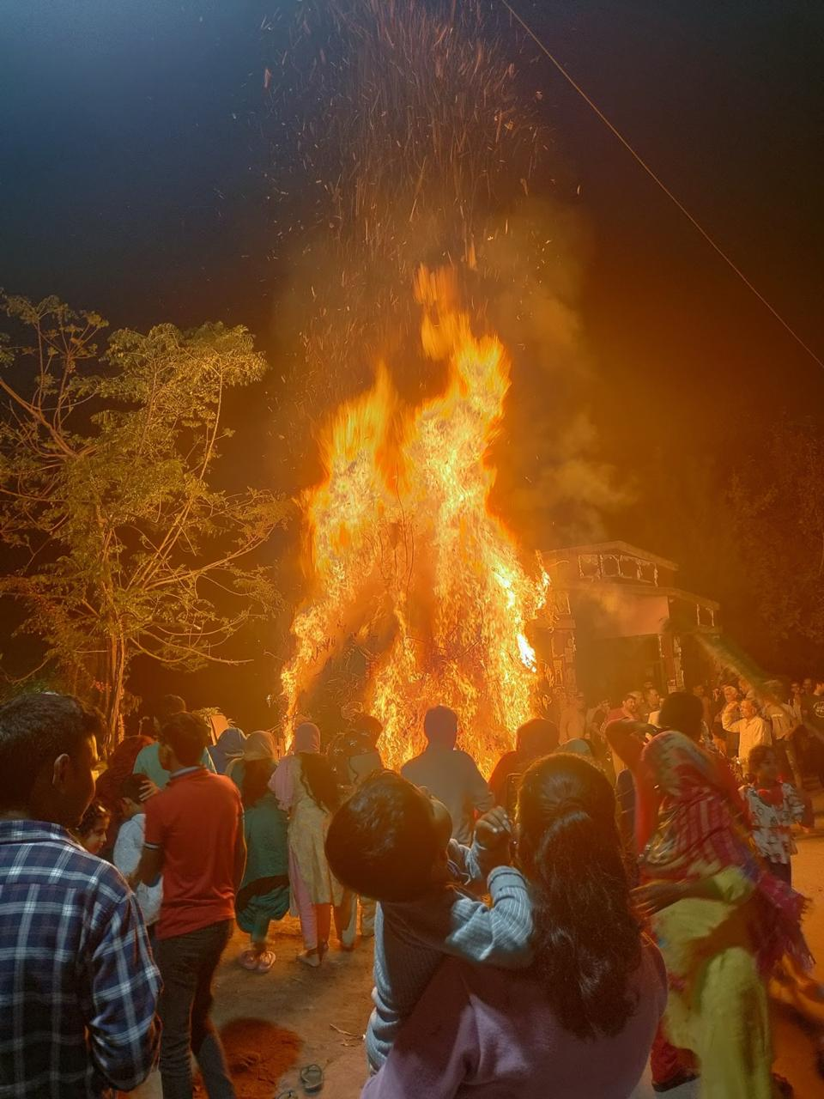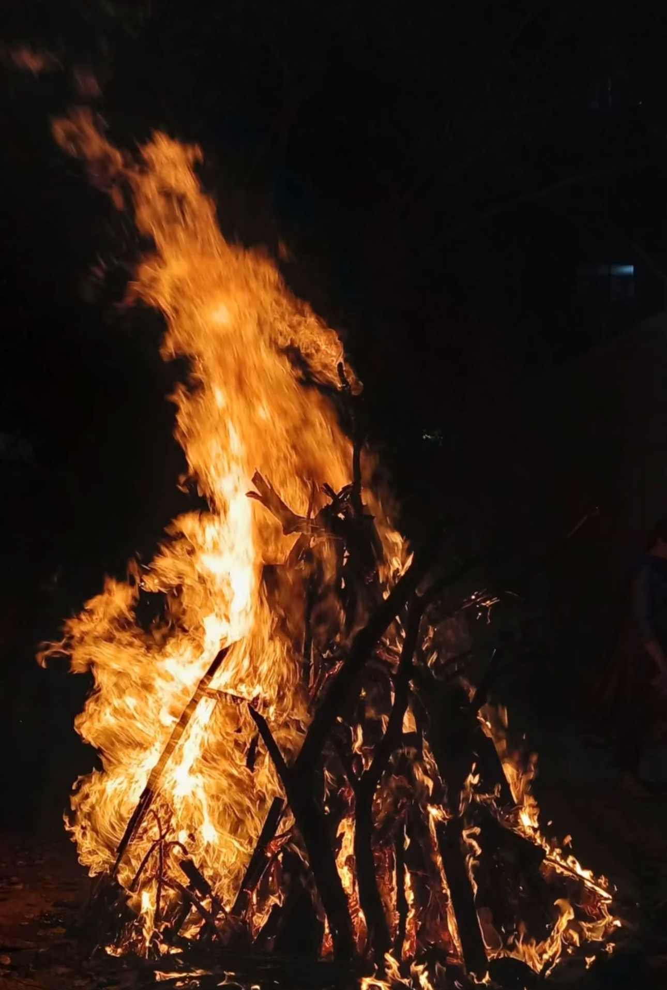

Movie Recommendation- Delhi 6
COVERAGE REPORT – Dastaan's Delhi 6 Film Recommendation
Date: March 2025
Dastaan, the Film and Photography Society of Bharati College, released a heartfelt recommendation video for Delhi 6, a film that captures the soul of Old Delhi—its people, its contradictions, and its spirit. The video titled Dilli, Dilwalon Ki began with a poetic ode:
"Itihas ke pannon mei hai Dilli, suron ke saaz mei hai Dilli, bhaa jaye dil ko vo ehsaas hai Dilli."
Through thoughtful visuals and narration, the team brought alive the essence of Delhi 6, inviting viewers to look beyond the chaos and embrace the beauty of coexistence in the heart of the capital.
Delhi 6, directed by Rakeysh Omprakash Mehra and produced by Mehra along with Ronnie Screwvala, is a story woven through the alleys of Old Delhi. It follows Roshan, an NRI who returns with his ailing grandmother to her homeland and slowly discovers the complexities and deep-seated issues within the close-knit community. With music by A.R. Rahman and a backdrop of the symbolic "Kala Bandar" that haunts the city, the film highlights themes of identity, superstition, and communal harmony.
Interestingly, while the film celebrates the charm of Chandni Chowk and Old Delhi, these locations were recreated in Sambhar, a small town in Rajasthan, where entire sets were built to resemble the authentic streets of Delhi 6.
Dastaan's recommendation offered a fresh perspective on this cinematic gem, encouraging viewers to not just watch the film—but feel it, understand it, and reflect on the spirit of Delhi that it so beautifully captures.
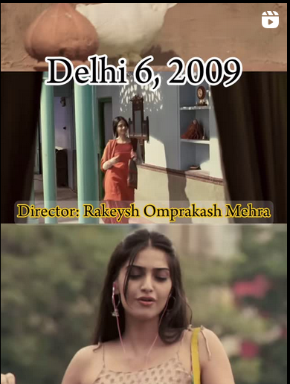

Photo Submission Drive
COVERAGE REPORT – Dastaan's Photo Submission Drive
Date: April 2025
Dastaan, the Film and Photography Society of Bharati College, recently initiated a creative call for entries, inviting its members to submit photographs that spoke not just to the eye, but to the soul. With an open theme centered around beauty and stillness in motion, members responded with breathtaking frames and poetic captions that merged visual storytelling with lyrical depth.
Among the standout submissions was a serene image of a dog perched on a cliff, its golden fur glowing in the soft hues of twilight. Accompanied by the caption, "Golden fur in soft fleeting light, / Beholding where the sky greets tonight. / Soft zephyrs in velvety melodies weave, / Dreams that meander, never leave," the photo encapsulated a tender moment of calm observation, a creature lost in the horizon’s embrace.
Another entry explored the nocturnal chaos of city life. Taken in the heart of an LED-lit street, the photograph pulsed with energy and intrigue, with the line, "In the absence of the moon’s embrace, / the night unravels the million faces / all lost inside the city’s flame." It beautifully captured the dichotomy of solitude and vibrancy that urban nights so often bring.
A moment of quietude was frozen in a photo of a lone pigeon against a dreamy backdrop. Its accompanying words, "A moment of hush, the world stays still, / clouds drift slow, rivers gleam, / the soul just listens, free and full," painted a meditative pause, urging the viewer to breathe with nature’s rhythm.
Lastly, a photograph of a winding path shaded by lush green bamboo stood out for its rich textures and a caption that whispered serenity: "Stone path, hushed and lone, / bamboos hum a lullaby, / time drifts like a breeze." This image transported the viewer into a green cocoon of solitude and wandering thoughts.
The submission drive turned out to be more than a photography activity—it became a canvas for Dastaan’s members to reflect, express, and imagine. It brought forward the diverse perspectives of visual poets and storytellers, celebrating the quiet magic hidden in everyday scenes.
