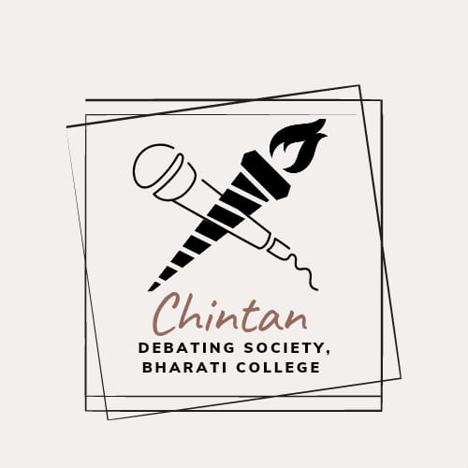
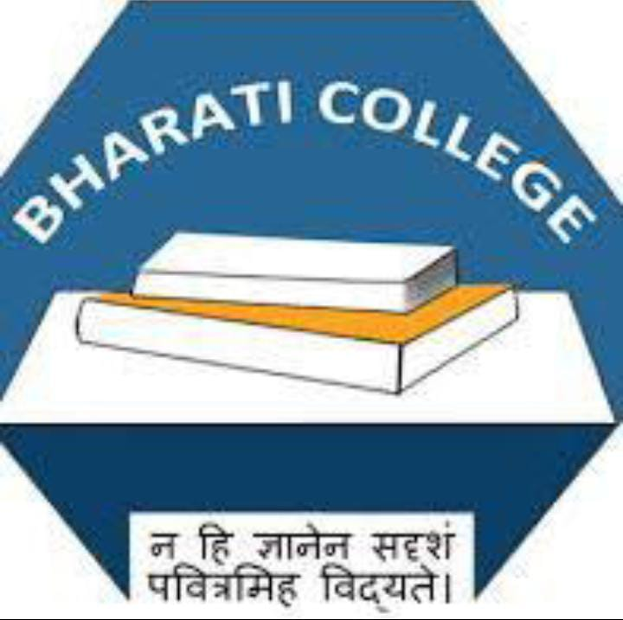

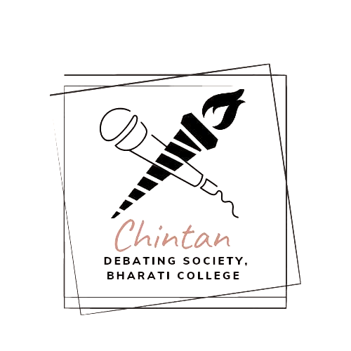

Chintan Annual Report
2024-25

CHINTAN - THE DEBATING SOCIETY
BHARATI COLLEGE
UNIVERSITY OF DELHI

ANNUAL REPORT 2024-25
“It is not the victory but the excellence of the debate that defines true success.”
— Anonymous

Chintan- The Debating Society of Bharati College, stands at the forefront of fostering intellectual inquiry, critical reasoning, and articulate advocacy among the student body. Throughout the academic year, Chintan has upheld its legacy of excellence by organising a series of intellectually rigorous events that transcended conventional discourse, offering platforms for profound engagement with contemporary and enduring issues.
In collaboration with prestigious academic and cultural organisations, Chintan has expanded its horizons, further establishing its prominence within and beyond the college community. Through structured debates, comprehensive workshops, and specialised training sessions, the society has consistently nurtured analytical skills, public speaking proficiency, and a spirit of constructive dialogue among its members.
Chintan’s distinguished presence at intercollegiate and national-level competitions has not only garnered accolades but has also contributed significantly to enhancing the academic prestige of Bharati College. Our members' consistent achievements stand as a testament to the society’s commitment to excellence and intellectual growth.
As we reflect on a year of remarkable accomplishments, we extend our deepest appreciation to our dedicated members, mentors, and collaborators. Looking ahead, Chintan remains resolute in its vision: to cultivate discerning thinkers, articulate leaders, and responsible global citizens, thereby continuing to enrich the academic and cultural fabric of Bharati College.
EVENTS FOR THE ACADEMIC YEAR 2024-25

- Webinar on the Art of Public Speaking
Date: August 22, 2024
Speaker: Akansha Thakral
As part of its commitment to fostering oratory and critical thinking skills, Chintan, the Debating Society of Bharati College, organised a webinar titled “The Art of Public Speaking”, conducted by Ms. Akanksha Thakral. Founder of Mantrana Debating Society at Kalindi College and Nextage Skillsetters Pvt Ltd, Ms. Thakral brings over 15 years of expertise in public speaking, leadership, and personal development.
The session addressed dismantling language barriers, structuring arguments, and achieving a balance between content and presentation. Ms. Thakral provided actionable techniques to enhance public speaking across diverse settings. Emphasising authenticity and the strategic use of personal strengths, the webinar provided participants with practical tools to enhance their public speaking skills. Active engagement from attendees reflected the session’s success in building confidence and fostering effective communication.

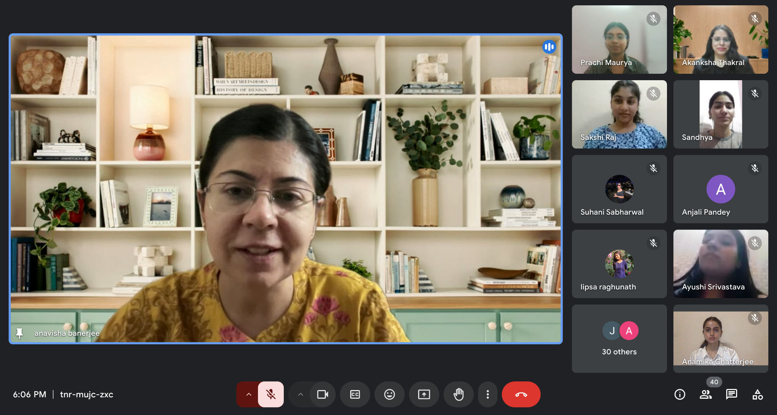
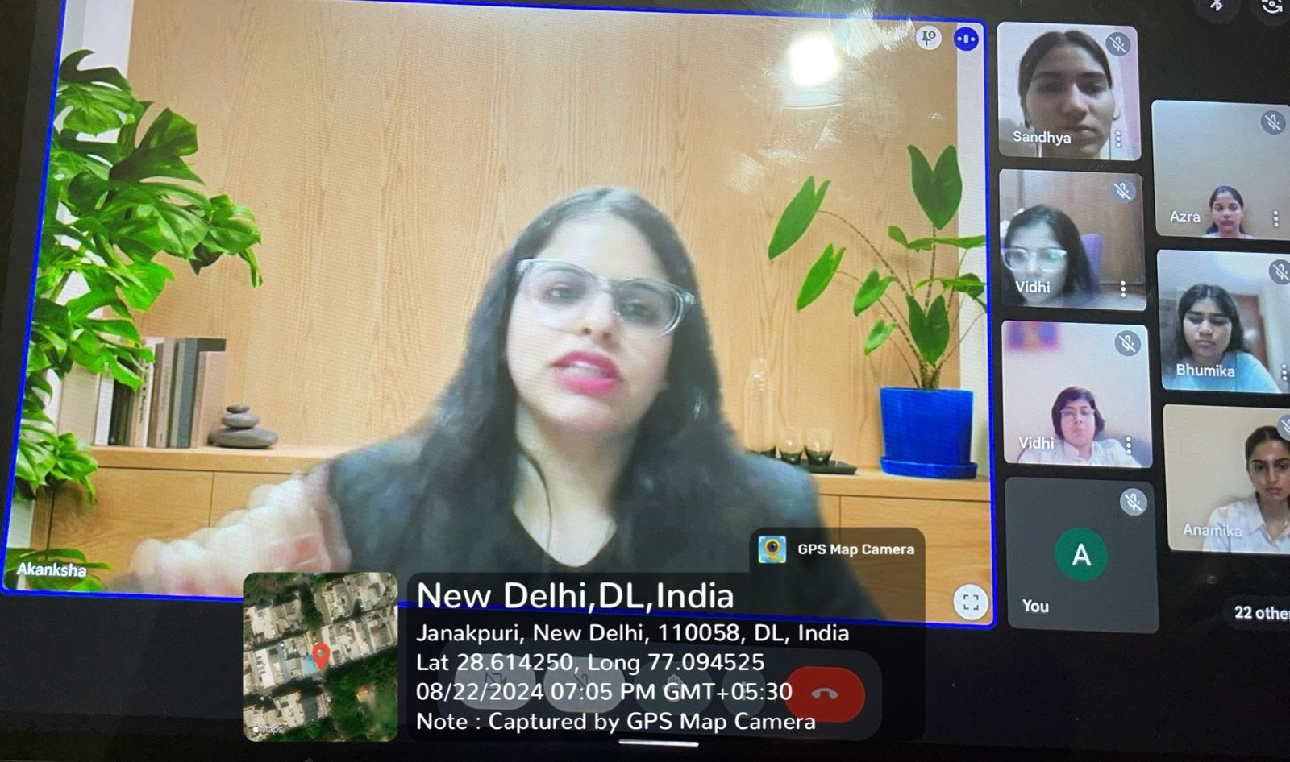

- Freshers' Cultural Societies Orientation
Event: Annual Freshman Society Orientation
Date: September 3, 2024
On September 3, 2024, Chintan- The Debating Society of Bharati College, participated in the college’s orientation programme for first-year students, introducing them to the society’s vision and activities. The session commenced with a welcome address by the Convener, Dr. Anavisha Banerjee, who highlighted Chintan’s evolution into a vibrant platform for students passionate about debate and public speaking.
General Secretary Anamika Chatterjee provided an overview of the society’s initiatives, emphasising its role in fostering critical thinking, leadership, and professional development. The contributions of Working President Prachi Maurya and Vice President Anjali Pandey were also acknowledged for their pivotal roles in guiding and strengthening the society. The orientation concluded with an invitation for freshers to join Chintan’s dynamic community dedicated to articulate expression and intellectual engagement.
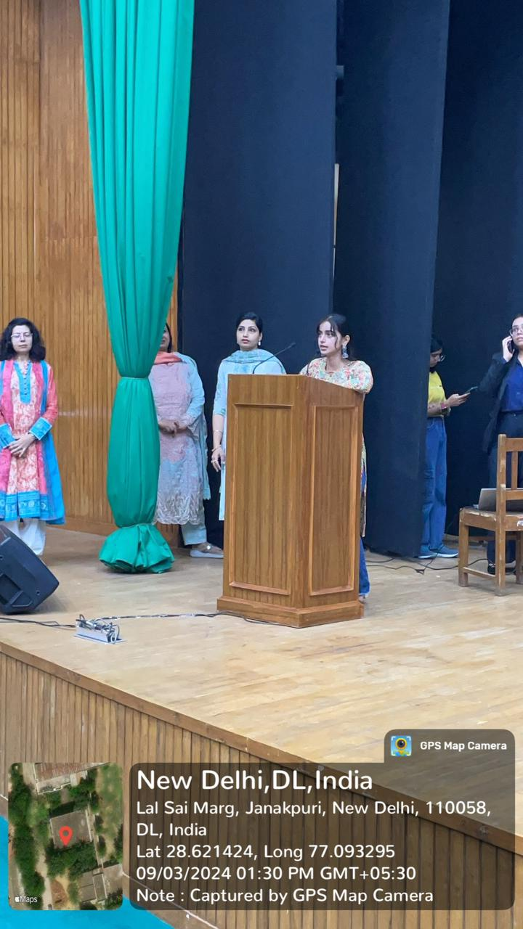
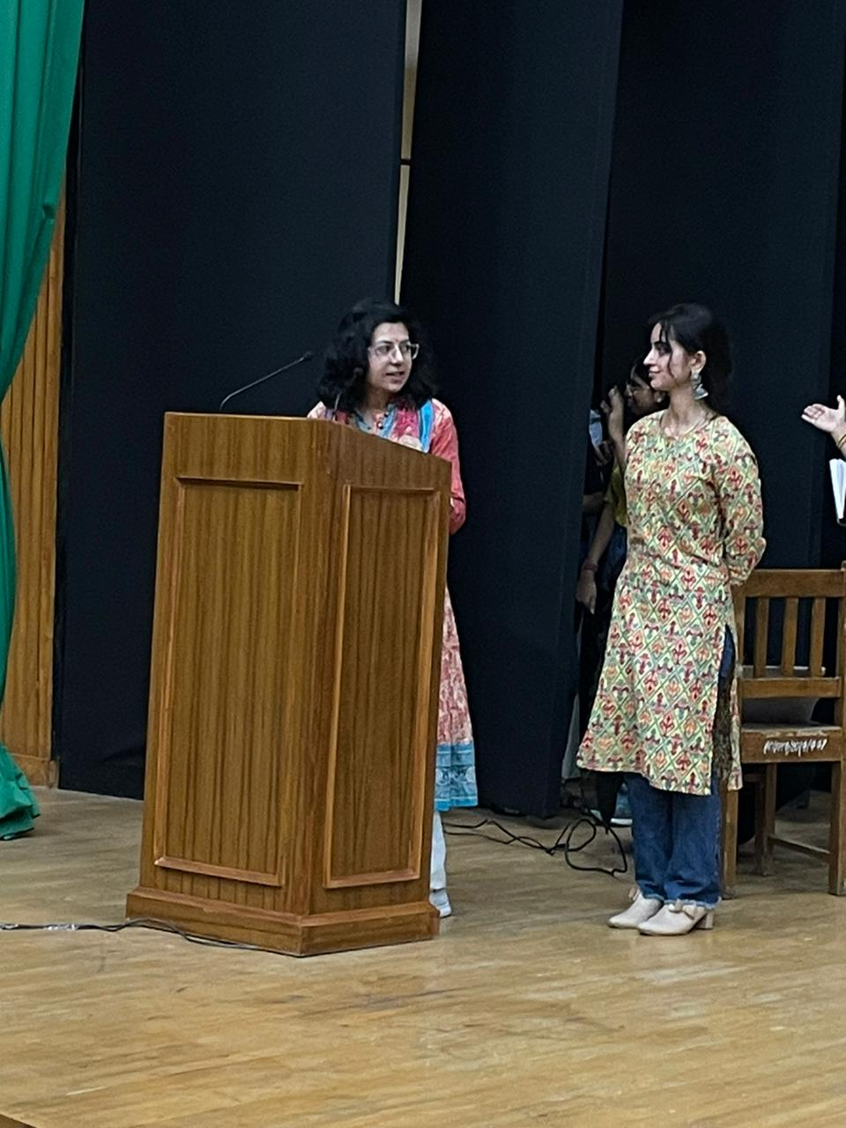

- Chintan Auditions
Event: Annual Auditions
Date: 24th September 2024
Chintan- The Debating Society of Bharati College, University of Delhi, conducted its auditions for the academic year 2024–25, welcoming a new cohort of aspiring debaters. The session commenced with an address by Sakshi, Public Relations Head, who introduced the society’s vision and the structure of the auditions. She emphasised the significance of debate in shaping critical thought and leadership, setting a formal tone for the proceedings.
Participants engaged with the topic, "What approach strengthens the nation's sovereignty: Globalisation or Nationalism?", offering diverse and insightful perspectives. The audition panel, comprising President Prachi Maurya, Vice President Anjali Pandey, General Secretary Anamika Chatterjee, and Joint Secretary Jansi, evaluated candidates on eloquence, analytical depth, and persuasive ability. The auditions witnessed a display of exceptional talent, making the selection process both rigorous and competitive.
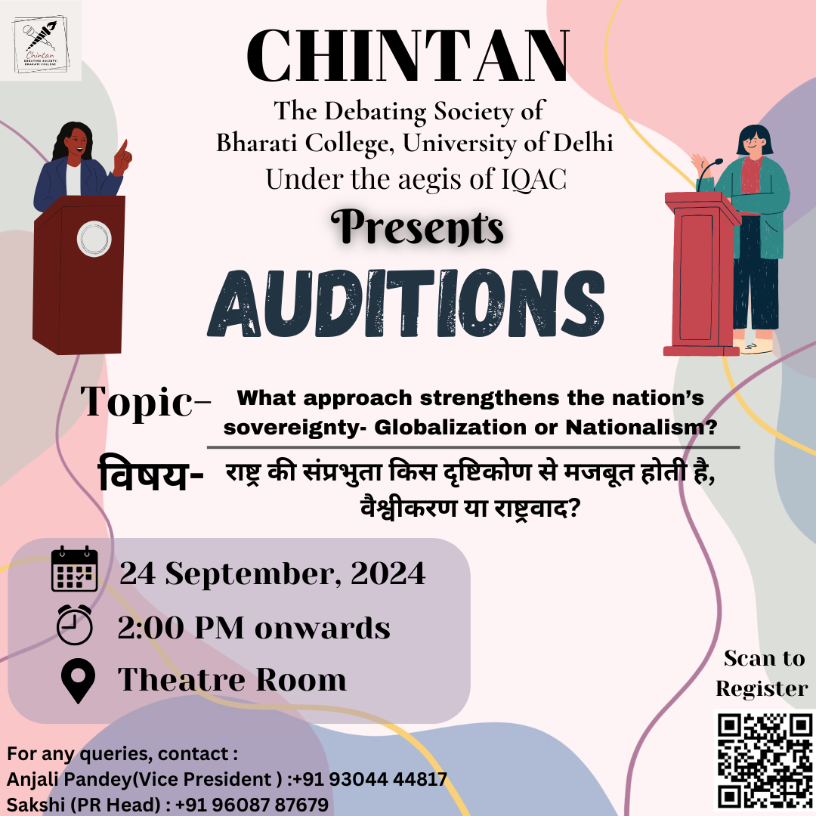
Concluding the session, the President addressed all participants with words of encouragement and gratitude, commending their effort and enthusiasm. The final selection of candidates reflected Chintan’s commitment to upholding excellence in debate and fostering a vibrant intellectual community for the upcoming academic year.
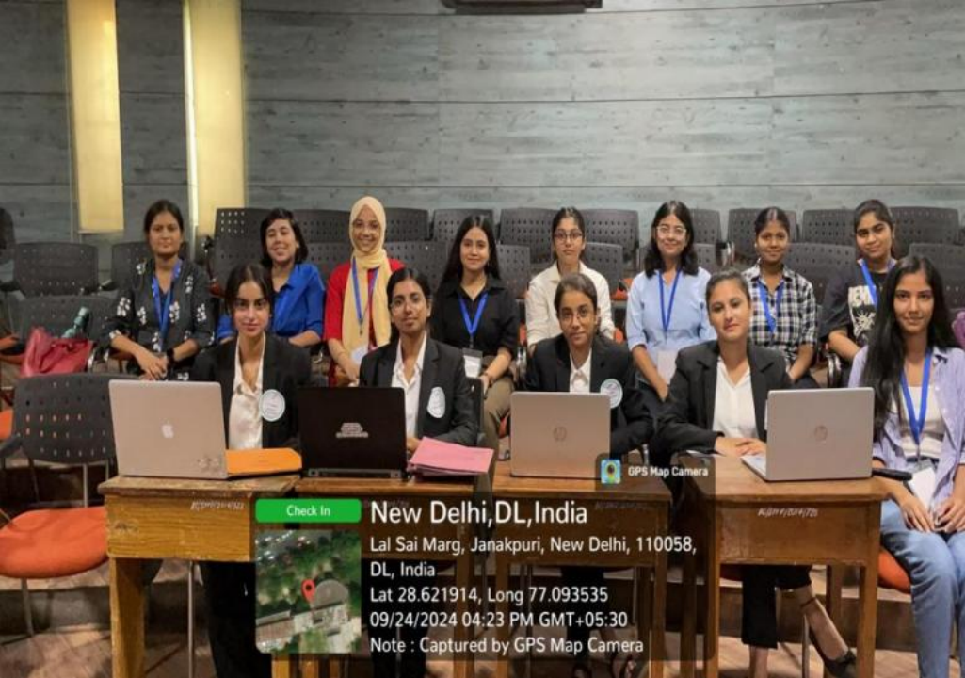

- Investiture-cum-Orientation Ceremony
Event: Induction of New Members and Core Team
Date: 30th September, 2024
Chintan- The Debating Society of Bharati College, hosted its annual orientation-cum-investiture ceremony to welcome new members and formally induct the incoming core team for the academic session 2024–25. The event, anchored by senior executive Azra, commenced with a reflection on Chintan’s distinguished legacy spanning over twelve years. The Convener, Dr. Anavisha Banerjee, was honoured with a token of appreciation, followed by an address that emphasised the society’s commitment to nurturing intellectual discourse. Rekha Ma'am further inspired the gathering with her words of encouragement, reinforcing the values of community and collaboration.
A formal badge ceremony was conducted, wherein each core team member outlined their vision for Chintan’s future. President Prachi Maurya delivered an inspiring address that emphasised unity, gratitude, and leadership through dialogue. Core members shared their responsibilities, while senior and super-senior executives reflected on their journeys within the society, fostering a culture of mentorship and open communication.
The orientation concluded with introductions from the new members, who articulated their motivations for joining Chintan. The session culminated in vibrant interactions, reaffirming the society’s commitment to cultivating rhetorical excellence, critical inquiry, and an inclusive community spirit.
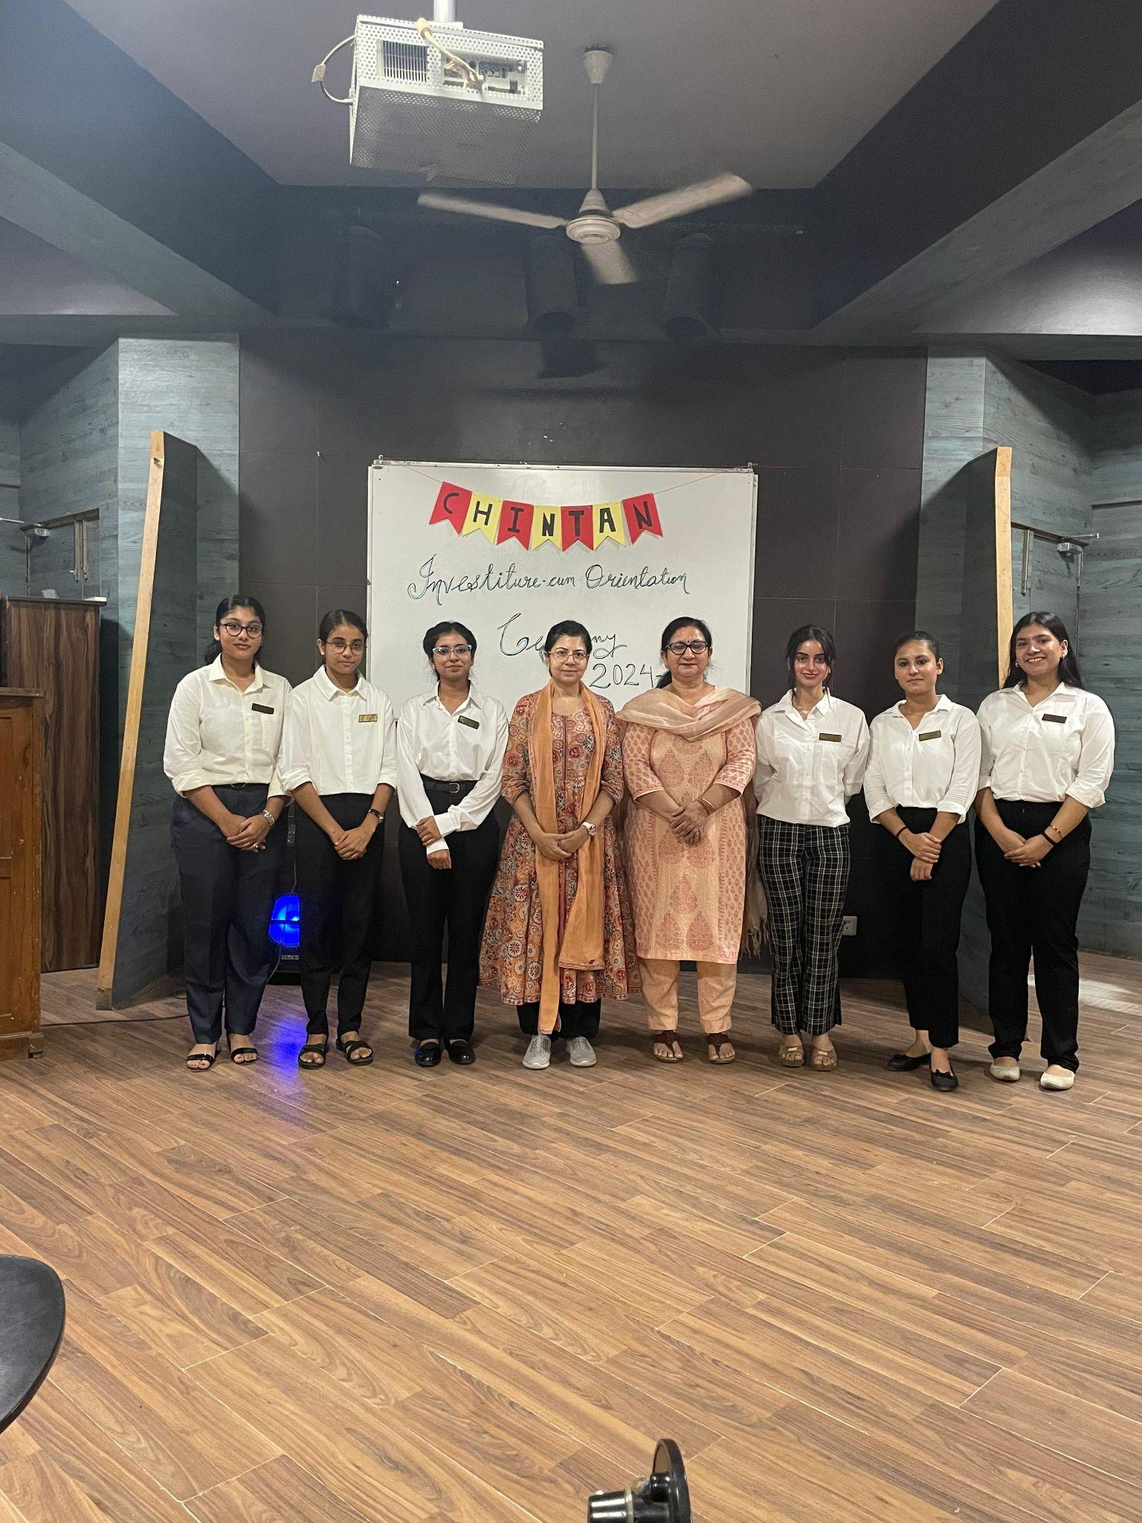
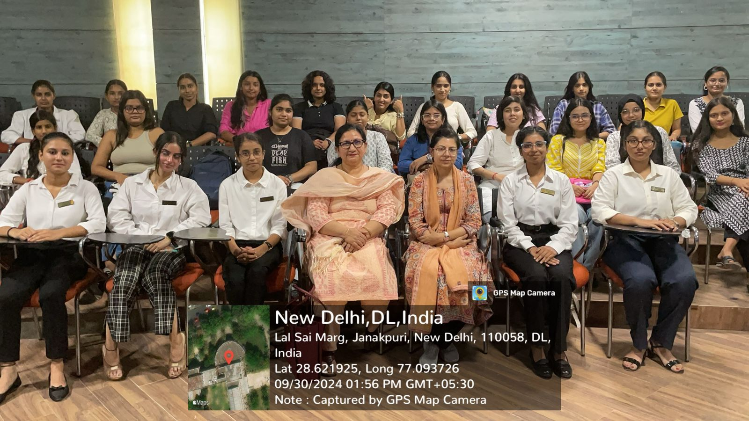

- Turncoat Debate and MUN Training Session
Date: 20th October, 2024
Purpose: Skill Development in Debate and MUN Procedures
Chintan, the Debating Society of Bharati College, organised a comprehensive training session focused on turncoat debate and Model United Nations (MUN) to strengthen members’ rhetorical and diplomatic competencies. The session was led by Vice President Anjali Pandey and General Secretary Anamika Chatterjee, following an opening address by President Prachi Maurya that emphasised the importance of structured discourse and global awareness. Participants were introduced to the fundamental principles of turncoat debate and MUN, including procedural rules, formal codes of conduct, and ethical frameworks.
Fostering an interactive environment, Anjali and Anamika encouraged active participation through discussions and queries, ensuring conceptual clarity. A supporting PowerPoint presentation facilitated deeper understanding, providing a visual guide to complex debate and MUN protocols.
The session concluded with members expressing heightened confidence in their ability to navigate future debating and MUN platforms. This initiative reaffirmed Chintan’s ongoing commitment to nurturing articulate, informed, and globally conscious student leaders within Bharati College.
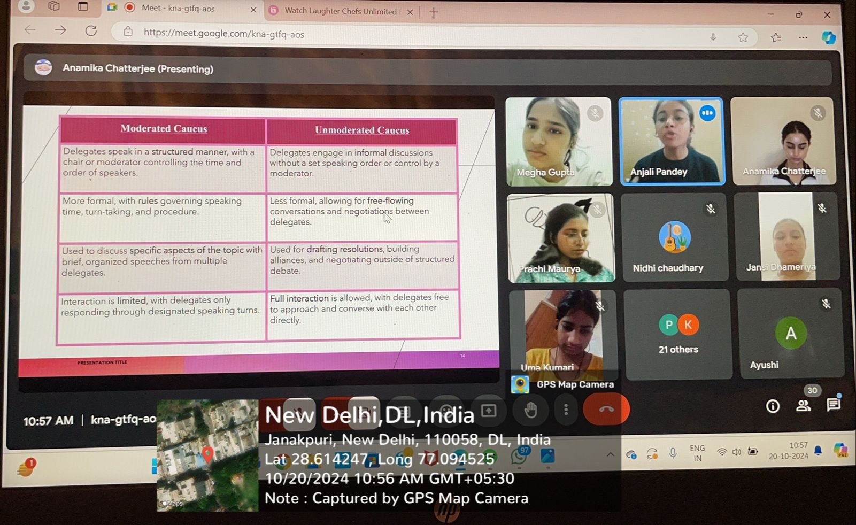
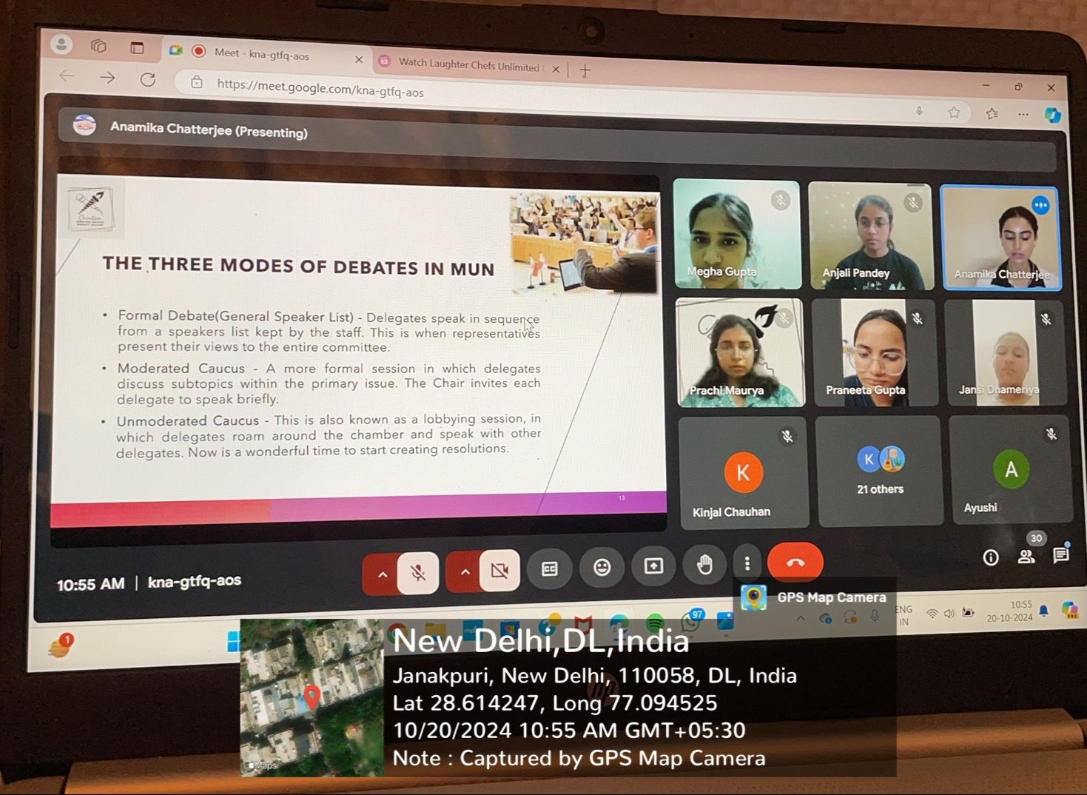
- Turncoat Debate Competition
Date: 22nd October, 2024
Purpose: Skill Development and Intellectual Engagement
Chintan- The Debating Society of Bharati College, in collaboration with the Redstockings Literary Society (RLS), organised a Turncoat Debate Competition on 22nd October 2024. This collaborative initiative reflected the commitment of both societies to fostering intellectual engagement, critical thinking, and articulate expression among students. The competition was organised under the broader vision of "Viksit Bharat 2047," envisioning a progressive, sustainable, and intellectually empowered India. Through the fusion of debate and literary analysis, the event promoted a multidisciplinary approach to discourse, essential for holistic academic development.
The competition centred on the timely and complex theme, “Is perpetual economic growth compatible with environmental sustainability?” Participants were challenged to engage dynamically, switching between opposing viewpoints and showcasing their analytical depth, spontaneity, and adaptability—skills vital for navigating contemporary global challenges. The session was inaugurated by Anamika Chatterjee, General Secretary of Chintan, and Monishka Rao, Treasurer of RLS, who introduced the objectives of the event and welcomed the distinguished panel of judges: Dr. Eti Sharma and Ms. Lalita Ratnoo, both esteemed faculty members recognised for their contributions to academic research and student mentorship.
Guided by the continuous support and supervision of Dr. Anavisha Banerjee, Convener of both societies, the competition witnessed a vibrant exchange of ideas. Participants demonstrated remarkable rhetorical agility and persuasive abilities, effectively balancing structured reasoning with emotive appeal. The interactive format allowed for spontaneous interjections and audience engagement, further enriching the intellectual atmosphere of the competition.
The event concluded on a celebratory note, recognising outstanding performances that exemplified the spirit of critical debate and informed discussion. Senior Executive Anshika Jha secured the first position, Super Senior Executive Vidhi Pathak attained the second, and Executive Members Tanisha Chopra and Kanishka shared the third place. Their success highlighted the society’s continuous efforts in cultivating public speaking excellence and critical analysis among students.
This collaborative competition reaffirmed Chintan's commitment to nurturing a thoughtful, articulate, and socially conscious debating community at Bharati College. By encouraging students to critically engage with issues of national and global significance, Chintan continues to contribute meaningfully to the academic and intellectual growth envisioned under Viksit Bharat 2047.
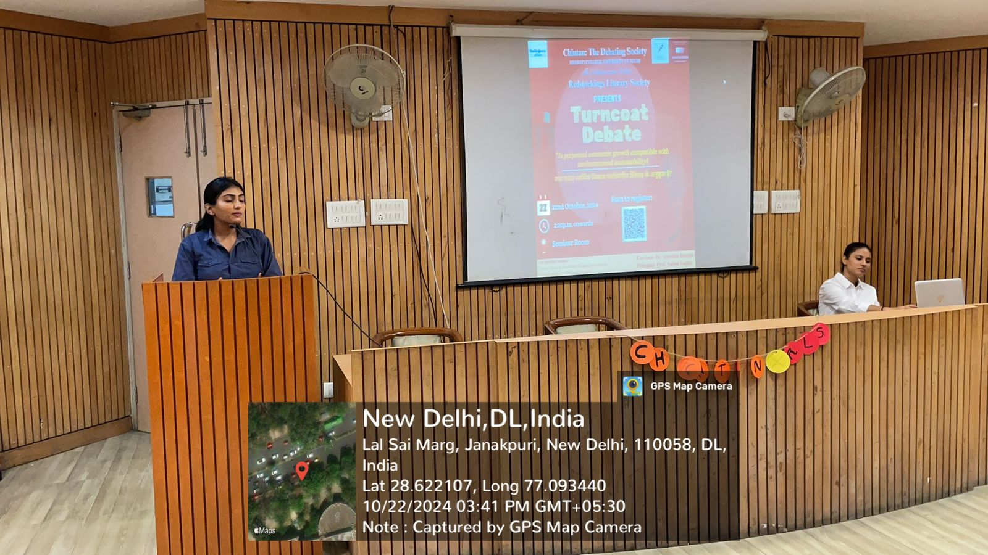
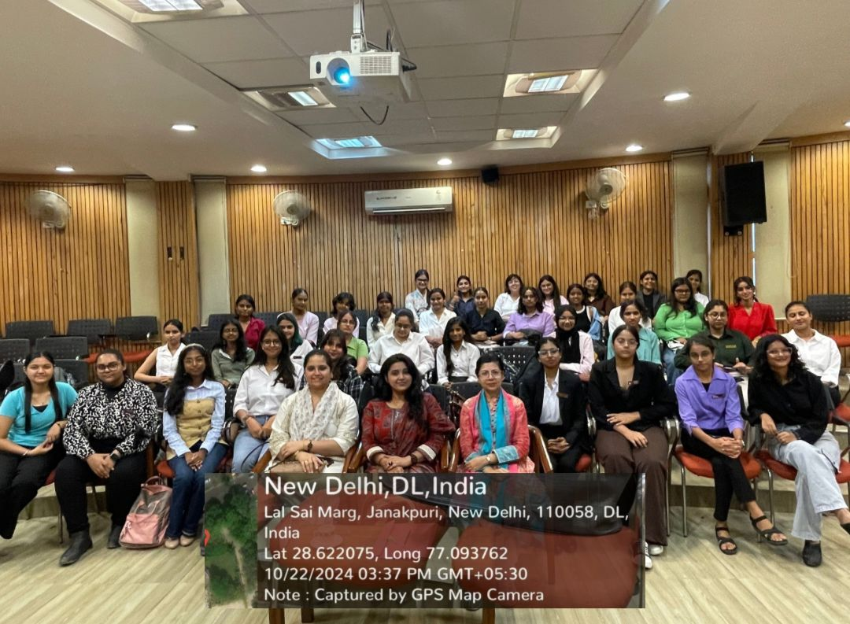
7. Debating skills workshop
Facilitators: Prachi Maurya (President)
Date: 15th February, 2025
Purpose: Skill Development in all forms of debating formats
Chintan- the Debating Society of Bharati College, conducted an insightful workshop aimed at honing its members' debating and rhetorical skills. Led by President Prachi Maurya, the session provided a comprehensive overview of various debate formats, essential skills, and strategic techniques. Through a series of interactive activities, the workshop fostered critical thinking, effective argumentation, teamwork, and analytical precision. Participants gained both theoretical insights and practical exposure, reinforcing their understanding of the core principles of competitive debating.
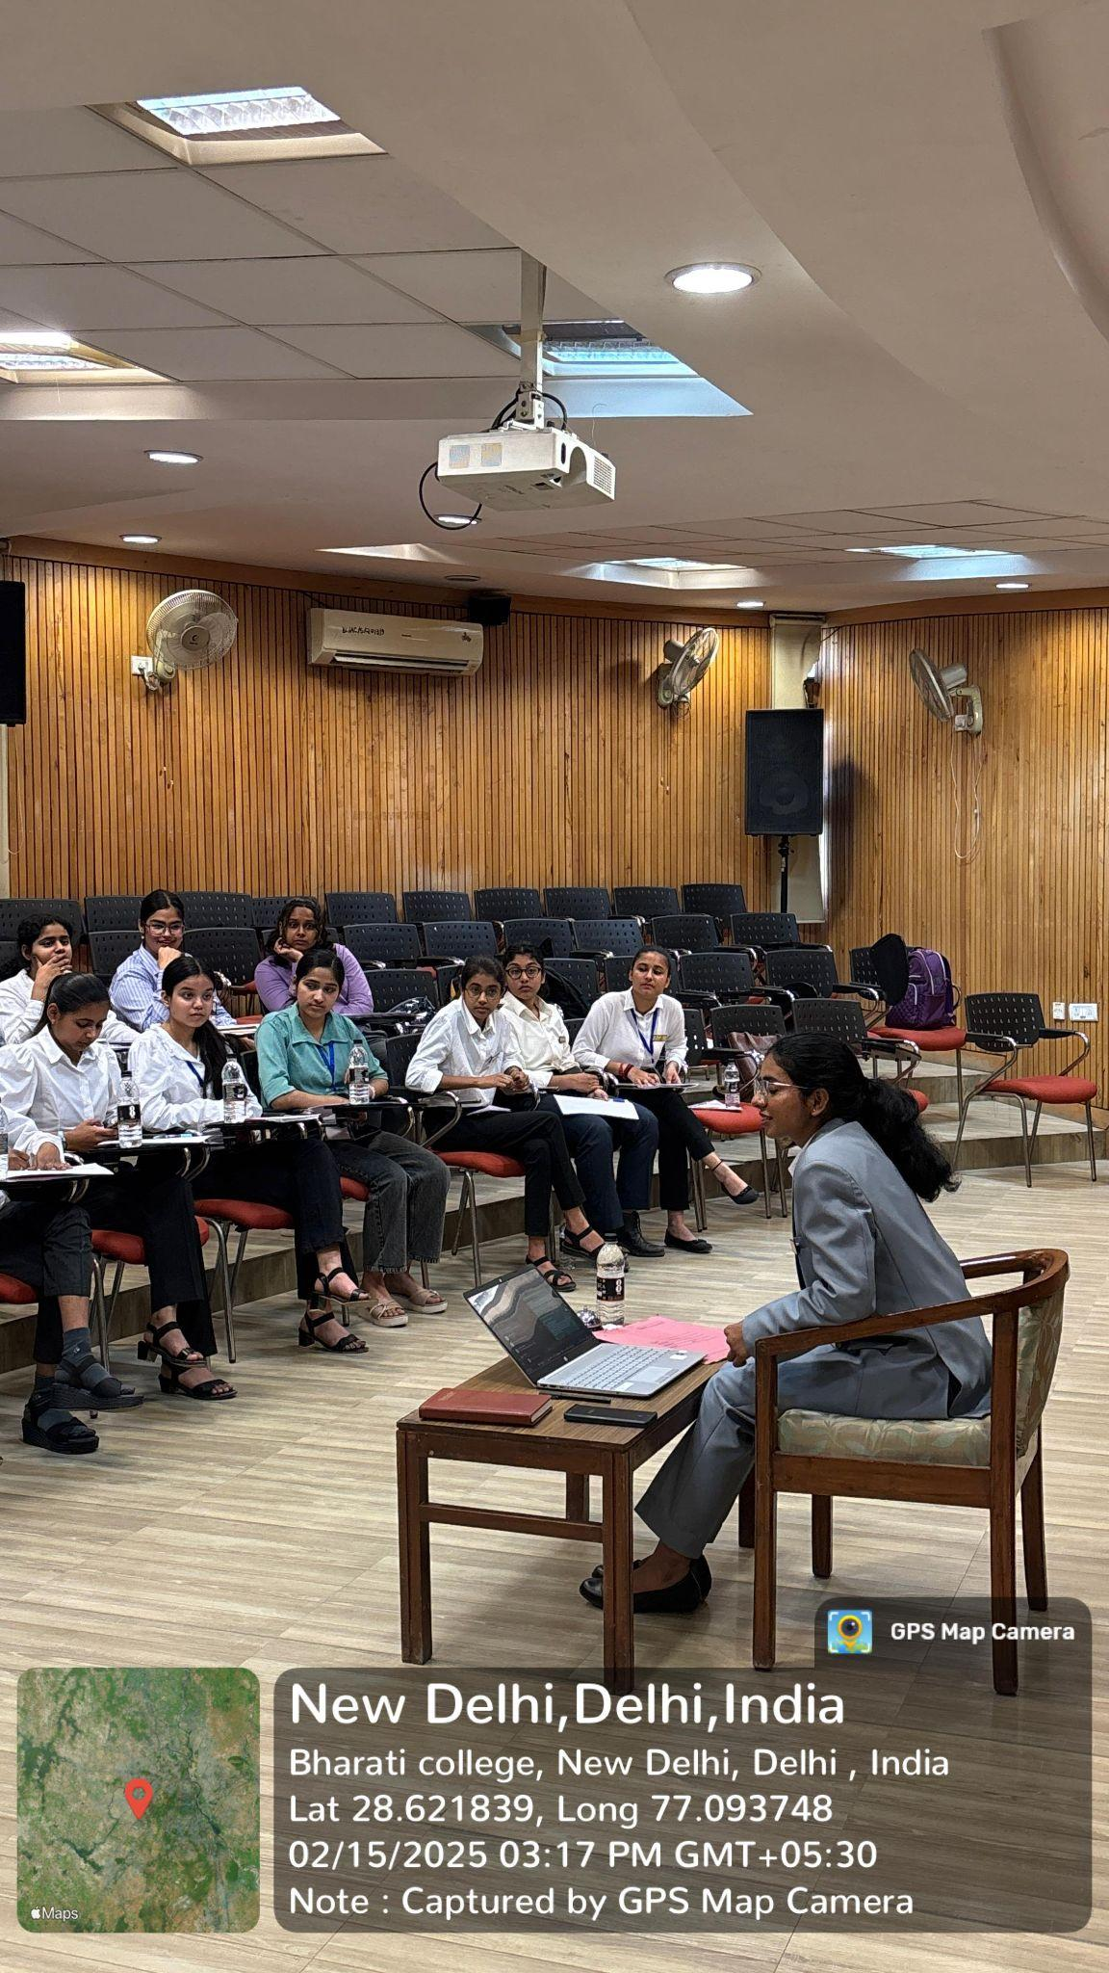
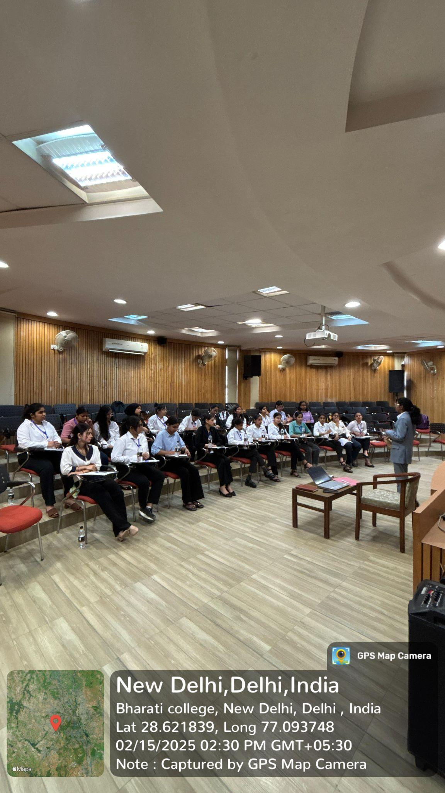
The workshop focused on key elements such as active listening, teamwork in Parliamentary and Lincoln-Douglas formats, and cross-examination techniques. The President guided members through impromptu rebuttals and counterarguments, enhancing their ability to think critically and respond spontaneously. A significant highlight was the Debate Marathon, which encouraged quick thinking and adaptability, followed by a Mock Parliamentary Debate on the topic: Religious Symbols on Public Buildings. This real-time exercise allowed participants to apply their newly developed skills in a structured, competitive environment, solidifying Chintan's commitment to nurturing articulate, analytical thinkers.

8. AWAAZ’25
Date: 28th February, 2025
Chintan - The Debating Society of Bharati College, has consistently benefited from the unwavering support of Abhivyakti, the college’s vibrant Annual Cultural Fest. This platform not only celebrates the creative talents of students but also provides an invaluable opportunity for intellectual exchange. As part of Abhivyakti’25, Awaaz'25 Chintan successfully organised Awaaz'25, a prestigious debate competition that has become synonymous with intellectual rigour and expression within the college. The event exemplifies Chintan’s commitment to fostering a culture of thoughtful discussion, encouraging students to refine their rhetorical skills and broaden their perspectives through engagement with critical societal issues.
The competition was inaugurated by Trisha Tomar, Super Senior Executive, and Tanisha Chopra, Executive Member of Chintan, who warmly welcomed the participants and set the stage for a compelling series of debates. The topic for discussion, ‘One Nation, One Election: Is it Practical? ' sparked rich discussions on the practicalities of implementing such a political reform in India. The event was judged by the core team of Chintan, including Prachi Maurya (President), Anjali Pandey (Vice President), Anamika Chatterjee (General Secretary), and Jansi (Joint Secretary), whose expertise ensured a rigorous evaluation process that upheld the high standards of the competition.
Awaaz ’25 attracted enthusiastic participation from students across Delhi, showcasing the competition's far-reaching impact. Participants from diverse academic backgrounds demonstrated exceptional argumentation, critical thinking, and rebuttal skills, contributing to the competition’s lively and intellectually stimulating atmosphere. The registration fee of ₹50 per participant was a nominal contribution to the pool of ₹8000 in cash prizes, which were awarded to the winners and runners-up. The spirited discussions, strategic argumentation, and effective communication reflected the intellectual vibrancy fostered by Chintan within Bharati College.
After a meticulous evaluation by the judging panel, the competition concluded with Devansh Shukla from Rajdhani College securing the first place, while Khanak Gaur from Indraprastha College for Women emerged as the runner-up. Special Mentions were awarded to Ritesh Dongre from Atma Ram Sanatan Dharma College and Abhigya Singh from Jamia Millia Islamia for their commendable performances. These achievements highlighted the outstanding intellectual capabilities of the participants and the competitive nature of the debate.
Awaaz ’25 stands as a testament to Chintan’s ongoing dedication to creating platforms for rigorous intellectual engagement. The success of the event further solidified its role in shaping a future generation of debaters and thinkers, equipped to engage with and contribute meaningfully to global conversations. As participants left the event with enhanced knowledge, improved debating skills, and expanded networks, they joined a legacy of academic excellence that Chintan continues to uphold within Bharati College.
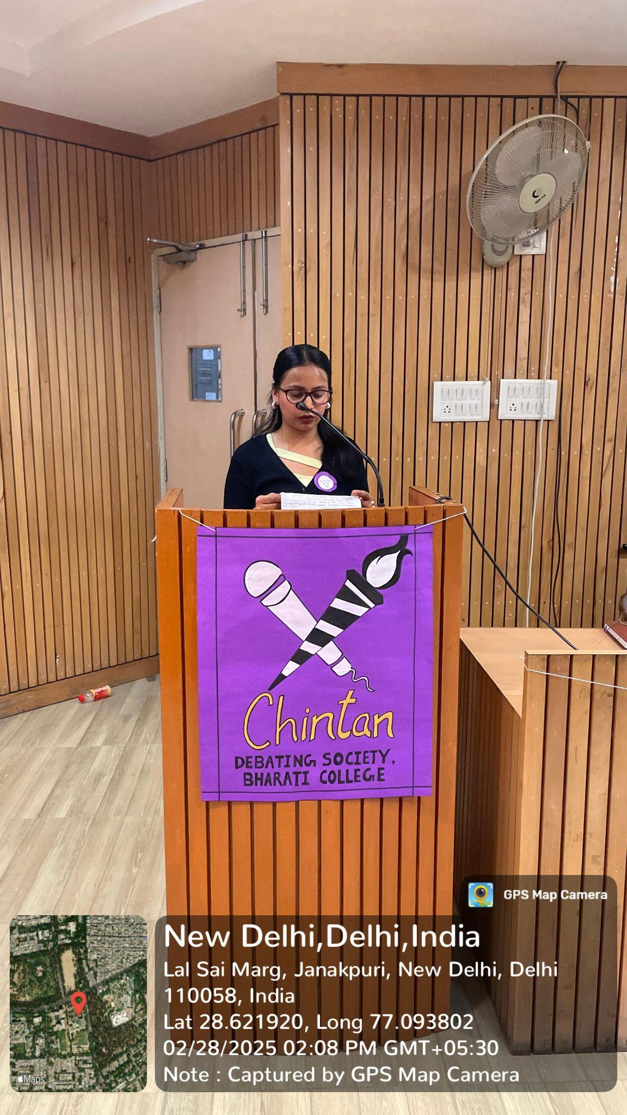
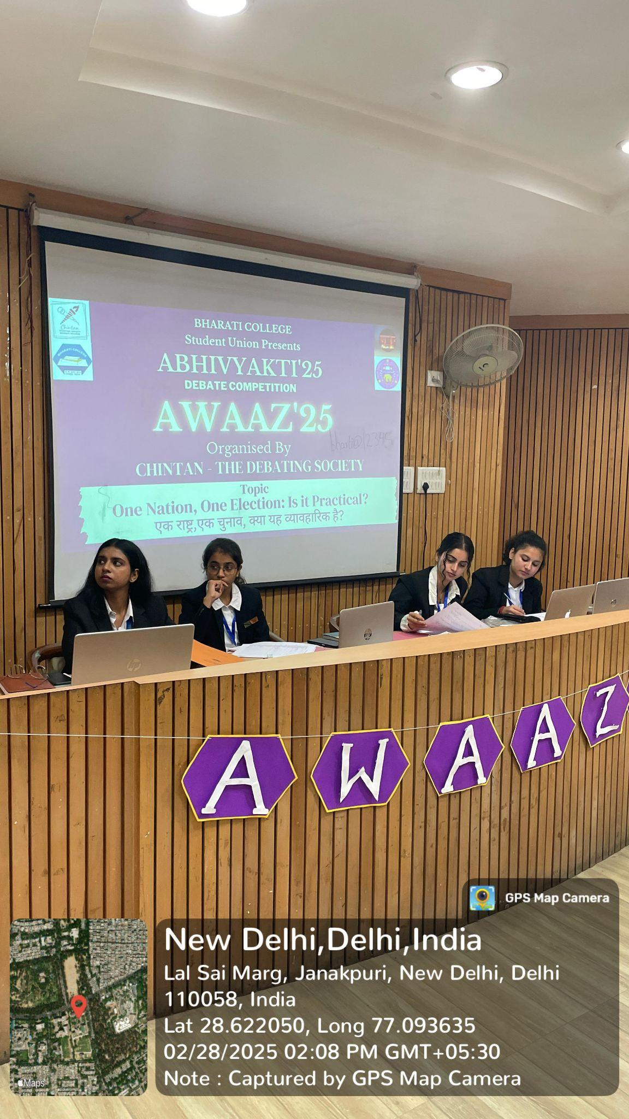
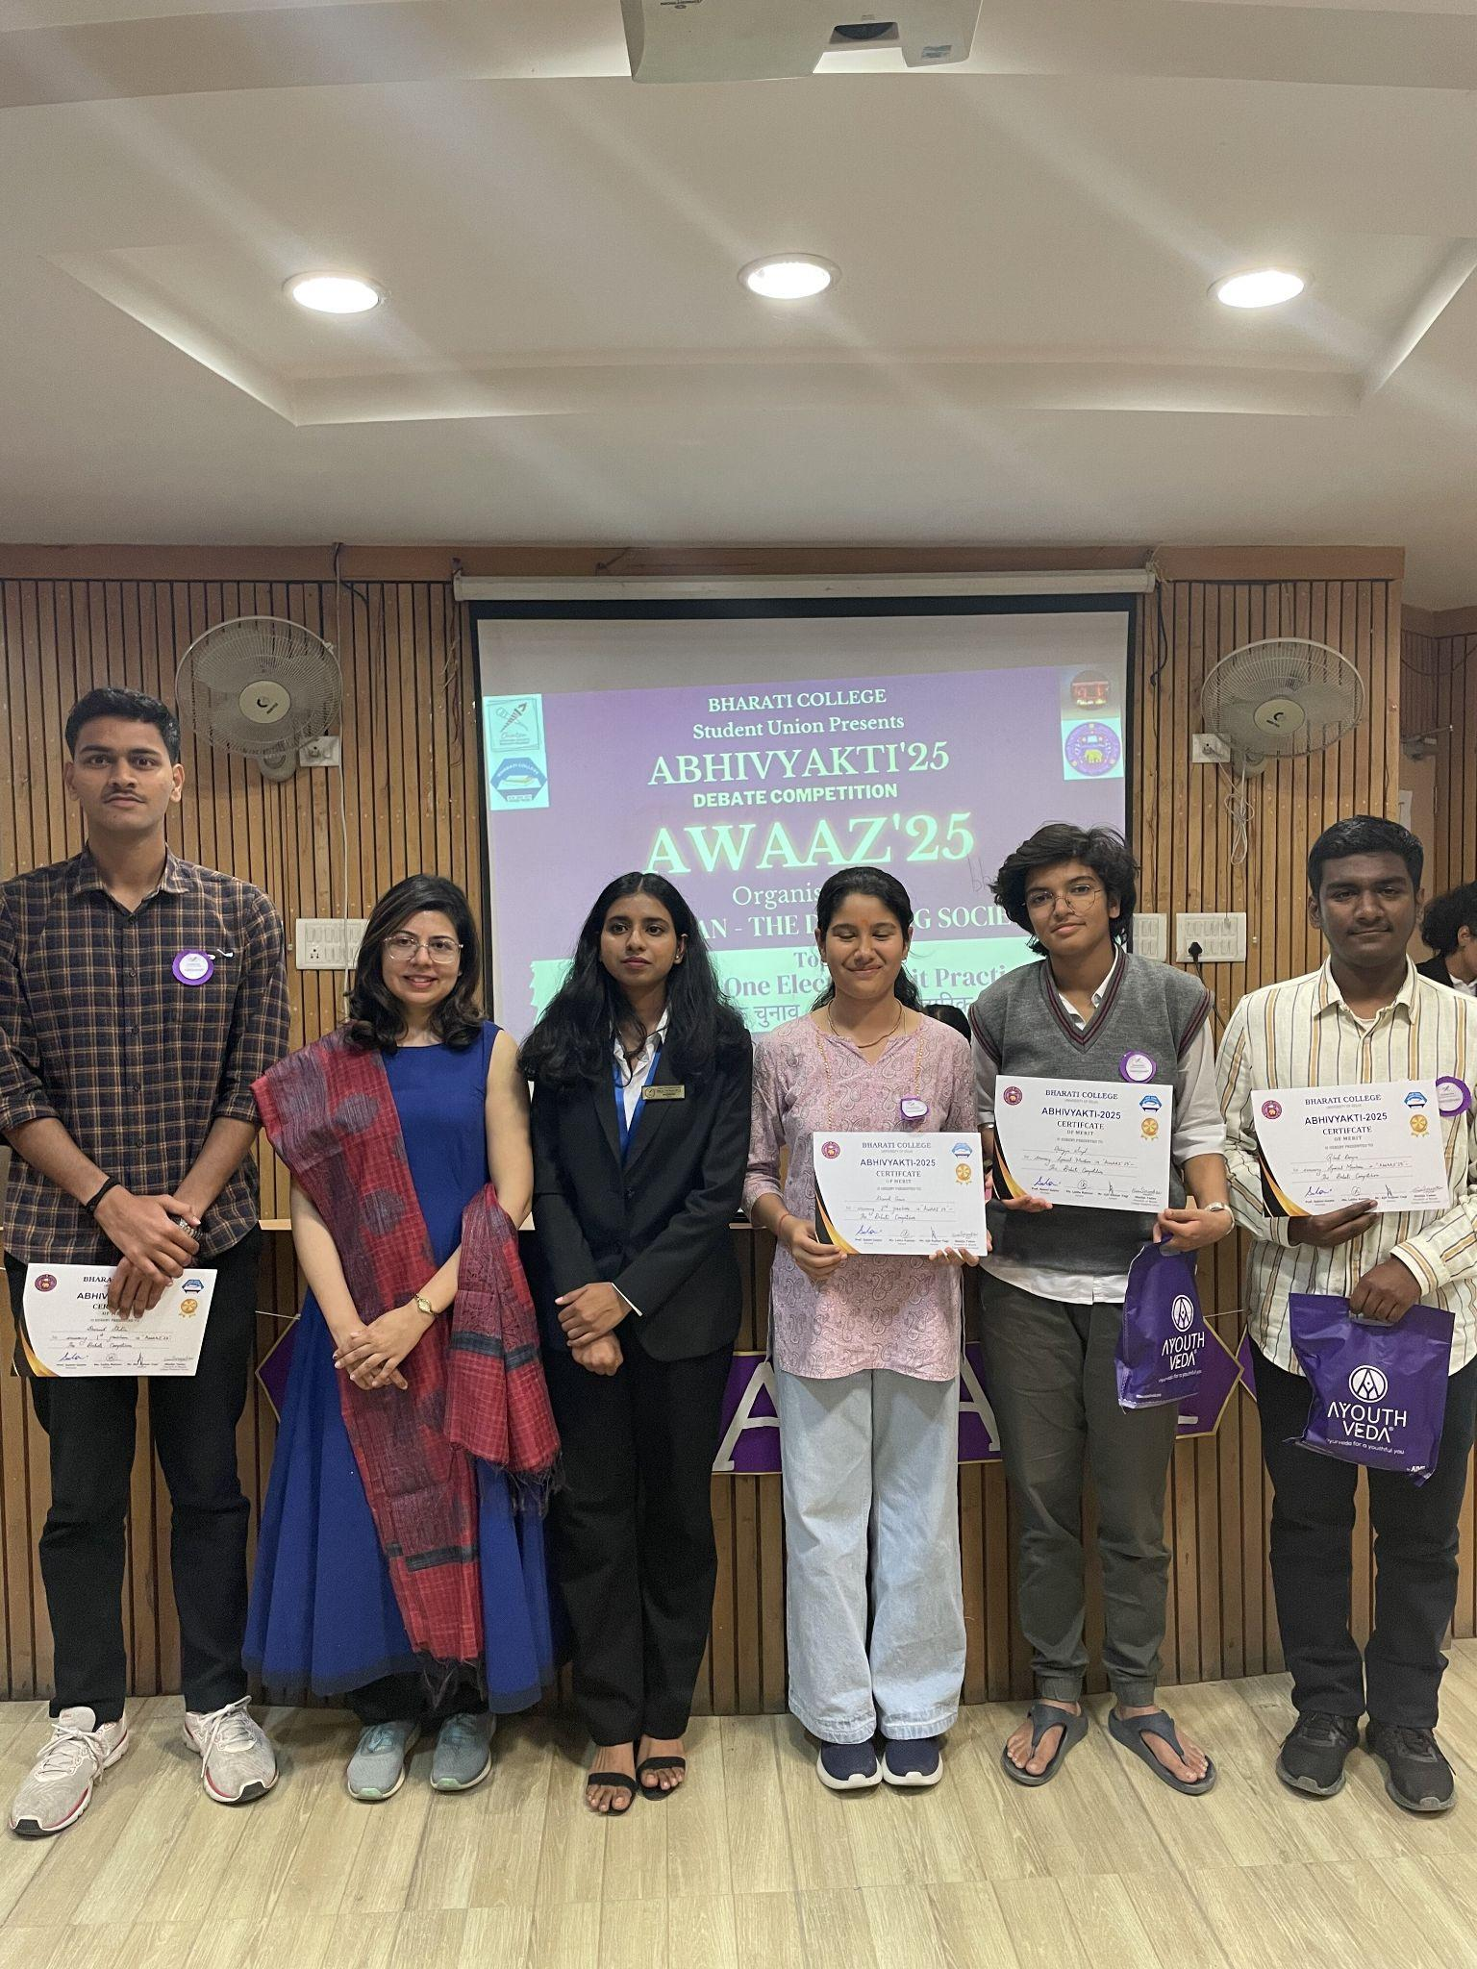
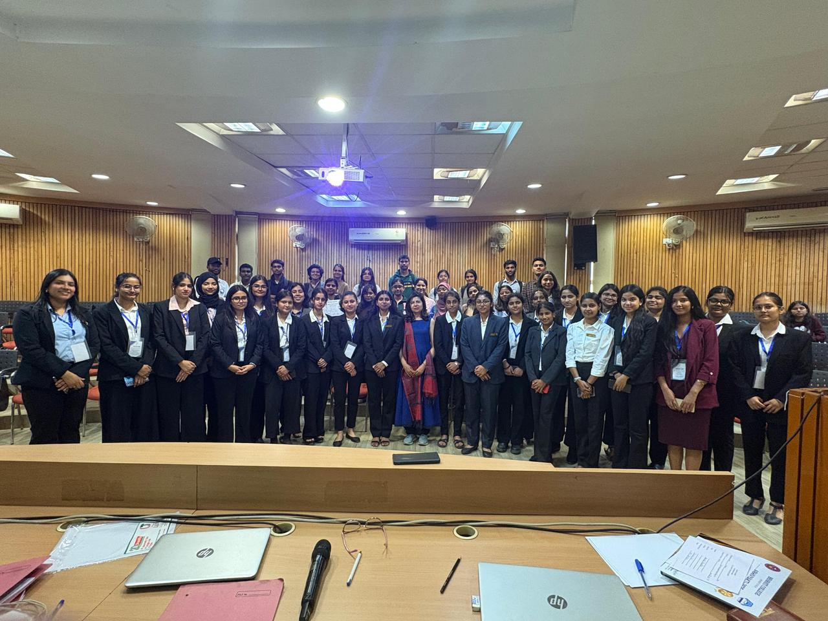

9. Speaker Session

Date: 24th April, 2025
Speaker: Prof. (Dr.) Sangit Sarita Dwivedi, Political Scientist

Chintan- The Debating Society of Bharati College, hosted an insightful session on India’s youth-centric demographic and its implications for national development. The session commenced with a thoughtful introduction by Sakshi Raj Wardhan, Public Relations Head, followed by a warm welcome from Dr. Anavisha Banerjee, Convener of Chintan. Prof.. (Dr.) Sangit Sarita Dwivedi led the discourse on the topic Demographic Dividend or Dilemma? The Role of Youth in Viksit Bharat critically examines whether India’s youth demographic, comprising over 65% of the population under 35, represents a demographic dividend or a developmental dilemma. She emphasised the need for strategic policies, inclusive development, and targeted investments to harness the potential of this young workforce.
The speaker further stressed the importance of skill-based education, job creation aligned with youth aspirations, and gender equity as critical factors in realising this demographic potential. Dr. Dwivedi highlighted comparisons with ASEAN and developed nations, pointing to the necessity for timely reforms to prevent issues such as underemployment and brain drain. The session concluded with a stimulating Q&A, followed by appreciative addresses from Dr. Anavisha Banerjee and Chintan’s President, Prachi Maurya, who both thanked the speaker for her valuable insights into the role of youth in shaping India’s future.

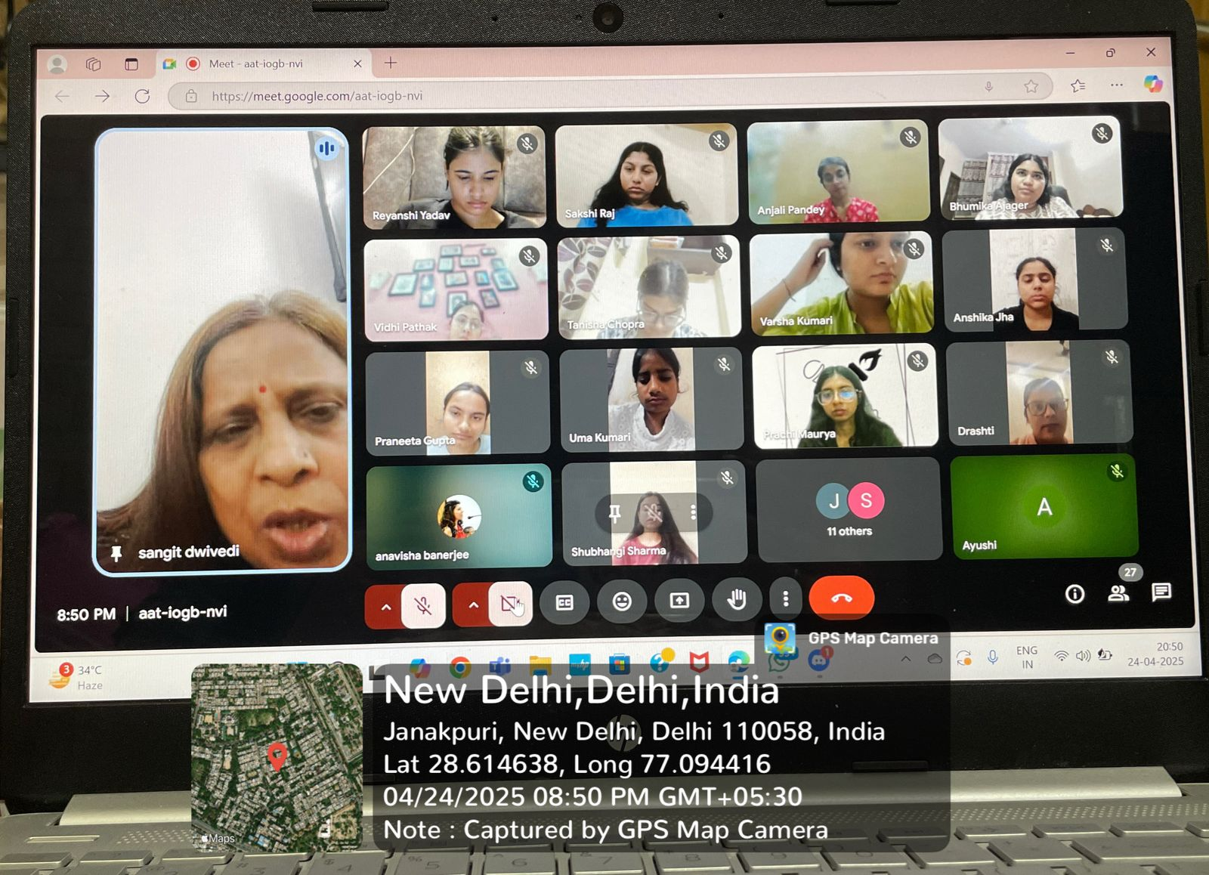
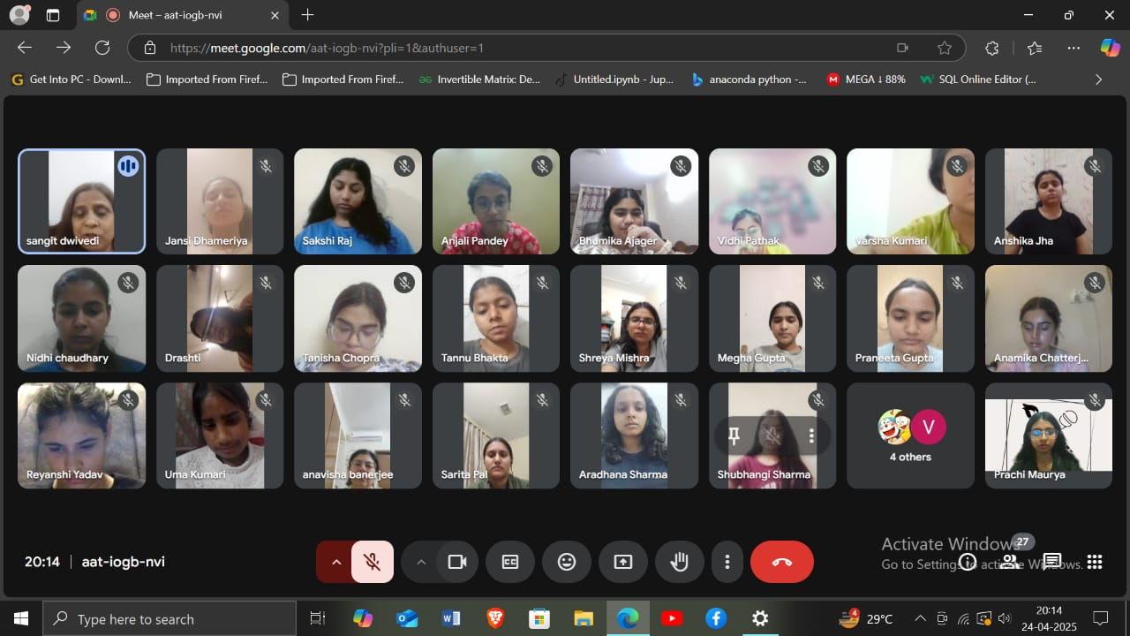

COLLABORATIONS FOR THE ACADEMIC YEAR 2024-25

- CHINTAN X REDSTOCKINGS
Chintan- The Debating Society of Bharati College, collaborated with Redstockings, the English Literary Society of Bharati College, to host a highly anticipated event, the turncoat debate competition, that combined their collective expertise in intellectual discourse and literary analysis. This partnership was marked by a joint commitment to enhance the cultural and academic engagement within the college, providing a platform for dynamic discussions on pressing societal issues. The collaboration successfully united the strengths of both societies, facilitating a multidisciplinary approach to debates and fostering an environment conducive to open dialogue. Through this event, Chintan and Redstockings showcased their shared vision of cultivating thought-provoking and transformative conversations among students.

- CHINTAN X MANTHAN
Chintan- The Debating Society of Bharati College, entered into a year-long collaboration with Manthan, the Nukkad Natak Society of the institution, in a formal partnership aimed at strengthening the cultural fabric of the college. Through this collaboration, both societies worked together to promote each other's initiatives and social media content within the college community. By engaging with Manthan, Chintan enhanced its role in encouraging both debate and performance-based arts, creating a platform for students to express themselves in diverse formats, while also cultivating a spirit of unity and collaboration.

- CHINTAN X COMMERCE SOCIETY, KMC
Chintan- The Debating Society of Bharati College, partnered with the Commerce Society of Kirori Mal College (KMC) for a collaborative effort aimed at amplifying their academic and extracurricular endeavours. The alliance was focused on promoting intellectual exchange between students of different disciplines, particularly in the realm of public speaking and debates. This partnership provided a valuable opportunity for Chintan to broaden its engagement beyond the confines of Bharati College, allowing both societies to share their expertise in organising high-quality social media networking collabs and fostering deeper connections within the broader academic community. Through this collaboration, Chintan and the Commerce Society aimed to enhance cross-college networking and facilitate the holistic development of students in both academic and extracurricular spheres.
CHINTAN’S SOCIAL MEDIA

https://www.instagram.com/p/DIyxLchSkQR/?igsh=a3h5c3VxMWg3d3Uw

https://www.instagram.com/p/DGBMg7dyBoq/?igsh=MWZnajg0N3d1M2prMw==

https://www.instagram.com/p/DGLmaagypi7/?igsh=aDdwZXVzNTRoY3Rl

https://www.instagram.com/p/DBLNEyvy6a7/?igsh=bWNnMngzN2MwMjF0

https://www.instagram.com/p/DABJDSpyKNq/?igsh=bWJyYjczNzdibHU5

https://www.instagram.com/p/C-8SyQGyeWC/?igsh=d2VhanJnbjB5aGh2

CHINTAN ACHIEVEMENTS

This semester, Chintan's achievements spanned MUNS, debates, speeches, and declamations, showcasing the society's versatility. Students participated with remarkable wit, extensive knowledge, and unwavering confidence, consistently exemplifying excellence across diverse platforms.

- On 22nd September 2024, Vidhi Pathak, a Super Senior Executive member of Chintan, received the Honourable Mention Award in the UNGA committee at Yuvamanthan, a Model United Nations conference organised in collaboration with the Shaheed Bhagat Singh MUN Society. This recognition highlights her exceptional diplomatic skills and in-depth understanding of global issues.

- Anshika Jha, a Senior Executive of Chintan, secured the first position in an extempore competition organised by the Cathect Society under the theme Karamsthiti: Mental Health and Work-Life Balance, commemorating World Mental Health Day. The event occurred on October 14, 2024, and highlighted the significance of mental health awareness and work-life harmony.

- On 6th September 2024, Vidhi Pathak, a Super Senior Executive member of Chintan, was honoured with the Best Interjection Award at The Exponents, an intra-college debate competition organised in collaboration with YUVA. This prestigious event showcased exceptional rhetorical talent and critical thinking.

- On October 14th, 2024, Tanisha Chopra, a Senior Executive of Chintan, secured the third position in an extempore competition organised by the Cathect Society on the theme "Karamsthiti: Mental Health and Work-Life Balance" in honour of World Mental Health Day.
- On 14 October 2024, Anjali Pandey, the Vice President of Chintan, competed in an event organised by Cathect Society under the theme "Karamsthiti: Mental Health and Work-Life Balance"—an event in honour of World Mental Health Day. She secured second place and was awarded a certificate.

- On 6th September 2024, Trisha Tomar, a Super Senior Executive of Chintan, featured in the intra-college debate competition by YUVA (Bharati College) and secured a special mention.

- On 28th August 2024, Vidhi Pathak, Super Senior Executive of Chinta,n participated in an Extempore competition organised by Viksit Bharat Ambassador Club, Bharati College, and won the first position. She was awarded a certificate and a cash prize.

- On 28th August 2024, Sakshi Raj Wardhan, the Public Relations Head of Chintan, achieved first place in The Exponents, an intra-college Extempore Competition organised by the Viksit Bharat Ambassador Club in collaboration with YUVA.

- On 20th October 2024, Anshika Jha, a Senior Executive member of Chintan, participated in the Sententia Model United Nations organised by Kirori Mal College, University of Delhi. She secured a Special Mention.

- On 13 January 2025, Anjali Pandey, Vice President of Chintan, achieved second position in the Declamation Competition organised by YUVA and NSS Bharati.
- On 13 January 2025, Tanisha Chopra, Executive Member of Chintan, was honoured with a special mention in the Declamation Competition conducted by YUVA and NSS Bharati.
- On 13 January 2025, Anshika Jha, Senior Executive Member of Chintan, was honoured with a special mention in the Declamation Competition hosted by YUVA and NSS Bharati.
- On 24 January 2025, Nidhi, Executive Member of Chintan, secured the second runner-up position in the Extempore Debate organised by Pravaah – The History Department of Bharati College.
- On 25 January 2025, Anshika Jha, Senior Executive Member of Chintan, won the Best Speaker award in the Inter-College Declamation Competition organised by Atma Ram Sanatan Dharma College, University of Delhi, and received a cash prize of ₹1000. The topic of the event was “Role of Empowering Girls in Shaping a Peaceful Global Future.”
- On 11 February 2025, Anshika Jha secured first position in the Inter-College Debate Competition organised by the Department of Sociology under Samavesha 2025, winning a trophy and a cash prize of ₹2000.
- On 12 February 2025, Vidhi Arora, Super Senior Executive Member of Chintan, secured second position in the Negotiator’s Knockout organised by Vanijya Samiti, Bharati College.
- On 12 February 2025, Anshika Jha secured first position in the Negotiator’s Knockout competition held as part of Commercio’25, organised by Bharati College, and was awarded a cash prize of ₹500.
- On 13 February 2025, Tanisha Chopra, Executive Member of Chintan, was honoured with a special mention and a gift hamper in Naturaleza 2025, conducted by Haritashray – The Eco Club Society of Lady Irwin College, University of Delhi.
- On 30 March 2025, Nidhi, Executive Member of Chintan, secured the Third Best Speaker position in the Conventional Debate hosted by Deshbandhu College, University of Delhi.
- Anshika Jha, Senior Executive Member of Chintan, secured first position in the Inter-College Extempore Competition organised by the Women Development Cell, Bharati College, and was awarded a cash prize of ₹1000.
- Anshika Jha, Senior Executive Member of Chintan, secured third position (Honourable Mention) in the Inter-University Declamation Competition – Podium Pulse 2.0, hosted by Akhilesh Das Gupta Institute of Professional Studies.
- On 16 April 2025, Anamika Chatterjee, Secretary of Chintan, along with Anshika Jha, Senior Executive Member, secured third position in Vichar Manthan 7.0 – The National Debate Competition (Extempore-Turncoat format) organised at Rajdhani College, and received a combined cash prize of ₹3000.
- On 17 April 2025, Anshika Jha, Senior Executive Member of Chintan, secured third position in Adamya 6.0 – Inter-College Conventional Debate, hosted by Maitreyi College’s Internal Committee, and was awarded a cash prize of ₹500.

- On 23 April 2025, Shubhangi Sharma, an Executive Member of Chintan, was declared 3rd Runner up in the Debate Competition organised by YUVA on the occasion of Bharat Parv: The Youth Conclave.
- On 19 April 2025, Anshika Jha, Senior Executive Member of Chintan, was honoured with a special mention and a cash prize of ₹2500 in the UNCSW Committee at the Generational Youth Summit 2025.
- On 23 April 2025, Anshika Jha, Senior Executive Member of Chintan, was declared Best Debater in the Debate Competition organised by YUVA on the occasion of Bharat Parv: The Youth Conclave.

- On 23 April 2025, Sakshi Rajwardhan, public relations head of Chintan, was declared achieved best interjctor in the Debate Competition organised by YUVA on the occasion of Bharat Parv: The Youth Conclave.

- On 15th October 2024, Prachi Maurya, President of Chintan, served as a distinguished jury member for the Creative Writing Competition organised by the Research and Development Cell at Aditi Mahavidyalaya.

- On 20th February 2025, Prachi Maurya, President of Chintan, adjudicated the Extempore Competition hosted by Palaash - The Eco Club.

- On 16th April 2025, Prachi Maurya, President of Chintan, was invited as a jury member for four events—Creative Writing, Blackout Poetry, English Slam Poetry, and Hindi Slam Poetry—at Lehza'25, the annual literary fest organised by Areopagitica, the Creative Writing Society of Shaheed Bhagat Singh Evening College.
CHINTAN OFFICE BEARERS 2024-2025:
S. No. | Year | Name | Course | Roll No. | Email | Position in Society
1. | 2 | Sakshi Raj Wardhan | B.A. (Hons.) Journalism | 23520/32 | rajsakshi1127@gmail.com | Public Relations Head
2. | 2 | Ayushi Srivastava | B.Com (Hons.) | 23504/155 | bhoomiayushi@gmail.com | Social Media Head
3. | 2 | Jansi | B.A. (Hons.) Journalism | 23520/11 | Jansi Dhameriya | Joint Secretary
4. | 3 | Anamika Chatterjee | B.A. (Hons.) History | 22/450 | Anamika Chatterjee | General Secretary
5. | 2 | Anjali Pandey | B.A. (Hons.) Journalism | 23520/6 | Anjali Pandey | Vice-President
6. | 3 | Prachi Maurya | B.Sc (Hons.) Mathematics | 22/1433 | prachimaurya156@gmail.com | President

CHINTAN TEAM MEMBERS 2024-25

S. No. | Year | Name | Course | Roll No. | Email | Position in Society
1. | 1 | Aradhna | B.A Program (Economics + OMSP) | 24501/EO/02 | saradhana729@gmail.com | Executive Member
2. | 1 | Praneeta Gupta | B.Com | 24503/99 | praneetagupta910@gmail.com | Executive Member
3. | 1 | Tanisha Chopra | B.A. (Hons.) Psychology | 24528/52 | tanishachopra211@gmail.com | Executive Member
4. | 1 | Uma Kumari | B.A. (Hons.) Hindi | 24516/25 | umakumari2872006@gmail.com | Executive Member
5. | 1 | Shubhangi Sharma | B.A. (Hons.) Journalism | 24520/52 | shubhangisharma494@gmail.com | Executive Member
6. | 1 | Reyanshi Yadav | B.A. (Hons.) Journalism | 24520/75 | reyanshiyadav6642@gmail.com | Executive Member
7. | 1 | Nidhi | B.A. (Hons.) Journalism | 24520/33 | nidhichaudhary0500@gmail.com | Executive Member
8. | 1 | Akansha Bhati | B.A. (Hons.) Journalism | 24520/76 | akanshabhati186@gmail.com | Executive Member
9. | 1 | Megha Gupta | B.A. (Hons.) Political Science | 24527/41 | mg26527131@gmail.com | Executive Member
10. | 2 | Drishti sengar | B.Com | 23503/35 | drashtis5789@gmail.com | Senior Executive Member
11. | 2 | Azra Sharfia | B.Com (Hons.) | 23504/23 | sharfiaazra@gmail.com | Senior Executive Member
12. | 2 | Varsha Kumari | B.A. (Hons.) History | 23518/62 | varsha270229@gmail.com | Senior Executive Member
13. | 2 | Shreya Yadav | B.A. (Hons.) Sociology | 23530/45 | shreyayadav28005@gmail.com | Senior Executive Member
14. | 2 | Anshika Jha | B.Sc (Hons.) Mathematics | 23563/2 | anshikajhaaa@gmail.com | Senior Executive Member
15. | 2 | Sarita Pal | B.Com (Hons.) | 23504/156 | saritapal1504@gmail.com | Senior Executive Member
16. | 3 | Bhumika Ajager | B.A. (Hons.) Sociology | 22/1312 | bhumikaajager@gmail.com | Super Senior Executive Member
17. | 3 | Vidhi Arora | B.Com (Hons.) | 22/1611 | vidhiarora20042@gmail.com | Super Senior Executive Member
18. | 3 | Tannu Bhakta | B.A. (Hons.) Political Science | 22/750 | tannubhakta144@gmail.com | Super Senior Executive Member
19. | 3 | Trisha Tomar | B.Com | 22/1900 | tomartrisha5@gmail.com | Super Senior Executive Member
20. | 3 | Vidhi Pathak | B.A. (Hons.) History | 22/451 | vidhipthk2004@gmail.com | Super Senior Executive Member
21. | 3 | Shreya Mishra | B.A Program (History + Political Science) | 22/2229 | Shreya78mishra98@gmail.com | Super Senior Executive Member

CHINTAN ATTENDANCE 2024-25

Semester 1,3 & 5

MEMBER NAME | SEMESTER | ATTENDANCE
Prachi Maurya | 5 | S3
Anamika Chatterjee | 5 | S3
Tannu Bhakta | 5 | S3
Vidhi Arora | 5 | S2
Bhumika Ajager | 5 | S2
Trisha Tomar | 5 | S2
Vidhi Pathak | 5 | S2
Shreya Mishra | 5 | S3
Anjali Pandey | 3 | S3
Jansi | 3 | S2
Sakshi Raj Wardhan | 3 | S3
Ayushi Srivastava | 3 | S2
Drashti sengar | 3 | S2
Azra Sharfia | 3 | S2
Varsha Kumari | 3 | S2
Shreya Yadav | 3 | S1
Anshika Jha | 3 | S1
Sarita Pal | 3 | S1
Praneeta Gupta | 1 | S1
Tanisha Chopra | 1 | S2
Uma Kumari | 1 | S1
Shubhangi Sharma | 1 | S1
Reyanshi Yadav | 1 | S1
Nidhi | 1 | S1
Akansha Bhati | 1 | S1
Megha Gupta | 1 | S1
Aradhna | 1 | S1

Semester 2,4 & 6

MEMBER NAME | SEMESTER | ATTENDANCE
Prachi Maurya | 6 | S3
Anamika Chatterjee | 6 | S3
Tannu Bhakta | 6 | S3
Vidhi Arora | 6 | S3
Bhumika Ajager | 6 | S3
Trisha Tomar | 6 | S3
Vidhi Pathak | 6 | S3
Shreya Mishra | 6 | S3
Anjali Pandey | 4 | S3
Jansi | 4 | S3
Sakshi Raj Wardhan | 4 | S3
Ayushi Srivastava | 4 | S3
Drashti sengar | 4 | S3
Azra Sharfia | 4 | S2
Varsha Kumari | 4 | S3
Shreya Yadav | 4 | S3
Anshika Jha | 4 | S2
Sarita Pal | 4 | S2
Praneeta Gupta | 2 | S3
Tanisha Chopra | 2 | S3
Uma Kumari | 2 | S2
Shubhangi Sharma | 2 | S2
Reyanshi Yadav | 2 | S2
Nidhi | 2 | S2
Akansha Bhati | 2 | S2
Megha Gupta | 2 | S2
Aradhna | 2 | S3

Team

- CORE TEAM
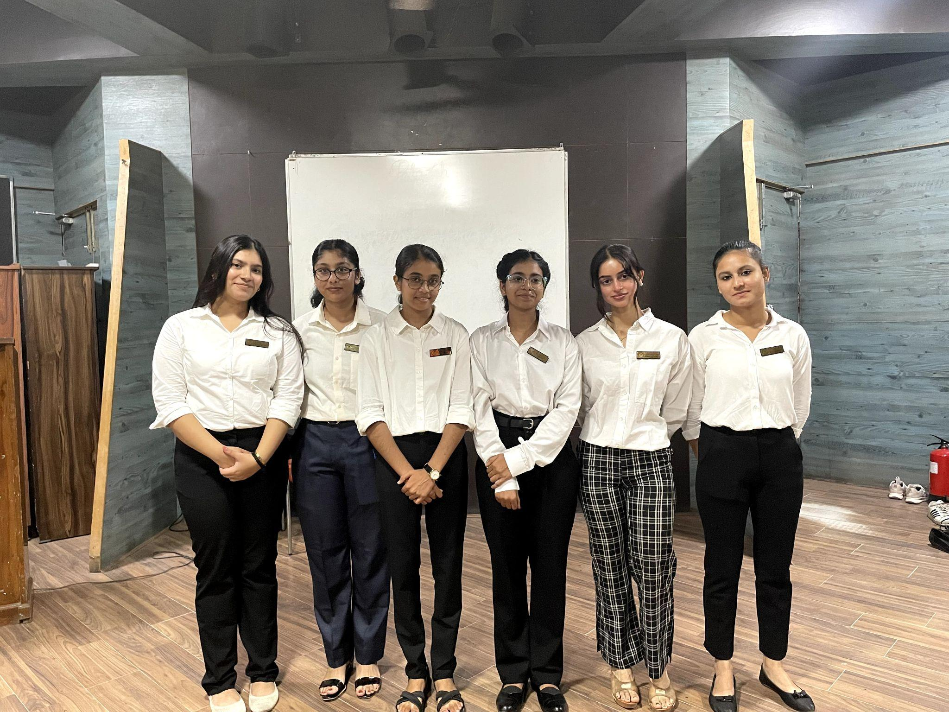

CHINTAN OFFICE BEARERS 2024-2025
(Left to Right )Ayushi Srivastava, Sakshi Raj Wardhan, Anjali Pandey, Prachi Maurya,
Anamika Chatterjee, Jansi

- Prachi Maurya - President

- Anjali Pandey - Vice President

- Anamika Chatterjee - General Secretary

- Jansi - Joint Secretary

- Sakshi Raj Wardhan - PR Head

- Ayushi Srivastava - Social Media Head

Super Senior Executive members

Bhumika Ajager
Vidhi Arora
Tannu Bhakta
Trisha Tomar
Vidhi Pathak
Shreya Mishra

Senior Executive members

Drishti sengar
Azra Sharfia
Varsha Kumari
Shreya Yadav
Anshika Jha
Sarita Pal

Executive members

Aradhna
Praneeta Gupta
Tanisha Chopra
Uma Kumari
Shubhangi Sharma
Reyanshi Yadav
Nidhi
Akansha Bhati
Megha Gupta

Convener:
Dr. Anavisha Banerjee
Co-Conveners:
Dr. Savita Jemini
Dr. Rekha Sharma

With steadfast commitment, we overcame challenges, driven by innovation and perseverance. Chintan remains focused on fostering growth and empowering all its members to reach their full potential. We aim to continue this impactful journey in the future.

Regards,
CHINTAN - THE DEBATING SOCIETY
BHARATI COLLEGE
UNIVERSITY OF DELHI.

