Cathect- Department of Psychology
Bharati College
University of Delhi

Collective reports of the council elections,
mental health day event, activities and workshop
that happened under the banner of
Cathect - Department of Psychology,
Under the Supervision of IQAC
from September 2024 onwards under
Prof. Manju Sharma, TIC
Department of Psychology

Cathect- Department of Psychology
Under the Supervision of IQAC
Bharati College, University of Delhi
Report on Council Elections: 2024-25

19th September 2025, Bharati College, University of Delhi: Cathect Society, the Department of Psychology of Bharati College conducted the council elections for the session 2024-25.

The nominations for the council posts were pre-invited via the departmental email address. The candidates contesting for the position of President, Vice President, Joint Secretary and Treasurer successfully carried out their campaigning for all the batches of the department, providing distinct yet encouraging visions for their roles in the council.

The elections were held with impartiality and just competition under the supervision of the esteemed professors Ms. Tavishi Sanghi and Ms. Reebika on 19th September, 2025. The votes were counted in the presence of the respective representatives of the candidates to ensure transparency. The new office bearers expressed their gratitude and vowed to work for the betterment of society.

The individual interviews for the remaining council were carried out by Ms. Tavishi Sanghi and Ms. Reebika in the presence of the newly elected President, Aditi Sehrawat and Vice President, Prerna Kandpal. The heads and respective members of the creative, editorial, event management, public relations, and social media teams were finalised and the results were announced on the evening of 24th September, 2025. The new council was warmly welcomed with each member looking forward to work with full potential and vigor.

Key Outcomes of the Event:
- Held on 19th September, 2025, in the Psychology Lab of Bharati College by Cathect Society, Department of Psychology.
- Transparent and just elections with pre-invited nominations were held under the supervision of the professors.
- Aditi Sehrawat was elected as the departmental President, Prerna Kandpal as the Vice- President, Muskan Saifi as the Treasurer and Moli Chowdhary as the Joint Secretary by the students of the department.
- Remaining council was selected on the basis of an interview by Ms. Reebika and Ms. Tavishi Sanghi.

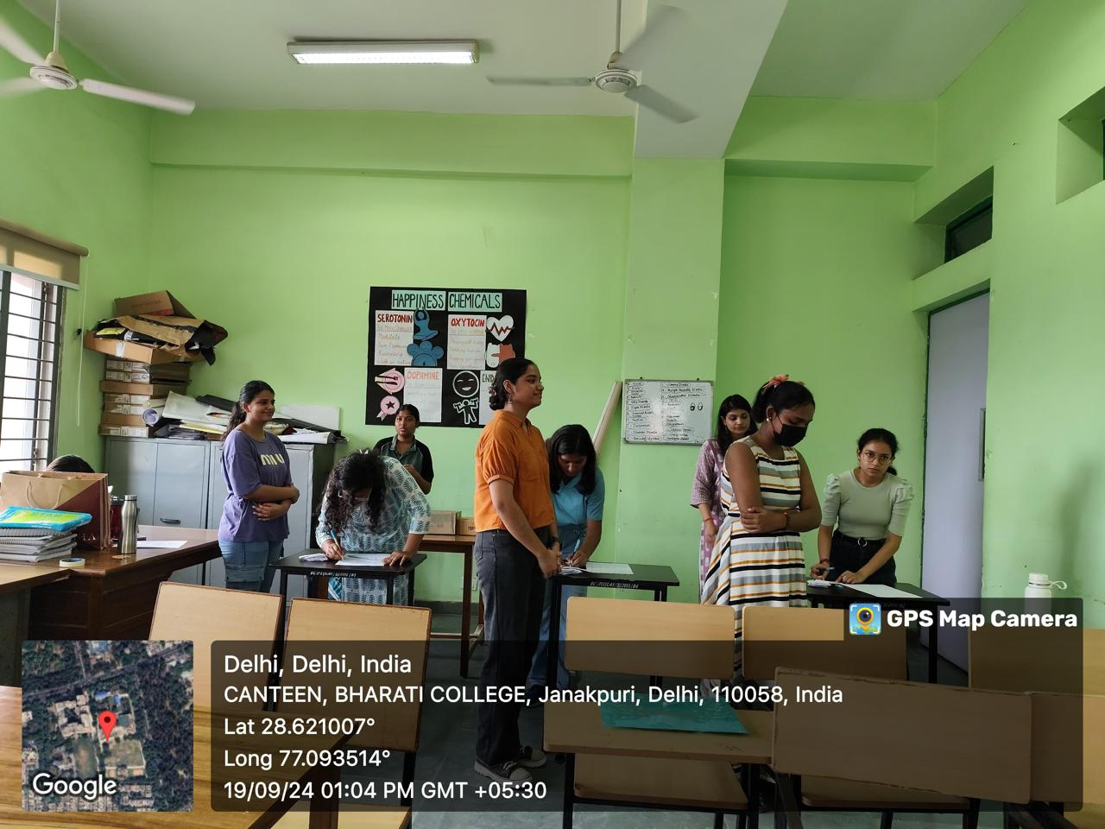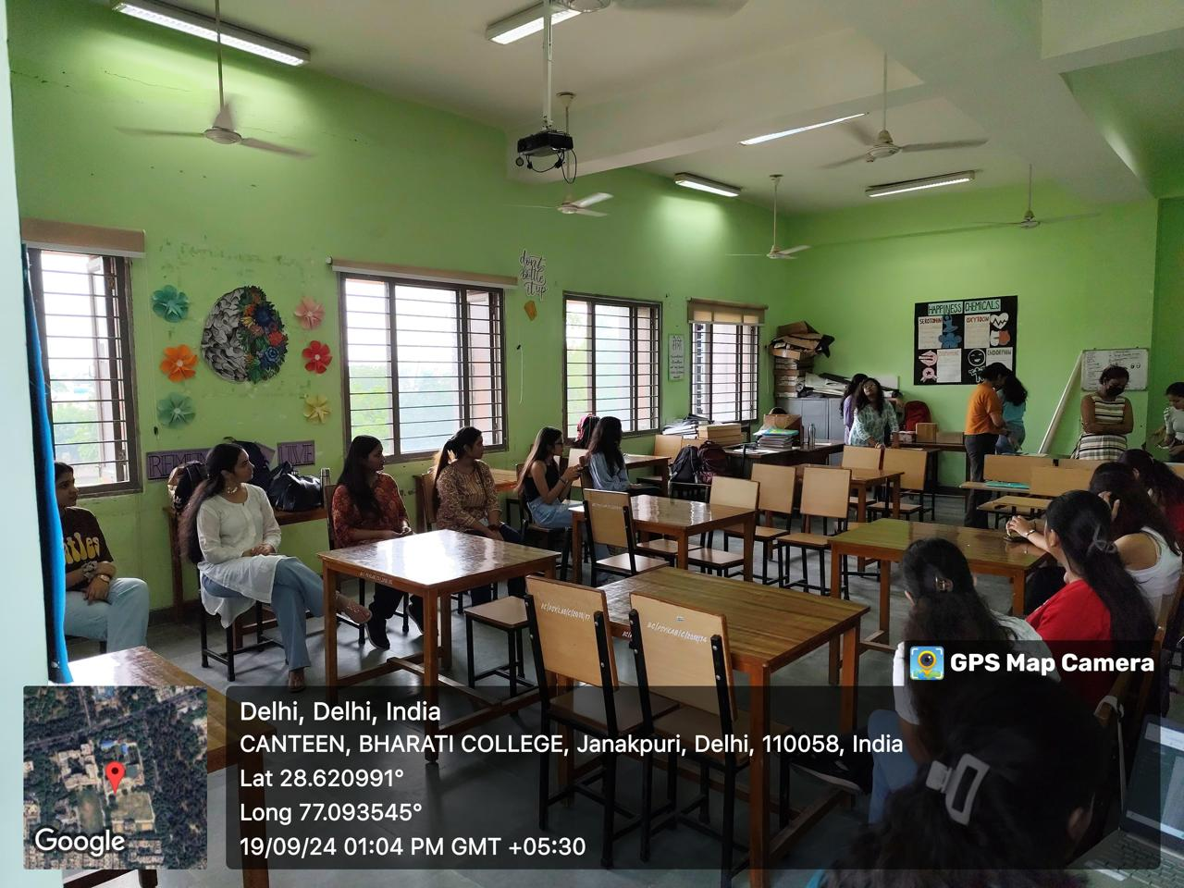

Cathect- Department of Psychology
Under the supervision of IQAC
Bharati College, University of Delhi
Mental Health Week Event- 2024
Karmasthiti: Mental Health and Work Life Balance

14th and 15th October 2024, Bharati College, University of Delhi: Cathect Society, the Department of Psychology of Bharati College, under the supervision of Internal Quality Assurance Cell organized a two-day event “Karmasthiti: Mental Health and Work-Life Balance” on October 14–15, 2024, in observance of World Mental Health Day. Centered around the theme “Mental Health in the Workspace,” the event combined academic insight, creative expression, and interactive participation to raise awareness about mental well-being.
The inaugural ceremony featured speeches by esteemed faculty, lighting of the lamp, and a heartfelt poem recitation by Dr. Manju Sharma. The first session was led by Prof. Prakash Chaudhary, who discussed the importance of cognitive well-being, busted mental health myths, and highlighted the connection between physical and mental health. Following this, Ms. Anisha Batra conducted an engaging workshop, “Zen in the Hustle,” where she introduced CBT techniques, emotional regulation strategies, and the concept of SMART goals to help students balance personal and professional demands.
The day continued with a debate competition on mental health at the workplace, judged by Dr. Manju Sharma, Ms. Sheetal Chaudhary, and Ms. Jaya Yadav. Alongside, various creative stalls and performances, including a musical set by Swaragini (from Dr. Bhim Rao Ambedkar College), added vibrancy to the event.
On October 15, Dr. Sunil Gupta delivered an interactive lecture on how emotional well-being affects decision-making, incorporating film clips and self-care practices like time management and deep breathing. Ms. Spriha Kamboj used a Jenga demonstration to explore stress and introduced tools like the Eisenhower Matrix, Pomodoro Technique, and the Eat That Frog method for productivity.

Engaging activities included a doodling contest themed “Karmasthiti,” an open mic session for sharing mental health experiences, and the Feelings ka Adda stall featuring emotional expression exercises like Mandala coloring, vent-out boxes, and letter writing. The event also included a reflective workshop for faculty by Ms. Tavishi Sanghi, where participants engaged in introspective exercises like writing life chapters and personal eulogies in a calming environment.

Karmasthiti concluded with a high-energy jamming session by Mridang, Bharati College’s dance and music society, promoting community and connection as vital elements of mental well-being. The event was a successful blend of education, empathy, and engagement, aiming to break stigmas and prioritize mental health in workspaces.

Key Outcomes:
- The workshops and speeches were held in the seminar room, while the open mic and doodling competitions took place in the central lawn.
- Dr. Sunil Gupta’s session provided valuable insights into emotional well-being and decision-making, emphasizing how emotions impact our personal and professional lives.
- Ms. Spriha Kamboj led a workshop on achieving work-life balance, discussing time management strategies, stress control methods, and the importance of self-care and social support.
- Ms. Tavishi Sanghi conducted a workshop for teaching and non-teaching staff on workplace mental health and well-being, promoting mental health awareness across all levels.
- The event concluded with a lively jamming session by Mridang in the seminar room, bringing the day to a spirited close.

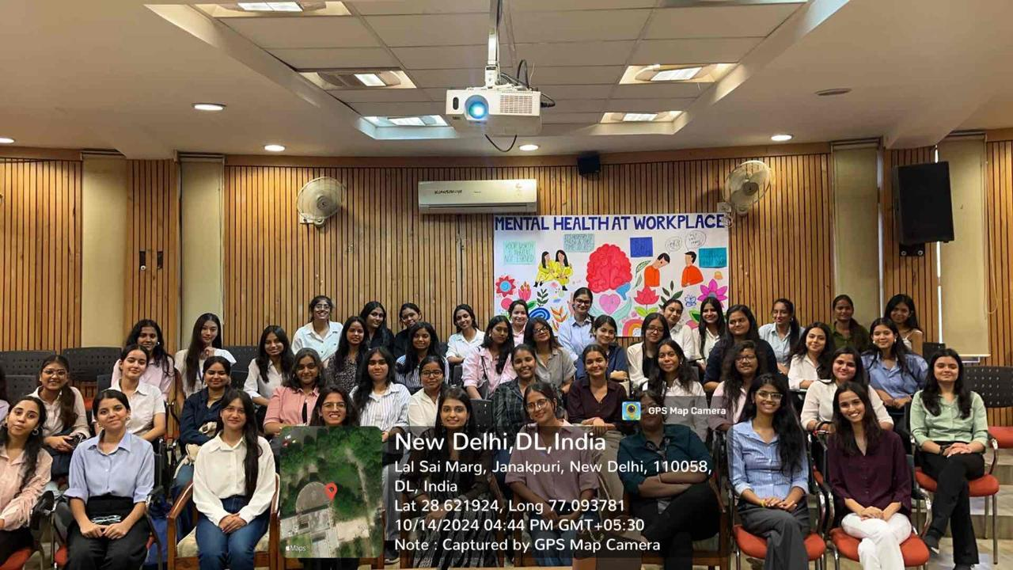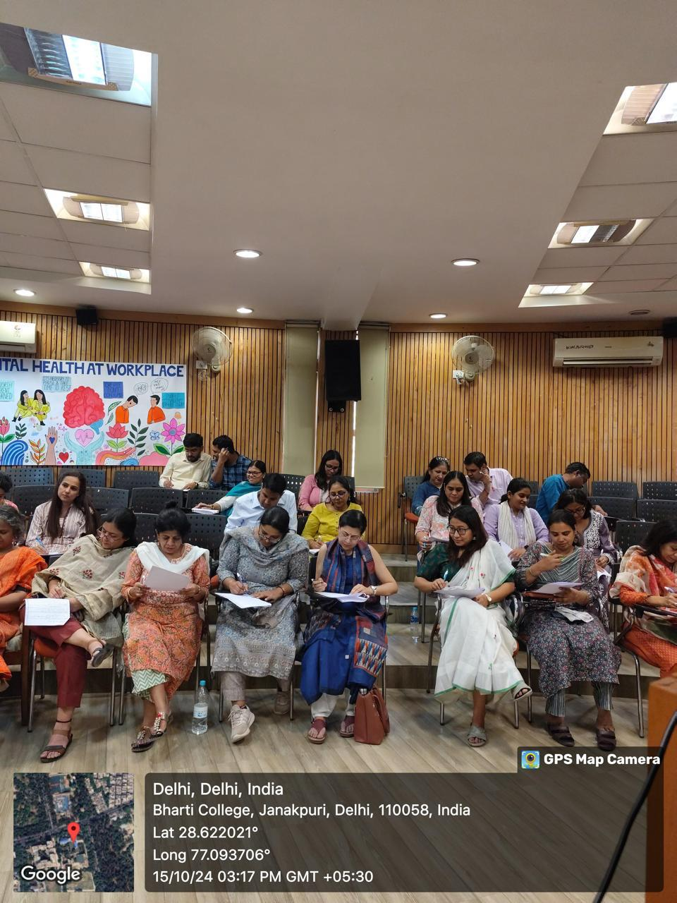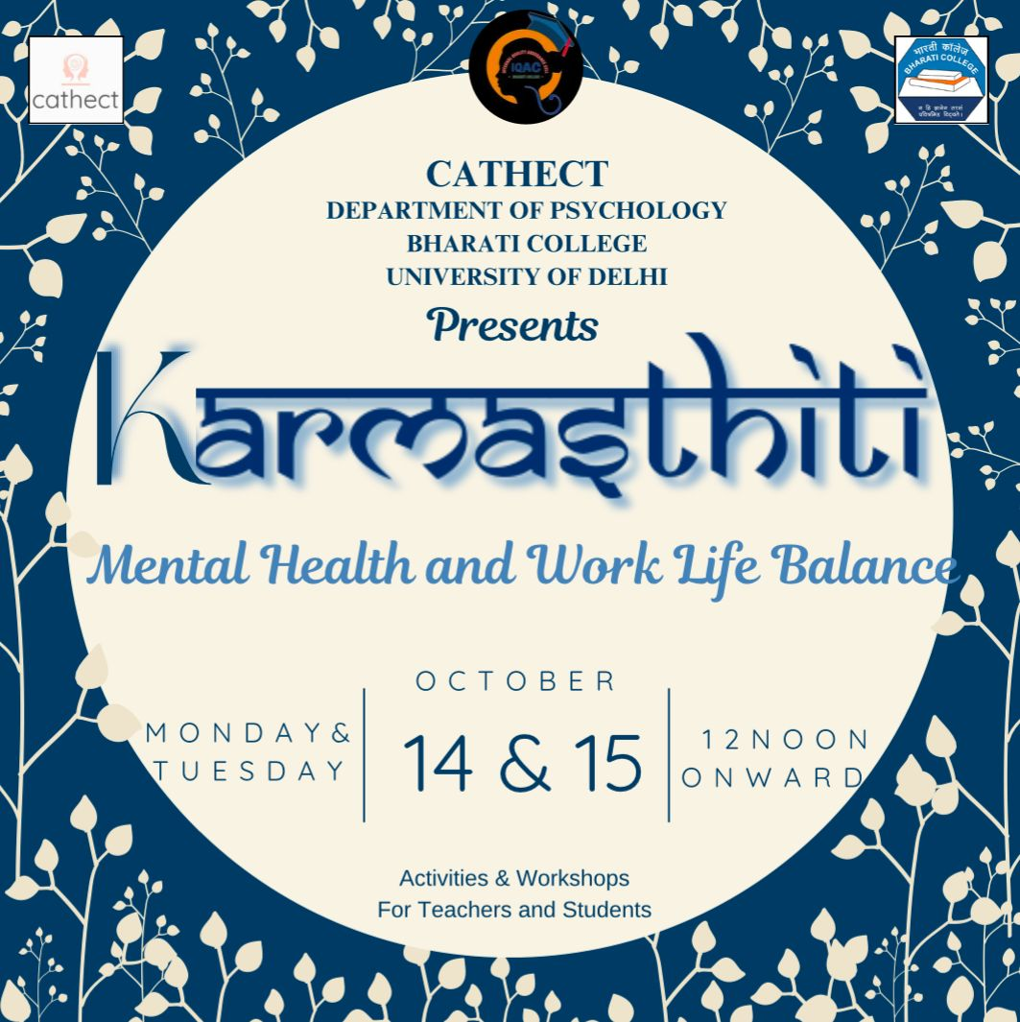
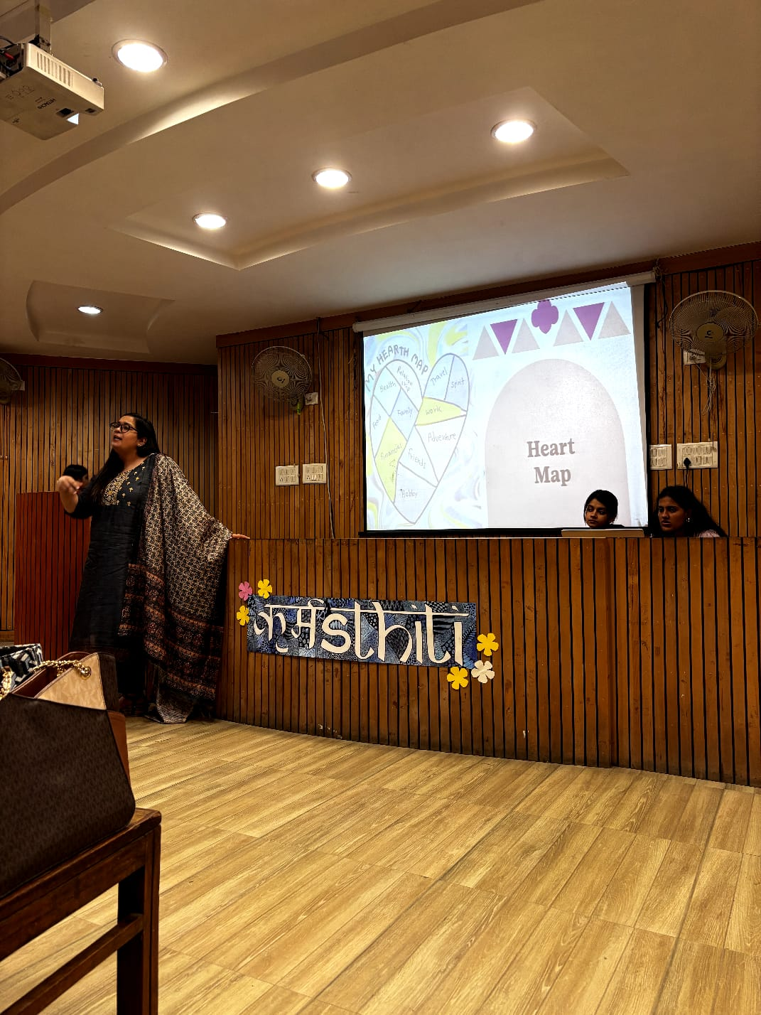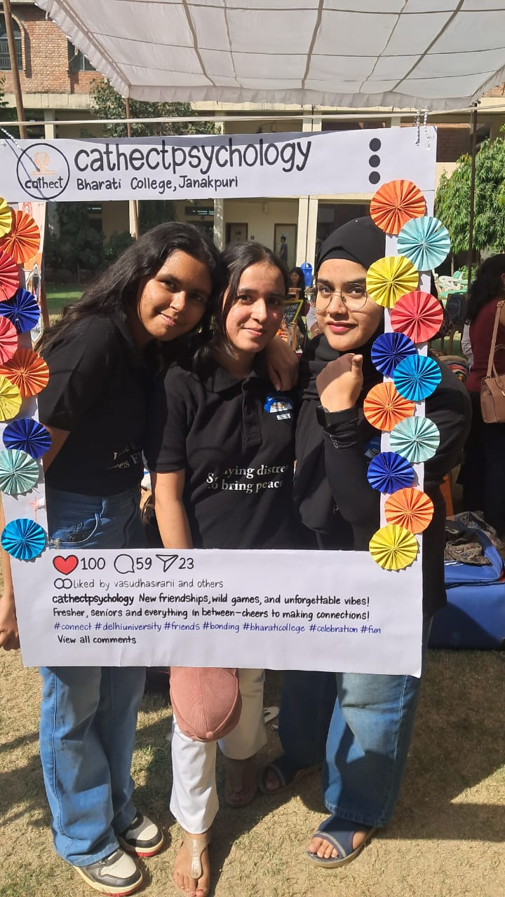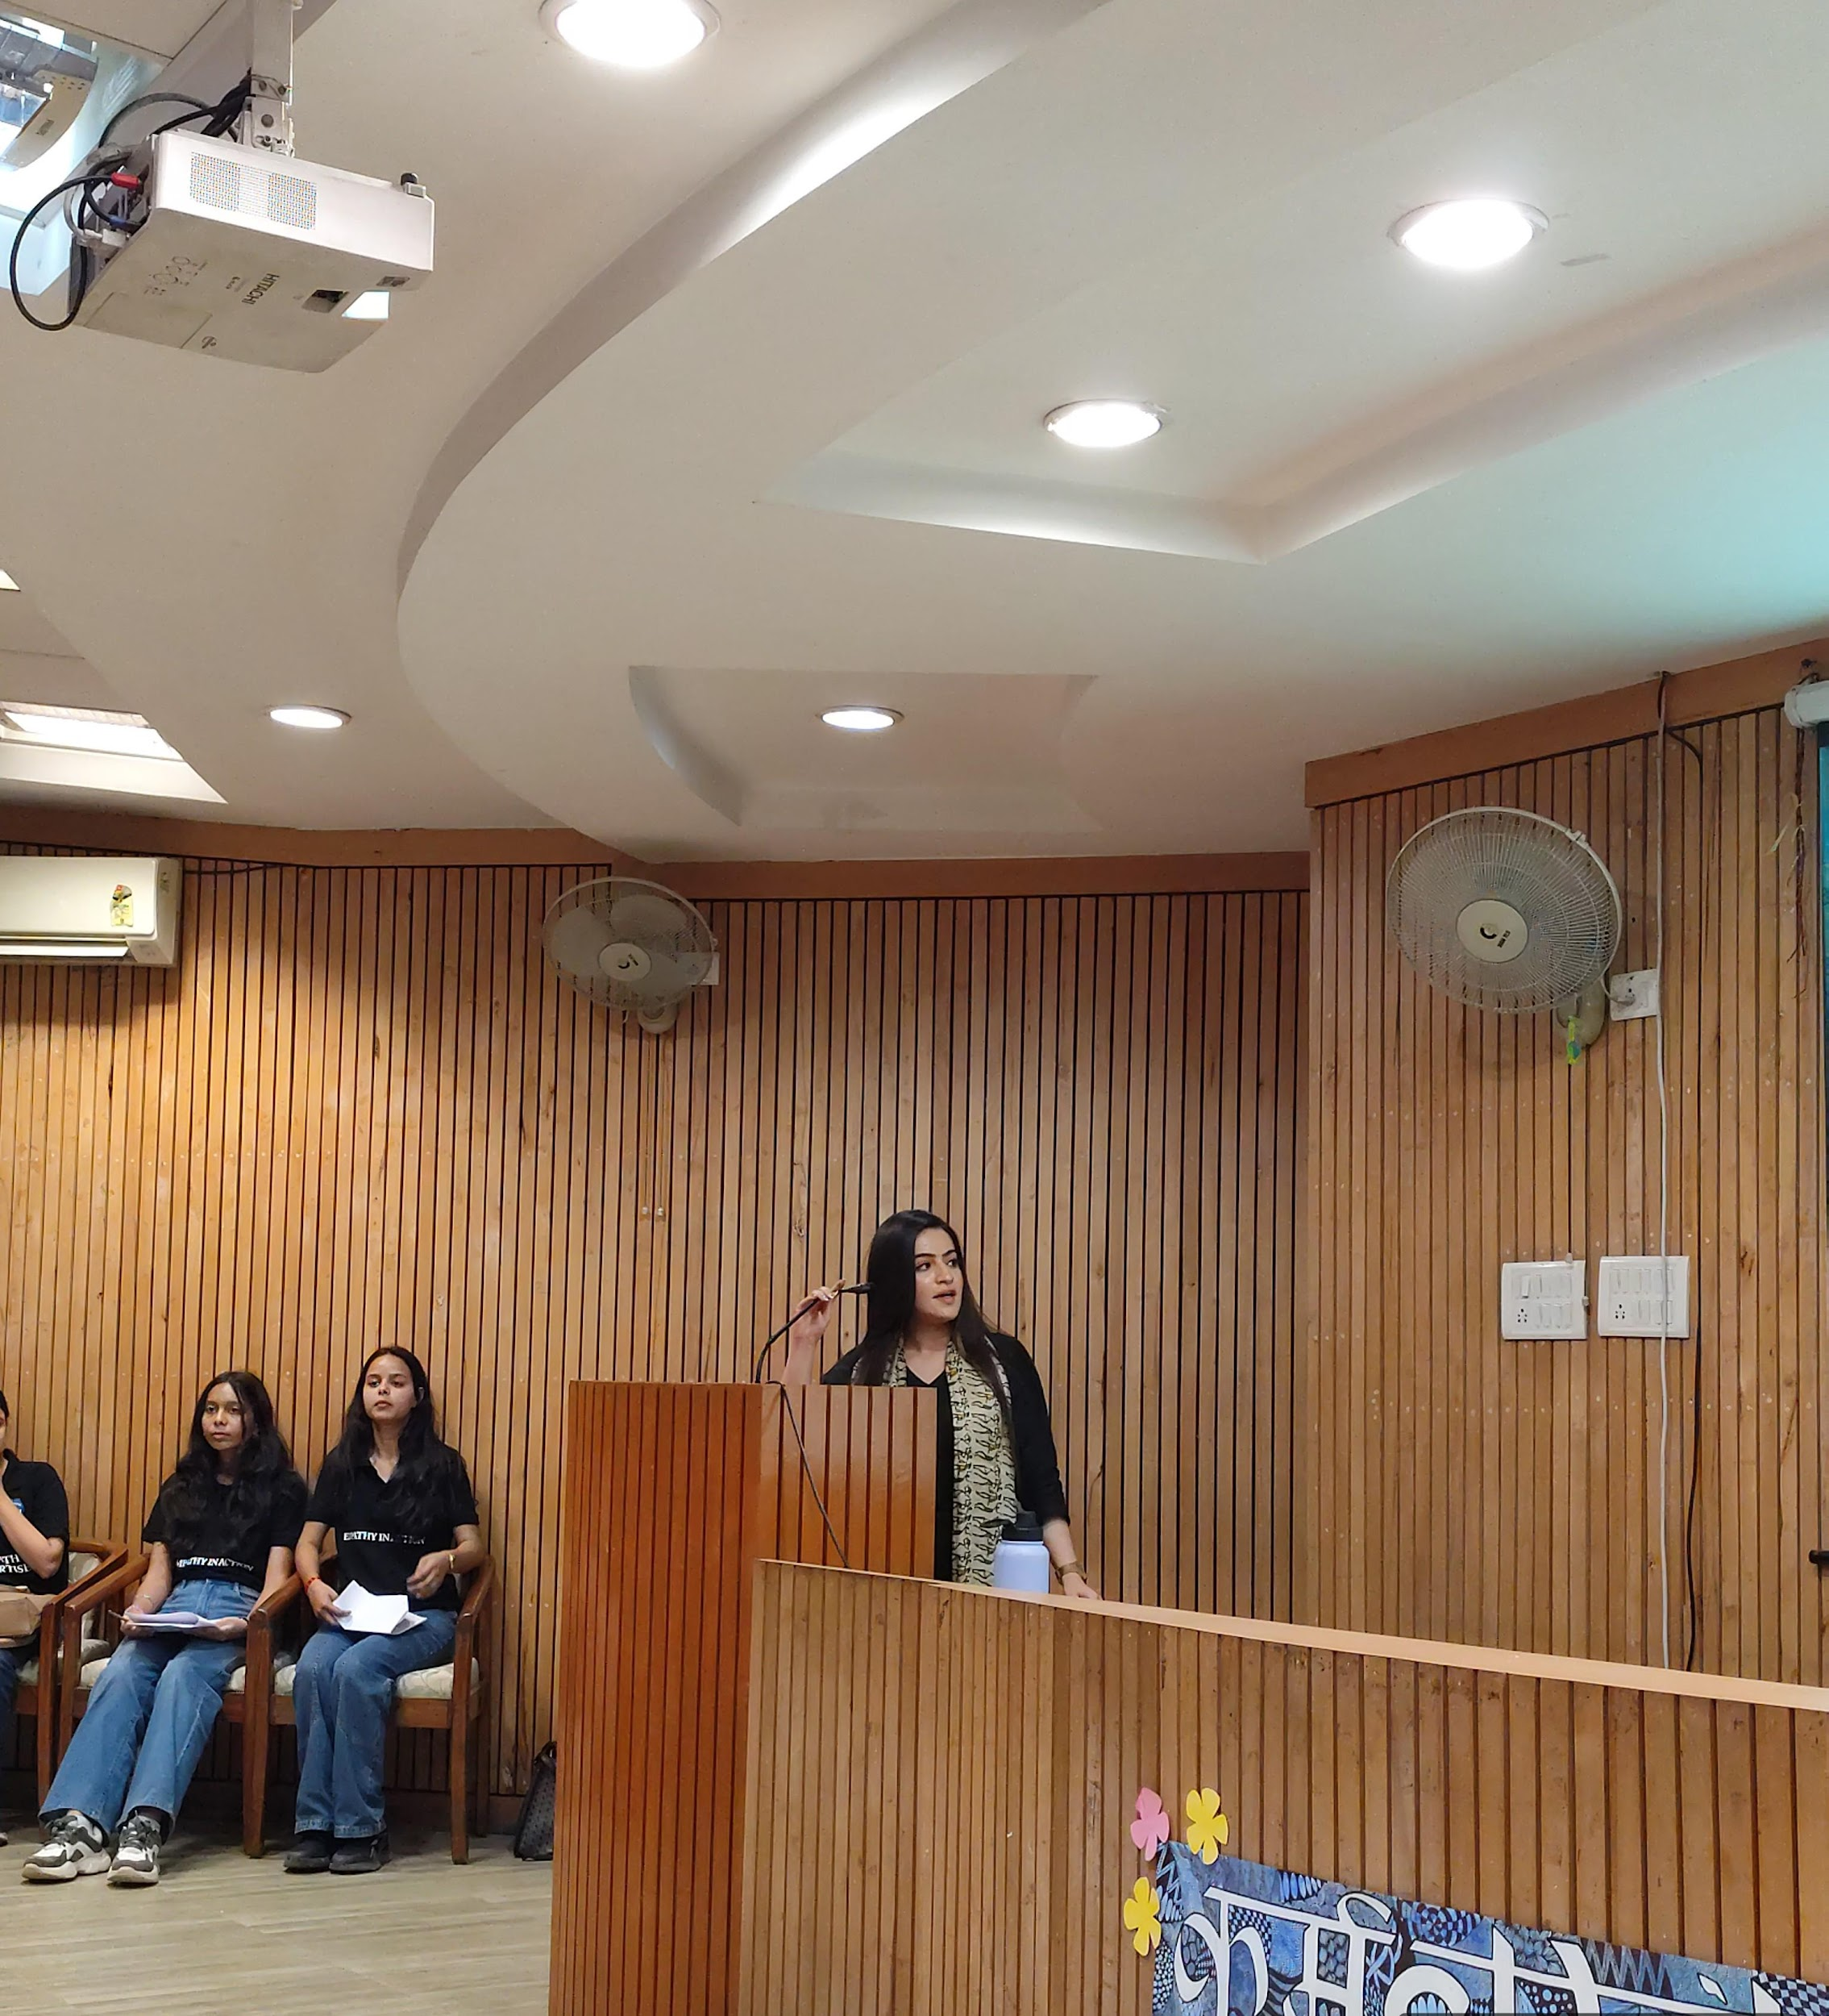
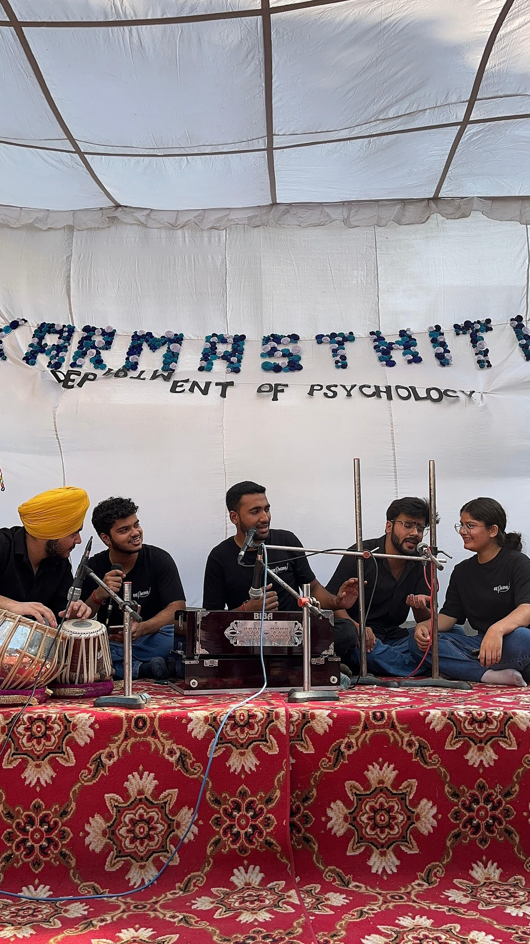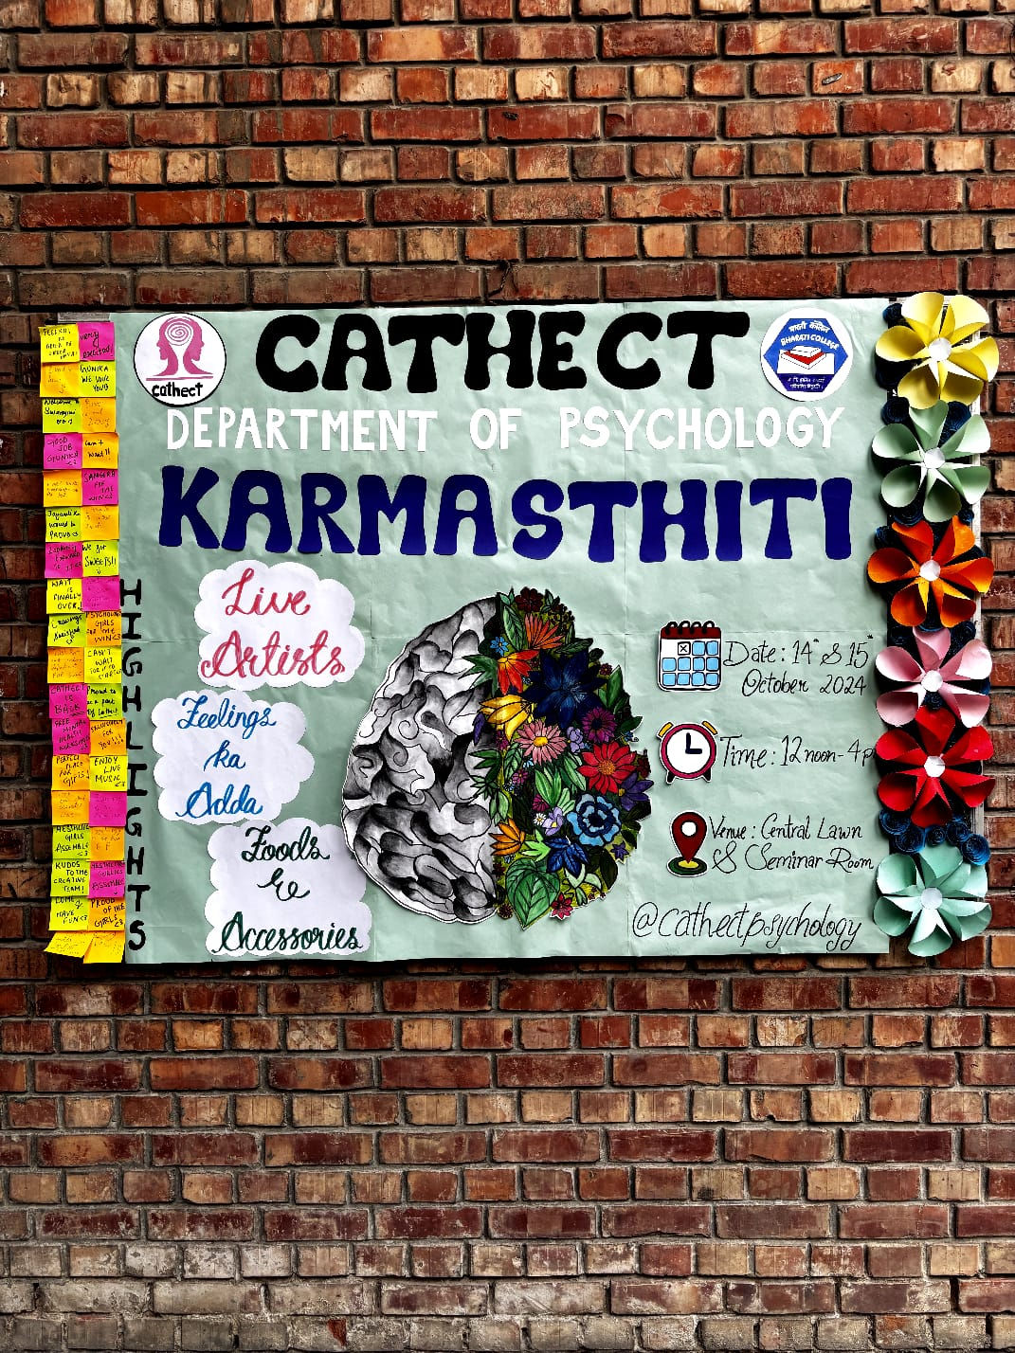

Cathect- Department of Psychology
Under the supervision of IQAC
Bharati College
University of Delhi
Movie Analysis Workshop

23rd October 2024, Bharati College, University of Delhi: Cathect Society, the Department of Psychology at Bharati College under the supervision of IQAC, conducted a workshop on Movie Analysis for second and third-year students of the department. The workshop aimed to help students understand the deeper aspects of themes, character development, and mental health portrayals in films. It began with a warm welcome from the host to the speaker, Ms. Mehak Dua, followed by Ms. Tavishi Sanghi presenting her with a token of appreciation.

Ms. Dua started the session by briefing students on the basics of movie analysis. She emphasized that films should be watched critically, with attention to connections with course content, and recommended a structured approach. She advised watching movies twice: first, to gain an initial impression with a critical eye, and second, to take notes and reflect on how initial perceptions may shift. Using the Bollywood movie “Dear Zindagi” as an example, she led an in-depth discussion on its themes, portrayal of mental health symptoms, the role of the therapist, family environment, and the protagonist’s relationships.

The speaker then expanded on essential aspects to consider during analysis, such as scene portrayals, character representation, cultural remarks, metaphors, and casual statements. She explained how these elements can convey a film's message and societal impact. The movie analysis process was broken down into steps: focusing on details, assessing the overall tone and theme, and including timestamps in notes.

Students were also introduced to different types of movie analysis, with a focus on narrative analysis as particularly applicable. Ms. Mehak then discussed the process of writing a movie analysis.

The workshop concluded with a Q&A session, where students asked questions, and Ms. Mehak provided insights and clarifications.

Key Outcomes:
- The workshop was held in the Seminar Room at Bharati College on October 23, 2024, to enhance students’ analytical skills.
- Ms. Mehak provided invaluable insights into film analysis techniques, guiding students through a structured approach to interpreting movies.
- The session was engaging and informative, with students actively participating in discussions.
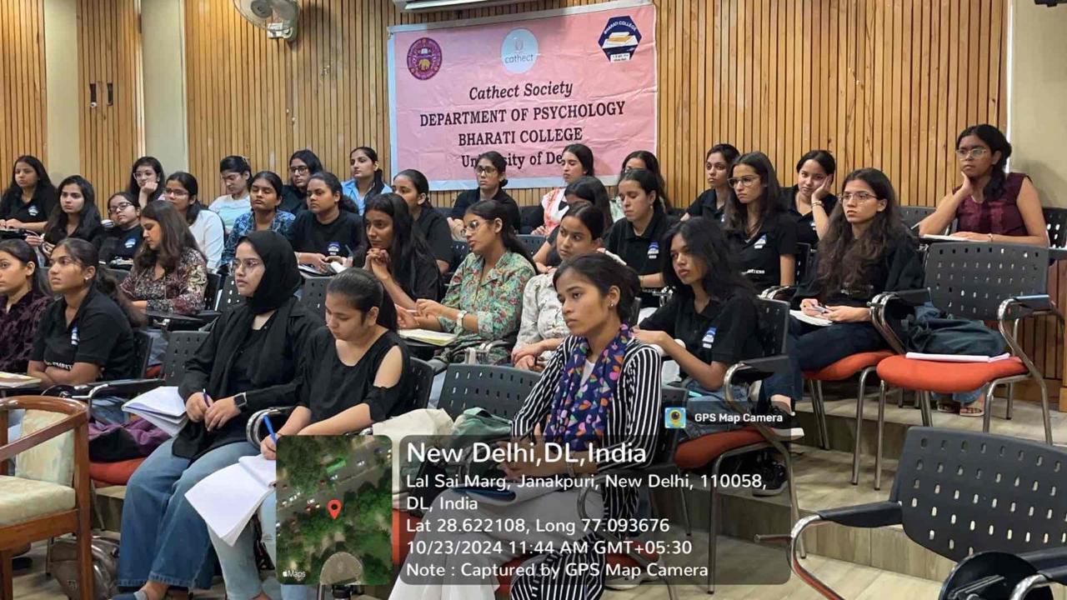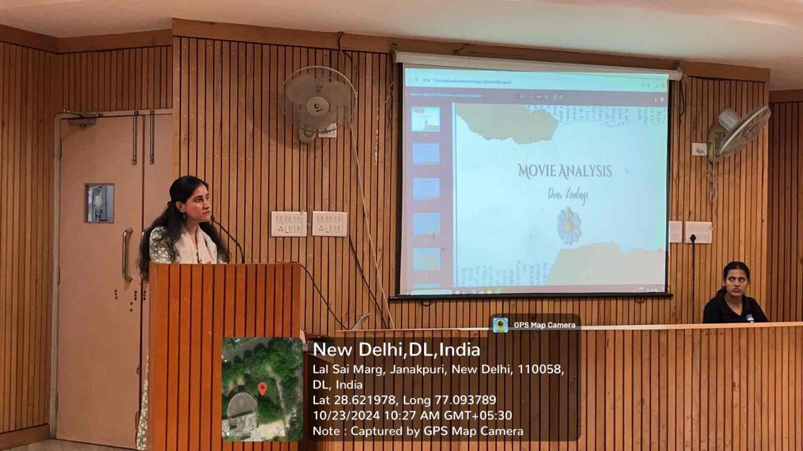
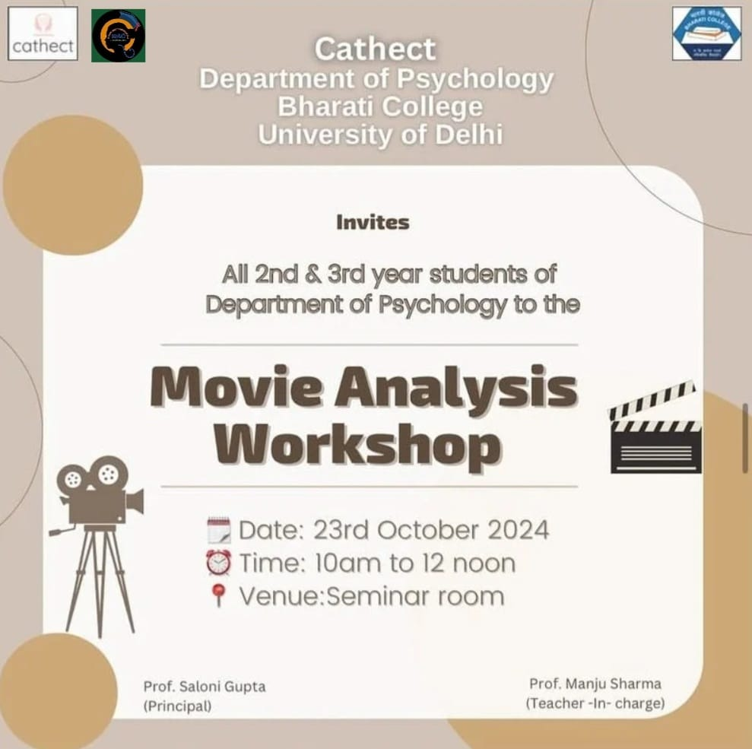

Cathect- Department of Psychology
Under the supervision of IQAC
Bharati College, University of Delhi
Ethnic Day Report

14th November 2024, Bharati College, University of Delhi: The Department of Psychology at Bharati College under the supervision of IQAC, hosted an Ethnic Day celebration on 14th November 2024, uniting students from all years in a vibrant and informal gathering. The event, which showcased the rich cultural diversity of the students, was organized with the aim of fostering unity among them. The celebration was a delightful opportunity for students to connect, share in cultural pride, and create lasting memories.

The event began with a warm welcome to the students, who were dressed elegantly in sarees and kurtis, setting a vibrant tone for the occasion. The primary goal of the event was to foster stronger bonds among students from all three years of the Department of Psychology. To achieve this, several interactive games were organized, including a lively round of dumb charades. The students were divided into two teams, sparking a healthy competitive spirit between them. However, it was the shared laughter and enjoyment that truly stood out, making the event a memorable experience for everyone involved.
The event continued with an exciting ramp walk, where the students showcased their elegance and confidence. Each participant radiated confidence, making the ramp walk a highlight of the celebration. The atmosphere was filled with more energy and joy as everyone danced their hearts out as a lively music session invited students to join hands and dance freely, celebrating the moment.

The event concluded with the President, Aditi Sehrawat, expressing her gratitude to all those who attended, distributing toffees as a sweet gesture of appreciation, and wished everyone well. Students then gathered near the auditorium, posing for individual and group photographs with the entire department, capturing beautiful memories of the day.

Highlights:
- The celebration of Ethnic Day on 14th November, 2024, at Bharati College.
- A collaborative effort by the Department of Psychology students to create more bonding and connections with each other.
- Fun and interactive games that brought excitement to students.
- An exciting ramp walk, where the students walked elegantly and confidently
- The joy of receiving toffees which brought back beautiful memories from school life as the event was conducted on Children’s Day.

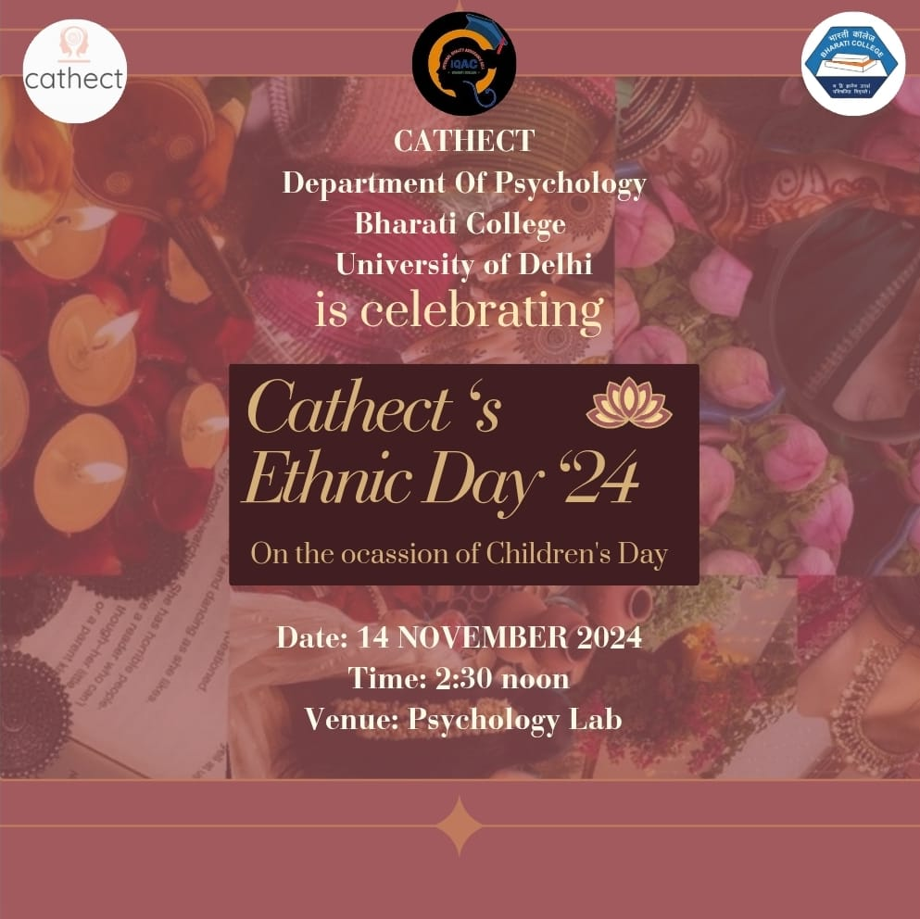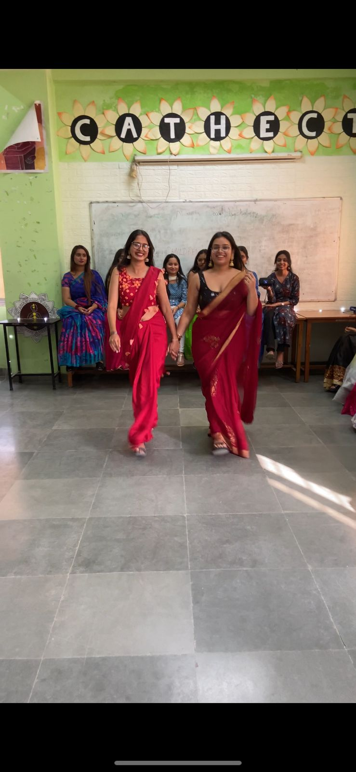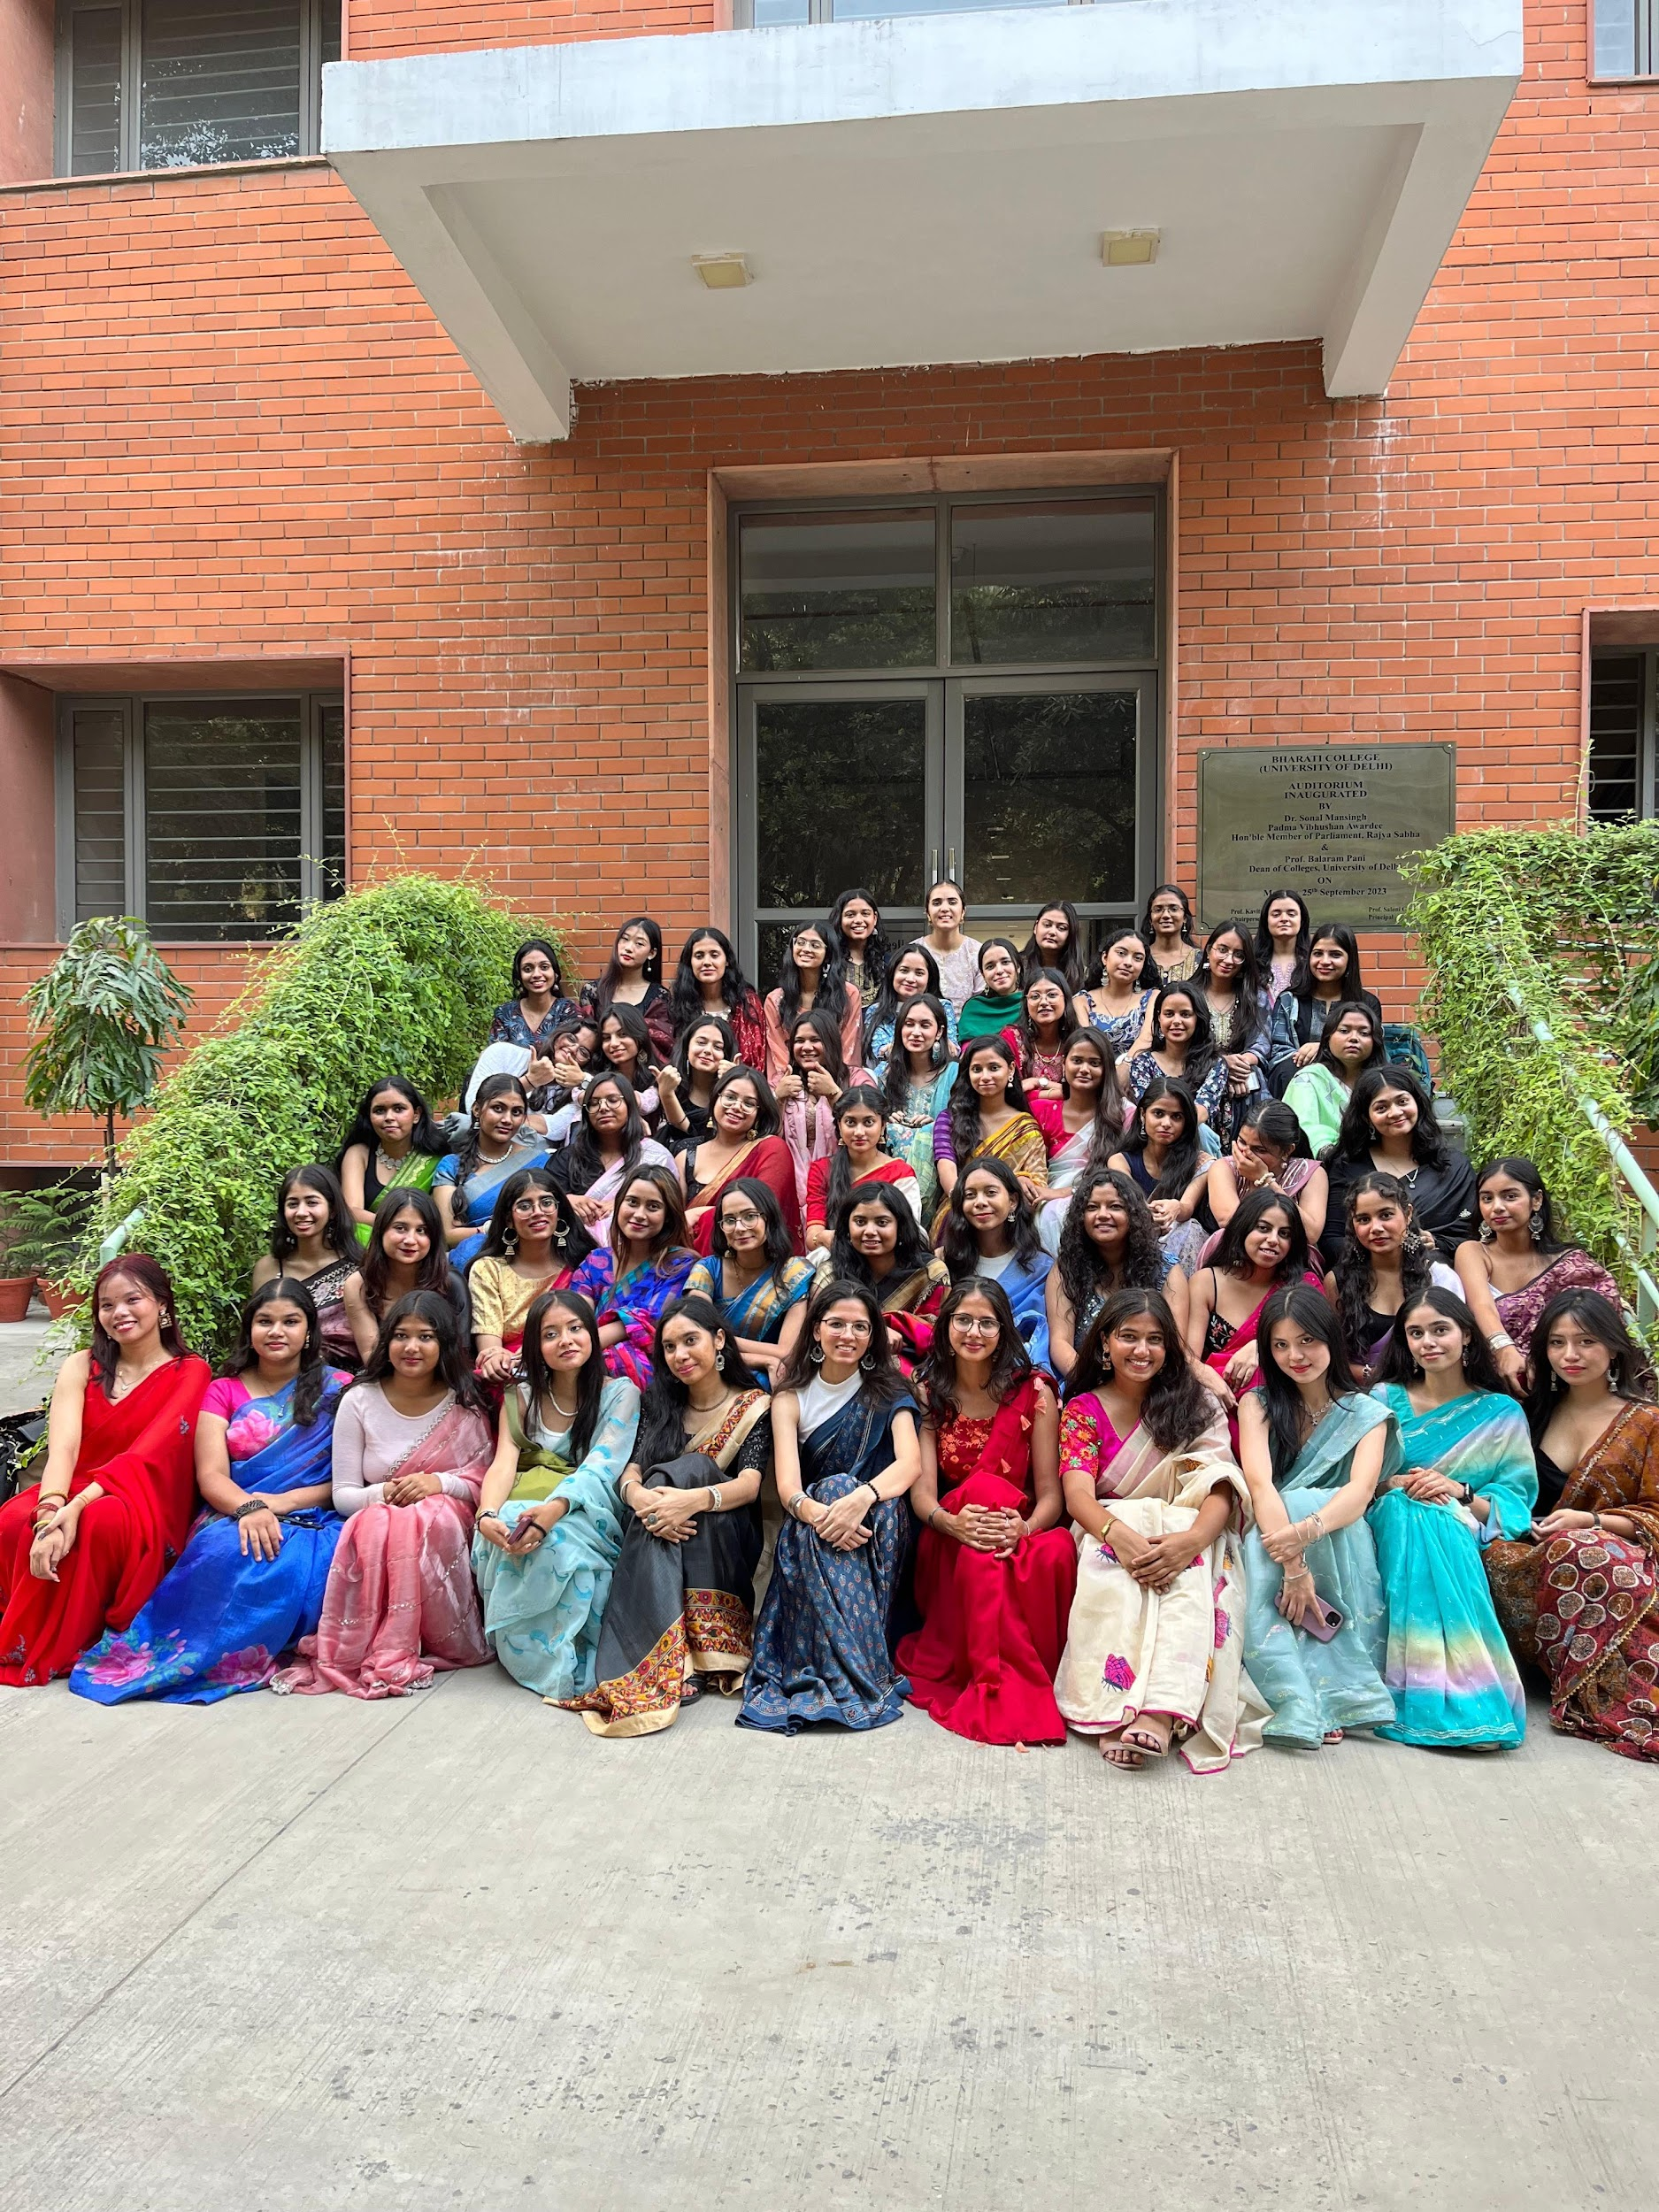

Cathect- Department of Psychology
Under the supervision of IQAC
Bharati College, University of Delhi
Research Discussion Session

29th January, 2025, Bharati College, University of Delhi: The Department of Psychology at Bharati College, University of Delhi, under the supervision of IQAC, hosted a research discussion session on 29th January 2025, for the third-year students of the department. The session was conducted by Dr Bhawna Shivan from the Sociology Department who gave valuable knowledge and insights on research.

The discussion began with the question “Why do we do research?” and the students engaged and interacted in a healthy discussion with the professor. She further expanded the workshop on other important topics of research such as ethical considerations in research, decolonisation in research, and different types of research. The purpose of this discussion was to clarify some basic concepts about conducting research, the goals and purpose of research and to have healthy and interactive discussions with the students to expand their knowledge.
The discussion concluded with a doubt-clearing session with students and Ms. Reebika, Assistant Professor, Department of Psychology expressing her gratitude by giving a token of appreciation to Dr. Shivan. Students expressed their gratitude towards her by giving a heartfelt round of applause.
Key Highlights:
- The research paper discussion on 29th January, 2025, at Bharati College.
- A collaborative effort by the Department of Psychology and Department of Sociology to expand the knowledge on research.
- A healthy and interactive discussion on research.
- A doubt-clearing session by the end of the session

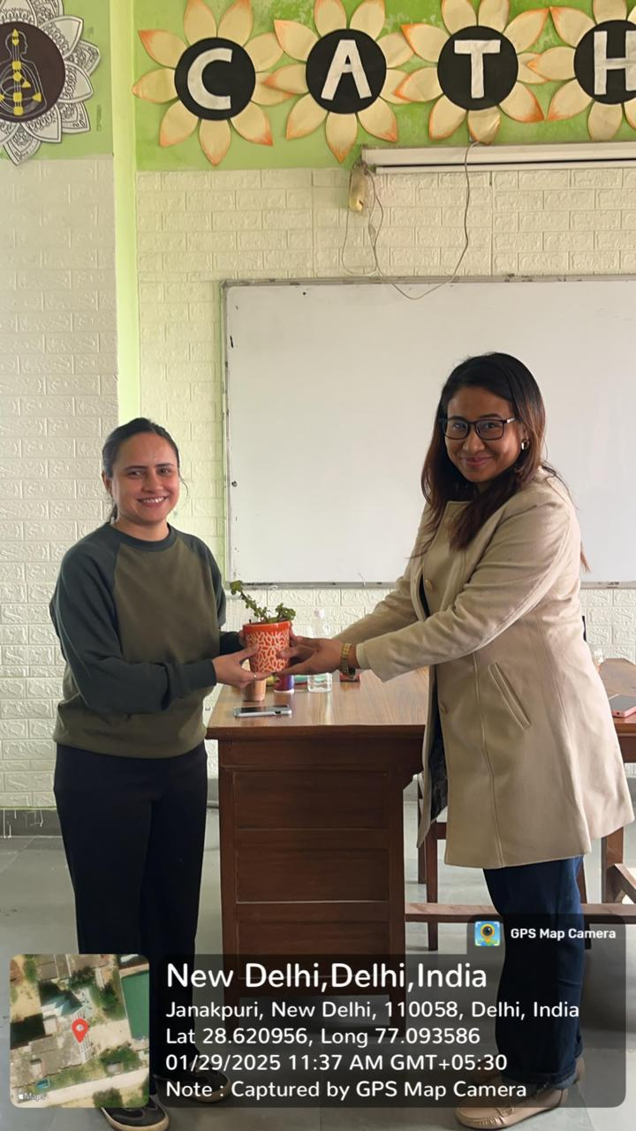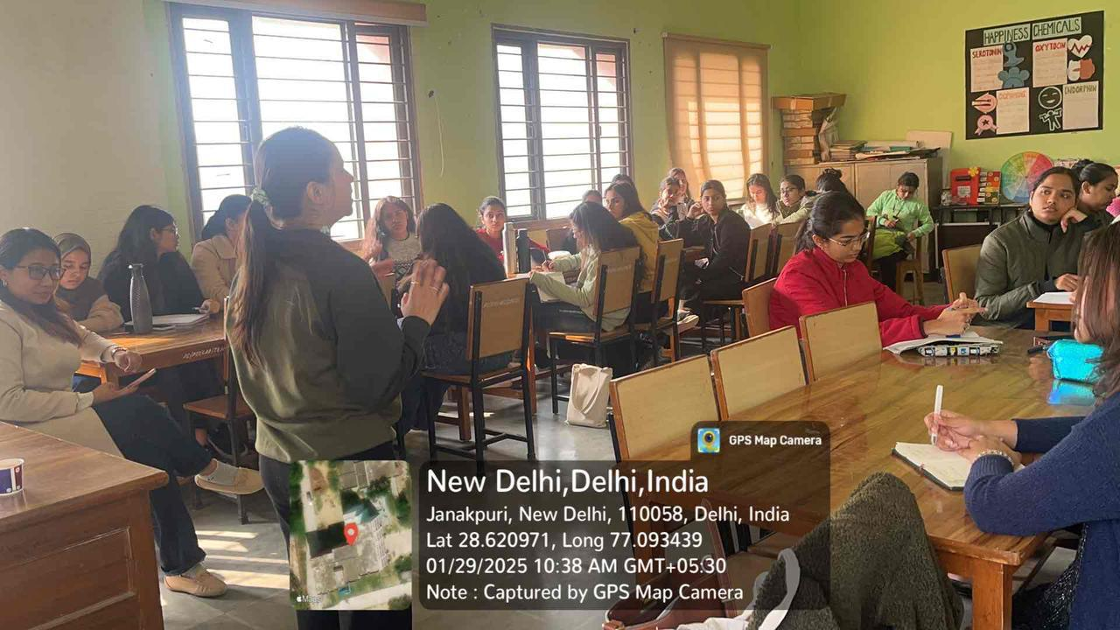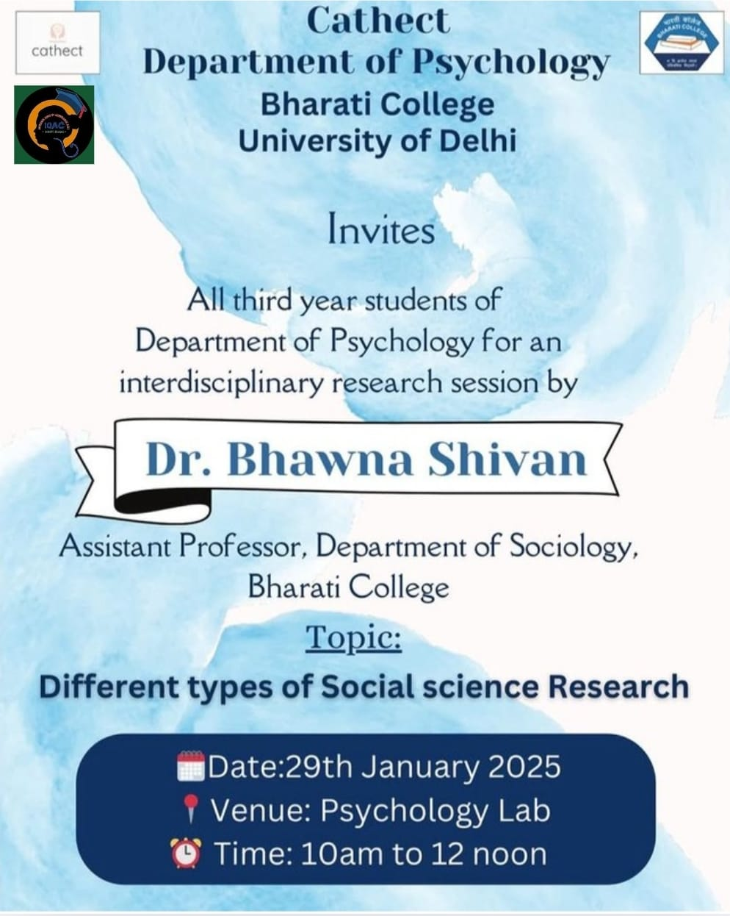

Cathect- Department of Psychology
Under the supervision of IQAC
In Collaboration with
Research Committee
Bharati College, University of Delhi
Workshop on Research Paper Writing and Publication

17th February 2025, Bharati College, University of Delhi: Cathect Society, Department of Psychology, Bharati College, in association with IQAC and the Research Committee, conducted an interdisciplinary workshop on Research Paper Writing and Publication on February 17, 2025. The workshop was conducted to provide students with the necessary skills in academic writing, from developing research ideas to becoming proficient in qualitative research techniques. It was conducted in the college auditorium and saw a huge response from students of different departments of Bharati College.
The event began with the lamp-lighting ceremony, during which the T.I.C., Prof. Manju Sharma, along with the esteemed guests and faculty members, lit the lamp to seek blessings. This was followed by a graceful Ganesh Vandana performed by Anshika Khanna and Lakshika, setting a calm and enlightening tone for the day. The ceremony was followed by insightful sessions conducted by prominent speakers who provided valuable insights into research.
The sessions provided valuable insights into research methodologies and academic resources. Dr. Harinder Sandhu covered key aspects of formulating a research idea, including scientific methods, research problem selection, and common mistakes in the process. Mr. Chandrajeet Singh and Ms. Preeti Vats guided students on using college software, citation techniques, and the significance of E-resources. Dr. Anshu Chaudhary conducted a session on qualitative research, discussing data collection methods, analysis techniques, and the role of qualitative research in social sciences. Each session concluded with a doubt-clearing segment, ensuring an engaging and informative experience for students.

Key Outcomes:
- Dr. Harinder Sandhu introduced the fundamental principles of research formulation that comprised scientific approach to research, generation of ideas, importance of social science research, and categories of research designs.
- Mr. Charanjeet Singh and Ms. Preeti Vats guided students through the use of digital tools, citation styles, and citation strategies.
- Dr. Anshu Chaudhary led a comprehensive session on qualitative research with focus on data collection as well as analytical methods.
- Participants were requested to fill in an online feedback survey to offer their comments on learning and their experiences at the workshop.

19th February, 2025, Bharati College, University of Delhi: The second day of the Research Paper Workshop focused on advanced methodologies and practical tools for research. The sessions provided insights into both qualitative and quantitative approaches, with expert speakers guiding attendees through the intricacies of data collection, questionnaire formulation, and statistical analysis.

The event commenced with an inaugural address, setting the tone for the day's discussions. Following this, Dr. Halley S. Thokchom from Aryabhatta College, University of Delhi, led an insightful session on ‘How to Approach Quantitative Research Methods’. He elaborated on the formulation of a qualitative approach to research, setting objectives for quantitative research design, and techniques for data collection. He emphasized that once a tool becomes standardized, the result becomes universal. While covering the topic, he focused on how different research designs are used for quantitative studies, furthermore stating that the statistical part of a research could be outsourced however one should always know the process of interpreting the data.

Prof. Anupama Mahajan from Bharati College, University of Delhi, conducted the next session, focusing on ‘How to Form a Questionnaire and Data Collection Process’. She started the session with a discussion over the types of research—basics, exploratory and, conclusive. She then provided detailed explanations of structuring effective questionnaires and best practices in data gathering, ensuring the validity and reliability of the research.

The afternoon session featured Dr. Shilpi Sahi and Dr. Sonali Jain, Assistant Professors from the Department of Commerce, Bharati College, University of Delhi. They introduced participants to Excel and SPSS, covering essential statistical tools for data analysis. The session included various topics like—-Basics of SPSS and Excel in social science research, session creation, data screening and entry, descriptive analysis, correlation analysis, and hypothesis testing. Attendees actively engaged in hands-on exercises, applying statistical concepts to real-world research problems.

Key Outcomes:
- Through Dr. Thokchom’s insightful session, participants gained a deeper understanding of the fundamentals of quantitative research.
- The session on questionnaire formulation by Prof. Mahajan helped students refine their data collection methods.
- Through Dr. Sahi’s hands-on training with Excel and Dr. Jain’s insights on using SPSS empowered students with practical research tools.
- The interactive format encouraged engagement and critical thinking among attendees.

21st February, 2025, Bharati College, University of Delhi: The Cathect Society, Department of Psychology, Bharati College, in association with IQAC and the Research Committee, conducted an interdisciplinary workshop on Research Paper Writing and Publication on February 21, 2025.The third day of the workshop featured a series of sessions aimed at equipping students with essential skills for writing and publishing a research paper. It was conducted in the college auditorium and saw a huge response from students of different departments of Bharati College.
Dr. Kanika Ahuja conducted a session in which she emphasized "how to write a research paper" and "how to publish a research paper." Based on her extensive experience in this field, she addressed all the key elements of writing a research paper, including the ethical considerations involved.
Dr. Akshat Pushpam conducted a session on developing a publication strategy in research, the criteria for publication, and formatting. Each session concluded with a doubt-clearing session, ensuring an informative learning experience for the students.

Key Outcomes:
- The workshop provided the students with a proper insight into research writing and publishing.
- Dr. Kanika Ahuja's lecture on "The Art of Writing Paper" provided them with a systematic understanding of how to write a research paper effectively.
- Mr. Akshat Pushpam's lecture on "Publication" explained how a research paper should be published, from formulating a strategy to the need for formatting.
- Students learned the main academic writing points, enhancing their research writing skills.
- The workshop sessions allowed the participants to engage with experts and gain valuable insights into writing and publishing a research paper.

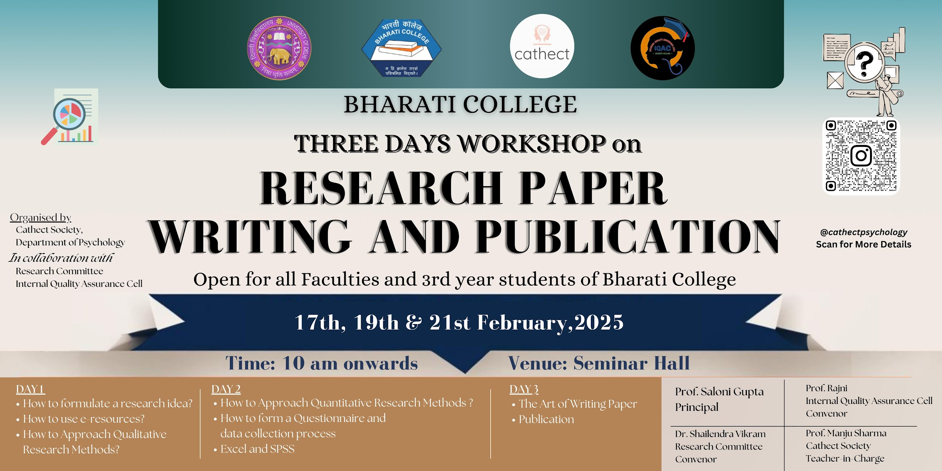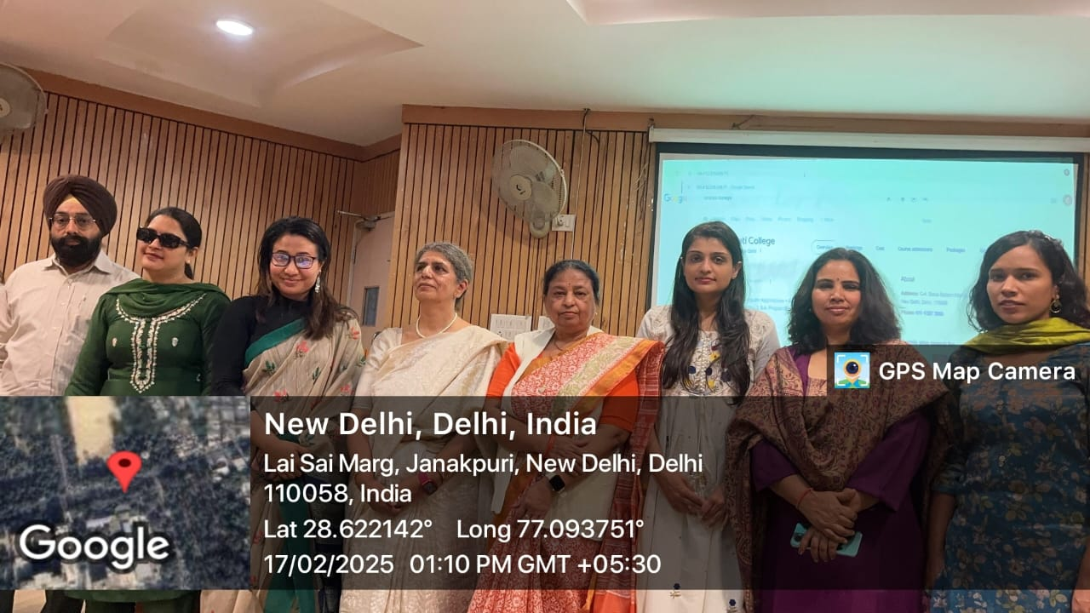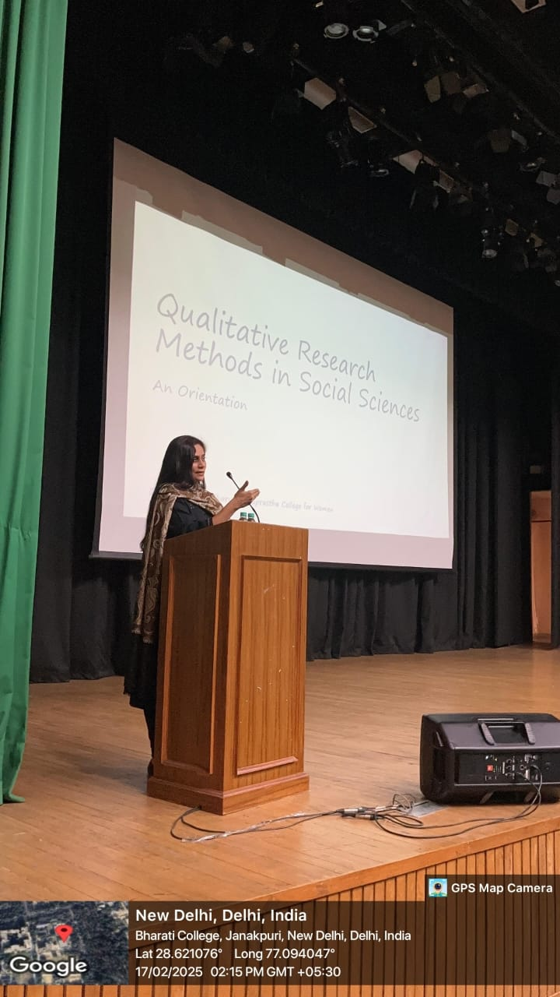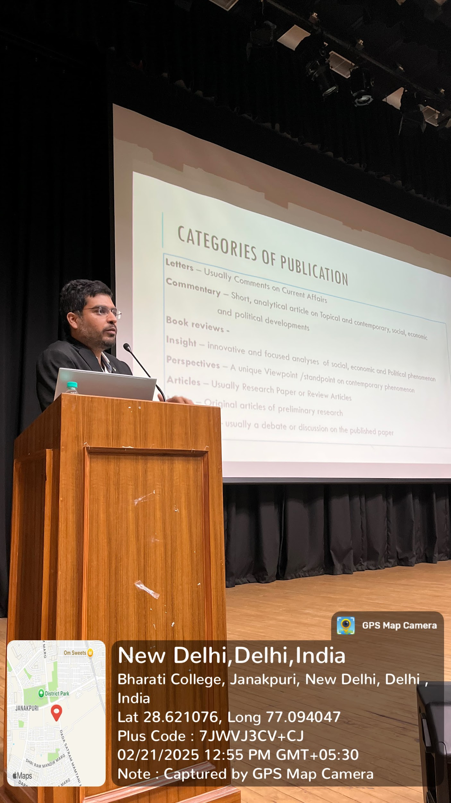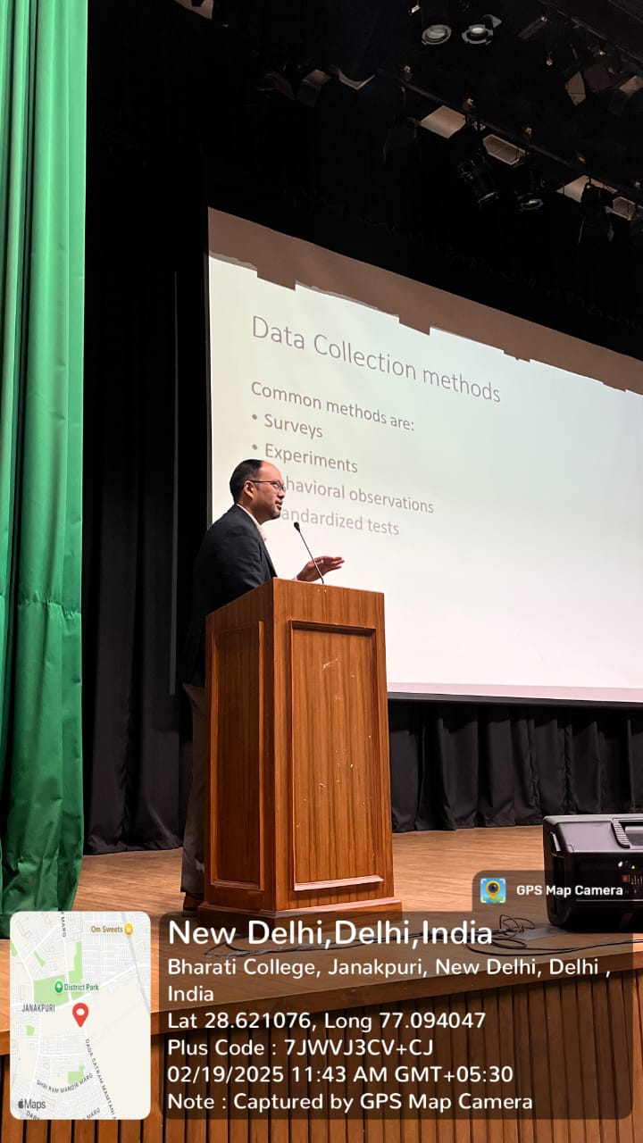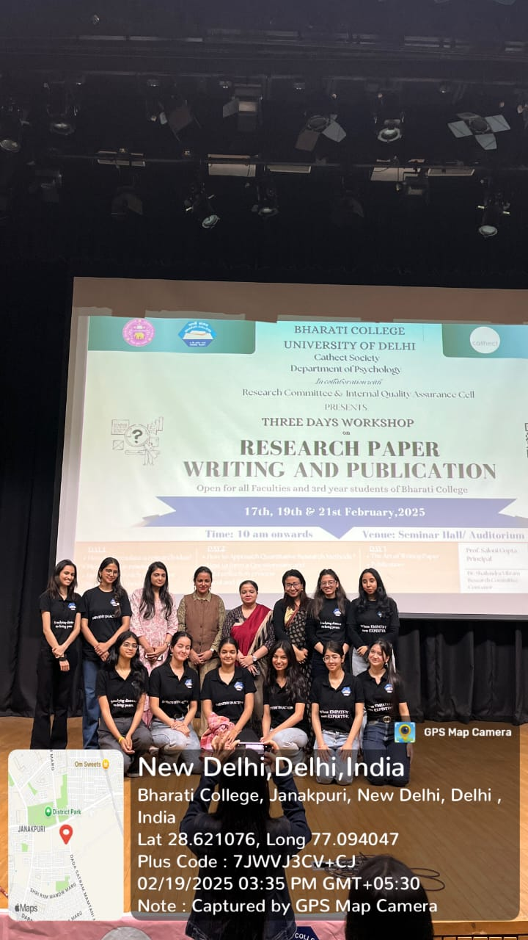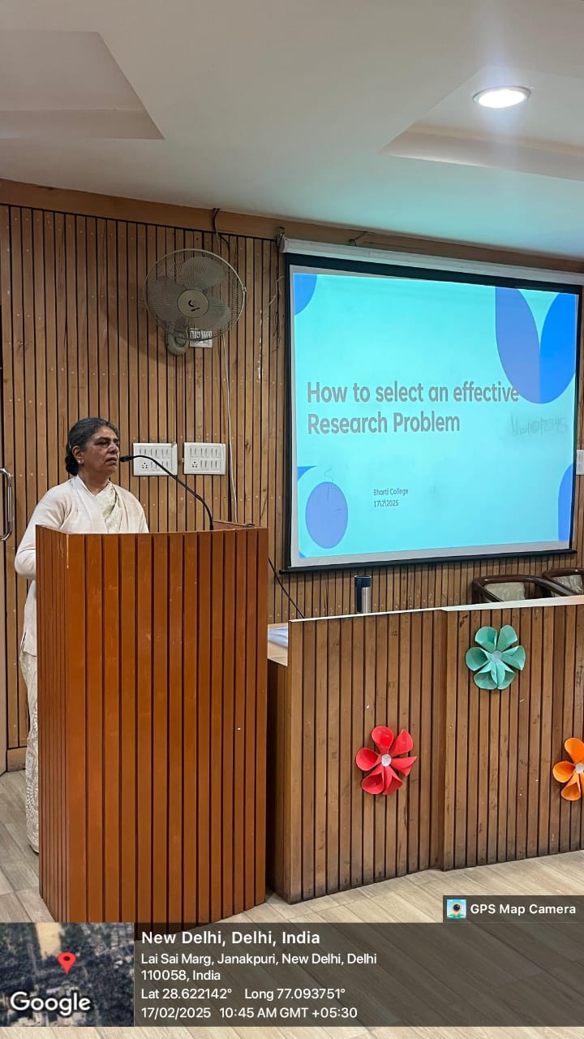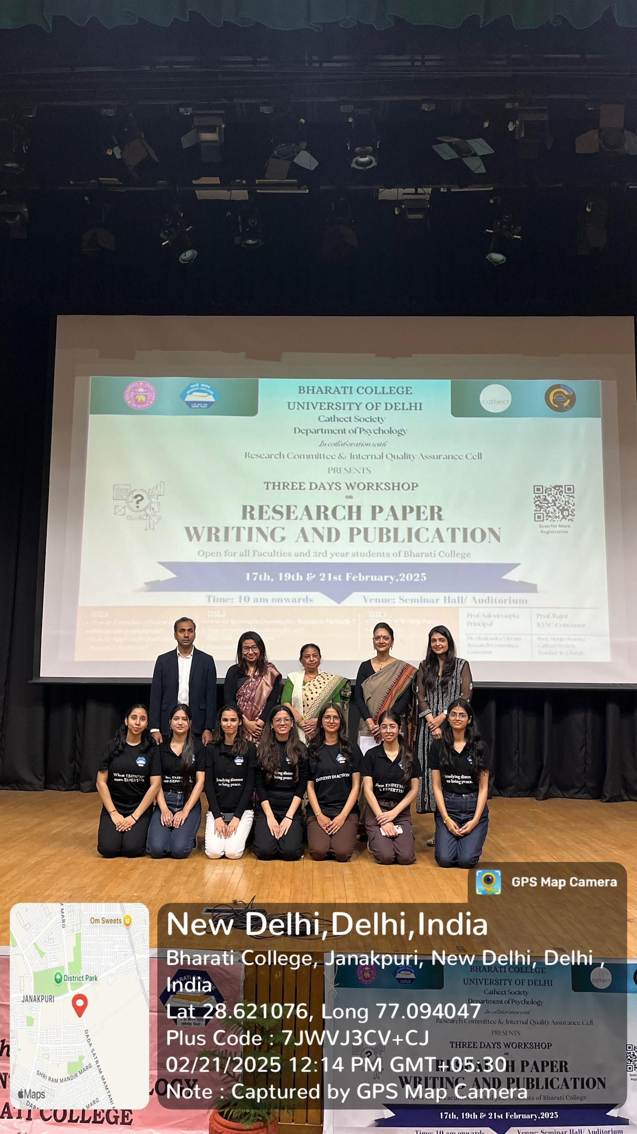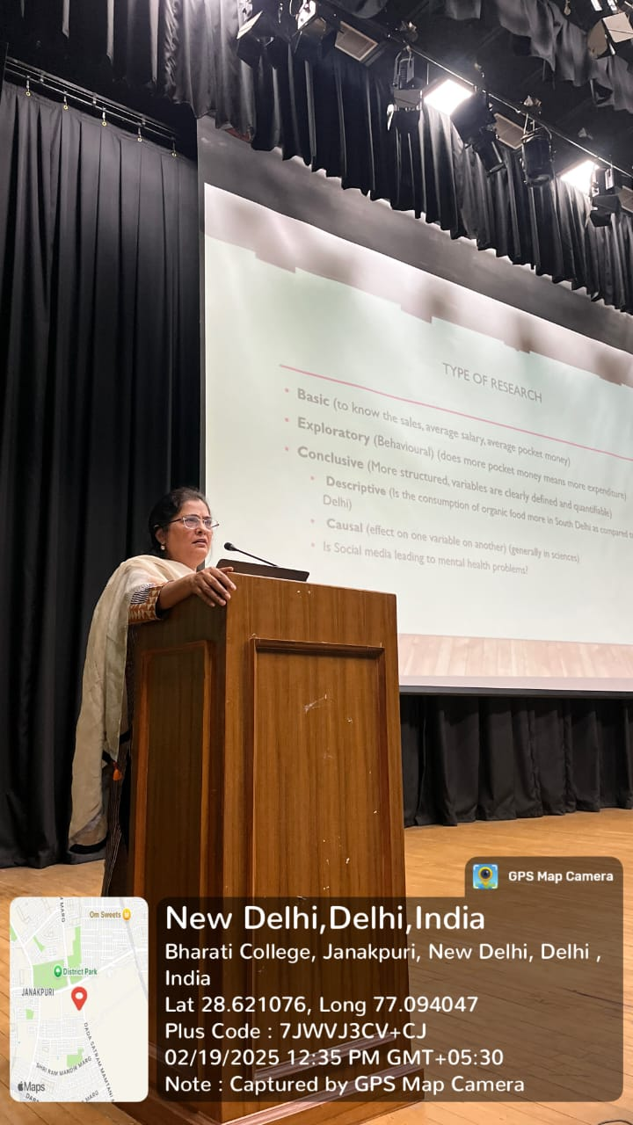

Cathect- Department of Psychology
Under the supervision of IQAC
Bharati College, University of Delhi
Alumni Meet: 2024-25

7th March 2025, Bharati College, University of Delhi: The Department of Psychology, Bharati College, under the supervision of IQAC organized the much-anticipated Alumni Meet on 7th March 2025, which brought together former students, faculty members, and current students for a day filled with insightful talks, fun games, and cherished memories. The event took place in the Psychology Lab and welcomed alumni from various institutions who shared their experiences, career insights, and expertise.
The alumni speakers included Eesha Dua from Amity University, who shared her clinical experiences at major hospitals; Ananya Sacheti from Christ University, who spoke about conscious relationships and inner child work; Sneh Babra from NFSU, Gandhinagar, who discussed her work in Neuropsychology and rehabilitation; Mahi Panda from the University of Leeds, who provided insights on cognitive development and studying abroad; Ayushi Chakma from Delhi University, North Campus; and Rakhi Lamba, Jannat Bano, and Jasmine Lohia from B.R. Ambedkar University. The alumni shared helpful tips on CUET preparation, university interviews, attendance requirements, campus life, and managing college exams, offering students practical guidance for their academic and professional journeys.
Highlights:
- Reconnecting with distinguished alumni and building meaningful connections between former and current psychology students.
- Gaining valuable career advice through alumni-led sessions covering diverse fields within psychology.
- Participating in interactive games, discussions, and team-building exercises designed to foster a strong sense of community.
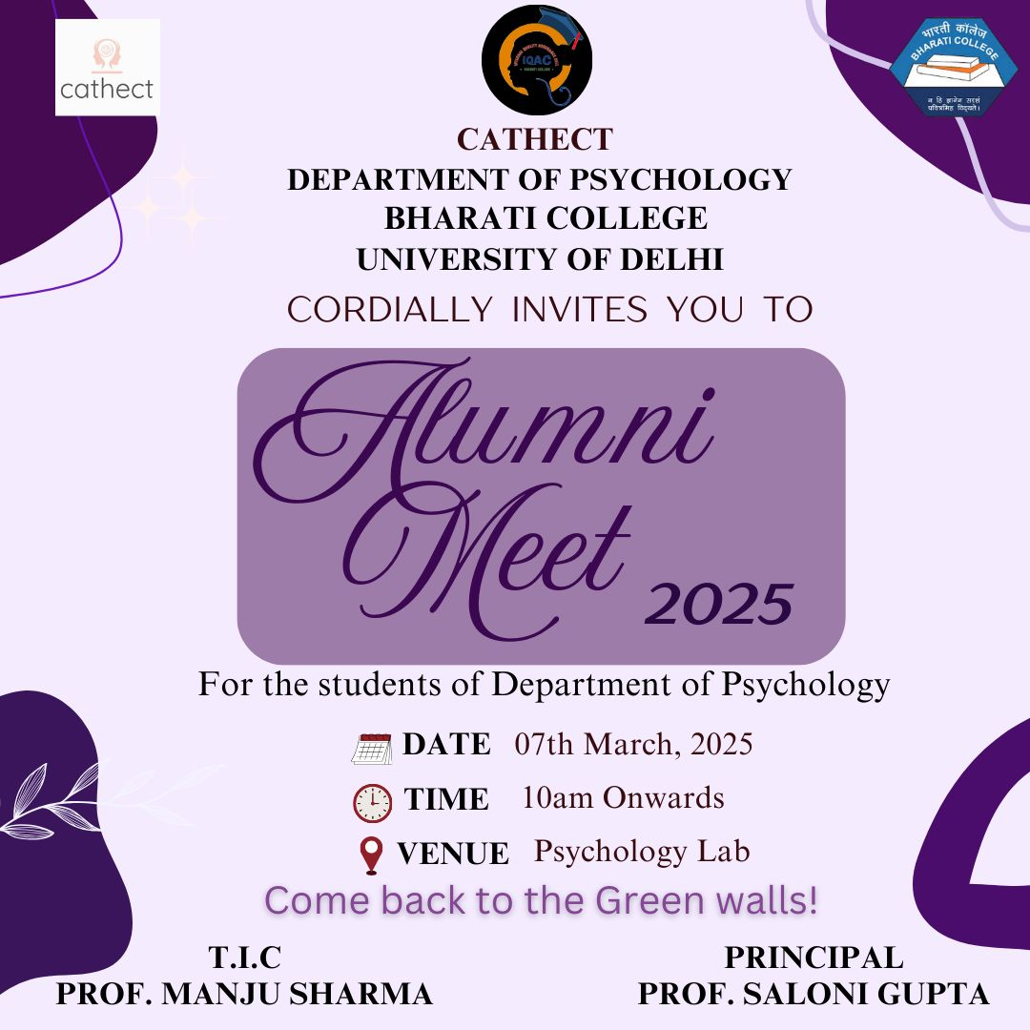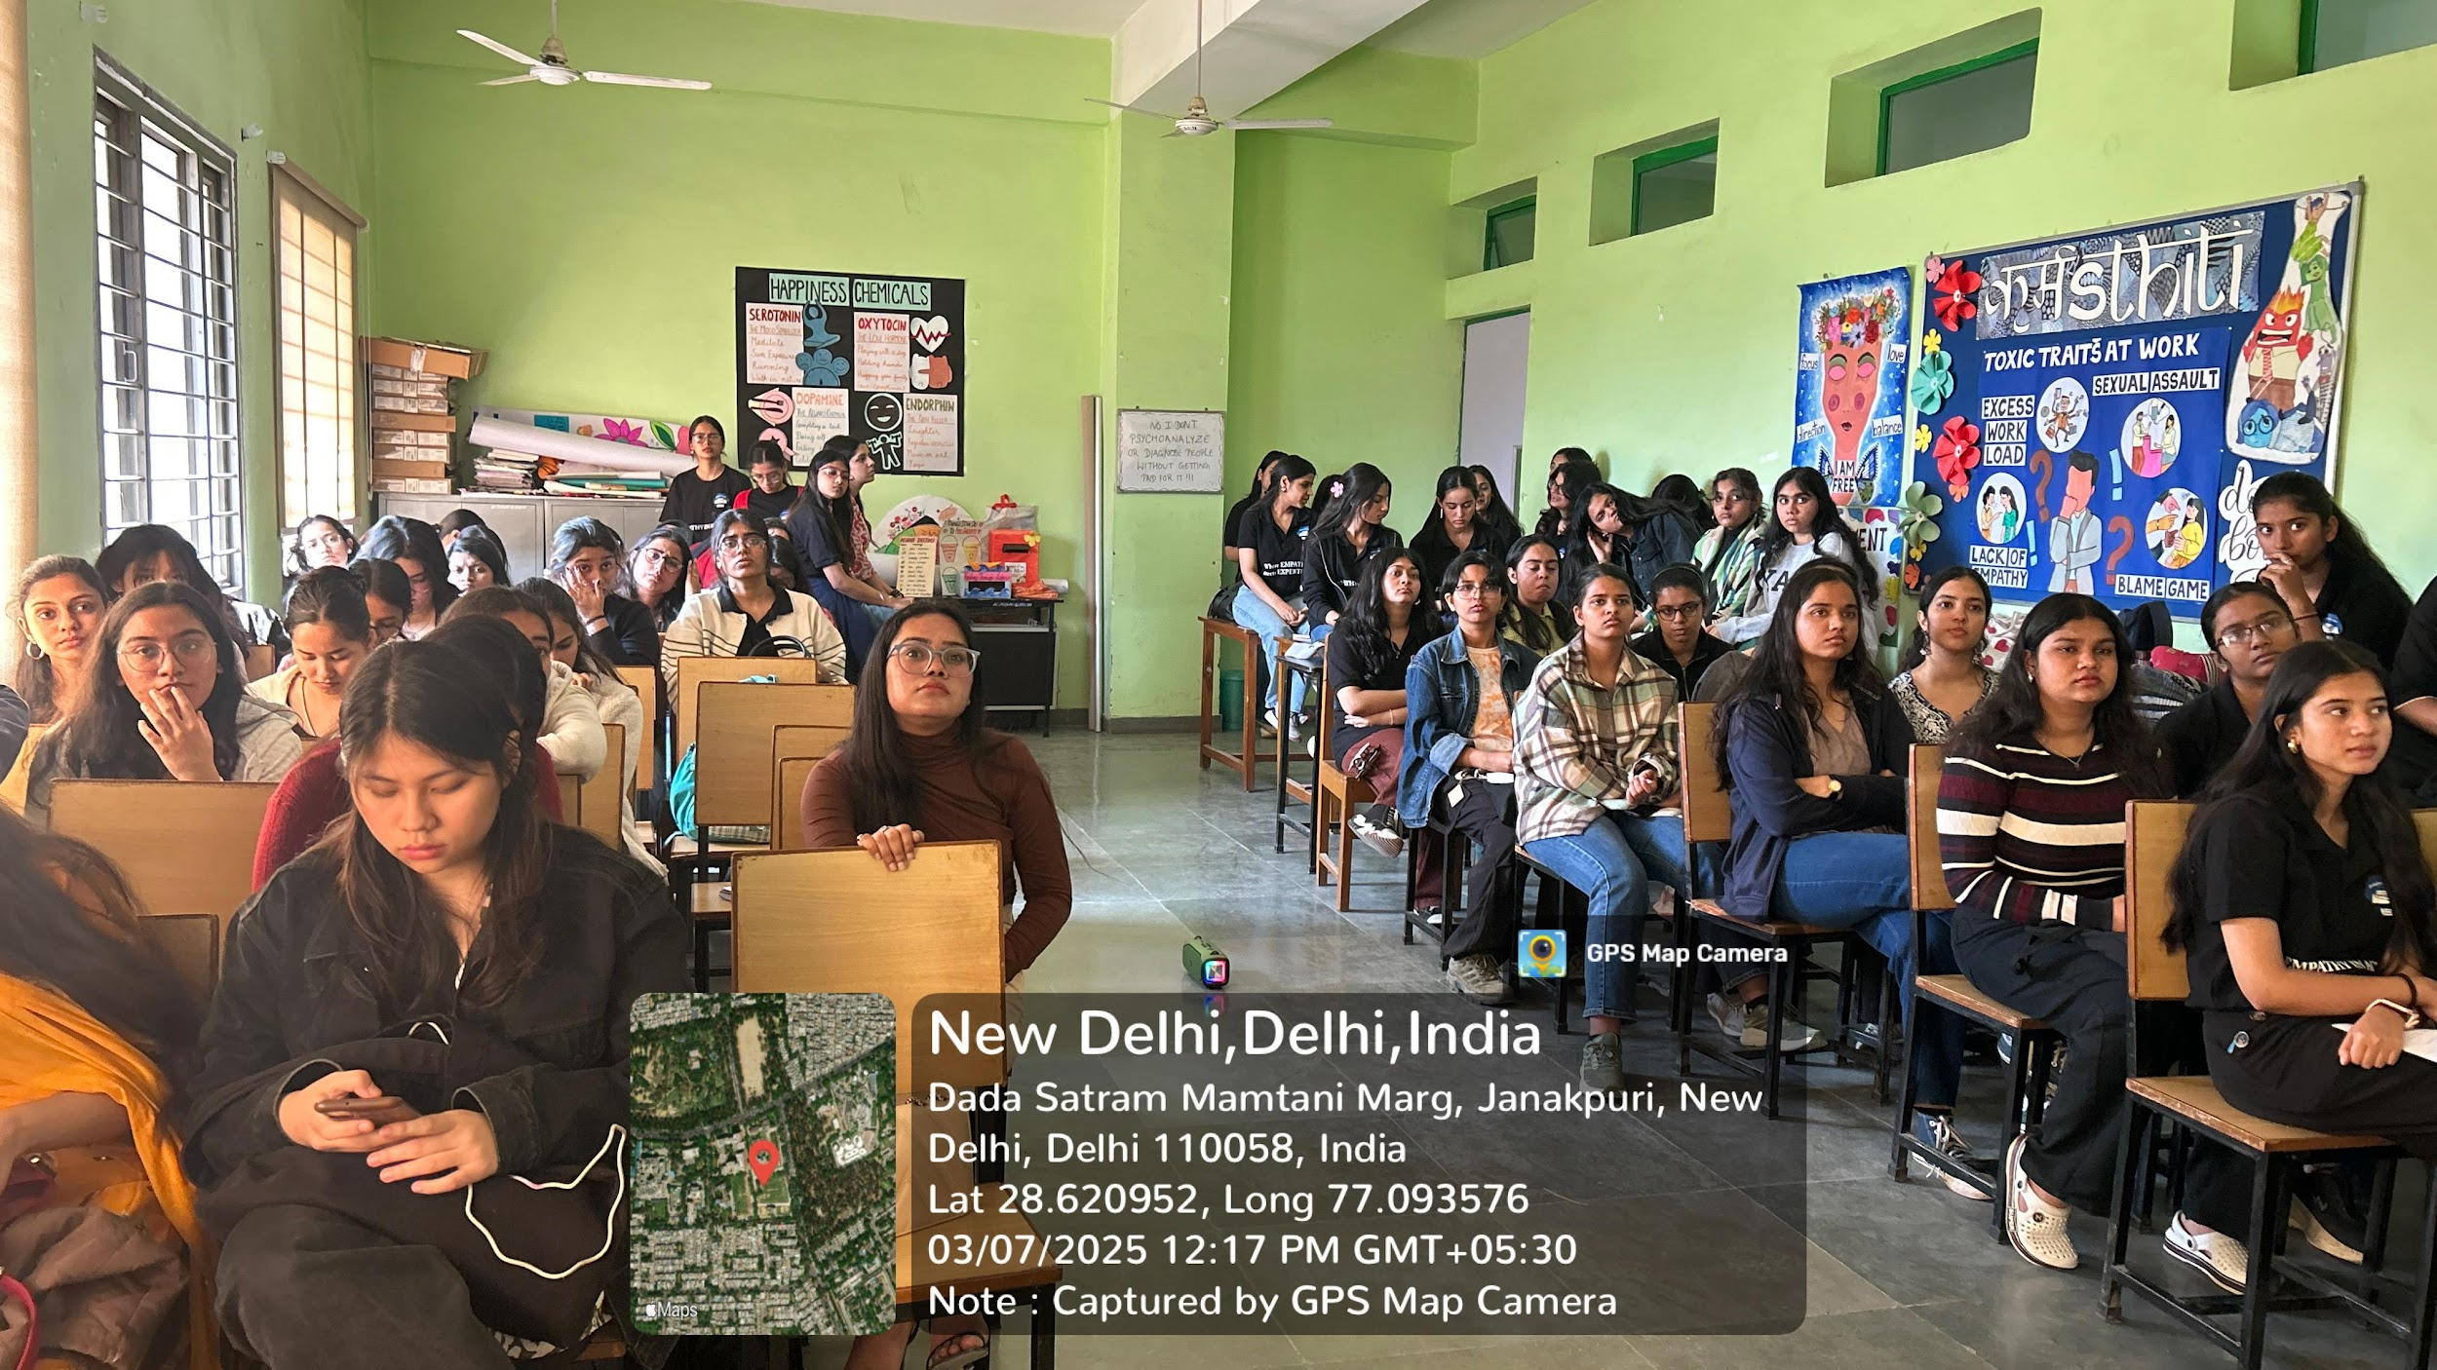

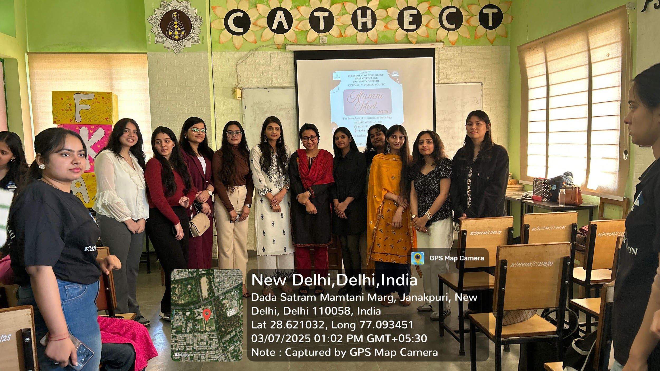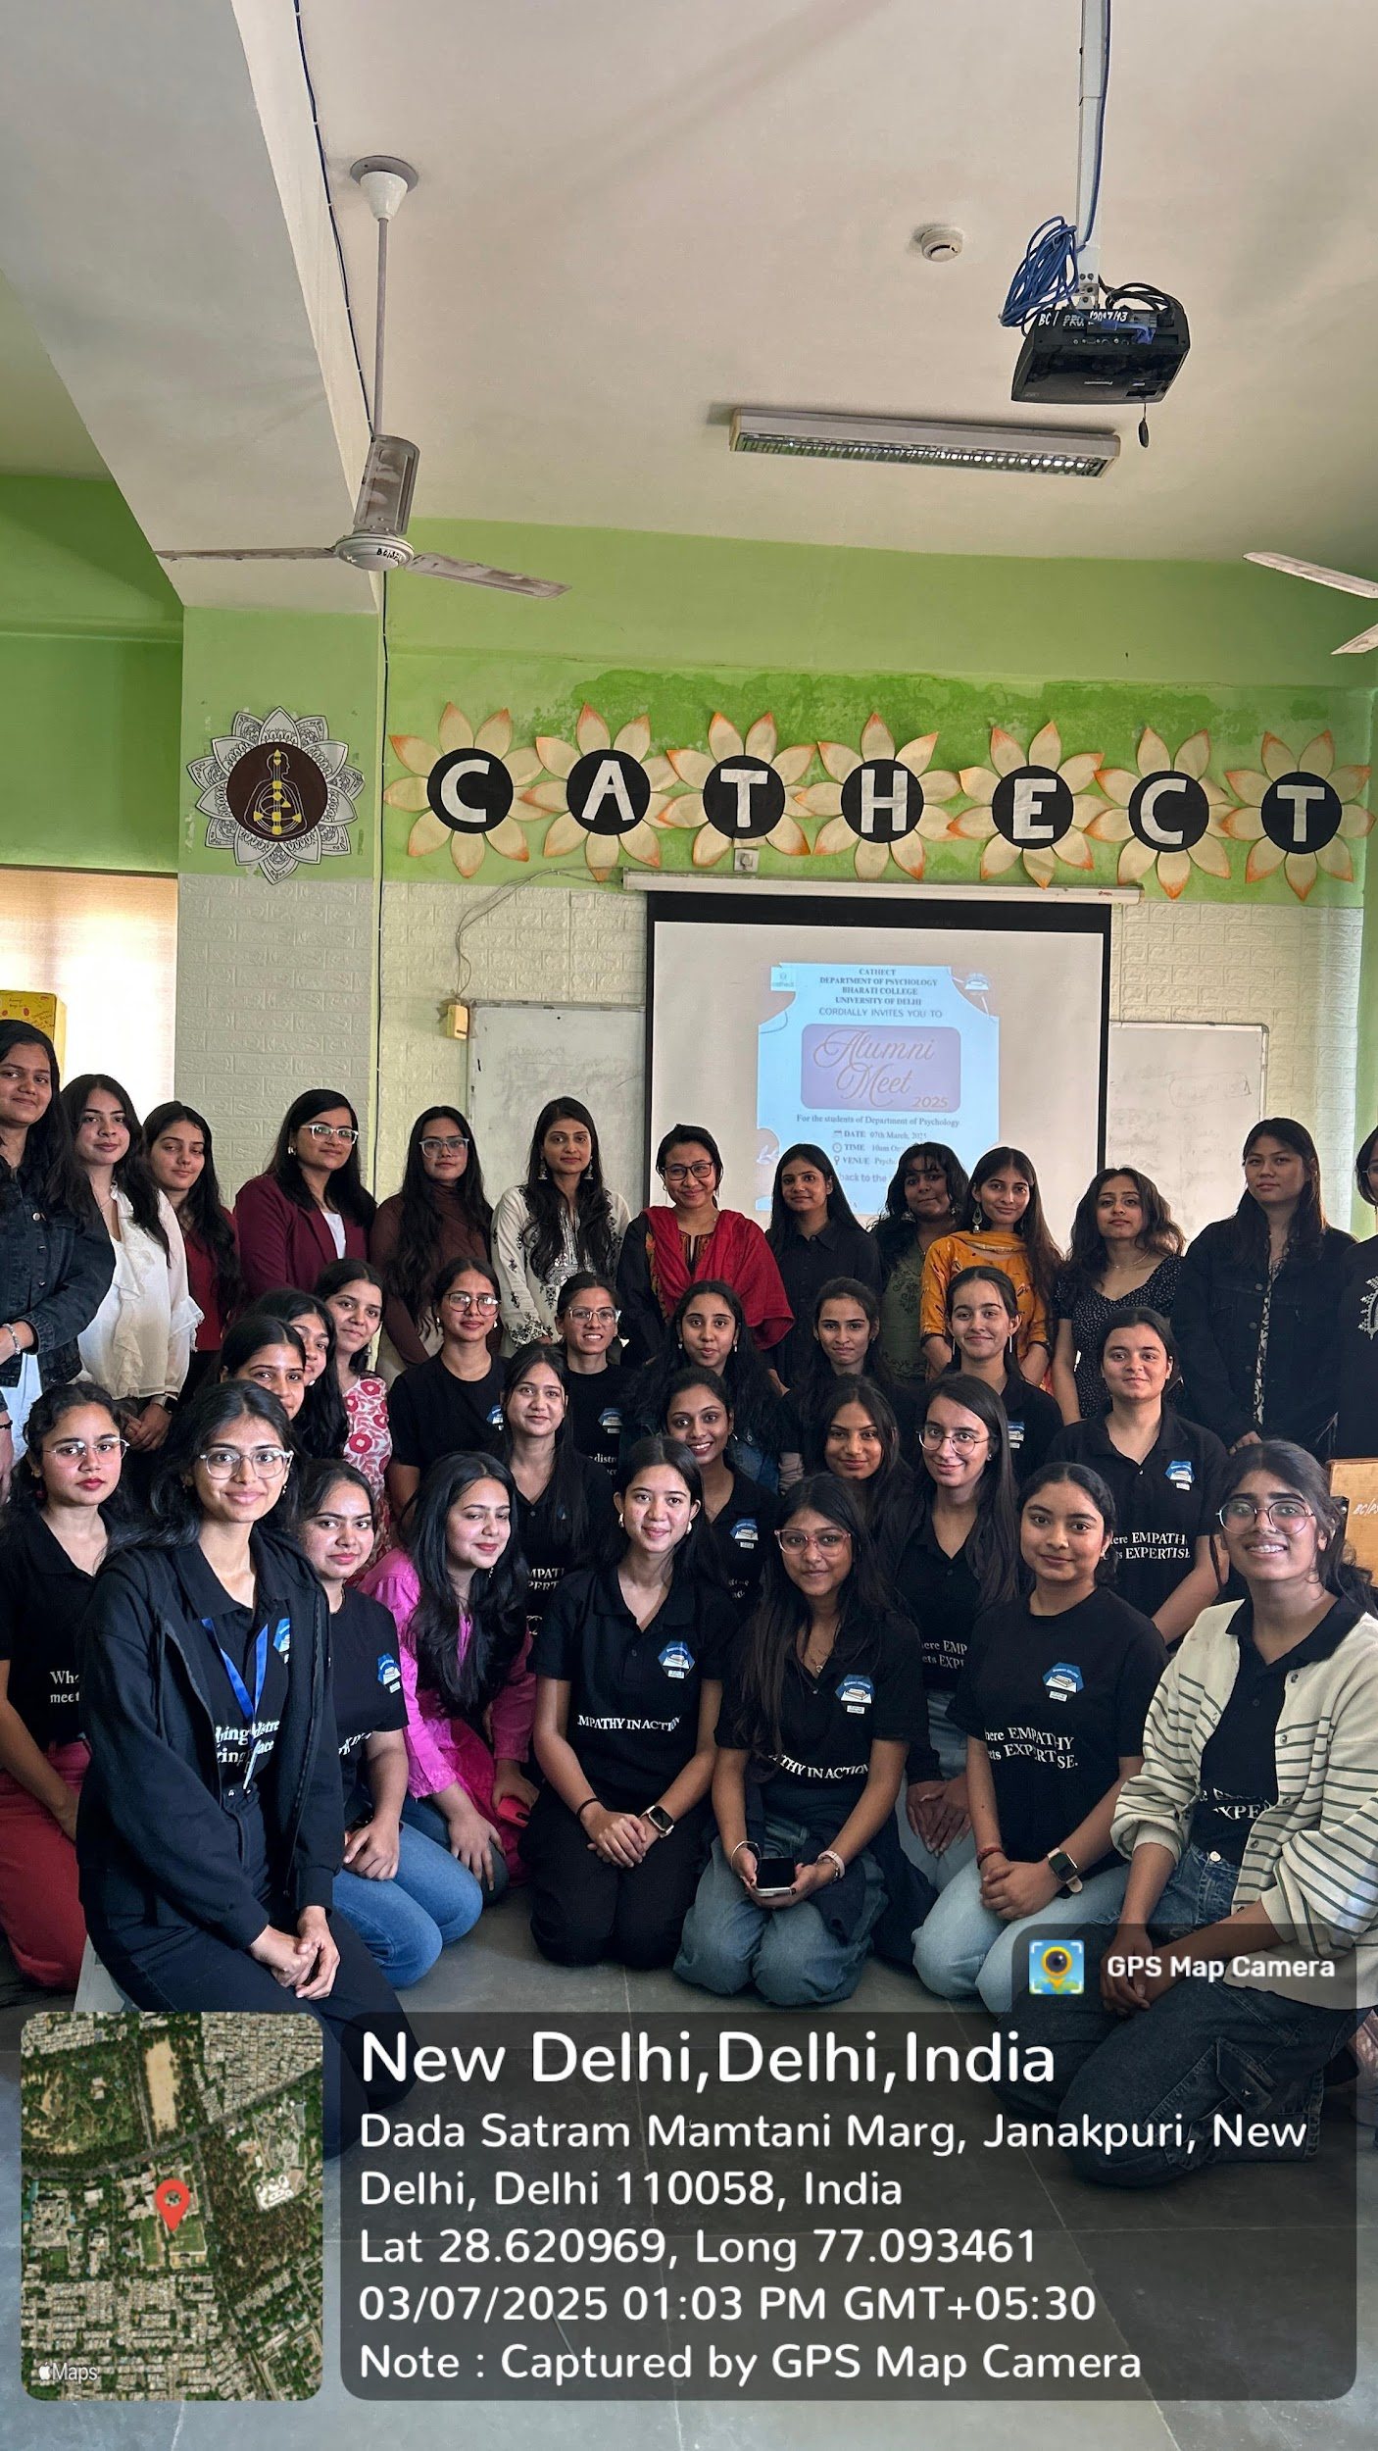

Cathect- Department of Psychology
Under the supervision of IQAC
Bharati College, University of Delhi
Annual Fest 2025
Inside out: Emotions on Display

25th and 26th March 2025, Bharati College, University of Delhi: Cathect Society, Department of Psychology at Bharati College, hosted its annual fest 'Inside Out: Emotions on Display' on 25th–26th March 2025. Sponsored by Bunkdays, Headquarter of Drinks, and Sumvaik Consulting Group, the two-day event celebrated raw emotion, creativity, and community through a range of vibrant competitions and expressive showcases.

The fest opened with a traditional lamp-lighting ceremony, a high-energy dance performance, and an engaging interactive session on the importance of expressing all emotions by Sandli Gupta and Viniti, students of the psychology department. The campus came alive with competitions and colorful stalls at the Central Lawn that invited emotional expression, joy, and creative exploration.
Highlights included a Debate on whether humans are responsible for their emotions or only their actions, where Aayush Bhardwaj and Ritesh Dongre won Best Team, and Harsh Prakash Jha was named Best Speaker. In Emotion Palette, students channeled their feelings into visual art, judged by Garima Singh Tawtiya. Izhaar, the poetry competition judged by Ms. Bhavna Kale and Dr. Manju Sharma, featured moving performances in Hindi and English. The winner of the competition was Shriya Sharma of Ramanujan College. The photography contest Emotions in Motion captured fleeting emotional moments, with Shruti Bhasin winning first place.
The Dance Competition Soul Sync, judged by Dr. Sajni K Narayanan, showcased heartfelt performances, with Samriddhi Tandon taking first prize. The fest concluded with Darlings in Dilemma, a fashion show judged by Mrs. Ritu Sharma, where contestants expressed emotion through costume and presence—Antariksha and Anannya Das emerged as the winner and first runner up respectively.
The event also featured food from Taco Bell, Soulful Bites, and regional vendors, refreshing drinks by HQD, and creative stalls by brands like Maira, Aamdani, and EmoAid. Inside Out was a powerful blend of intellect, creativity, and emotion—leaving behind a campus buzzing with expression and connection.
Highlights:
- Held in the Seminar Room, Theatre Room and the Central Lawn at Bharati College, organised by the Cathect Society, Department of Psychology.
- All six competitions were successfully executed, with high student engagement and creative participation.
- The debate competition fostered critical dialogue on the ethics of emotions and behaviours.
- The art, poetry, and photography competitions allowed students to explore and present their emotional experiences in powerful, creative ways.
- The fashion and dance shows transformed the lawn into a vibrant stage for expressive performance, linking aesthetic design with psychological themes.

