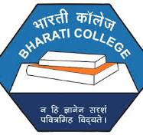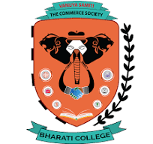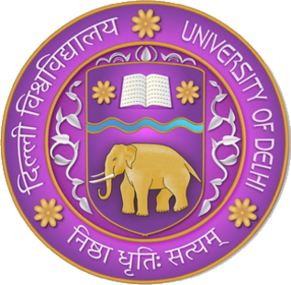
VANIJYA SAMITI – THE COMMERCE SOCIETY
BHARATI COLLEGE, UNIVERSITY OF DELHI
ANNUAL REPORT 2024-25
Here we present collective report of all the events, competitions, seminars and webinars conducted under the banner of Vanijya Samiti – The Commerce Society in the Annual Year of 2024-25 under the guidance of our Convener – Dr. Poonam Ma’am and Dr. Arif Sir and our TIC Mrs. Chitrangada Kapoor Ma’am and Mrs. Arshi Zareen Ma’am.

Summary of all the events that took place in the Year 2024-25 are mentioned below:
September 2024 -
Webinar on Breast Cancer
Venue: Google Meet
Date: 27th Sep 2024
Time: 6:00 PM
Speaker: Mr. Shrenik Shah

October 2024
Career Counselling Workshop
Venue: Seminar Room
Date: 10 October 2024
Time: 12:00 Pm
Speaker: Mr. Himanshu Sharma

How to start earning on social media
Venue: Room G2
Date: 18 October 2024
Time: 10:00 A.M.
Speaker: Mr. Jay Dattani

How to do well in case study
Venue: Google Meet
Date: 20 October 2024
Time: 5:00 PM
Speaker: Mrs. Tarannum Naseem Raza

Len-den: Trade Wisely: Reviving the art of barter system
Venue: Seminar Room
Date: 24 October 2024
Time: 11:00 A.M.
No. of Students participates:

January 2025
What after graduation?
Venue: Google Meet
Date: 25 Jan 2025
Time: 3:00 P.M.
Speaker: Mr. Anil Bhadauria

February 2025
Commercio'25 – The Annual Fest of Vanijya Samiti
Venue: Bharati College, University of Delhi
Date: 12 and 13 Feb 2025
Time: 9 A.M.

Abhiyakti'25 X Vanijya’25
Venue: Bharati College, University of Delhi
Date: 28 Feb 2025
Time: 10 A.M.

March’25
Webinar on Canva Pro Essential
Venue: Zoom
Date: 8 March 2025
Time: 3 P.M.
Speaker: Mr. Gaurav Singla

OCTOBER’24

REPORT OF BREAST CANCER WEBINAR
College: Bharati College, University of Delhi
Date of the webinar: 27 September 2024, 6:00 PM
Department/Society: Vanijya Samiti, The Commerce Society, Bharati College
Program: Health Talk
Activity Title: Webinar on Breast Cancer Treatment

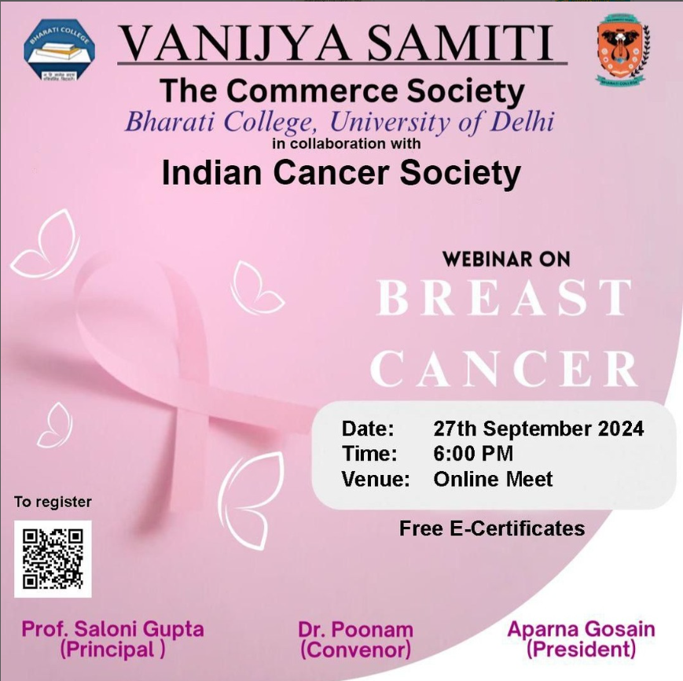
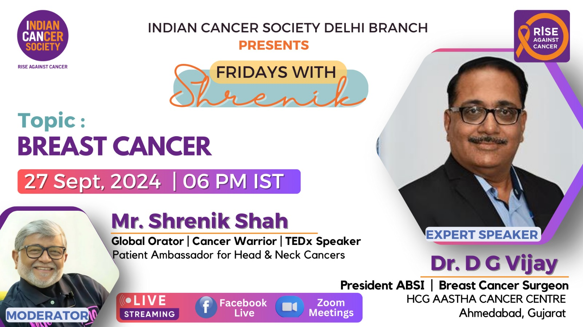
Breast cancer remains one of the most common types of cancer affecting women, particularly as they age. The webinar on breast cancer treatment highlighted some crucial points regarding its onset, detection, and treatment options. Here's a comprehensive summary of the information shared by the speaker.
The likelihood of developing breast cancer increases with age, particularly between the ages of 40 and 50. Although family history can play a role, breast cancer can occur even without hereditary links. It's important to recognize that while genes inherited from parents, like BRCA1 and BRCA2, are commonly identified as risk factors, many breast cancer cases happen due to non-hereditary factors.
If a lump is found in the breast, it is critical to seek medical advice immediately. There are different types of lumps, and not all are cancerous, but getting them checked by a healthcare professional is mandatory.
Signs that can be found are lumps or lumpiness, inexperienced pain or many other things. These signs should not be ignored, even if they occur after a viral infection or fever, which may delay timely examination. Consulting a gynaecologist or a doctor is advisable.
Early detection of breast cancer dramatically improves the chances of successful treatment. Regular self-exams and scheduled screenings, such as mammograms, are essential for early diagnosis.
Treatment of breast cancer depends on the stage at which it is detected. In the early stages, surgery is often recommended. If the tumour is small, it can be removed without the need for extensive surgery. In some cases, however, a mastectomy (removal of the entire breast) may be necessary. Fortunately, in about 50% of cases, breast conservation surgery is possible, meaning the breast can be saved.
FEEDBACK
Around 300 participants attended the webinar including students, scholars, professors and many other participants in the live meeting with the speaker on Zoom, Facebook and on Youtube as well.
All were impressed by the immense knowledge of the speaker and were thanking him for providing such crucial knowledge to all the participants which can help them to keep a check on their health in future.

PHOTOS & ATTENDANCE
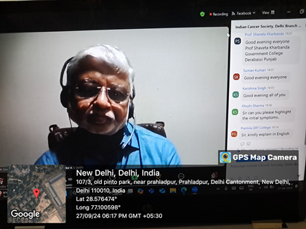
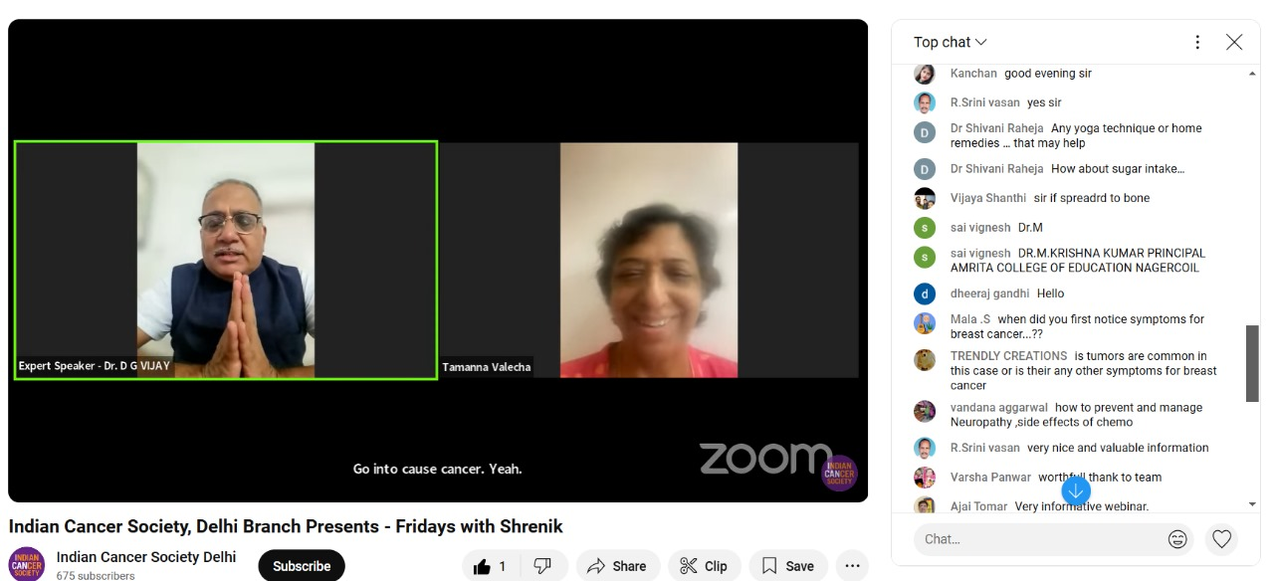
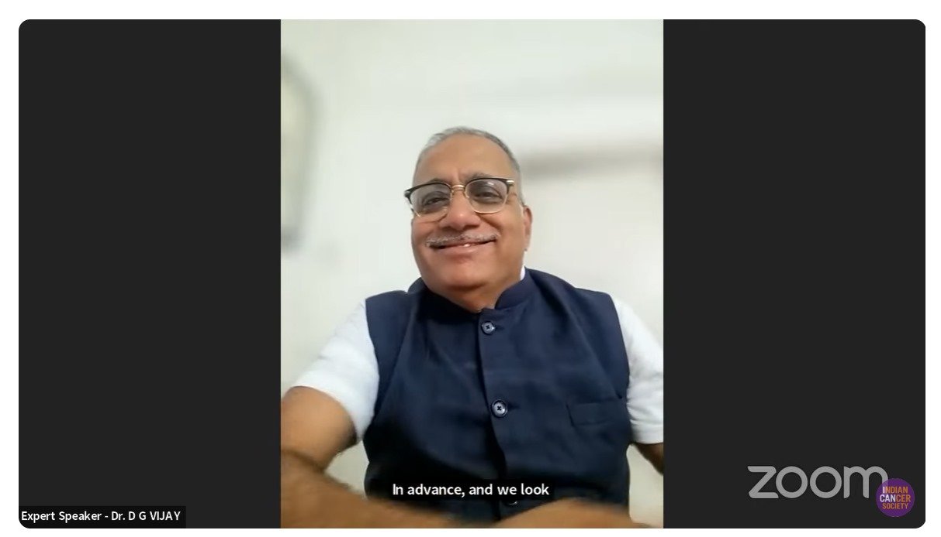

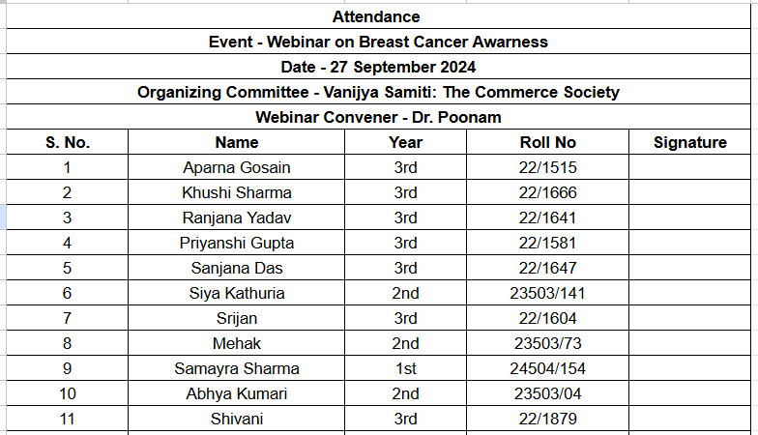

CAREER COUNSELLING SESSION
College: Bharati College, Delhi University
Date and Time of Activity: 10th October 2024, 12 p.m.
Department/Society: Vanijya Samiti, The Commerce Society, Bharati College
Program: Career Counselling Session
Activity Title: Career Counselling Session in Collaboration with ICSI

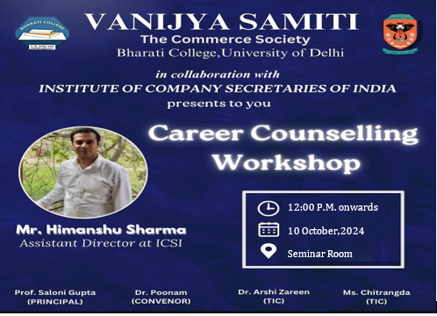
On 10th October 2024, the Vanijya Samiti of Bharati College, in collaboration with the Institute of Company Secretaries of India (ICSI), hosted a highly informative Career Counselling Session at 12:00 PM in Room 104. The event aimed to enlighten students about career prospects in Company Secretaryship and provide professional guidance on navigating this dynamic career path.
The session was led by Mr. Himanshu Sharma, the Assistant Director at ICSI, whose impressive credentials and rich professional journey made the session highly engaging and insightful. Mr. Sharma holds an MBA in Operations Management, a Post Graduate Diploma in Journalism, and a B.Com degree from Delhi University. His extensive career includes seven years in the media industry, having worked with Zee Group, UTV Group, and Disney Group. Since 2011, he has been associated with ICSI, managing Placements, Career Awareness Programs, Seminars, and Student Training Programs.
Mr. Sharma began by introducing the Company Secretary course and the ICSI, highlighting the critical role of the institute in shaping professionals responsible for ensuring legal and regulatory compliance in organisations. The highly interactive session allowed students to actively engage with the speaker and gain a clearer understanding of the profession. He explained in detail what a Company Secretary does, emphasising that the CS is a key management personnel responsible for ensuring the organisation complies with laws and regulations. He stressed the importance of the CS role in the corporate world, explaining that it is a top management position, integral to corporate governance.
One of the key takeaways from the session was the flexibility of the Company Secretary (CS) career path, which offers a wide range of opportunities for professionals in the corporate world. Mr. Himanshu Sharma highlighted that a CS professional is not limited to just working for an organization; they have the option to pursue an employment career or as a self-employed consultant. This dual pathway allows individuals to either take up senior roles in corporate governance within companies or offer their expertise as independent consultants, providing advisory services on matters like compliance, corporate laws, and strategic management to multiple clients.
Mr. Sharma also explained the stages of the CS course, highlighting that the exams have no negative marking, which eases the pressure on students and encourages a focus on thorough understanding rather than fear of penalties. Furthermore, the exams are conducted multiple times a year, offering flexibility for students to choose when they are best prepared to take them. This adaptable structure allows students to balance their studies with other commitments, making it more convenient to pursue the course at their own pace while progressing toward a successful career in Company Secretaryship.
FEEDBACK
The event was met with an overwhelmingly positive response, with more than 100 participants, including students from various disciplines eager to explore career avenues in Company Secretaryship. Many attendees expressed gratitude for the insights shared, recognizing the value of Mr. Sharma's guidance in shaping their future career paths. The session concluded with a call for more career-oriented workshops, reflecting the students' eagerness for further professional development opportunities.

PHOTOS AND ATTENDANCE
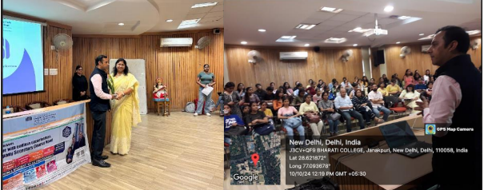
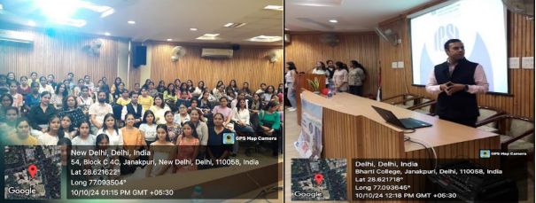
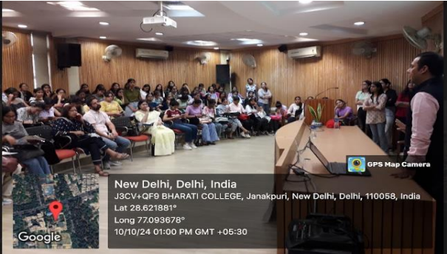
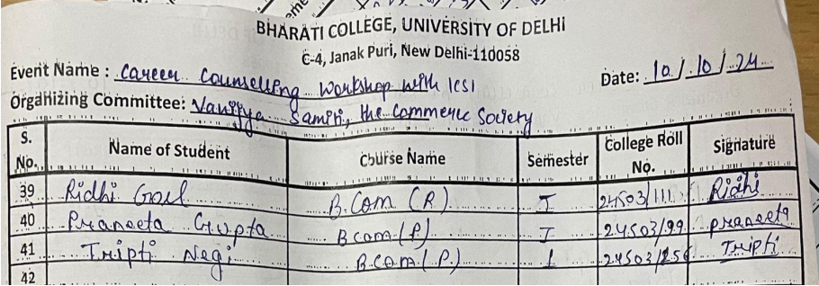
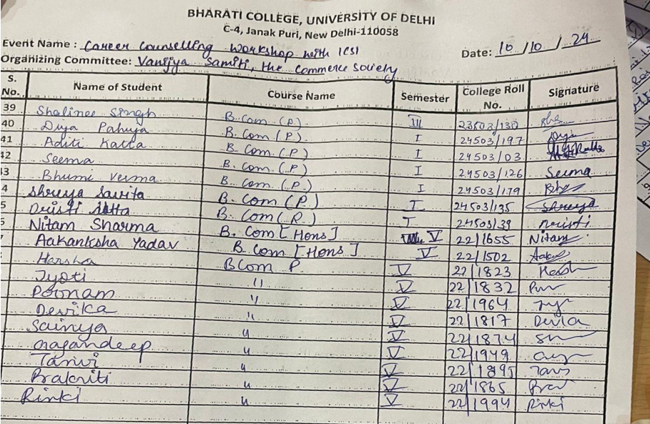
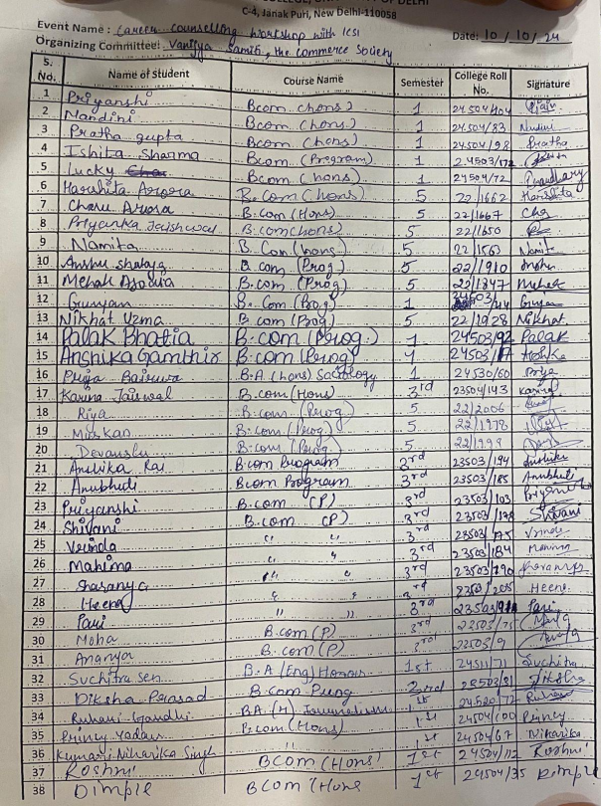
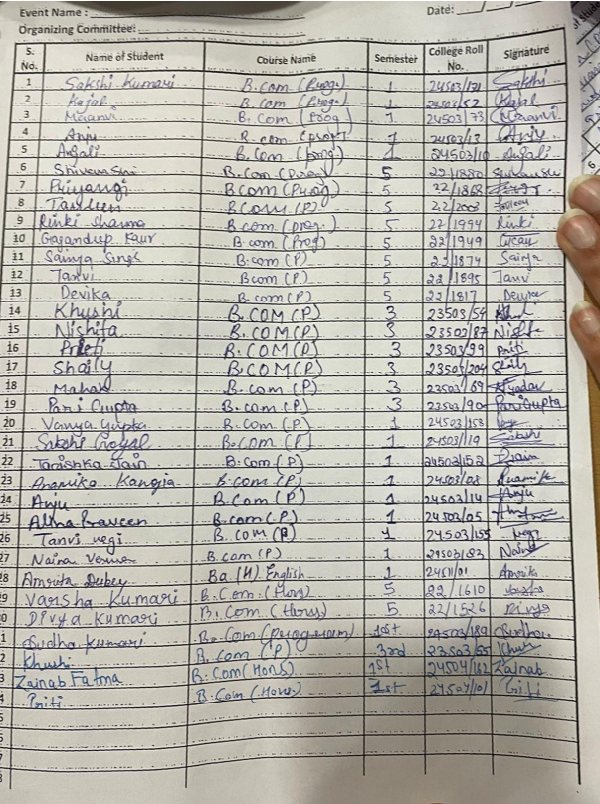
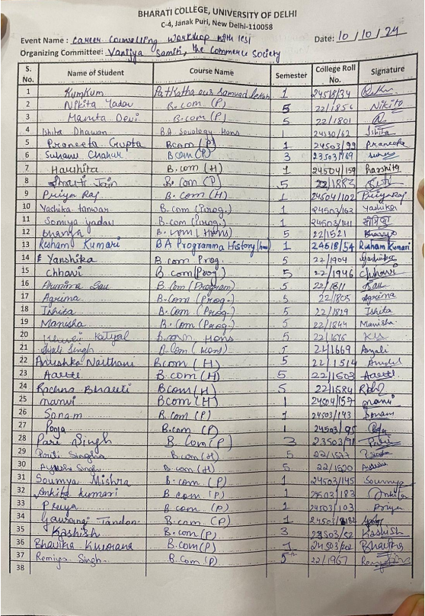

HOW TO START EARNING ON SOCIAL MEDIA SESSION
College: Bharati College, University of Delhi
Date and Time of Session: 18th October 2024, 10 a.m.
Department/Society: Vanijya Samiti, The Commerce Society, Bharati College
Program: How to start earning on social media Session
Activity Title: How to Start Earning on Social Media in collaboration with IIDE, The Digital School.
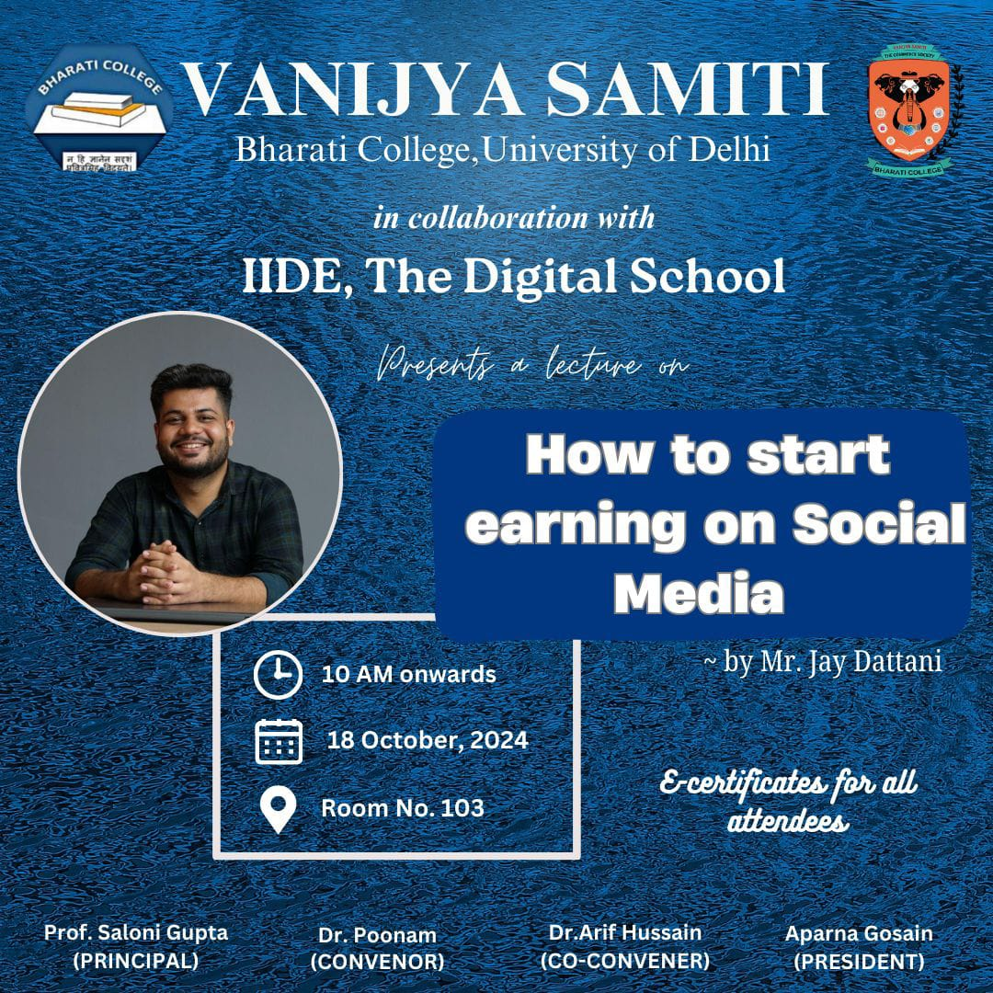
On 18th October 2024, Vanijya Samiti of Bharati College, in collaboration with the Indian Institute of Digital Education (IIDE), hosted a highly informative session on "How to Earn on Social Media" at 10:00 AM in the G2 Room at the new building. The event aimed to enlighten students about career prospects by using social media and provide professional guidance on navigating this dynamic career path.
The session led by Mr. Jay Dattani on Social Media Marketing was highly insightful and practical. His ability to break down complex strategies into easy-to-understand steps made the content accessible for both beginners and experienced creators. Starting with personal experiences and practical tips, such as monitoring time spent on Instagram, added a relatable touch to the presentation. The emphasis on profile optimization and the importance of having a clear bio and call to action was particularly helpful, providing actionable advice for improving one’s social media presence.
The section on content creation stood out, as Mr. Dattani explained the importance of choosing a niche, providing value, and honing video editing and presentation skills. His examples of monetization strategies, such as brand partnerships and affiliate marketing, offered concrete ways to turn social media efforts into income, which was highly motivating. The session's interactive nature, including advice on content formats and audience engagement techniques, added practical value to the learning experience.
Overall, Mr. Dattani’s session was engaging, informative, and full of real-world applications, leaving participants equipped with the tools and knowledge to successfully grow and monetize their social media platforms. It would be beneficial to have more sessions like this, focusing on deeper aspects of content strategy and monetization.
FEEDBACK
Mr. Jay Dattani’s session on Social Media Marketing was informative and practical, offering clear strategies for optimizing profiles, creating valuable content, and monetizing efforts through brand partnerships and affiliate marketing. His approachable teaching style and actionable tips made the session highly engaging and beneficial for aspiring social media creators.
PHOTOS & ATTANDANCE
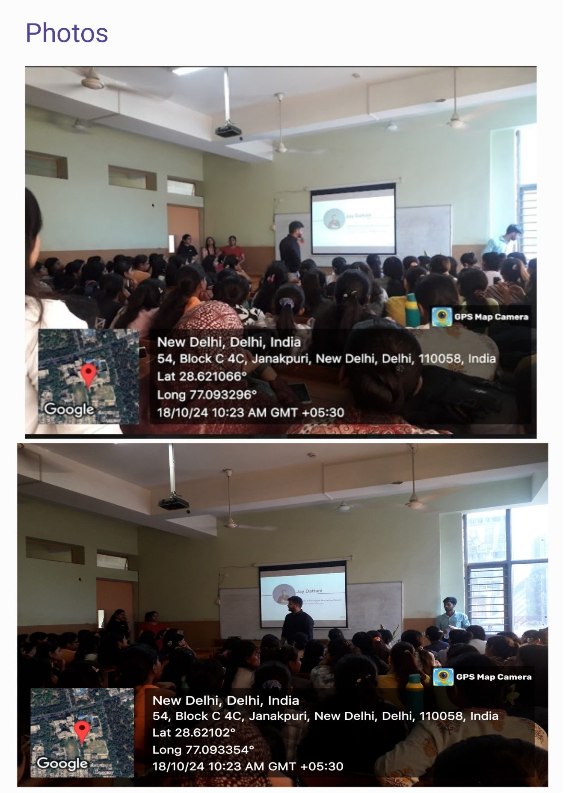

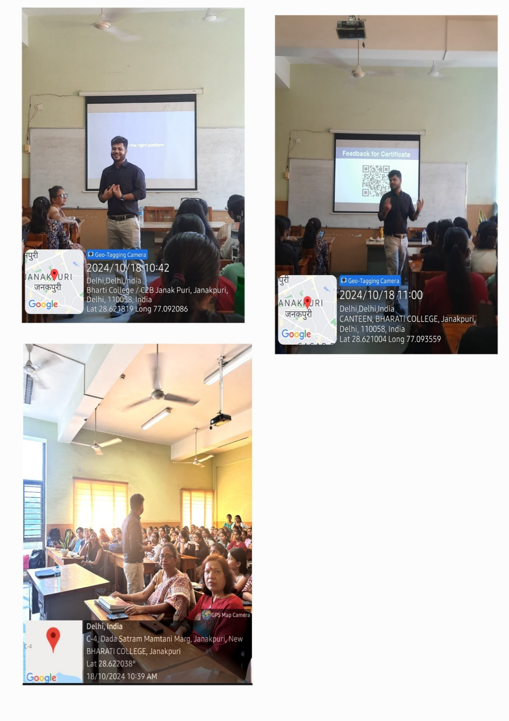

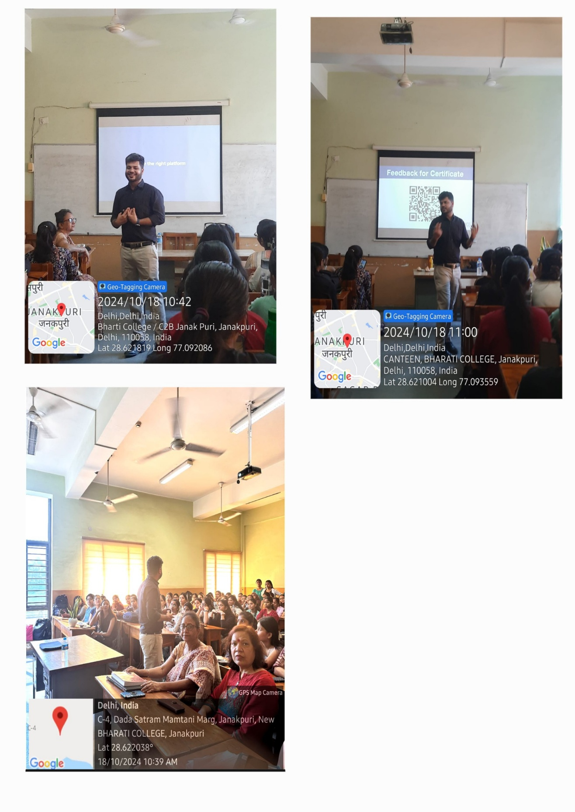

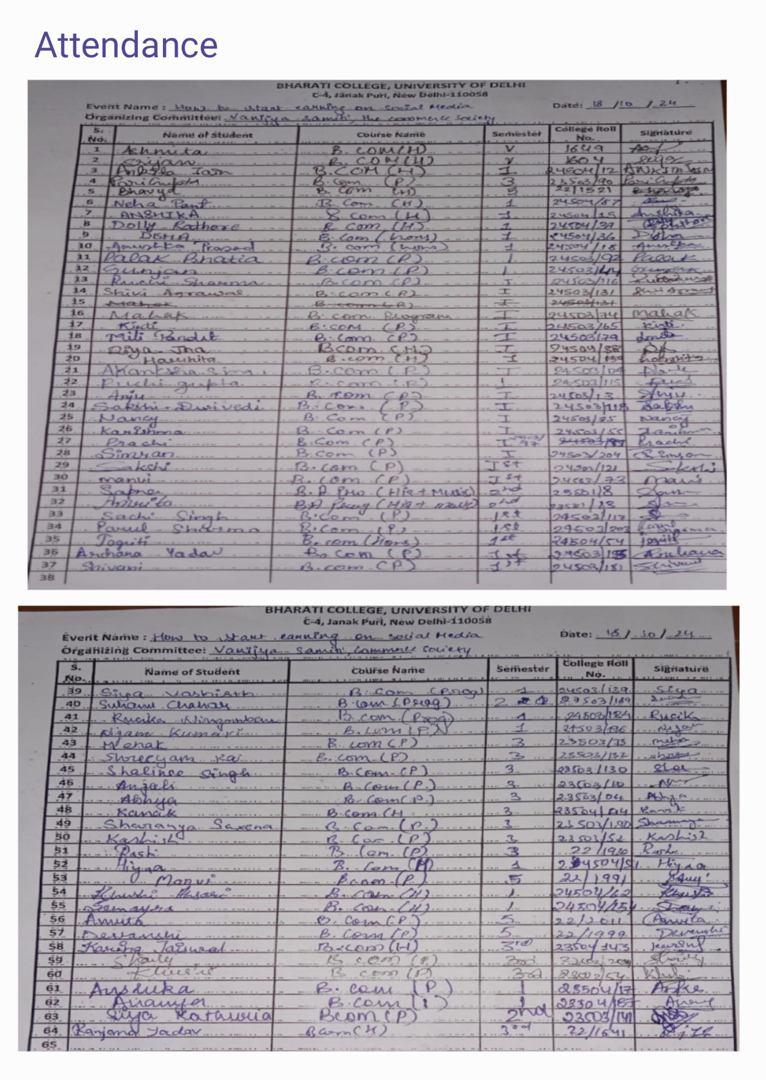

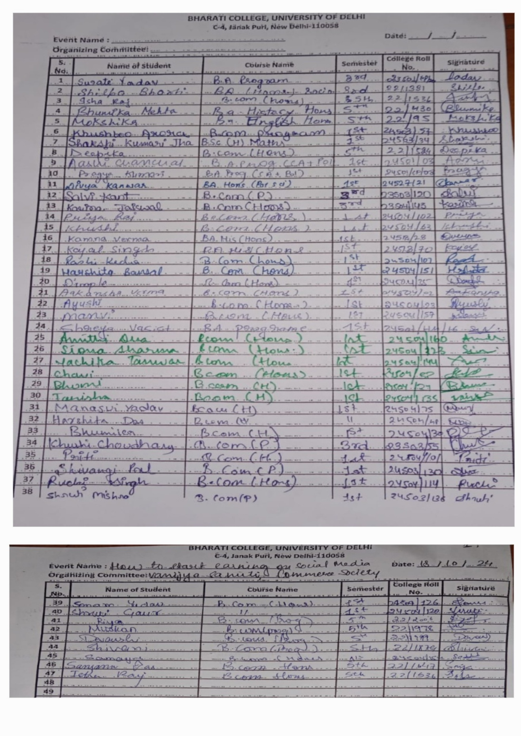

HOW TO DO WELL IN CASE STUDIES SESSION REPORT
College: Bharati College, University of Delhi
Date and Time of Session: 20th October 2024, 05 p.m.
Department/Society: Vanijya Samiti, The Commerce Society, Bharati College Program: How to do well in case studies and how to Excel in case studies
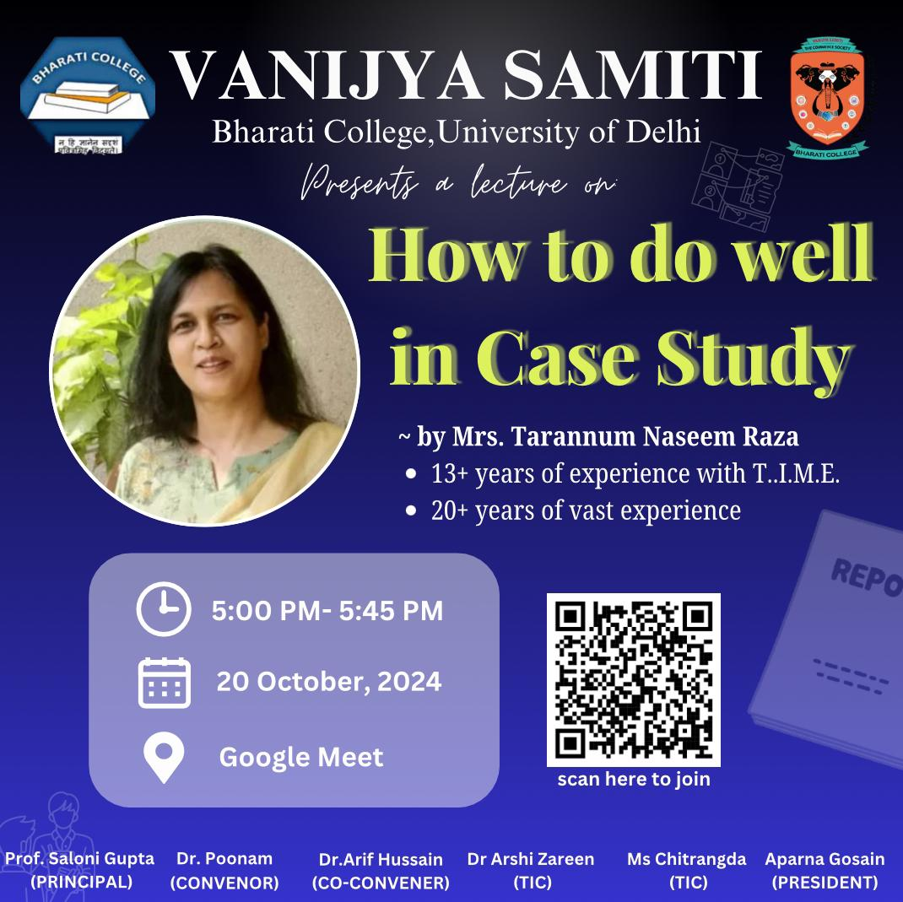
Vanijya Samiti of Bharati College successfully conducted an exclusive webinar titled "How to Do Well in Case Studies" on October 20, 2024. The session featured Mrs. Tarannum Naseem Raza, a seasoned professional with over 20 years of experience in engineering and management, who guided the attendees on excelling in case study analysis.
Mrs. Tarannum shared valuable insights into approaching case studies with a structured mindset. She emphasised the importance of logical thinking, problem identification, and clear communication of solutions. Her engineering background and management skills provided a unique perspective on how to combine technical knowledge with managerial decision-making.
The session concluded with a lively Q&A, where students sought advice on common challenges faced during case study analysis. Mrs. Tarannum addressed questions on time management during exams, structuring responses, and leveraging one's strengths in a case study.
The webinar successfully fulfilled its objective of equipping students with essential skills for excelling in case studies. Vanijya Samiti aims to organise more such sessions in the future to continue supporting the holistic development of students.
FEEDBACK
98% of attendees found the session highly relevant to their academic and career interests. Participants praised the speaker’s expertise and the applicability of the strategies discussed.
PHOTOS & ATTANDANCE
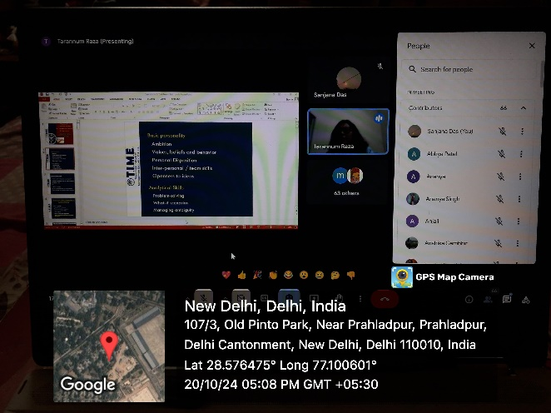
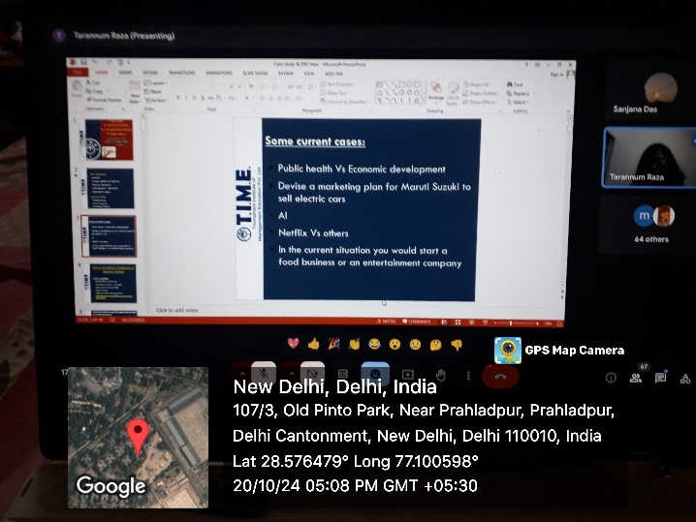
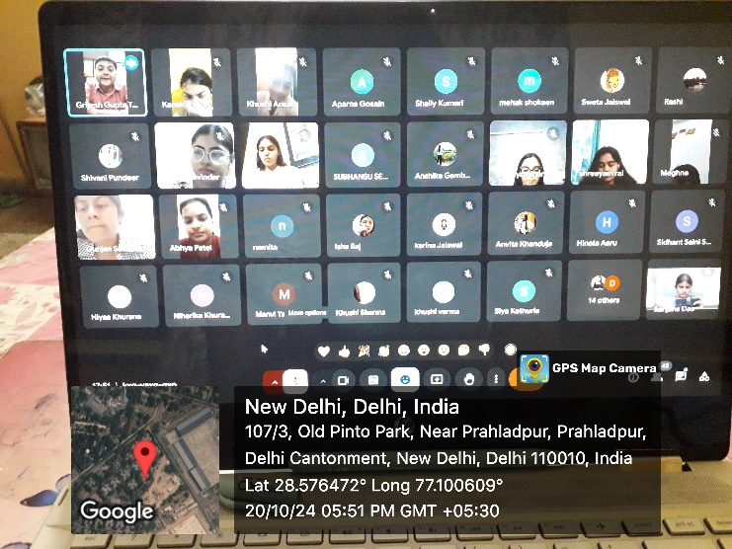

ATTANDANCE PERFORMA
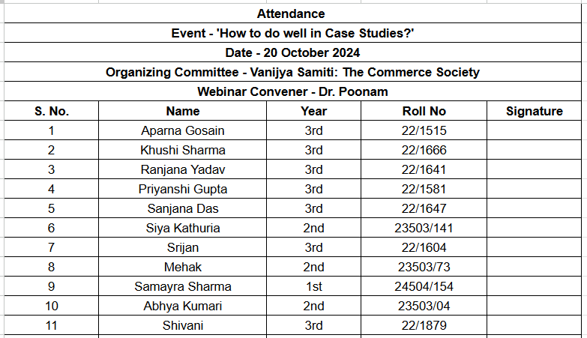

लेन देन
Trade wisely: Reviving the Art of Barter
College : Bharati College, University of Delhi
Date and Time of Session: 24th October 2024, 11 A.M.
Department/Society: Vanijya Samiti, The Commerce Society, Bharati College
Program: लेन देन - The Barter Competition

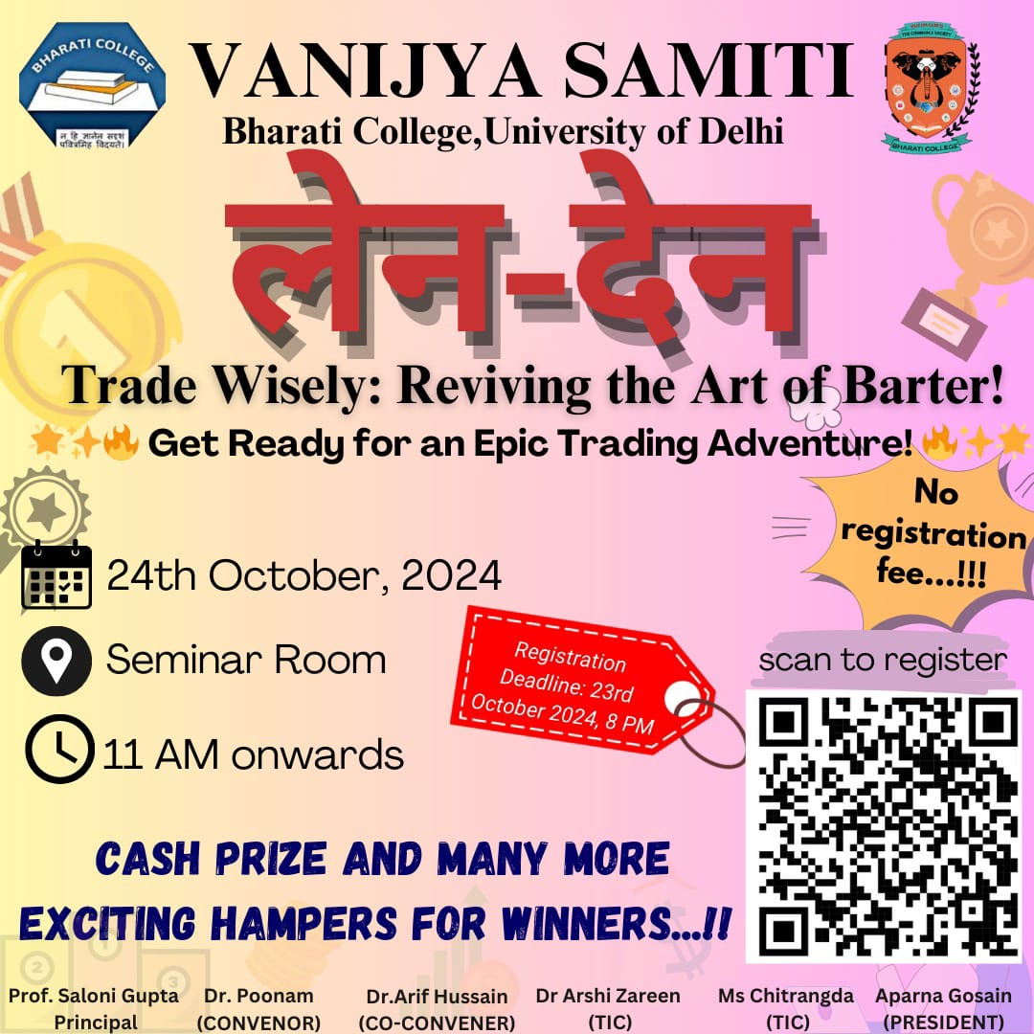

The motive of a "Len-Den" barter competition is to teach economic fundamentals, negotiation, and creativity by exchanging goods without money.
On 24th October 2024 a unique and engaging event, "Len-Den: The Barter Competition," was organised by Vanijya Samiti - The Commerce society at Bharati College the Seminar room at 11 AM. The event aimed to revive the age-old concept of barter, encouraging participants to trade goods and services without money, thus enhancing their understanding of negotiation, value assessment, and resource management.

Each of the 12 participants started with a single pen, which they had to trade up by bartering. The participants were divided into four groups:
1. Group 1: Tanishka and Preeti began with a pen as a basic commodity of the barter system and then exchanged the items like keychains, hair clips, hair ribbons, a phone cover, and lip gloss.
2. Group 2: Shweta, Manvi, and Bhavika began with a pen as the first commodity of the competition and laten on exchanged items such as a calculator, marker, umbrella, scissors, and a toy octopus.
3. Group 3: Deepanahi, Swati, and Riya started with a pen as the first commodity of the competition and then exchanged the items like perfume, a specs box, bow, mirror, and notebook in their trades.
4. Group 4: Participants bartered items such as a bottle, cream, perfume, Vicks, and body butter among themselves and ended the competition with a good note.

Seven society members acted as vendors, adding variety and challenges to the exchanges. The competition consisted of multiple three-minute rounds where participants traded items with the goal of increasing their value with each swap.

HIGHLIGHTS AND SKILLS DEMONSTRATED

The event saw some remarkable achievements:
- Khushi and Raj Hans secured the highest-valued items by the end.
- Shweta Jesval led in the number of exchanges, showcasing great networking skills.
- Bhavika was recognized for her excellent pitching and negotiation skills.
All items were then returned to their original owners, maintaining the event's integrity.

FEEDBACK

"Len-Den: The Barter Competition" successfully blended fun with educational value, as students developed essential negotiation and communication skills. The event concluded with a group photo of all participants, with special recognition for the winners. Vanijya Samiti initiative provided a hands-on learning experience that left a lasting impression on everyone involved.

PHOTOS & ATTANDANCE
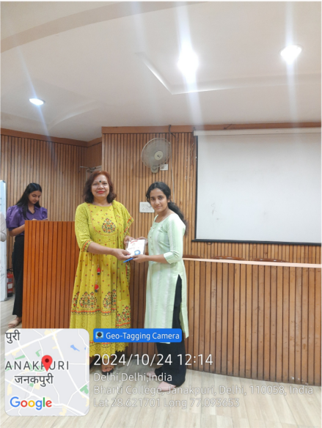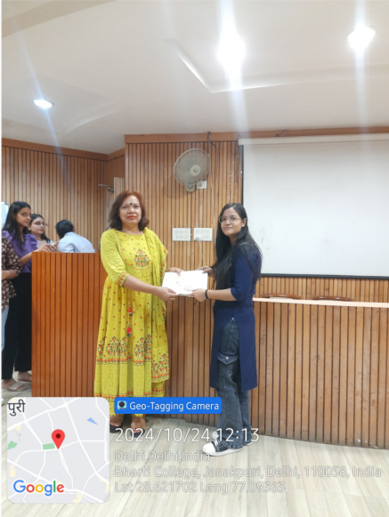
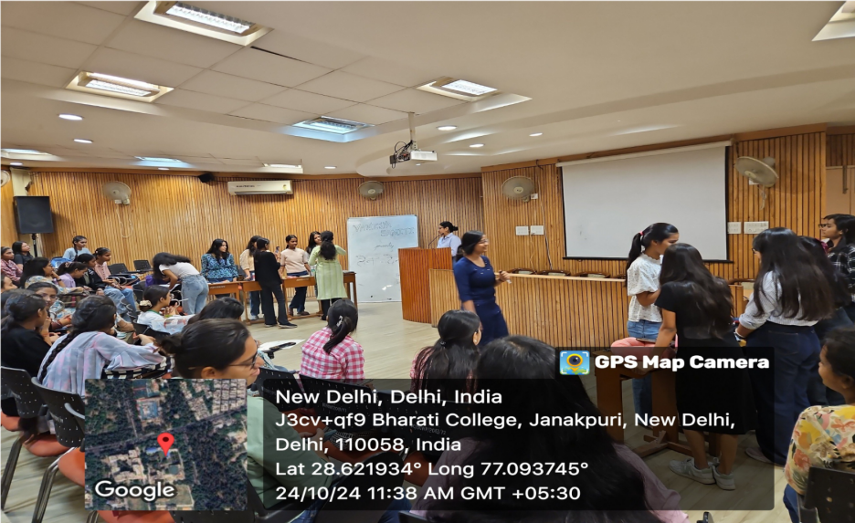
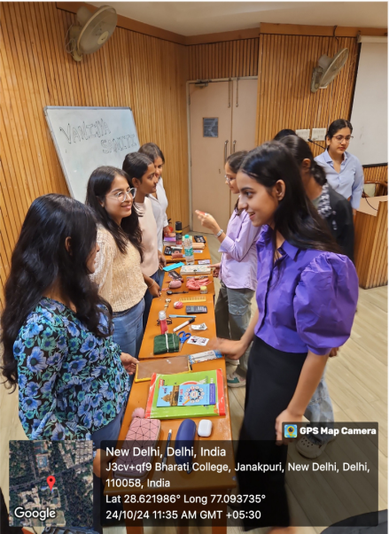

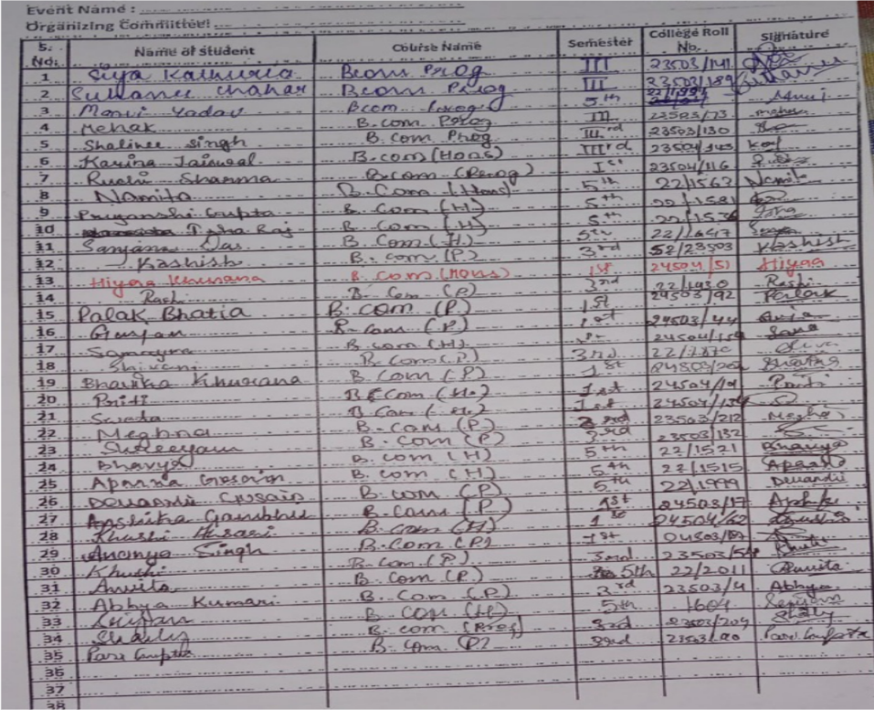
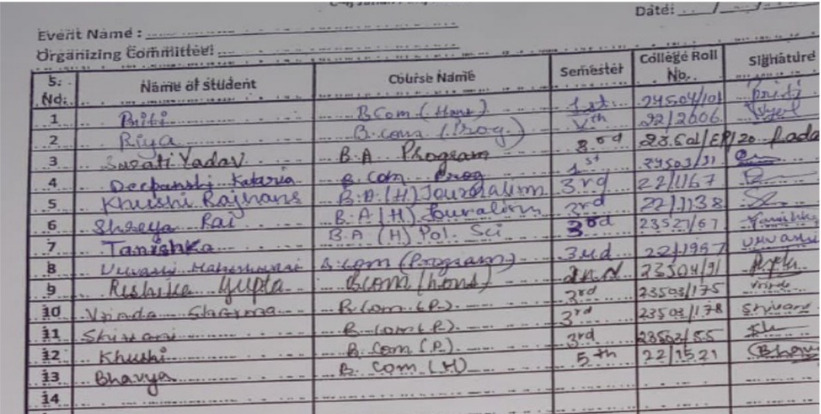

JANUARY’25

REPORT ON ‘WHAT AFTER GRADUATION?’
College: Bharati College, University of Delhi
Date and time of activity: 25 January 2025, 3 P.M.
Department/Society: Vanijya Samiti, The Commerce Society, Bharati College
Program: Webinar on `What after graduation’?
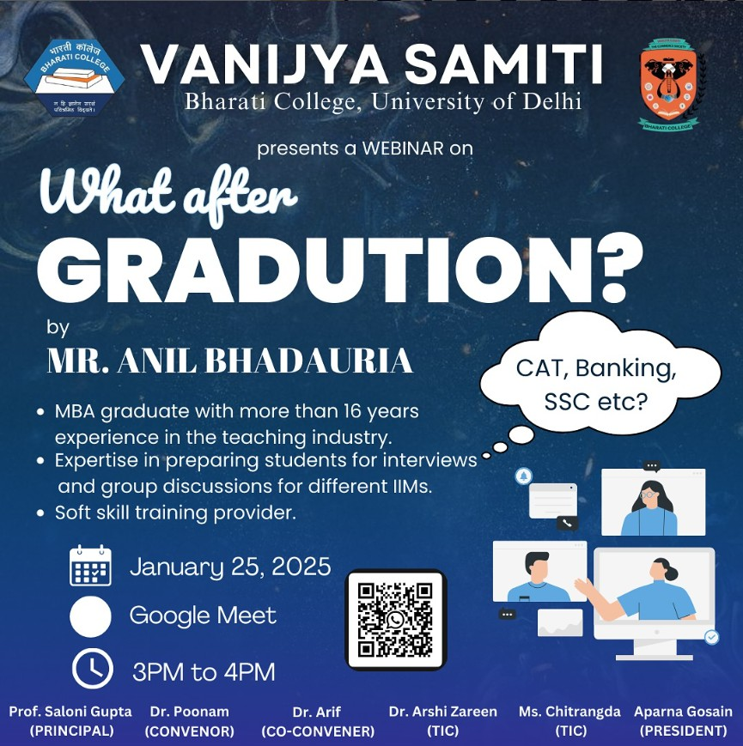
Activity title: Webinar on 'What after Graduation’ (Overview on exams like SSC, Banking exam and CAT)

EVENT HIGHLIGHTS:
- Overview of competitive exams like CAT, Banking, and SSC.
- Preparation strategies for the exams.
- Salaries are provided in that field.
- Discussion of cut-offs and number of applicants.
- Discussion about questions to be asked in exams and interviews.

Competitive exams like CAT, Banking, and SSC offer pathways to rewarding careers in management, banking, and government sectors. CAT evaluates Quantitative Aptitude, Logical Reasoning, and Verbal Ability, leading to MBA programs with salaries ranging from ₹12–₹30 LPA. Banking exams like IBPS PO and SBI PO focus on Numerical Ability, Reasoning, and General Awareness, with starting salaries of ₹5–₹8 LPA. SSC exams like SSC CGL test Quantitative Aptitude, English, and General Intelligence, offering ₹4–₹6 LPA along with government benefits. These exams see lakhs of applicants, with CAT cut-offs often exceeding the 95th percentile and banking/SSC exams having intense competition due to limited seats.
Participants actively engaged in the Q&A segment, clarifying their doubts regarding exam patterns and resources. Students who gained clarity on career options after graduation. The session motivated attendees to explore and prepare for competitive exams. Students raised specific queries about preparation strategies, timelines, and reliable resources for different exams. The speaker provided personalized advice, helping participants address their challenges. The webinar also inspired students to explore less conventional paths alongside mainstream options, urging them to align their career choices with their skills and interests.

FEEDBACK:

Post-event feedback was overwhelmingly positive. Students appreciated the clarity of the information provided, the practical tips shared for exam preparation, and the motivational aspects of the session, which encouraged them to take charge of their career paths.

CONCLUSION:
The webinar, organised by Vanijya Samiti, was a resounding success. It provided students with actionable insights into their career development, and participants' feedback highlighted the session's relevance and usefulness in shaping their post-graduation plans. The event reinforced Vanijya Samiti's commitment to the holistic development of its students, proving once again its role as a guiding force in shaping future professionals.

PHOTOS & ATTANDANCE
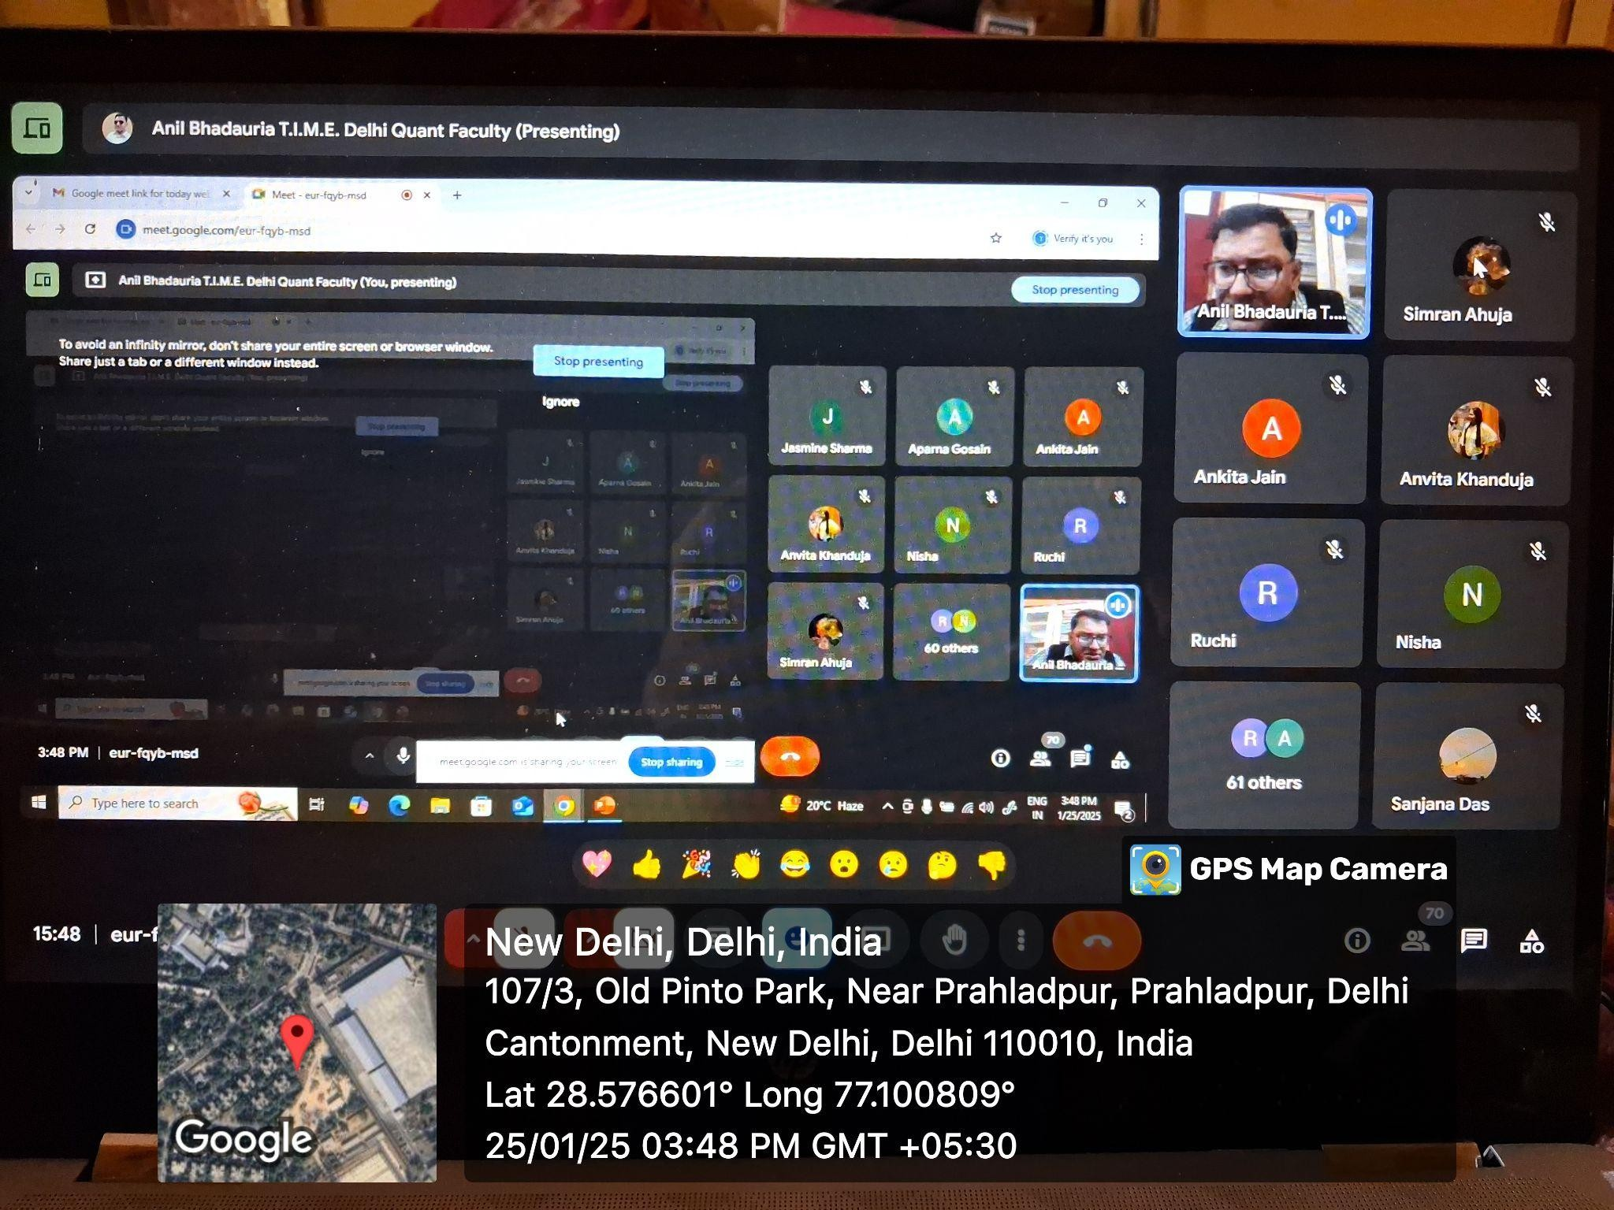
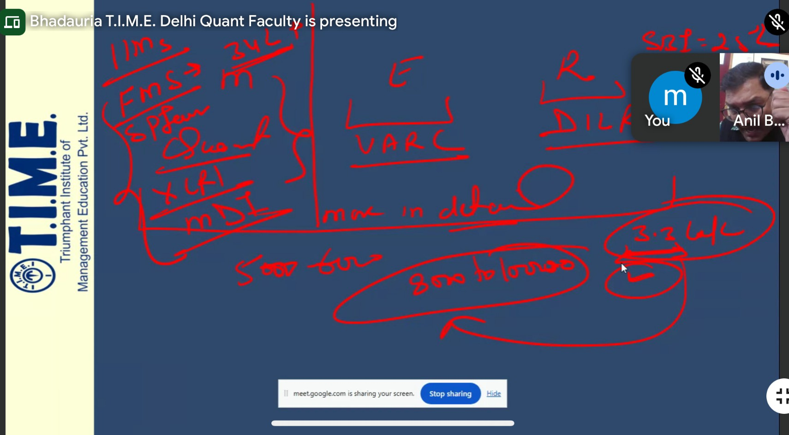

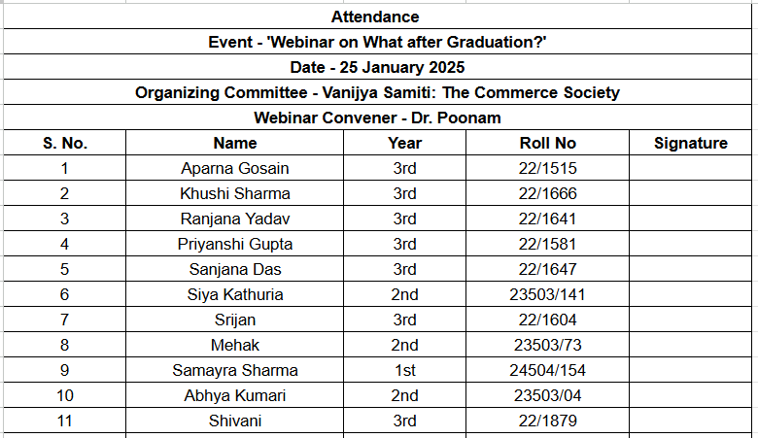

FEBRUARY’25

REPORT ON THE ANNUAL COMMERCE FEST - COMMERCIO 25

DAY 1

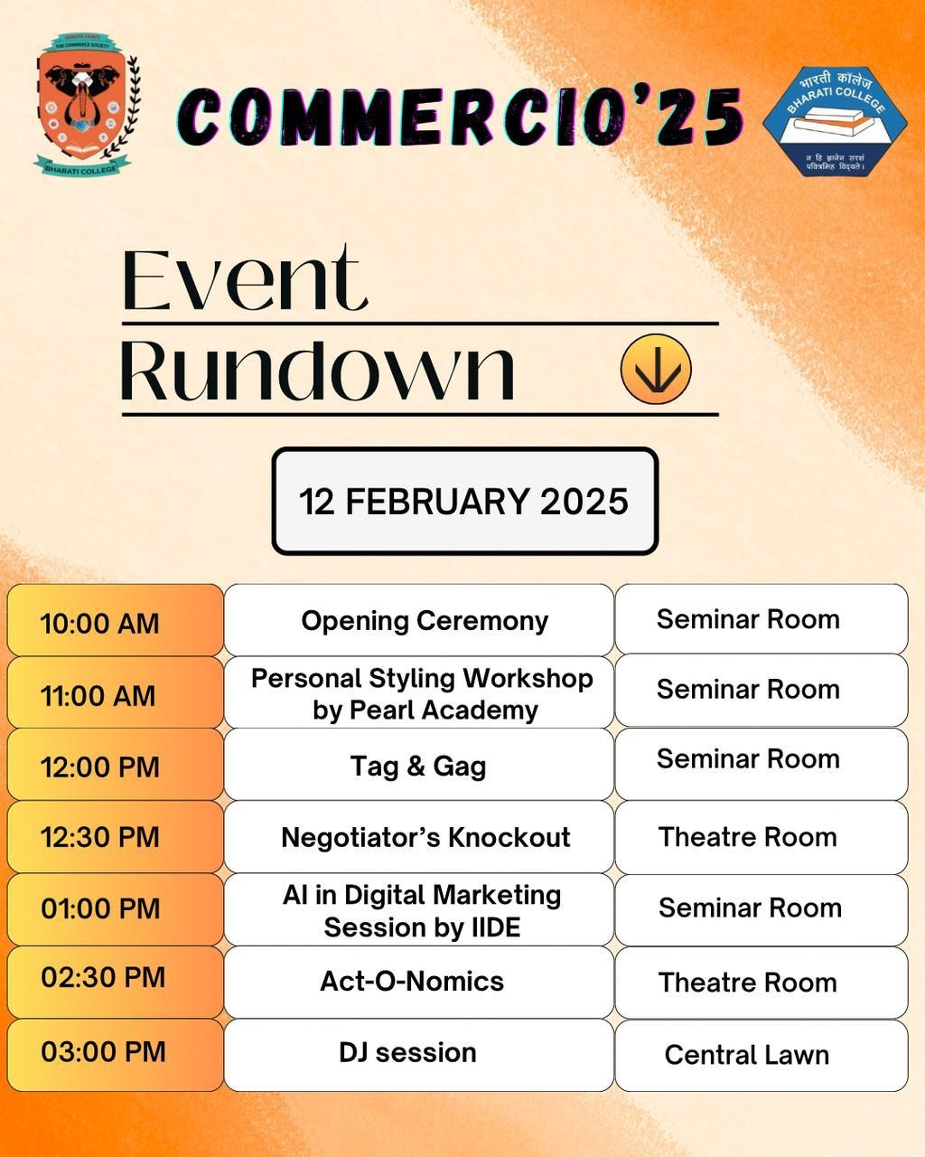

College: Bharati College, University of Delhi
Date and Time of Session: 12th February 2025, 11 A.M. Department/Society: Vanijya Samiti, The Commerce Society, Bharati College Program: Commercio’25
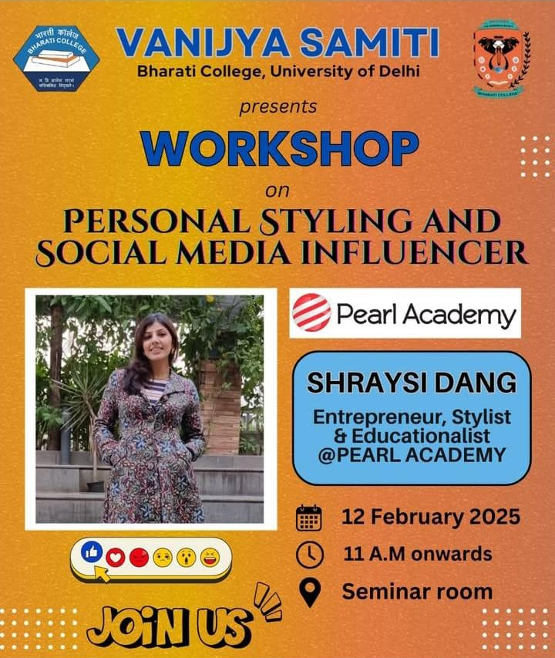

On 12th February 2025 a unique and engaging event, "Personal Styling Workshop” was organized by the Vanijya Samiti as they collaborated with Pearl Academy for the seminar.
The event educated students on using color palettes, personal styling, and maintaining good body posture, helping them enhance their appearance, confidence, and overall presentation.
The session began with a warm welcome speech, followed by an introduction to Ms. Shrayas, our honorable guest who delivered an insightful speech on personal styling.
The speaker Ms. Shrayasi shared her experience working on movie brand campaigns and collaborating with notable actors such as Janhvi Kapoor and Amitabh Bachchan. She defined styling and personal style, engaging students by asking them to share their thoughts on what personal style means, with responses focusing on comfortable dressing and individual choices.

Ms. Shrayasi emphasized the importance of accessories, shoes, body language, and posture. She demonstrated how body posture influences personal appearance and asked students about the influencers they follow, with many mentioning Nancy Tyagi and Meenakshi Dutt. She also shared her admiration for influencer Rishika Tyagi, who promotes sustainability in fashion.

The session delved into trends, with Ms. Shrayasi mentioning Sapna Rai, known for promoting upcycled products. She discussed the importance of understanding one’s ethics in personal styling and body shapes, advising on how to correct certain body posture, such as for the triangle body shape, and the significance of choosing the right colors. She also highlighted the difference between compliments on one’s dress and compliments on one's overall appearance, stressing that true confidence comes from being happy with your personal style, regardless of others’ opinions.

In an interactive segment, Ms. Shrayasi discuss the significance of body energy and balance, using the concept of Ying (female energy) and Yang (male energy). She referred to image consultants, stating that they help clients develop their personal style. Drawing examples from popular figures like Daljeet Dosanjh and Ranveer Singh, she explained how individuals create and express their image.

The session also covered minimalistic vs. minimalist dressing styles, with a critique on earthy color palettes. Shrayasi referred to celebrities like Sonam Kapoor and Janhvi Kapoor, analyzing their styles. She introduced the 5Ws + 1H framework (Who, What, Where, When, Why, and How) to assess the styling choices for different occasions. Shrayasi further explained the importance of attention to detail, such as the sweetheart blouse design, and how styling techniques bring the entire look together.

A practical session followed, where students were given a task to break down and remix images of four individuals to create a new, unique persona. This activity aimed to demonstrate how small changes in styling can transform one’s entire personality.

The event concluded with a Q&A session where Ms. Shrayasi addressed student inquiries, offering advice on capturing images that reflect their personal style. Her closing quote, “Style is a way to say who you are without having to speak,” encapsulated the essence of the seminar.

The event took place in the seminar room of Bharati College and was a huge success in educating students on the intricacies of personal styling and its impact on self-expression and confidence.

FEEDBACK
The session, led by Ms. Shrayasi, offered insightful perspectives on personal styling, drawing from her experience working with renowned actors like Janhvi Kapoor and Amitabh Bachchan. She emphasized the importance of understanding one’s personal style, focusing on aspects such as clothing comfort, accessories, body language, and posture. She also highlighted the role of influencers like Rishika Tyagi, who promote sustainability, and discussed trends with a focus on ethics. Ms. Shrayasi explained how body shape affects styling and the importance of choosing the right colors. She also distinguished between compliments on attire and personal compliments, sharing her own experiences. The session included an interactive task where students broke down images to see how small styling changes can transform a look.

PHOTOS & ATTANDANCE
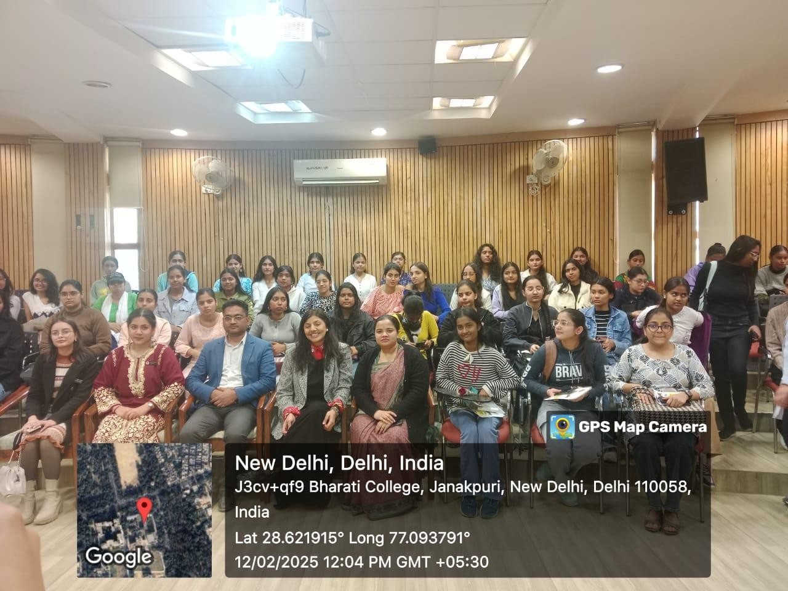
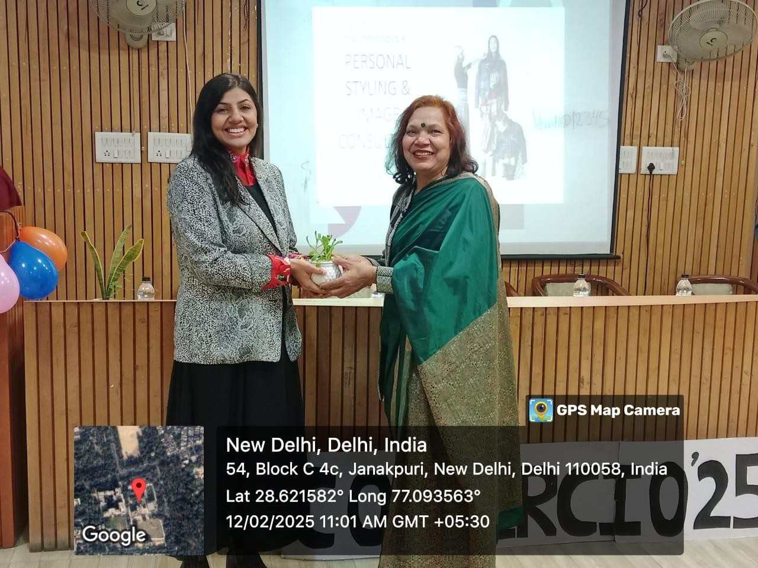

Program: Tag ‘N’ Gag : The Creative Pitch Battle Competition
Event Overview: The event, TAG ‘N’ GAG: The Creative Pitch Battle, was a part of

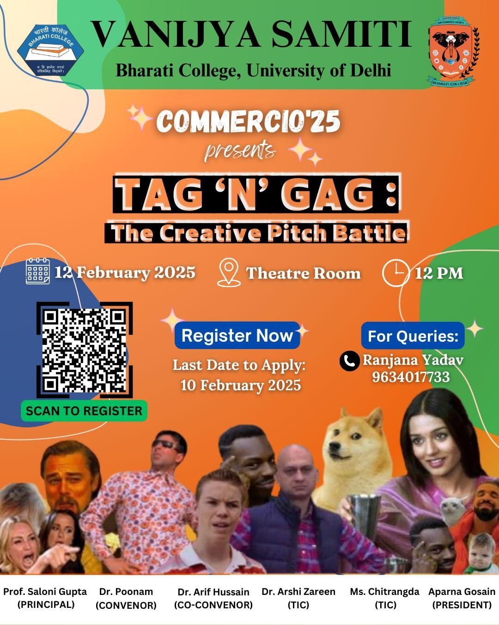

Commercio 25 and aimed at testing participants' creativity and marketing skills through tagline formation and meme creation. A total of 9 teams participated, consisting of 18 participants in total.
Competition structure: Each round, teams were allotted a random product or service through a chit system where 10 minutes were given to create a catchy tagline and 35 minutes were provided to design a meme based on the product/service.

The competition started around 12:15 PM and all the teams completed the task in the allotted time, where 1st position was awarded to ‘Anurag & Diksha’ and the Runner-up was ‘Bhumika Gupta & Jhanvi’.

The event was a great success, showcasing the participants' innovative thinking and marketing abilities in a fun and engaging manner.Overall, the event was a resounding success, fostering teamwork, quick thinking, and marketing prowess among students.
It set a high benchmark for future editions of Commercio and left the audience entertained and inspired.

PHOTOS
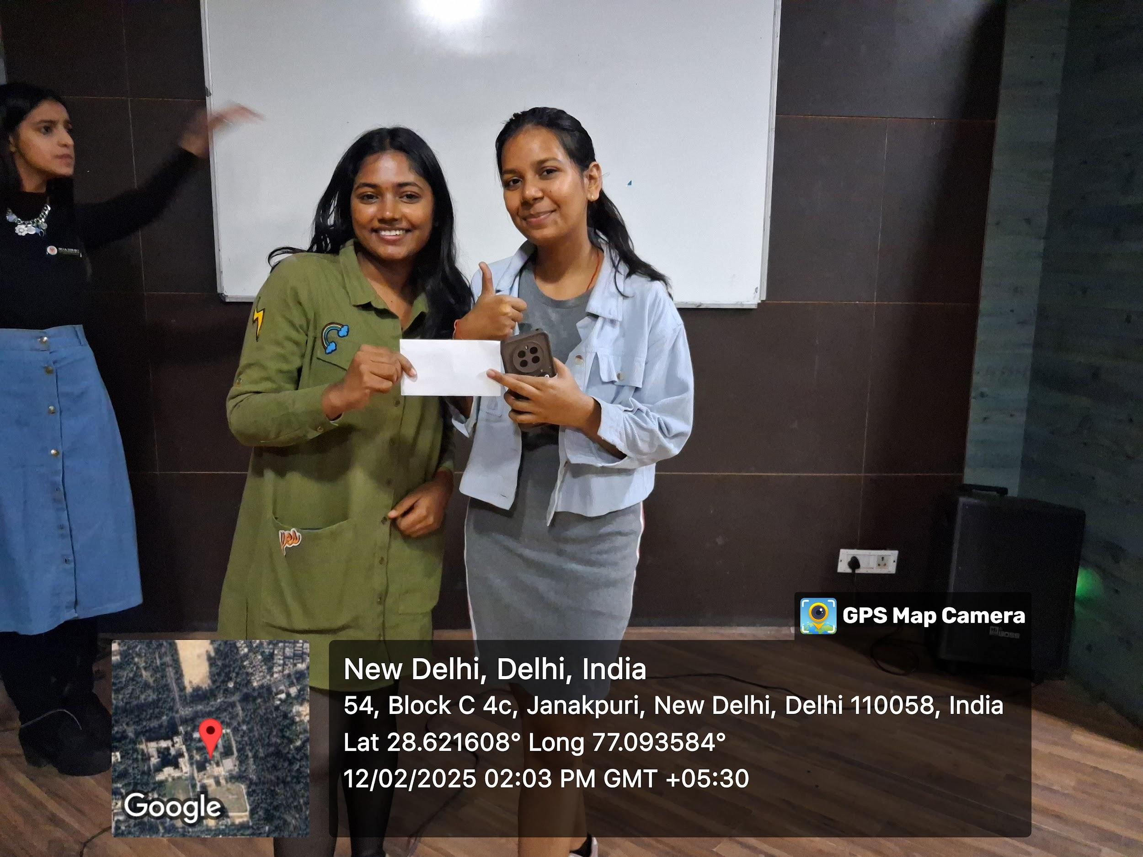
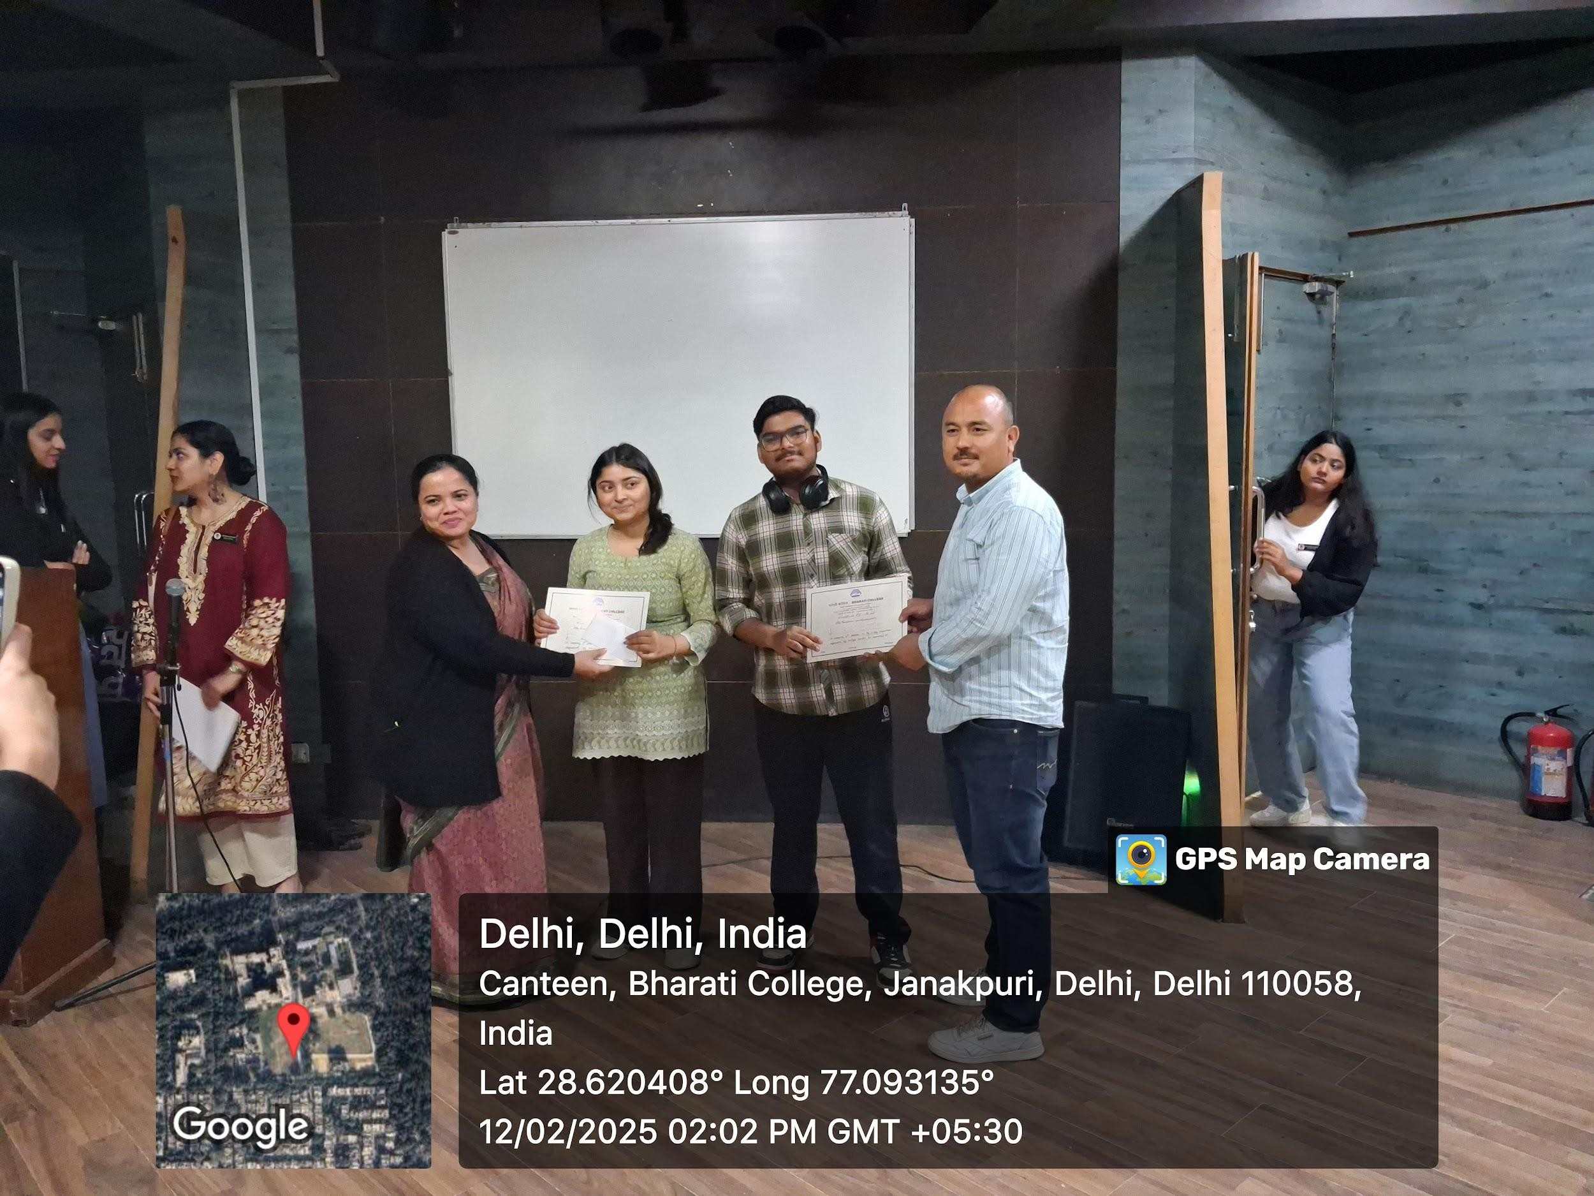
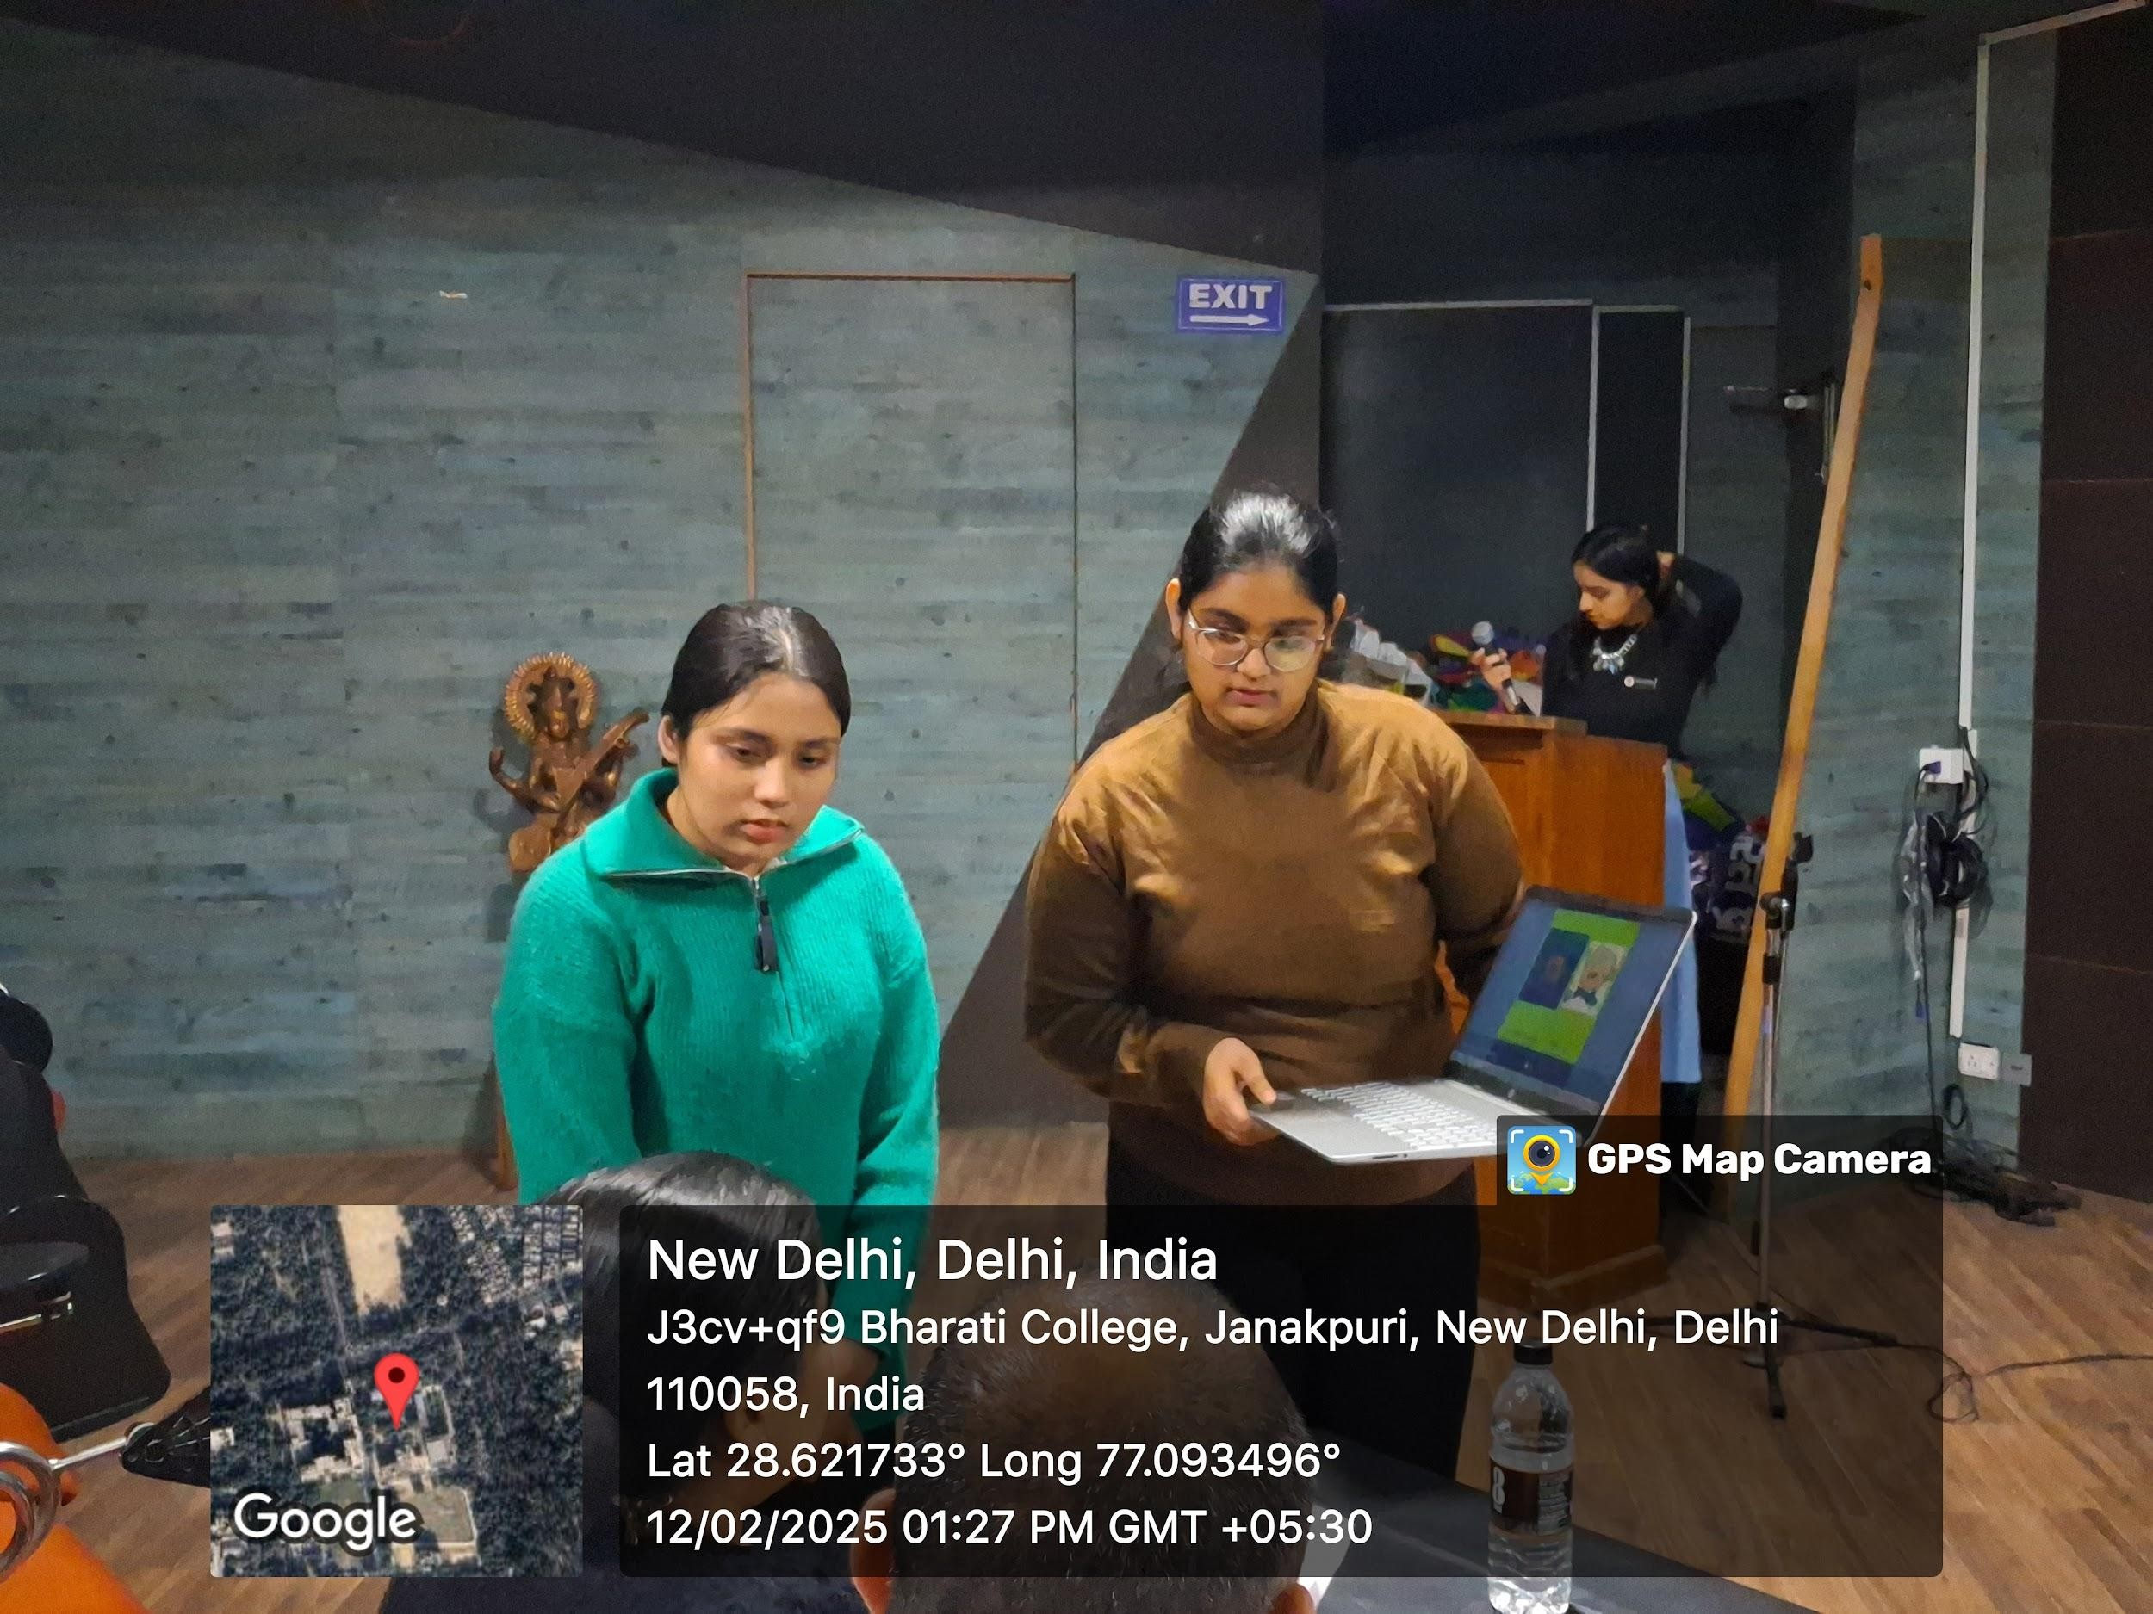

Program: The Negotiator's Knock-Out
Activity Title: The event aimed to test the participants' skills in negotiating values, leadership approaches, handling diversity, and responding to industry challenges, including the impact of COVID-19.
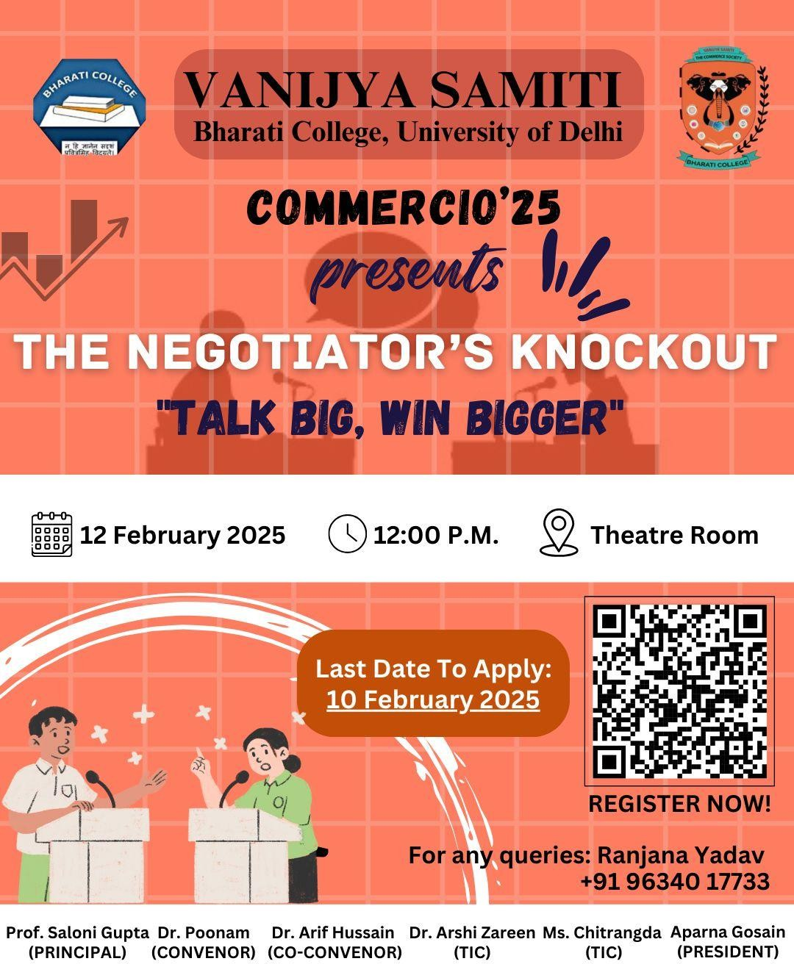

On 12th February, 2025 a unique and engaging event, " The Negotiator's Knock-Out:Talk Big, Win Bigger" was organized by the Vanijya Samiti-The Commerce society a of Bharati College at the theater room at 12:30 P.M.

The negotiation simulation event took place in a theater room with 10 teams competing in pairs, each given 15 minutes to negotiate on various aspects related to team management and leadership strategies. The focus was on creating democratic policies while addressing future concerns and industry-specific examples like McDonald's and Google. The winners were decided based on their ability to negotiate effectively, present ideas, and maintain professionalism.
Negotiation Topics:
- Team Dynamics and Leadership Negotiation: The primary negotiation focused on how HR teams should engage with other teams within the organization.
- Value Negotiation: The teams discussed what core values should be prioritized in the organization. They debated how values align with both employee engagement and leadership effectiveness.
- Leadership Negotiation: Teams discussed leadership styles, emphasizing how democratic leadership helps in creating inclusive, productive workplaces. Both teams were keen to highlight that leaders must be adaptable, especially in uncertain times.
- Futuristic Details: The teams talked about futuristic leadership strategies, stressing that leaders need to be adaptable to technological and organizational changes. The importance of evolving leadership styles was a central theme.
- Diversity Management: A major focus was on how to manage diversity within teams. Both teams emphasized the importance of creating inclusive policies that allow for the integration of professionals from various backgrounds and regions.
- Industry Examples: To strengthen their points, the teams brought up real-world examples like McDonald's and Google, noting how these companies have successfully diversified their workforce and adapted to changing environments.
- Response to COVID-19: A significant part of the discussion focused on how the pandemic reshaped leadership strategies. The teams agreed that remote work, adaptability, and employee well-being became key factors for success during this period.
- Democratic Policies: Both teams presented the idea of a democratic HR policy, where employees’ voices are heard and leadership decisions are made with collective input. The importance of employee participation was highlighted as an essential part of business success.
- Food Industry Negotiation - Aayushi and Aastha: In a parallel negotiation, Aayushi and Aastha tackled the topic of leadership and team management within a food company. Their negotiation revolved around the following key areas:
- Richness and Reach: Aayushi and Aastha discussed the potential strategies for increasing the reach of a food company. They debated whether to prioritize quality or quantity when scaling up, citing examples of companies that have thrived due to their strong brand reputation and customer trust.
- Gradual Changes: They suggested a gradual approach to expansion, much like McDonald's did when it started spreading across the globe. Both agreed that steady growth allows companies to adapt better to new markets and demographics, ensuring long-term success.
- Sustainability: Their discussions also revolved around how food companies need to be sustainable, keeping both consumer demands and environmental impact in mind.

1st position was secured by Muskan Raj and Anshika Jha secured and 2nd position was secured by Vidhi Arora and Mansa Bharti.

Both winning teams demonstrated strong negotiation skills, professionalism, and effective teamwork, presenting compelling arguments and ideas related to leadership, diversity, and future-proof strategies.

FEEDBACK
The negotiation event provided an insightful platform for participants to showcase their skills in team management, leadership strategies, and diversity management. It was an excellent learning experience for all involved, with real-world examples and practical strategies for handling challenges faced by businesses today. The winners, Muskan Raj and Anshika Jha, and Vidhi Arora and Mansa Bharti, stood out for their ability to negotiate effectively, think critically, and present solutions to complex business issues.

PHOTOS
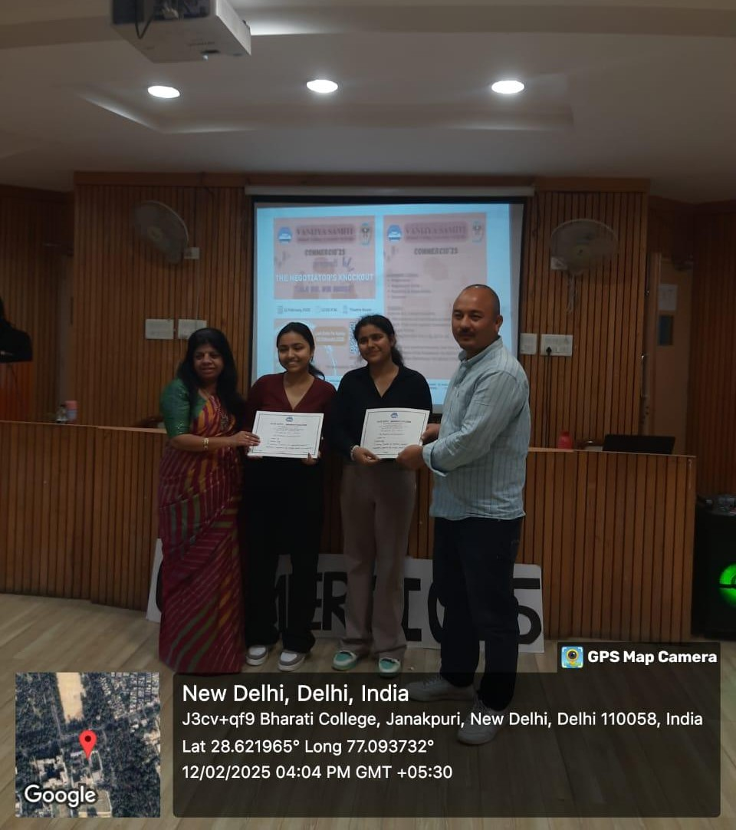
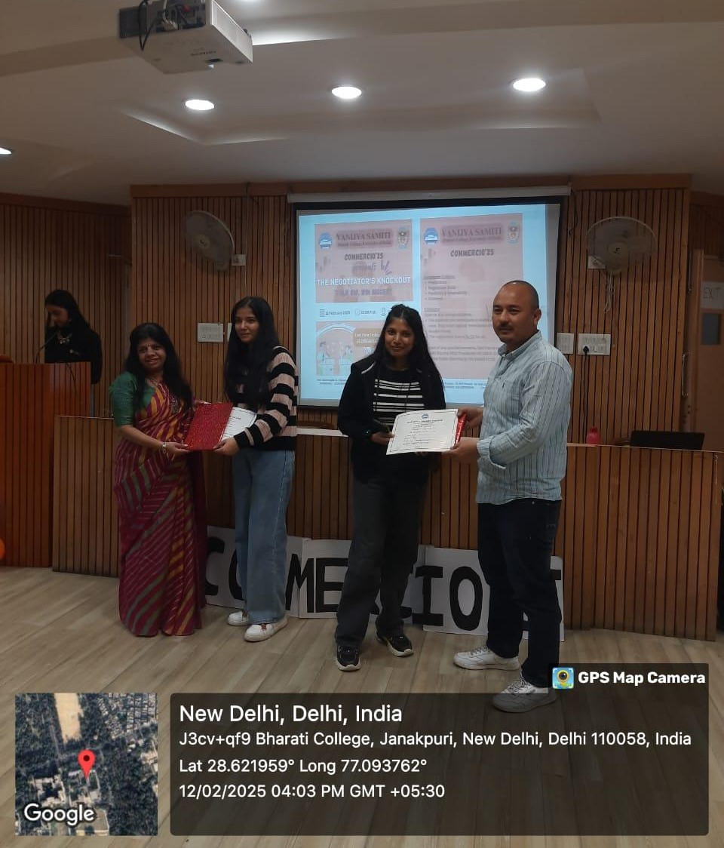

Program: Speaker's session on AI in digital marketing
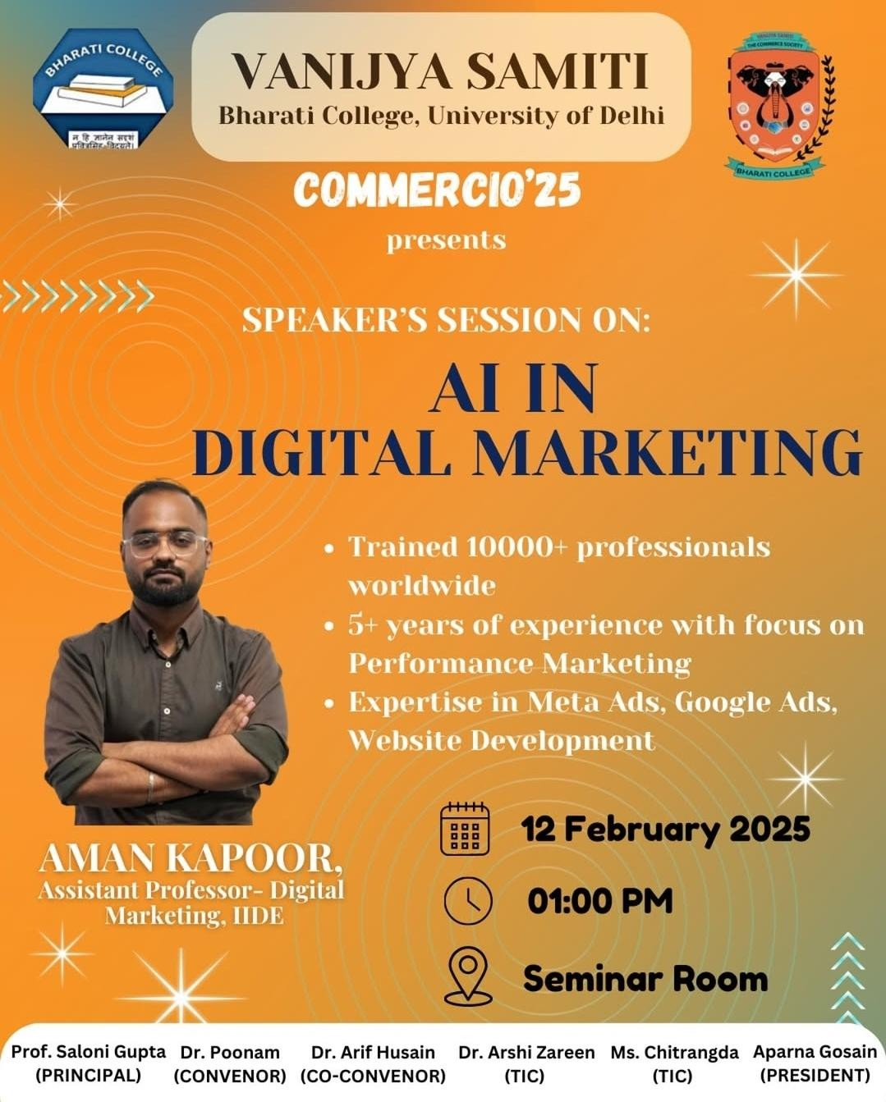

The AI in Digital Marketing seminar, conducted under Commercio 25, was aimed at educating students and professionals about the role of artificial intelligence in modern marketing strategies. The event featured expert insights from Aman Kapoor, who shared his extensive knowledge on AI-driven marketing tools and their applications.

KEY TOPICS COVERED

- Introduction to AI in Digital Marketing: The session began with an overview of AI’s impact on digital marketing, emphasizing its role in improving performance marketing and customer behavior analysis. The speaker highlighted how AI is transforming the industry by automating processes, personalizing customer experiences, and optimizing marketing strategies.
- AI Models & Tools Discussed: Aman Kapoor introduced various AI models and tools used in digital marketing. He discussed ChatGPT, which aids in content creation, customer support, and automation. Zomato AI was presented as a tool for personalized food recommendations, while Gemini was highlighted for its role in content and SEO optimization. The speaker also mentioned Kyra-AI Model as an emerging AI technology for marketing campaigns, demonstrating its potential in enhancing audience targeting and engagement.
- AI’s Functionality in Digital Marketing: The discussion included AI’s role in PET (Persona, Environment, Task) modeling, explaining how AI helps in understanding
customer personas, analyzing the environment through market trends, and automating tasks for efficiency. The speaker showcased how AI is used for generating images through Meta AI and creating LinkedIn connection request messages tailored to professional networking.
- Practical Tasks & Demonstrations: The seminar included interactive practical sessions. The first task demonstrated how to generate images using Meta AI, showcasing the power of AI-driven creativity in marketing. The second task focused on crafting LinkedIn connection request messages with AI, helping attendees understand how AI personalizes outreach efforts. Attendees were also provided with certificates for participating in the seminar. The session concluded with an engaging query session, where participants had the opportunity to ask questions and clarify their doubts.

FEEDBACK

Post-event feedback was overwhelmingly positive. Students appreciated the clarity of information provided.Practical tips shared for exam preparation.The motivational aspects of the session that encouraged them to take charge of their career paths.

CONCLUSION

The seminar provided valuable insights into AI applications in digital marketing, helping attendees understand how AI-powered tools can enhance marketing strategies. The interactive nature of the session allowed participants to gain hands-on experience, making it an enriching and informative event. The discussion on AI models, practical tasks, and real-world applications ensured that attendees left with a comprehensive understanding of AI’s growing influence in digital marketing.

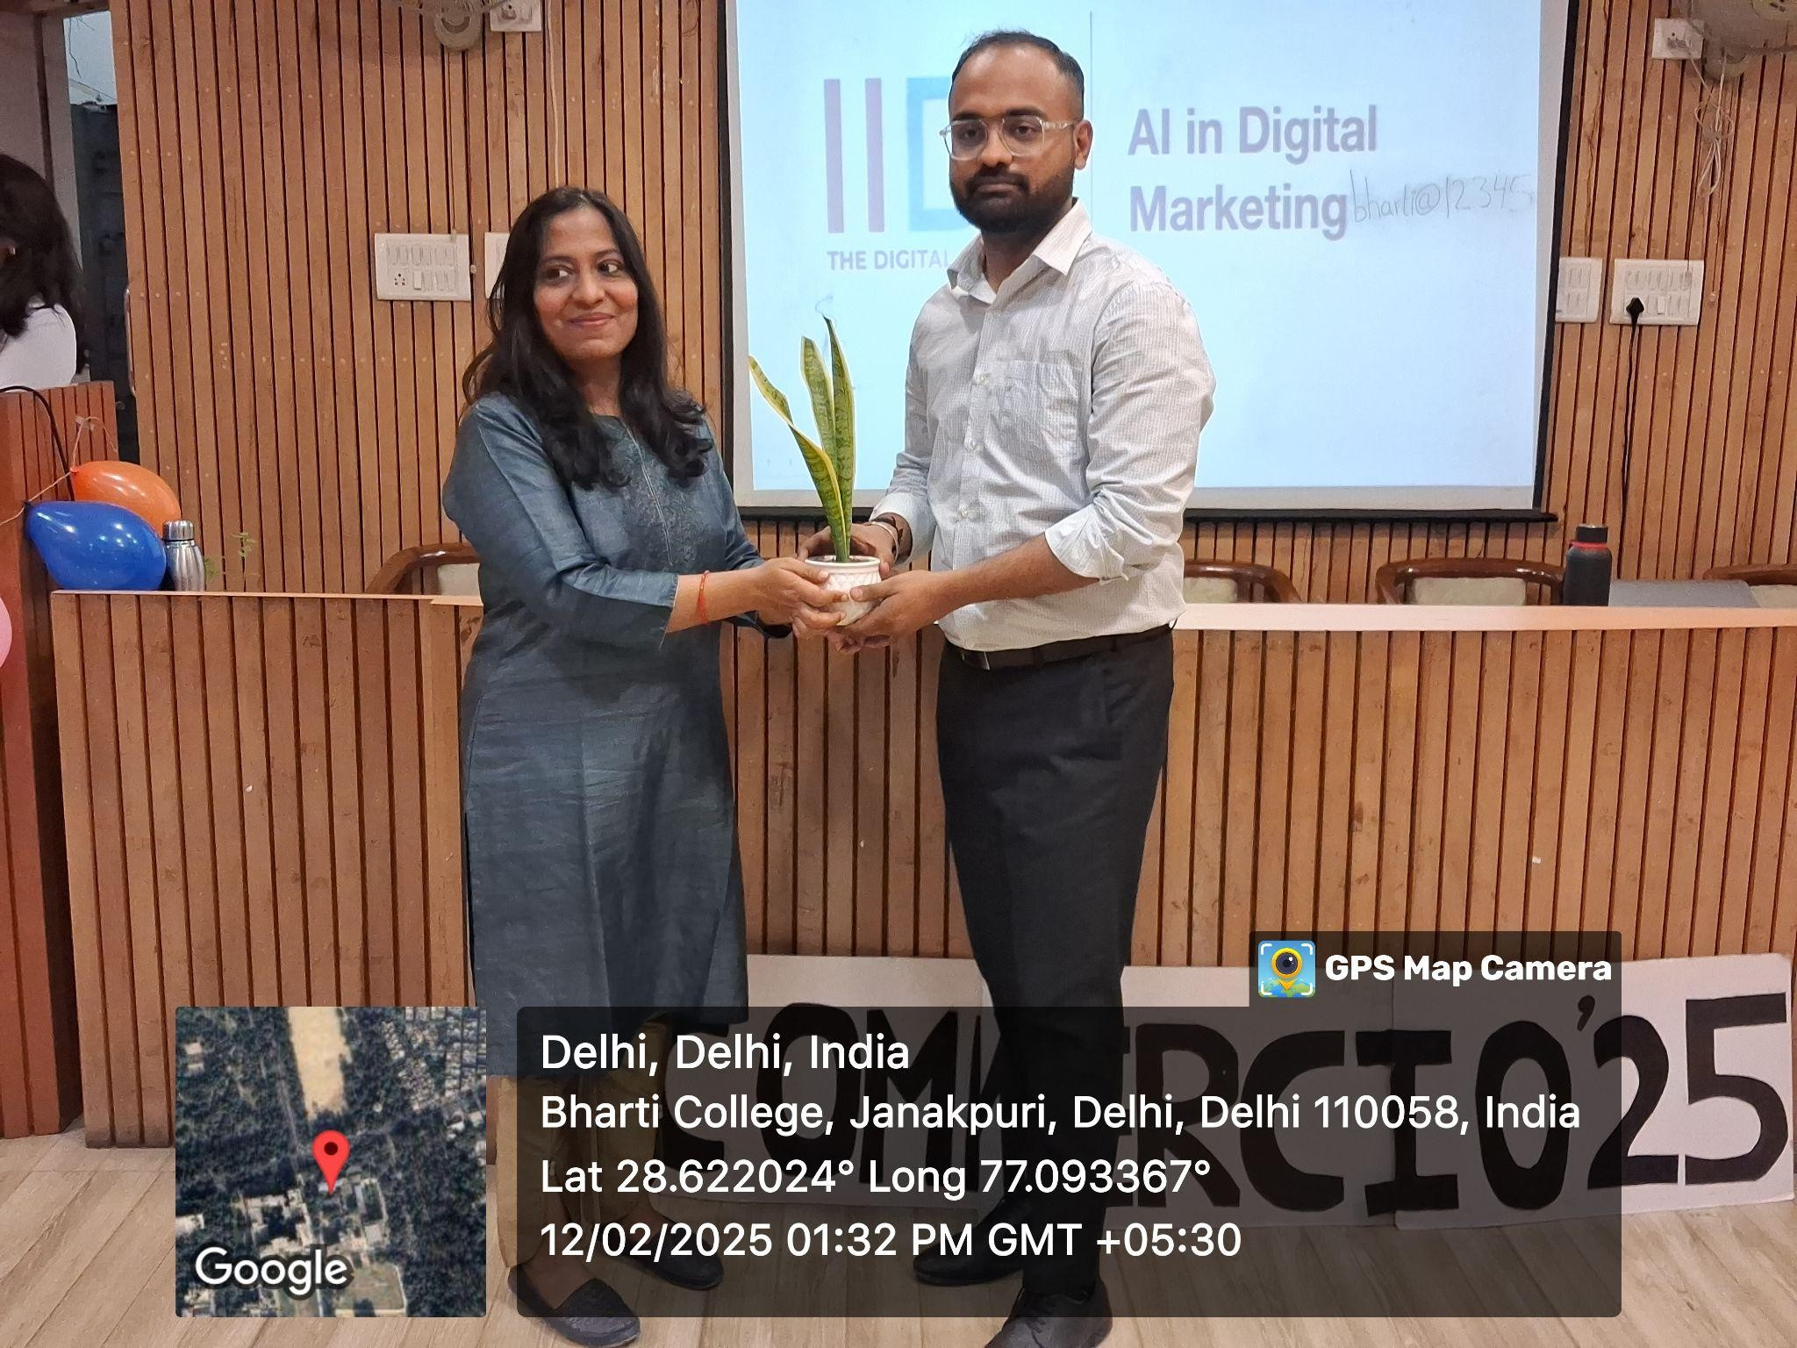
PHOTOS

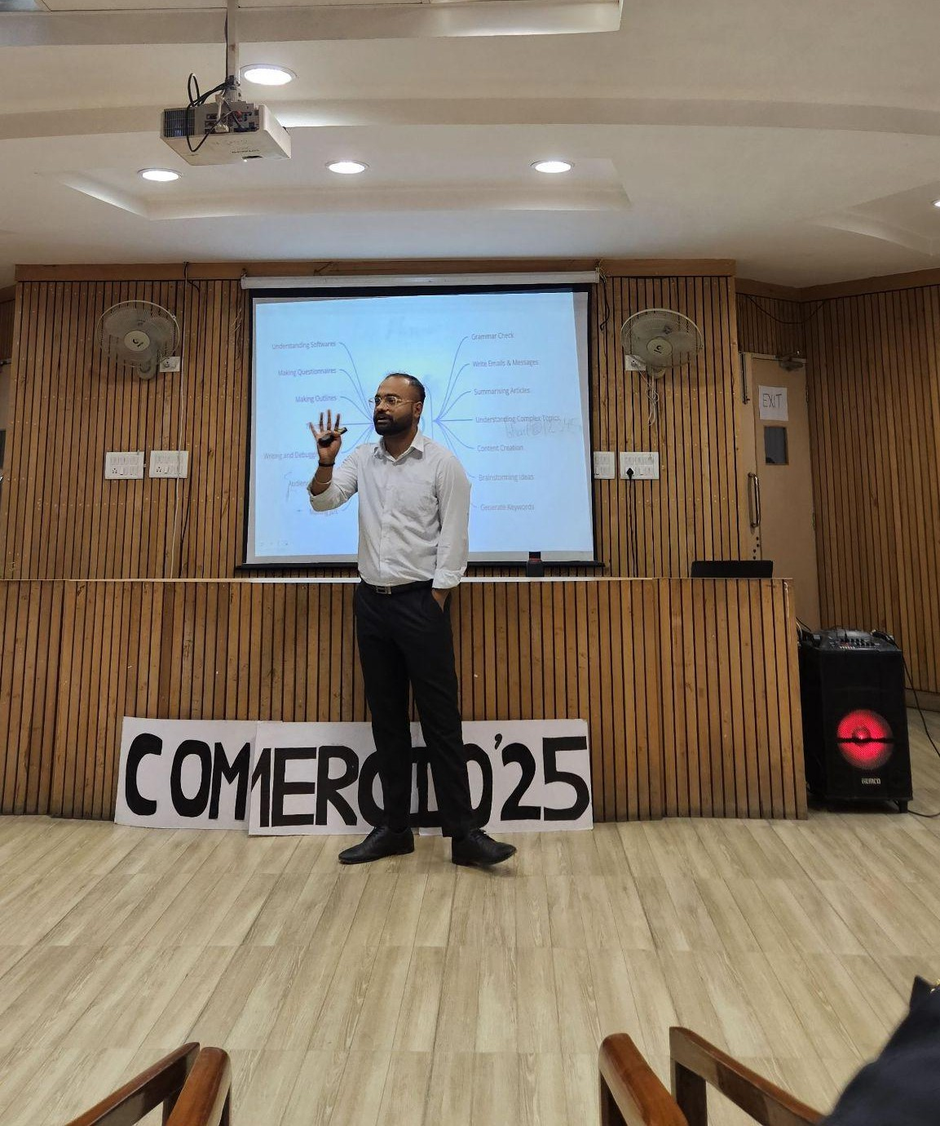

Program: Act-o-nomics: Where Business meets Drama
Activity Title: Competition aim is to make learning commerce fun by encouraging teamwork, creativity, and critical thinking.
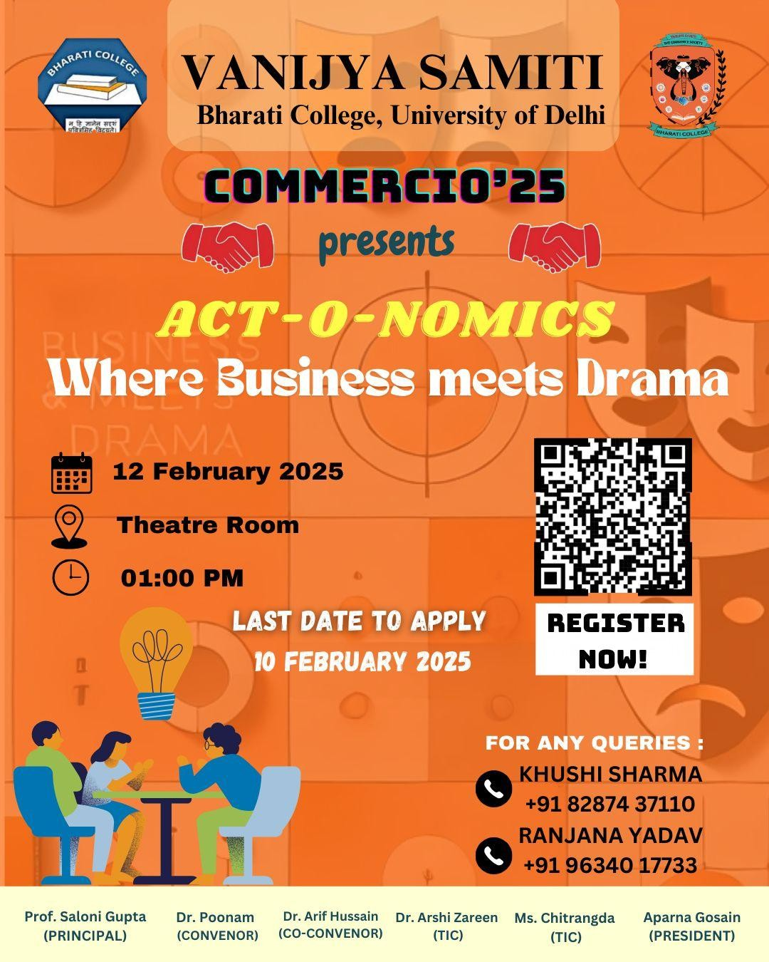

On 12th February, 2025 a unique and engaging event, "Act-O-Nomics: Where Business Meets Drama”, was organized by the Vanijya Samiti in the seminar room at 1 P.M.

It was successfully conducted, engaging participants in an interactive and educational game where teams acted out commerce-related terms using non-verbal cues. The event aimed to enhance teamwork, communication, and business knowledge in a fun and competitive setting.

PARTICIPATION & PERFORMANCE
A total of eight teams participated in the game, demonstrating creativity and enthusiasm. The teams attempted to guess the words based on their teammates’ silent actions, with varying levels of success.

WINNERS & AWARDS

- Winning Team: Radhika, Shanili, and Diksha emerged victorious with the best performance.
- First Prize: Salvi, Garima, and Karinna were awarded for their outstanding participation and efforts.

FEEDBACK
The event was a great success, fostering a fun learning environment while testing participants’ business knowledge in an engaging format. It encouraged teamwork, quick thinking, and non-verbal communication skills. The enthusiasm and participation from all teams made Act-O-Nomics an enjoyable and memorable experience for everyone involved.

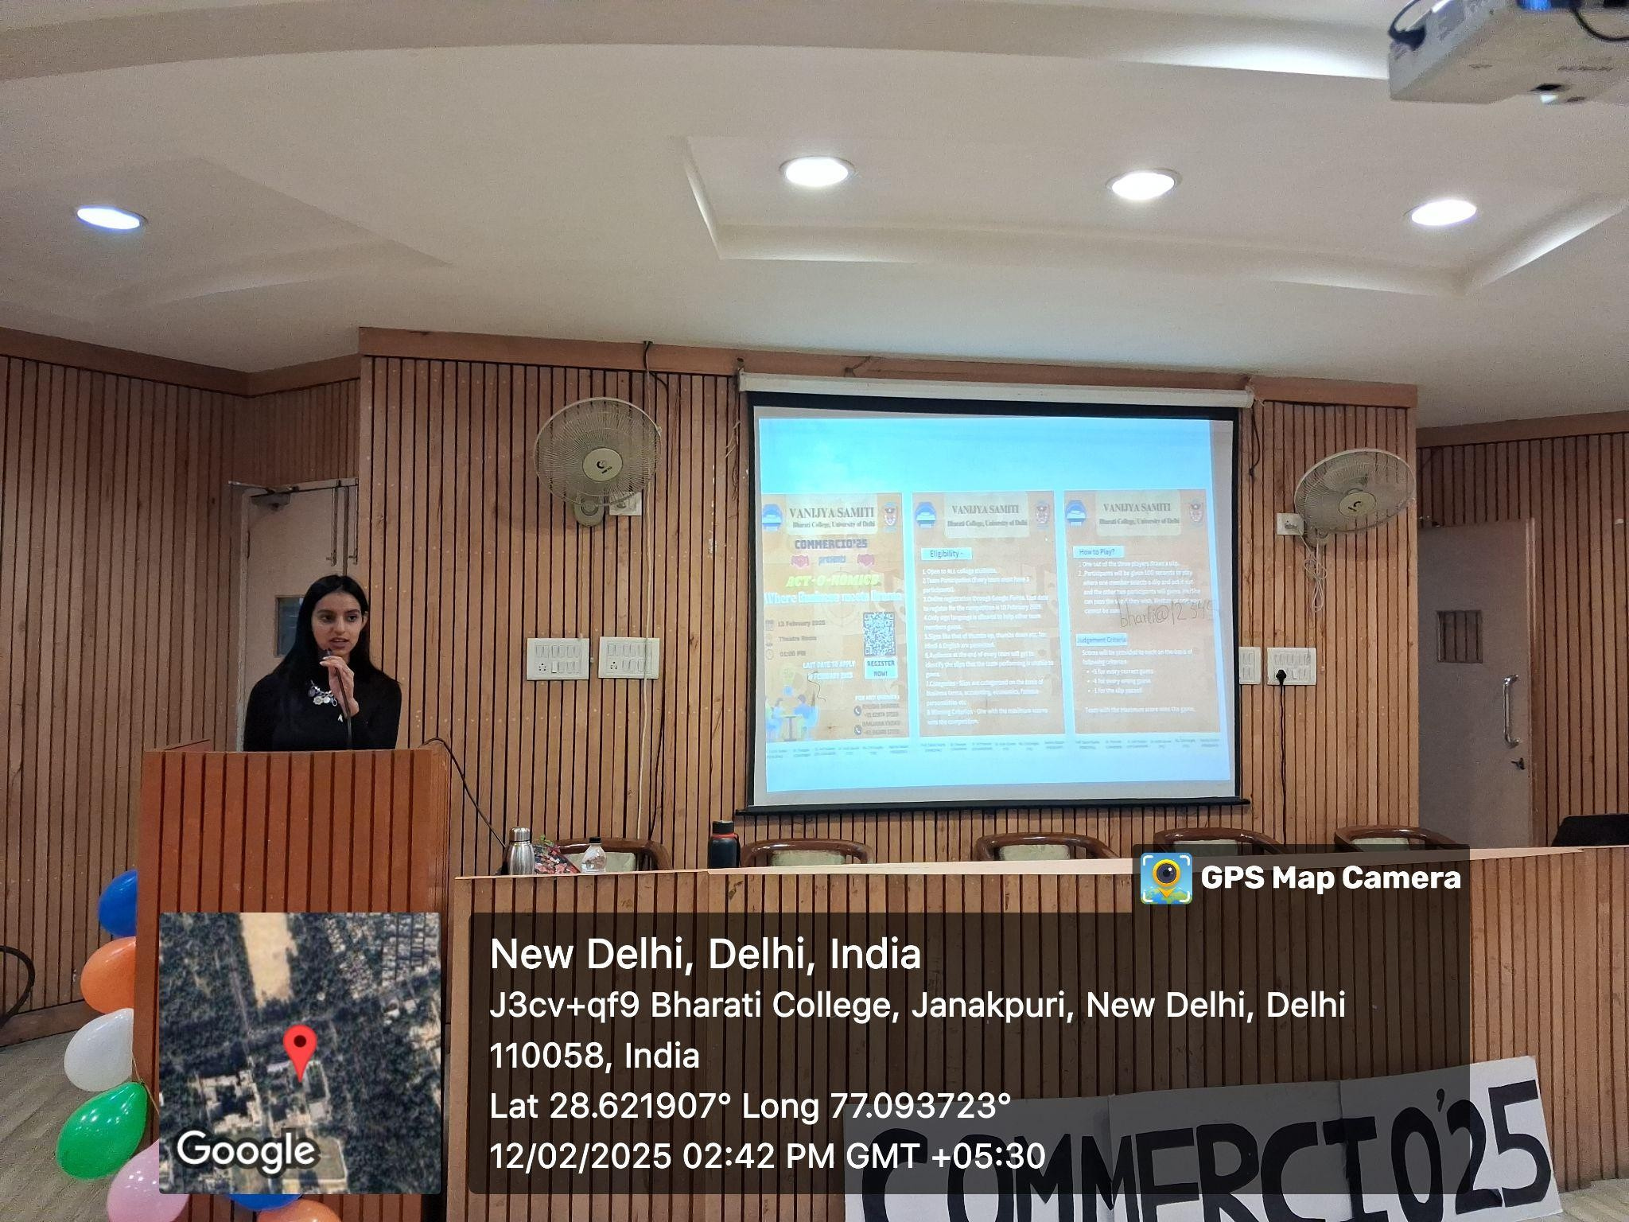
PHOTOS & ATTANDANCE

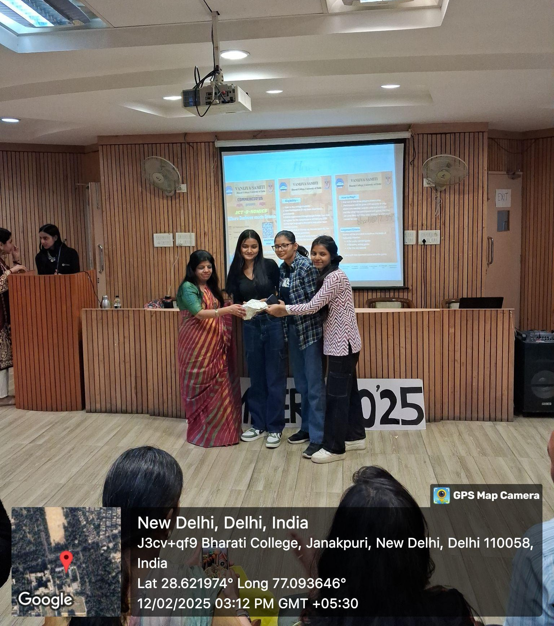
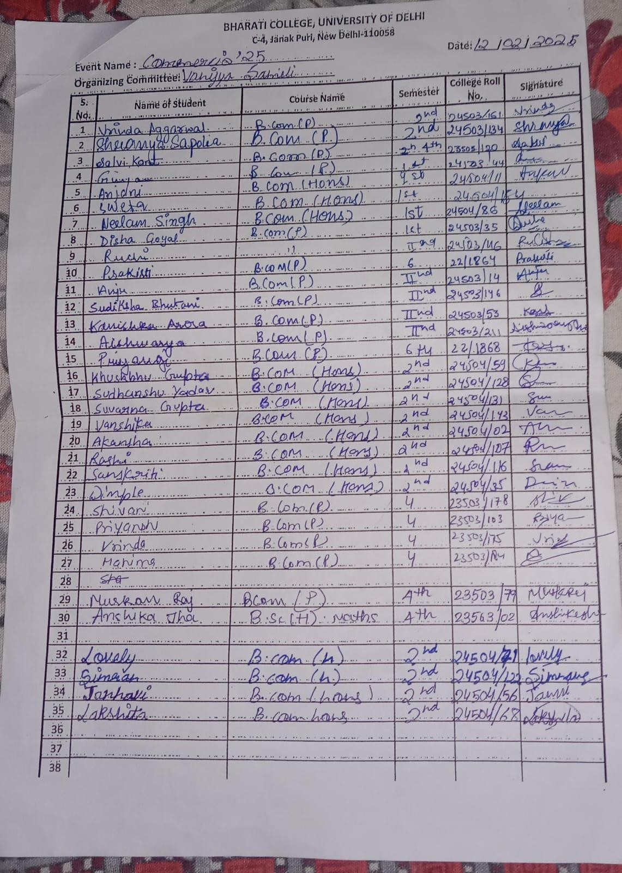

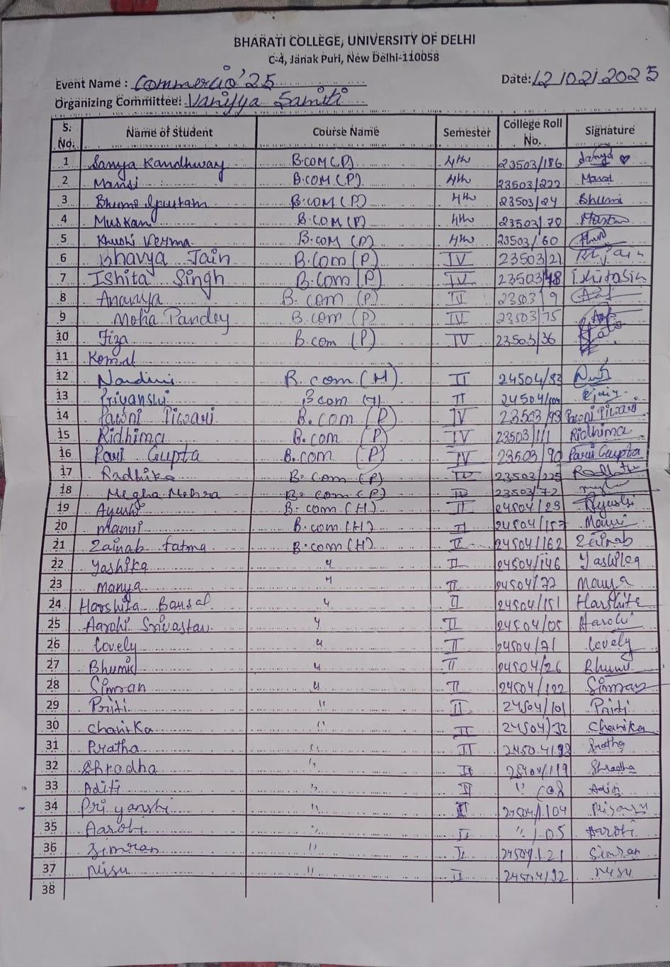

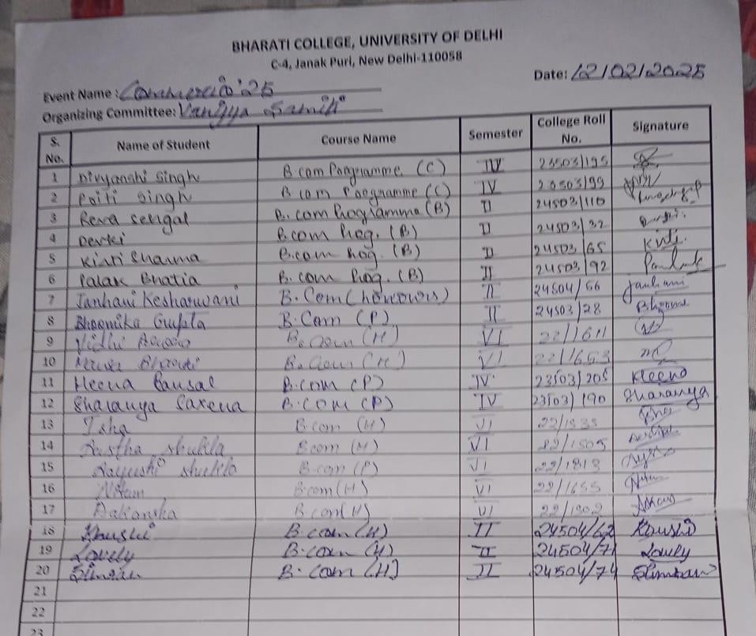

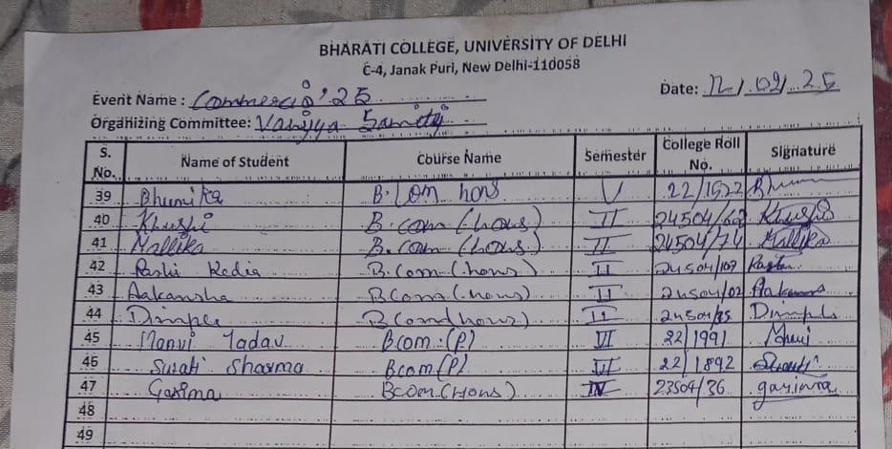

REPORT ON THE ANNUAL COMMERCE FEST - COMMERCIO 25

DAY 2
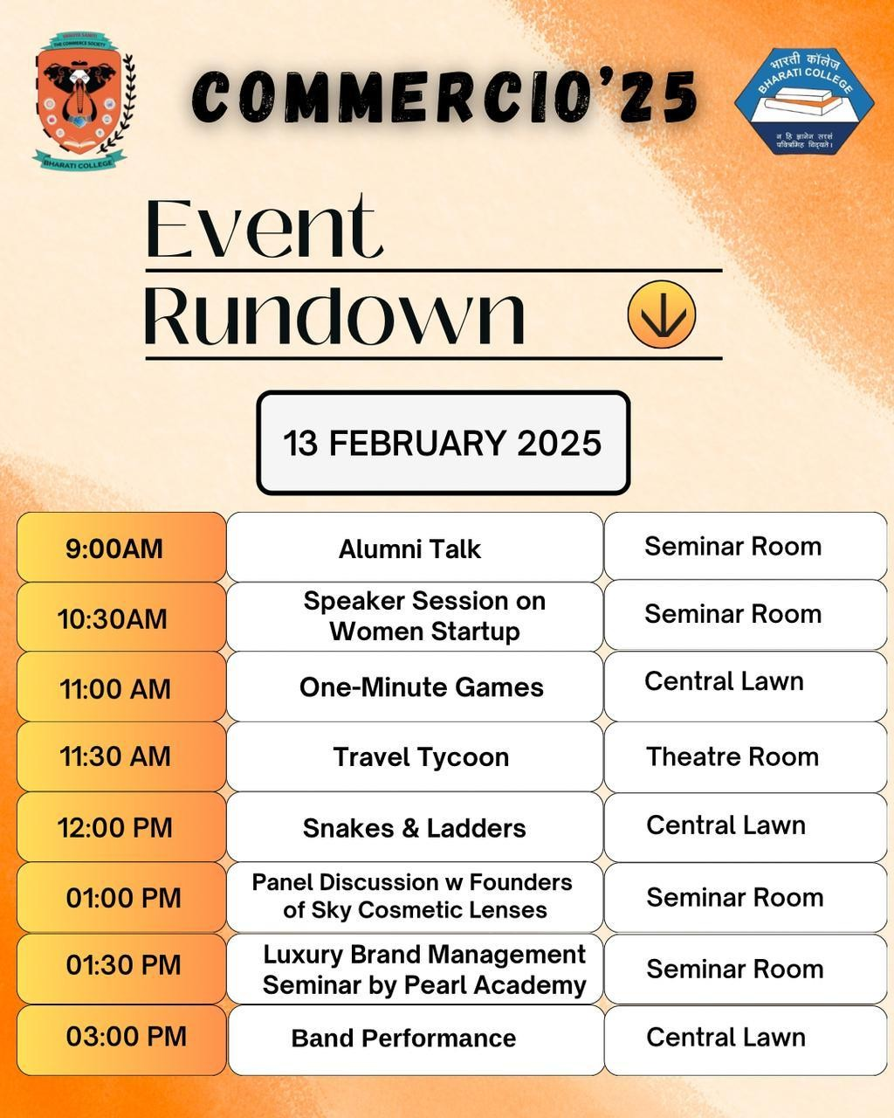

College: Bharati College, University of Delhi
Date and time of activity: 13th February 2025, 9 A.M.
Department/Society: Vanijya Samiti, The Commerce Society, Bharati College
Program: Commercio’25 - Day 2
Activity title: Alumni talk

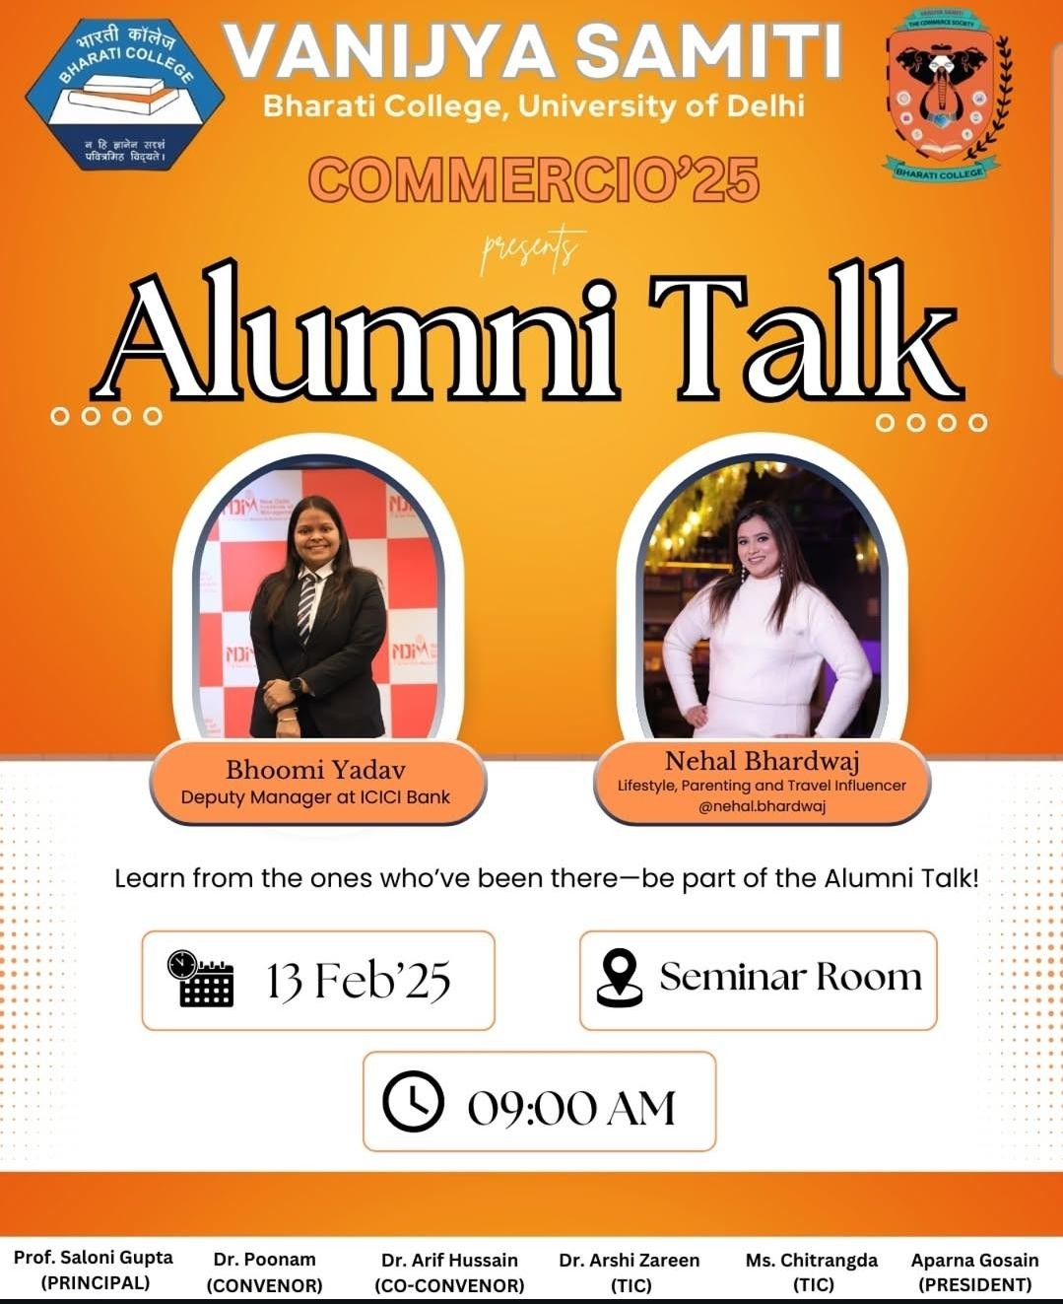

As part of Commercio’25, the annual fest organised by Vanijya Samiti, the Commerce Department organized an engaging Alumni Talk session featuring two distinguished alumni – Bhoomi Yadav and Nehal Bhardwaj. The session was facilitated by the esteemed professors of the department.
Bhoomi Yadav, Deputy Manager at ICICI Bank, shared her professional journey in the banking sector. She provided valuable insights into industry trends, career advancement strategies, and the importance of leadership and ethics in the corporate world. Her talk offered students a deeper understanding of opportunities in finance and banking.
Nehal Bhardwaj, a successful lifestyle, parenting, and travel influencer, spoke about her
experience in the digital content space. She highlighted the evolution of digital influencing as a career, strategies for monetizing content, and the challenges of building a personal brand. Her insights into social media growth and brand collaboration resonated strongly with students interested in digital entrepreneurship.
The primary objective of the session was to offer career guidance, industry insights, and skill development opportunities. It also served as a platform for students to network with alumni, fostering future mentorship and motivation. Through the real-life success stories shared by the speakers, students were inspired to pursue their aspirations with confidence and clarity.

CONCLUSION

The Alumni Talk at Commercio ‘25 proved to be a valuable initiative that strengthened the bond between alumni and students. By providing real-world insights and career guidance, the event helped students prepare for their professional journeys with confidence and a strategic mindset. The talk was interactive, informative, and inspiring, setting a strong foundation for future career-building initiatives at Bharati College.

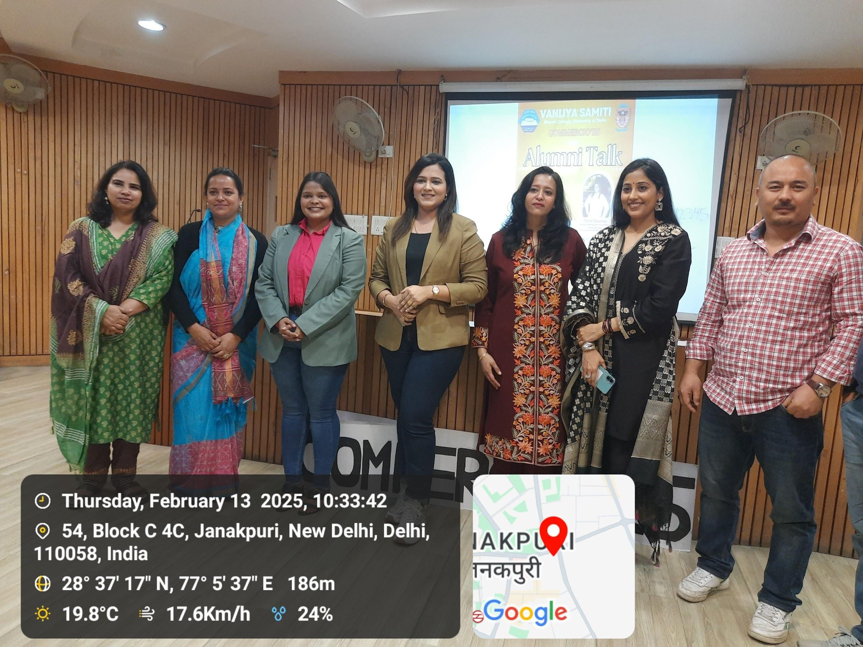
PHOTO
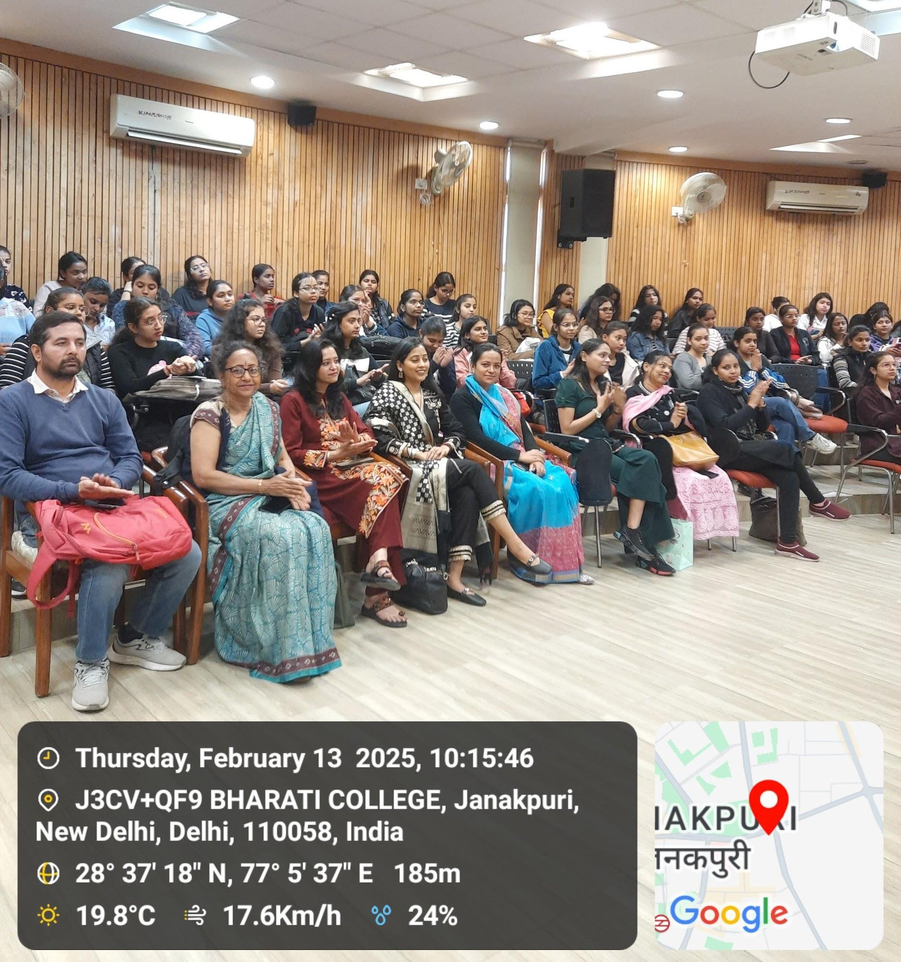

Program: Speaker Session on Woman Startup
Activity Title: The aim was to motivate individuals to take charge of their financial future and explore opportunities in earning, investing, and growing through entrepreneurship.

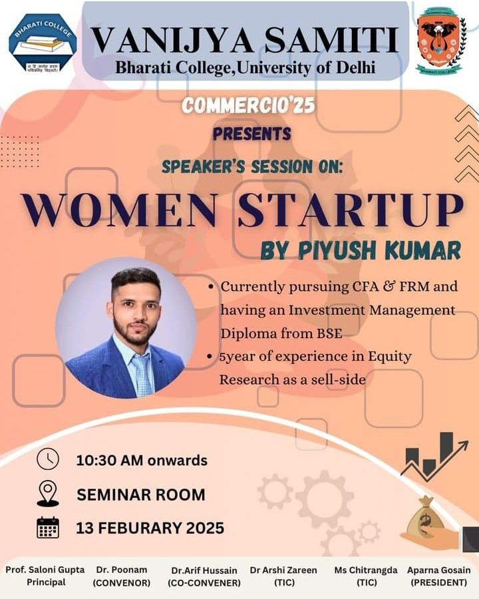

On 13th February 2025, Vanijya Samiti organized a unique and engaging speaker session titled "Women Startup" as part of Commercio '25. The event was held in the seminar room at 10:30 A.M. and featured Mr. Piyush Kumar as the guest speaker. The session centered around financial empowerment, personal finance management, and entrepreneurship, with a special focus on encouraging women to take initiative in their professional journeys.
Mr. Kumar emphasized the importance of taking charge of one’s finances from an early stage. He shared practical tips on budgeting, investing through mutual funds and SIPs, and the significance of starting small but consistent financial habits. He also inspired the audience to begin earning early—through part-time jobs, freelancing, or side hustles—as a path to financial independence.
A key focus of the session was increasing women's engagement in income-generating activities. Mr. Kumar highlighted success stories of renowned women entrepreneurs such as Falguni Nayar (Nykaa), Vineeta Singh (Sugar Cosmetics), Ghazal Alagh (Mamaearth), Rashmi Daga (PickMyWork), and Divya Gokulnath (Byju’s), using their journeys as motivational examples.
He also discussed the importance of supporting new women entrepreneurs through mentorship, professional networking, and sharing opportunities. Mr. Kumar encouraged students to utilize platforms like LinkedIn and Twitter to build their networks and expand their reach in the professional world.
The session concluded with an interactive Q&A round, where Mr. Kumar addressed questions on investment strategies, entrepreneurship tips, and balancing work with personal life. The talk was highly informative and motivating, leaving the audience with a fresh perspective on financial independence and entrepreneurial possibilities.

FEEDBACK

The session led by Piyush Kumar was an enlightening experience for the attendees, especially women, who felt inspired to take charge of their financial futures. By sharing real-life examples of successful entrepreneurs and offering practical advice on managing
money, starting a career, and building a network, Piyush provided actionable insights to the participants. His encouragement to actively engage on social media, connect with mentors, and explore entrepreneurship undoubtedly inspired many to take the next step in their financial and professional journeys.

PHOTOS
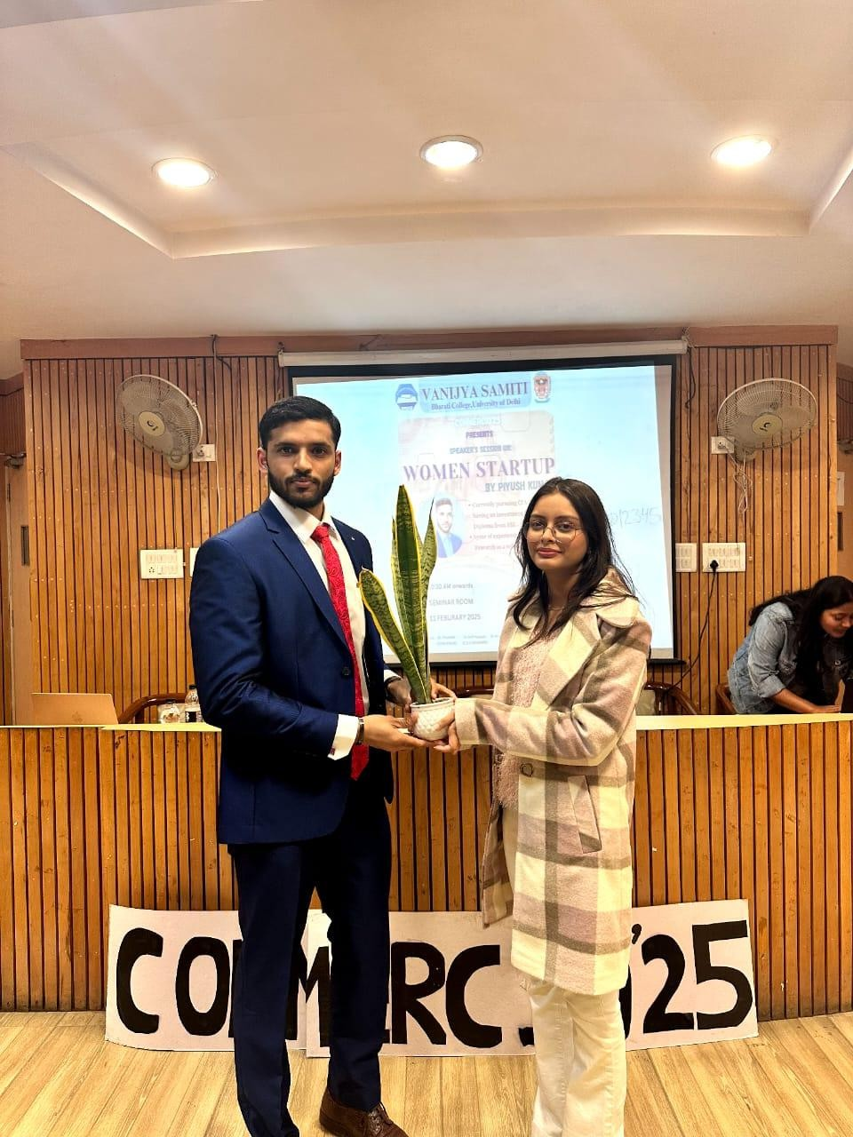

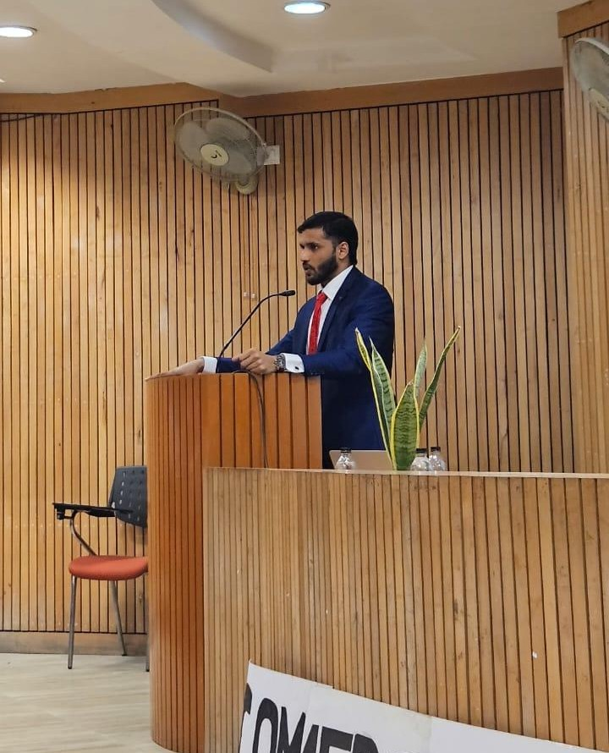

Program: Travel Tycoon competition
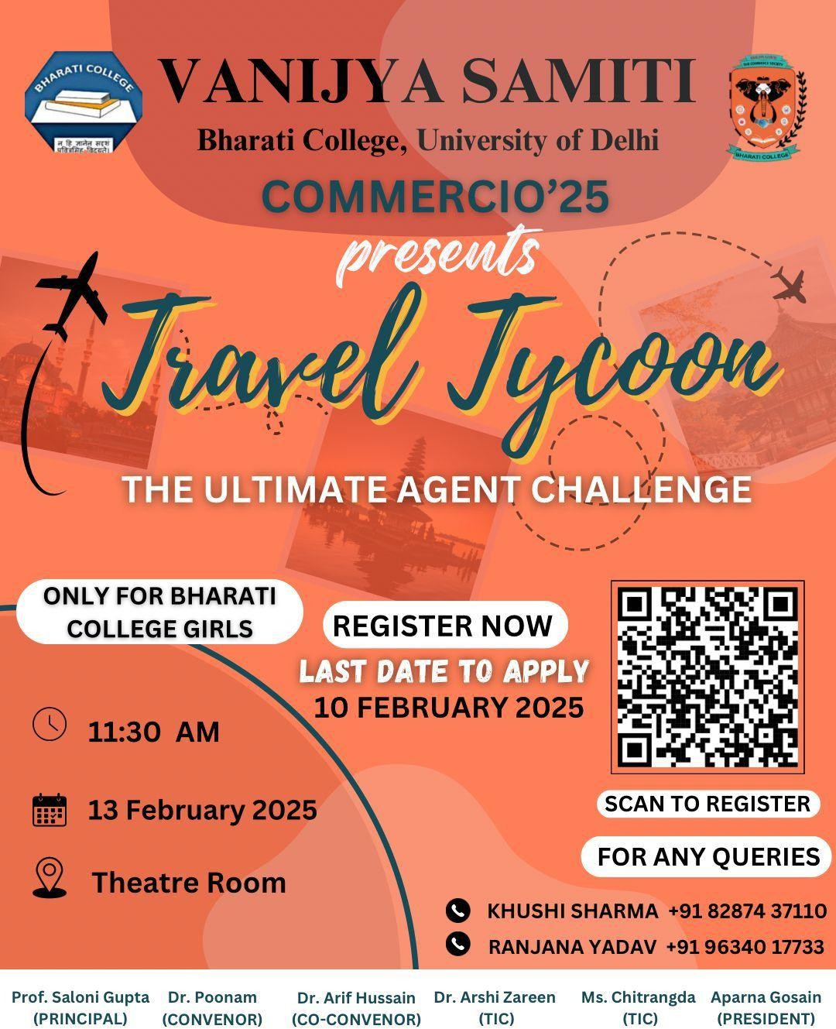

The Vanijya Samiti of Bharati College, University of Delhi, successfully organized an exciting event titled "Travel Tycoon – The Ultimate Agent Challenge" as part of Commercio ‘25.
The event took place on 13th February 2025 at 11:30 AM in the Theatre Room and was conducted exclusively for the students of Bharati College.
The event was executed seamlessly, thanks to the dedicated efforts of the organizing committee, faculty members, and student coordinators. The participants showcased great enthusiasm and competitive spirit as the challenge tested their abilities in decision-making, business strategy, and tourism management.
Participants engaged in a high-energy competition designed to evaluate their strategic thinking, entrepreneurial mindset, and understanding of the travel industry. The objective was to promote decision-making and business acumen among students in a simulated real-world context.

A total of 7 teams, comprising 13 participants, competed within a 30-minute time frame. After a close contest, Chhavi Arora secured the first position, while Taniya Aggarwal and Hardika Uppal, participating as a team, won the second position.
The event proved to be both enriching and enjoyable, further contributing to the entrepreneurial spirit of Commercio ‘25.
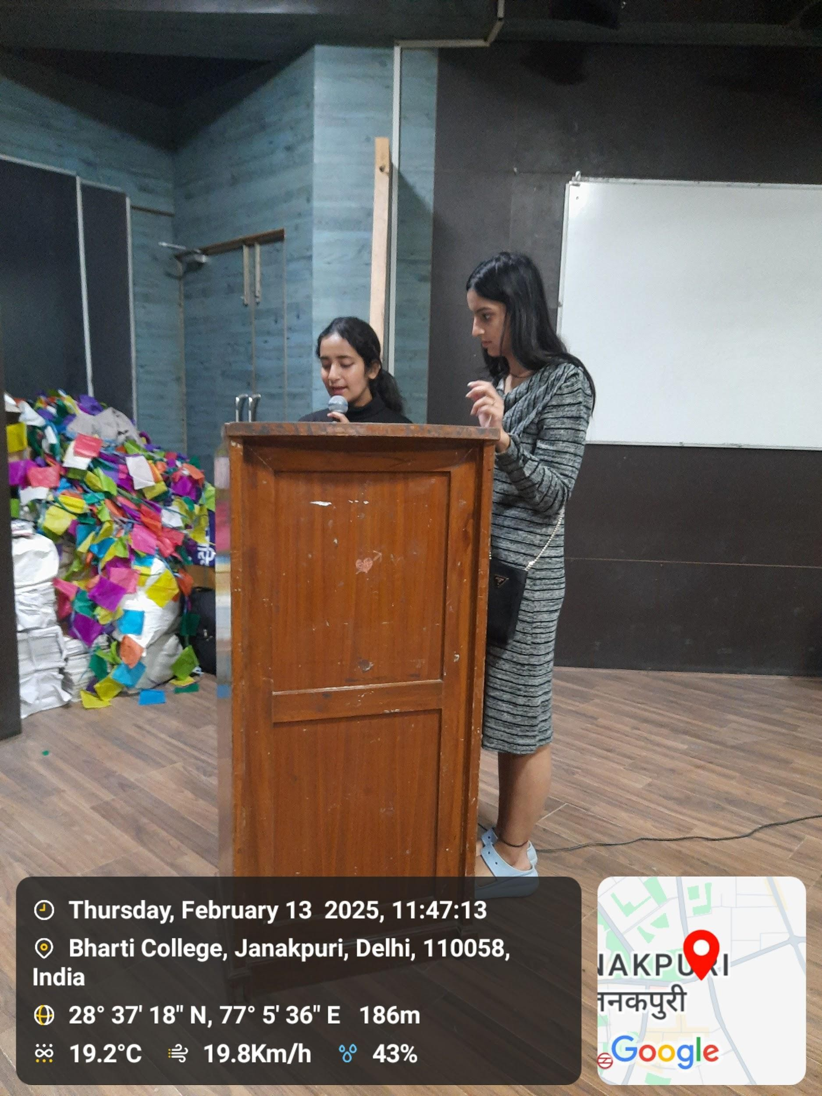
PHOTOS

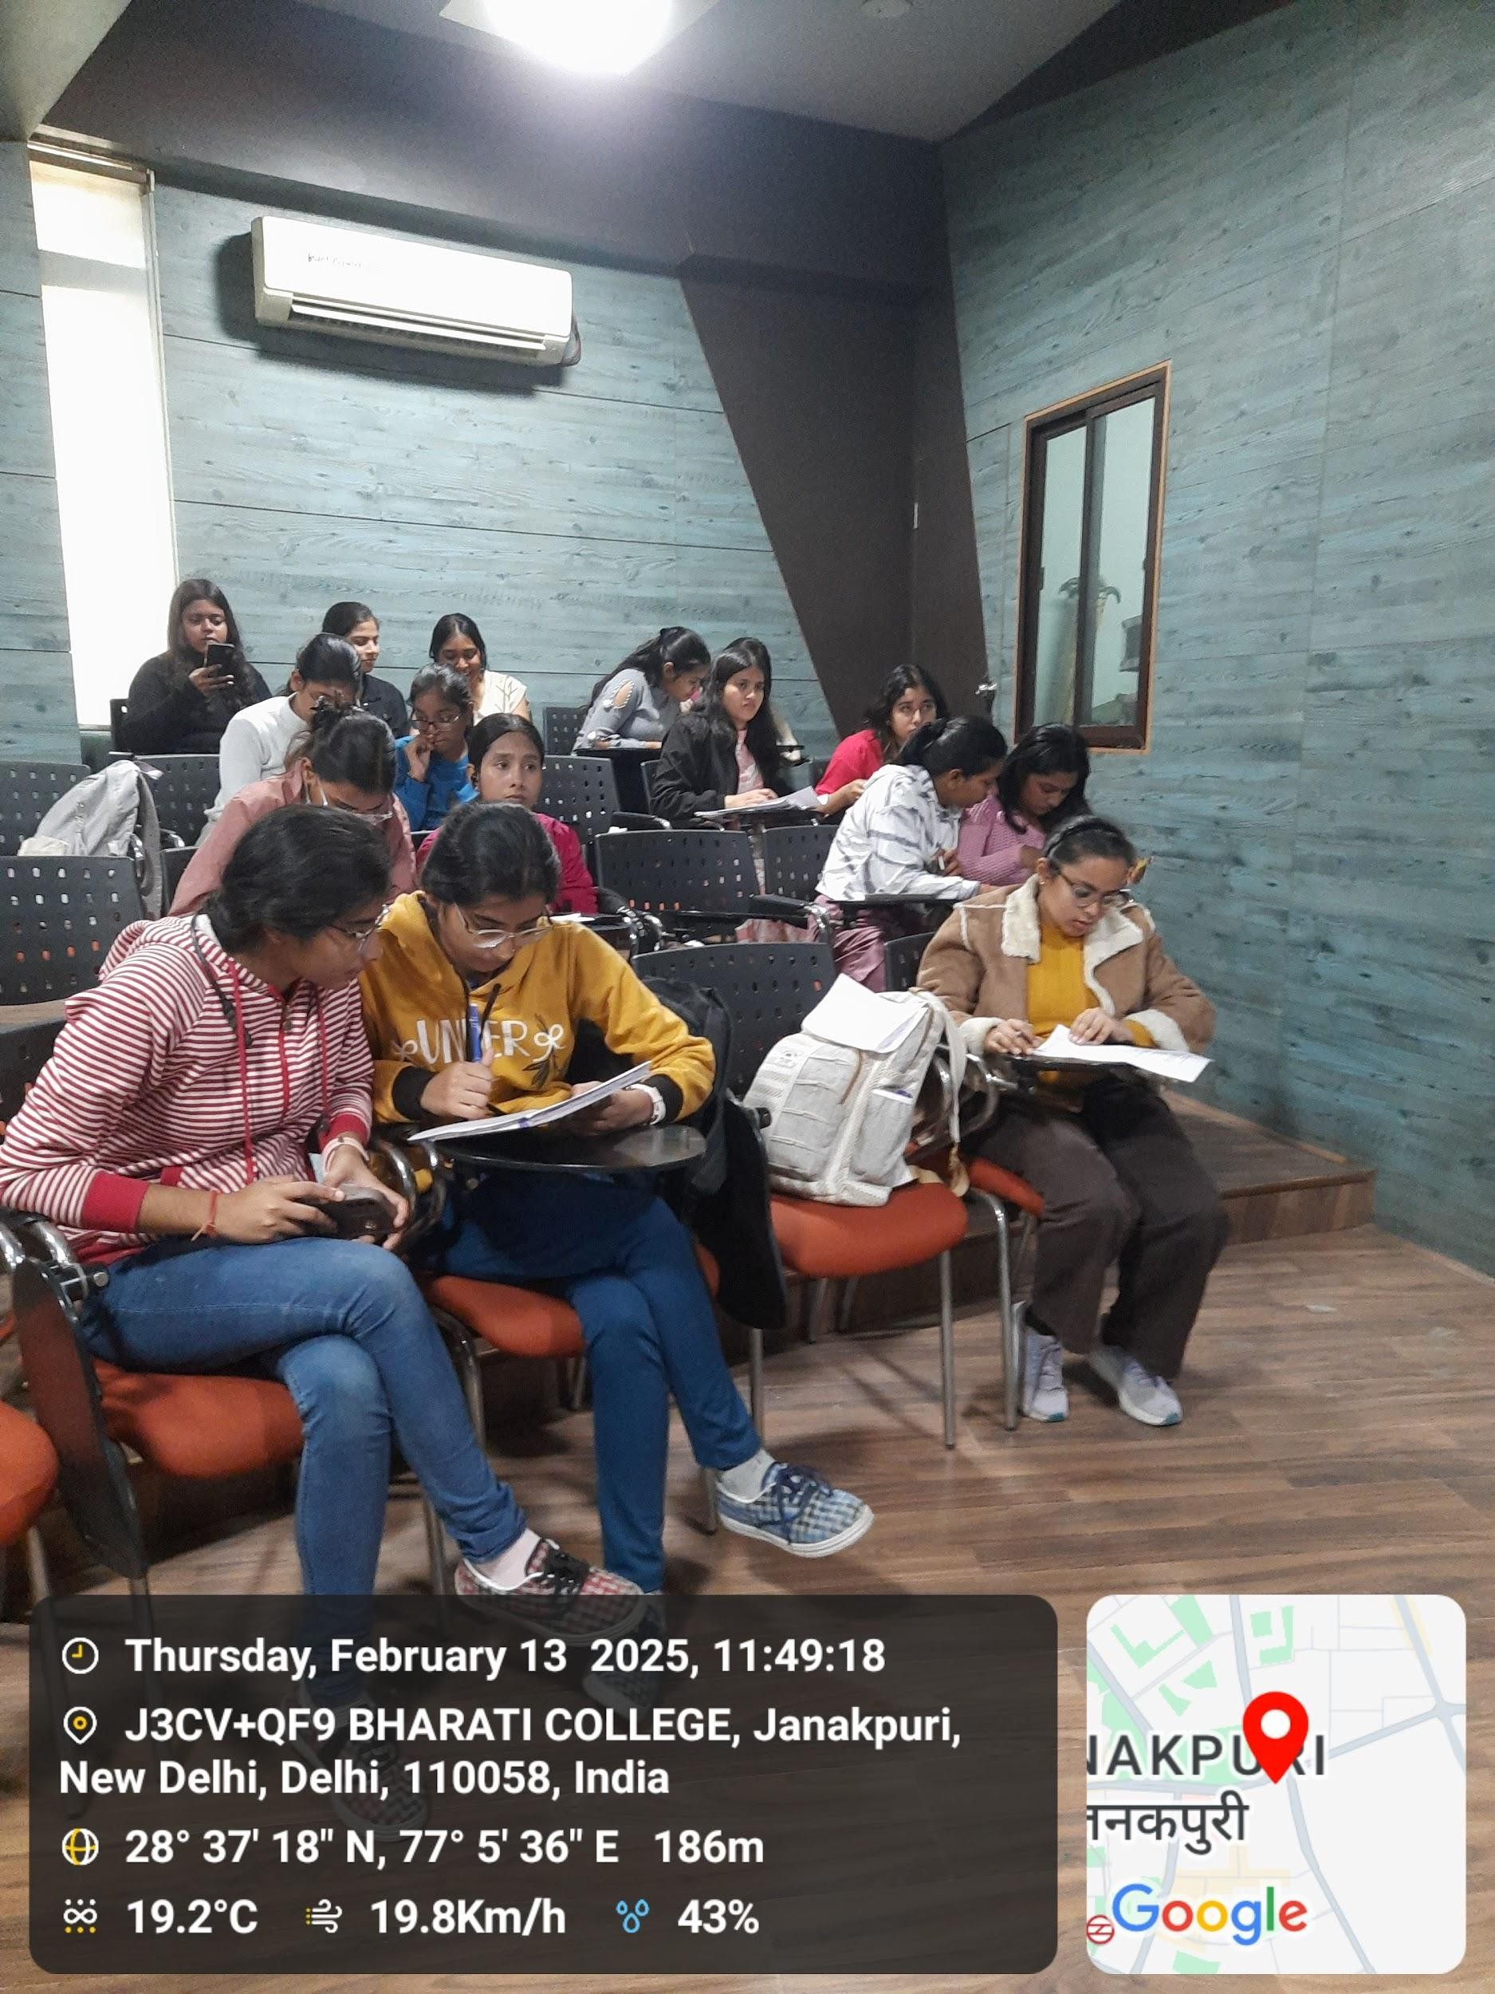

Program: Snakes and Ladders Competition
Activity Title: The "Snakes and Ladders" competition offers students a fun, engaging way to develop strategic thinking, risk-taking, and adaptability while learning important business skills in a lighthearted, interactive setting.
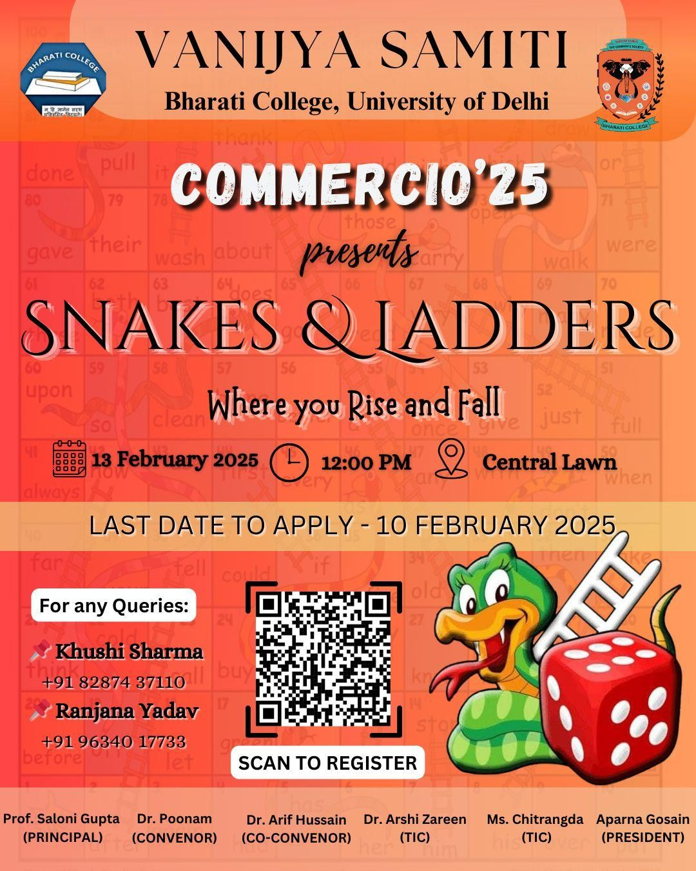

On 13th February 2025, Vanijya Samiti organized a unique and engaging event titled "Snakes and the Ladder: Where You Rise and Fall!" as part of Commercio ‘25. The event was held at 1:30 P.M. in the seminar room and was exclusively curated for the students of Bharati College.
The Snakes & Ladders Competition offered an exciting blend of fun and learning by combining the classic board game with commerce-related challenges. Participants had the opportunity to test both their luck and knowledge of commerce in a creative and interactive format.

Round 1: Classic Snakes & Ladders
In the first round, participants played a traditional game of Snakes & Ladders, with added hurdles to increase the difficulty and excitement. The first player to reach the end of the board from each group advanced to the next round.

Winners from Round 1:

- Group 1: Rachna, Arti, Tina – Winner: Tina
- Group 2: Garima, Nimi, Navya – Winner: Garima
- Group 3: Lavish, Himika, Salvi – Winner: Salvi
- Group 4: Jhanvi, Bhumika, Rashi – Winner: Jhanvi
- Group 5: Priyanshi, Khushi, Suhani, Hina – Winner: Suhani

Round 2: Commerce Quiz Challenge
In the final round, the qualifiers competed again on a Snakes & Ladders board, but with a special twist—each time a player landed on a snake, they had to answer a
commerce-related question to avoid sliding down. A correct answer allowed them to continue without penalty, while a wrong answer meant moving down the snake.
Participants tackled 15 challenging questions that covered diverse topics such as economics, accounting, and business management, adding a dynamic educational aspect to the game.

Winner:
Tina emerged as the overall winner of the competition and was awarded a certificate of achievement along with a book hamper as a token of appreciation.

Feedback:
The Snakes & Ladders Competition was a resounding success, combining fun and learning in an innovative format. It helped participants enhance their commerce knowledge while promoting teamwork and healthy competition. Congratulations to Tina and all the participants for making the event both educational and memorable.

PHOTOS
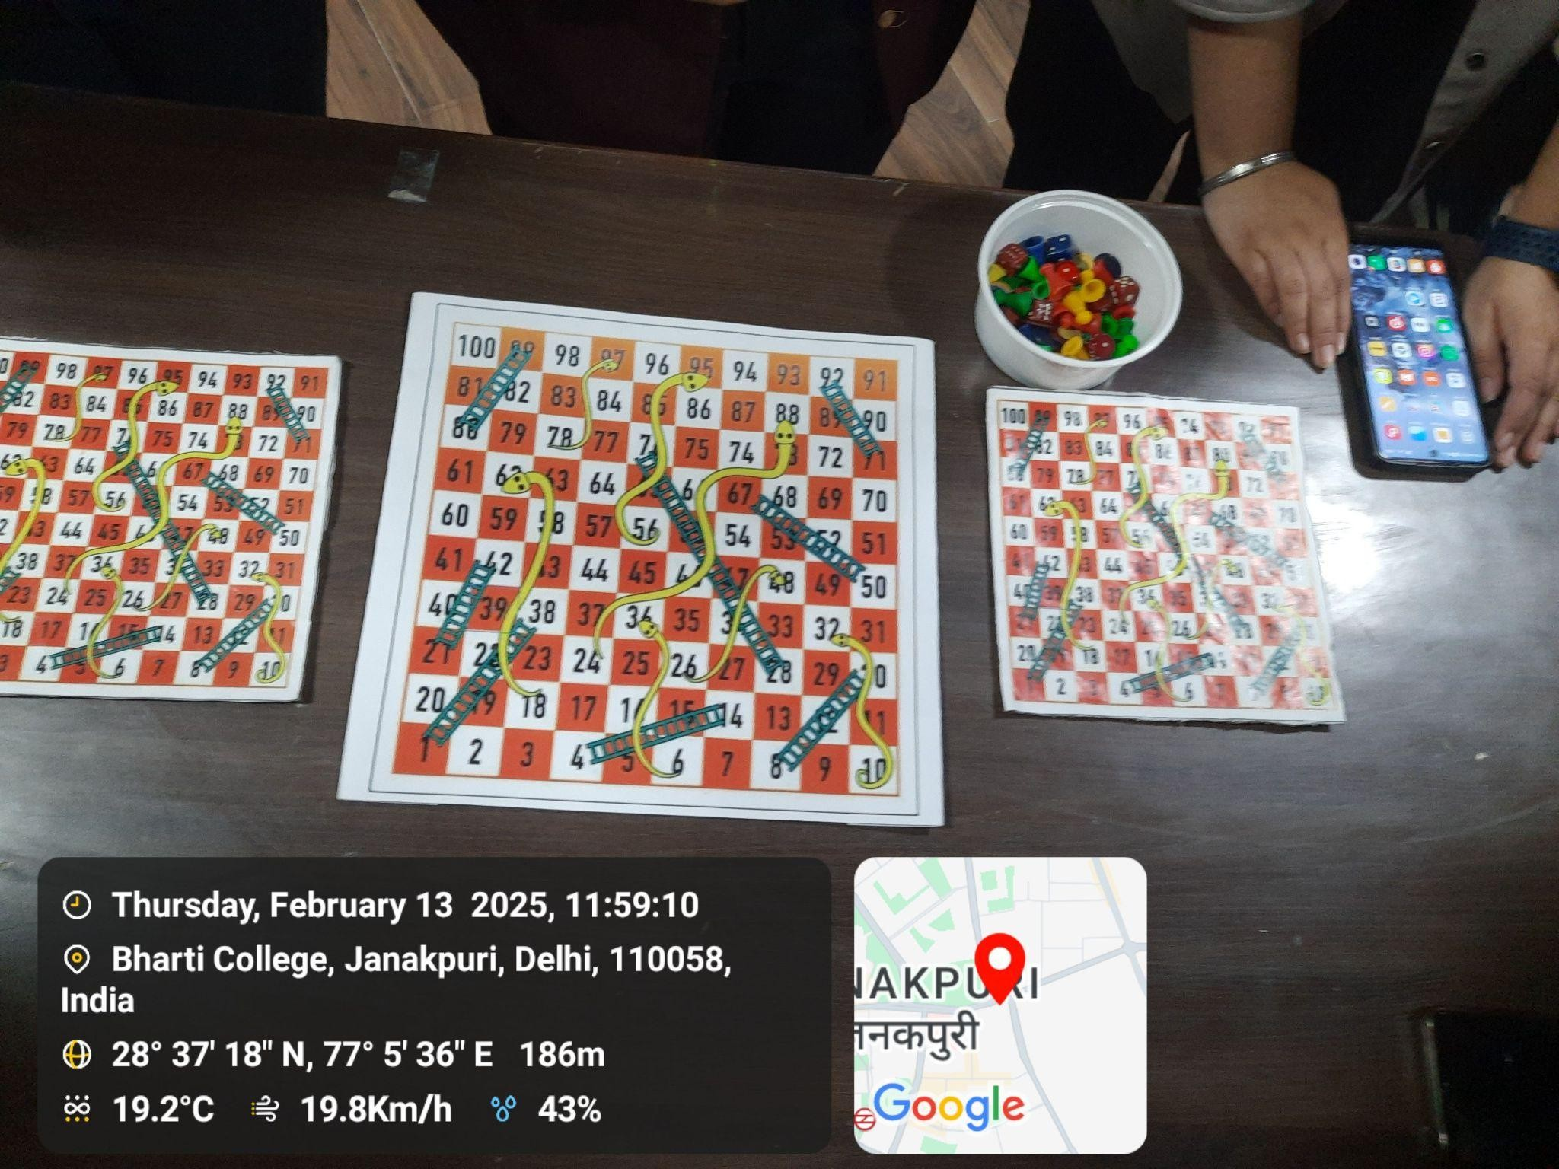

Program: Panel discussion
Activity title: Panel Discussion with founders of Sky Cosmetic Lenses
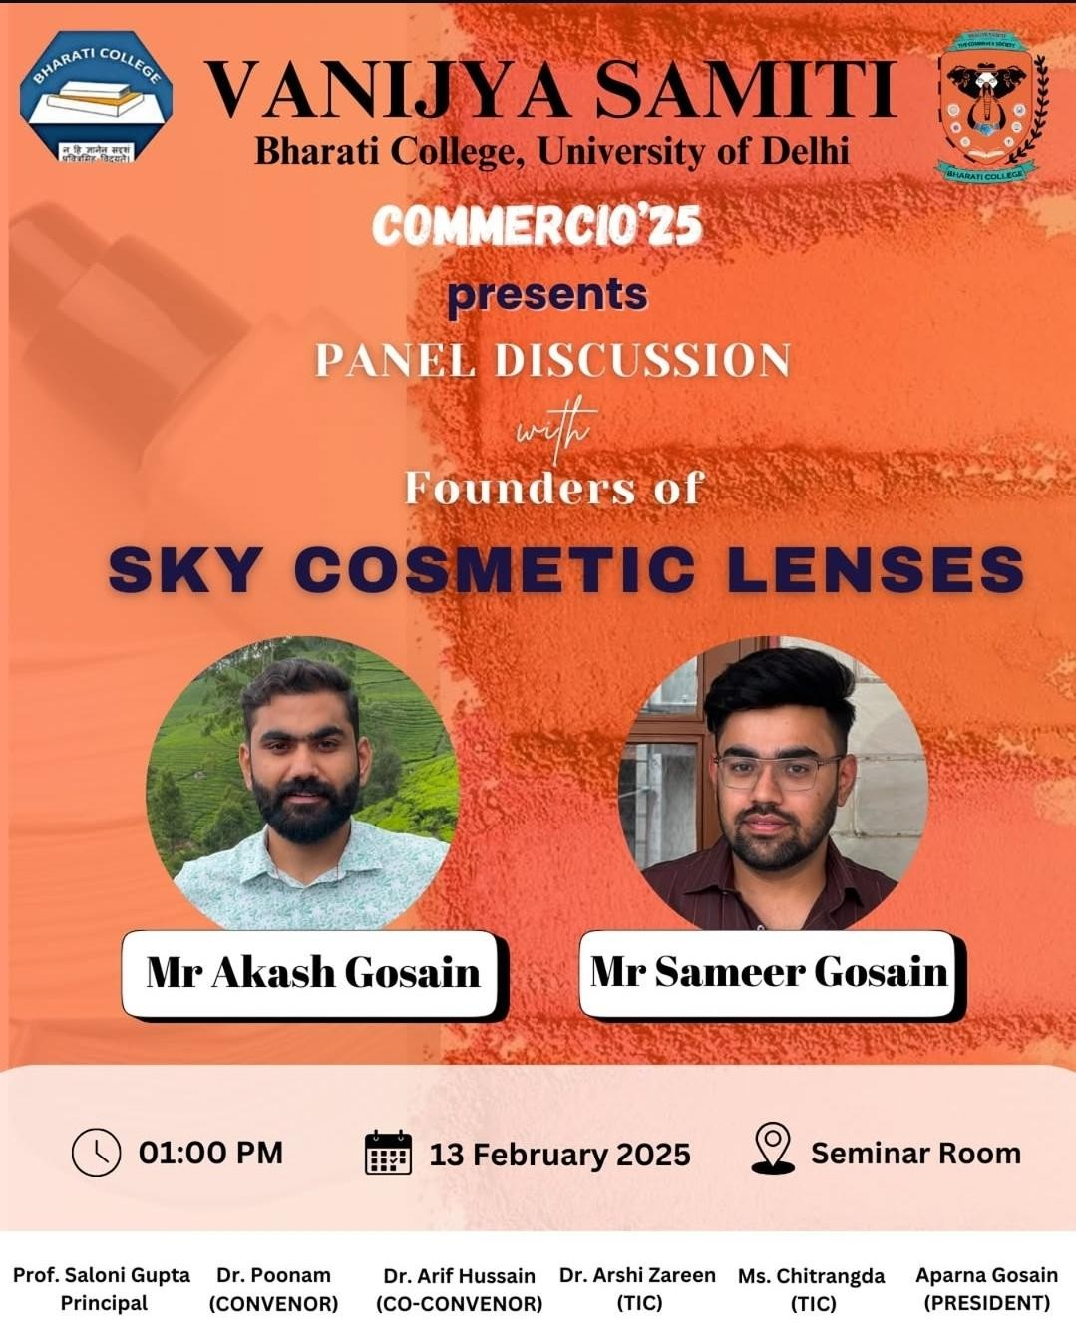

Sky Cosmetic Lenses, founded by Mr. Akash Gosain and Mr. Sameer Gosain, offered high-quality cosmetic contact lenses known for their aesthetic appeal and comfort. During Commercio '25, an interactive session was held where the founders addressed a series of insightful and thought-provoking questions, showcasing their expertise and providing valuable information about the product.
The panel delivered well-informed responses to key questions, highlighting the unique features, styles, maintenance, suitability, and usage of Sky Cosmetic Lenses.

QUESTIONS AND HIGHLIGHTS:

What made Sky Cosmetic Lenses different from other cosmetic lens brands?
Sky Cosmetic Lenses stood out due to their high-quality materials, advanced
moisture-retaining technology, and a broad range of natural and vibrant colors. They were designed to offer both comfort and style, minimizing dryness and irritation for the users.

What colors and styles were available in Sky Cosmetic Lenses?
The lenses were offered in various shades, including natural tones like hazel, brown, and gray, as well as bold hues such as blue, green, and violet.

How were Sky Cosmetic Lenses to be maintained to ensure eye safety?
To ensure eye safety, users were advised to:

- Clean the lenses daily with a recommended lens solution.
- Store them in a clean case filled with fresh solution.
- Avoid sleeping with the lenses on.
- Wash hands before handling the lenses.
- Replace lenses as per the prescribed schedule to avoid infections.

Were Sky Cosmetic Lenses suitable for people with sensitive or dry eyes?
Yes, the lenses were specifically designed with advanced hydration technology, making them suitable for individuals with sensitive or dry eyes.

Could Sky Cosmetic Lenses be worn daily, or were they meant for occasional use only?
Sky Cosmetic Lenses were available in both daily and extended-wear options, allowing users to choose based on their preferences—whether for everyday use or special occasions.

How did Sky Cosmetic Lenses enhance natural eye color?
The lenses used high-definition pigmentation that blended seamlessly with the natural eye color, enhancing its depth and brightness.

Conclusion
Sky Cosmetic Lenses successfully combined aesthetics, comfort, and safety. With their wide color range, hydration technology, and user-friendly maintenance, the lenses catered to those seeking both daily wear and occasional use. The session concluded with a strong emphasis on proper usage and care to ensure a safe and satisfying experience for all users.

PHOTOS
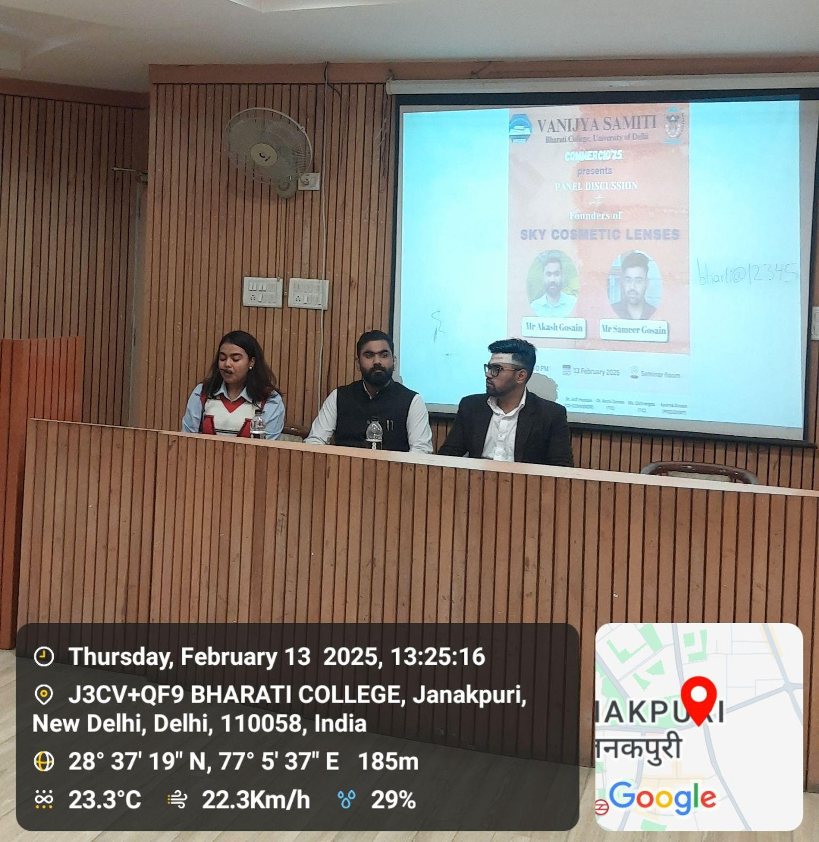
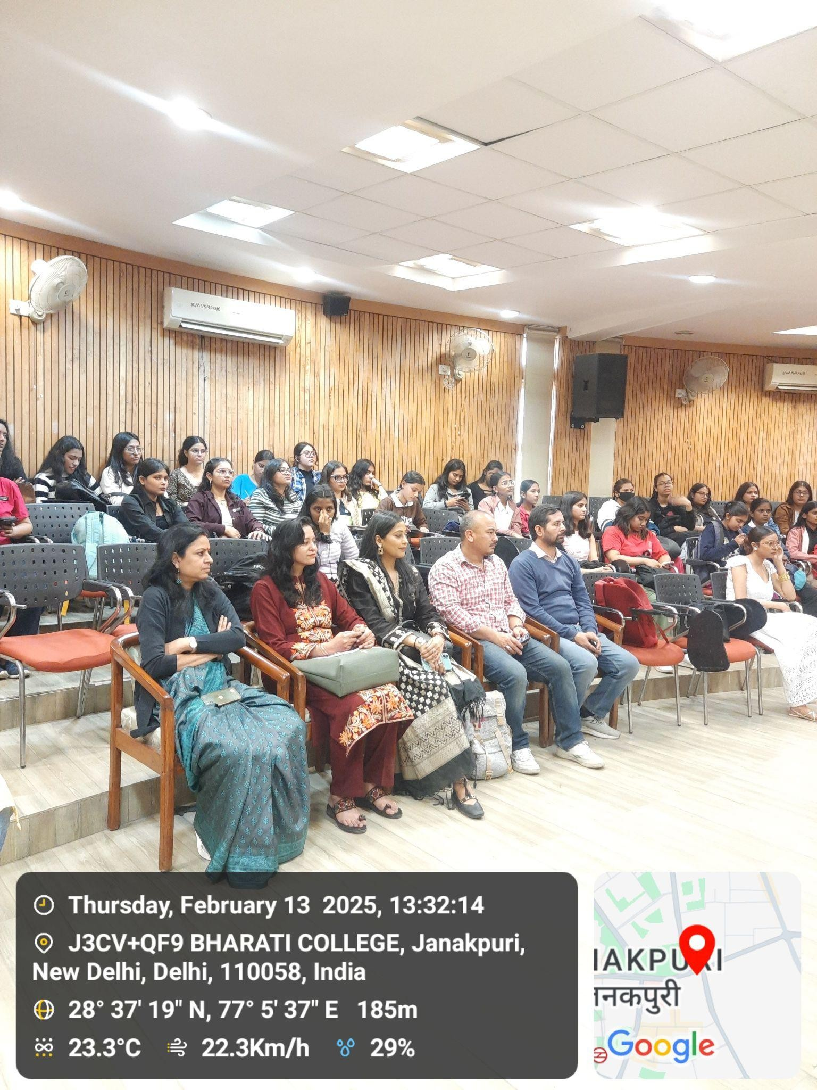

Program: Session of Luxury brand management
Activity Title: Dive into the fascinating journey of luxury brands from the 17th century to the modern era. Understand their exclusivity, brand value, marketing strategies, and global dominance. Explore real-world examples like Gucci, Cartier, and Rolex, and analyze how luxury brands shape consumer perception and economic impact.

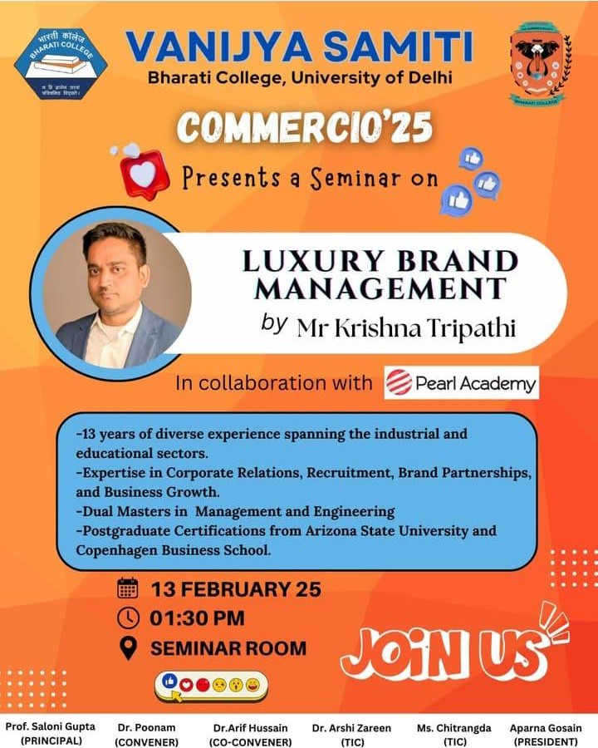

On 13th February 2025, the Vanijya Samiti – The Commerce Society of Bharati College, in collaboration with Pearl Academy, organized a unique and engaging session on "Luxury Brand Management" at 1:30 P.M. in the seminar room. The session was hosted by Krishna Tripathi and facilitated by Mala Ma’am, and provided students with an in-depth understanding of the evolution, strategies, and exclusivity of luxury brands.
The session began with a discussion on what defined a luxury brand, emphasizing elements such as high cost, exclusivity, fine craftsmanship, and strong brand value. The host clarified that not all expensive products were considered luxury items—using the iPhone as an example of a premium product rather than a luxury one.
A key distinction was made between brand value (an intangible perception based on consumer trust and reputation) and total capital valuation (the financial worth of a company). It was highlighted that luxury brands build their value through exclusivity rather than mass marketing.
The session traced the origins of luxury houses from the 17th to 19th centuries, featuring case studies on Chanel, Gucci, and Cartier. Chanel was recognized for its unique selling proposition (USP) of elegant design and its role in empowering women. Gucci’s emergence during the 18th century was noted, while Cartier was praised for maintaining exclusivity by selling only to European royalty.
Key strategies discussed during the session included:

- Limited market exposure: Luxury brands were shown to avoid open-market advertising.
- Exclusive customer service: For example, Zara’s international policy of assigning one salesperson per customer.
- Selective distribution: Brands like Rolex limited their number of showrooms to maintain exclusivity.
The session also explored the role of the metaverse in luxury branding, showcasing how 3D virtual experiences were being used to represent luxury products in immersive environments.
Students were encouraged to consider the importance of luxury brand management in MBA and commerce education, as it offered essential insights into branding strategies, consumer psychology, and market influence.

FEEDBACK
The session on Luxury Brand Management proved to be highly insightful, offering a comprehensive understanding of the historical roots and strategic frameworks of luxury branding. The comparison between brand value and capital valuation, along with case studies of renowned brands like Chanel, Gucci, and Cartier, captivated the audience. The event successfully bridged traditional luxury branding with modern-day innovations like the metaverse, making it an educational and practical experience for all attendees.

ATTANDANCE

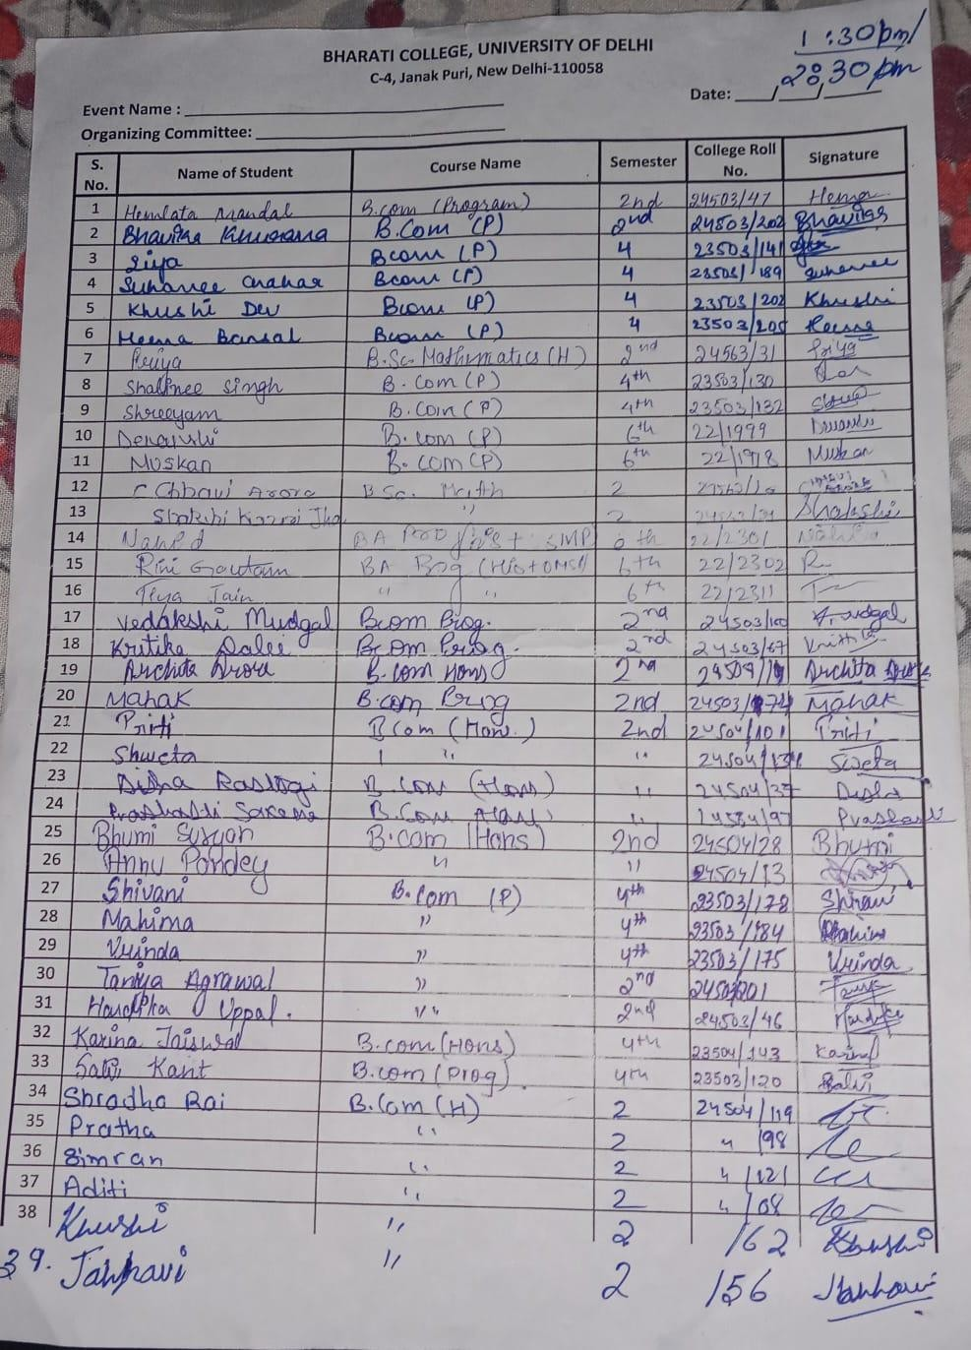

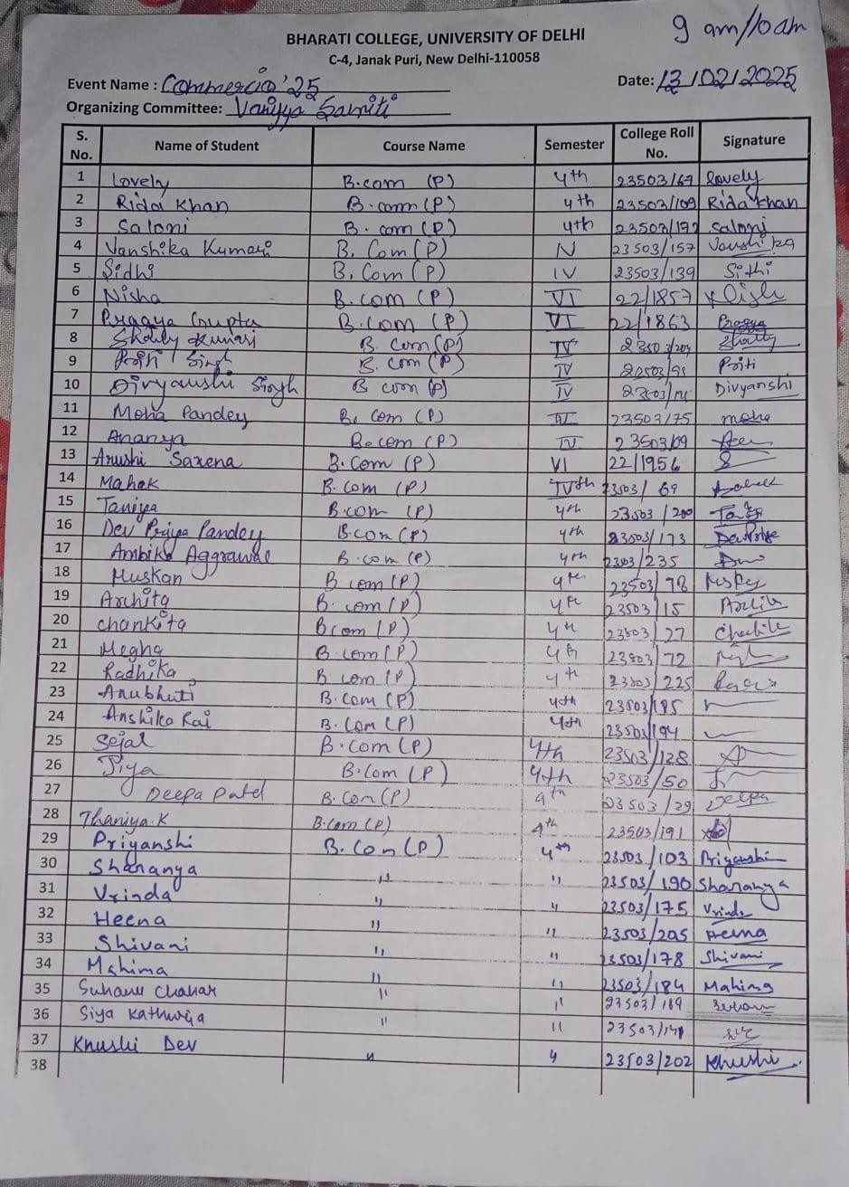

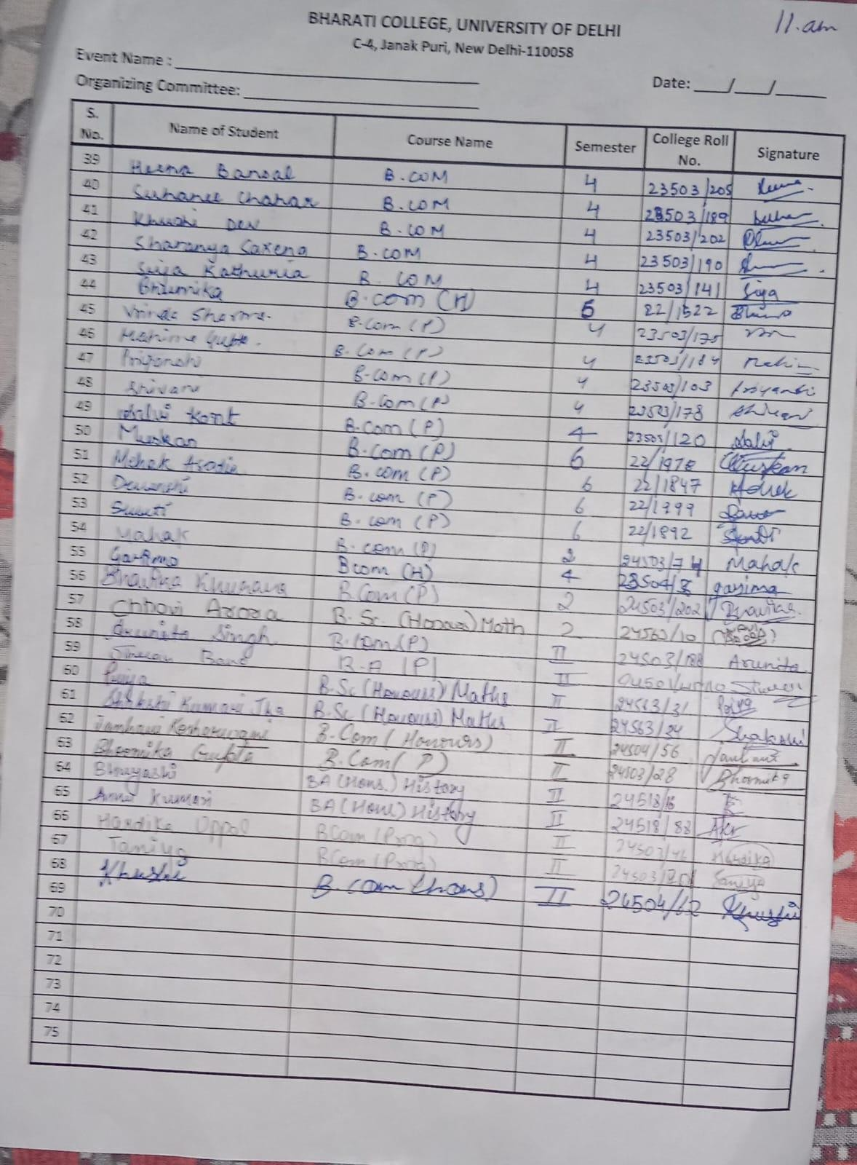

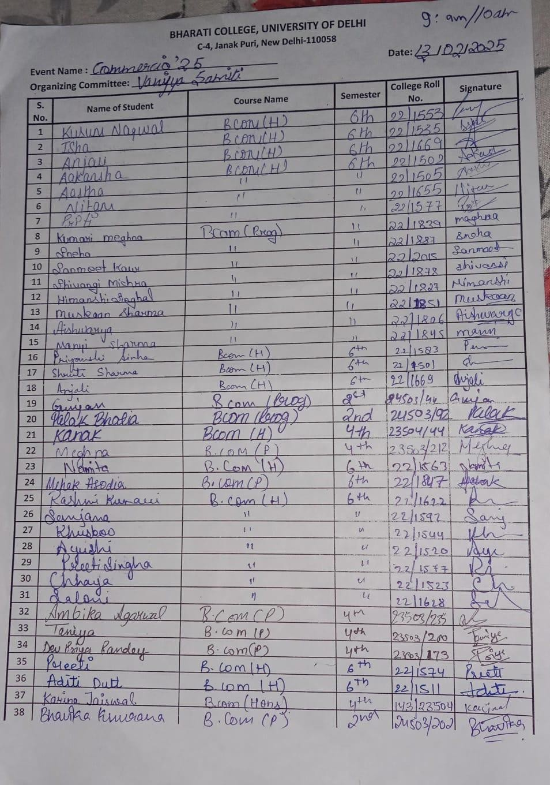

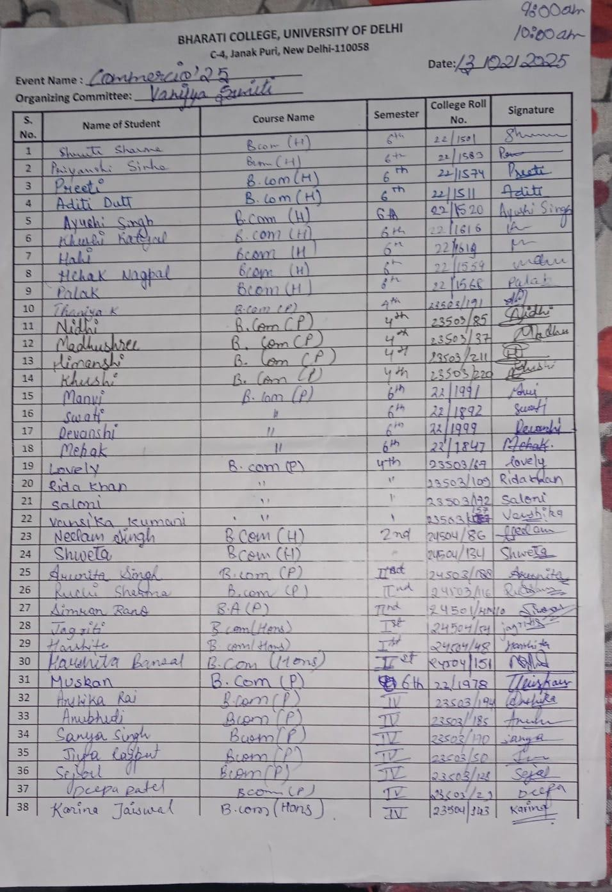
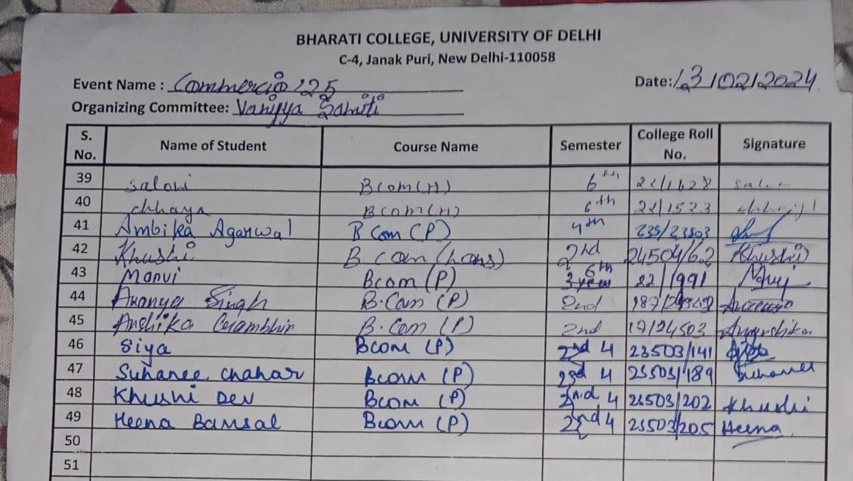
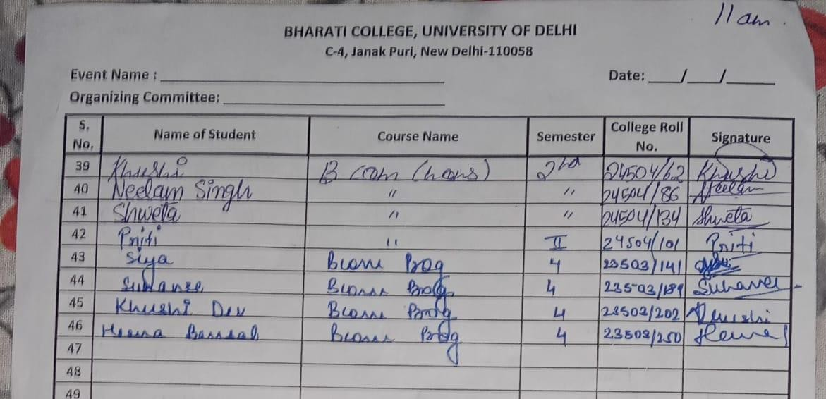

College: Bharati College, University of Delhi
Date and Time of Activity: 28 Feb 2025, 12 P. M.
Department/Society: Vanijya Samiti, The Commerce Society, Bharati College
Program: Abhivyakti'25
Activity Title: SNAKES AND LADDERS: Up you Grow, Down You Blow
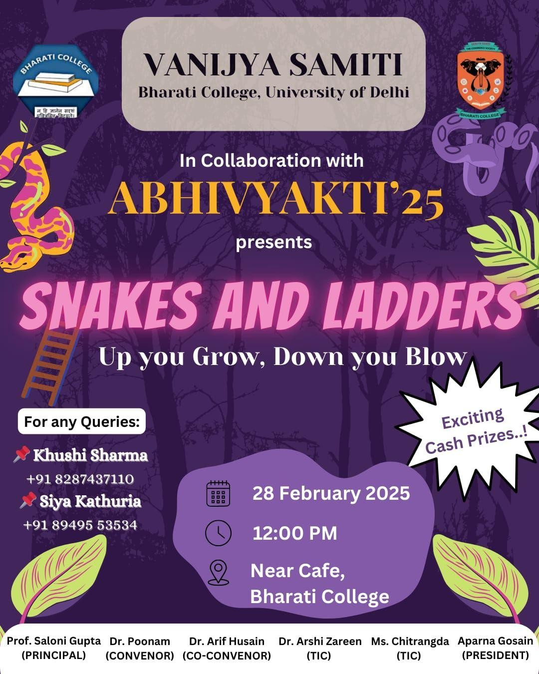

Vanijya Samiti, in collaboration with Abhivyakti'25, successfully organized an exciting and intellectually stimulating event-"Snakes and Ladders: Up You Grow, Down You Blow." This unique commerce quiz infused a strategic twist into the classic board game, mirroring real-world business scenarios where opportunities serve as ladders for growth and challenges act as snakes that can set one back. The event aimed to test participants' commercial awareness, decision-making skills, and strategic thinking, all while ensuring a thrilling and competitive experience.

GAME FORMAT & RULES

The event drew a remarkable turnout, with students eager to put their commerce knowledge to the test in a dynamic and interactive setting.

BASIC GAMEPLAY:

- Maximum Participants per Round: Six
- Turn Sequence: Determined by a commerce-related question; the fastest correct response decided the order.
- Dice Rolling & Movement: Players rolled a dice but could only advance after correctly answering a commerce-related question.
- Ladders & Snakes Mechanism:
  - Landing on a Ladder → Answer a question correctly to climb up.
  - Landing on a Snake → Answer a question correctly to avoid sliding down

ADDITIONAL RULES:

- Rolling a Six granted an extra turn, but the player had to answer an additional question correctly.
- Three Consecutive Incorrect Answers resulted in a skipped turn.
- If Two Players Landed on the Same Spot, both had to answer a question before proceeding.
- Use of Mobile Phones was strictly prohibited, and violations resulted in penalties or disqualification.
- The Judge's Decision was final in case of any disputes. Any misconduct or arguments with organizers resulted in immediate disqualification.

OBJECTIVE OF THE EVENT:

The objective of the event "Snakes and Ladders: Up You Grow, Down You Blow" was to provide an engaging platform for students to enhance their commercial awareness, decision-making skills, and strategic thinking. By incorporating a unique twist on the classic board game, the event aimed to simulate real-world business scenarios where participants navigated through opportunities (ladders) and challenges (snakes), thereby fostering both learning and competitive spirit. The event sought to blend fun with education, encouraging participants to apply their knowledge of commerce while developing quick thinking and problem-solving abilities in an interactive environment.

The event was met with enthusiastic responses from both participants and spectators. Students praised the unique format, appreciating how it combined learning with entertainment. Many expressed a strong desire for more such interactive, skill-enhancing competitions in the future. The event successfully fostered commercial awareness, encouraged strategic decision-making, and created an atmosphere of fun and learning. The session concluded with a vote of thanks to the organizing team, participants, and volunteers, followed by the prize distribution ceremony.

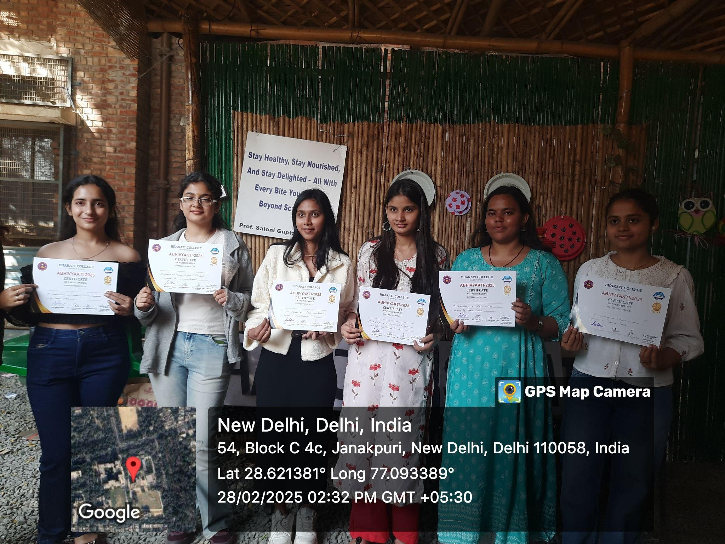
PHOTOS
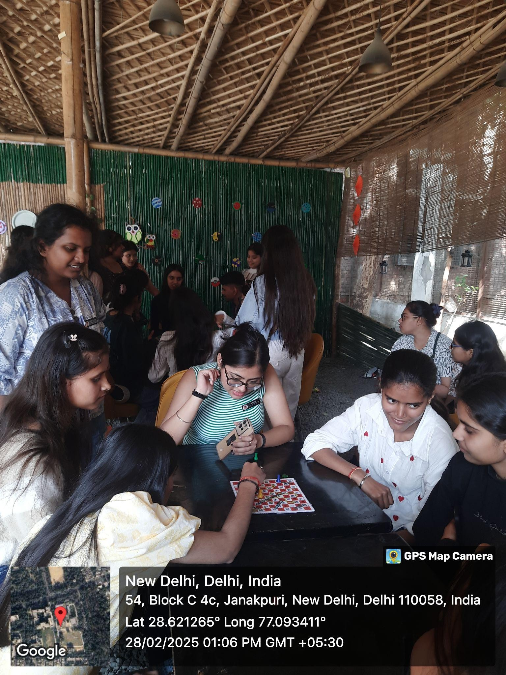

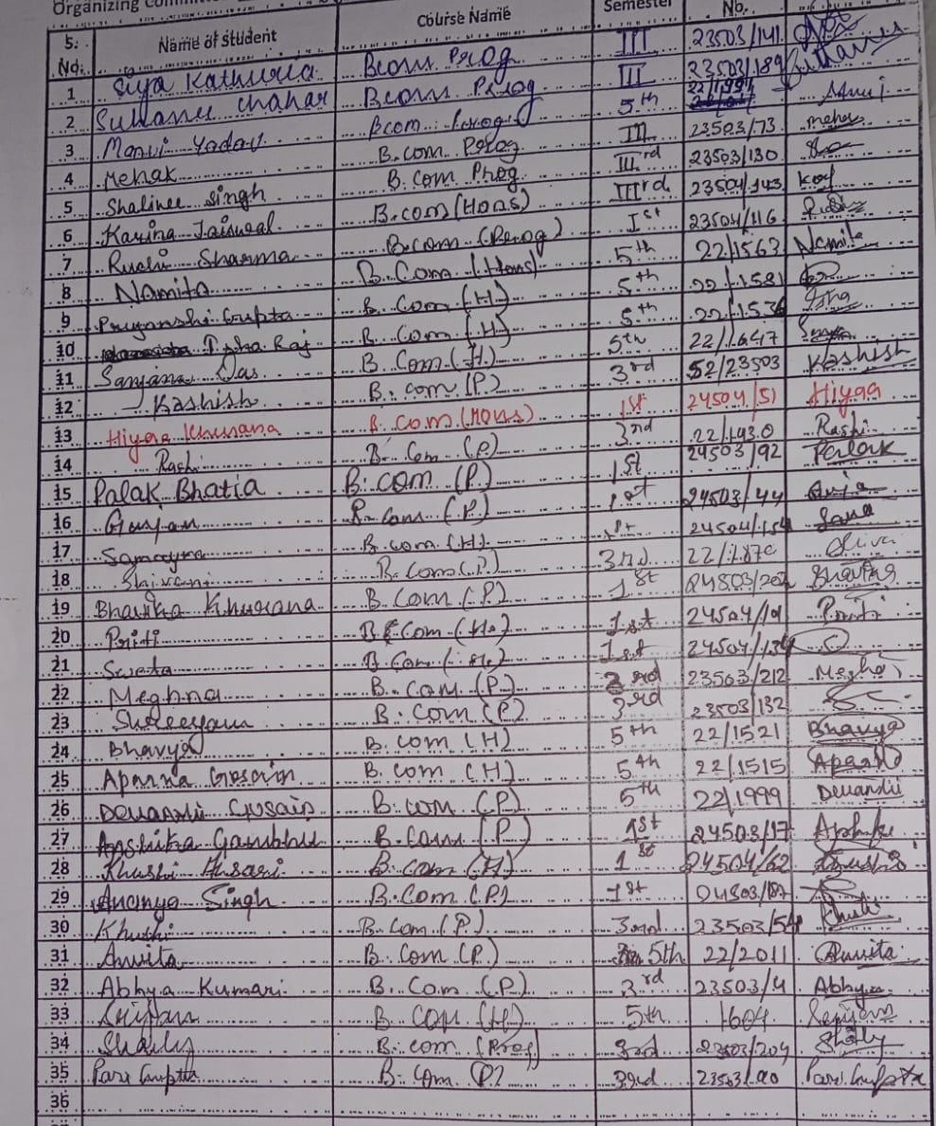
ATTANDANCE

MARCH’25

College: Bharati College, University of Delhi
Date and Time of Session: 8 March 2025, 3:00 P.M.
Department/Society: Vanijya Samiti, The Commerce Society, Bharati College
Program: Speaker Session on Canva Pro Essentials
Activity Title: Mastering Canva Pro: Essential Tips & Tricks for Stunning Designs – A Speaker Session on Unlocking Creativity, Efficiency, and Professional Design Features

On 8th March 2025 a unique and engaging webinar took place on the topic ‘Canva Pro Essentials’, organized by the Vanijya Samiti - The Commerce Society at 3:00 P.M.
The Canva Pro Essentials Speaker Session was conducted online via Zoom. The session was led by Gourav Singla, a renowned designer, educator, and founder of GSTUDIOS, India. With extensive experience in the design industry, Gourav Singla has trained over 5000 students and collaborated with numerous creators and influencers.
The session aimed to equip participants with essential skills and advanced features of Canva Pro to enhance their design proficiency and efficiency.

Key Highlights of the Session
1. Introduction to Canva Pro
- Overview of Canva and its importance for designers, marketers, and content creators
- Difference between Canva Free and Canva Pro
- Key advantages of using Canva Pro for professional design work
2. Essential Features of Canva Pro
- Copy-Paste Functionality: How to efficiently duplicate elements and designs
- Colour Selection & Themes: Choosing and applying colours to enhance visual appeal
- Typography & Font Management: Selecting fonts, adjusting text styles, and improving readability
- Layering & Alignment Tools: Organizing design elements for a professional layout
- Shortcut Keys: Quick commands to speed up the design process
3. Advanced Tools in Canva Pro
- Background Remover: Easily remove backgrounds from images for professional designs
- Magic Media & AI Tools: Utilizing Canva's AI-powered tools for design automation
- Canva Apps & Integrations: Exploring various third-party apps within Canva to enhance functionality
- Stock Images & Videos: Accessing premium content for creating high-quality designs
4. Practical Demonstration & Hands-on Learning
- Real-time Design Creation: Step-by-step demonstration of designing a social media post.
- Portfolio Building with Canva: How to create a visually appealing portfolio using Canva.
- Website Prototyping: Using Canva for designing website layouts and presentation templates.
5. Additional Tips & Insights
Google Tools Integration:
- Using Google Slides, Google Photos, and other tools with Canva.
- Adblockers & Browser Extensions: Enhancing workflow efficiency with useful browser extensions.
- Tracking Price Drops on Canva Subscriptions: Using tools like Keepa for price tracking.

FEEDBACK
The session provided valuable insights into Canva Pro's advanced features, helping attendees understand its full potential. Participants learned practical design techniques, shortcuts, and tips to improve their workflow and create professional-quality designs.
The workshop ended with a Q&A session, where attendees clarified their doubts and received expert guidance from Gourav Singla. Overall, the session was highly informative and beneficial for both beginners and professionals looking to enhance their Canva skills.

KEY TAKEAWAYS:
- Master essential Canva Pro tools and shortcuts.
- Leverage AI and automation for efficiency.
- Create stunning designs with ease.
- Improve workflow using integrations and browser extensions.
This session was a great learning experience, equipping participants with the knowledge to create impactful and professional designs using Canva Pro.

PHOTOS
