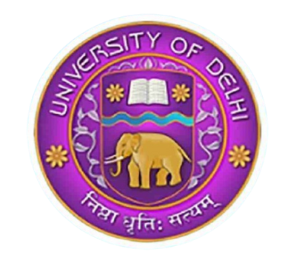
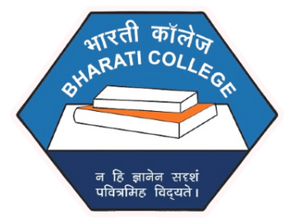
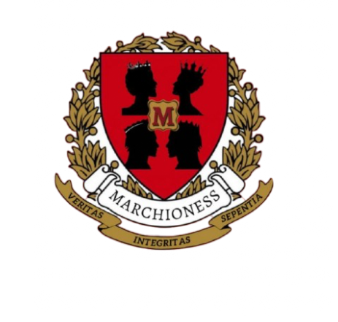

MARCHIONESS
THE MARKETING & ADVERTISING SOCIETY
BHARATI COLLEGE, UNIVERSITY OF DELHI

MARCHIONESS BHARATI 02

TABLE OF CONTENT

Online Events
Mark Quest: Journeying into AI-Enhanced Markets
Website Inauguration
Offline Events
Mark Crest: MBA Career Peaks
ROOH’ 25 : The Annual Marketing Fest Mark Wars: Innovate, Persuade,
Conquer!
Mark Saga: The Fandom Chronicle!
Mark Heist: The Ultimate Steal!
Media Partner Coverages
Protest March: In Collaboration with Jagriti
Dholida: In Collaboration with Students’ Help Desk
Freshers’ 24 : In collaboration with Elantre & BCSU

MARCHIONESS BHARATI
03

ONLINE EVENTS

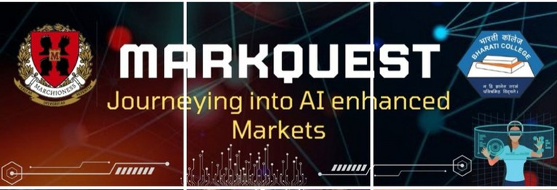



MARKQUEST SERIES: SEASON 1

GGRRAAPPHHIICC

AABBOOUUTT TTHHEE EEVVEENNTT

DATE: 21 st July 2024
THEME: Journeying into AI- Enhanced Markets PLATFORM: Instagram
NO. OF EPISODES: 3
Markquest was a knowledge- driven digital series that explored the role of AI in modern marketing, helping aspiring marketers understand how technology was
reshaping the industry. From AI- powered personalization to predictive analytics and automation, the series broke down the complexities of AI in a way that was engaging, interactive, and practical.

OOBBJJEECCTTIIVVEESS
Bridging AI and marketing: Understanding how
artificial intelligence influences consumer behavior, market strategies, and brand engagement.

MARCHIONESS BHARATI 04


MARCHIONESS BHARATI 05

Exploring Real- World Cases – Analyzing brands l ike Spotify, Netflix, and Zomato, where AI has driven
marketing success.
Making AI Accessible – Simplifying AI- driven
marketing strategies for students, marketers, and business enthusiasts.
Encouraging Interactive Learning – Providing a
platform for discussions, Q& A sessions, and innovative insights from marketing professionals.

EEPPIISSOODDEESS

Spotify: The Algorithm Behind Music Personalization Discover how Spotify’ s powerful AI decodes your l istening habits to curate hyper- personalized playlists that feel
l ike they know you better than your best friend delivering the r ight track at the r ight moment, every t ime.

Netflix: How AI Enhances Content Recommendations
Explore how Netflix’ s cutting- edge recommendation engine leverages AI to serve you the perfect binge-
worthy series, transforming your watching experience into a seamless journey of endless entertainment
tailored just for you.

Zomato: AI-Powered Customer Engagement & Growth Strategies
Uncover how Zomato harnesses the power of AI to drive
user engagement and business growth — from predicting your next meal craving to optimizing delivery logistics
with uncanny precision.

MARCHIONESS BHARATI 06

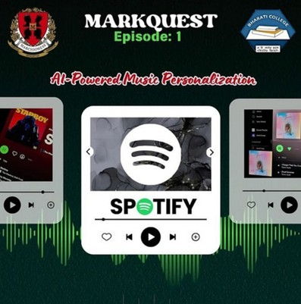
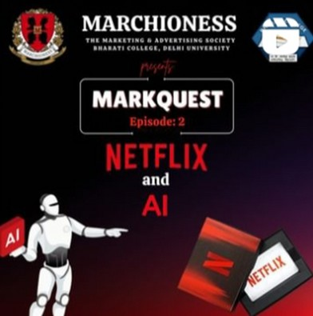

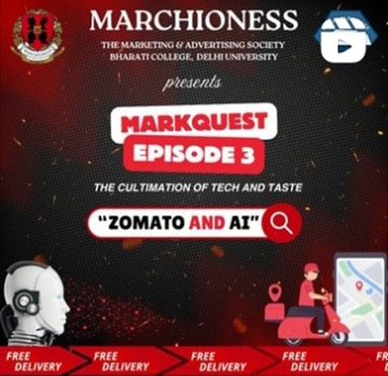

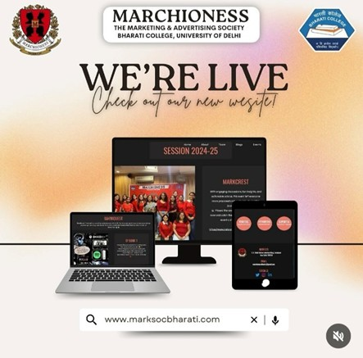


OFFICIAL WEBSITE INAUGURATION

GGRRAAPPHHIICC

AABBOOUUTT TTHHEE EEVVEENNTT
On 01 st December 2024 , Marchioness celebrated the official launch of i ts website, marking a significant
milestone in the society' s journey. This event provided an opportunity to showcase the hard work and creativity
that went into developing the website, which will serve as a digital hub for the society’ s activities, events, and
achievements. The website launch was an exciting
moment that brought together students and faculty to explore and engage with Marchioness in the digital
space.
DEVELOPMENT CREDITS: KHUSHI DEV
MARCHIONESS BHARATI 07

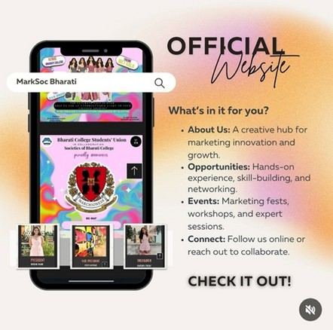
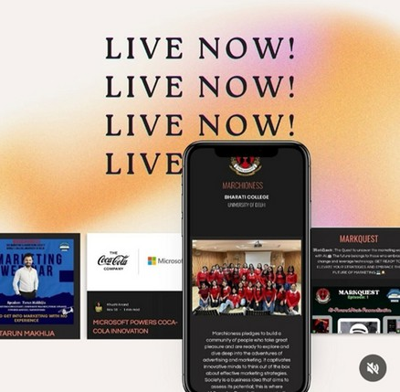

MARCHIONESS BHARATI 08

OOBBJJEECCTTIIVVEESS
Introduce the official Marchioness website to the
college community, making i t an accessible platform for information and resources.
Provide a space for students and stakeholders to engage with the society' s work, events, and future plans.
Highlight the importance of digital presence in modern marketing and advertising.
Showcase student- led initiatives and creative
campaigns to inspire collaboration and innovation.
Strengthen the society' s brand identity through a consistent and professional online presence.

MARCHIONESS BHARATI 09

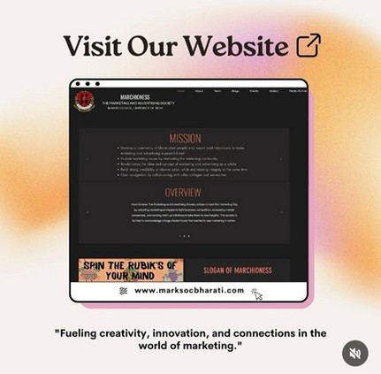
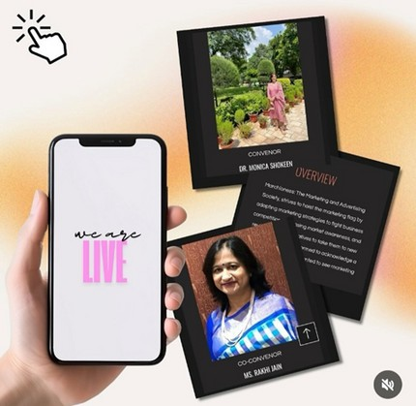

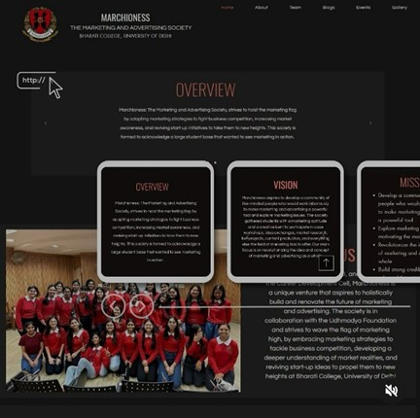

MARCHIONESS BHARATI
10

OFFLINE EVENTS

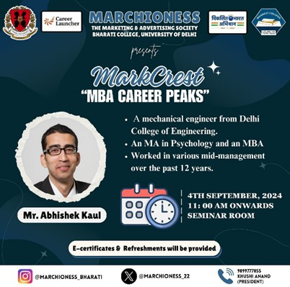

MARKCREST: MBA CAREER PEAKS

GGRRAAPPHHIICC

AABBOOUUTT TTHHEE EEVVEENNTT
DATE: 04 th September 2024 DAY: Wednesday
TIME: 1 1 : 00 AM To 1 : 00 PM
VENUE: Seminar Room
THEME: MBA Career Peaks
The Field of business management is constantly evolving, requiring aspiring professionals to stay informed about
career pathways and industry expectations. MARKCREST:
MBA Career Peaks was organized by Marchioness to provide students with valuable insights into MBA
entrance exams, career trajectories, and essential skills needed to excel in the corporate world.
MARCHIONESS BHARATI 11


MARCHIONESS BHARATI 12

OOBBJJEECCTTIIVVEESS
The primary aim of MARKCREST was to equip students with a clear understanding of the MBA journey, from
entrance preparation to career opportunities. The key objectives included:
Providing clarity on various MBA entrance exams such as CAT, XAT, SNAP, and NMAT.
Offering insights into MBA specializations and their relevance in today’ s job market.
Discussing skills and strategies essential for cracking competitive exams.
Addressing queries regarding B- school selection, admission processes, and industry expectations

SSPPEEAAKKEERRSS’’ SSUUMMMMAARRYY
Speakers’ Name

Abhishek Kaul
PROFILE & BACKGROUND

Mechanical Engineer from Delhi College of Engineering; an MA in Psychology, and later pursued an MBA.
Experience: Over 12 years in mid-management roles across various industries.
INSTAGRAM ID

@cldelhi_mba
LINKEDIN PROFILE

https://www.linkedi n.com/company/car eer-launcher/

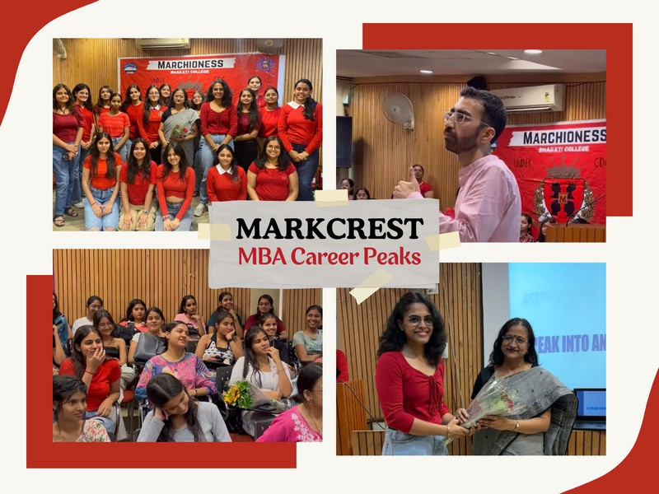

KKEEYY OOUUTTCCOOMMEESS
Clear Understanding of MBA Pathways: Insights into major entrance exams (CAT, XAT, SNAP, NMAT, GMAT), their structure, and preparation strategies.
Essential Skill Development: Emphasis on analytical thinking, communication, leadership, and t ime
management for MBA success.
Career Clarity: Guidance on specializations, job roles, and industry prospects, helping students align their
interests with career opportunities.
Practical Exam Strategies: Focus on t ime
management, mock tests, resource selection, and balancing studies with MBA prep.
Motivation & Industry Insights: Mr. Abhishek Kaul’ s
journey inspired students to explore unconventional paths and adapt to industry changes.
Stronger Student Engagement: Encouraged
participation in future career events, mentorship
programs, and peer study groups under Marchioness.

MARCHIONESS BHARATI 13

MARCHIONESS BHARATI 14

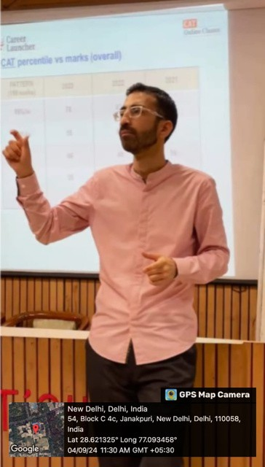
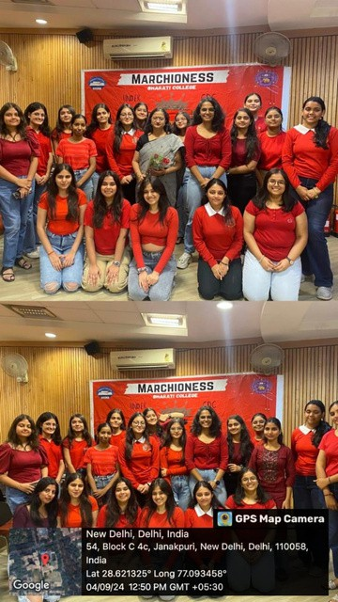

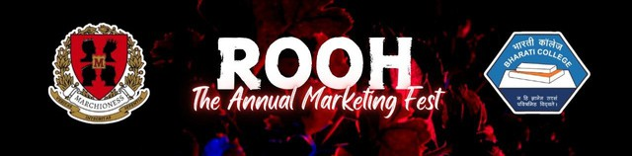
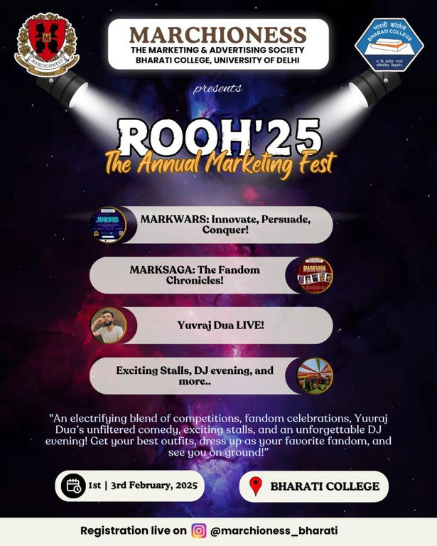


ROOH’25: The Annual Marketing Fest

GGRRAAPPHHIICCSS

AABBOOUUTT TTHHEE EEVVEENNTT
As part of Rooh: The Annual Marketing Fest, two
f lagship events were hosted — Day 1 : Mark Wars, a dynamic marketing and entrepreneurship
competition, and Day 2 : Mark Saga, a captivating
blend of storytelling, creativity, hands- on strategy,
MARCHIONESS BHARATI 15

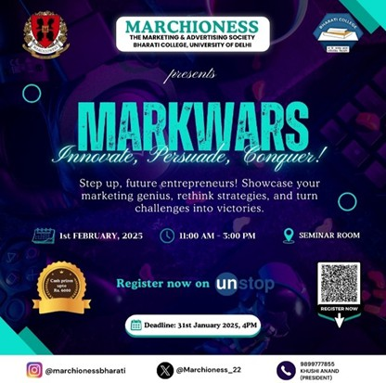



MARCHIONESS BHARATI 16

and profound insights into digital marketing, further amplified by an exclusive session with Mr. Yuvraj Dua, a celebrated influencer with over 1 Million followers
across social media. Despite being the inaugural
edition, Marchioness remarkably secured this high- profile personality along with a prestigious t i t le
sponsorship from “ Luv 4 Churros” and an exclusive
gifting partnership with “ I l lustrate Express,” elevating Rooh’ s stature and setting an extraordinary
benchmark for collegiate marketing fests.

DDAAYY 11
MMaarrkkwwaarrss:: IInnnnoovvaattee,, PPeerrssuuaaddee,, CCoonnqquueerr..
DATE: 01 February 2025 DAY: Saturday
TIME: 1 1 : 00 AM TO 02 : 00 PM VENUE: SEMINAR ROOM

GGRRAAPPHHIICC

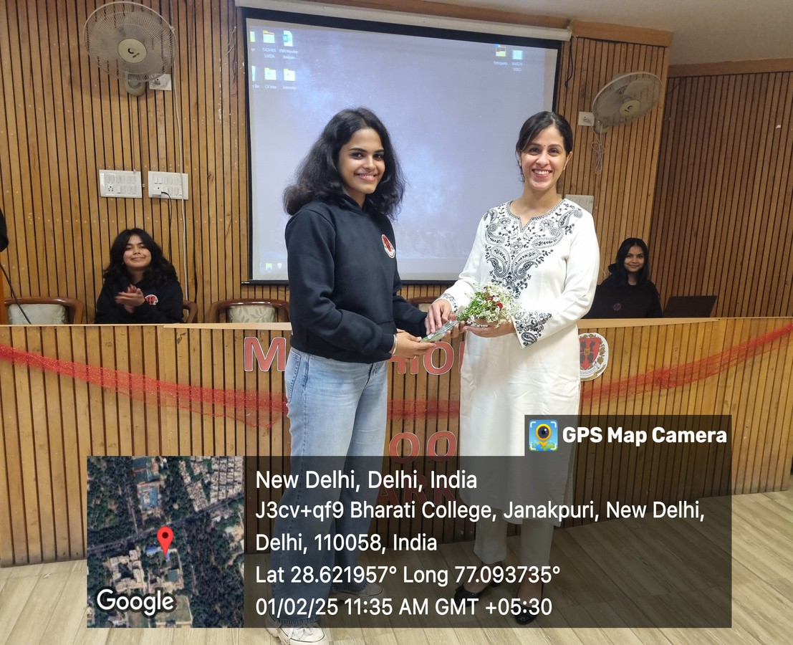


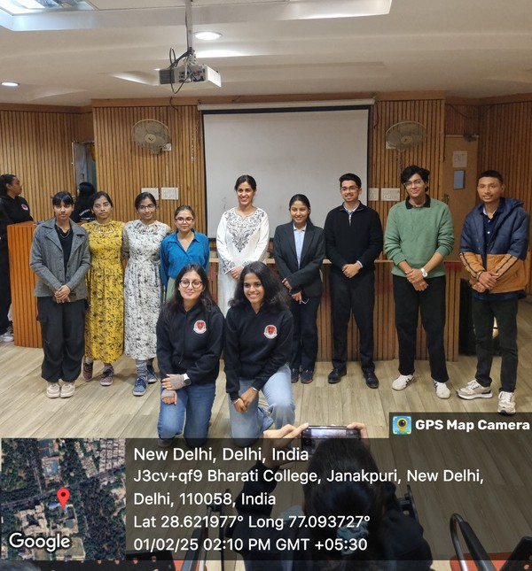
CONCEPT & FORMAT
Mark Wars was designed as an intense marketing
battle, where participants had to develop and pitch innovative marketing strategies under challenging conditions.
Participants were required to think on their feet, adapt to real- t ime marketing challenges, and
persuade judges with their creative problem- solving skills.

KEY HIGHLIGHTS & OUTCOMES
Students gained practical exposure to business strategy, advertising, and branding.
The event encouraged quick decision- making,
persuasive communication, and competitive spirit.
I t successfully bridged academic marketing
concepts with industry- driven applications, making learning dynamic and engaging.

MARCHIONESS BHARATI 17



MARCHIONESS BHARATI 18

LIST OF CONTESTANTS
NAME OF PARTICIPANTS

Aditya Bhatnagar

Kashish Chowdhary

Aman Rai and Kashish Gupta

Aditya Sethi

Ayushi Shukla

Aastha Shukla

Mokshi Saini

Priyanka Chowdhary
PRODUCT CATEGORY

Sports

E-Commerce Sports
Health & Wellness

Mental Heath & Well-Being Clothing & Accessories
E-Commerce

Mental Heath & Well-Being

RESULTS

NAME OF PARTICIPANT | NAME OF PRODUCT | CASH PRIZE
Aditya Bhatnagar | Strikers Showdown | Rs. 3000
Kashish Chowdhary | Sahayak | Rs. 2000
Aman Rai and Kashish Gupta | U Play | Rs. 1000

MARCHIONESS BHARATI 19

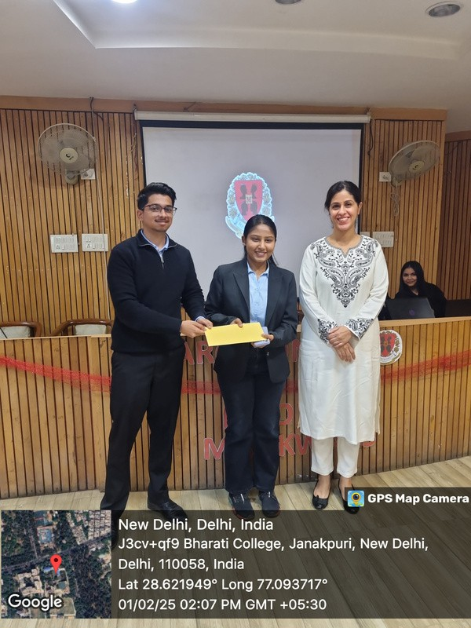
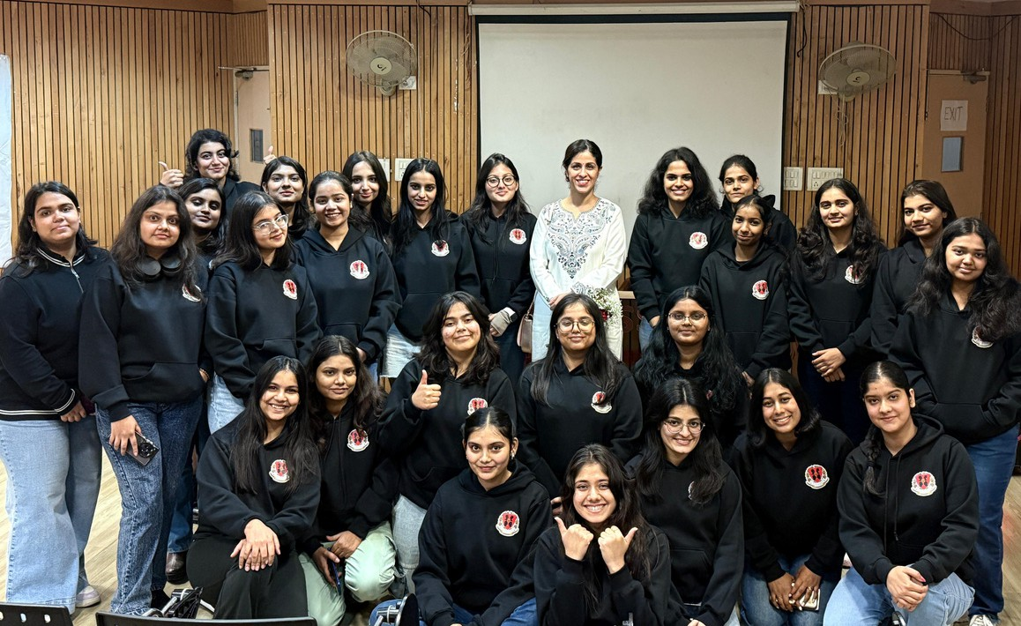
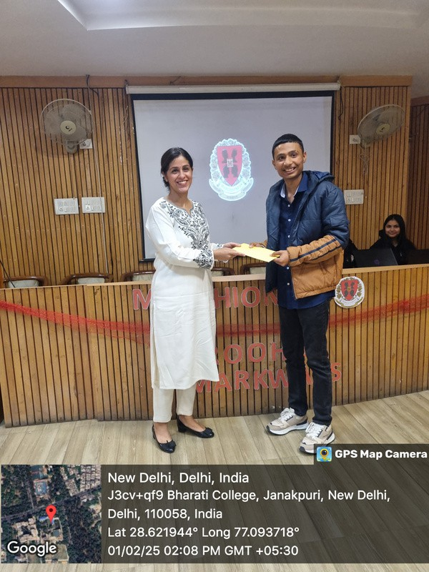

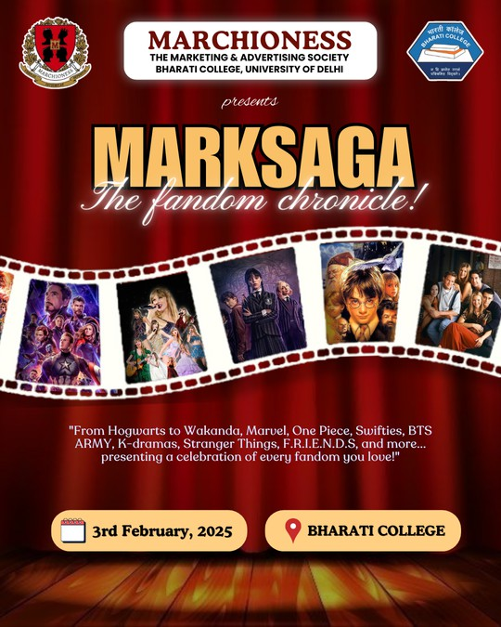



MARCHIONESS BHARATI 20
DAY 2
MarkSaga: The Fandom Chronicle!

ABOUT THE EVENT
DATE: 03 February 2025 DAY: Monday
TIME: 10 : 00 AM TO 05 : 00 PM
VENUE: Bharati College (Central Lawn & Auditorium)
Mark Saga was a unique storytelling- based marketing event that integrated fandom culture and brand
narratives.
Participants leveraged pop culture references,
f ictional storytelling, and brand- building techniques to craft compelling marketing strategies.

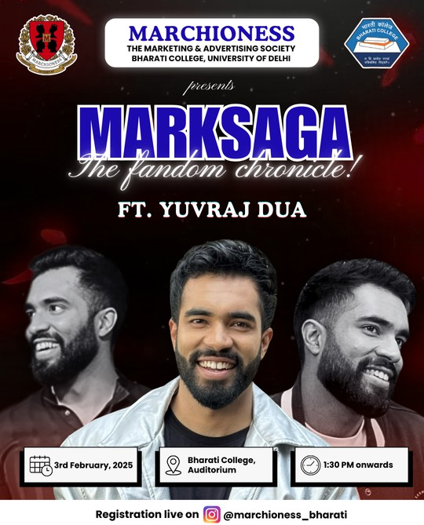


CCEELLEEBBRRIITTYY GGUUEESSTT SSPPEEAAKKEERR:: MMRR.. YYUUVVRRAAJJ DDUUAA

Marchioness had the honour of hosting celebrated influencer Mr. Yuvraj Dua, known for his signature satire and digital storytelling, with a strong digital presence and personal brand.
As part of Mark Saga, he blended humour and insight, which truly resonated with the audience.

KKEEYY HHIIGGHHLLIIGGHHTTSS && OOUUTTCCOOMMEESS
The event enhanced creative marketing skills by
pushing students to merge storytelling with business acumen.
The interactive session with Yuvraj Dua provided
valuable insights into influencer marketing, content creation, and brand- building in the digital era.
MARCHIONESS BHARATI 21


MARCHIONESS BHARATI 22

AACCHHIIEEVVEEMMEENNTTSS

High Student Engagement & Participation
Both events attracted significant participation from marketing enthusiasts across multiple colleges. The
competitive and interactive format ensured high energy and active involvement throughout.

Practical Industry-Relevant Learning
Participants sharpened their skills in branding,
storytelling, and persuasive marketing through hands- on activities that connected classroom theory with real-
world marketing practice.

Influence & Social Media Visibility
Marchioness ensured robust digital coverage for both events. A reel featuring Yuvraj Dua gained exceptional
attraction online, significantly increasing the visibility of both the fest and Bharati College.

Recognition & Rewards
Winners of Mark Wars received certificates and cash
prizes, encouraging excellence in marketing strategy and boosting student motivation to participate in similar
opportunities.

Sponsorship Success: A Milestone for Marchioness
Marchioness secured both monetary and gifting sponsorships for i ts debut fest, an outstanding
achievement that validated the society’ s credibility and
outreach. With “ Luv 4Churros ” as the Title Sponsor and
“ I l lustrate Express” as the Gifting Sponsor , this success set the stage for future collaborations and elevated the professional stature of the fest.


Establishing a Legacy with ROOH’ 25
ROOH marked Marchioness’ debut annual fest, setting new standards for creativity, scale, and execution
through impactful events l ike Mark Wars and Mark Saga. I ts success showcased the society’ s innovation, vision,
and ability to blend education, entertainment, and real- world marketing exposure seamlessly.

IIMMPPAACCTT
The second day of ROOH, centered around Mark Saga,
became a vibrant convergence of fandoms, marketing, and content creation. I t created a dynamic, memorable experience that resonated deeply with attendees.

Creativity in Action & Meaningful Connections
Mark Saga redefined how storytelling and digital
content can drive modern marketing. I t also became a collaborative hub where students connected over
shared interests in pop culture, branding, and creativity.

Yuvraj Dua' s Electrifying Presence
The appearance of Yuvraj Dua brought unmatched energy, drawing 500 + attendees and packing the auditorium. His talk offered insights into influencer marketing, digital branding, and l i fe as a content
creator, leaving the audience inspired and engaged.

Social Media Triumph
A reel from the event soared to 5 Million+ views and
200 k+ l ikes, continuing to trend and bring widespread attention to Bharati College. Moreover, participants
shared their own content from the day, boosting
individual engagement and further strengthening the college’ s online presence.
MARCHIONESS BHARATI 23

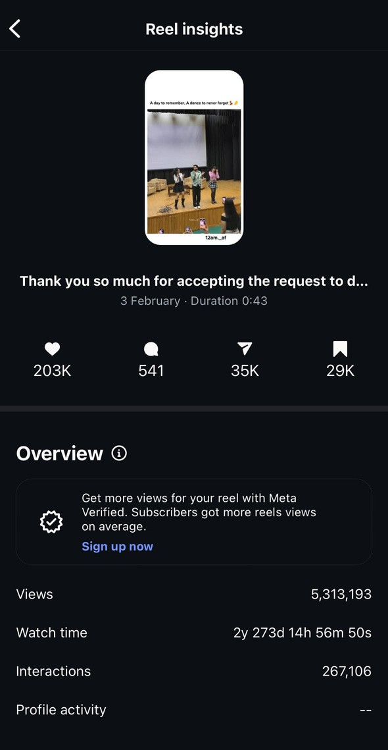
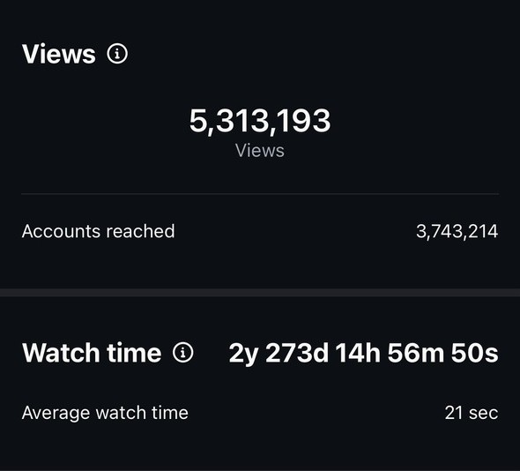


MARCHIONESS BHARATI 24

SSOOCCIIAALL MMEEDDIIAA TTRRIIUUMMPPHH:: RREEEELL EENNGGAAGGEEMMEENNTT && IIMMPPAACCTT HHIIGGHHLLIIGGHHTTSS!!

MARCHIONESS BHARATI 25

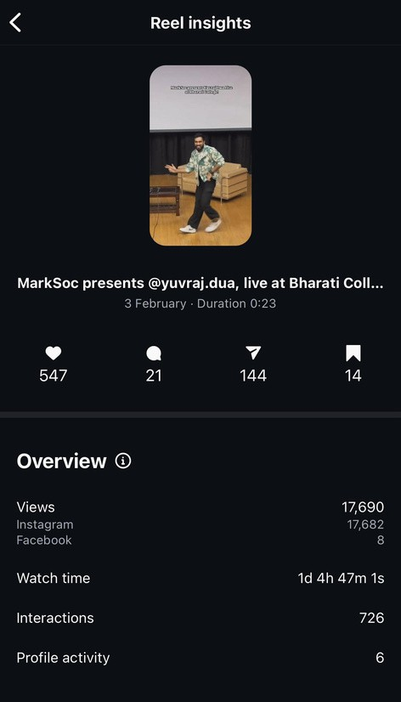
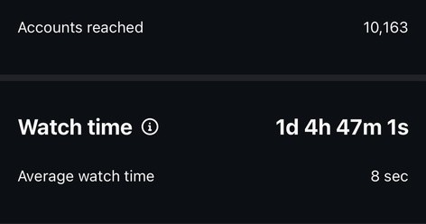
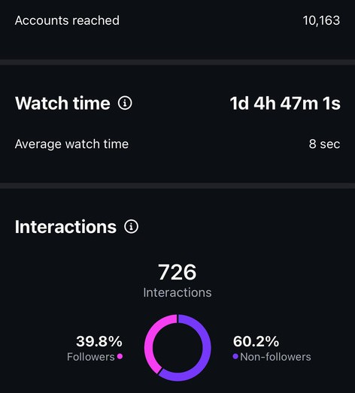
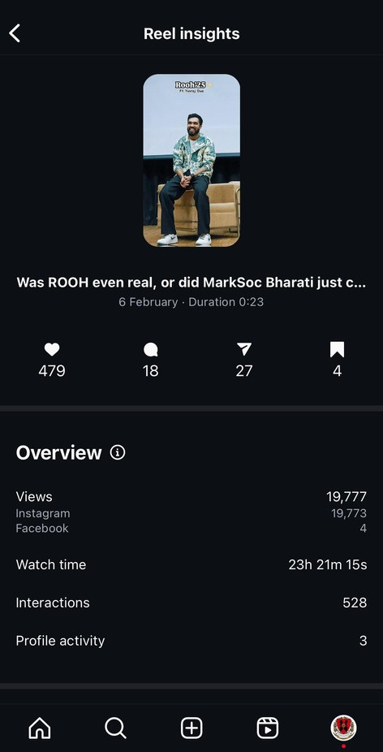
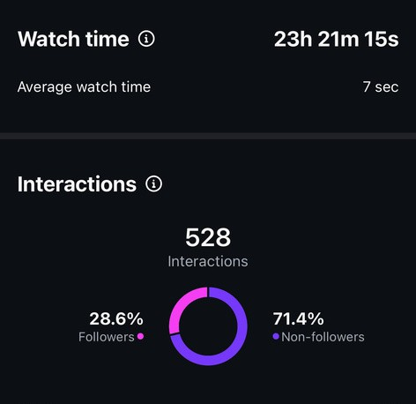

MARCHIONESS BHARATI 26

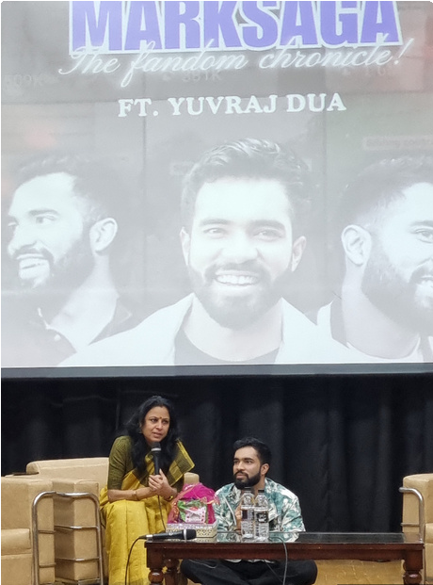
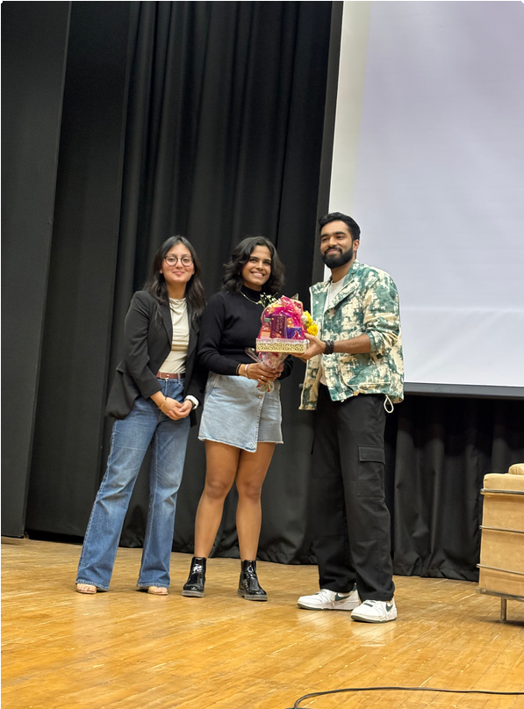
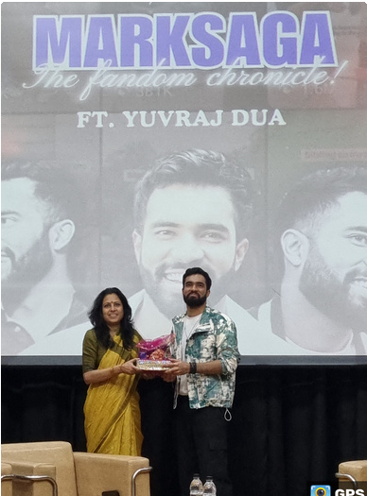
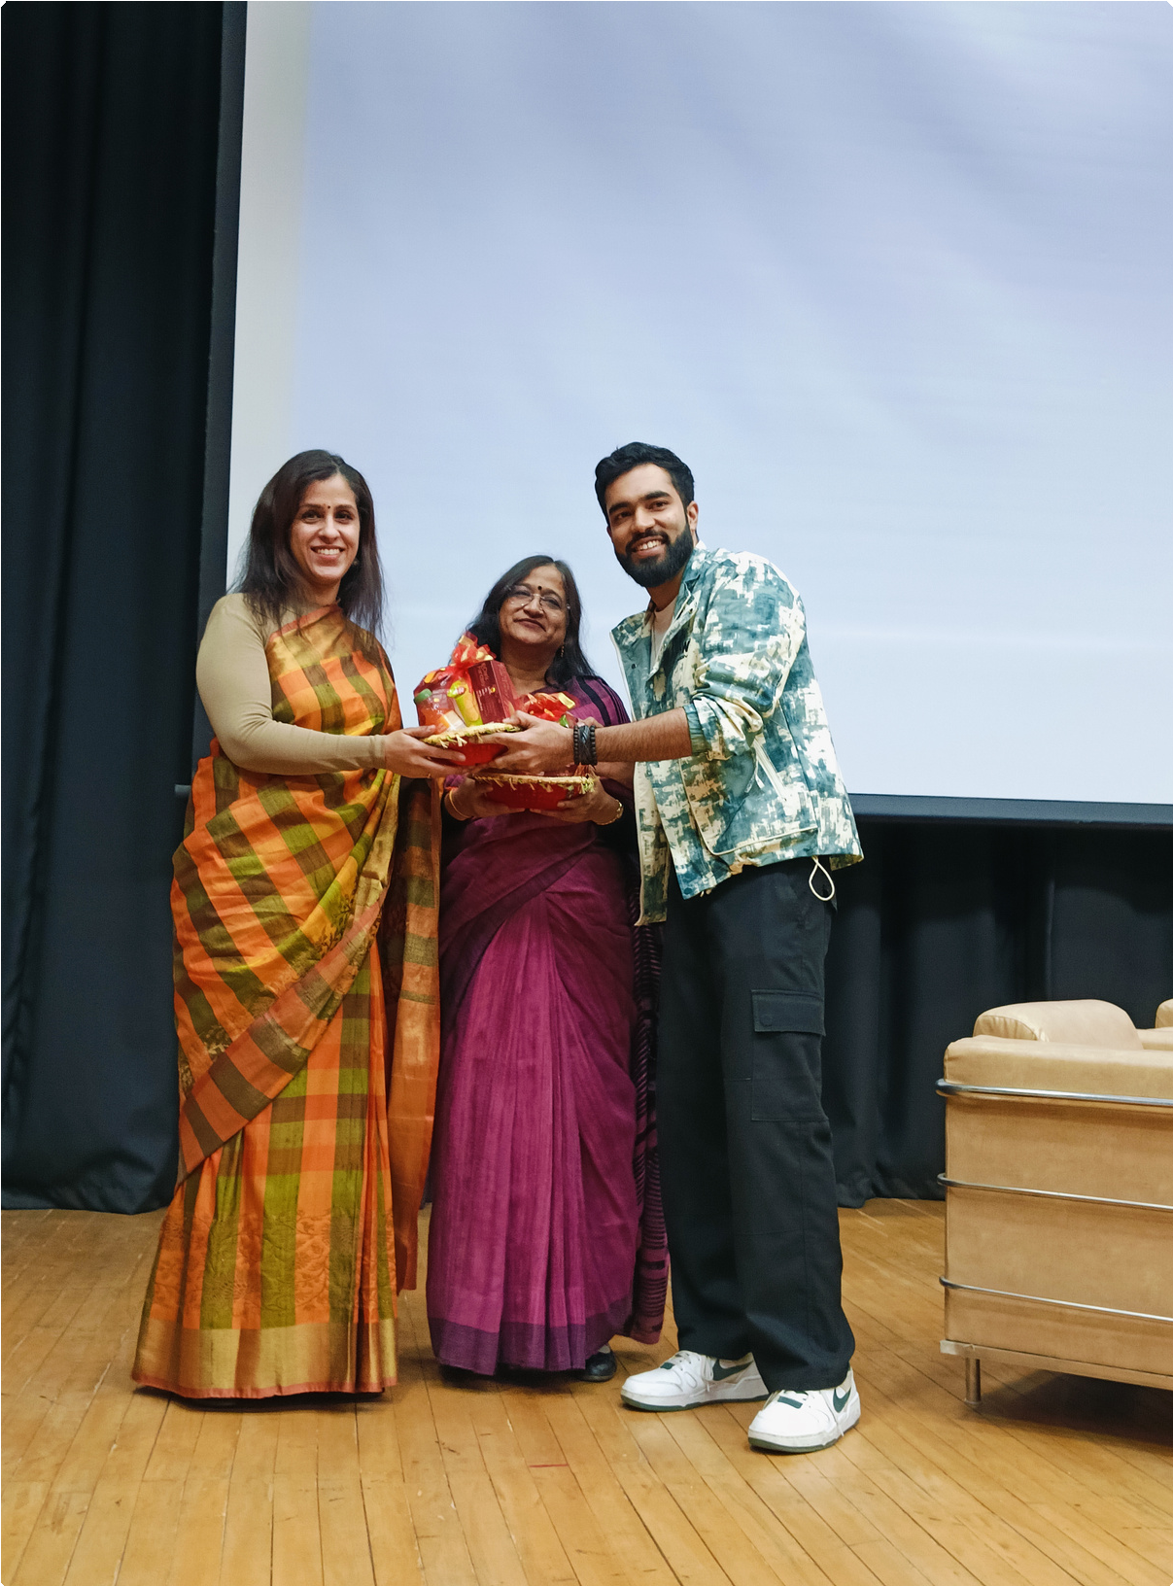
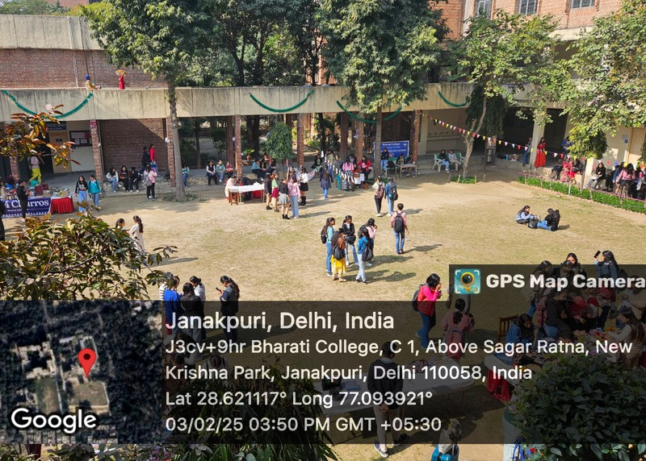
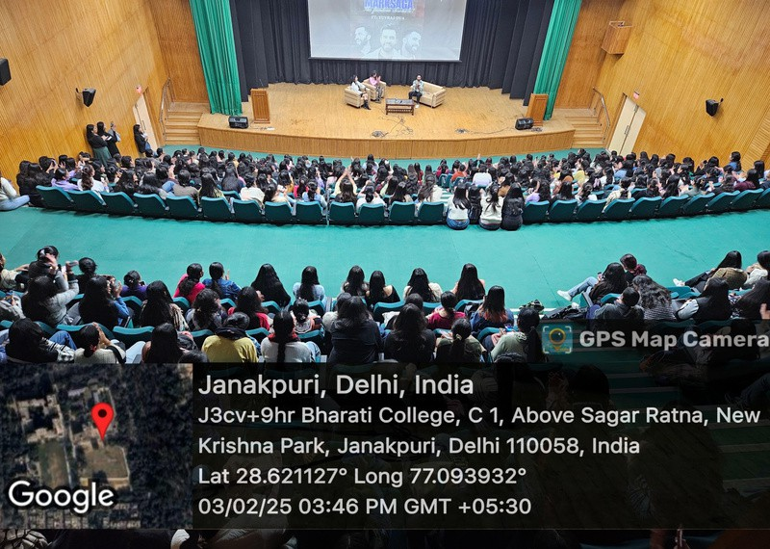
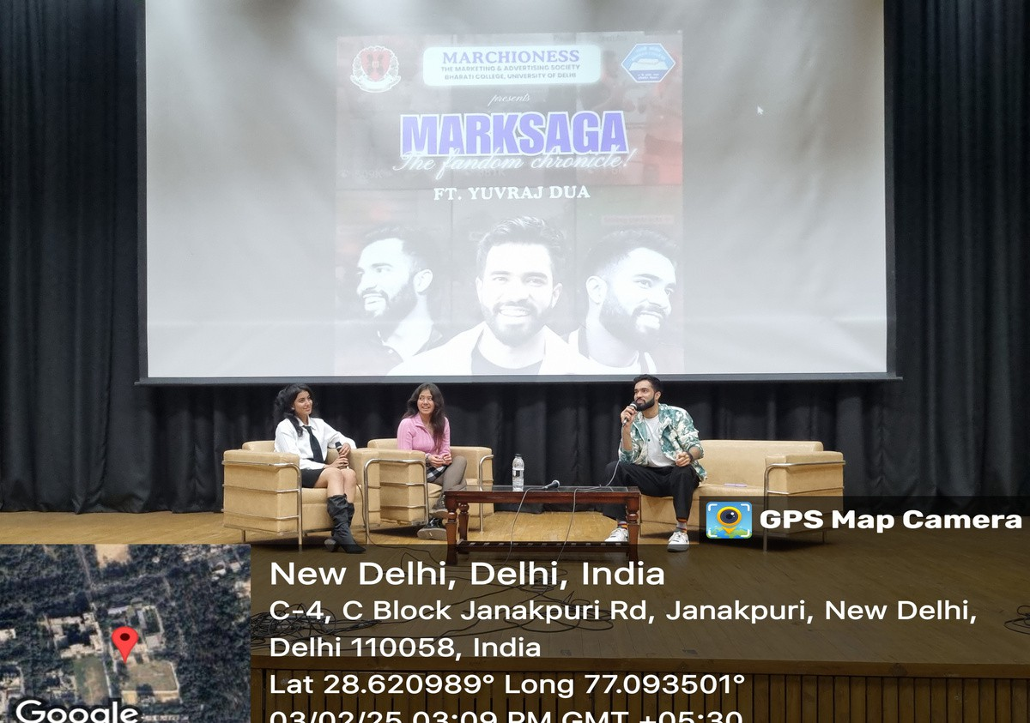

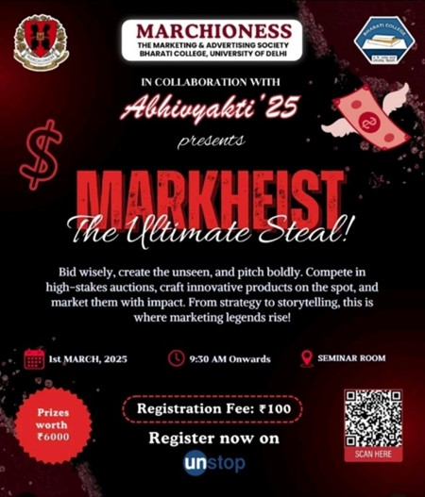


MARCHIONESS BHARATI 27

MARKHEIST: The Ultimate Steal
IN COLLABORATION WITH ABHIVYAKTI

GGRRAAPPHHIICC

AABBOOUUTT TTHHEE EEVVEENNTT
DATE: 01 st March 2025 DAY: Saturday
TIME: 9 : 30 AM To 12 : 00 PM
VENUE: Seminar Room
Marketing is more than just selling, i t ’ s about crafting
compelling narratives, influencing consumer decisions, and making brands unforgettable. Mark Heist: The
Ultimate Steal was conceptualized to embody this spirit, challenging young minds to think beyond conventional



marketing tactics and dive into a world of strategic storytelling, creativity, and competitive brand
positioning.

OOBBJJEECCTTIIVVEESS

Mark Heist was designed to bridge the gap between theoretical marketing concepts and real- world
applications through an interactive, high- stakes competition. The event aimed to:
Foster creativity and strategic thinking by challenging participants to develop innovative marketing
campaigns.
Enhance problem- solving and decision- making skills through competitive bidding and pitching rounds.
Provide hands- on experience in branding, advertising, and storytelling, preparing students for real marketing scenarios.
Encourage collaboration and networking, enabling participants to interact with peers and other
marketing enthusiasts.
Create an engaging and competitive learning
environment that pushes students to think quickly and adapt to new challenges.

IIMMPPAACCTT && KKEEYY OOUUTTCCOOMMEESS

Enhanced Practical Learning & Skill Development
Participants gained hands- on experience in marketing, negotiation, and decision- making, while also honing
essential skills l ike strategic thinking, creativity,
teamwork, and persuasive communication, bridging
academic concepts with real- world marketing practice.

MARCHIONESS BHARATI 28


MARCHIONESS BHARATI 29

Successful Brand Execution & Competitive
Engagement: Mark Heist’ s innovative structure and immersive experience strengthened Marchioness’
brand presence, while i ts multi- round format fostered healthy competition, challenging participants to think critically, adapt quickly, and stay engaged
throughout.
Networking & Collaboration: Participants interacted with peers, seniors, and industry- inspired challenges, building valuable connections within the marketing
and advertising community.
Recognition & Motivation: Winners and participants received acknowledgment for their strategic
excellence, boosting their confidence and
encouraging future participation in marketing challenges.
Higher Reach & Engagement: The event saw increased engagement both offline and online, with students
actively participating, discussing, and sharing
experiences, contributing to the growing influence of Marchioness within the college community.

RREESSUULLTTSS
NAME OF PARTICIPANT

Ayush
Paridhi Rajput Navya Aggarwal
NAME OF SERVICE PRIZES

GaanaDock Rs. 4000

SoulMate Rs. 2000

Releaf Gift Hamper

MARCHIONESS BHARATI 30

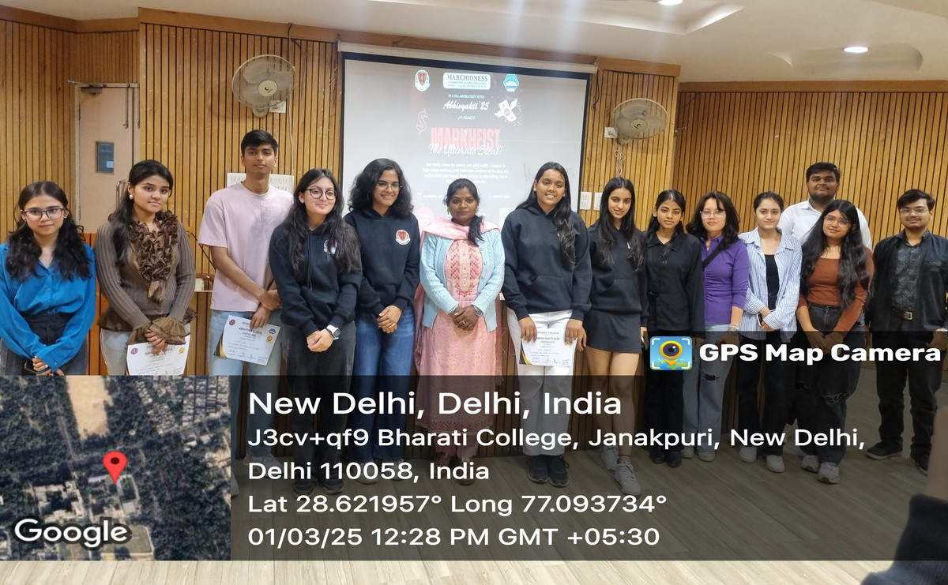

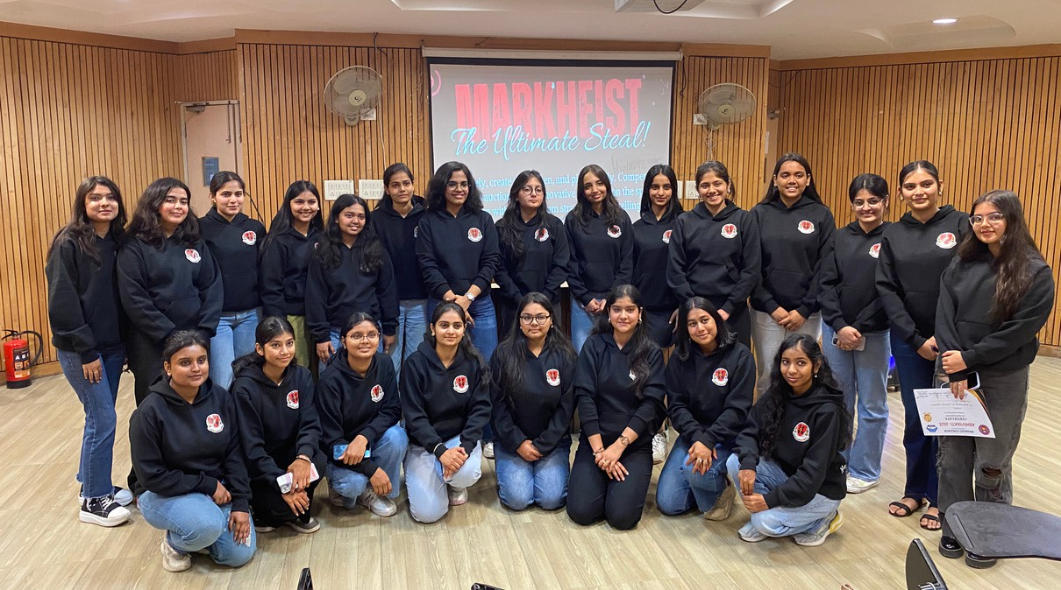

MARCHIONESS BHARATI 31

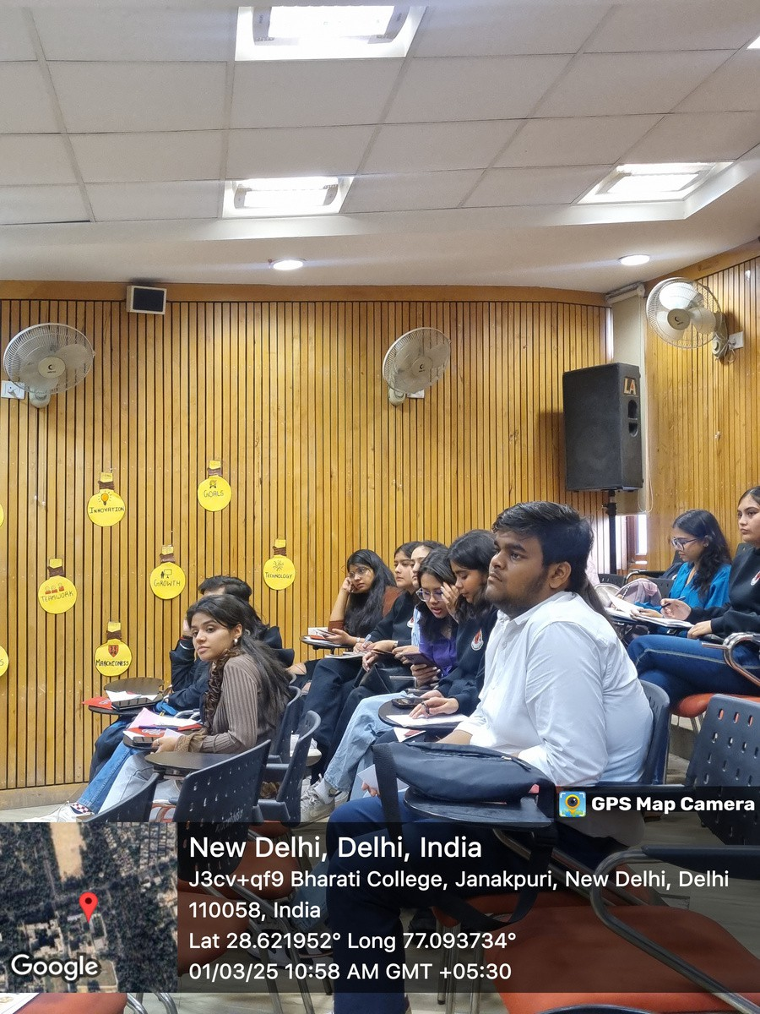
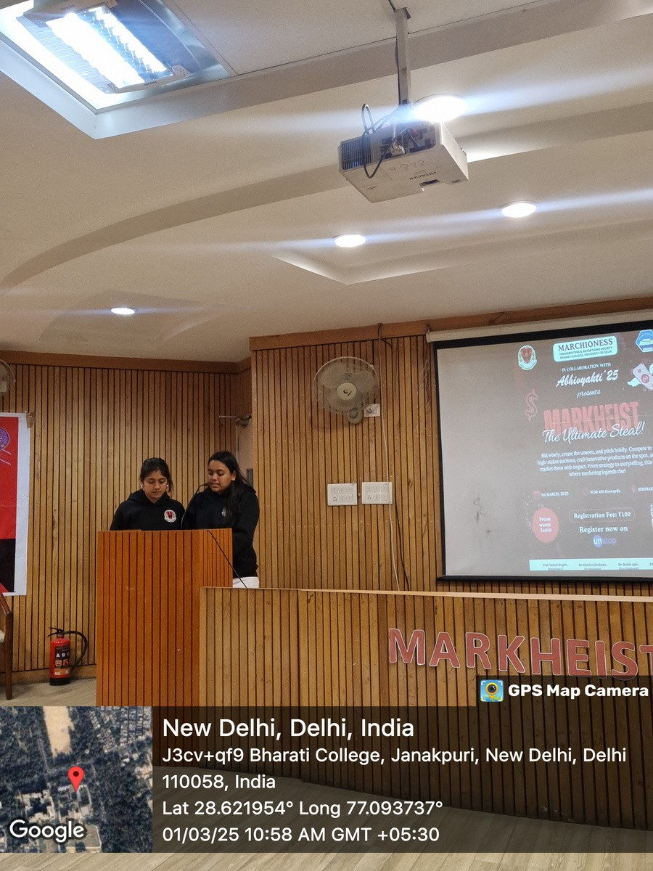
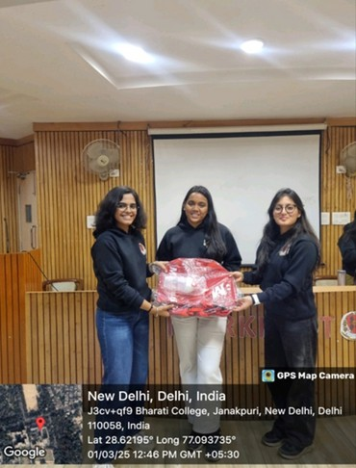
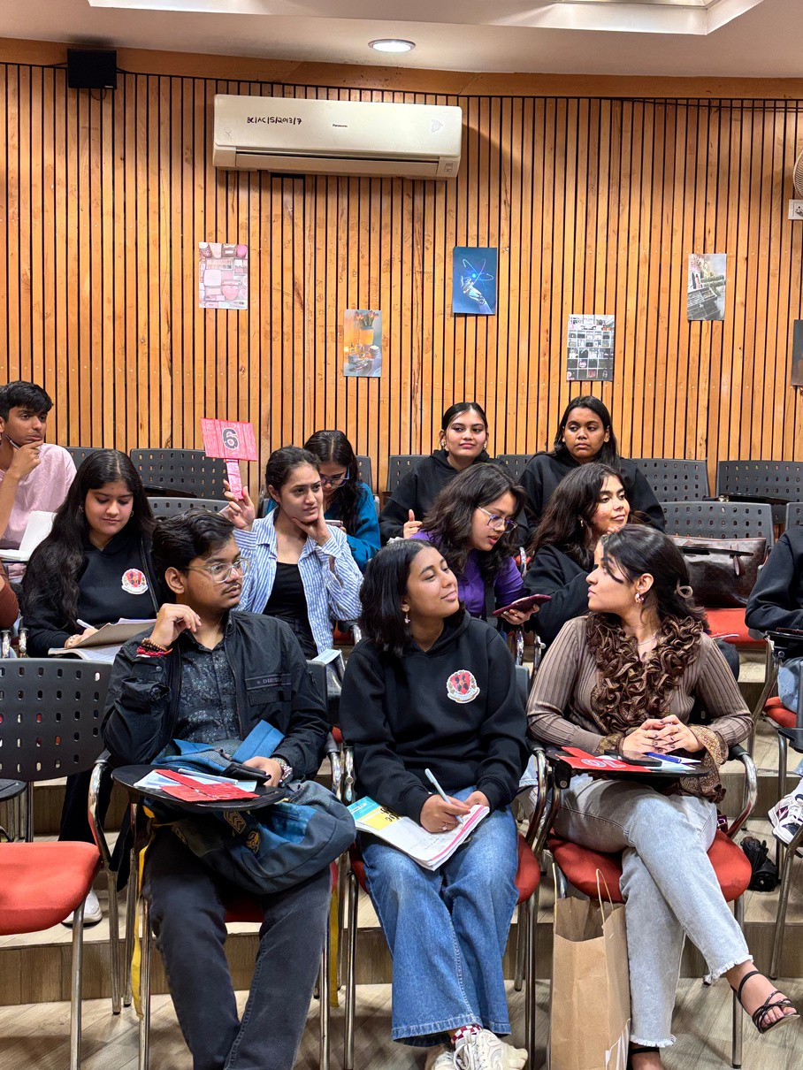

MARCHIONESS BHARATI 32

MEDIA PARTNER COVERAGES

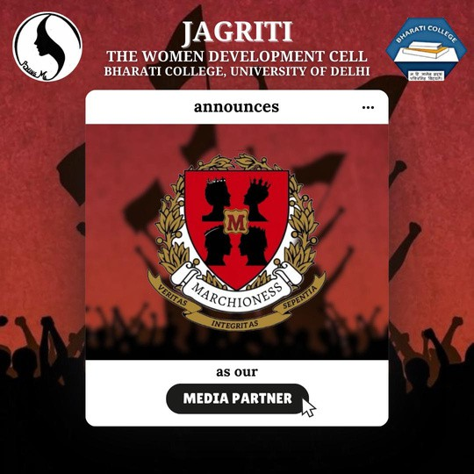


MARCHIONESS BHARATI 33

PROTEST MARCH
IN COLLABORATION WITH JAGRITI

GGRRAAPPHHIICC

AABBOOUUTT TTHHEE EEVVEENNTT
DATE: 28 th August 2024 VENUE: Bharati College
ORGANISED BY: Jagriti: The Women’ s Development Cell MEDIA PARTNER: Marchioness: The Marketing &
Advertising Society
In response to the tragic Kolkata incident, Marchioness
collaborated with Jagriti to raise awareness and demand justice. Leveraging i ts community outreach, Marchioness amplified voices against gender- based violence and
expanded the message to a wider audience, reinforcing the call for safer environments and accountability.



OOBBJJEECCTTIIVVEESS
The primary aim of this collaboration was to:
Demand justice for the Kolkata rape victim and highlight the need for systemic change.
Raise awareness about the r ising cases of gender- based violence in India.
Encourage student activism, ensuring that young voices contribute to the f ight for women’ s safety.
Pressurize authorities to take swift and decisive action against perpetrators.
Ensure mass outreach and widespread awareness by marketing the urgency of reforms on a large scale. By strategically leveraging Marchioness’ digital presence and engagement- driven platform, the collaboration
aimed to amplify the strike’ s visibility and educate a broader audience on the issue.

AACCHHIIEEVVEEMMEENNTTSS

Mass Participation and Student Engagement: The protest march witnessed an impressive turnout of students and faculty who came together with
placards, banners, and slogans, turning the event into a powerful expression of collective resistance against injustice.
Extensive Media Coverage: Marchioness served as the official media partner and documented the event
through reels, photographs, and stories. These were actively shared on social media to amplify the
message and extend i ts impact beyond the campus.

MARCHIONESS BHARATI 34

MARCHIONESS BHARATI
35

Chief Guest & Outreach: The event received coverage across multiple news channels and featured Ms.
Sareena Chhibber, Vice President of Nari Shakti
Morcha, as chief guest, who joined students in raising voice and calling for action.
Digital Advocacy and Awareness Campaign: A strong digital campaign using hashtags and widely shared
content sparked meaningful online engagement,
encouraged participation, and broadened awareness about the issue.
Strategic Outreach and Content Amplification: The collaboration strategically utilized Marchioness’
digital platform to market the cause to a wider
audience. Through compelling content and consistent messaging, the campaign educated, informed, and
mobilized people beyond institutional boundaries.
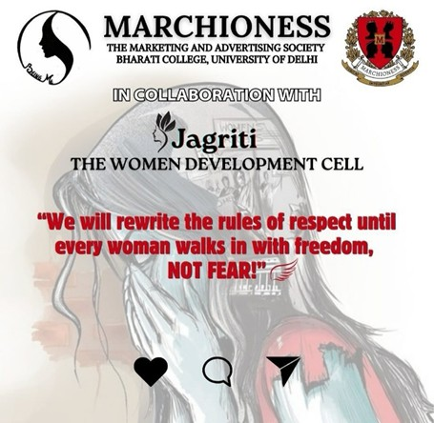

MARCHIONESS BHARATI 36

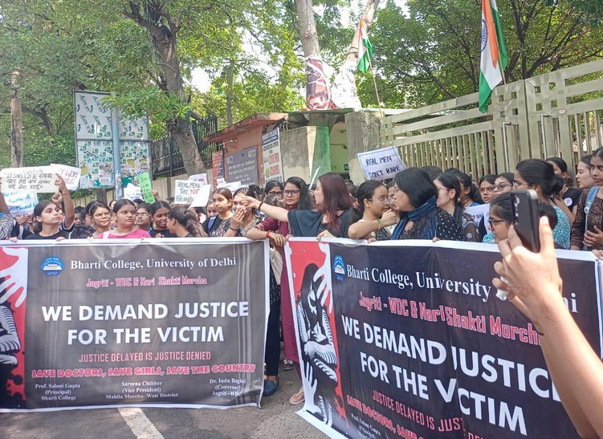
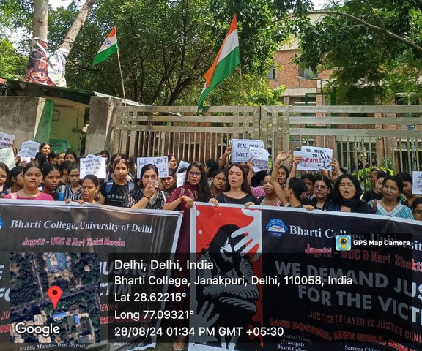
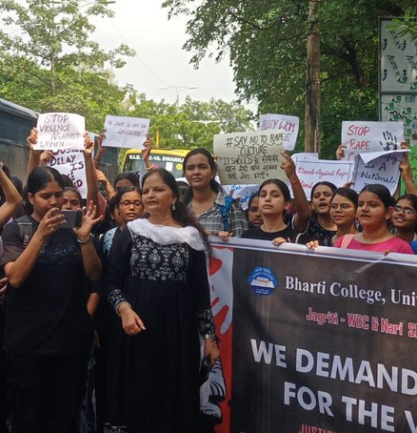

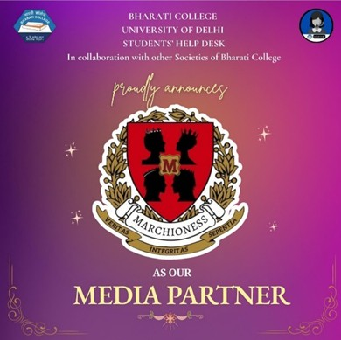


MARCHIONESS BHARATI 37

DHOLIDA: The Garba Fest & Diwali Mela
IN COLLABORATION WITH STUDENTS’ HELPDESK

GGRRAAPPHHIICC

AABBOOUUTT TTHHEE EEVVEENNTT
DATE: 19 th October 2024
VENUE: Bharati College (Central Lawn) ORGANISED BY: Students' Help Desk
MEDIA PARTNER: Marchioness: The Marketing & Advertising Society
Dholida: The Garba Night & Diwali Fest was a vibrant
celebration organized in collaboration with the Students’ Help Desk of Bharati College, with Marchioness serving as the Official Media Partner .



The event combined the cultural essence of Navratri and Diwali into an evening f i l led with dance, music, festive
stalls, and community engagement. Through this
collaboration, the event successfully brought students together to embrace tradition, joy, and festive spirit.

OOBBJJEECCTTIIVVEESS

To highlight Bharati College’ s vibrant cultural identity by reaching wider audiences through impactful digital content.
To establish Marchioness as a campus media and
marketing leader through extensive event coverage, real- t ime storytelling, and engaging reels.
To amplify the event’ s visibility and influence on social media, making Dholida a digitally celebrated fest
beyond campus.
To bring students together through Garba, Dandiya, and cultural activities, creating a strong sense of
community.
To provide a platform for students to creatively express themselves through performances and traditional celebrations.
To promote student entrepreneurship through festive stalls, encouraging innovation and business exposure.

AACCHHIIEEVVEEMMEENNTTSS

Massive Participation and Enthusiasm : The event saw an overwhelming turnout, with students dressed in
traditional attire actively participating in Garba and Dandiya, creating a l ively and festive atmosphere
f i l led with energy, music, and synchronized dance.

MARCHIONESS BHARATI 38

MARCHIONESS BHARATI 39

Successful Collaboration Between Student Bodies: The partnership between Marchioness and Students’ Help Desk led to seamless event execution, blending media coverage, event planning, and cultural
coordination for a well- promoted and smoothly managed celebration.
Diverse and Engaging Festivities: From Garba and
Dandiya to DJ night and cultural performances, along with Diwali- themed stalls offering food, handmade
decor, books, and accessories, the event catered to a wide range of interests and drew a large, enthusiastic crowd.

Extensive Media Coverage by Marchioness:
Marchioness effectively captured and showcased the spirit of Dholida through dynamic reels, interviews,
and exclusive social media content, enhancing the event’ s visibility and reach.
Social Media Triumph & Digital Reach : Dholida’ s official event reels and coverage by Marchioness
garnered over 27 , 000 + views, significantly amplifying the college’ s cultural presence online and turning the celebration into a digital sensation beyond campus
boundaries.

A Strengthened Sense of Community and
Celebration: Dholida brought students together in a vibrant display of cultural appreciation and unity,
creating a memorable festive experience that left participants eager for future celebrations.

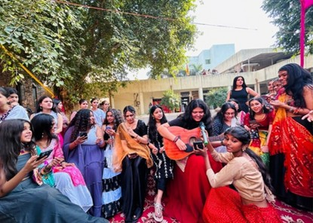
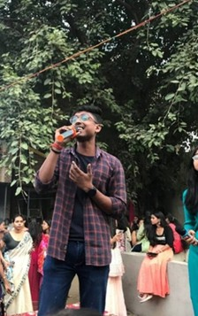
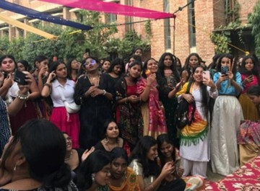
MARCHIONESS BHARATI 40

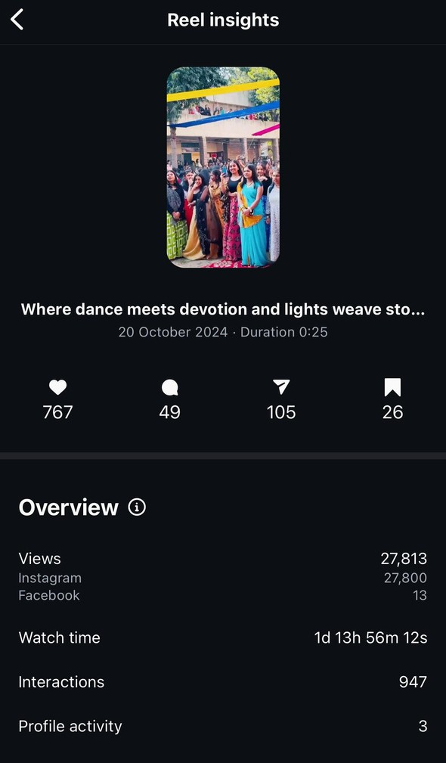
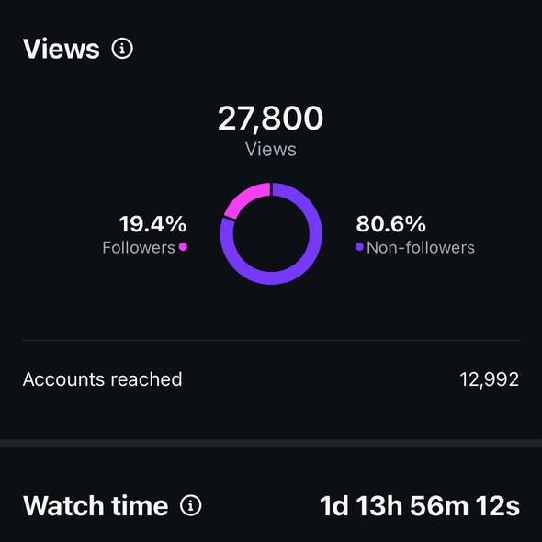
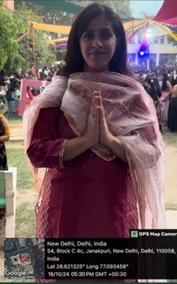

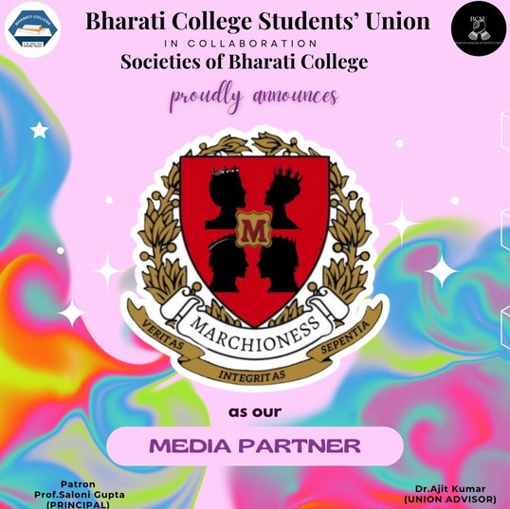
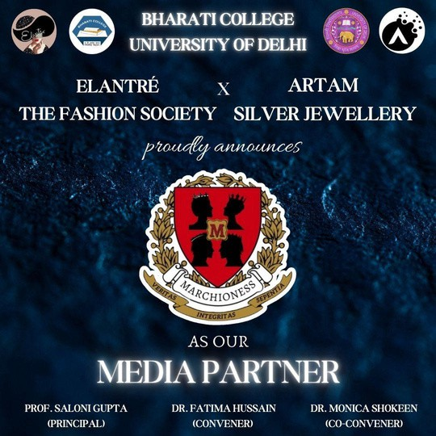

MARCHIONESS BHARATI 41

NEWBIES BASH’24: The Official Freshers
IN COLLABORATION WITH ELANTRE & BCSU

GGRRAAPPHHIICC

AABBOOUUTT TTHHEE EEVVEENNTT

DATE: 25 th October 2024 DAY: Friday
TIME: 10 : 00 AM - 3 : 00 PM
VENUE: Bharati College Auditorium
ORGANISERS: Bharati College Students’ Union & Elantre: The Fashion Society
MEDIA PARTNER: Marchioness: The Marketing & Advertising Society


Newbies Bash’ 24 : The Official Freshers' Event was a grand welcome celebration for the incoming batch of students at Bharati College. Organized with “ Artam Jewellery ” as
the Title Sponsor and Marchioness as the Official Media Partner , the event was a spectacular blend of cultural
performances, talent showcases, and interactive
sessions, marking the beginning of an exciting college journey for freshers.

OOBBJJEECCTTIIVVEESS

To warmly welcome new students while fostering
meaningful interaction between freshers and seniors, creating a vibrant and inclusive campus culture from day one.
To showcase the college’ s creative and cultural spirit through captivating performances that reflected
talent, diversity, and enthusiasm.
To maximize outreach and engagement through
Marchioness’ exclusive media coverage. Our team
took the lead in documenting every vibrant moment of the event with artistic precision and emotional depth.
From high- quality reels and curated photographs to behind- the- scenes glimpses, the content was crafted to not only capture memories but also narrate a
compelling story of celebration and unity.
Our multi- platform publicity strategy ensured that the event made waves across social media, generating
strong engagement, enhancing the event’ s recall value, and positioning Marchioness as a creative media powerhouse within the college circuit.
To collaborate with Artam Jewellery, a partnership
that added elegance and grandeur to the event while giving the brand meaningful visibility among the
student audience.

MARCHIONESS BHARATI 42


MARCHIONESS BHARATI 43

AACCHHIIEEVVEEMMEENNTTSS

Unprecedented Student Participation and
Enthusiasm : The event witnessed an overwhelming turnout as freshers actively took part in various
performances and activities, creating an atmosphere f i l led with energy, excitement, and unforgettable
memories.
Diverse and Engaging Activities : A dynamic l ineup of cultural performances, fashion showcases, dance,
music, and interactive games allowed students to
express themselves creatively, build confidence, and connect with their peers.

Strategic Marketing and Digital Promotion :
Marchioness led an impactful digital campaign before, during, and after the event, using teasers, event
highlights, and aesthetic reels to build anticipation
and ensure maximum reach. The curated content not only promoted the event but also positioned the
college as a hub of vibrant student l i fe on social media.
Extensive Media Coverage by Marchioness : As the official media partner, Marchioness captured the
vibrancy of the event through real- t ime reels,
photography, and videography, effectively boosting visibility and engagement across platforms, turning the event into a visual and digital success.
A Strengthened Sense of Belonging among Freshers : The event played a key role in helping freshers break the ice, fostering a warm, inclusive, and welcoming
environment that set the tone for their college journey ahead.

MARCHIONESS BHARATI 44

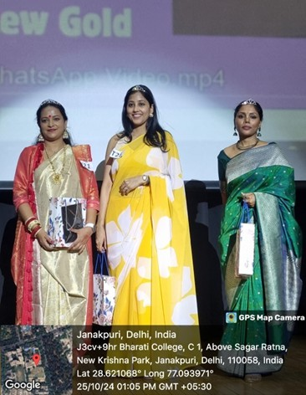
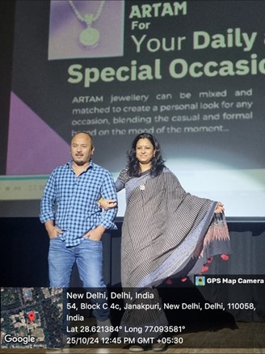

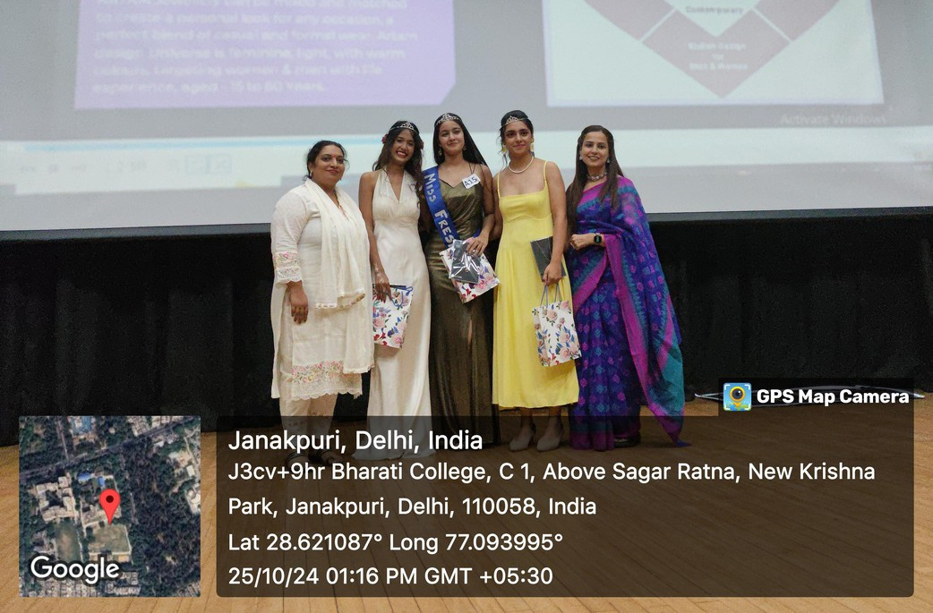

MARCHIONESS BHARATI 45

