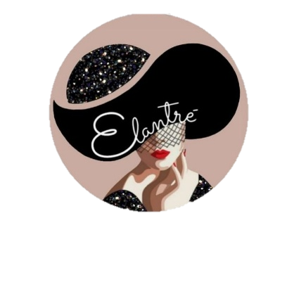
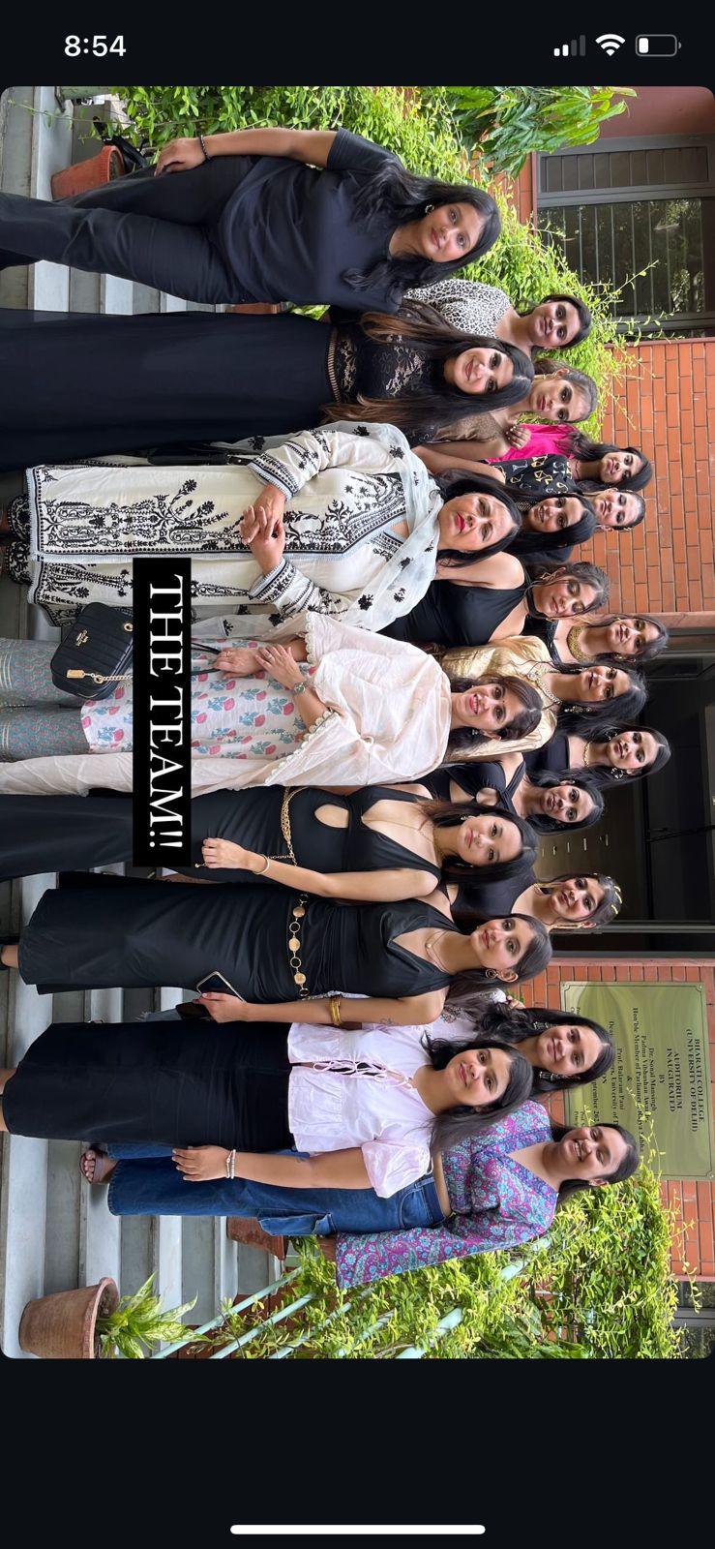
ELANTRE: THE FASHION SOCIETY
BHARATI COLLEGE, UNIVERSITY OF DELHI
CONVENOR: Dr. Fatima Hussain CO- CONVENOR Dr. Monica Dahiya

ANNUAL REPORT: 2024-2025
The report summarises Elantre’s participation in various events from June 2024 to January 2025.

SEPTEMBER 2024
ANNUAL DAY(19/09/2024)
Elantre performed on the occasion of Annual Day focusing on the theme women empowerment where it highlighted and encouraged the role of women in society.

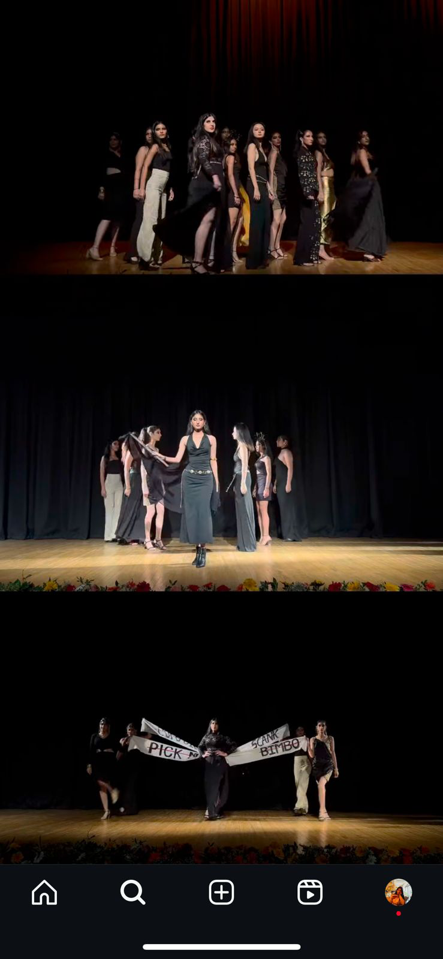

AUDITIONS ( 25/09/2024)
In a quest to redefine campus couture, Elantre hosted auditions this September opening its runway to passionate new members

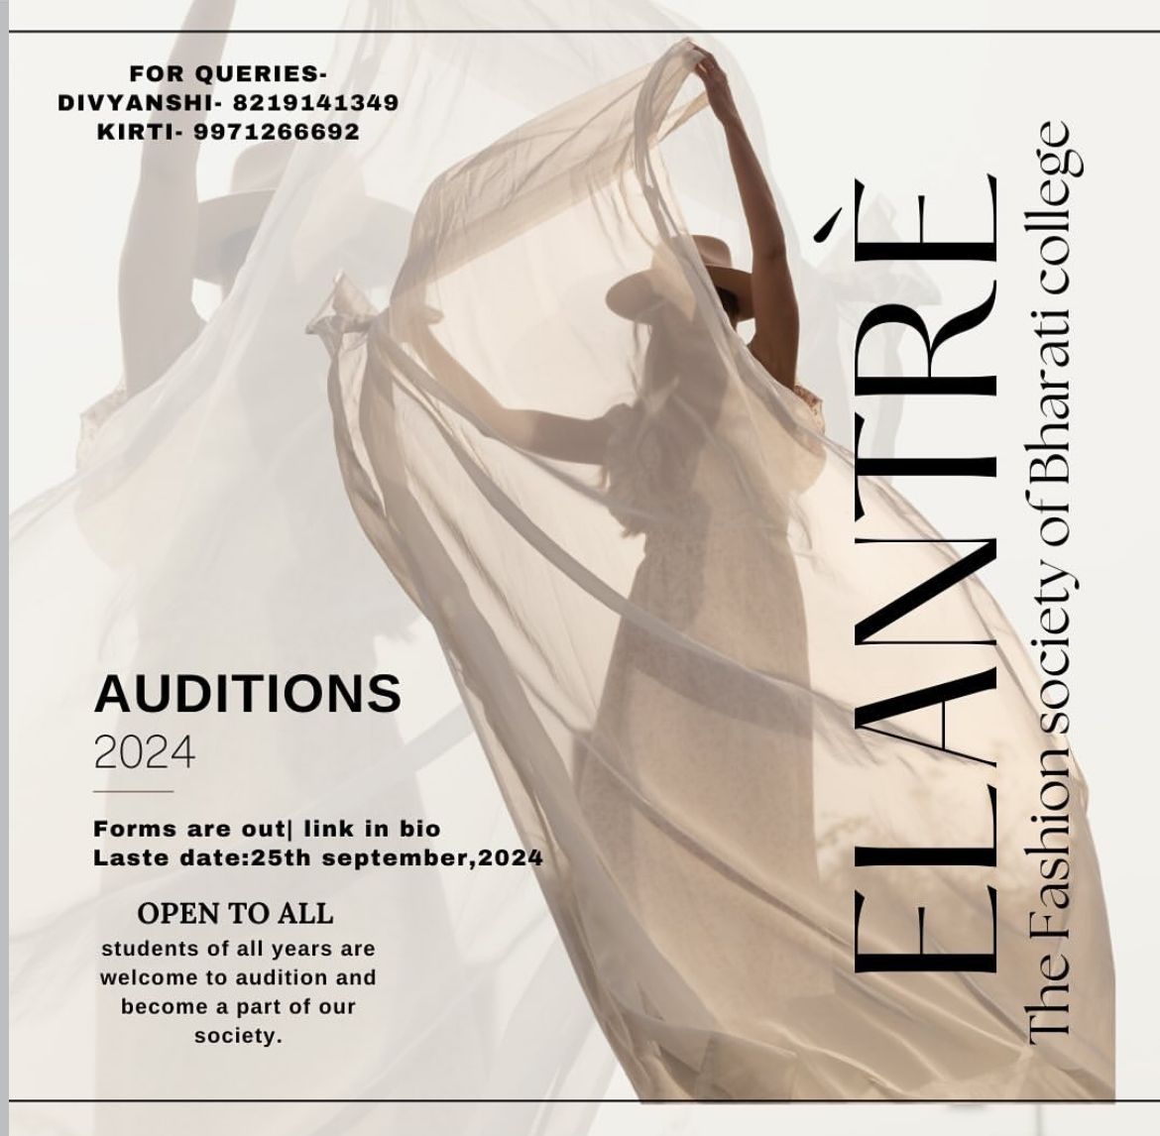

OCTOBER 2024
FRESHERS(15/10/2024)- Elantre in collaboration with Artam Silver Jewellery delivered a captivating performance at the Freshers event focusing on the theme Tech Couture- Unweiling the silver lining in your style.

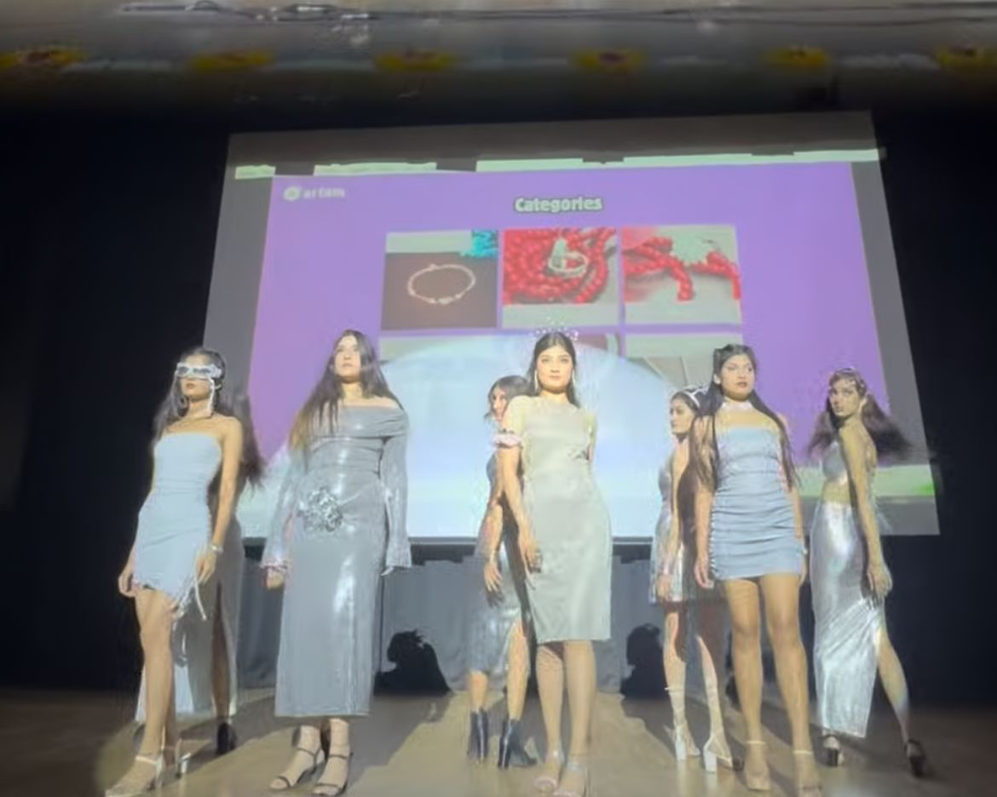

FEBRUARY 2025
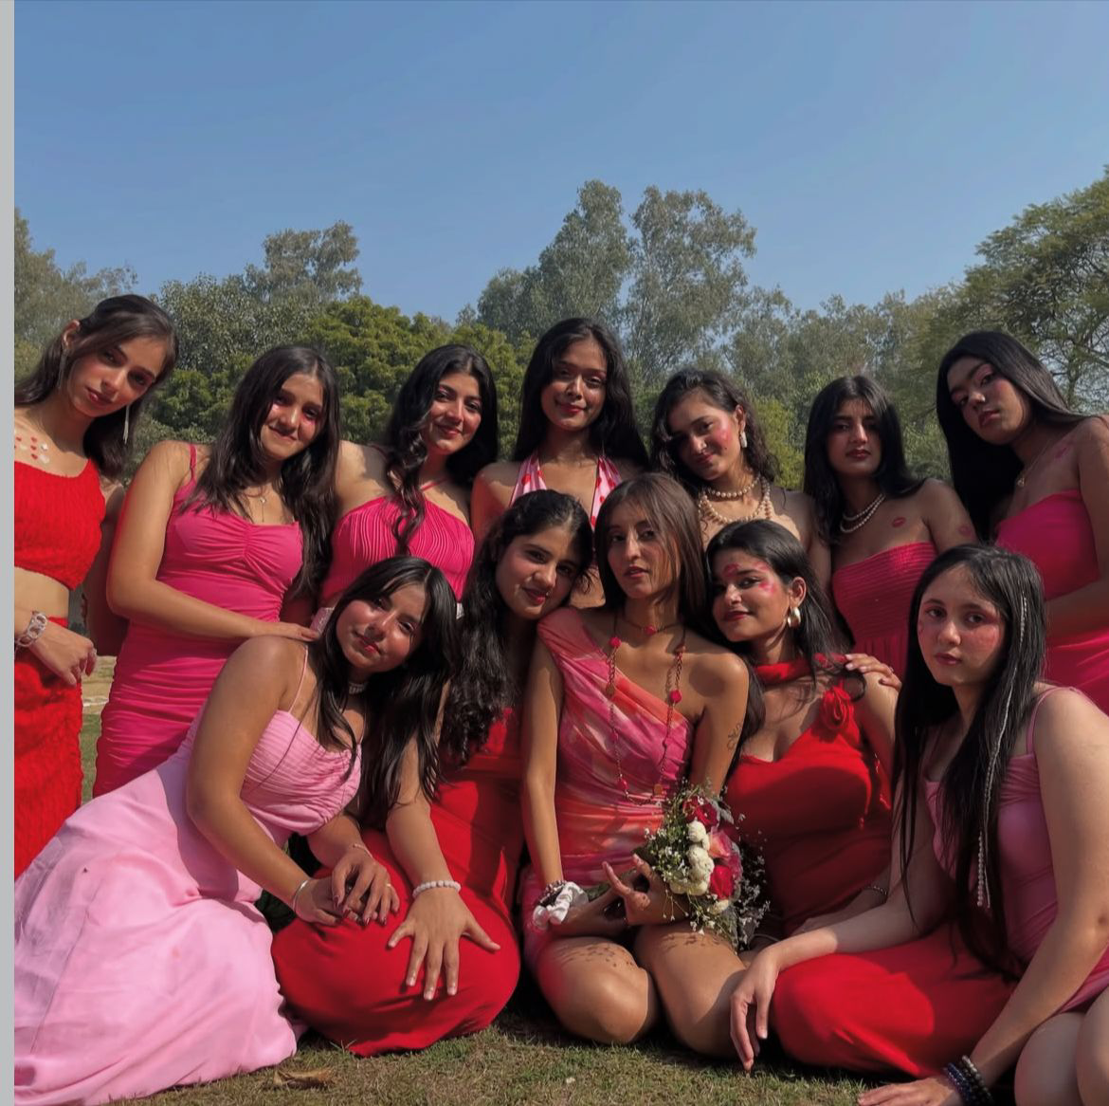
GALENTINES PHOTOSHOOT(03/02/2025)- In the spirit of sisterhood and self-love, Elantre hosted a vibrant Galentine's Day photoshoot in February, celebrating friendship, fashion, and fierce femininity. The event brought together creativity, confidence, and camaraderie, capturing the true essence of the month of love

CAPRICIEUX(17/02/2025)- Elantre organised and managed a ramp walk competition held during the Annual Fest- ABHIVYAKTI’25 of our college. It was successful in gathering the participation of various colleges from Delhi and nearby institutes . Eventually ending the competition with a final walk by Elantre itself.
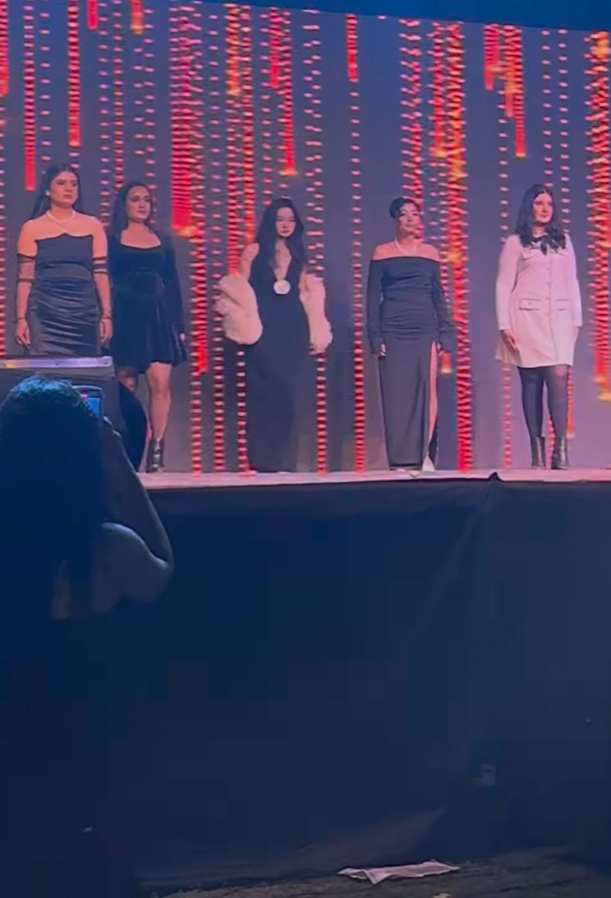
MARCH 2025
MAKEUP WORKSHOP(03/03/2025)- In March, Elantre organized an exclusive makeup workshop led by Makeup Head Khushi, offering members a hands-on experience to enhance their artistry, explore trending techniques, and gain insights into professional styling. The session aimed to empower participants with skills in self-grooming and stage-ready looks, aligning with Elantre's commitment to holistic grooming and creative excellence.

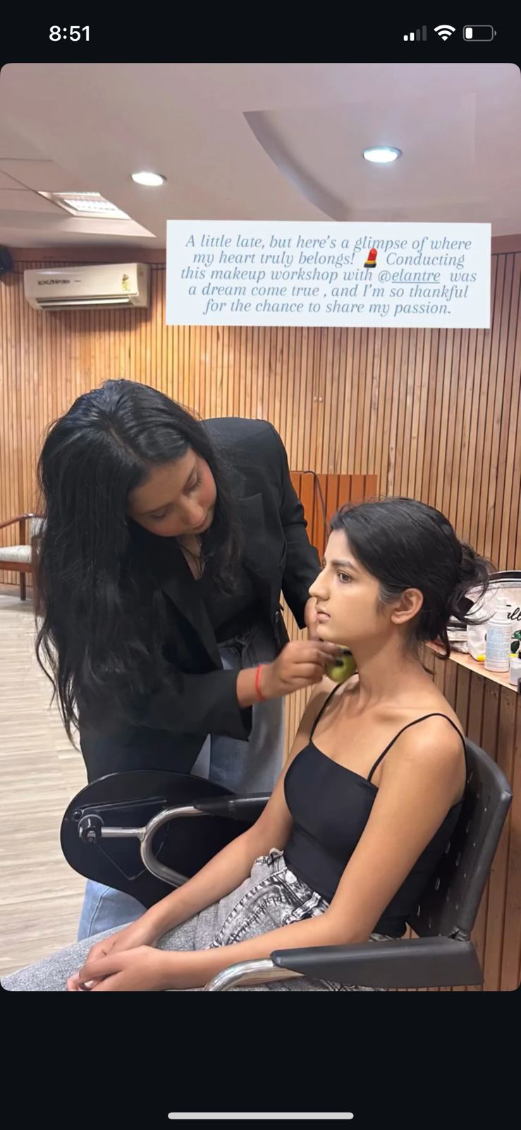

ELANTRE X AREYA(21/03/2025- On 21st March 2024, Elantre performed at the Leadership Summit organized by Areya, The Leadership Cell. The event was centered around the theme of 'Women Empowerment,and Elantre’s performance beautifully embodied the strength, resilience, and spirit of womanhood, leaving a lasting impact on the audience.
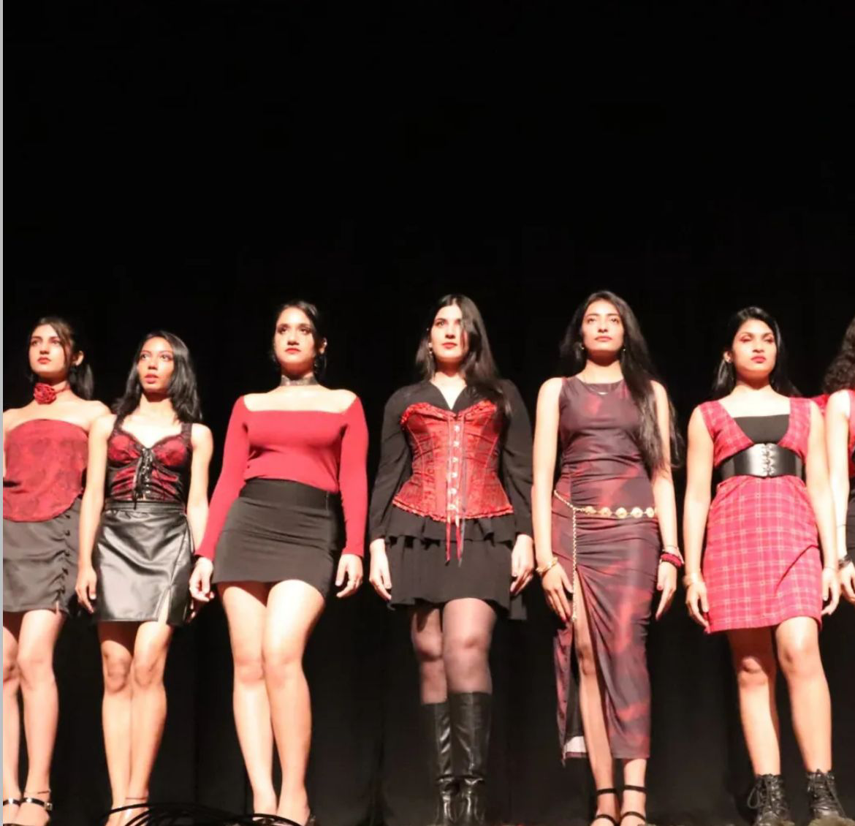

ACHIEVEMENTS
- Our Makeup Head Khushi Sharma won 1st prize at the Makeup Competition organized by Jagriti- The Women Development Cell of Bharati College, University of Delhi.
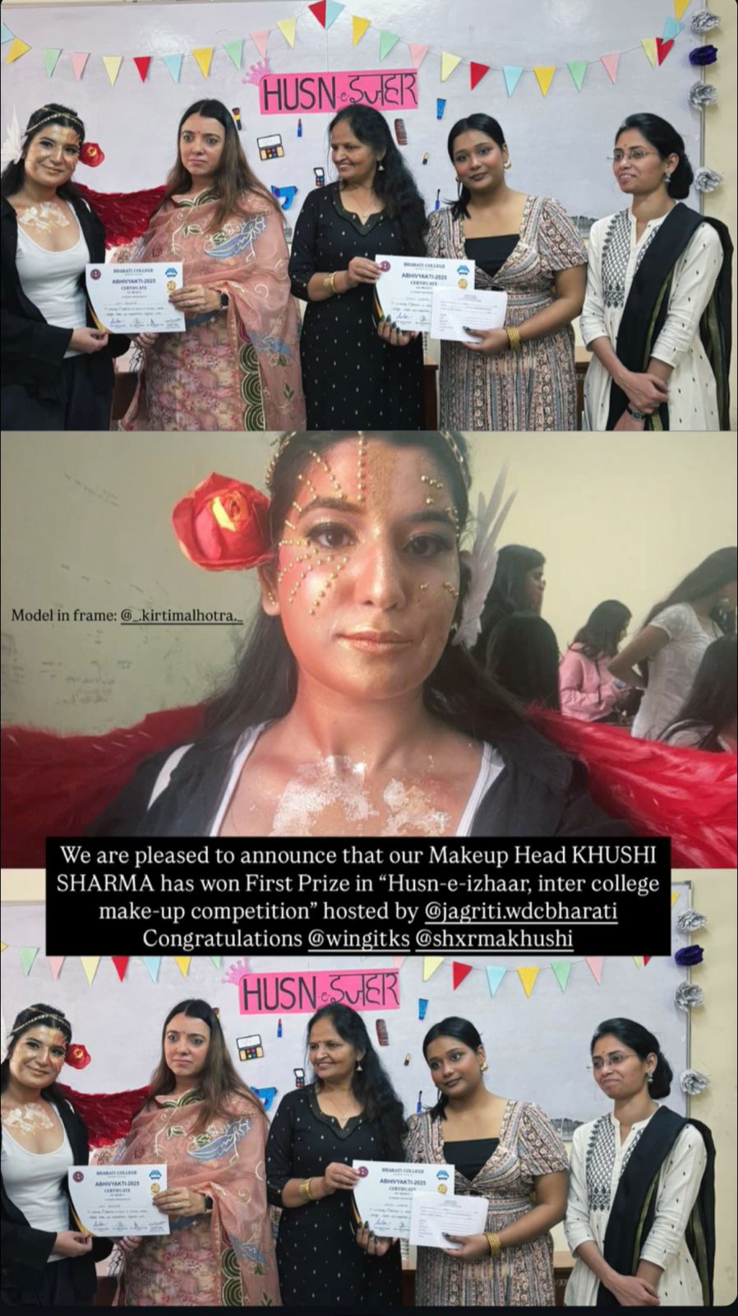

- Our Model, Ananya Das won 2nd position in Fashion Show Competition organised by Cathect Society- Department of Psychology of Bharati College, University of Delhi.
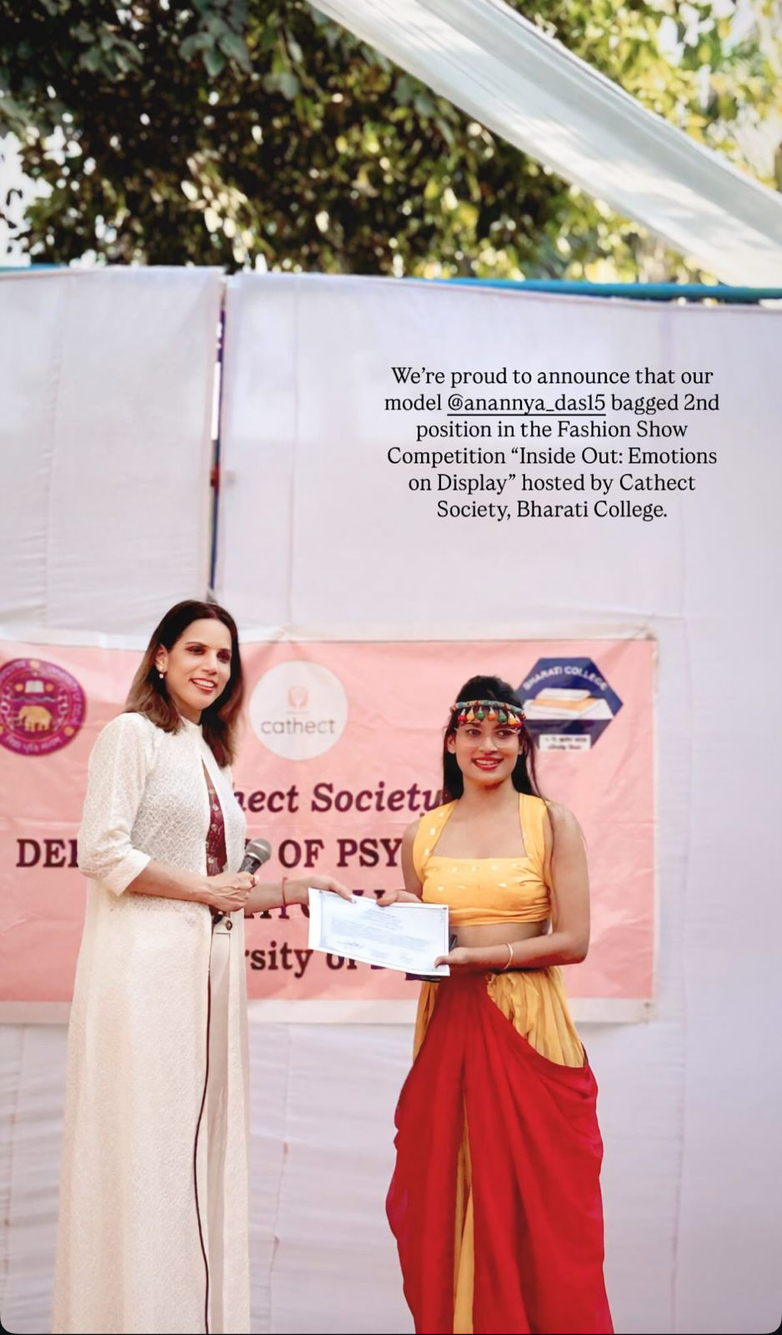

- Our Makeup Head Khushi Sharma along with Kanishka Khosla won 1st position in Makeup Competition organised by Maitreyi College
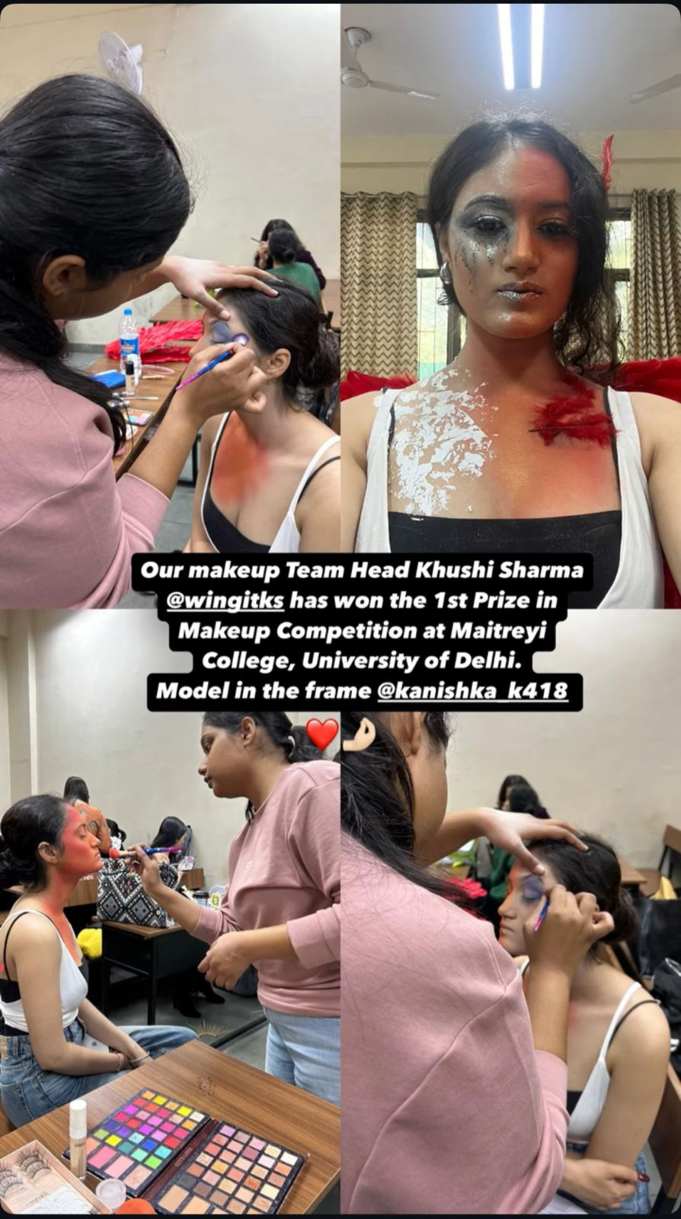
- Our Model Ananya Das won 3rd position at Cultural Ramp walk Competition organised by Ramjas College.

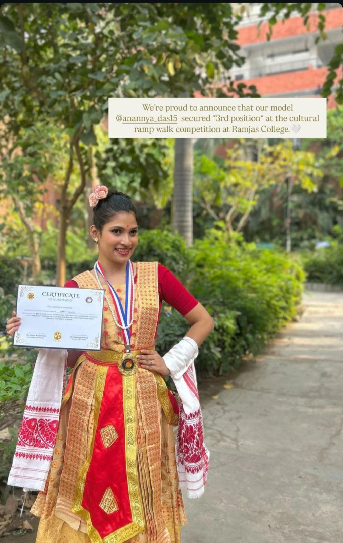

In summary, Elantre has demonstrated remarkable initiative by organizing a series of impactful events and actively participating in numerous college and inter-college competitions, both as a collective unit and through individual representation. Consistent efforts have led to several notable achievements and accolades, each serving as a proud milestone in this journey and a testament to Elantre’s dedication, creativity, and commitment to excellence in the field of fashion and performance.

