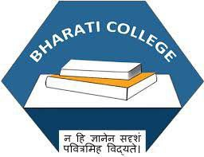 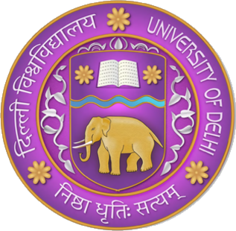

**Under the ages of IQAC**

**KAVYA- ABHIVYAKTI KA SAAJHA MANCH**

* Convenor- Mr Akshat Pushpam
* Aryama Sharma ( President )
* Himanshi Gawra (Vice President)
* Shobha (Secretary)
* Sakchhi Singh ( Joint secretary)
* Muskan Aggarwal ( Event head)
* Preyasi (Event co-head)
* Khushi Verma (Content head)
* Adya Mishra ( Content head )
* Sneha Aggarwal ( Social Media head)
* Purbhashree (Social Media co-head)
* Tapasya (Graphics head)
* Aashna ( Public Relations head)

ABOUT

Kavya is a vibrant student community passionate about poetry. We celebrate and nurture creativity through poetry, writing, and critical analysis, offering a platform for students to explore their literary interests and refine their talents.

Our society fosters a community of like-minded individuals who share a passion for storytelling and expression. We host exciting events such as poetry sessions, competitions, speaker series, open-mic nights, and writing workshops, providing opportunities for members to showcase their work and learn from established authors. Kavya promotes interdisciplinary collaboration and creative thinking, creating a dynamic space for literary enthusiasts to connect and grow.

ACTIVITES

|  |  |  |
| --- | --- | --- |
| Sr.no | Event | Date |
| 1 | Hindi diwas | 14 September 2024 |
| 2 | Parody of poetry | 26 September 2024 |
| 3 | The Alchemy of words | 4 October 2024 |
| 4 | Types of poetry session | 23 October 2024 |
| 5 | A love that heals, a love that burns, an unspoken confession | 26 November 2024 |
| 6 | Alfaaz | 28 February 2025 |
| 7 | Aspects of life | 6 February 2025 |
| 8 | The words that mends | 18 February2025 |

EVENTS

**Hindi Diwas – Kavya: A Shared Platform of Expression**

The Hindi Diwas celebration took place on 14th September 2024, at Bharti College in Room 103, starting at 12:00 PM. This significant event aimed to honor the Hindi language and its rich cultural heritage through a variety of engaging activities, including poetry recitations, inspiring speeches, and thought-provoking discussions. The presence of esteemed guests, Professor Ankita and Professor Jatin, added depth and gravitas to the occasion, highlighting the importance of the Hindi language in contemporary society.

The venue was beautifully decorated, creating an inviting and warm atmosphere that encouraged participation. Students from various backgrounds presented their self-composed poems on a range of themes, showcasing their literary talent and creativity. Each poem reflected personal experiences and cultural nuances, resonating deeply with the audience.

The event concluded with a heartfelt note of appreciation for all contributors, emphasizing the collective effort that made the celebration successful. Participants left feeling inspired and connected, having shared in the joy of expressing their love for the Hindi language and culture.

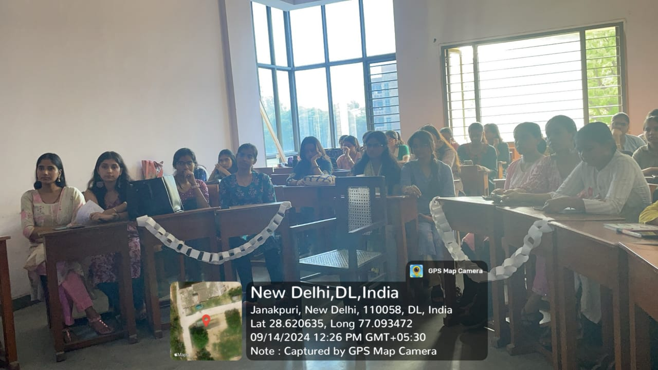

### Parody of Poetry

The Parody of Poetry session took place on 26th September 2024, in front of the Auditorium Building, from 1:00 PM to 1:30 PM. This lively event was led by the dynamic duo, Aryama Sharma and Himanshi Gawra, who created an engaging atmosphere for participants to explore poetry through a humorous and satirical lens.

The session provided a unique space for attendees to discuss their personal poetic journeys, sharing the inspirations that drive their creativity. The conversation delved into the significance of parody in poetry, highlighting how humor can make complex themes more relatable and accessible to a broader audience. Participants were encouraged to share their own creative expressions, leading to a rich tapestry of ideas and insights.

As attendees engaged in meaningful discussions about poetry’s impact on society and individual experiences, laughter and camaraderie filled the air. The session concluded on an uplifting note, leaving participants inspired and motivated to continue their poetic endeavors, armed with new perspectives on the art of parody and its role in enriching the poetic landscape.

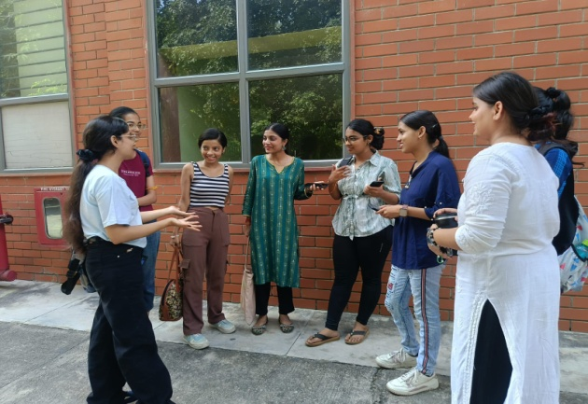

### The Alchemy of Words – Kavya Society Speaker Session

The Alchemy of Words speaker session was organized by the Kavya Society at Bharti College to delve into the transformative power of poetry and its impact on society. The event featured a series of insightful discussions led by esteemed guest speakers, Dr. Nandini Sen and Dr. Shailendra Vikram. They emphasized poetry’s vital role in shaping culture and empowering individuals, highlighting how words can inspire change and foster connection.

Throughout the session, students showcased their creativity by presenting self-composed poems that reflected their unique perspectives and experiences. Each poem resonated with the audience, sparking meaningful conversations about the themes of identity, resilience, and empowerment. Additionally, a batch ceremony for the core team was conducted, celebrating their hard work and dedication to promoting literary expression within the college community.

The event concluded with a delightful cake-cutting ceremony, marking a moment of celebration and unity. Attendees were also excited about the announcement of the Kavya Bharati Instagram series, aimed at promoting women’s empowerment through poetry, encouraging more voices to join the conversation and share their stories.

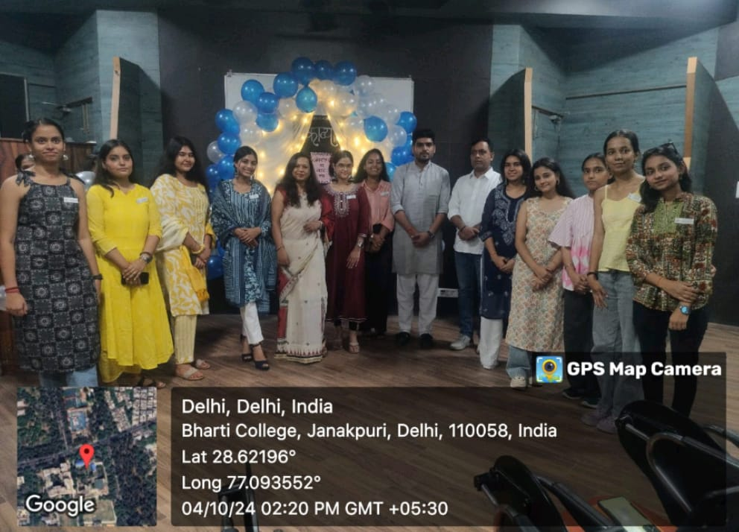

### Poetry Session – A Love That Burns, A Love That Heals, and Unspoken Confessions

The poetry session, held on 26th November 2024, in Room 203 at 1:00 PM, revolved around the evocative theme "A Love That Burns, A Love That Heals, and Unspoken Confessions." This engaging session was guided by Convenor Akshat Sir and led by President Aryama Sharma, providing a welcoming platform for students to express their deepest emotions through the art of poetry.

The event featured a unique black-and-white dress code, which not only added to the aesthetic appeal but also symbolized the contrasting aspects of love—its passionate intensity and its soothing, healing qualities. Participants presented a variety of self-composed poems that explored different dimensions of love, ranging from the joy of romantic connections to the pain of loss and the beauty of unspoken feelings.

As the final poetry session of the year, it marked a fitting conclusion to the society’s creative journey, leaving a lasting impression on all attendees. The heartfelt expressions shared during the session fostered a sense of community and understanding, encouraging everyone to embrace their vulnerabilities and celebrate the transformative power of love through poetry.

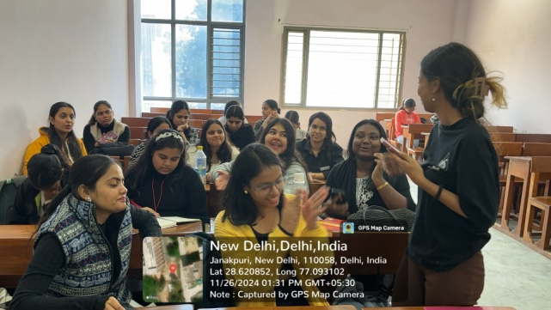

### Poetry Session: Types of Poetry

In this engaging session, we delve into the captivating world of poetry, exploring the various types and forms that enrich the literary landscape. From lyrical verses that evoke deep emotions to structured sonnets that showcase precision and artistry, we celebrate the incredible diversity and depth of poetic expression. Each form of poetry carries its own unique characteristics and cultural significance, reflecting the myriad ways in which humans articulate their thoughts and feelings.Throughout the session, we highlight the historical context and evolution of different poetic forms, inviting participants to appreciate the beauty of poetry in its many styles. From free verse to haikus and ballads, each type serves as a window into the human experience, allowing us to connect with emotions and stories that resonate across various cultures.

As we journey through these poetic expressions, we uncover the universal themes of love, loss, joy, and resilience, demonstrating how poetry can bridge gaps between diverse experiences. This exploration not only enhances our understanding of literature but also fosters a deeper appreciation for the art of storytelling through verse.

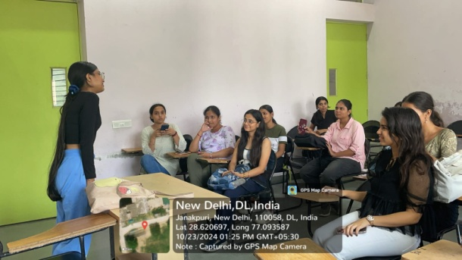

### Alfaaz - A Literary Celebration by Kavya Society

Kavya Society successfully organized **Alfaaz** as part of **Abhivyakti’25**, a vibrant literary event dedicated to celebrating creativity and self-expression. The event featured three engaging competitions: **Rhyme Rage**, **Verse Vibe**, and **Inkpulse**, attracting 45 talented participants from various colleges, showcasing their literary prowess.

The session was inaugurated by Society Convenor Dr. Akshat Pushpam, who delivered insightful remarks following a traditional lamp lighting ceremony. The presence of our respected Principal, Prof. (Dr.) Saloni Gupta, added prestige to the occasion. Esteemed judges, Miss Sharika Gangadharan, author of Nakhun, Sawalon ke Dher mein Ek Sawal, and Mr. Vimlok Tiwari, author of Yayavar - Adhoore Ahsaas, provided thoughtful feedback and praised the participants for their creativity.

Winners of the **Rhyme Rage** competition were honored with tokens of appreciation and certificates, with Shraddha Chaturvedi securing 1st place and Christina taking 2nd. The event concluded on a high note, featuring a photography session and closing remarks from President Aryama Sharma, reaffirming Alfaaz’s commitment to promoting creativity and celebrating the literary spirit among students.

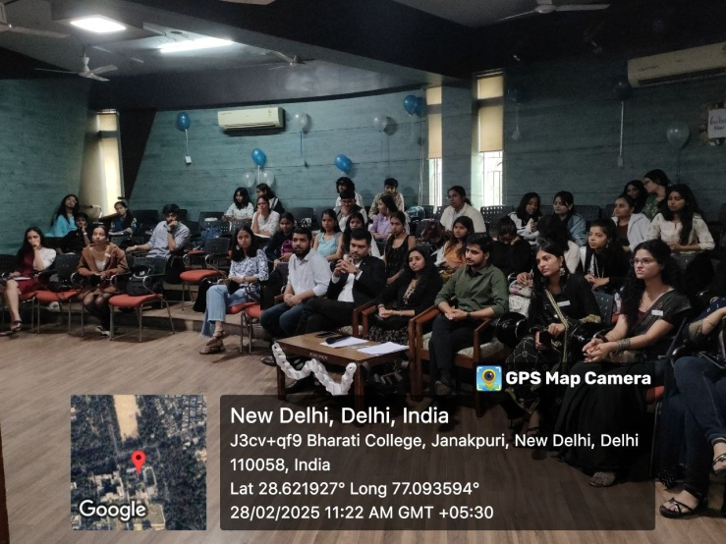

### Poetry Session on Aspects of Life

The Kavya Society, a passionate group of students dedicated to literature and writing, organized an engaging session titled "Poetry Session on Aspects of Life," held on 6 February 2025. Led by President Aryama Sharma and fellow members, the session aimed to promote diversity and creativity in poetic expression among participants.

During this interactive gathering, attendees explored how poetry serves as a powerful medium to express and understand various aspects of life, including emotions, experiences, and personal perspectives. The discussion evolved to address contemporary themes, focusing on how poetry can articulate modern issues such as social justice, identity, and technology. Participants analyzed how poets from diverse cultures use language and form to convey their unique experiences.

The session emphasized poetry's role in fostering empathy, understanding, and social change. Throughout the event, participants engaged in lively discussions, shared their own poetic works, and provided constructive feedback to one another. This interactive experience left all members enriched and inspired, highlighting the profound impact of poetry in navigating the complexities of life.

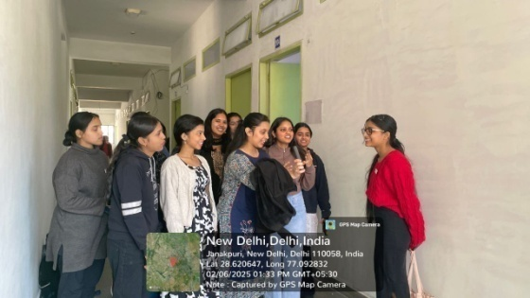

### Sharing Session: The Words That Mend

On 18th February 2025, Kavya – The Poetry Society – hosted a heartwarming sharing session themed “The Words That Mend.” This interactive gathering provided a welcoming space for students to express their emotions, experiences, and creativity through poetry and spoken word.The session attracted not only society members but also enthusiastic students from outside the organization, fostering a diverse community of voices. It transformed into a soulful exchange where poetry became a powerful medium for connection and healing. Participants shared personal reflections, offering verses that resonated with themes of empathy, hope, and understanding.

The atmosphere was filled with warmth and encouragement, creating an environment where every voice was heard and appreciated. The session truly lived up to its theme, demonstrating that words have the remarkable ability to mend hearts and bring people together. Through their heartfelt compositions, participants cultivated a sense of community and support, highlighting the profound impact of poetry in navigating life’s challenges. This enriching experience left attendees inspired and connected, reinforcing the importance of sharing our stories through the art of language.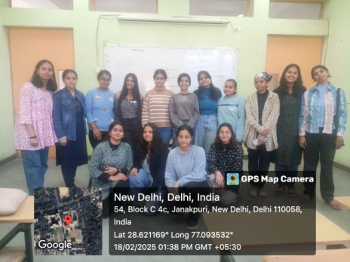

CONCLUSION

The series of events organized by Kavya Society exemplifies a vibrant celebration of poetry and its transformative power in fostering creativity, connection, and cultural appreciation. From the heartfelt expressions during **Hindi Diwas** to the engaging discussions in the **Parody of Poetry** session, each gathering provided a unique platform for students to explore and articulate their emotions and experiences through the art of verse.

The **Alchemy of Words** speaker session highlighted the significant role poetry plays in shaping societal narratives, while the **Poetry Session on Aspects of Life** and **Sharing Session: The Words That Mend** emphasized the importance of empathy and understanding in our shared human experience. These events not only encouraged participants to share their voices but also cultivated a supportive community that values literary expression.

Through competitions like **Alfaaz**, the society showcased the incredible talent of budding writers, inspiring them to continue their poetic journeys. Overall, Kavya Society’s initiatives have fostered a deeper appreciation for poetry, proving that words can indeed mend hearts, bridge gaps, and empower individuals to share their stories, enriching the cultural fabric of the college community.

ANNEXURE

ATTENDANCE:-

|  |  |  |  |  |  |  |  |
| --- | --- | --- | --- | --- | --- | --- | --- |
| Aspects of life | | Parody of poetry | A love that heals | | | The word that mend’s | |
| 1. Aryama  2. Khushi  3. Abhaya  4. Pratibha  5. Divyanshi  6. Tapasya  7. Neha  8. Paridhi | | 1. Aryama  2. Himanshi  3. Renu  4. Khushi  5. Sweta  6. Priya  7. Divyanshi  8. Dhairya  9.Pratibha | 1. Aryama  2. Preyasi  3. Sakchhi  4. Shobha  5. Tapasya  6. Khushi  7. Renu  8. Priya  9. Purbashree  10. Sneha  11. Pratibha | | | 1. Sakchhi  2. Shobha  3. Himanshi  4. Aryama  5. Muskan  6. Priya  7. Pratibha  8. Abhaya  9. Divyanshi  10. Khushi  11. Deepti | |
|  |
| The alchemy of words | Types of poetry sessions | | Hindi diwas | | ANNUAL EVENT | |
| 1. Aryama  2. Himanshi  3. Shobha  4. Sneha  5. Paridhi  6. Aashma  7. Renu  8. Aadya  9. Purbashree  10. Muskan  11. Preyasi  12. Divyanshi  13. Sweta  14. Pratibha  15. Priya  16. Khushi  17. Dhairya  18. Abhaya  19. Tapsaya | 1. Aryama  2. Renu  3. Shobha  4. Sakchhi  5. Sneha  6. Paridhi  7. Khushi  8. Muskan  9. Tapasya  10.Preyasi  11.Abhaya  12. Purbashree  13.Pratibha  14.Priya  15.Ekta  16.Dhairya  17.Anjana  18. Dipti | | 1. Aryama Sharma  2. Himanshi  3. Shobha  4. Sakchhi  5. Sneha  6. Paridhi  7. Khushi  8. Muskan  9. Aashna  10. Renu  11. Asma  12. Nisha  13. Divyanshi | | 1.Aryama  2.Himanshi  3.Shobha  4.Sneha  5.Paridhi  6.Aashna  7.Renu  8.Purbashree  9.Muskan  10.Divyanshi  11.Sweta  12.Pratibha  13.Priya  14.Abhaya  15.Tapasya  16.Renu  17.Sakchhi  18.Khushi  19.Preyasi  20.Ekta  21.Dhairya  22.Anjana  23.Dipti | |