
Note on Equal Opportunity Cell (EOC) Activities 2024–2025
Bharati College, University of Delhi
The Equal Opportunity Cell (EOC) of Bharati College functioned with unwavering commitment throughout the academic session 2024–2025, focusing on enhancing inclusivity, promoting equity, and addressing the concerns of students with disabilities (PwD). The EOC continued its efforts to institutionalize support structures and drive infrastructure improvements to ensure accessible and dignified education for all students. The committee actively reviewed the college infrasture and recommended the repair of ramps and the need for tactile paths. The performance of the 2 laptops which were burdened by software for the visually challenged were upgraded and their performance enhanced.
The EOC also collaborated with NGOs like Saksham to conduct awareness workshops on disability rights and technological interventions. Through these, students were introduced to assistive devices like screen readers, smart canes, tactile currency identifiers, and educational apps tailored for the visually impaired. Simulated activities and firsthand testimonies played a crucial role in dismantling biases and promoting empathy.
Beyond the classroom, the Cell organized events under the banner of Equilibrium – The Equality Fest, including talent hunts, folk music competitions, and motivational talks. These initiatives fostered a spirit of celebration and representation for PwD students, many of whom participated with enthusiasm. The Cell ensured inclusive participation by companion volunteers for students requiring assistance.
Another important intervention was in support facilitation. Many students with disabilities who had queries about reimbursement of writer fees, hostel security deposits, and government scholarships were individually mentored. The EOC provided clerical even for students who had passed out of college.
As part of the Cell’s commitment to such persons the committee members took care of the individual mentorship needs.
In conclusion, the Equal Opportunity Cell at Bharati College has made concrete strides this academic year in ensuring inclusion is not just a policy but a lived practice. While significant achievements have been made, the Cell remains mindful of the continued challenges and the need for sustained institutional commitment in the years ahead.

Workshop Report: Sensitization on Assistive Devices for the Visually Impaired

This workshop was organized by the Equal Opportunity Cell of Bharati College in collaboration with Saksham, an NGO working for the blind. The event focused on raising awareness about the challenges faced by visually impaired individuals and showcased assistive technologies including tactile tools, audio devices, and accessible apps. Students participated in activities such as currency identification, cup-filling simulations, and blindfold navigation games.
Objective of the Workshop
The workshop aimed to educate and sensitize students about the daily challenges faced by visually impaired individuals and to showcase how assistive technologies and tactile tools can support independence and dignity. It also sought to foster empathy and encourage student participation in inclusive practices.
The session was led by representatives from Saksham, a pioneering NGO working in the field of disability rights, with a special focus on accessibility tools for the blind and low vision individuals.
1. Demonstration of Assistive Devices
Participants were introduced to a wide range of tools that empower visually impaired individuals:
- Screen readers like JAWS and NVDA for computers.
- Refreshable Braille displays and Braille slates.
- Talking calculators, tactile rulers, and smart canes.
- Liquid level indicators — devices that beep when a cup or glass is nearly full to prevent spillage.
- Label readers and voice-enabled mobile apps that assist with object identification.
2. Rupee Currency Identification Tools
Special emphasis was placed on the tactile features on Indian currency notes:
- Students were shown how the raised printing, variable sizes, and specific symbols on ₹10, ₹50, ₹100, ₹200, ₹500, and ₹2000 notes assist blind users.
- Devices like Tiffy Templates, smartphone apps (like Cash Reader), and audio-based identification tools were demonstrated.
- Students tried blindfolded exercises to identify currency using tactile features, promoting hands-on empathy.
3. Interactive Games and Simulation Activities
The session included:
- Blindfold navigation games where students navigated small obstacle courses using white canes.
- Team-based tactile puzzles and word games that introduced participants to the challenges of visual absence and the creative strategies used by blind individuals.
- A "Pour and Stop" game using the cup-filling device to demonstrate spatial judgment without sight.
4. Testimonies from Visually Impaired Participants
Participants heard firsthand experiences from visually impaired professionals and students about:
- Navigating education systems
- Using assistive technology for daily tasks
Facing societal stigma and finding pathways to independence
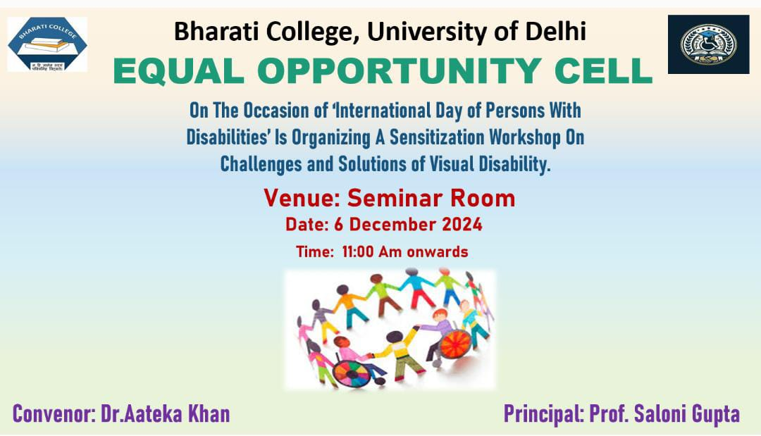

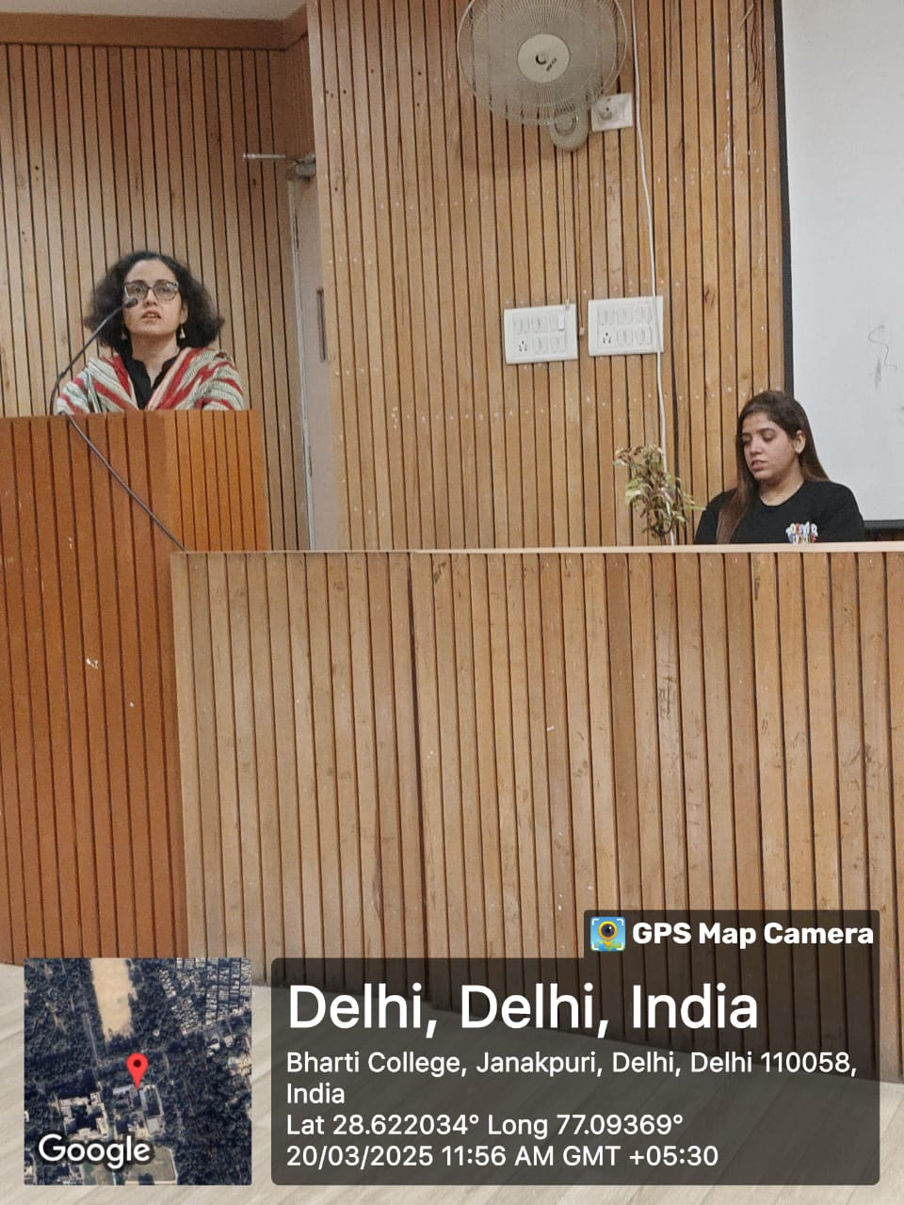

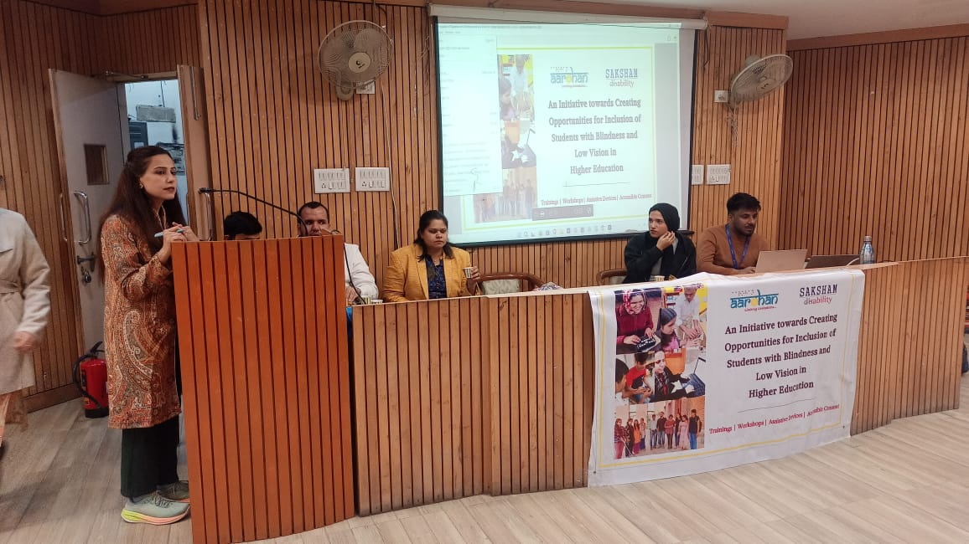

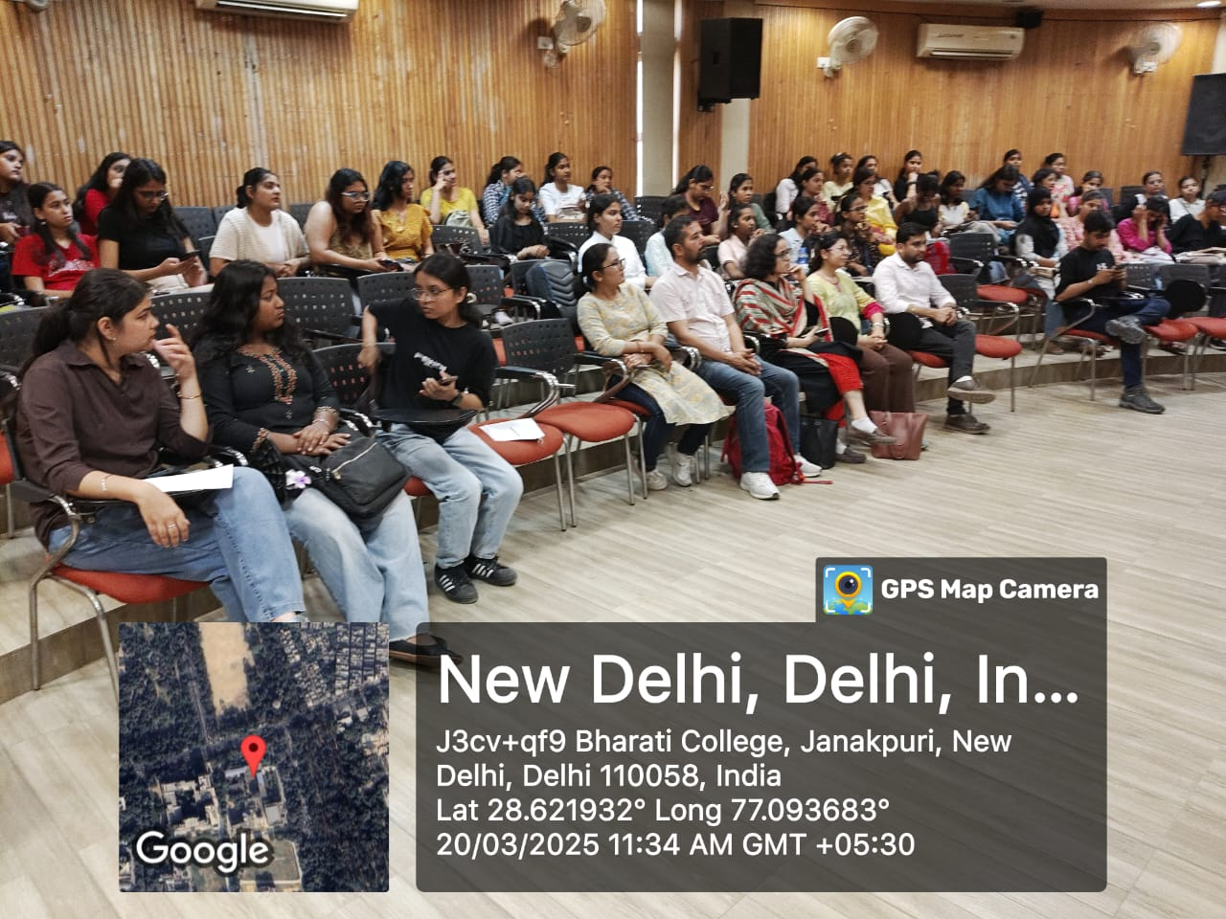

Equilibrium – The Equality Fest
The EOC held its annual festival on 20th March 2025. The event was compared by a student volunter. The speaker was felicitated with a potted sapling. We had a dynamic speaker Ms Simran Chawla who shared her inspirational journey of being a science student in a system which was ill equipped with the requirements of a near blind student. However, her perseverance and the efforts of her encouraging mother and teachers paid off. Ms Chawla also sensitized the audience with the needs of persons with disabilities and spoke of the challenges she faced as a food vlogger being a differently abled person. She had covered nearly 30 restaurants so far and had more than 11 thousand subscribers on Instagram. The students were very impressed by her achievements. The session ended with a vote of thanks.
Next, we had two categories of competitions, one of students with disabilities and the other for general students. Talent Hunt was open for PwD and folk singing was a competition open for all students. There was enthusiastic participation in the general category and apart from the 1st 2nd and 3rd prizes a special prize was also announced. Unfortunately, there was a single participant in the category for students with disability. She was given a special prize.

